**Weekly Status Report – Niles Guo Sept 3, 2017**

**This week’s activity:**

1. Other than the first week of class, worked on finalizing the first iteration of taxonomy.

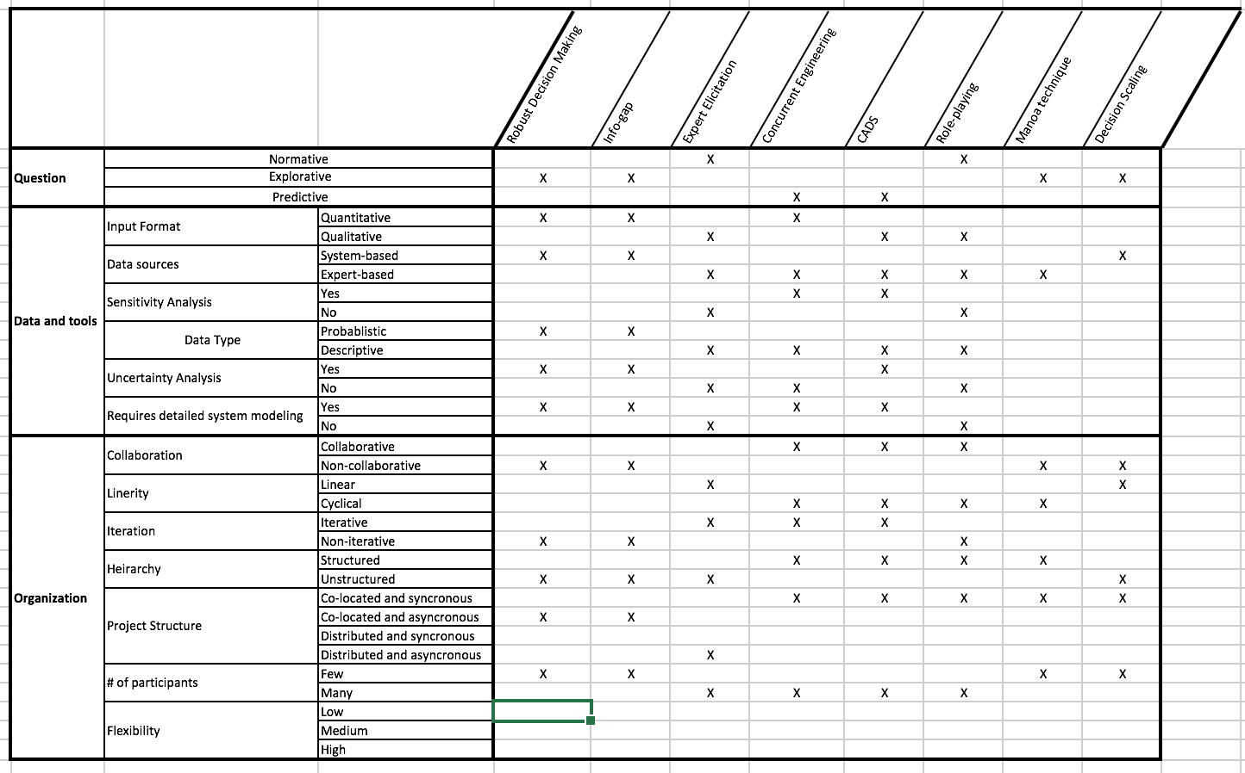

1. Included additional categories and re-arranged certain categories within each other.

|  |  |  |
| --- | --- | --- |
| **Question** | Normative: Given a policy goal, how do you reach that goal? | |
| Explorative: What are the possible scenarios? | |
| Predictive: What is the best solution, or what will the outcome be? | |
| **Data and tools** | Include Qualitative? | Yes: data has qualitative inputs |
| No: data is all quantitative |
| Include Expert input? | No: data is sourced exclusively from system inputs. |
| Yes: Data can come from expert inputs. |
| Sensitivity Analysis | Yes: Sensitivity analysis is conducted. |
| No: Sensitivity analysis is not conducted. |
| Data Type | Probablistic: Data includes probabilistic/stochastic inputs |
| Descriptive: Data is only descriptive |
| Uncertainty Analysis | Yes: uncertainty analysis is conducted |
| No: uncertainty analysis is not conducted |
| Requires detailed system modeling | Yes |
| No |
| **Organization** | Collaboration | Collaborative |
| Non-collaborative |
| Linearity | Linear |
| Cyclical |
| Iteration | Iterative |
| Non-iterative |
| Hierarchy | Structured: formalized team structure, usually with a team leader |
| Unstructured: Flat structure, with very little formalized rules in place |
| Project Structure | Co-located and synchronous |
| Co-located and asynchronous |
| Distributed and synchronous |
| Distributed and asynchronous |
| # of participants | Few (1-3) |
| Many (more than 3) |
| Flexibility | Low |
| Medium |
| High |

**Issues/Agenda for next meeting**

1. Present some more of the taxonomy work for another iteration review.

**Next week’s activity:**

1. Continue to work on project progress timeline and build a usable project timeline for the semester.
2. Start to look into useful case studies