**Weekly Status Report – Niles Guo Aug 4, 2017**

**This week’s activity:**

1. Downloaded and built a local version of the Energy Transition Model (<http://www.energytransitionmodel.com)>, and investigated on the ease to change the interface to suit our needs. From the limited time spent with the tool, while the data source is easy to plug and change, changes in the interface will be much more difficult. Also, it’s currently designed for one user to specify parameters for the system, rather than for a collaborative environment.

With that being said, there are a lot of cues and ideas we can take from how they presented the information to users. For example, a constant summary bar appears at the bottom the page, showing some of the interesting outputs and targets. As users change the parameters, the summary bar updates itself with newer numbers along with direction.

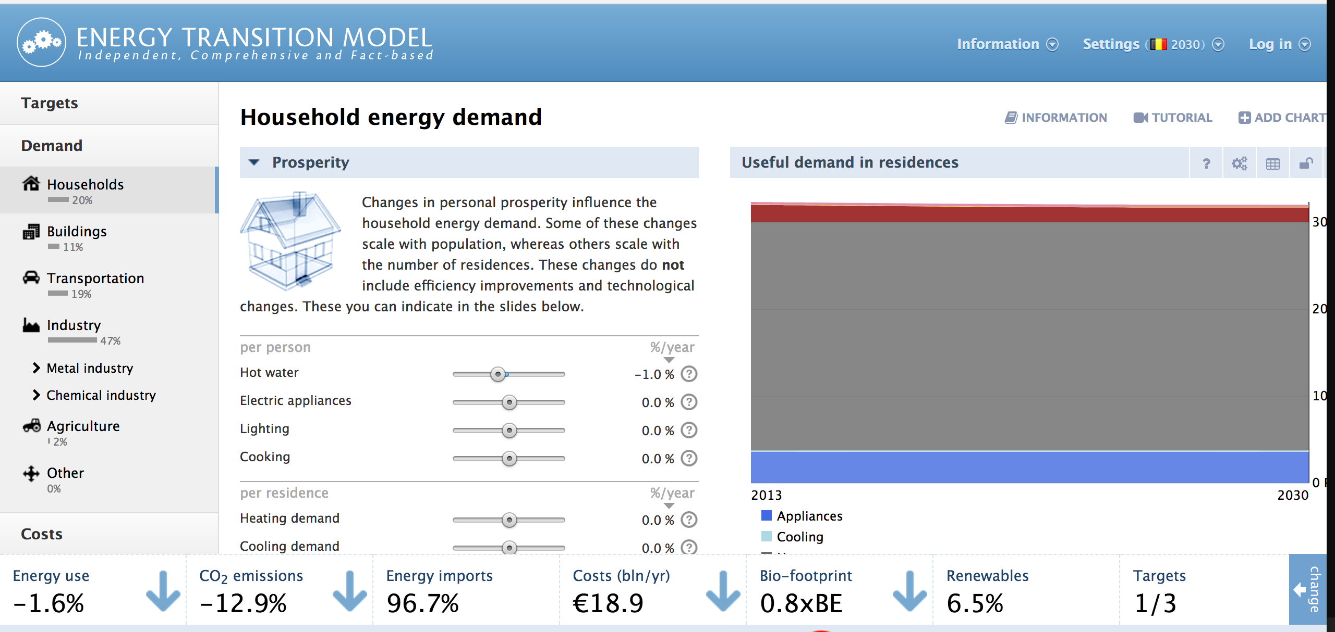

There are also graphs that can provide visual cues on what their actions mean in the model, and how different choices can impact energy use and transition.

1. Identified a set of 8 research gaps, categorized into three sections. Took three of them and started to formulate research questions, hypothesis, and tasks for each of them. I will share a draft prior to our next meeting.
2. Received from Tim his GAMS optimization model for the case study he ran. Investigated how to integrate this with Rebecca’s work.

**Issues/Agenda for next meeting**

1. Go over the draft research plans. I would appreciate any feedback on how I identified the research gaps, identified hypothesis, and defined the research tasks to answer those questions.
2. Next steps on how to work with Andres and his lab.
3. If we get more information prior to our meeting, we can discuss how we can use the Bay Game to validate our CADS work.

**Next week’s activity:**

1. With more information, investigate the Bay game and how we can utilize it to validate CADS.
2. Refine the research plans based on your feedback.

**Journal Article Review**

Abadie, Luis M., and José M. Chamorro. "Monte Carlo valuation of natural gas investments." Review of Financial Economics 18.1 (2009): 10-22.

In this particular paper published in 2009, Abadie and Chamorro attempted to evaluate the financial viability of natural gas investments (through a case study of NGCC power plant and a LNG facility). Understanding that the result of this analysis will very much depend on energy prices, natural gas prices, and regulatory realities, the authors used a Monte-Carlo approach to estimate the price of carbon, energy prices, and natural gas prices, with gas and electricity historical prices taken from the NYMEX NG futures contract and the Spanish electricity market.

One of the key assumptions made by the authors was that energy and electricity prices are made up of two components, a short-term component that displays high volatility, seasonal effects, but also mean reversion, and a long-term component that can be modeled using a geometric Brownian motion. The authors argued that because NGCC and LNG facilities are always long-term investments, the long-term component of the prices are the more important ones, especially since the short-term volatility will reversed to the mean. However, this approach (a common one in the financial sector to model stock prices) do assume price independence, and does not take account of rare events that will have massive effects on energy prices. The authors recognized this limitation and mentioned there is a need for more sophisticated stochastic models for energy and electricity prices.

A couple of factors made this paper interesting in the CADS context. The first is that it illustrated another research potential research gap in this space, since future energy and electricity prices are an important component of any CADS model. If they cannot be accurately modeled, then the result of CADS approach will be less robust. Secondly, this does show how we can apply stochastic methods to address uncertainties in some of our parameters, especially inputs that are volatile or hard to quantify (income distribution, housing rental prices etc.). Finally, this case study provides an opportunity to validate CADS approach, and see if our modeling result resembles the one taken by the authors.