**Weekly Status Report – Niles Guo Nov 12, 2017**

**This week’s activity:**

1. Started to write the full paper using the outline.
2. Created the full decision tree. However, instead of manually creating the decision tree, I decided to use R to create the decision tree instead. This minimizes the number of levels for the decision tree, and if new attributes or new methods are added in the future, this tree can be recreated quickly to incorporate the new information.

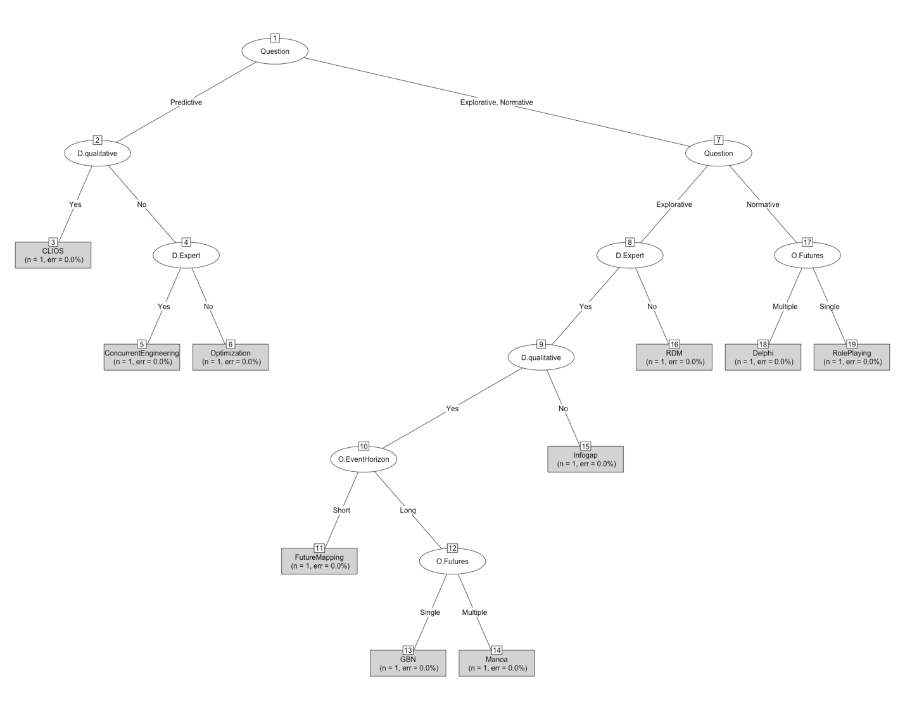

**Issues/Agenda for next meeting**

1. Is it worth to reposition the methods section to add the small machine learning component (building the decision tree automatically) into the paper?

**Next week’s activity:**

1. Write the draft of a paper.