BIT235 Object Oriented Programming
Week 4 Workshop - Arrays
Chen Zhihan (S1580887)

GitHub: https://github.com/chenzhihan1751-cyber/bit235javaproject/tree/main/JavaProjects/Week04-Workshop4
Part A answers questions 1 to 8 of the Arrays exercise sheet.
Part B answers the three extended array exercises: passing an array to a method, bubble sort, and binary versus linear search.
Every program was compiled with javac (release 8) and run in the VS Code integrated terminal; the screenshots below are the real runs.

Part A - Arrays exercise

Q1. Creating an array (shorthand)
Create an int array called numbers using the shorthand method, containing the values 3, 6, 9, 12, 15.
Answer:
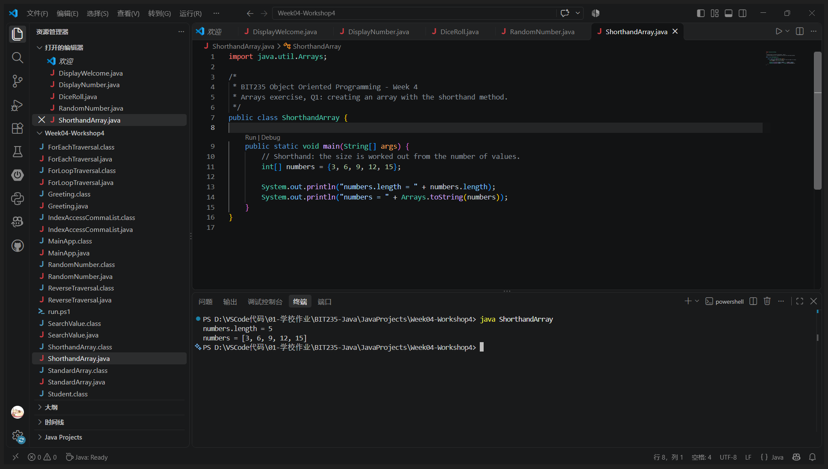
VS Code - java ShorthandArray
Program: ShorthandArray.java
import java.util.Arrays;
/*
* BIT235 Object Oriented Programming - Week 4
* Arrays exercise, Q1: creating an array with the shorthand method.
*/
public class ShorthandArray {
public static void main(String[] args) {
// Shorthand: the size is worked out from the number of values.
int[] numbers = {3, 6, 9, 12, 15};
System.out.println("numbers.length = " + numbers.length);
System.out.println("numbers = " + Arrays.toString(numbers));
}
}
Output:
numbers.length = 5
numbers = [3, 6, 9, 12, 15]

Q2. Creating an array (standard method)
Create an int array called values with new int[], five elements, and assign the values 12, 4, 1, 8, 7.
Answer:
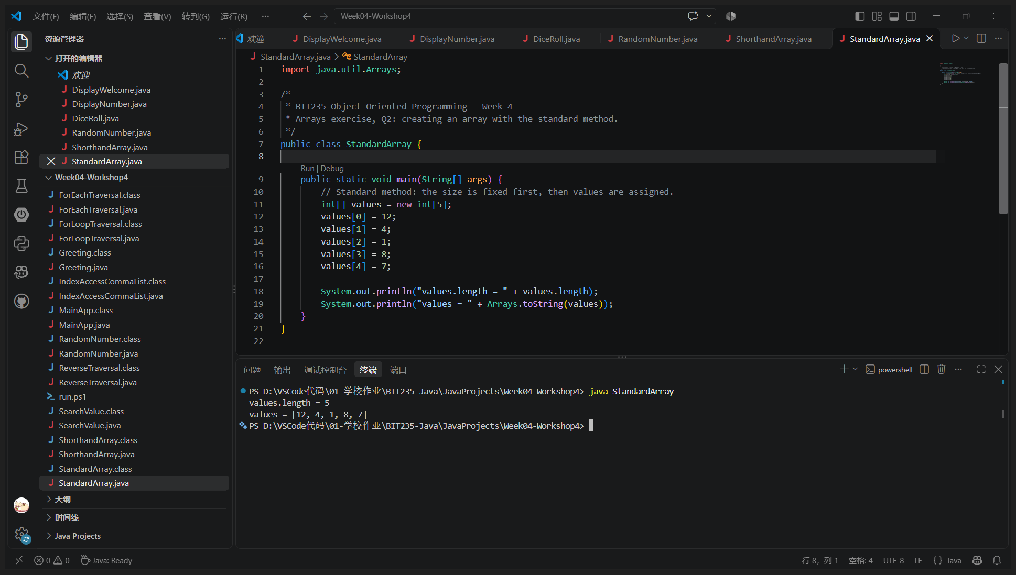
VS Code - java StandardArray
Program: StandardArray.java
import java.util.Arrays;
/*
* BIT235 Object Oriented Programming - Week 4
* Arrays exercise, Q2: creating an array with the standard method.
*/
public class StandardArray {
public static void main(String[] args) {
// Standard method: the size is fixed first, then values are assigned.
int[] values = new int[5];
values[0] = 12;
values[1] = 4;
values[2] = 1;
values[3] = 8;
values[4] = 7;
System.out.println("values.length = " + values.length);
System.out.println("values = " + Arrays.toString(values));
}
}
Output:
values.length = 5
values = [12, 4, 1, 8, 7]

Q3. Traversing an array using .length
Using the numbers array from Q1, write a for loop that prints each value, using numbers.length in the loop.
Answer:
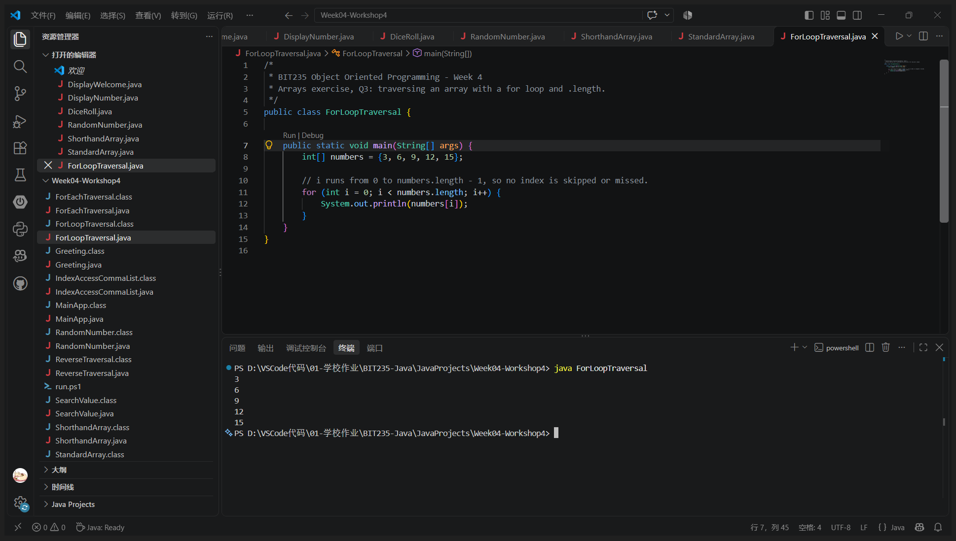
VS Code - java ForLoopTraversal
Program: ForLoopTraversal.java
/*
* BIT235 Object Oriented Programming - Week 4
* Arrays exercise, Q3: traversing an array with a for loop and .length.
*/
public class ForLoopTraversal {
public static void main(String[] args) {
int[] numbers = {3, 6, 9, 12, 15};
// i runs from 0 to numbers.length - 1, so no index is skipped or missed.
for (int i = 0; i < numbers.length; i++) {
System.out.println(numbers[i]);
}
}
}
Output:
3
6
9
12
15

Q4. Traversing an array using foreach
Using the values array from Q2, write a foreach loop that prints each value.
Answer:
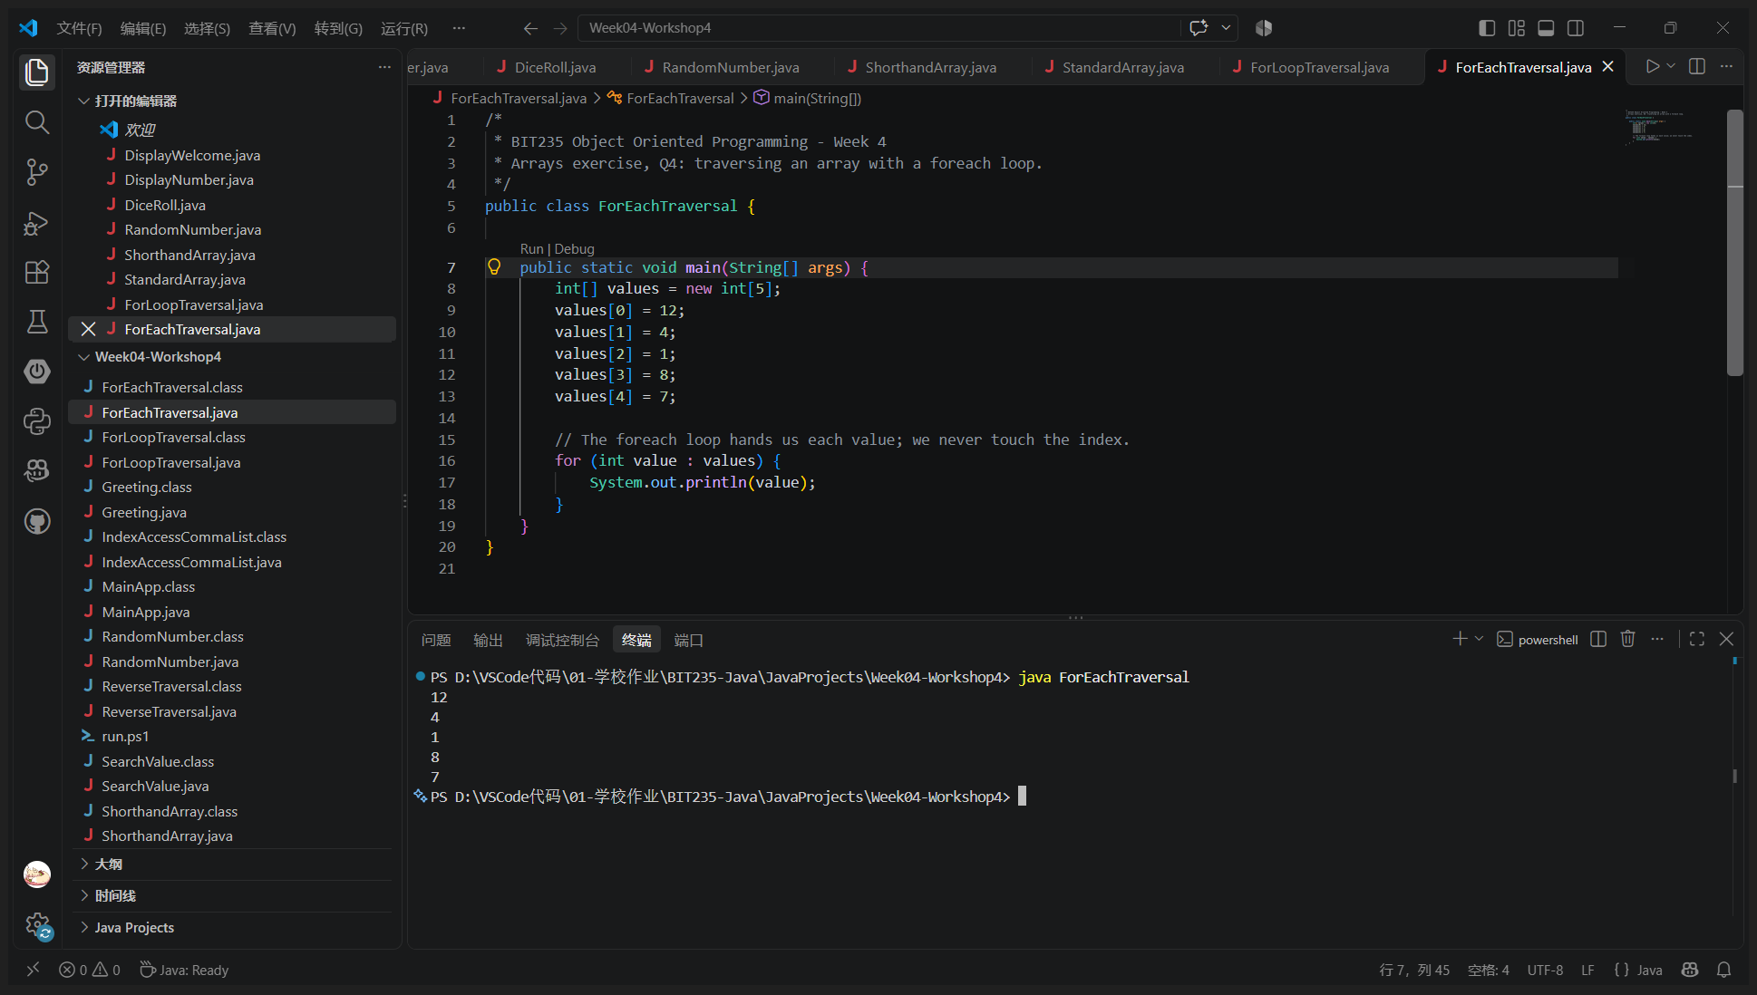
VS Code - java ForEachTraversal
Program: ForEachTraversal.java
/*
* BIT235 Object Oriented Programming - Week 4
* Arrays exercise, Q4: traversing an array with a foreach loop.
*/
public class ForEachTraversal {
public static void main(String[] args) {
int[] values = new int[5];
values[0] = 12;
values[1] = 4;
values[2] = 1;
values[3] = 8;
values[4] = 7;
// The foreach loop hands us each value; we never touch the index.
for (int value : values) {
System.out.println(value);
}
}
}
Output:
12
4
1
8
7

Q5. Searching for a value (if statement)
Using the numbers array, write code with a loop and an if statement that checks whether the value 9 exists, printing "Value found" or "Value not found".
Answer:
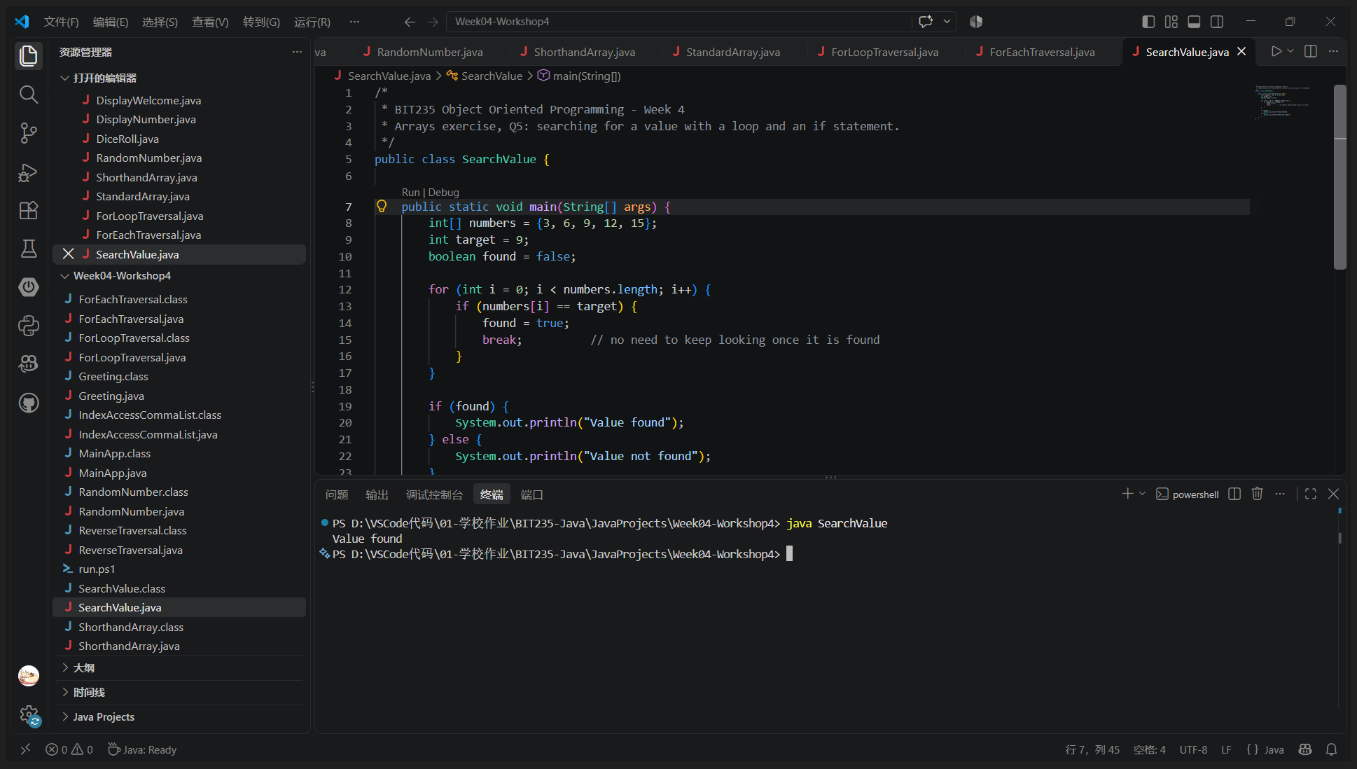
VS Code - java SearchValue
Program: SearchValue.java
/*
* BIT235 Object Oriented Programming - Week 4
* Arrays exercise, Q5: searching for a value with a loop and an if statement.
*/
public class SearchValue {
public static void main(String[] args) {
int[] numbers = {3, 6, 9, 12, 15};
int target = 9;
boolean found = false;
for (int i = 0; i < numbers.length; i++) {
if (numbers[i] == target) {
found = true;
break; // no need to keep looking once it is found
}
}
if (found) {
System.out.println("Value found");
} else {
System.out.println("Value not found");
}
}
}
Output:
Value found

Q6. Traversing an array in reverse
Using the values array from Q2, print the values in reverse order.
Note: the sample output on the exercise sheet (15 12 9 6 3) is the numbers array reversed, while the instruction names the values array. The program follows the instruction, so the values array is printed backwards: 7 8 1 4 12.
Answer:
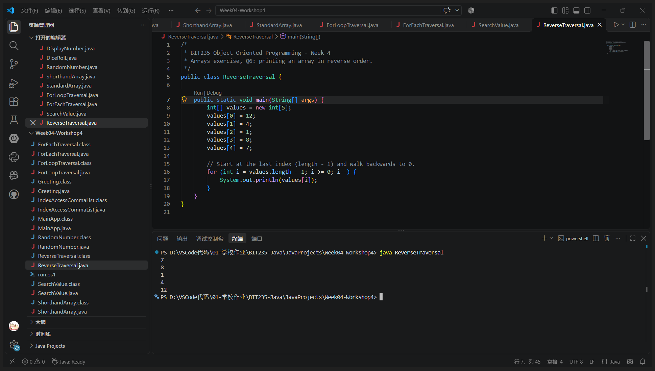
VS Code - java ReverseTraversal
Program: ReverseTraversal.java
/*
* BIT235 Object Oriented Programming - Week 4
* Arrays exercise, Q6: printing an array in reverse order.
*/
public class ReverseTraversal {
public static void main(String[] args) {
int[] values = new int[5];
values[0] = 12;
values[1] = 4;
values[2] = 1;
values[3] = 8;
values[4] = 7;
// Start at the last index (length - 1) and walk backwards to 0.
for (int i = values.length - 1; i >= 0; i--) {
System.out.println(values[i]);
}
}
}
Output:
7
8
1
4
12

Q7. Filling an array at runtime
Create an array called people of size 5. Fill it from user input with Scanner and break out when the user enters nothing. Then display the elements as a comma separated list.
Note: a foreach loop cannot fill an array, because it copies each element into a local variable and writing to that variable never reaches the array. The program reads the input with an indexed for loop and prints the result with the same comma separated pattern.
Answer:
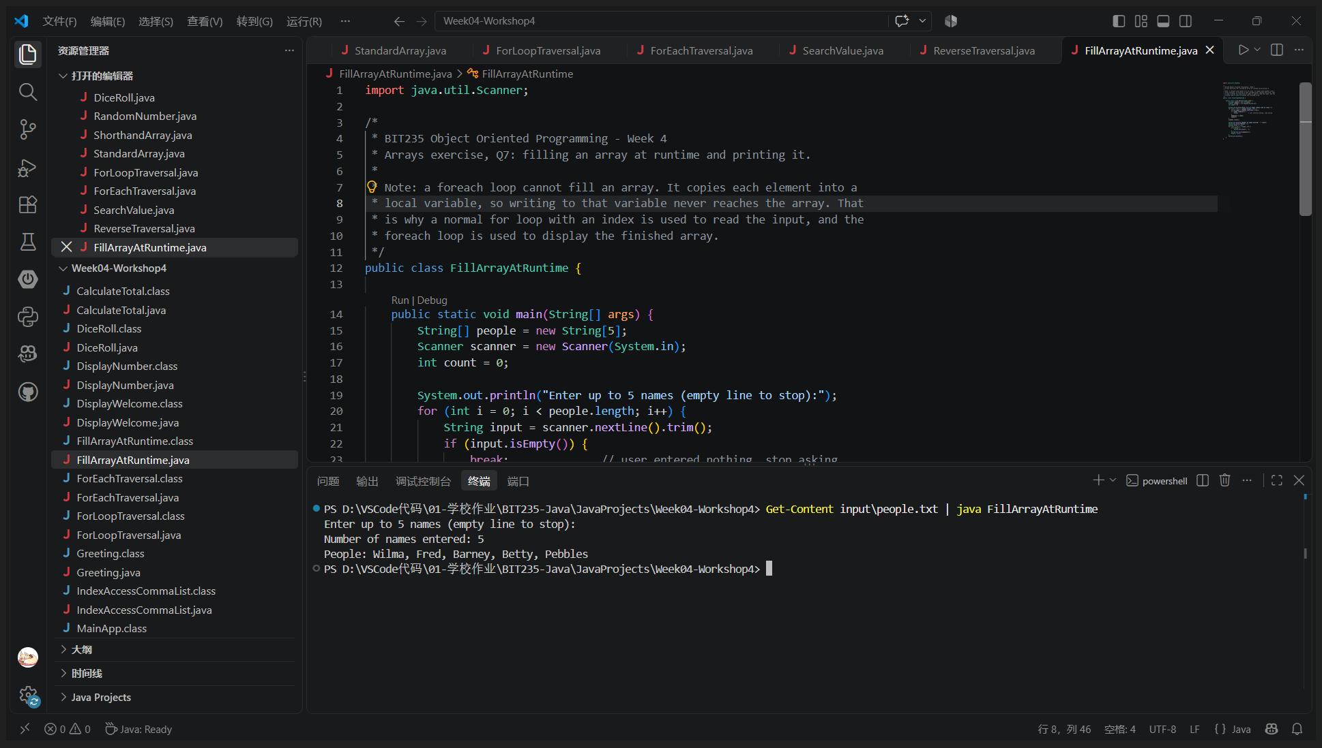
VS Code - Get-Content input\people.txt | java FillArrayAtRuntime (the five names are piped in as the typed input)
Program: FillArrayAtRuntime.java
import java.util.Scanner;
/*
* BIT235 Object Oriented Programming - Week 4
* Arrays exercise, Q7: filling an array at runtime and printing it.
*
* Note: a foreach loop cannot fill an array. It copies each element into a
* local variable, so writing to that variable never reaches the array. That
* is why a normal for loop with an index is used to read the input, and the
* foreach loop is used to display the finished array.
*/
public class FillArrayAtRuntime {
public static void main(String[] args) {
String[] people = new String[5];
Scanner scanner = new Scanner(System.in);
int count = 0;
System.out.println("Enter up to 5 names (empty line to stop):");
for (int i = 0; i < people.length; i++) {
String input = scanner.nextLine().trim();
if (input.isEmpty()) {
break; // user entered nothing, stop asking
}
people[i] = input;
count++;
}
scanner.close();
System.out.println("Number of names entered: " + count);
System.out.print("People: ");
boolean first = true;
for (int i = 0; i < count; i++) {
if (!first) {
System.out.print(", ");
}
System.out.print(people[i]);
first = false;
}
System.out.println();
}
}
Output:
Enter up to 5 names (empty line to stop):
Number of names entered: 5
People: Wilma, Fred, Barney, Betty, Pebbles

Q8. Accessing index
Using the people array, print each value on a single line separated by a comma, with no comma after the last value, for example: Wilma, Fred, Barney, Betty, Pebbles
Answer:
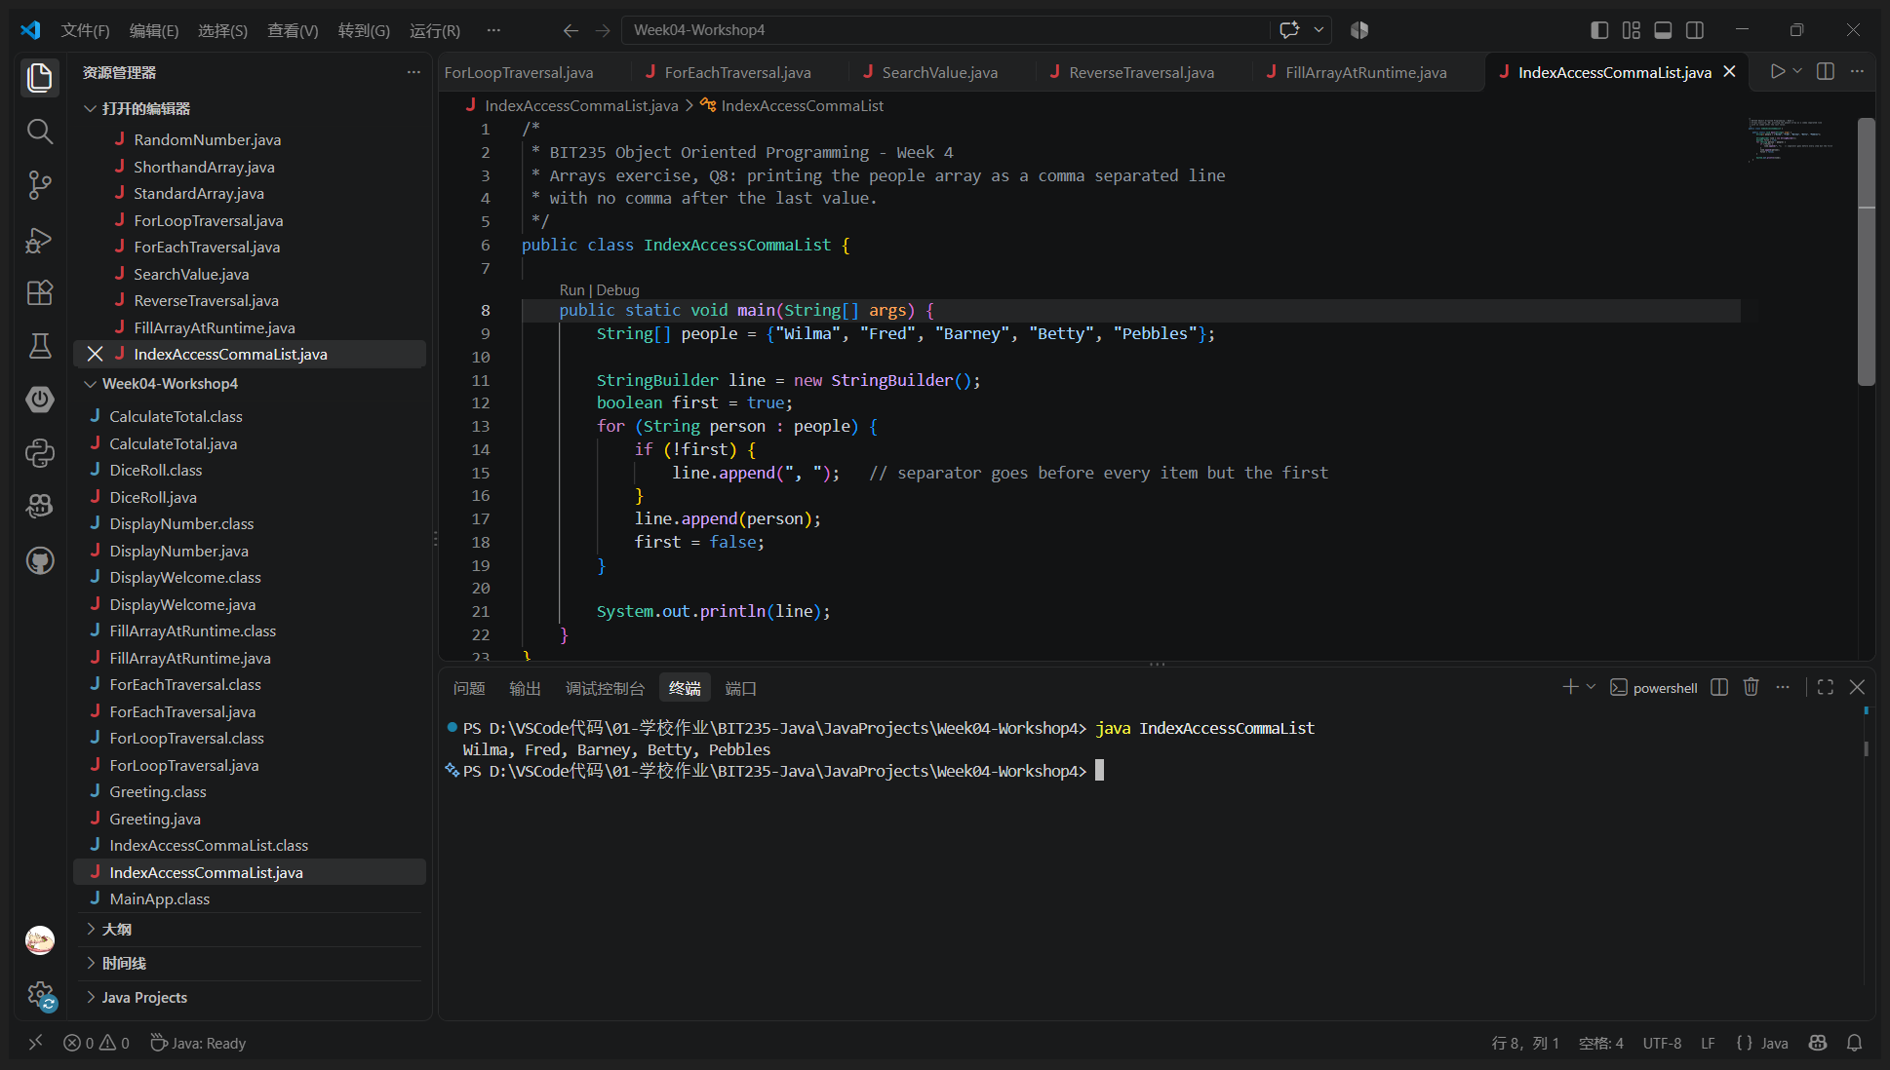
VS Code - java IndexAccessCommaList
Program: IndexAccessCommaList.java
/*
* BIT235 Object Oriented Programming - Week 4
* Arrays exercise, Q8: printing the people array as a comma separated line
* with no comma after the last value.
*/
public class IndexAccessCommaList {
public static void main(String[] args) {
String[] people = {"Wilma", "Fred", "Barney", "Betty", "Pebbles"};
StringBuilder line = new StringBuilder();
boolean first = true;
for (String person : people) {
if (!first) {
line.append(", "); // separator goes before every item but the first
}
line.append(person);
first = false;
}
System.out.println(line);
}
}
Output:
Wilma, Fred, Barney, Betty, Pebbles

Part B - Arrays extended exercises

Exercise 1 - Passing arrays to methods
Create an int array with the values 4, 7, 2, 9, 5. Write a static method called calculateTotal() that accepts an int array, returns an int and calculates the sum of all values. Call it from main, store the result in a variable called total and print it, for example: Total: 27
Answer:
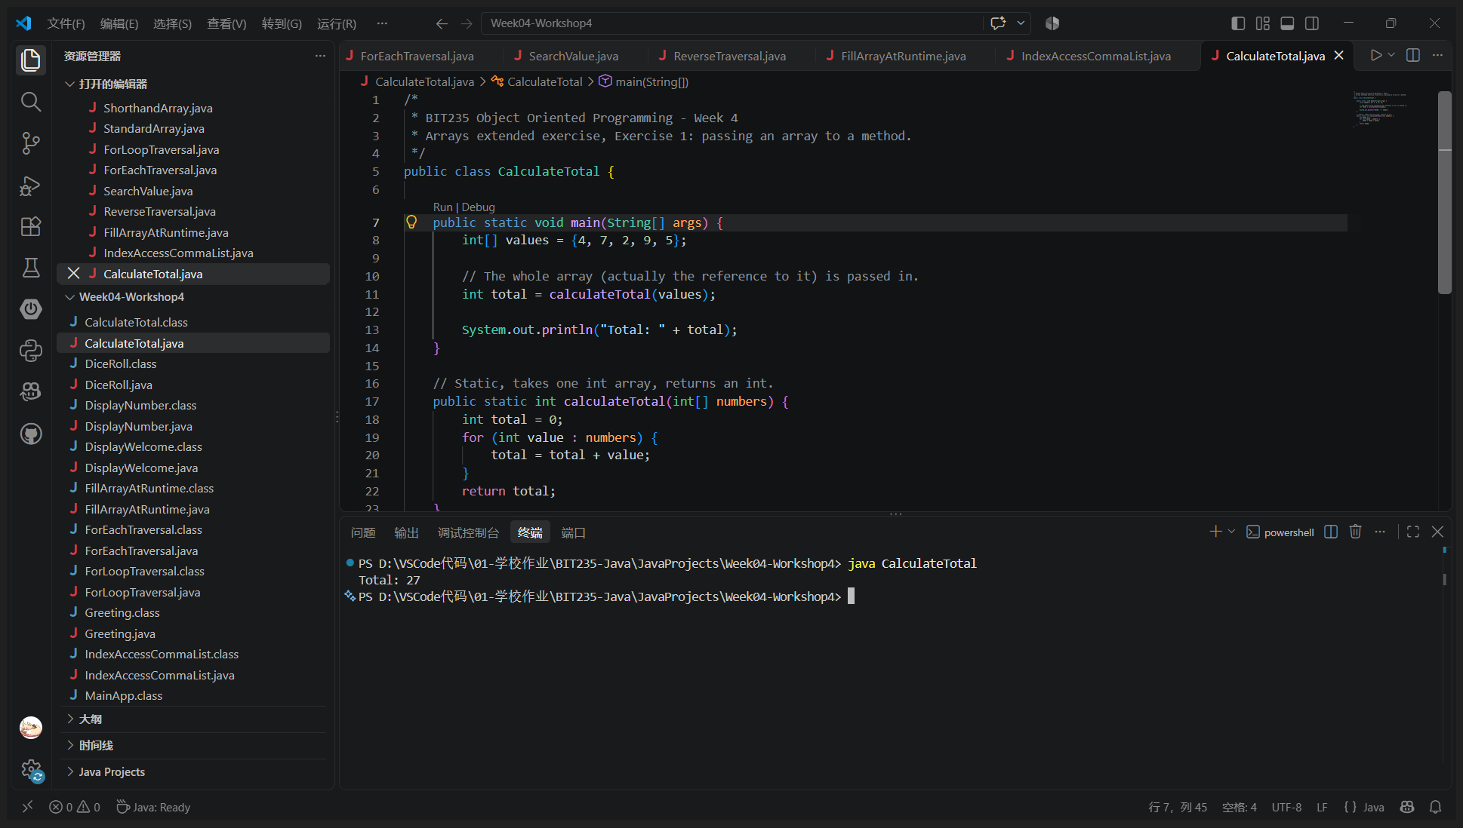
VS Code - java CalculateTotal
Program: CalculateTotal.java
/*
* BIT235 Object Oriented Programming - Week 4
* Arrays extended exercise, Exercise 1: passing an array to a method.
*/
public class CalculateTotal {
public static void main(String[] args) {
int[] values = {4, 7, 2, 9, 5};
// The whole array (actually the reference to it) is passed in.
int total = calculateTotal(values);
System.out.println("Total: " + total);
}
// Static, takes one int array, returns an int.
public static int calculateTotal(int[] numbers) {
int total = 0;
for (int value : numbers) {
total = total + value;
}
return total;
}
}
Output:
Total: 27

Exercise 2 - Sorting (bubble sort)
Write a program that bubble sorts an array of 20 unique values between 1 and 1000. Two neighbouring elements are compared and swapped when they are out of order, and the whole process repeats until a full pass makes no swap.
Answer:
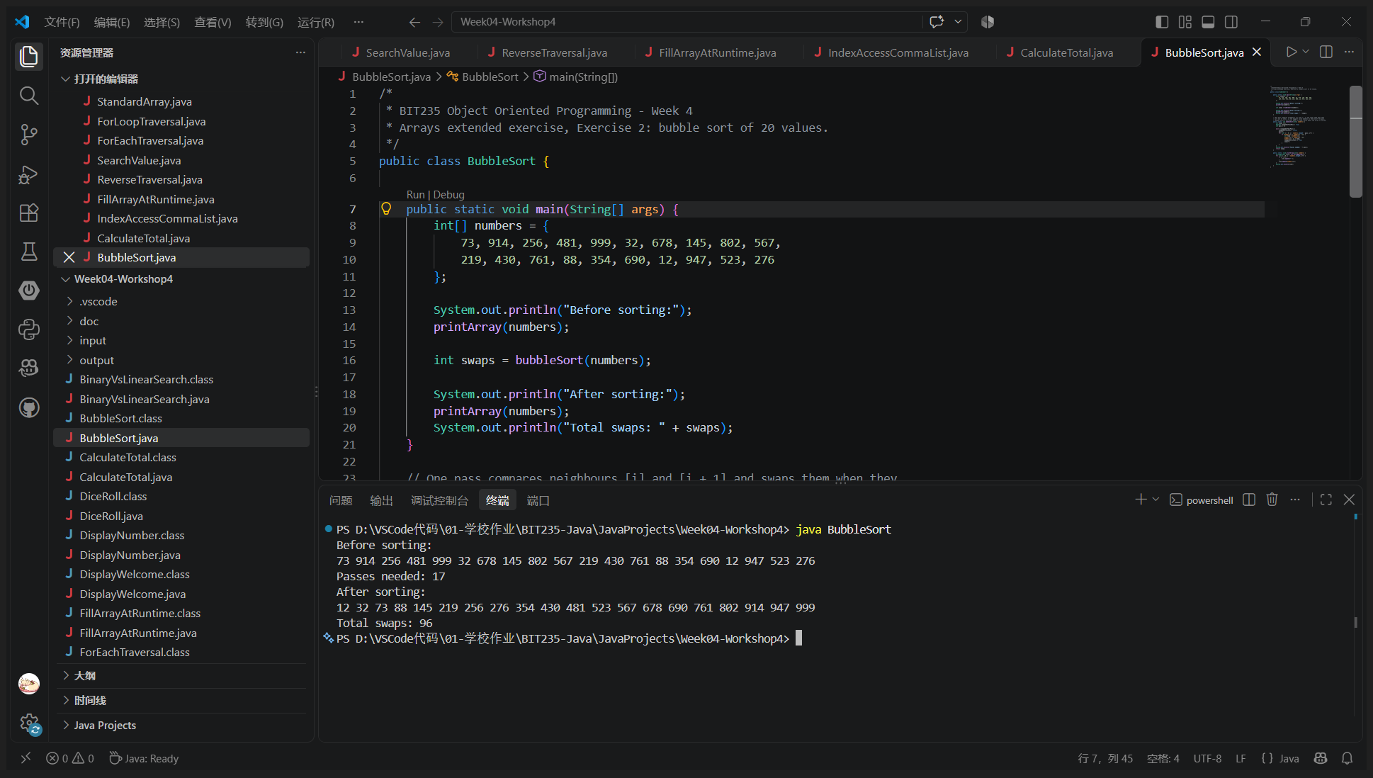
VS Code - java BubbleSort
Program: BubbleSort.java
/*
* BIT235 Object Oriented Programming - Week 4
* Arrays extended exercise, Exercise 2: bubble sort of 20 values.
*/
public class BubbleSort {
public static void main(String[] args) {
int[] numbers = {
73, 914, 256, 481, 999, 32, 678, 145, 802, 567,
219, 430, 761, 88, 354, 690, 12, 947, 523, 276
};
System.out.println("Before sorting:");
printArray(numbers);
int swaps = bubbleSort(numbers);
System.out.println("After sorting:");
printArray(numbers);
System.out.println("Total swaps: " + swaps);
}
// One pass compares neighbours [i] and [i + 1] and swaps them when they
// are out of order, so the biggest value bubbles to the end of the pass.
// Repeat until a full pass makes no swap, which means the array is sorted.
public static int bubbleSort(int[] numbers) {
int swaps = 0;
boolean swappedInThisPass = true;
int pass = 0;
while (swappedInThisPass) {
swappedInThisPass = false;
pass++;
for (int i = 0; i < numbers.length - pass; i++) {
if (numbers[i] > numbers[i + 1]) {
int temp = numbers[i];
numbers[i] = numbers[i + 1];
numbers[i + 1] = temp;
swappedInThisPass = true;
swaps++;
}
}
}
System.out.println("Passes needed: " + pass);
return swaps;
}
public static void printArray(int[] numbers) {
StringBuilder line = new StringBuilder();
for (int i = 0; i < numbers.length; i++) {
if (i > 0) {
line.append(" ");
}
line.append(numbers[i]);
}
System.out.println(line);
}
}
Output:
Before sorting:
73 914 256 481 999 32 678 145 802 567 219 430 761 88 354 690 12 947 523 276
Passes needed: 17
After sorting:
12 32 73 88 145 219 256 276 354 430 481 523 567 678 690 761 802 914 947 999
Total swaps: 96

Exercise 3 - Binary search (Task A and Task B)
Task A: extend the bubble sort program with a binary search, so the sorted array is searched by checking the middle element and then the left or right half. Task B: count the comparisons needed by the binary search and by a linear search over the unsorted list, then print a comparison of the two.
Result: for a target near the end of the list the binary search needed 3 comparisons where the linear search needed 19, and for a target that is not in the list it needed 4 against 20.
Answer:
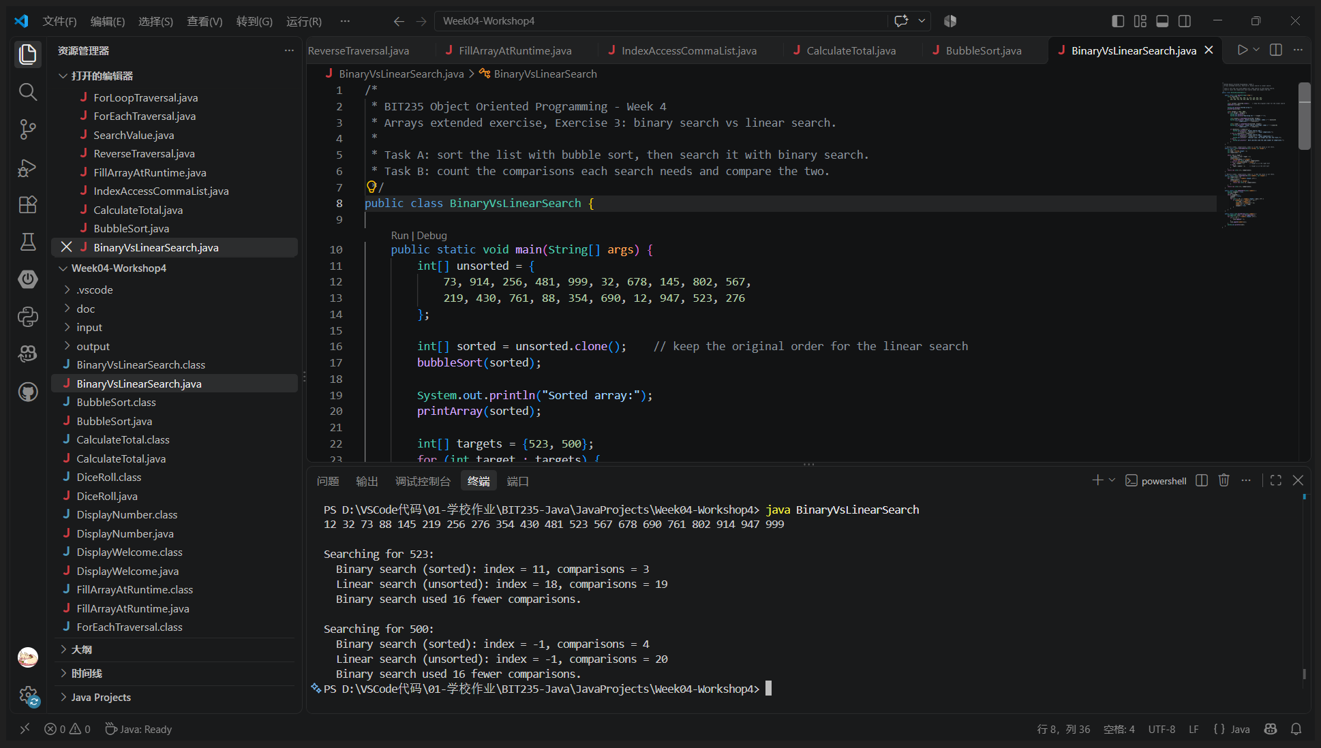
VS Code - java BinaryVsLinearSearch
Program: BinaryVsLinearSearch.java
/*
* BIT235 Object Oriented Programming - Week 4
* Arrays extended exercise, Exercise 3: binary search vs linear search.
*
* Task A: sort the list with bubble sort, then search it with binary search.
* Task B: count the comparisons each search needs and compare the two.
*/
public class BinaryVsLinearSearch {
public static void main(String[] args) {
int[] unsorted = {
73, 914, 256, 481, 999, 32, 678, 145, 802, 567,
219, 430, 761, 88, 354, 690, 12, 947, 523, 276
};
int[] sorted = unsorted.clone(); // keep the original order for the linear search
bubbleSort(sorted);
System.out.println("Sorted array:");
printArray(sorted);
int[] targets = {523, 500};
for (int target : targets) {
System.out.println();
System.out.println("Searching for " + target + ":");
int[] binary = binarySearch(sorted, target);
System.out.println(" Binary search (sorted): index = " + binary[0]
+ ", comparisons = " + binary[1]);
int[] linear = linearSearch(unsorted, target);
System.out.println(" Linear search (unsorted): index = " + linear[0]
+ ", comparisons = " + linear[1]);
if (binary[1] < linear[1]) {
System.out.println(" Binary search used "
+ (linear[1] - binary[1]) + " fewer comparisons.");
} else if (binary[1] > linear[1]) {
System.out.println(" Linear search used "
+ (binary[1] - linear[1]) + " fewer comparisons.");
System.out.println(" (Unusual case: the target was near the front.)");
} else {
System.out.println(" Both searches used the same number of comparisons.");
}
}
}
// Returns {index, comparisons}; index is -1 when the value is not there.
public static int[] binarySearch(int[] sorted, int target) {
int low = 0;
int high = sorted.length - 1;
int comparisons = 0;
while (low <= high) {
int middle = (low + high) / 2;
comparisons++;
if (sorted[middle] == target) {
return new int[] {middle, comparisons};
} else if (sorted[middle] < target) {
low = middle + 1; // target is in the right half
} else {
high = middle - 1; // target is in the left half
}
}
return new int[] {-1, comparisons};
}
// Returns {index, comparisons}; index is -1 when the value is not there.
public static int[] linearSearch(int[] numbers, int target) {
int comparisons = 0;
for (int i = 0; i < numbers.length; i++) {
comparisons++;
if (numbers[i] == target) {
return new int[] {i, comparisons};
}
}
return new int[] {-1, comparisons};
}
public static void bubbleSort(int[] numbers) {
boolean swapped = true;
int pass = 0;
while (swapped) {
swapped = false;
pass++;
for (int i = 0; i < numbers.length - pass; i++) {
if (numbers[i] > numbers[i + 1]) {
int temp = numbers[i];
numbers[i] = numbers[i + 1];
numbers[i + 1] = temp;
swapped = true;
}
}
}
}
public static void printArray(int[] numbers) {
StringBuilder line = new StringBuilder();
for (int i = 0; i < numbers.length; i++) {
if (i > 0) {
line.append(" ");
}
line.append(numbers[i]);
}
System.out.println(line);
}
}
Output:
Sorted array:
12 32 73 88 145 219 256 276 354 430 481 523 567 678 690 761 802 914 947 999
Searching for 523:
Binary search (sorted): index = 11, comparisons = 3
Linear search (unsorted): index = 18, comparisons = 19
Binary search used 16 fewer comparisons.
Searching for 500:
Binary search (sorted): index = -1, comparisons = 4
Linear search (unsorted): index = -1, comparisons = 20
Binary search used 16 fewer comparisons.

