BIT235 Object Oriented Programming
Week 4 - Methods Exercises
Chen Zhihan (S1580887)

GitHub: https://github.com/chenzhihan1751-cyber/bit235javaproject/tree/main/JavaProjects/Week04-Workshop4
The four method types are covered in order: void with no parameters, void with parameters, returning with no parameters, and returning with parameters.
Every program was compiled with javac (release 8) and run in the VS Code integrated terminal; the screenshots below are the real runs.

Question 1 - Void method (no parameters)
Write a method called displayWelcome(). It must not return a value and must not accept any parameters. It must print the message: Welcome to Java programming
Answer:
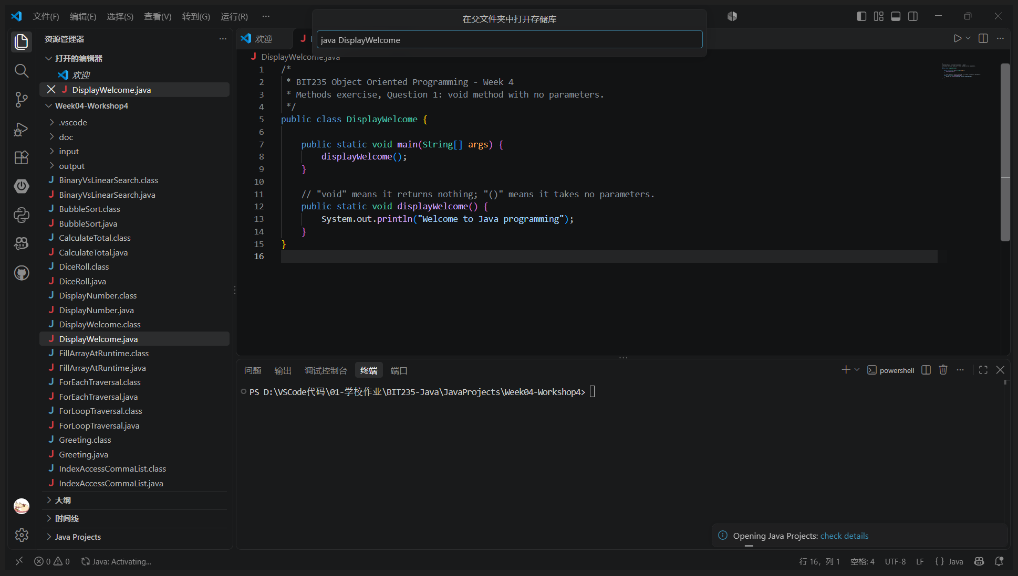
VS Code - java DisplayWelcome
Program: DisplayWelcome.java
/*
* BIT235 Object Oriented Programming - Week 4
* Methods exercise, Question 1: void method with no parameters.
*/
public class DisplayWelcome {
public static void main(String[] args) {
displayWelcome();
}
// "void" means it returns nothing; "()" means it takes no parameters.
public static void displayWelcome() {
System.out.println("Welcome to Java programming");
}
}
Output:
Welcome to Java programming

Question 2 - Void method (with parameter)
Write a method called displayNumber(). It must not return a value and must accept one int parameter. It must print "The number is: x".
Answer:
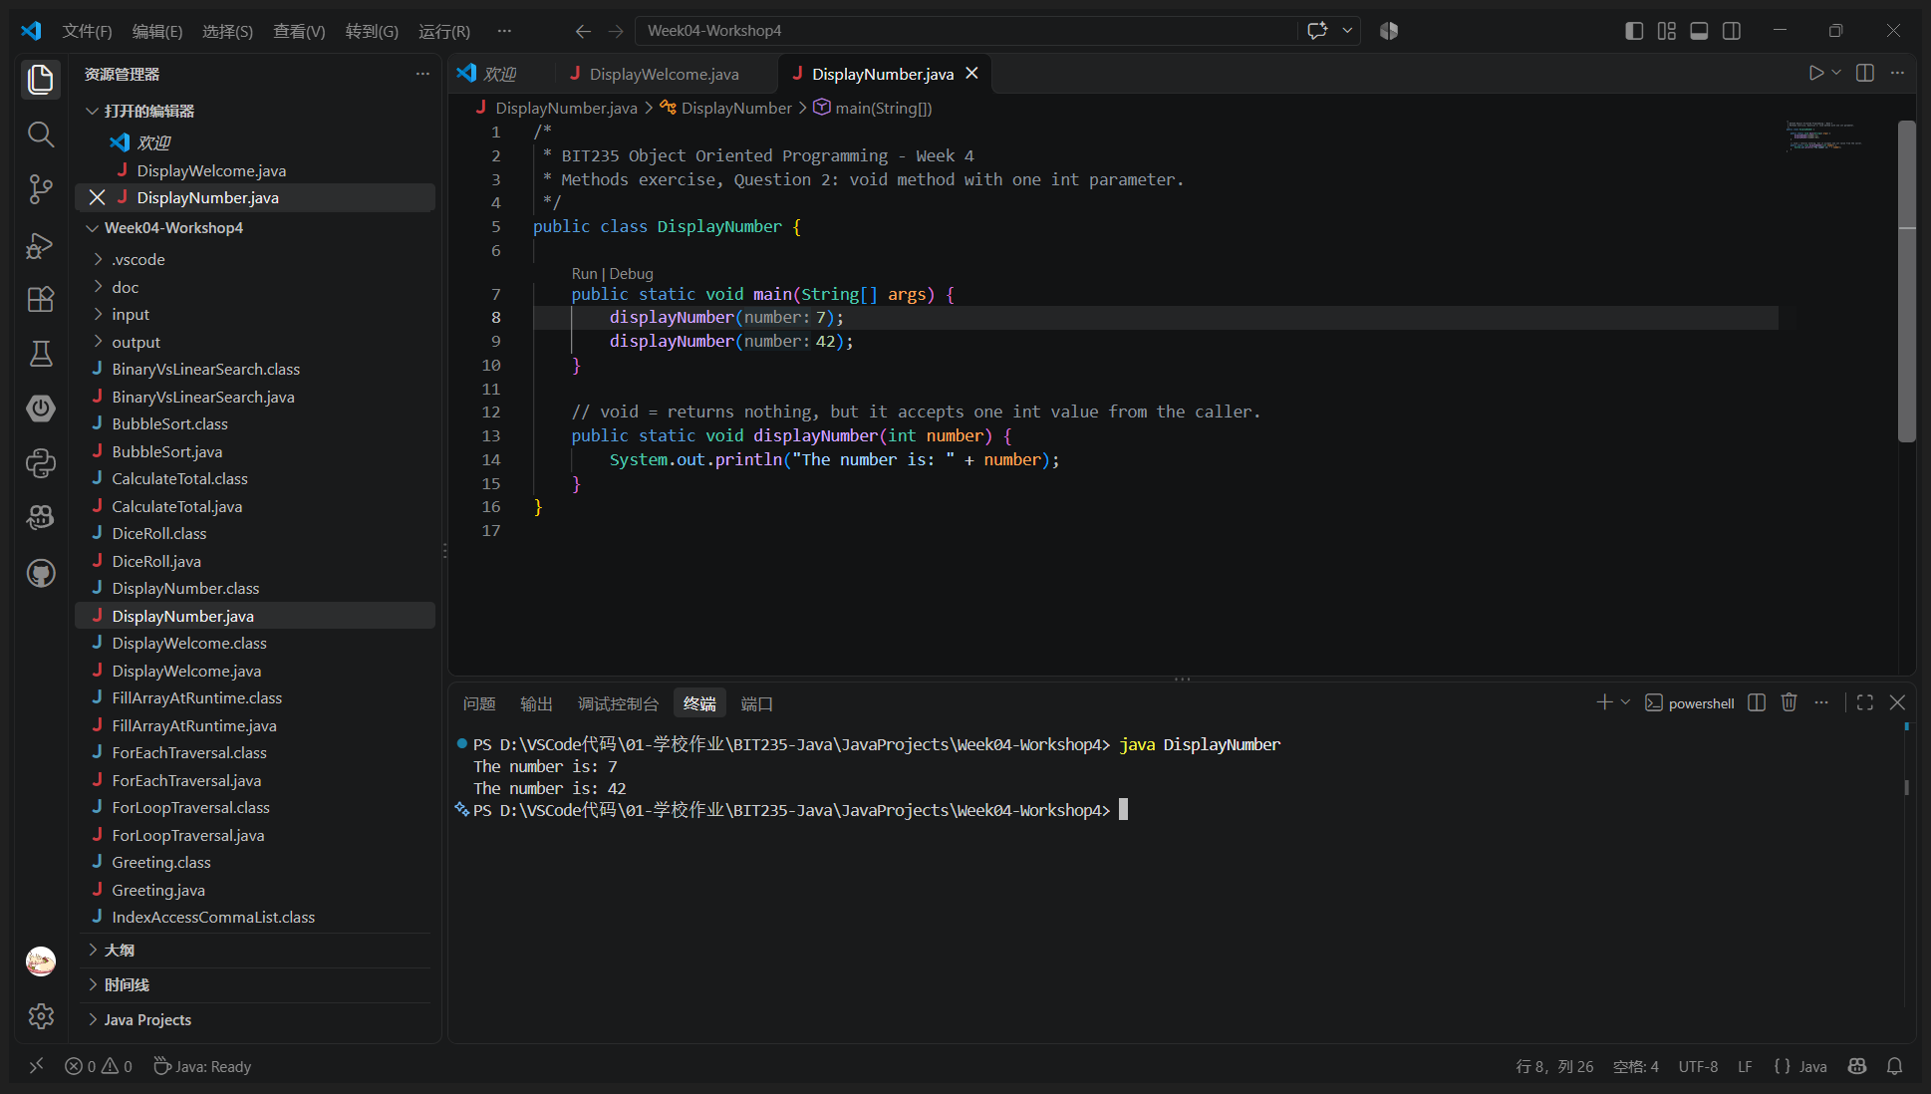
VS Code - java DisplayNumber
Program: DisplayNumber.java
/*
* BIT235 Object Oriented Programming - Week 4
* Methods exercise, Question 2: void method with one int parameter.
*/
public class DisplayNumber {
public static void main(String[] args) {
displayNumber(7);
displayNumber(42);
}
// void = returns nothing, but it accepts one int value from the caller.
public static void displayNumber(int number) {
System.out.println("The number is: " + number);
}
}
Output:
The number is: 7
The number is: 42

Question 3 - Returning method (no parameters)
Write a method called diceRoll(). It must return an int, must not accept any parameters, and must return a random number between 1 and 6. Call it twice, add the two values, print the rolls, then print "7 is a winner!!" when the total is 7 and "Try again." otherwise.
Answer:
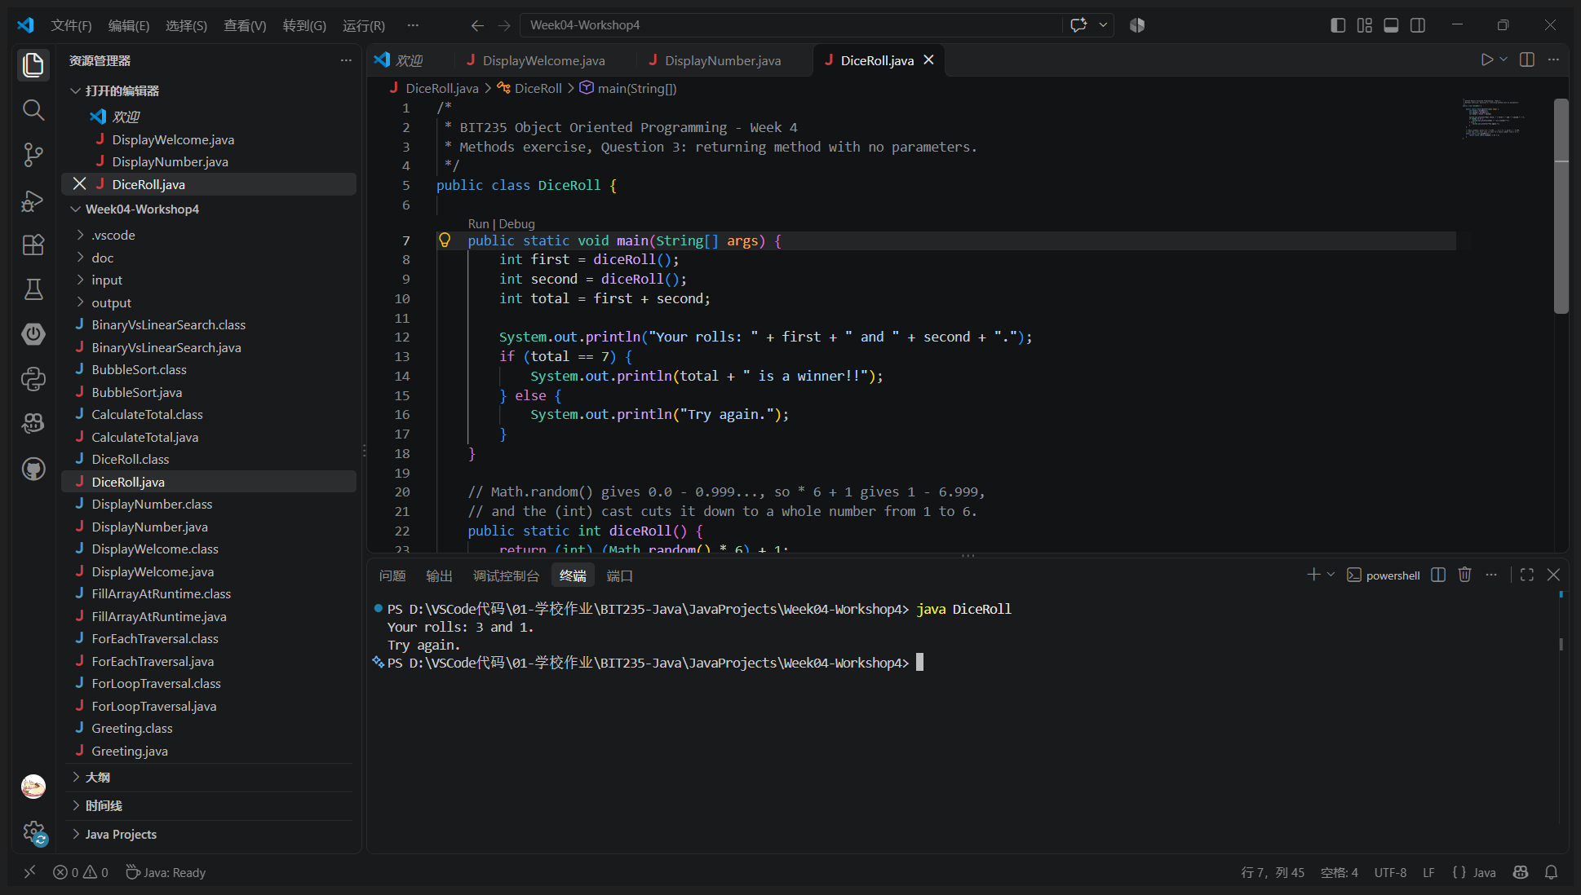
VS Code - java DiceRoll (the roll is random, so the result changes on every run)
Program: DiceRoll.java
/*
* BIT235 Object Oriented Programming - Week 4
* Methods exercise, Question 3: returning method with no parameters.
*/
public class DiceRoll {
public static void main(String[] args) {
int first = diceRoll();
int second = diceRoll();
int total = first + second;
System.out.println("Your rolls: " + first + " and " + second + ".");
if (total == 7) {
System.out.println(total + " is a winner!!");
} else {
System.out.println("Try again.");
}
}
// Math.random() gives 0.0 - 0.999..., so * 6 + 1 gives 1 - 6.999,
// and the (int) cast cuts it down to a whole number from 1 to 6.
public static int diceRoll() {
return (int) (Math.random() * 6) + 1;
}
}
Output:
Your rolls: 3 and 2.
Try again.

Question 4 - Returning method (with multiple parameters)
Write a method called randomNumber(). It must return an int, must accept two int parameters, and must return a random number between the first and the second parameter inclusive. The returned number must be displayed.
Answer:
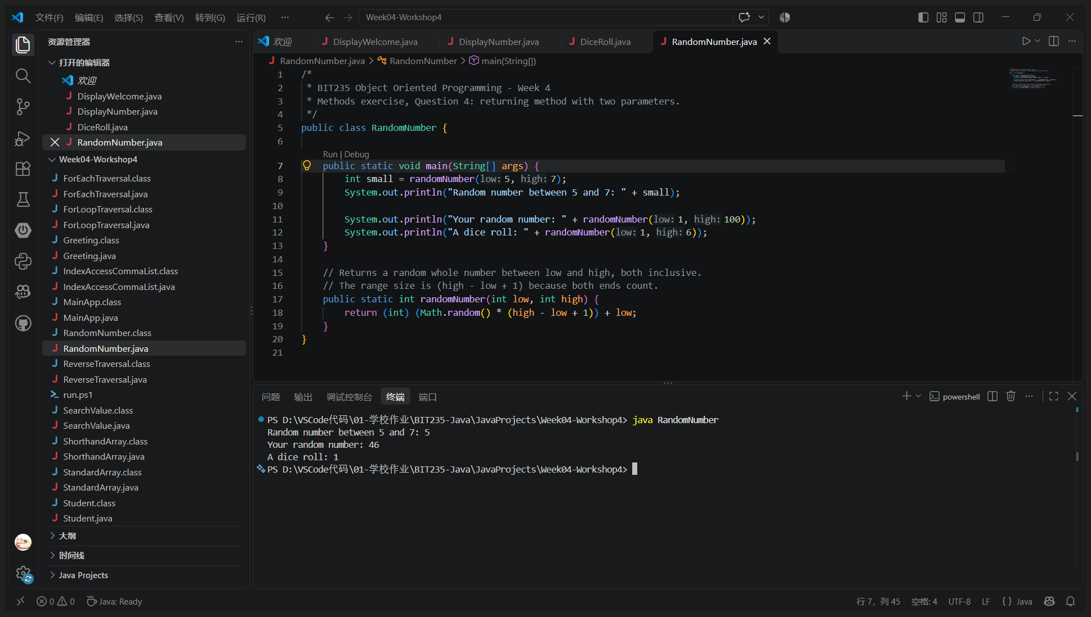
VS Code - java RandomNumber
Program: RandomNumber.java
/*
* BIT235 Object Oriented Programming - Week 4
* Methods exercise, Question 4: returning method with two parameters.
*/
public class RandomNumber {
public static void main(String[] args) {
int small = randomNumber(5, 7);
System.out.println("Random number between 5 and 7: " + small);
System.out.println("Your random number: " + randomNumber(1, 100));
System.out.println("A dice roll: " + randomNumber(1, 6));
}
// Returns a random whole number between low and high, both inclusive.
// The range size is (high - low + 1) because both ends count.
public static int randomNumber(int low, int high) {
return (int) (Math.random() * (high - low + 1)) + low;
}
}
Output:
Random number between 5 and 7: 6
Your random number: 10
A dice roll: 5

