BIT235 Object Oriented Programming
Week 4 Workshop - Classes and Objects
Chen Zhihan (S1580887)

GitHub: https://github.com/chenzhihan1751-cyber/bit235javaproject/tree/main/JavaProjects/Week04-Workshop4
The seven exercises move from the static world to the object world: a main class, a second class, an object, a field, several objects, and finally a second class of your own.
Every program was compiled with javac (release 8) and run in the VS Code integrated terminal; the screenshots below are the real runs.

Exercise 1 - Setting things up
Create a folder, open it in VS Code, then create MainApp.java with a class called MainApp, a main() method, and a print of the message: Hello from my first class. The file name must match the class name.
Answer:
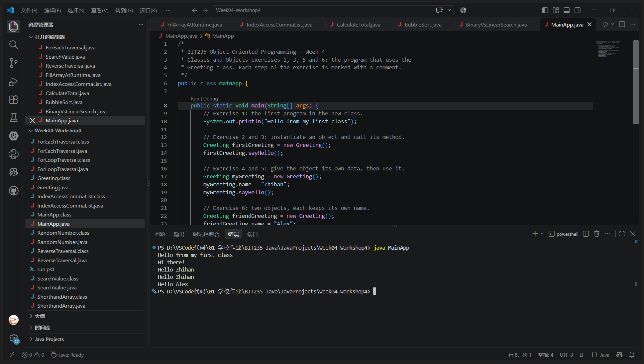
VS Code - java MainApp (the first line is exercise 1; the lines below it are exercises 3, 5 and 6 in the same run)
Program: MainApp.java (exercise 1 part)
public class MainApp {
public static void main(String[] args) {
System.out.println("Hello from my first class");
}
}
Output:
Hello from my first class

Exercise 2 - Creating a second class
Create Greeting.java with a class called Greeting and a method called sayHello() that prints Hi there!. The method must not be static, because it belongs to the object.
Answer:
Program: Greeting.java (exercise 2 part)
public class Greeting {
public void sayHello() {
System.out.println("Hi there!");
}
}

Exercise 3 - Creating an object
In MainApp.java, create an object of the Greeting class and call the sayHello method. Expected output: Hi there!
Answer:
Program: MainApp.java (exercise 3 part)
Greeting firstGreeting = new Greeting(); // instantiate the object
firstGreeting.sayHello(); // call its method
Output:
Hi there!

Exercise 4 - Adding data (fields)
In Greeting.java add the field String name; and modify sayHello so that it prints that name, for example: Hello <name>
Answer:
Program: Greeting.java (exercise 4 part)
public class Greeting {
String name; // field: every object keeps its own copy
public void sayHello() {
if (name == null || name.isEmpty()) {
System.out.println("Hi there!");
} else {
System.out.println("Hello " + name);
}
}
}

Exercise 5 - Using the object properly
In MainApp.java create a Greeting object, set the name to your own name and call the method. Example output: Hello Sally
Answer:
Program: MainApp.java (exercise 5 part)
Greeting myGreeting = new Greeting();
myGreeting.name = "Zhihan";
myGreeting.sayHello();
Output:
Hello Zhihan

Exercise 6 - Multiple objects (key concept)
In MainApp.java create two Greeting objects, one with your name and one with a friend's name, and call the method on both. Each object must print its own name.
Answer:
Program: MainApp.java (exercise 6 part)
Greeting friendGreeting = new Greeting();
friendGreeting.name = "Alex";
myGreeting.sayHello();
friendGreeting.sayHello();
Output:
Hello Zhihan
Hello Alex

Exercise 7 - Thinking in objects
Create Student.java with a field studentId and a method displayId(). In MainApp.java create two Student objects with different IDs and call displayId() on each.
Answer:
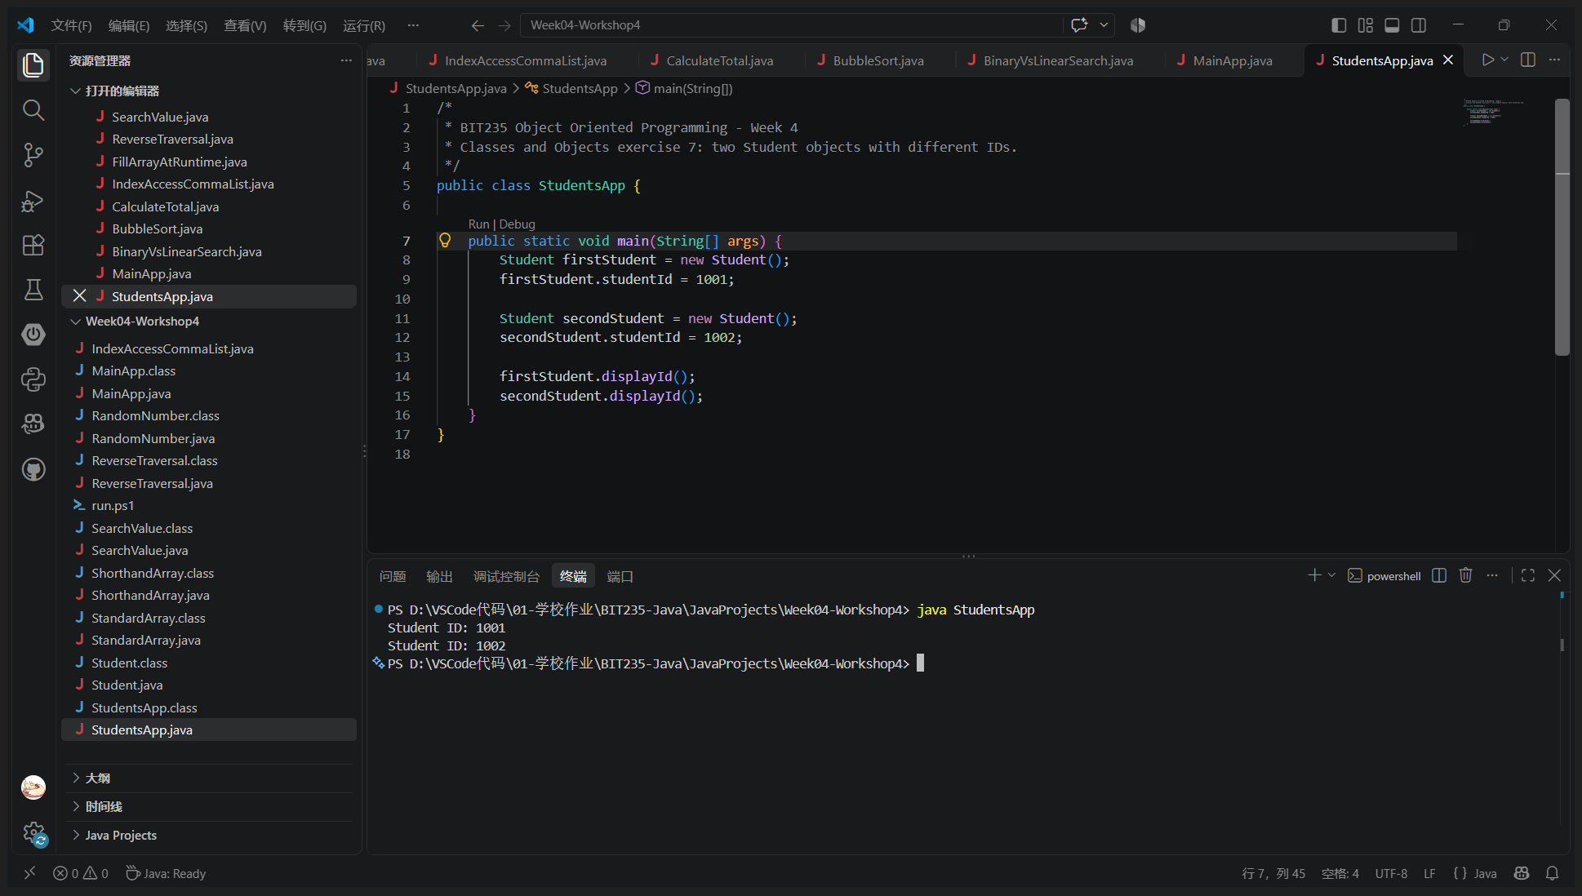
VS Code - java StudentsApp
Program: Student.java
/*
* BIT235 Object Oriented Programming - Week 4
* Classes and Objects exercise 7: a second class with its own field and method.
*/
public class Student {
int studentId;
public void displayId() {
System.out.println("Student ID: " + studentId);
}
}
Program: StudentsApp.java
/*
* BIT235 Object Oriented Programming - Week 4
* Classes and Objects exercise 7: two Student objects with different IDs.
*/
public class StudentsApp {
public static void main(String[] args) {
Student firstStudent = new Student();
firstStudent.studentId = 1001;
Student secondStudent = new Student();
secondStudent.studentId = 1002;
firstStudent.displayId();
secondStudent.displayId();
}
}
Output:
Student ID: 1001
Student ID: 1002

Final version of the two classes
The complete files as they are in the project folder. MainApp runs exercises 1, 3, 5 and 6 in one program, and the screenshot at exercise 1 shows that full run.
Program: Greeting.java (final)
/*
* BIT235 Object Oriented Programming - Week 4
* Classes and Objects exercises 2, 4 and 5: the object and its data live here.
*
* The method is NOT static: it belongs to the object, not to the class, so it
* has to be called on an object such as myGreeting.sayHello().
*/
public class Greeting {
// Field, not a local variable: every Greeting object keeps its own copy.
String name;
// Exercise 2 and 3 print "Hi there!" when no name has been given yet.
// Exercise 4 and 5 print "Hello " plus the name once the field is set.
public void sayHello() {
if (name == null || name.isEmpty()) {
System.out.println("Hi there!");
} else {
System.out.println("Hello " + name);
}
}
}
Program: MainApp.java (final)
/*
* BIT235 Object Oriented Programming - Week 4
* Classes and Objects exercises 1, 3, 5 and 6: the program that uses the
* Greeting class. Each step of the exercise is marked with a comment.
*/
public class MainApp {
public static void main(String[] args) {
// Exercise 1: the first program in the new class.
System.out.println("Hello from my first class");
// Exercise 2 and 3: instantiate an object and call its method.
Greeting firstGreeting = new Greeting();
firstGreeting.sayHello();
// Exercise 4 and 5: give the object its own data, then use it.
Greeting myGreeting = new Greeting();
myGreeting.name = "Zhihan";
myGreeting.sayHello();
// Exercise 6: two objects, each keeps its own name.
Greeting friendGreeting = new Greeting();
friendGreeting.name = "Alex";
myGreeting.sayHello();
friendGreeting.sayHello();
}
}
Output of java MainApp:
Hello from my first class
Hi there!
Hello Zhihan
Hello Zhihan
Hello Alex

