BIT235 Object Oriented Programming
Week 1 Tutorial – Java Revision Exercises
Name: ZHIHAN CHEN Student ID: S1580887

Exercise 1 – Declaring Variables
Question: Create variables with appropriate data types for your age, your height in metres, your first initial, and whether you are enrolled in BIT235. The values are hard coded (no user input) and then printed.

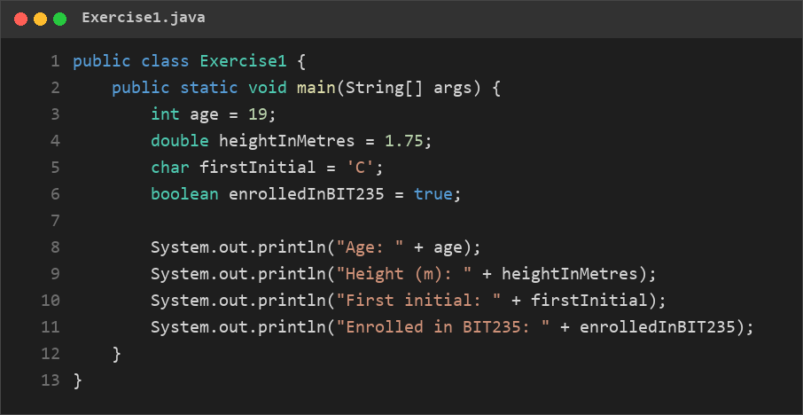
Exercise1.java

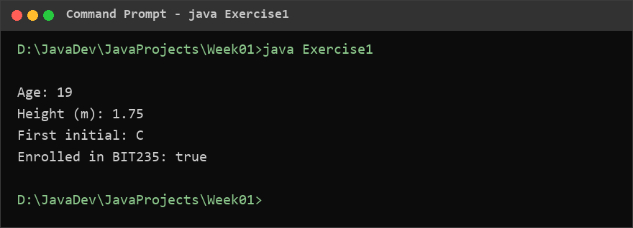
Console output – java Exercise1

Exercise 2 – Arithmetic Expressions
Question: Declare int a = 12; and int b = 5; and print the result of a + b, a - b, a * b, a / b and a % b. Explain why division behaves the way it does.

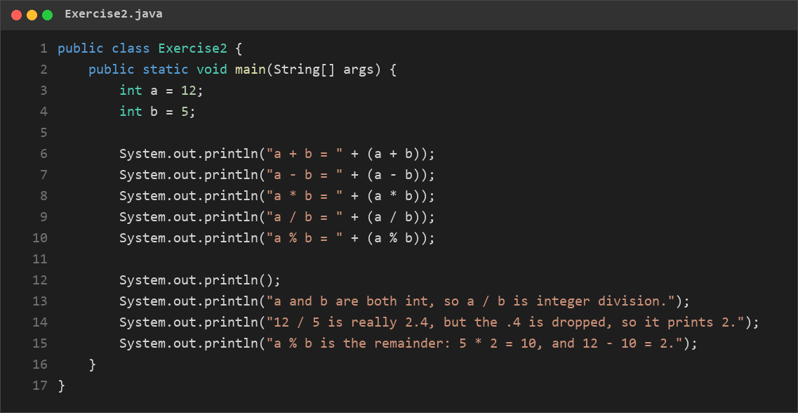
Exercise2.java

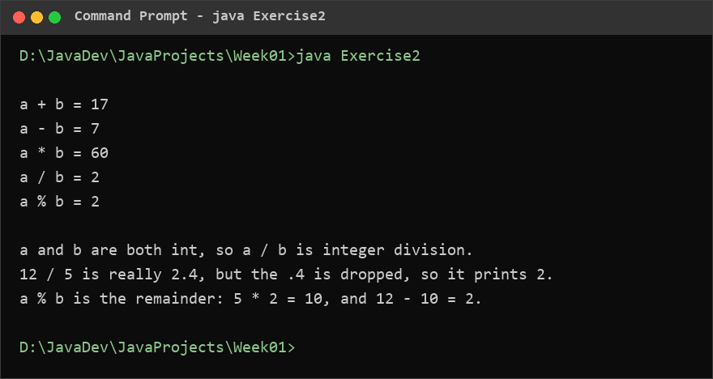
Console output – java Exercise2

Exercise 3 – Type Casting
Question: Declare int total = 7; and int count = 2; and calculate the average as a decimal value. Print the correct result.

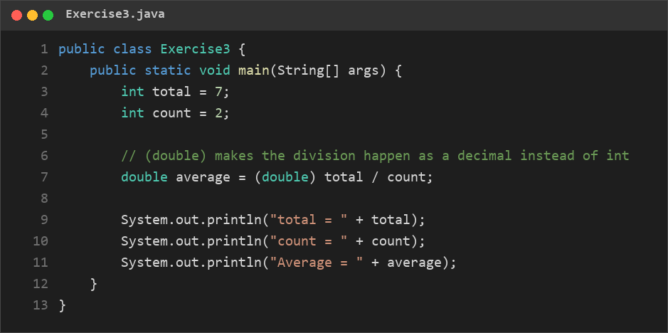
Exercise3.java

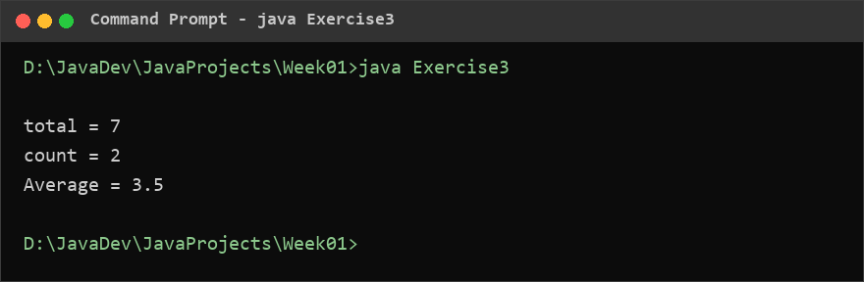
Console output – java Exercise3

Exercise 4 – User Input and Comparison
Question: Ask the user to enter their age. If the age is 18 or older print “You are an adult.”, otherwise print “You are under 18.”

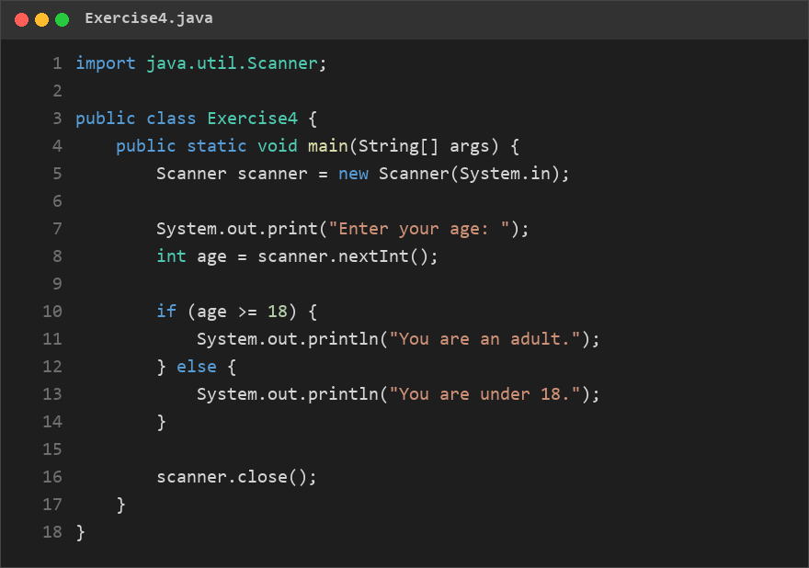
Exercise4.java

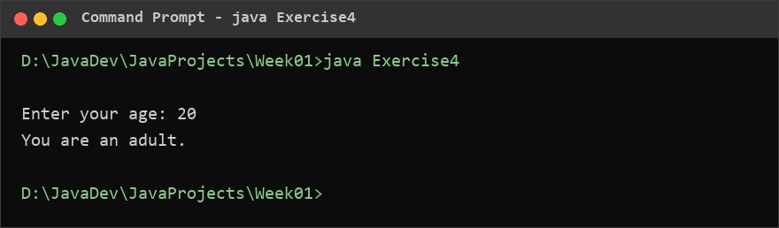
Console output – java Exercise4

Exercise 5 – Positive, Negative, or Zero
Question: Ask the user to enter a number and print one of: “Positive”, “Negative”, “Zero”.

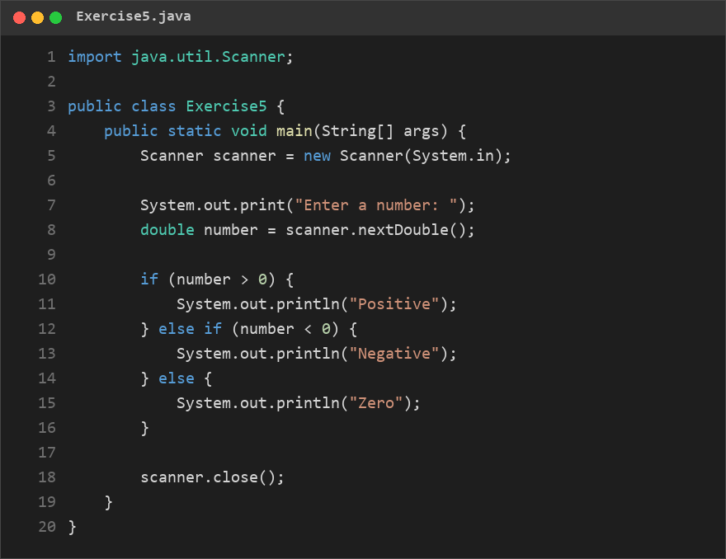
Exercise5.java

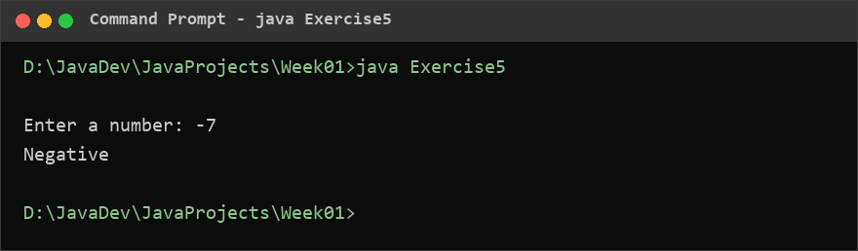
Console output – java Exercise5

Exercise 6 – Even or Odd
Question: Ask the user for an integer and determine whether it is even or odd (hint: use %).

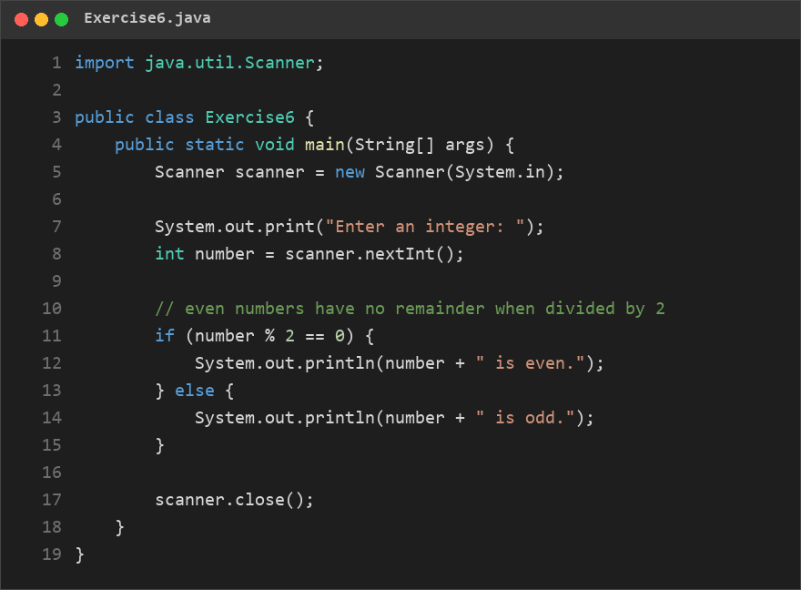
Exercise6.java

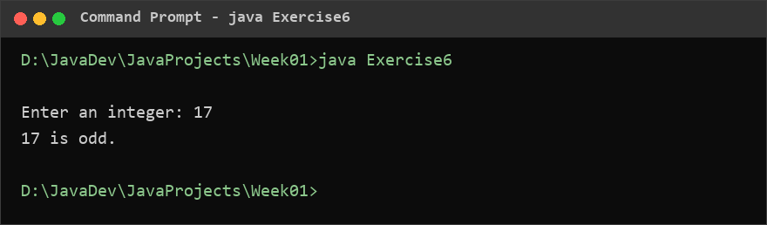
Console output – java Exercise6

Exercise 7 – Simple Grading System
Question: Ask the user to enter a mark (0–100) and print one of: HD (80–100), D (70–79), C (60–69), P (50–59), F (below 50).

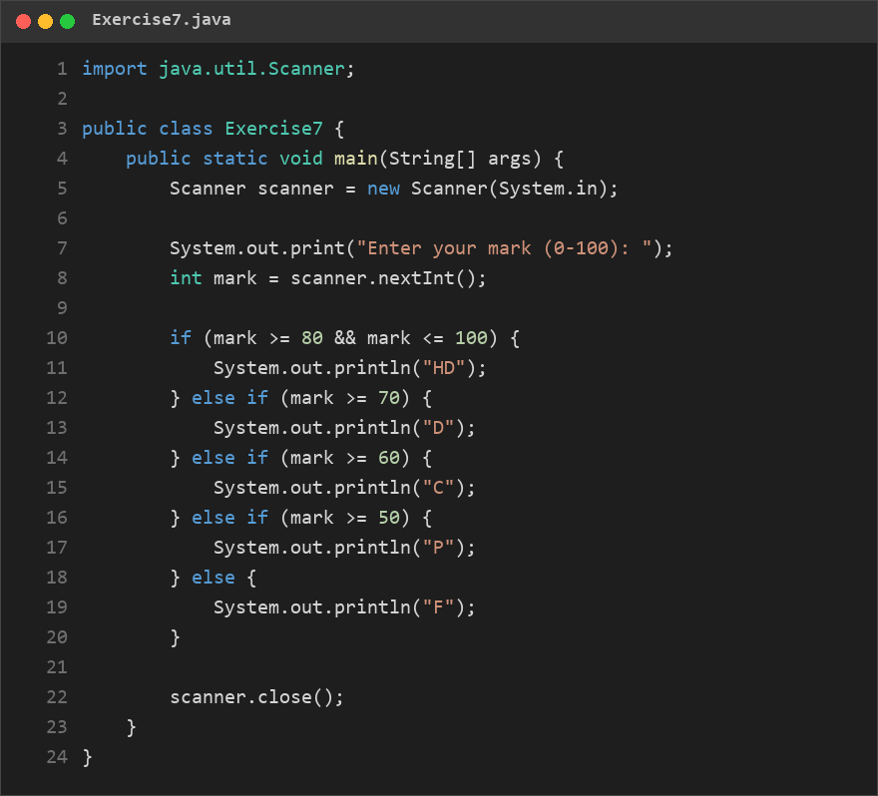
Exercise7.java

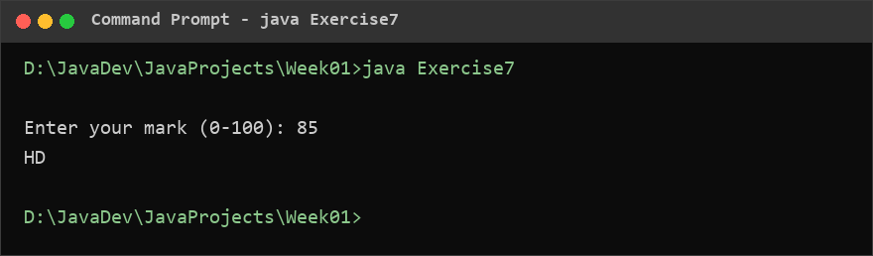
Console output – java Exercise7

Exercise 8 – Boolean Expressions
Question: Declare int temperature = 32; and print “It is hot.” when temperature is greater than 30, “It is mild.” for 20–30, and “It is cold.” for below 20.

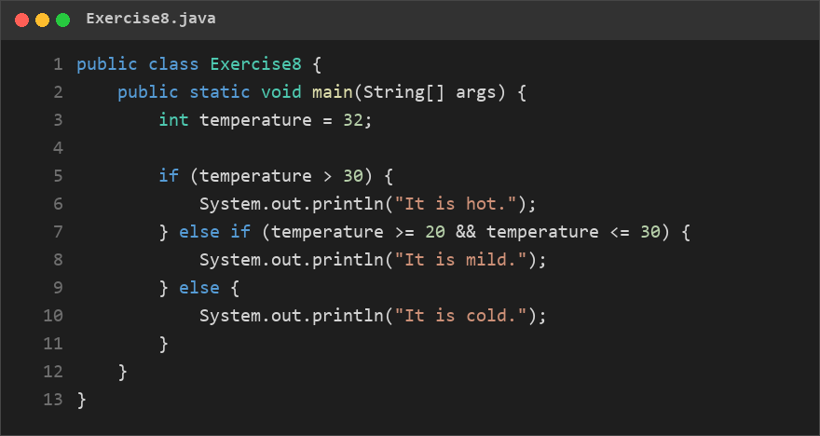
Exercise8.java

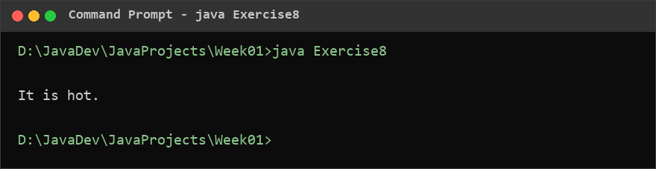
Console output – java Exercise8

Exercise 9 – Logical Operators
Question: Ask the user to enter a username and a password. If the username equals “admin” AND the password equals “java123”, print “Login successful.”, otherwise print “Access denied.”
Why .equals() and not ==? == compares whether the two variables point to the same String object, while .equals() compares the characters inside them. A String built at run time (such as one entered with Scanner) is a different object from the literal, so == would be false even when the text is identical and the login would fail.

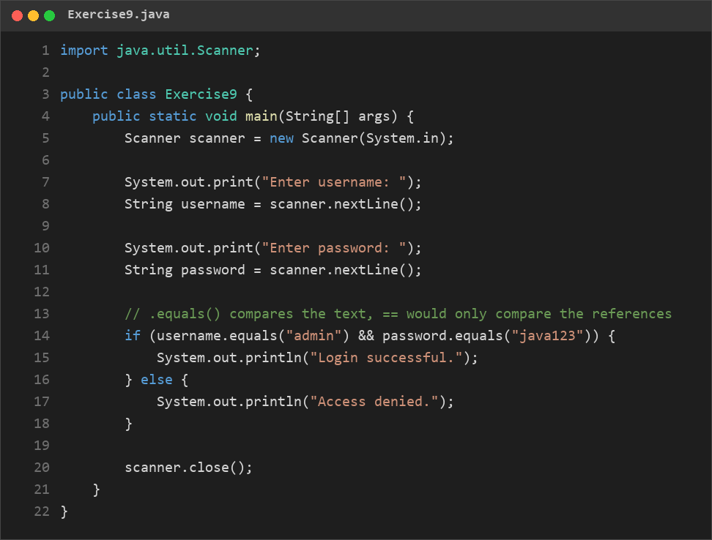
Exercise9.java

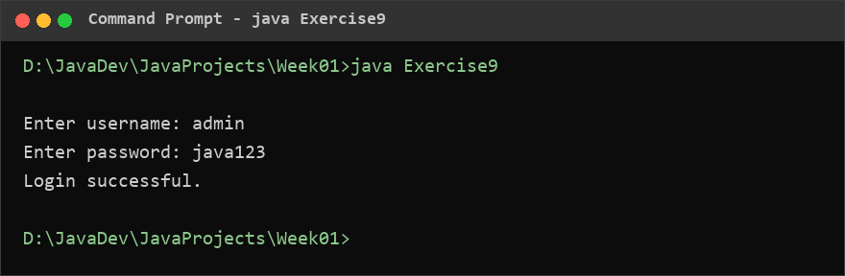
Console output – java Exercise9

Exercise 10 – Mini Decision Program
Question: Ask the user to enter their age and whether they have a driver licence (true/false). If the age is at least 18 AND they have a licence print “You can drive independently.” If the age is at least 16 but less than 18 AND they have a licence print “You can drive with restrictions.” Otherwise print “You cannot drive.”

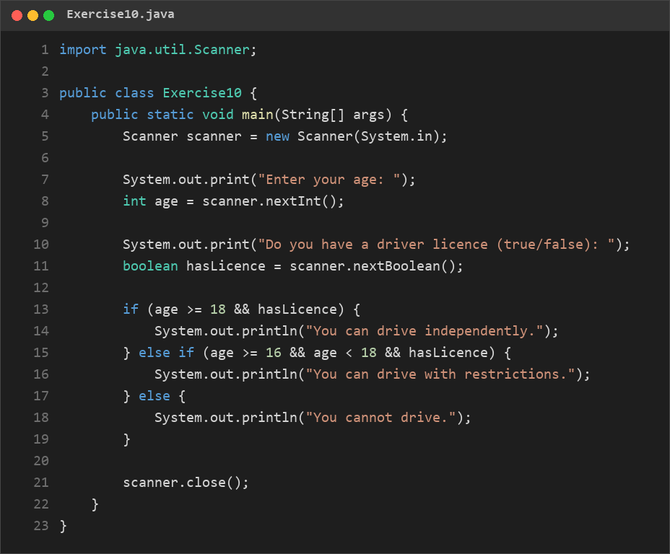
Exercise10.java

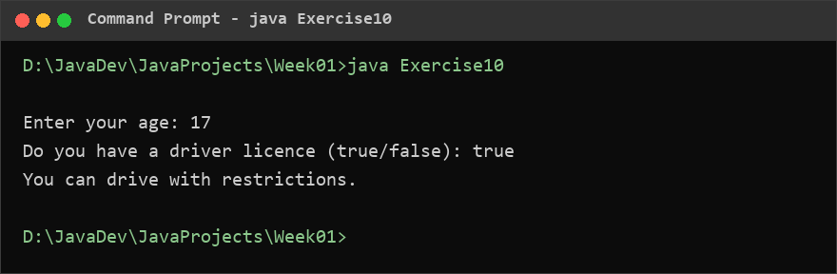
Console output – java Exercise10

