Workshop 3

Programming Structures in Java

Part 1: StringBuffer
- Using StringBuffer for Dynamic User Messages
In a web application, we need to dynamically construct personalized welcome messages based on a user's name and location.
public class WelcomeMessage {
public static void main(String[] args) {
String name = "Alice";
String city = "Melbourne";

// Use StringBuffer to construct a personalized message
StringBuffer message
….
….
….

System.out.println(message);

}
}

Expected Output:
Welcome, Alice! We hope you're enjoying your time in Melbourne.
You task
Complete the code on 3 lines (replacing the 3 ellipses …)
Answer (A complete program):
VS Code screenshot - the whole window, with the code in the editor and the run in the terminal:
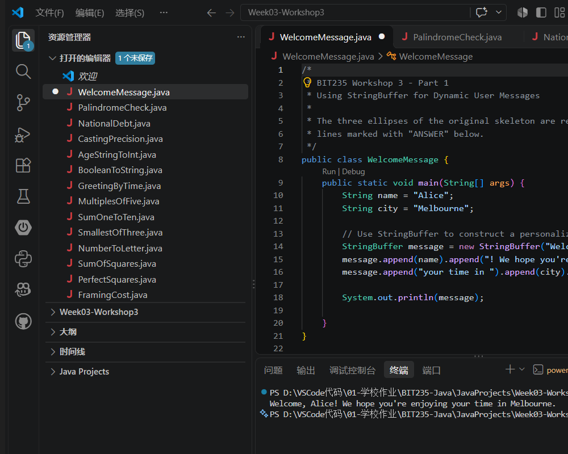

Program: WelcomeMessage.java
/*
* BIT235 Workshop 3 - Part 1
* Using StringBuffer for Dynamic User Messages
*
* The three ellipses of the original skeleton are replaced by the three
* lines marked with "ANSWER" below.
*/
public class WelcomeMessage {
public static void main(String[] args) {
String name = "Alice";
String city = "Melbourne";

// Use StringBuffer to construct a personalized message
StringBuffer message = new StringBuffer("Welcome, "); // ANSWER 1
message.append(name).append("! We hope you're enjoying "); // ANSWER 2
message.append("your time in ").append(city).append("."); // ANSWER 3

System.out.println(message);

}
}

Output:
Welcome, Alice! We hope you're enjoying your time in Melbourne.

- Reversing Strings
Your friend "Palomine" loves word games, especially palindromes (words that read the same forward and backward).
Write a program that checks if a word is a palindrome using StringBuffer.
Use Scanner to receive inputs from the console.
Answer (A complete program):
VS Code screenshot - the whole window, with the code in the editor and the run in the terminal:
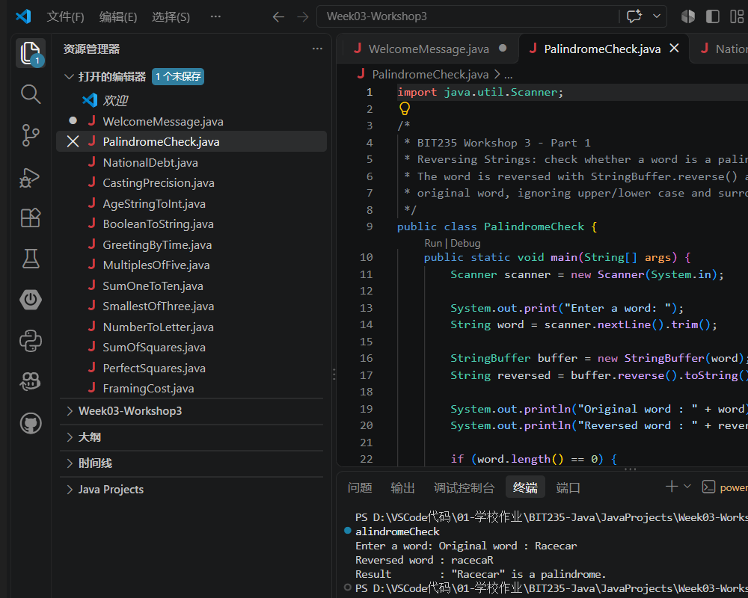

Program: PalindromeCheck.java
import java.util.Scanner;

/*
* BIT235 Workshop 3 - Part 1
* Reversing Strings: check whether a word is a palindrome.
* The word is reversed with StringBuffer.reverse() and compared with the
* original word, ignoring upper/lower case and surrounding spaces.
*/
public class PalindromeCheck {
public static void main(String[] args) {
Scanner scanner = new Scanner(System.in);

System.out.print("Enter a word: ");
String word = scanner.nextLine().trim();

StringBuffer buffer = new StringBuffer(word);
String reversed = buffer.reverse().toString();

System.out.println("Original word : " + word);
System.out.println("Reversed word : " + reversed);

if (word.length() == 0) {
System.out.println("No word was entered.");
} else if (word.equalsIgnoreCase(reversed)) {
System.out.println("Result : \"" + word + "\" is a palindrome.");
} else {
System.out.println("Result : \"" + word + "\" is NOT a palindrome.");
}

scanner.close();
}
}

Output (input: Racecar):
Enter a word: Original word : Racecar
Reversed word : racecaR
Result : "Racecar" is a palindrome.

Output (input: hello):
Enter a word: Original word : hello
Reversed word : olleh
Result : "hello" is NOT a palindrome.

Part 2: Casting
Type your answers into each question or paste in screenshots of your code.
- Widening or Narrowing
- Which is larger – a short or an int and what can each hold?
- Which is larger – a char or a short?
- Which is larger – double or a float?
- Which is larger – an int or a float?
Answer:
Which is larger - a short or an int, and what can each hold?
An int is larger: it is 32 bits wide, while a short is only 16 bits. A short holds whole numbers from -32,768 to 32,767. An int holds whole numbers from -2,147,483,648 to 2,147,483,647, so widening short -> int is always safe and is done automatically.
Which is larger - a char or a short?
Neither is larger: both are 16 bits, but their ranges differ. A char is unsigned and holds 0 to 65,535 (Unicode code units), so it cannot store a negative number. A short is signed and holds -32,768 to 32,767, so it can store negatives but not values above 32,767. Converting between them therefore needs an explicit cast.
Which is larger - double or a float?
A double is larger and more precise: 64 bits, a range of about +/-1.7 x 10^308 and 15-16 significant decimal digits. A float is 32 bits, about +/-3.4 x 10^38 and only 7 significant digits. float -> double is a safe widening conversion; double -> float can lose precision, so it needs an explicit cast.
Which is larger - an int or a float?
It depends what 'larger' means. In value range a float is larger: it reaches about +/-3.4 x 10^38, while an int stops at 2,147,483,647. In precision the int wins: it stores every integer exactly up to 2^31-1, whereas a float has only a 24-bit mantissa, so integers above 16,777,216 are no longer stored exactly. Converting int -> float is a widening conversion in the Java language specification, but it can still lose precision for large values.
- Explicit Casting (Narrowing Conversion in Java)
Examples:
public class NarrowingExample {
public static void main(String[] args) {
double pi = 3.14;
int intPi = (int) pi; // Explicit cast from double to int
System.out.println("Integer Pi: " + intPi); // Output: 3 (decimal part is truncated)
}
}

public class IntToCharExample {
public static void main(String[] args) {
int asciiValue = 97;
char letter = (char) asciiValue; // Explicit cast from int to char
System.out.println("Character: " + letter); // Output: 'a'
}
}
Your task:
Write a single program that explores the following:
- Find out what the USA’s national debt is and assign it to a long. Then assign that long to an int and display it to the screen. Does the value change?
- What happens when you create a double that holds the US national debt, and you then assign it to a byte and display that result?

Answer:
VS Code screenshot - the whole window, with the code in the editor and the run in the terminal:
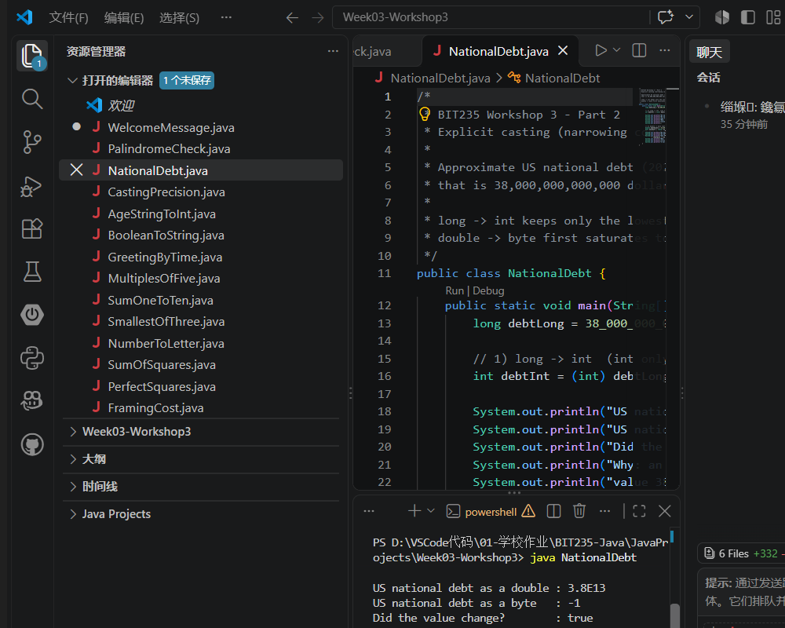

Program: NationalDebt.java
/*
* BIT235 Workshop 3 - Part 2
* Explicit casting (narrowing conversion) using the USA national debt.
*
* Approximate US national debt (2026): about 38 trillion US dollars,
* that is 38,000,000,000,000 dollars.
*
* long -> int keeps only the lowest 32 bits, so the value wraps around.
* double -> byte first saturates to int, then keeps the lowest 8 bits.
*/
public class NationalDebt {
public static void main(String[] args) {
long debtLong = 38_000_000_000_000L;

// 1) long -> int (int only has 32 bits, so the high bits are lost)
int debtInt = (int) debtLong;

System.out.println("US national debt as a long : " + debtLong);
System.out.println("US national debt as an int : " + debtInt);
System.out.println("Did the value change? : " + (debtInt != debtLong));
System.out.println("Why: an int keeps only the lowest 32 bits, so the");
System.out.println("value 38,000,000,000,000 wraps around to a negative int.");
System.out.println();

// 2) double -> byte (byte only keeps the lowest 8 bits)
double debtDouble = 38_000_000_000_000.0;
byte debtByte = (byte) debtDouble;

System.out.println("US national debt as a double : " + debtDouble);
System.out.println("US national debt as a byte : " + debtByte);
System.out.println("Did the value change? : "
+ (debtByte != debtDouble));
System.out.println("Why: the double is far outside the byte range, so it is");
System.out.println("first clamped to Integer.MAX_VALUE and only the lowest");
System.out.println("8 bits survive, which gives -1.");
}
}

Output:
US national debt as a long : 38000000000000
US national debt as an int : -1870635008
Did the value change? : true
Why: an int keeps only the lowest 32 bits, so the
value 38,000,000,000,000 wraps around to a negative int.

US national debt as a double : 3.8E13
US national debt as a byte : -1
Did the value change? : true
Why: the double is far outside the byte range, so it is
first clamped to Integer.MAX_VALUE and only the lowest
8 bits survive, which gives -1.

- Casting Between double, float, and int
Remember that
- A double (64-bit) is more precise than float (32-bit).
- Casting from double to float may result in precision loss.
Examples
Casting double to float (Precision Loss)
public class DoubleToFloat {
public static void main(String[] args) {
double largeDecimal = 123456.789123456; // High precision
float smallerDecimal = (float) largeDecimal; // Explicit cast to float
System.out.println("Double: " + largeDecimal);
System.out.println("Float: " + smallerDecimal); // Precision loss
}
}
Output:
Double: 123456.789123456
Float: 123456.79
Casting float to double (Safe Widening)
public class FloatToDouble {
public static void main(String[] args) {
float num = 3.14f; // 32-bit float
double largerNum = (double) num; // Implicit or explicit cast
System.out.println("Float: " + num);
System.out.println("Double: " + largerNum); // Extra precision added
}
}
Your tasks:
- Place the value of PI, accurate to 10 decimal places, in a double and then assign that to a float and compare the results when both the float and double are printed to the console.
- Assign a dollar amount with 2 cent values to a double (e.g. double a = 23.99) and note what occurs in terms of precision when printed to the console.
- Repeat the previous requirement, but with a dollar value of zero cents e.g., 23.00.
Answer:
VS Code screenshot - the whole window, with the code in the editor and the run in the terminal:
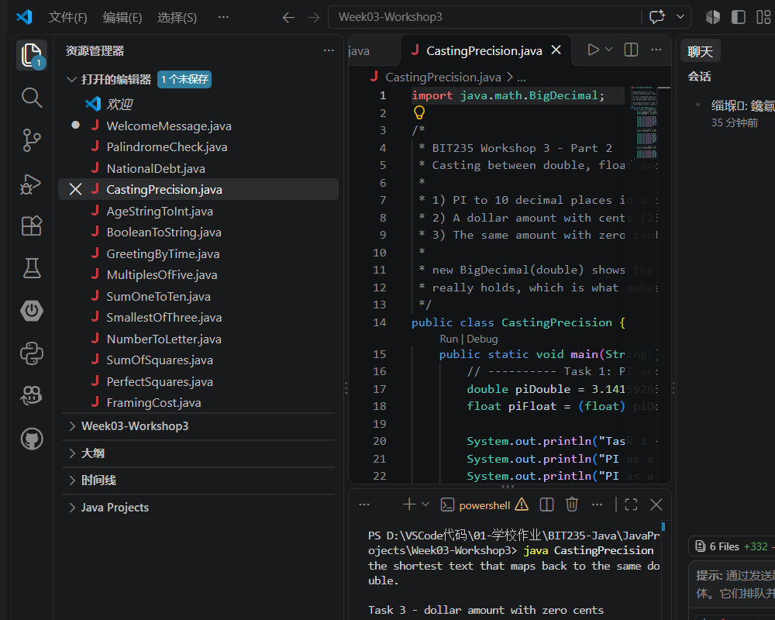

Program: CastingPrecision.java
import java.math.BigDecimal;

/*
* BIT235 Workshop 3 - Part 2
* Casting between double, float and int: precision loss.
*
* 1) PI to 10 decimal places in a double, then narrowed to a float.
* 2) A dollar amount with cents (23.99) stored in a double.
* 3) The same amount with zero cents (23.00).
*
* new BigDecimal(double) shows the exact binary value that the double
* really holds, which is what makes the rounding visible.
*/
public class CastingPrecision {
public static void main(String[] args) {
// ---------- Task 1: PI accurate to 10 decimal places ----------
double piDouble = 3.1415926535;
float piFloat = (float) piDouble;

System.out.println("Task 1 - PI (10 decimal places)");
System.out.println("PI as a double : " + piDouble);
System.out.println("PI as a float : " + piFloat);
System.out.println("Difference : " + (piDouble - piFloat));
System.out.println("The float keeps only about 7 significant digits,");
System.out.println("so the last decimal places of PI are lost.");
System.out.println();

// ---------- Task 2: 23.99 (dollars and cents) ----------
double withCents = 23.99;

System.out.println("Task 2 - dollar amount with 2 cent values");
System.out.println("Stored value : " + withCents);
System.out.println("Exact double : " + new BigDecimal(withCents));
System.out.println("23.99 cannot be stored exactly in binary, so the double");
System.out.println("holds a value slightly below 23.99. println only shows");
System.out.println("the shortest text that maps back to the same double.");
System.out.println();

// ---------- Task 3: 23.00 (zero cents) ----------
double withoutCents = 23.00;

System.out.println("Task 3 - dollar amount with zero cents");
System.out.println("Stored value : " + withoutCents);
System.out.println("Exact double : " + new BigDecimal(withoutCents));
System.out.println("23.00 is a whole number and can be represented exactly,");
System.out.println("so no rounding error appears (printed as 23.0).");
}
}

Output:
Task 1 - PI (10 decimal places)
PI as a double : 3.1415926535
PI as a float : 3.1415927
Difference : -8.751257318806438E-8
The float keeps only about 7 significant digits,
so the last decimal places of PI are lost.

Task 2 - dollar amount with 2 cent values
Stored value : 23.99
Exact double : 23.989999999999998436805981327779591083526611328125
23.99 cannot be stored exactly in binary, so the double
holds a value slightly below 23.99. println only shows
the shortest text that maps back to the same double.

Task 3 - dollar amount with zero cents
Stored value : 23.0
Exact double : 23
23.00 is a whole number and can be represented exactly,
so no rounding error appears (printed as 23.0).

- Converting String to a Primitive
Example:
public class StringToPrimitive {
public static void main(String[] args) {
int num = Integer.parseInt("123"); // "123" → 123
double d = Double.parseDouble("3.14"); // "3.14" → 3.14
boolean b = Boolean.parseBoolean("true"); // "true" → true
System.out.println("Integer: " + num);
System.out.println("Double: " + d);
System.out.println("Boolean: " + b);
}
}
Your task:
Declare a String and initialise it with your age. Then convert it to an int and then display that int to the console.
Answer:
VS Code screenshot - the whole window, with the code in the editor and the run in the terminal:
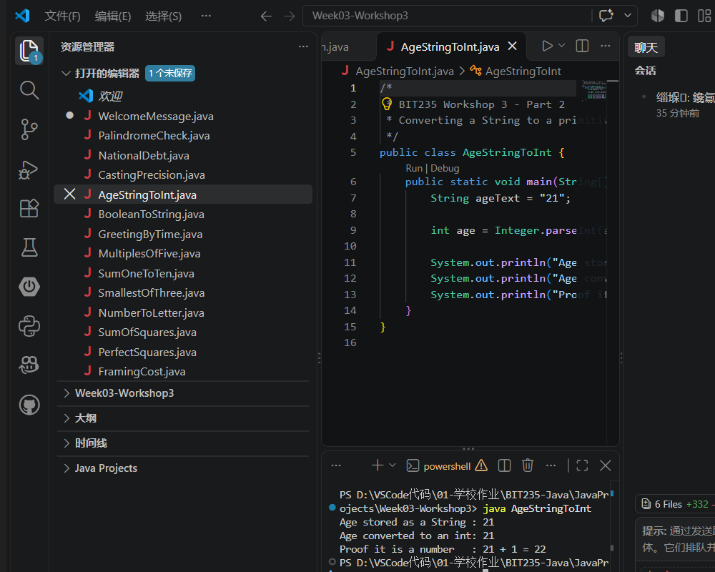

Program: AgeStringToInt.java
/*
* BIT235 Workshop 3 - Part 2
* Converting a String to a primitive with Integer.parseInt().
*/
public class AgeStringToInt {
public static void main(String[] args) {
String ageText = "21";

int age = Integer.parseInt(ageText);

System.out.println("Age stored as a String : " + ageText);
System.out.println("Age converted to an int: " + age);
System.out.println("Proof it is a number : " + age + " + 1 = " + (age + 1));
}
}

Output:
Age stored as a String : 21
Age converted to an int: 21
Proof it is a number : 21 + 1 = 22

- Converting a Primitive to String
Example:
public class PrimitiveToString {
public static void main(String[] args) {
int num = 456;
String str = String.valueOf(num); // 456 → "456"
System.out.println("String: " + str);
}
}
Your task:
Imagine you are building a user account management system, where you need to store the active/inactive status of a user as a String in a database or display it on a webpage.
Create a boolean variable called status that can store only true or false.
Before writing to the database, it will need to be converted to a String. See if you can perform that conversion using String.valueOf() while displaying status to the console
Answer:
VS Code screenshot - the whole window, with the code in the editor and the run in the terminal:
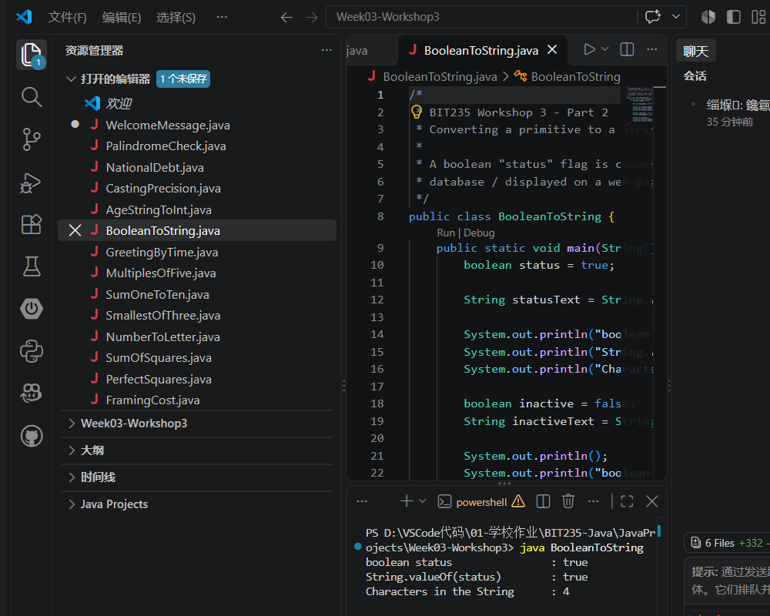

Program: BooleanToString.java
/*
* BIT235 Workshop 3 - Part 2
* Converting a primitive to a String with String.valueOf().
*
* A boolean "status" flag is converted to text before it is written to a
* database / displayed on a web page.
*/
public class BooleanToString {
public static void main(String[] args) {
boolean status = true;

String statusText = String.valueOf(status);

System.out.println("boolean status : " + status);
System.out.println("String.valueOf(status) : " + statusText);
System.out.println("Characters in the String : " + statusText.length());

boolean inactive = false;
String inactiveText = String.valueOf(inactive);

System.out.println();
System.out.println("boolean inactive status : " + inactive);
System.out.println("String.valueOf(inactive) : " + inactiveText);
}
}

Output:
boolean status : true
String.valueOf(status) : true
Characters in the String : 4

boolean inactive status : false
String.valueOf(inactive) : false

Part 3: Conditional logic & Loops

Exercises 1
- Write a program to take an input number from user between 1 and 24. Use if statement to display the output. If the input is less than 18, print a "Good day" greeting, otherwise print "Good evening".
- Write a while loop that prints out multiples of 5 between 10 and 95
- Write a while loop to add up the values 1 to 10 and print the sum once the loop has finished
Answer:
VS Code screenshot - the whole window, with the code in the editor and the run in the terminal:
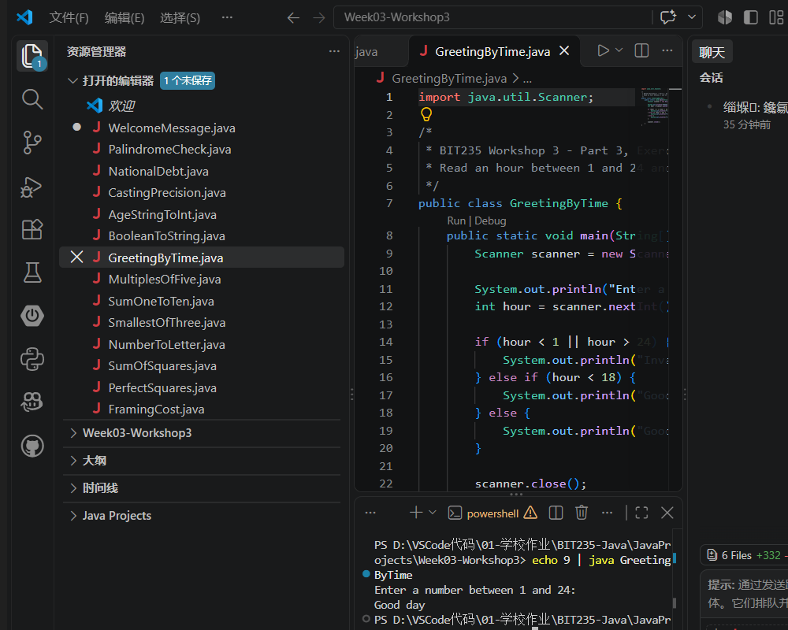

Program 1: GreetingByTime.java
import java.util.Scanner;

/*
* BIT235 Workshop 3 - Part 3, Exercise 1 (a)
* Read an hour between 1 and 24 and print the matching greeting.
*/
public class GreetingByTime {
public static void main(String[] args) {
Scanner scanner = new Scanner(System.in);

System.out.println("Enter a number between 1 and 24:");
int hour = scanner.nextInt();

if (hour < 1 || hour > 24) {
System.out.println("Invalid input: the number must be between 1 and 24.");
} else if (hour < 18) {
System.out.println("Good day");
} else {
System.out.println("Good evening");
}

scanner.close();
}
}

Output (hour = 9):
Enter a number between 1 and 24:
Good day

Output (hour = 20):
Enter a number between 1 and 24:
Good evening
VS Code screenshot - the whole window, with the code in the editor and the run in the terminal:
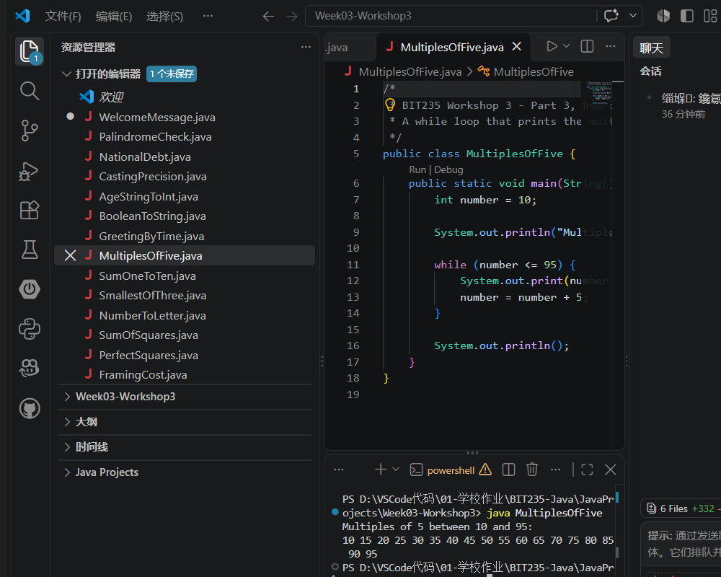

Program 2: MultiplesOfFive.java
/*
* BIT235 Workshop 3 - Part 3, Exercise 1 (b)
* A while loop that prints the multiples of 5 between 10 and 95.
*/
public class MultiplesOfFive {
public static void main(String[] args) {
int number = 10;

System.out.println("Multiples of 5 between 10 and 95:");

while (number <= 95) {
System.out.print(number + " ");
number = number + 5;
}

System.out.println();
}
}

Output:
Multiples of 5 between 10 and 95:
10 15 20 25 30 35 40 45 50 55 60 65 70 75 80 85 90 95
VS Code screenshot - the whole window, with the code in the editor and the run in the terminal:
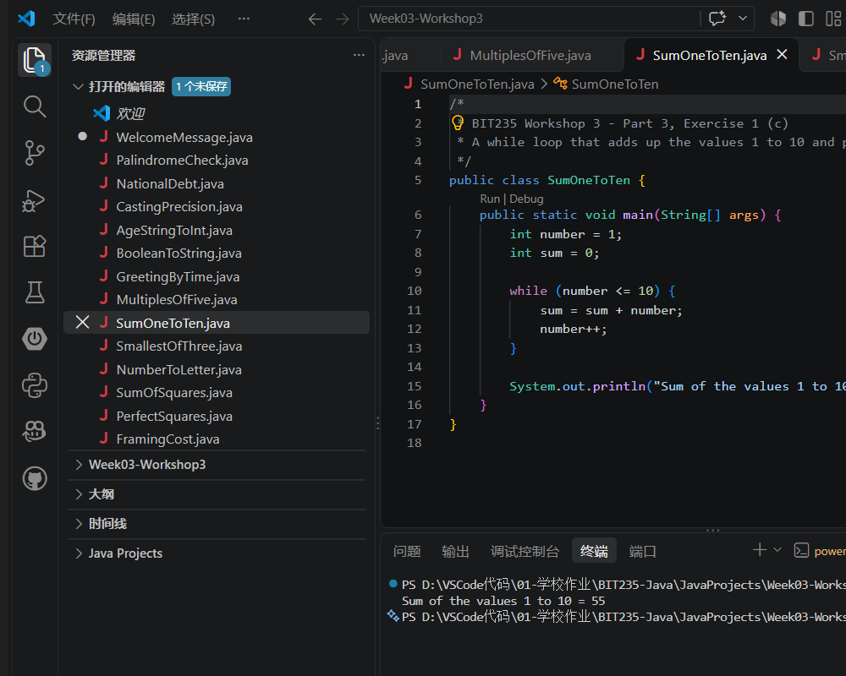

Program 3: SumOneToTen.java
/*
* BIT235 Workshop 3 - Part 3, Exercise 1 (c)
* A while loop that adds up the values 1 to 10 and prints the sum.
*/
public class SumOneToTen {
public static void main(String[] args) {
int number = 1;
int sum = 0;

while (number <= 10) {
sum = sum + number;
number++;
}

System.out.println("Sum of the values 1 to 10 = " + sum);
}
}

Output:
Sum of the values 1 to 10 = 55

Exercise 2
Write a program that prompts the user to input three numbers. The program should output the smallest number(s).
Answer:
VS Code screenshot - the whole window, with the code in the editor and the run in the terminal:
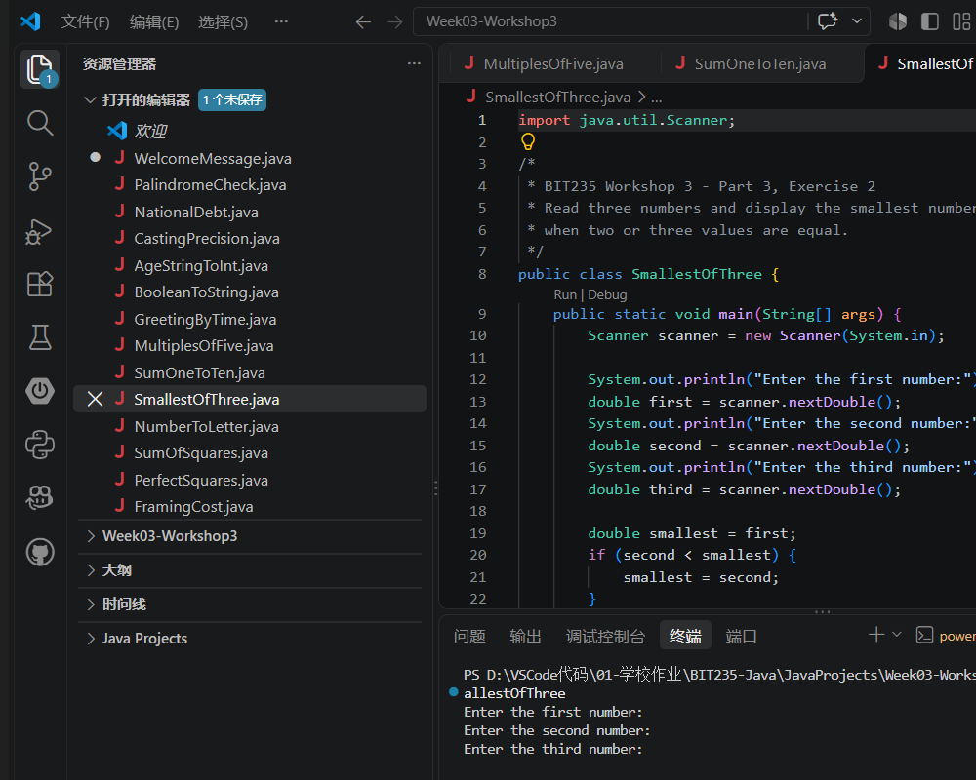

Program: SmallestOfThree.java
import java.util.Scanner;

/*
* BIT235 Workshop 3 - Part 3, Exercise 2
* Read three numbers and display the smallest number(s) - all of them
* when two or three values are equal.
*/
public class SmallestOfThree {
public static void main(String[] args) {
Scanner scanner = new Scanner(System.in);

System.out.println("Enter the first number:");
double first = scanner.nextDouble();
System.out.println("Enter the second number:");
double second = scanner.nextDouble();
System.out.println("Enter the third number:");
double third = scanner.nextDouble();

double smallest = first;
if (second < smallest) {
smallest = second;
}
if (third < smallest) {
smallest = third;
}

System.out.println();
System.out.println("The numbers are : " + first + ", " + second
+ ", " + third);
System.out.print("The smallest number(s): ");

if (first == smallest) {
System.out.print(first + " ");
}
if (second == smallest) {
System.out.print(second + " ");
}
if (third == smallest) {
System.out.print(third + " ");
}
System.out.println();

scanner.close();
}
}

Output:
Enter the first number:
Enter the second number:
Enter the third number:

The numbers are : 12.0, 5.0, 8.0
The smallest number(s): 5.0

Exercise 3
Write a program that prompts the user to input an integer between 0 and 35. If the number is less than or equal to 9, the program should output the number, otherwise, it should output A for 10, B for 11, C for 12, ... , and Z for 35. (Hint: Use the cast operator, (char) ( ), for numbers>= 10. For uppercase characters A=65, B=66 etc)
Answer:
VS Code screenshot - the whole window, with the code in the editor and the run in the terminal:
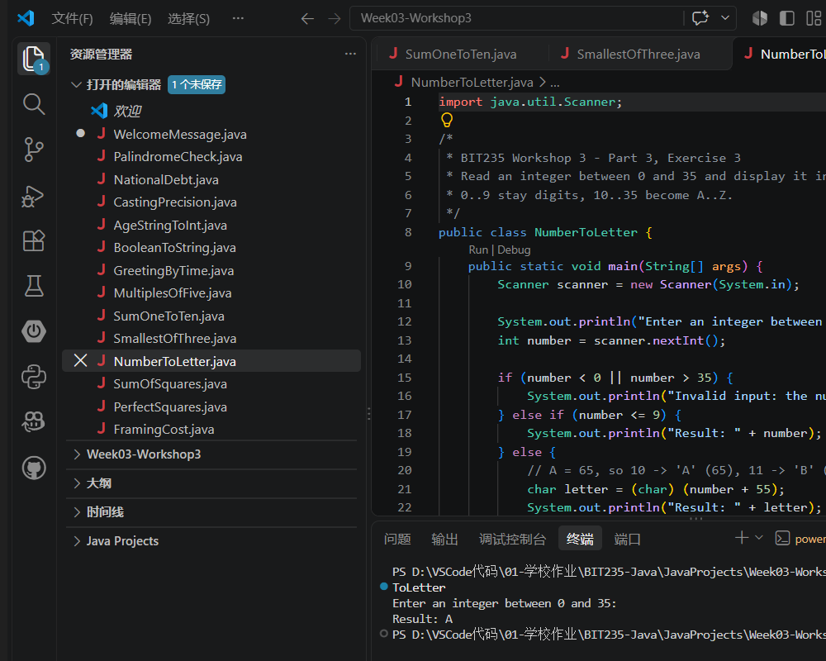

Program: NumberToLetter.java
import java.util.Scanner;

/*
* BIT235 Workshop 3 - Part 3, Exercise 3
* Read an integer between 0 and 35 and display it in "base 36":
* 0..9 stay digits, 10..35 become A..Z.
*/
public class NumberToLetter {
public static void main(String[] args) {
Scanner scanner = new Scanner(System.in);

System.out.println("Enter an integer between 0 and 35:");
int number = scanner.nextInt();

if (number < 0 || number > 35) {
System.out.println("Invalid input: the number must be between 0 and 35.");
} else if (number <= 9) {
System.out.println("Result: " + number);
} else {
// A = 65, so 10 -> 'A' (65), 11 -> 'B' (66) ... 35 -> 'Z' (90)
char letter = (char) (number + 55);
System.out.println("Result: " + letter);
}

scanner.close();
}
}

Output (input 10):
Enter an integer between 0 and 35:
Result: A

Output (input 7):
Enter an integer between 0 and 35:
Result: 7

Exercise 4
Exercise 4A: Write a Java program to compute the sum of the squares of the first 100 integers.

Exercise 4B: Write a Java program to display all the integers between 1 and 100 that are perfect squares.
(Hint: A perfect square is a number whose square root is a whole number, for instance 1 is a perfect square, but 2 and 3 are not and 4 is a perfect square since the square root of 4 is 2 and 2 is a whole number)

Answer:
VS Code screenshot - the whole window, with the code in the editor and the run in the terminal:
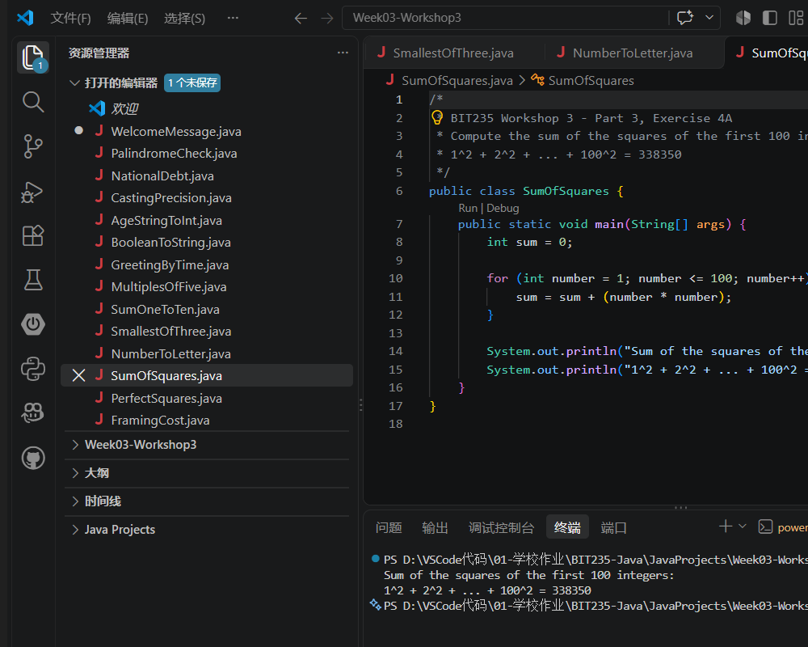

Program 1 (Exercise 4A): SumOfSquares.java
/*
* BIT235 Workshop 3 - Part 3, Exercise 4A
* Compute the sum of the squares of the first 100 integers.
* 1^2 + 2^2 + ... + 100^2 = 338350
*/
public class SumOfSquares {
public static void main(String[] args) {
int sum = 0;

for (int number = 1; number <= 100; number++) {
sum = sum + (number * number);
}

System.out.println("Sum of the squares of the first 100 integers:");
System.out.println("1^2 + 2^2 + ... + 100^2 = " + sum);
}
}

Output:
Sum of the squares of the first 100 integers:
1^2 + 2^2 + ... + 100^2 = 338350
VS Code screenshot - the whole window, with the code in the editor and the run in the terminal:
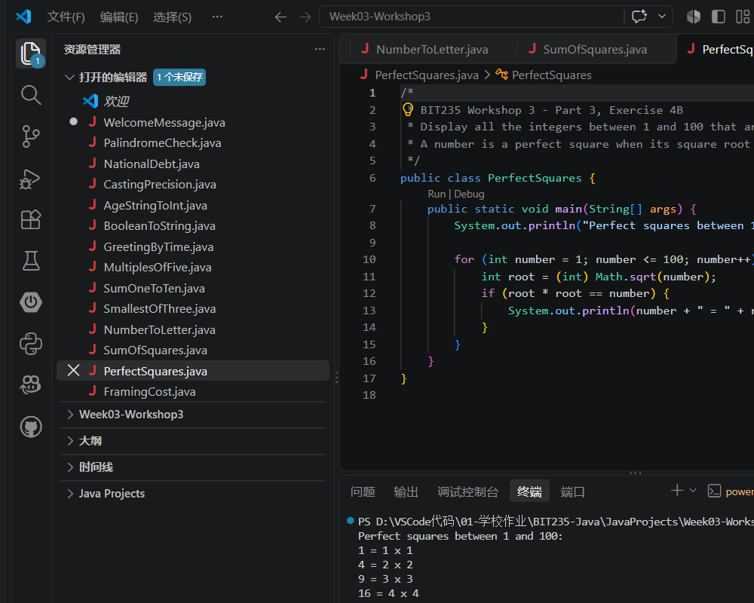

Program 2 (Exercise 4B): PerfectSquares.java
/*
* BIT235 Workshop 3 - Part 3, Exercise 4B
* Display all the integers between 1 and 100 that are perfect squares.
* A number is a perfect square when its square root is a whole number.
*/
public class PerfectSquares {
public static void main(String[] args) {
System.out.println("Perfect squares between 1 and 100:");

for (int number = 1; number <= 100; number++) {
int root = (int) Math.sqrt(number);
if (root * root == number) {
System.out.println(number + " = " + root + " x " + root);
}
}
}
}

Output:
Perfect squares between 1 and 100:
1 = 1 x 1
4 = 2 x 2
9 = 3 x 3
16 = 4 x 4
25 = 5 x 5
36 = 6 x 6
49 = 7 x 7
64 = 8 x 8
81 = 9 x 9
100 = 10 x 10

Exercise 6
You have several pictures of different sizes that you would like to frame. A local picture framing store offers two types of frames-regular and fancy. The frames are available in white and can be ordered in any colour the customer desires. Suppose that each frame is 1 inch wide. The cost of colouring the frame is $0.10 per inch. The cost of a regular frame is $0.15 per inch and the cost of a fancy frame is $0.25 per inch. The customer can also choose to put crowns on the corners, which costs $0.35 per crown. Write a program that prompts the user to input the following information and then output the cost of framing the picture:
a. The length and width, in inches, of the picture.
b. The type of the frame.
c. Customer's choice of colour to colour the frame.
d. If the user wants to add the crowns, then the number of crowns.
Answer:
VS Code screenshot - the whole window, with the code in the editor and the run in the terminal:
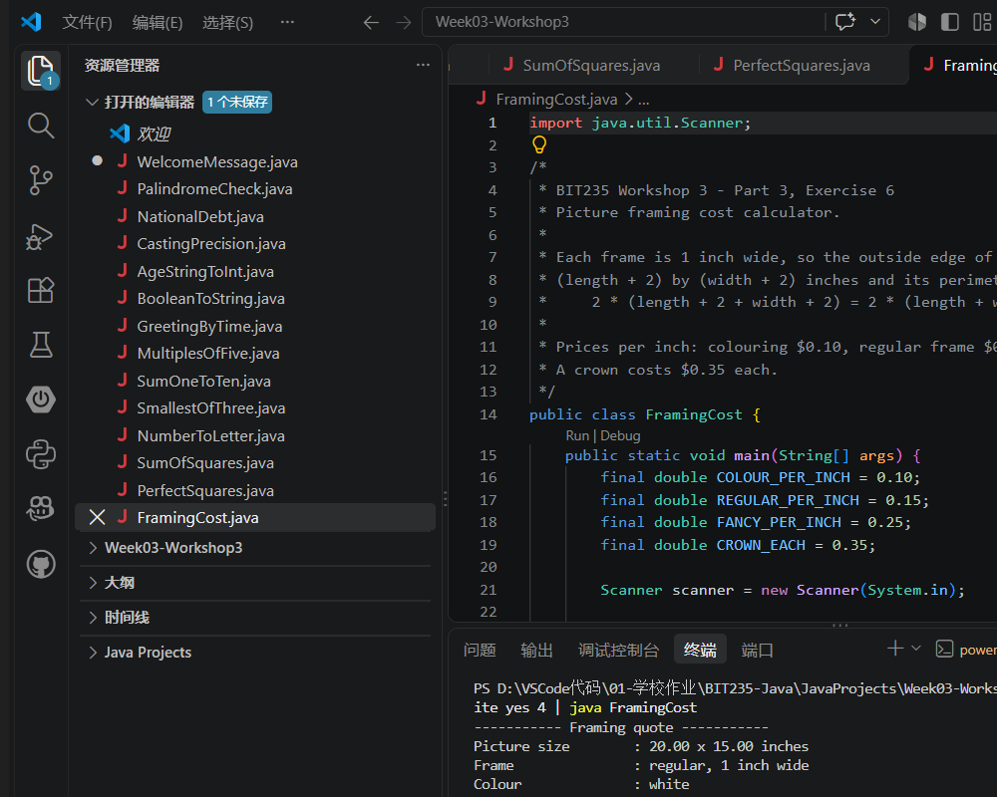

Program: FramingCost.java
import java.util.Scanner;

/*
* BIT235 Workshop 3 - Part 3, Exercise 6
* Picture framing cost calculator.
*
* Each frame is 1 inch wide, so the outside edge of the frame is
* (length + 2) by (width + 2) inches and its perimeter is
* 2 * (length + 2 + width + 2) = 2 * (length + width + 4) inches.
*
* Prices per inch: colouring $0.10, regular frame $0.15, fancy frame $0.25.
* A crown costs $0.35 each.
*/
public class FramingCost {
public static void main(String[] args) {
final double COLOUR_PER_INCH = 0.10;
final double REGULAR_PER_INCH = 0.15;
final double FANCY_PER_INCH = 0.25;
final double CROWN_EACH = 0.35;

Scanner scanner = new Scanner(System.in);

System.out.println("Length of the picture (inches):");
double length = scanner.nextDouble();
System.out.println("Width of the picture (inches):");
double width = scanner.nextDouble();

System.out.println("Type of frame (regular/fancy):");
String frameType = scanner.next().trim().toLowerCase();

System.out.println("Colour of the frame:");
String colour = scanner.next().trim();

System.out.println("Add crowns? (yes/no):");
String crownsAnswer = scanner.next().trim().toLowerCase();
int crowns = 0;
if (crownsAnswer.startsWith("y")) {
System.out.println("Number of crowns:");
crowns = scanner.nextInt();
}

double framePerInch;
String frameName;
if (frameType.startsWith("f")) {
framePerInch = FANCY_PER_INCH;
frameName = "fancy";
} else if (frameType.startsWith("r")) {
framePerInch = REGULAR_PER_INCH;
frameName = "regular";
} else {
System.out.println("Unknown frame type, using a regular frame.");
framePerInch = REGULAR_PER_INCH;
frameName = "regular";
}

double perimeter = 2 * (length + width + 4);
double colourCost = perimeter * COLOUR_PER_INCH;
double frameCost = perimeter * framePerInch;
double crownCost = crowns * CROWN_EACH;
double totalCost = colourCost + frameCost + crownCost;

System.out.println();
System.out.println("----------- Framing quote -----------");
System.out.printf("Picture size : %.2f x %.2f inches%n",
length, width);
System.out.printf("Frame : %s, 1 inch wide%n",
frameName);
System.out.printf("Colour : %s%n", colour);
System.out.printf("Frame perimeter : %.2f inches%n", perimeter);
System.out.printf("Colouring (%.2f/in): $%.2f%n",
COLOUR_PER_INCH, colourCost);
System.out.printf("Frame (%.2f/in): $%.2f%n",
framePerInch, frameCost);
System.out.printf("Crowns (%d x $%.2f): $%.2f%n",
crowns, CROWN_EACH, crownCost);
System.out.printf("TOTAL COST : $%.2f%n", totalCost);
System.out.println("-------------------------------------");

scanner.close();
}
}

Output:
Length of the picture (inches):
Width of the picture (inches):
Type of frame (regular/fancy):
Colour of the frame:
Add crowns? (yes/no):
Number of crowns:

----------- Framing quote -----------
Picture size : 20.00 x 15.00 inches
Frame : regular, 1 inch wide
Colour : white
Frame perimeter : 78.00 inches
Colouring (0.10/in): $7.80
Frame (0.15/in): $11.70
Crowns (4 x $0.35): $1.40
TOTAL COST : $20.90
-------------------------------------

