Workshop - Method overloading

Predicting Method Overloading Behavior
Consider the following Java code:
public class OverloadDemo {

public static void display(int num) {
System.out.println("Integer: " + num);
}

public static void display(double num) {
System.out.println("Double: " + num);
}

public static void display(String str) {
System.out.println("String: " + str);
}

public static void main(String[] args) {
display(5);
display(5.5);
display("Hello");
display('A');
display(100L);
}
}
Task
- Write down the expected output of this program, explaining which method is called for each display() invocation in the main method.
Answer
Expected output:
Integer: 5
Double: 5.5
String: Hello
Integer: 65
Double: 100.0
Which method is called, and why:
display(5) - 5 is an int literal, so display(int) is an exact match in the first phase of overload resolution.
display(5.5) - 5.5 is a double literal, so display(double) is an exact match.
display("Hello") - a String literal matches display(String) exactly.
display('A') - 'A' is a char and there is no display(char). Java first tries to match without boxing or varargs, and it is allowed to widen a primitive. char is a 16-bit unsigned integer type, so it widens to int; display(int) is the most specific applicable method (int comes before long, float and double in the widening chain), so the program prints the code point of 'A', which is 65.
display(100L) - 100L is a long and there is no display(long). long widens to float or double; it cannot narrow to int. Of the applicable methods only display(double) is reachable by widening, so it prints 100.0.
Rule: overload resolution happens at compile time. The compiler picks the most specific method that is applicable without narrowing, so the argument's static type decides the output.

Understanding Ambiguity in Method Overloading
Examine the following Java code:
public class Calculator {
public static void main(String[] args) {
System.out.println(calculate(10, 20));
System.out.println(calculate(10L, 20));
System.out.println(calculate(10, 20L));
System.out.println(calculate(10.5, 20.5));
}

public static int calculate(int a, long b) {
System.out.println("Method 1");
return (int) (a + b);
}

public static long calculate(long a, int b) {
System.out.println("Method 2");
return a + b;
}
}

Tasks
- Explain why the compiler will not allow one or more of these statements.

- What would happen if you tried to call calculate(10, 20) without any type casting? Would it compile? Why or why not?
Answer
What javac reports:
demo-errors\CalculatorAmbiguity.java:12: error: reference to calculate is ambiguous
System.out.println(calculate(10, 20));
^
both method calculate(int,long) in CalculatorAmbiguity and method calculate(long,int) in CalculatorAmbiguity match
demo-errors\CalculatorAmbiguity.java:15: error: no suitable method found for calculate(double,double)
System.out.println(calculate(10.5, 20.5));
^
method CalculatorAmbiguity.calculate(int,long) is not applicable
(argument mismatch; possible lossy conversion from double to int)
method CalculatorAmbiguity.calculate(long,int) is not applicable
(argument mismatch; possible lossy conversion from double to long)
2 errors
Why the statements are rejected:
calculate(10, 20) - both arguments are int. Method 1 takes (int, long), so 20 would be widened to long. Method 2 takes (long, int), so 10 would be widened to long. Both methods are applicable with exactly one widening conversion, and neither is more specific than the other (each one is better in a different parameter position), so the call is ambiguous and the compiler stops with "reference to calculate is ambiguous".
calculate(10.5, 20.5) - both arguments are double. Neither (int, long) nor (long, int) can take a double: double to int or long is a narrowing conversion and Java never applies narrowing implicitly, so there is no applicable method at all.
Would calculate(10, 20) compile without any type casting?
No. There is no calculate(int, int) method, and the two methods that do exist are equally applicable after one widening step, so the compiler cannot choose one. A cast removes the ambiguity by making one call an exact match, for example calculate(10, 20L) calls Method 1 and calculate(10L, 20) calls Method 2. This is a compile-time error, not a run-time decision: Java fixes the overload from the static types of the arguments.
The calls that do compile, and what they print:
Method 1
30
Method 2
30
The two rejected calls are commented out in CalculatorAmbiguityFixed.java; the screenshot below is the compiler output for the version exactly as it appears in the workshop sheet (demo-errors/CalculatorAmbiguity.java).
VS Code - javac reports the ambiguity and the missing method (integrated terminal).
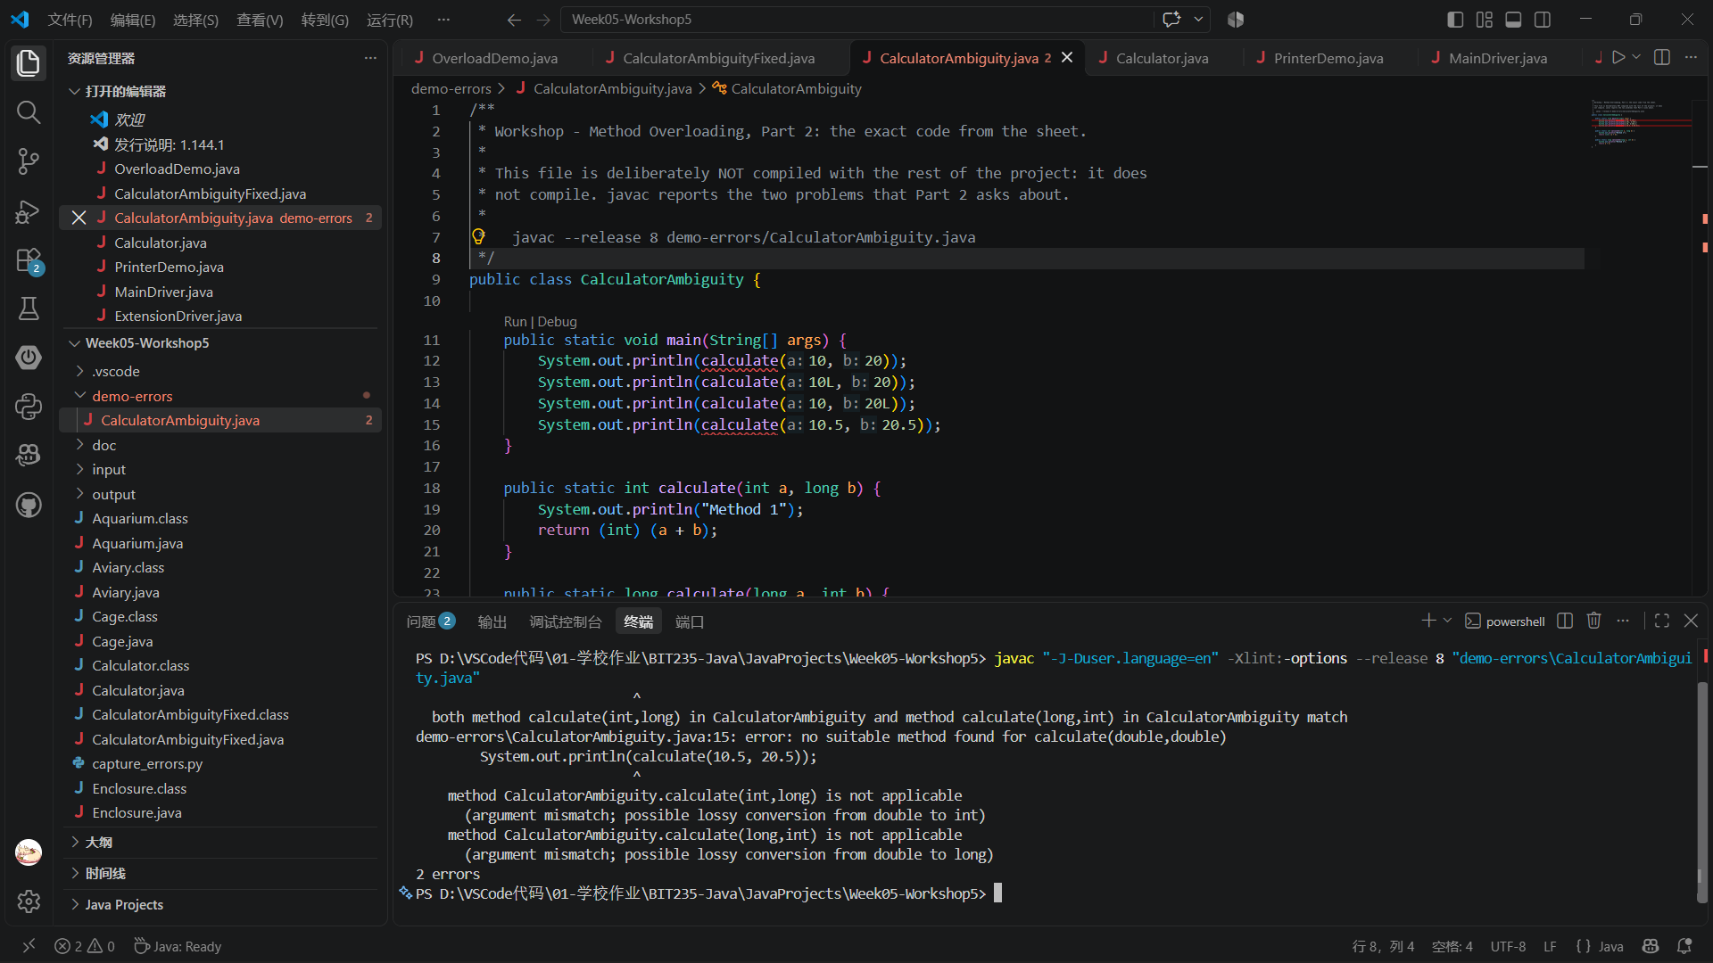

Understanding Method Overloading
Write a Java program that contains a single class called “Calculator” that contains these 4 methods:
- public static void main()
- public static int multiply(int a, int b) – which multiplies two integers and returns the result.
- public static double multiply(double a, double b) – which multiplies 2 double values and returns the result.
- public static int multiply(int a, int b, int c) – which multiplies 3 integers and returns the result.
Tasks
- Call each of the overloaded methods.
- Write System.out.println() statements in your main method that will display messages and the method results, like this:
Multiplication of two integers: 15
Multiplication of two doubles: 20.25
Multiplication of three integers: 120
- Screenshot of the program running in VS Code (Calculator.java, integrated terminal):
VS Code - java Calculator
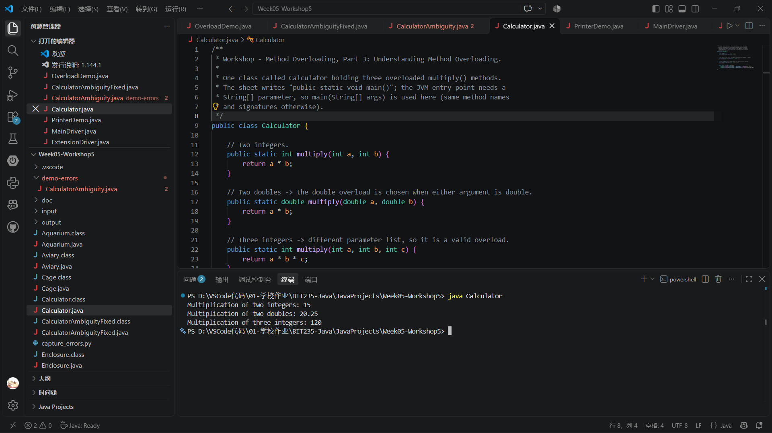
Program (Calculator.java):
/**
* Workshop - Method Overloading, Part 3: Understanding Method Overloading.
*
* One class called Calculator holding three overloaded multiply() methods.
* The sheet writes "public static void main()"; the JVM entry point needs a
* String[] parameter, so main(String[] args) is used here (same method names
* and signatures otherwise).
*/
public class Calculator {

// Two integers.
public static int multiply(int a, int b) {
return a * b;
}

// Two doubles -> the double overload is chosen when either argument is double.
public static double multiply(double a, double b) {
return a * b;
}

// Three integers -> different parameter list, so it is a valid overload.
public static int multiply(int a, int b, int c) {
return a * b * c;
}

public static void main(String[] args) {
System.out.println("Multiplication of two integers: " + multiply(5, 3));
System.out.println("Multiplication of two doubles: " + multiply(4.5, 4.5));
System.out.println("Multiplication of three integers: " + multiply(4, 5, 6));
}
}
Output:
Multiplication of two integers: 15
Multiplication of two doubles: 20.25
Multiplication of three integers: 120
Note: the sheet writes "public static void main()". The JVM only starts a class through main(String[] args), so the signature used here is main(String[] args); the three multiply methods are exactly the ones requested.

Validating Overloaded Methods
Consider the following Java code snippets:
public class Main {
public static void main(String[] args) {
Printer printer = new Printer();
printer.print("Hello");
printer.print(42);
printer.print("Hello", 42);
}
}

class Printer {
void print(String message) {
System.out.println("Message: " + message);
}

void print(int number) {
System.out.println("Number: " + number);
}

void print(String message, int number) {
System.out.println("Message and Number: " + message + ", " + number);
}
}

Tasks
- Explain which printer methods are called/used.

- Modify the Printer class to include an additional overloaded method print(double value) that prints a double value. The expected output after modification:
Message: Hello
Number: 42
Message and Number: Hello, 42
Double value: 3.14
Screenshot of the modified program running in VS Code (PrinterDemo.java, integrated terminal):
VS Code - java PrinterDemo
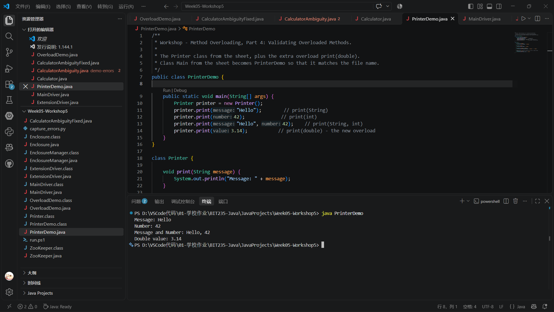
Which methods are called:
printer.print("Hello") calls print(String) - exact match on the argument type.
printer.print(42) calls print(int) - 42 is an int literal.
printer.print("Hello", 42) calls print(String, int) - two arguments, so only the two-parameter overload is applicable.
printer.print(3.14) calls the new print(double) - 3.14 is a double literal. Before the change this line would not have compiled, because a double cannot narrow to int.
The added overload does not break the existing calls: each argument list still has exactly one exact match, so the previous three lines print the same text as before.
Program (PrinterDemo.java, class Main from the sheet is named PrinterDemo to match the file):
/**
* Workshop - Method Overloading, Part 4: Validating Overloaded Methods.
*
* The Printer class from the sheet, plus the extra overload print(double).
* Class Main from the sheet becomes PrinterDemo so that it matches the file name.
*/
public class PrinterDemo {

public static void main(String[] args) {
Printer printer = new Printer();
printer.print("Hello"); // print(String)
printer.print(42); // print(int)
printer.print("Hello", 42); // print(String, int)
printer.print(3.14); // print(double) - the new overload
}
}

class Printer {

void print(String message) {
System.out.println("Message: " + message);
}

void print(int number) {
System.out.println("Number: " + number);
}

void print(String message, int number) {
System.out.println("Message and Number: " + message + ", " + number);
}

// Added for Part 4: a different parameter type, so this is a legal overload.
void print(double value) {
System.out.println("Double value: " + value);
}
}
Output:
Message: Hello
Number: 42
Message and Number: Hello, 42
Double value: 3.14

