BIT235 Object Oriented Programming
Melbourne Polytechnic - Semester 1, 2026
Workshop Extension - Bringing it home!
EnclosureManager: one controller for enclosures and keepers
Student: Chen Zhihan Student ID: S1580887
Repository: https://github.com/chenzhihan1751-cyber/bit235javaproject
Programs: Java 8 bytecode, compiled with javac 21.0.2 (--release 8) and run in the VS Code integrated terminal.

1. What this extension adds
Steps 1-20 are the same twenty steps as the OOP Concepts workshop, so the model (ZooKeeper, Enclosure, Cage, Aquarium, Aviary) and the answers are identical; the code is listed again in Appendix A so this document can be read on its own. The new part is the last page of the extension: an EnclosureManager class that acts as a central controller which stores enclosures, assigns keepers and prints a report.
The manager is the first step towards the assignment: instead of the driver wiring every object by hand, one object owns the collection and offers the operations the rest of the system needs. MainDriver then only talks to the manager.
2. The twenty steps in one paragraph each
Steps 1-3: ZooKeeper with id, givenName and familyName; displayDetails() prints them; one object created in main().
Steps 4-7: Enclosure gets a ZooKeeper field and assignKeeper(); displayDetails() prints id, capacity and the keeper's name; one enclosure and one keeper are created, linked and displayed.
Steps 8-11: Several keepers and several enclosures (Cage, Aquarium, Aviary), each with a different keeper, then all of them displayed.
Steps 12-14: An Enclosure[] array holds the three subclasses and the loop calls displayDetails() on each element.
Steps 15-16: A superclass reference can hold a subclass object because of inheritance; the overridden method that runs is chosen at run time, which is polymorphism (dynamic dispatch).
Steps 17-20: ZooKeeper keeps an ArrayList<Enclosure> and assignEnclosure(); one keeper manages several enclosures and the program prints which enclosures belong to each keeper.
3. EnclosureManager
The starter code from the sheet is used as given: a private ArrayList<Enclosure>, addEnclosure(), assignKeeperToEnclosure(int index, ZooKeeper k) with a bounds check, and printReport() which calls displayDetails() on every enclosure and prints a separator. One small helper, getEnclosureCount(), was added so the driver can print how many enclosures the report contains.
Design notes:
- The manager owns the collection, so the driver never keeps its own list of enclosures - there is one source of truth.
- assignKeeperToEnclosure() delegates to Enclosure.assignKeeper(), which keeps the keeper's own list in sync, so the same relationship is visible from both objects.
- The bounds check means an invalid index is ignored instead of throwing IndexOutOfBoundsException, which keeps the controller safe to call from a menu or a test.
- printReport() relies on polymorphism: it only knows Enclosure, but each element prints its own type, capacity, keeper and extra field.
EnclosureManager.java
import java.util.ArrayList;

/**
* Workshop Extension (OOP Concepts Extension PDF, page 2): central controller.
*
* This is the starter code from the sheet. It stores enclosures, assigns keepers
* and prints a report.
*/
public class EnclosureManager {

private ArrayList<Enclosure> enclosures;

public EnclosureManager() {
enclosures = new ArrayList<Enclosure>();
}

public void addEnclosure(Enclosure e) {
enclosures.add(e);
}

public void assignKeeperToEnclosure(int index, ZooKeeper k) {
if (index >= 0 && index < enclosures.size()) {
enclosures.get(index).assignKeeper(k);
}
}

public void printReport() {
for (Enclosure e : enclosures) {
e.displayDetails();
System.out.println("----------------------");
}
}

// Small extra helper so the report can also show the size of the collection.
public int getEnclosureCount() {
return enclosures.size();
}
}
4. Using it from the driver
The code from page 3 of the sheet is used unchanged inside ExtensionDriver (the class is renamed so MainDriver can stay the driver for steps 3-20; the two would otherwise clash). Only the constructor arguments were added, because Cage and Aquarium in this project take their extra fields in the constructor.
ExtensionDriver.java
/**
* Workshop Extension - driver from page 3 of the sheet ("How to use it in MainDriver").
*
* The class is called ExtensionDriver so that MainDriver can stay the driver for
* steps 3-20 of the OOP Concepts sheet; the body is the code from the sheet.
*
* Run: java ExtensionDriver
*/
public class ExtensionDriver {

public static void main(String[] args) {
EnclosureManager manager = new EnclosureManager();
Cage c1 = new Cage("C-301", 4, 25.0);
Aquarium a1 = new Aquarium("A-301", 8, "Salt water", 3.0);
ZooKeeper z1 = new ZooKeeper(1000001, "Sam", "Lee");
ZooKeeper z2 = new ZooKeeper(1000002, "Alex", "Kim");

manager.addEnclosure(c1);
manager.addEnclosure(a1);
manager.assignKeeperToEnclosure(0, z1);
manager.assignKeeperToEnclosure(1, z2);

System.out.println("Zoo report - " + manager.getEnclosureCount() + " enclosures");
System.out.println("======================");
manager.printReport();
}
}
5. Output
Zoo report - 2 enclosures
======================
Type : Cage
Enclosure ID : C-301
Capacity : 4
ZooKeeper : Sam Lee
Mesh size : 25.0 mm
----------------------
Type : Aquarium
Enclosure ID : A-301
Capacity : 8
ZooKeeper : Alex Kim
Water type : Salt water
Depth : 3.0 m
----------------------
6. Running it in VS Code
VS Code - java ExtensionDriver (integrated terminal).
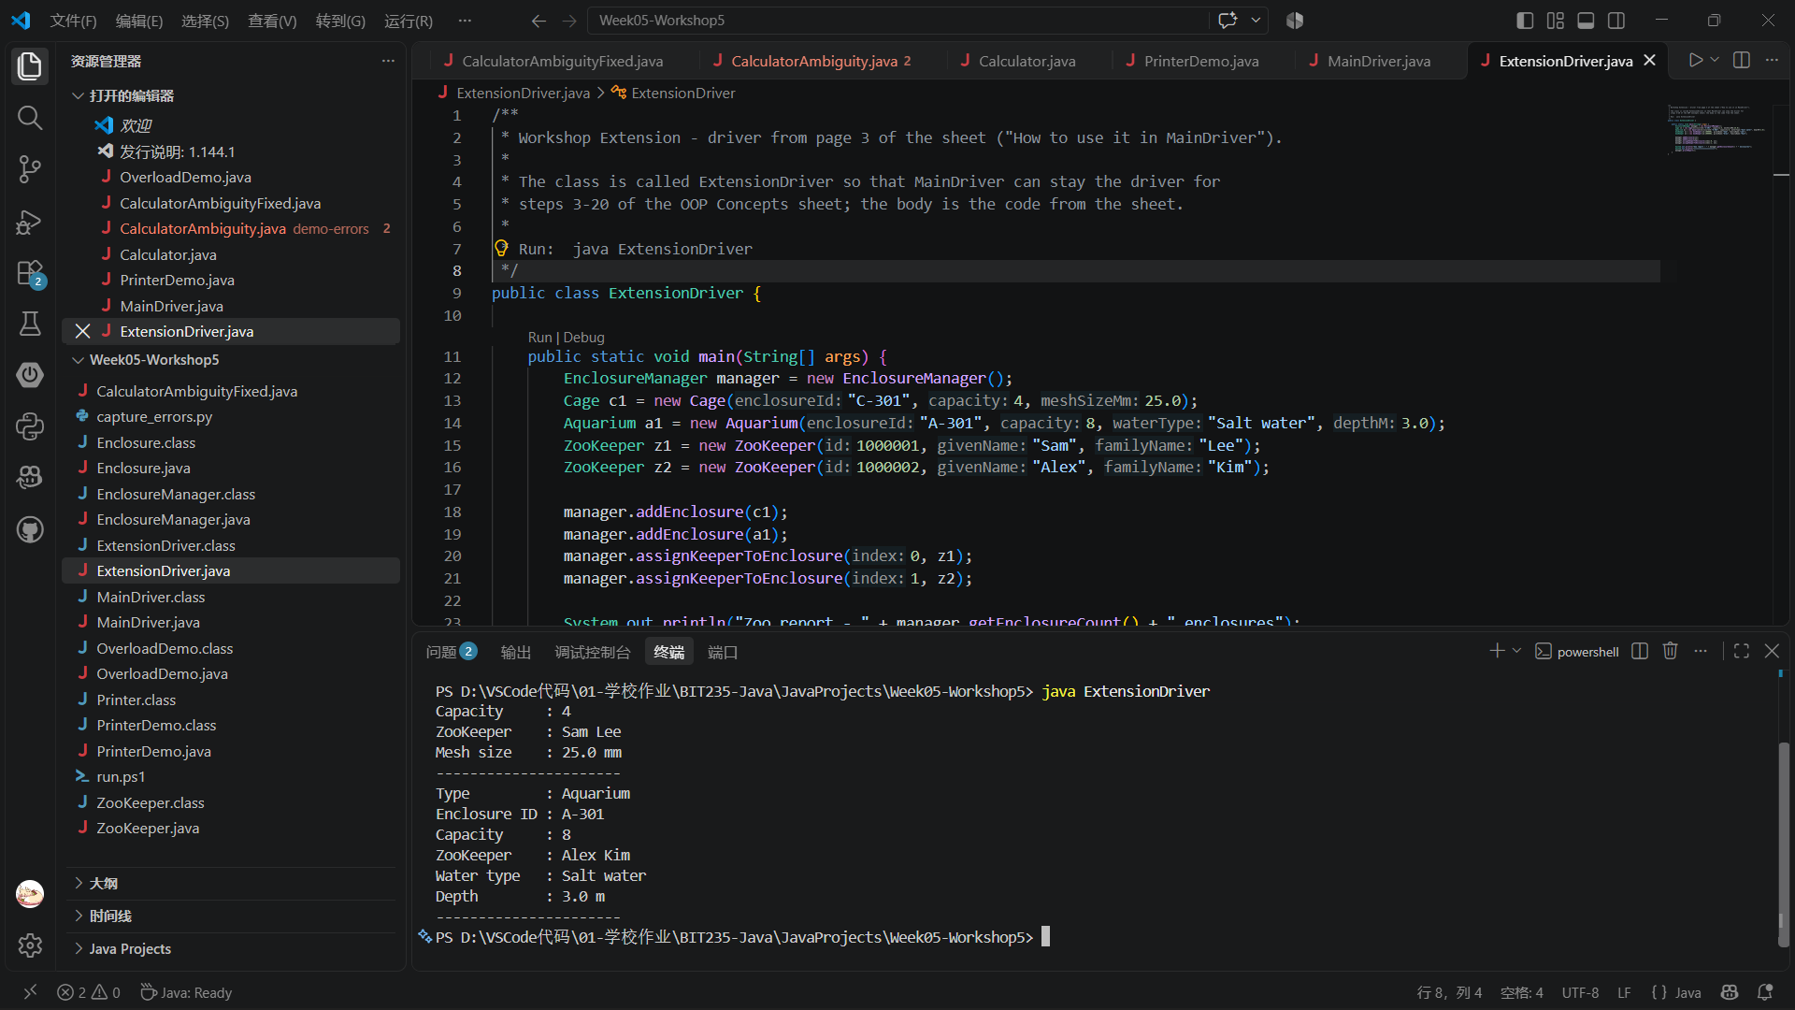
7. What I would add next
The manager is a natural place for the assignment features: a method to find an enclosure by id, a removeEnclosure() that also unlinks the keeper, and a report that groups enclosures by keeper. Because the manager owns the collection, those changes stay in one class instead of spreading through main().
Appendix A - full source
ZooKeeper.java
import java.util.ArrayList;

/**
* OOP Concepts Workshop, steps 1-3 and 17-20.
*
* Steps 1-3 : id, givenName and familyName fields plus displayDetails().
* Steps 17-20: a keeper can be assigned to more than one enclosure, so the class
* keeps an ArrayList<Enclosure> and offers assignEnclosure().
*/
public class ZooKeeper {

private int id;
private String givenName;
private String familyName;

// Step 17: one keeper, many enclosures.
private ArrayList<Enclosure> enclosures;

public ZooKeeper(int id, String givenName, String familyName) {
this.id = id;
this.givenName = givenName;
this.familyName = familyName;
this.enclosures = new ArrayList<Enclosure>();
}

public int getId() {
return id;
}

public String getGivenName() {
return givenName;
}

public String getFamilyName() {
return familyName;
}

public String getFullName() {
return givenName + " " + familyName;
}

public ArrayList<Enclosure> getEnclosures() {
return enclosures;
}

// Step 2: print the keeper's details.
public void displayDetails() {
System.out.println("ZooKeeper ID : " + id);
System.out.println("ZooKeeper : " + getFullName());
}

// Step 18: assign one more enclosure to this keeper.
public void assignEnclosure(Enclosure e) {
if (e == null) {
return;
}
if (!enclosures.contains(e)) {
enclosures.add(e);
}
// Keep both sides of the relationship in step: the enclosure also needs
// to know its keeper, otherwise Enclosure.displayDetails() shows "none".
if (e.getKeeper() != this) {
e.assignKeeper(this);
}
}

public void removeEnclosure(Enclosure e) {
enclosures.remove(e);
}

// Step 20: list every enclosure this keeper is responsible for.
public void displayEnclosures() {
System.out.println("Enclosures managed by " + getFullName() + ":");
if (enclosures.isEmpty()) {
System.out.println(" (none)");
return;
}
for (Enclosure e : enclosures) {
System.out.println(" - " + e.getEnclosureId()
+ " (" + e.getType() + ", capacity " + e.getCapacity() + ")");
}
}
}
Enclosure.java
/**
* OOP Concepts Workshop, steps 4-5.
*
* Step 4: new field ZooKeeper keeper and method assignKeeper(ZooKeeper k).
* Step 5: displayDetails() prints the enclosure id, the capacity and the name of
* the assigned keeper (keeper.givenName + keeper.familyName).
*
* Cage, Aquarium and Aviary extend this class, so a variable of type Enclosure
* can hold any of them (steps 12-16).
*/
public class Enclosure {

private String enclosureId;
private int capacity;

// Step 4: the keeper who looks after this enclosure.
private ZooKeeper keeper;

public Enclosure(String enclosureId, int capacity) {
this.enclosureId = enclosureId;
this.capacity = capacity;
}

public String getEnclosureId() {
return enclosureId;
}

public int getCapacity() {
return capacity;
}

public ZooKeeper getKeeper() {
return keeper;
}

// Step 4: assign the keeper to this enclosure. The link is kept on both
// sides so that ZooKeeper.displayEnclosures() can list the same relationship.
public void assignKeeper(ZooKeeper k) {
if (keeper != null && keeper != k) {
keeper.removeEnclosure(this);
}
this.keeper = k;
if (k != null && k.getEnclosures().indexOf(this) < 0) {
k.assignEnclosure(this);
}
}

// Overridden by the subclasses; used only when printing.
public String getType() {
return "Enclosure";
}

// Step 5: id, capacity and the assigned keeper's name.
public void displayDetails() {
System.out.println("Type : " + getType());
System.out.println("Enclosure ID : " + enclosureId);
System.out.println("Capacity : " + capacity);
if (keeper == null) {
System.out.println("ZooKeeper : (not assigned)");
} else {
System.out.println("ZooKeeper : "
+ keeper.getGivenName() + " " + keeper.getFamilyName());
}
}
}
Cage.java
/**
* OOP Concepts Workshop, step 9: a Cage is an Enclosure (inheritance).
* It adds its own field and overrides displayDetails() to show it, while still
* calling super.displayDetails() for the shared fields.
*/
public class Cage extends Enclosure {

private double meshSizeMm;

public Cage(String enclosureId, int capacity, double meshSizeMm) {
super(enclosureId, capacity);
this.meshSizeMm = meshSizeMm;
}

public double getMeshSizeMm() {
return meshSizeMm;
}

@Override
public String getType() {
return "Cage";
}

@Override
public void displayDetails() {
super.displayDetails();
System.out.println("Mesh size : " + meshSizeMm + " mm");
}
}
Aquarium.java
/**
* OOP Concepts Workshop, step 9: an Aquarium is an Enclosure (inheritance).
*/
public class Aquarium extends Enclosure {

private String waterType;
private double depthM;

public Aquarium(String enclosureId, int capacity, String waterType, double depthM) {
super(enclosureId, capacity);
this.waterType = waterType;
this.depthM = depthM;
}

public String getWaterType() {
return waterType;
}

public double getDepthM() {
return depthM;
}

@Override
public String getType() {
return "Aquarium";
}

@Override
public void displayDetails() {
super.displayDetails();
System.out.println("Water type : " + waterType);
System.out.println("Depth : " + depthM + " m");
}
}
Aviary.java
/**
* OOP Concepts Workshop, step 9: an Aviary is an Enclosure (inheritance).
*/
public class Aviary extends Enclosure {

private double flightHeightM;

public Aviary(String enclosureId, int capacity, double flightHeightM) {
super(enclosureId, capacity);
this.flightHeightM = flightHeightM;
}

public double getFlightHeightM() {
return flightHeightM;
}

@Override
public String getType() {
return "Aviary";
}

@Override
public void displayDetails() {
super.displayDetails();
System.out.println("Flight height: " + flightHeightM + " m");
}
}
MainDriver.java
/**
* OOP Concepts Workshop - driver for steps 3 and 6-20.
*
* Run: java MainDriver
*
* The steps are printed in order so the output can be matched against the
* workshop sheet.
*/
public class MainDriver {

public static void main(String[] args) {

// Step 3: one ZooKeeper object, displayDetails() called.
System.out.println("=== Step 3: one ZooKeeper object ===");
ZooKeeper oneKeeper = new ZooKeeper(1000000, "Nina", "Park");
oneKeeper.displayDetails();

// Steps 6-7: one Enclosure and one ZooKeeper, then assign and display.
System.out.println();
System.out.println("=== Steps 6-7: one Enclosure with a ZooKeeper assigned ===");
Enclosure firstEnclosure = new Enclosure("E-001", 6);
ZooKeeper sam = new ZooKeeper(1000001, "Sam", "Lee");
firstEnclosure.assignKeeper(sam);
firstEnclosure.displayDetails();

// Steps 8-11: several keepers, several enclosures (Cage, Aquarium, Aviary).
System.out.println();
System.out.println("=== Steps 8-11: several keepers and several enclosures ===");
ZooKeeper alex = new ZooKeeper(1000002, "Alex", "Kim");
ZooKeeper priya = new ZooKeeper(1000003, "Priya", "Nair");

Cage cage = new Cage("C-101", 4, 25.0);
Aquarium aquarium = new Aquarium("A-101", 12, "Salt water", 3.5);
Aviary aviary = new Aviary("V-101", 30, 8.0);

cage.assignKeeper(sam);
aquarium.assignKeeper(alex);
aviary.assignKeeper(priya);

cage.displayDetails();
System.out.println();
aquarium.displayDetails();
System.out.println();
aviary.displayDetails();

// Steps 12-14: an array of Enclosure holding different subclasses.
System.out.println();
System.out.println("=== Steps 12-14: an Enclosure[] array holding different types ===");
Enclosure[] enclosures = new Enclosure[3];
enclosures[0] = cage;
enclosures[1] = aquarium;
enclosures[2] = aviary;
for (Enclosure e : enclosures) {
// The variable is Enclosure, but the object's own displayDetails()
// runs - that is polymorphism (steps 15-16).
e.displayDetails();
System.out.println();
}

// Steps 17-20: one keeper managing several enclosures.
System.out.println();
System.out.println("=== Steps 17-20: one ZooKeeper managing several enclosures ===");
ZooKeeper manager = new ZooKeeper(1000004, "Dana", "Wong");
Cage cage2 = new Cage("C-201", 6, 20.0);
Aquarium aquarium2 = new Aquarium("A-201", 10, "Fresh water", 2.0);
Aviary aviary2 = new Aviary("V-201", 25, 6.5);

manager.assignEnclosure(cage2);
manager.assignEnclosure(aquarium2);
manager.assignEnclosure(aviary2);

manager.displayDetails();
manager.displayEnclosures();

// Step 20: every keeper and the enclosures they are responsible for.
System.out.println();
System.out.println("=== Step 20: every keeper and their enclosures ===");
ZooKeeper[] keepers = { oneKeeper, sam, alex, priya, manager };
for (ZooKeeper k : keepers) {
k.displayEnclosures();
System.out.println();
}
}
}

