BIT235 Object Oriented Programming
Melbourne Polytechnic - Semester 1, 2026
Workshop - OOP Concepts
ZooKeeper, Enclosure and polymorphism
Student: Chen Zhihan Student ID: S1580887
Repository: https://github.com/chenzhihan1751-cyber/bit235javaproject
Programs: Java 8 bytecode, compiled with javac 21.0.2 (--release 8) and run in the VS Code integrated terminal.

1. What the program builds
The workshop starts from the Enclosure project and grows it into a small zoo model. An Enclosure has an id, a capacity and an optional ZooKeeper; Cage, Aquarium and Aviary are subclasses of Enclosure; a ZooKeeper can look after several enclosures. MainDriver walks through steps 3 to 20 in order and prints a heading before each group so the output can be matched against the sheet.
- Enclosure - shared data (enclosureId, capacity, keeper) and displayDetails().
- Cage / Aquarium / Aviary - extend Enclosure, add their own field and override displayDetails() and getType().
- ZooKeeper - id, givenName, familyName, plus an ArrayList<Enclosure> so one keeper can be responsible for many enclosures.
- MainDriver - creates the objects and calls displayDetails() in the order the workshop asks for.
2. Steps 1-3: the ZooKeeper class
ZooKeeper holds the three fields from step 1 (id, givenName, familyName) and displayDetails() prints them. Step 3 creates one object in main() and calls the method, which produces:
=== Step 3: one ZooKeeper object ===
ZooKeeper ID : 1000000
ZooKeeper : Nina Park
The class also carries the ArrayList<Enclosure> used later in steps 17-20; the methods for that are explained in section 7.
ZooKeeper.java
import java.util.ArrayList;

/**
* OOP Concepts Workshop, steps 1-3 and 17-20.
*
* Steps 1-3 : id, givenName and familyName fields plus displayDetails().
* Steps 17-20: a keeper can be assigned to more than one enclosure, so the class
* keeps an ArrayList<Enclosure> and offers assignEnclosure().
*/
public class ZooKeeper {

private int id;
private String givenName;
private String familyName;

// Step 17: one keeper, many enclosures.
private ArrayList<Enclosure> enclosures;

public ZooKeeper(int id, String givenName, String familyName) {
this.id = id;
this.givenName = givenName;
this.familyName = familyName;
this.enclosures = new ArrayList<Enclosure>();
}

public int getId() {
return id;
}

public String getGivenName() {
return givenName;
}

public String getFamilyName() {
return familyName;
}

public String getFullName() {
return givenName + " " + familyName;
}

public ArrayList<Enclosure> getEnclosures() {
return enclosures;
}

// Step 2: print the keeper's details.
public void displayDetails() {
System.out.println("ZooKeeper ID : " + id);
System.out.println("ZooKeeper : " + getFullName());
}

// Step 18: assign one more enclosure to this keeper.
public void assignEnclosure(Enclosure e) {
if (e == null) {
return;
}
if (!enclosures.contains(e)) {
enclosures.add(e);
}
// Keep both sides of the relationship in step: the enclosure also needs
// to know its keeper, otherwise Enclosure.displayDetails() shows "none".
if (e.getKeeper() != this) {
e.assignKeeper(this);
}
}

public void removeEnclosure(Enclosure e) {
enclosures.remove(e);
}

// Step 20: list every enclosure this keeper is responsible for.
public void displayEnclosures() {
System.out.println("Enclosures managed by " + getFullName() + ":");
if (enclosures.isEmpty()) {
System.out.println(" (none)");
return;
}
for (Enclosure e : enclosures) {
System.out.println(" - " + e.getEnclosureId()
+ " (" + e.getType() + ", capacity " + e.getCapacity() + ")");
}
}
}
3. Steps 4-7: linking a ZooKeeper to an Enclosure
Step 4 adds the field ZooKeeper keeper and the method assignKeeper(ZooKeeper k) to Enclosure. assignKeeper() stores the reference and also registers the enclosure with the keeper, so the relationship is consistent in both directions.
Step 5 rewrites displayDetails() so it prints the enclosure id, the capacity and the keeper's name using keeper.getGivenName() and keeper.getFamilyName() (the fields are private, so the getters are used instead of keeper.givenName). If no keeper has been assigned the method prints "(not assigned)" instead of throwing a NullPointerException.
Steps 6-7 create one enclosure and one keeper, assign the keeper and display the result:
=== Steps 6-7: one Enclosure with a ZooKeeper assigned ===
Type : Enclosure
Enclosure ID : E-001
Capacity : 6
ZooKeeper : Sam Lee
Enclosure.java
/**
* OOP Concepts Workshop, steps 4-5.
*
* Step 4: new field ZooKeeper keeper and method assignKeeper(ZooKeeper k).
* Step 5: displayDetails() prints the enclosure id, the capacity and the name of
* the assigned keeper (keeper.givenName + keeper.familyName).
*
* Cage, Aquarium and Aviary extend this class, so a variable of type Enclosure
* can hold any of them (steps 12-16).
*/
public class Enclosure {

private String enclosureId;
private int capacity;

// Step 4: the keeper who looks after this enclosure.
private ZooKeeper keeper;

public Enclosure(String enclosureId, int capacity) {
this.enclosureId = enclosureId;
this.capacity = capacity;
}

public String getEnclosureId() {
return enclosureId;
}

public int getCapacity() {
return capacity;
}

public ZooKeeper getKeeper() {
return keeper;
}

// Step 4: assign the keeper to this enclosure. The link is kept on both
// sides so that ZooKeeper.displayEnclosures() can list the same relationship.
public void assignKeeper(ZooKeeper k) {
if (keeper != null && keeper != k) {
keeper.removeEnclosure(this);
}
this.keeper = k;
if (k != null && k.getEnclosures().indexOf(this) < 0) {
k.assignEnclosure(this);
}
}

// Overridden by the subclasses; used only when printing.
public String getType() {
return "Enclosure";
}

// Step 5: id, capacity and the assigned keeper's name.
public void displayDetails() {
System.out.println("Type : " + getType());
System.out.println("Enclosure ID : " + enclosureId);
System.out.println("Capacity : " + capacity);
if (keeper == null) {
System.out.println("ZooKeeper : (not assigned)");
} else {
System.out.println("ZooKeeper : "
+ keeper.getGivenName() + " " + keeper.getFamilyName());
}
}
}
4. Steps 8-11: several keepers, several enclosures
Three keepers and three different enclosure types are created, each enclosure gets its own keeper, and every enclosure is displayed:
Type : Cage
Enclosure ID : C-101
Capacity : 4
ZooKeeper : Sam Lee
Mesh size : 25.0 mm

Type : Aquarium
Enclosure ID : A-101
Capacity : 12
ZooKeeper : Alex Kim
Water type : Salt water
Depth : 3.5 m

Type : Aviary
Enclosure ID : V-101
Capacity : 30
ZooKeeper : Priya Nair
Flight height: 8.0 m
Cage.java
/**
* OOP Concepts Workshop, step 9: a Cage is an Enclosure (inheritance).
* It adds its own field and overrides displayDetails() to show it, while still
* calling super.displayDetails() for the shared fields.
*/
public class Cage extends Enclosure {

private double meshSizeMm;

public Cage(String enclosureId, int capacity, double meshSizeMm) {
super(enclosureId, capacity);
this.meshSizeMm = meshSizeMm;
}

public double getMeshSizeMm() {
return meshSizeMm;
}

@Override
public String getType() {
return "Cage";
}

@Override
public void displayDetails() {
super.displayDetails();
System.out.println("Mesh size : " + meshSizeMm + " mm");
}
}
Aquarium.java
/**
* OOP Concepts Workshop, step 9: an Aquarium is an Enclosure (inheritance).
*/
public class Aquarium extends Enclosure {

private String waterType;
private double depthM;

public Aquarium(String enclosureId, int capacity, String waterType, double depthM) {
super(enclosureId, capacity);
this.waterType = waterType;
this.depthM = depthM;
}

public String getWaterType() {
return waterType;
}

public double getDepthM() {
return depthM;
}

@Override
public String getType() {
return "Aquarium";
}

@Override
public void displayDetails() {
super.displayDetails();
System.out.println("Water type : " + waterType);
System.out.println("Depth : " + depthM + " m");
}
}
Aviary.java
/**
* OOP Concepts Workshop, step 9: an Aviary is an Enclosure (inheritance).
*/
public class Aviary extends Enclosure {

private double flightHeightM;

public Aviary(String enclosureId, int capacity, double flightHeightM) {
super(enclosureId, capacity);
this.flightHeightM = flightHeightM;
}

public double getFlightHeightM() {
return flightHeightM;
}

@Override
public String getType() {
return "Aviary";
}

@Override
public void displayDetails() {
super.displayDetails();
System.out.println("Flight height: " + flightHeightM + " m");
}
}
5. Steps 12-14: polymorphism with an array
The three objects are stored in an Enclosure[] array and the loop calls displayDetails() through the Enclosure reference:
Enclosure[] enclosures = new Enclosure[3];
enclosures[0] = cage;
enclosures[1] = aquarium;
enclosures[2] = aviary;
for (Enclosure e : enclosures) {
e.displayDetails();
}
Each object still prints its own type, its own extra field and its own keeper, even though the array type is Enclosure. The output is identical to the block in section 4, which is the point of steps 12-14.
6. Steps 15-16: why one Enclosure variable can hold different types
Step 15 - a variable of type Enclosure can refer to a Cage, an Aquarium or an Aviary because those classes extend Enclosure. Java allows a reference of a superclass type to point at an object of any subclass; the compiler only checks that the object is an Enclosure, which it is by inheritance. The variable type decides what the compiler lets you call, the object type decides which implementation actually runs.
Step 16 - the concept is polymorphism (dynamic method dispatch), built on inheritance and method overriding. displayDetails() is declared in Enclosure and overridden in Cage, Aquarium and Aviary, so the JVM picks the override that belongs to the real object at run time. Without overriding, the loop would call Enclosure.displayDetails() three times and the extra fields would never be printed.
7. Steps 17-20: one ZooKeeper, many enclosures
Step 17 changes ZooKeeper so it can be assigned to more than one enclosure: the class keeps an ArrayList<Enclosure> instead of a single reference. Step 18 adds assignEnclosure(Enclosure e), which adds the enclosure to that list and keeps the back-reference on the enclosure.
Step 19 updates the program so one keeper manages several enclosures, and step 20 prints the list for every keeper:
=== Steps 17-20: one ZooKeeper managing several enclosures ===
ZooKeeper ID : 1000004
ZooKeeper : Dana Wong
Enclosures managed by Dana Wong:
- C-201 (Cage, capacity 6)
- A-201 (Aquarium, capacity 10)
- V-201 (Aviary, capacity 25)
The last part of the output lists every keeper with the enclosures they are responsible for, including the keepers from steps 8-11, which shows that the one-to-many relationship works in both directions.
8. Running the program in VS Code
The project is compiled with javac 21 using --release 8 and each program is run in the VS Code integrated terminal. The screenshot below shows MainDriver.java and the real console output of the run.
VS Code - java MainDriver (integrated terminal, end of the output).
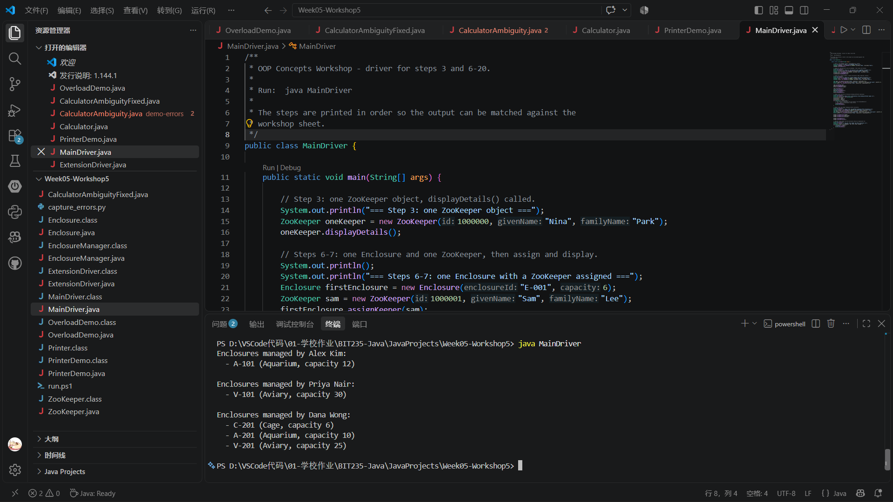
9. Complete console output
=== Step 3: one ZooKeeper object ===
ZooKeeper ID : 1000000
ZooKeeper : Nina Park

=== Steps 6-7: one Enclosure with a ZooKeeper assigned ===
Type : Enclosure
Enclosure ID : E-001
Capacity : 6
ZooKeeper : Sam Lee

=== Steps 8-11: several keepers and several enclosures ===
Type : Cage
Enclosure ID : C-101
Capacity : 4
ZooKeeper : Sam Lee
Mesh size : 25.0 mm

Type : Aquarium
Enclosure ID : A-101
Capacity : 12
ZooKeeper : Alex Kim
Water type : Salt water
Depth : 3.5 m

Type : Aviary
Enclosure ID : V-101
Capacity : 30
ZooKeeper : Priya Nair
Flight height: 8.0 m

=== Steps 12-14: an Enclosure[] array holding different types ===
Type : Cage
Enclosure ID : C-101
Capacity : 4
ZooKeeper : Sam Lee
Mesh size : 25.0 mm

Type : Aquarium
Enclosure ID : A-101
Capacity : 12
ZooKeeper : Alex Kim
Water type : Salt water
Depth : 3.5 m

Type : Aviary
Enclosure ID : V-101
Capacity : 30
ZooKeeper : Priya Nair
Flight height: 8.0 m

=== Steps 17-20: one ZooKeeper managing several enclosures ===
ZooKeeper ID : 1000004
ZooKeeper : Dana Wong
Enclosures managed by Dana Wong:
- C-201 (Cage, capacity 6)
- A-201 (Aquarium, capacity 10)
- V-201 (Aviary, capacity 25)

=== Step 20: every keeper and their enclosures ===
Enclosures managed by Nina Park:
(none)

Enclosures managed by Sam Lee:
- E-001 (Enclosure, capacity 6)
- C-101 (Cage, capacity 4)

Enclosures managed by Alex Kim:
- A-101 (Aquarium, capacity 12)

Enclosures managed by Priya Nair:
- V-101 (Aviary, capacity 30)

Enclosures managed by Dana Wong:
- C-201 (Cage, capacity 6)
- A-201 (Aquarium, capacity 10)
- V-201 (Aviary, capacity 25)
10. MainDriver.java
/**
* OOP Concepts Workshop - driver for steps 3 and 6-20.
*
* Run: java MainDriver
*
* The steps are printed in order so the output can be matched against the
* workshop sheet.
*/
public class MainDriver {

public static void main(String[] args) {

// Step 3: one ZooKeeper object, displayDetails() called.
System.out.println("=== Step 3: one ZooKeeper object ===");
ZooKeeper oneKeeper = new ZooKeeper(1000000, "Nina", "Park");
oneKeeper.displayDetails();

// Steps 6-7: one Enclosure and one ZooKeeper, then assign and display.
System.out.println();
System.out.println("=== Steps 6-7: one Enclosure with a ZooKeeper assigned ===");
Enclosure firstEnclosure = new Enclosure("E-001", 6);
ZooKeeper sam = new ZooKeeper(1000001, "Sam", "Lee");
firstEnclosure.assignKeeper(sam);
firstEnclosure.displayDetails();

// Steps 8-11: several keepers, several enclosures (Cage, Aquarium, Aviary).
System.out.println();
System.out.println("=== Steps 8-11: several keepers and several enclosures ===");
ZooKeeper alex = new ZooKeeper(1000002, "Alex", "Kim");
ZooKeeper priya = new ZooKeeper(1000003, "Priya", "Nair");

Cage cage = new Cage("C-101", 4, 25.0);
Aquarium aquarium = new Aquarium("A-101", 12, "Salt water", 3.5);
Aviary aviary = new Aviary("V-101", 30, 8.0);

cage.assignKeeper(sam);
aquarium.assignKeeper(alex);
aviary.assignKeeper(priya);

cage.displayDetails();
System.out.println();
aquarium.displayDetails();
System.out.println();
aviary.displayDetails();

// Steps 12-14: an array of Enclosure holding different subclasses.
System.out.println();
System.out.println("=== Steps 12-14: an Enclosure[] array holding different types ===");
Enclosure[] enclosures = new Enclosure[3];
enclosures[0] = cage;
enclosures[1] = aquarium;
enclosures[2] = aviary;
for (Enclosure e : enclosures) {
// The variable is Enclosure, but the object's own displayDetails()
// runs - that is polymorphism (steps 15-16).
e.displayDetails();
System.out.println();
}

// Steps 17-20: one keeper managing several enclosures.
System.out.println();
System.out.println("=== Steps 17-20: one ZooKeeper managing several enclosures ===");
ZooKeeper manager = new ZooKeeper(1000004, "Dana", "Wong");
Cage cage2 = new Cage("C-201", 6, 20.0);
Aquarium aquarium2 = new Aquarium("A-201", 10, "Fresh water", 2.0);
Aviary aviary2 = new Aviary("V-201", 25, 6.5);

manager.assignEnclosure(cage2);
manager.assignEnclosure(aquarium2);
manager.assignEnclosure(aviary2);

manager.displayDetails();
manager.displayEnclosures();

// Step 20: every keeper and the enclosures they are responsible for.
System.out.println();
System.out.println("=== Step 20: every keeper and their enclosures ===");
ZooKeeper[] keepers = { oneKeeper, sam, alex, priya, manager };
for (ZooKeeper k : keepers) {
k.displayEnclosures();
System.out.println();
}
}
}

