Workshop 6

Java Collections – OOP Concepts

Upload your code on GitHub and provide the link below
GitHub Link: https://github.com/chenzhihan1751-cyber/bit235javaproject

Exercise 1  Easy  Your answer (screenshot) | Write a Java program that stores the names of your 10 favorite songs in an array of strings. Also store the artist's name in a second array of strings. Output a list of the songs and artists.
Exercise 1 - VS Code run (screenshot)
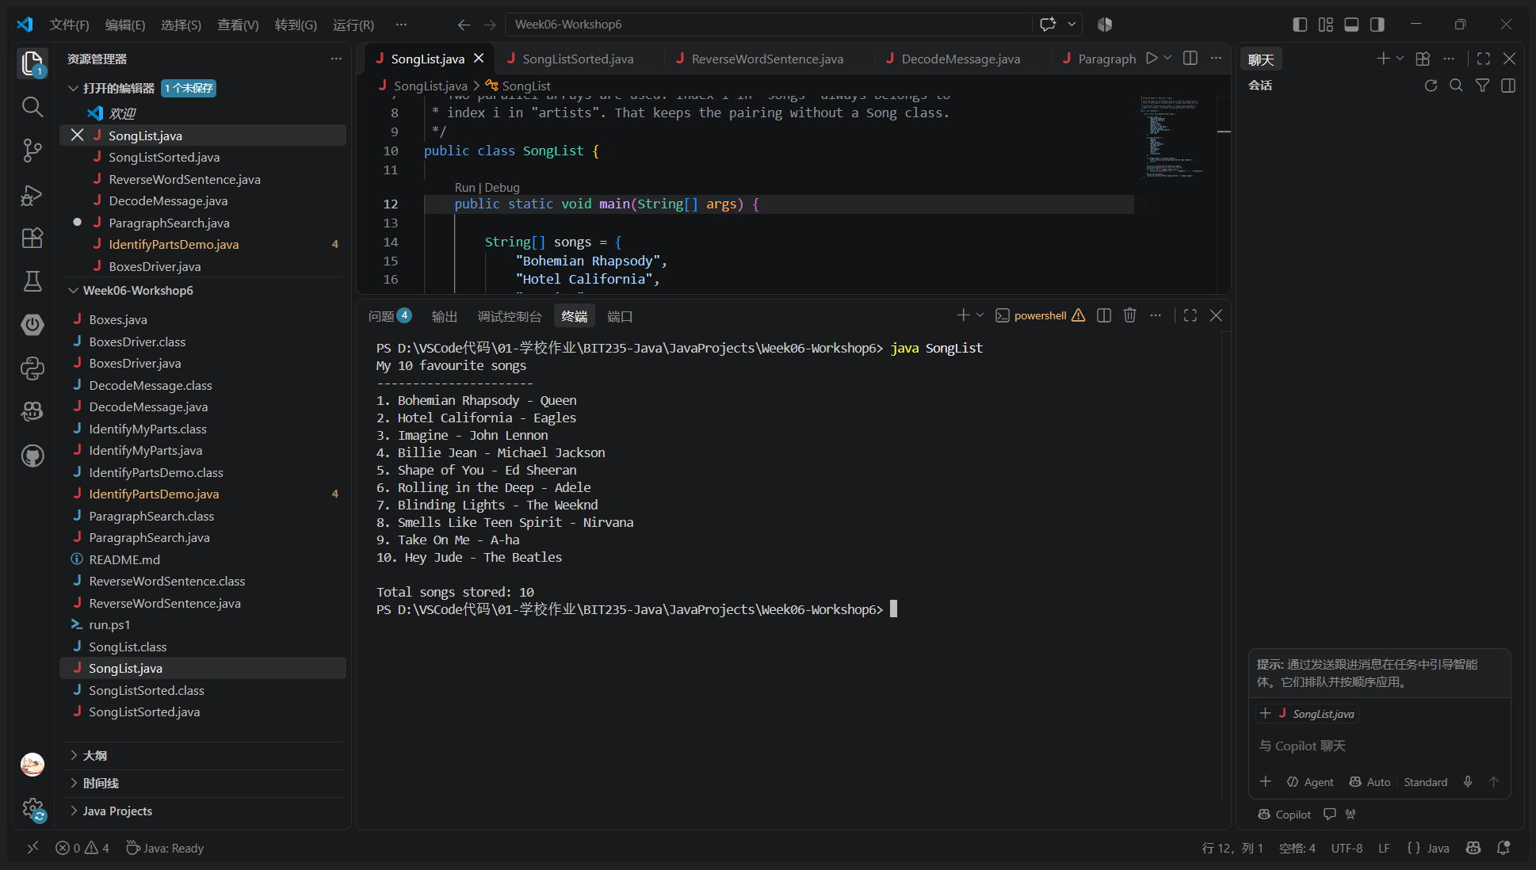
Program: SongList.java
/*
* BIT235 Workshop 6 - Exercise 1 (Easy)
*
* Store the names of 10 favourite songs in an array of strings and the
* artist of each song in a second array of strings, then output the list.
*
* Two parallel arrays are used: index i in "songs" always belongs to
* index i in "artists". That keeps the pairing without a Song class.
*/
public class SongList {

public static void main(String[] args) {

String[] songs = {
"Bohemian Rhapsody",
"Hotel California",
"Imagine",
"Billie Jean",
"Shape of You",
"Rolling in the Deep",
"Blinding Lights",
"Smells Like Teen Spirit",
"Take On Me",
"Hey Jude"
};

String[] artists = {
"Queen",
"Eagles",
"John Lennon",
"Michael Jackson",
"Ed Sheeran",
"Adele",
"The Weeknd",
"Nirvana",
"A-ha",
"The Beatles"
};

if (songs.length != artists.length) {
System.out.println("Arrays must be the same length.");
return;
}

System.out.println("My 10 favourite songs");
System.out.println("----------------------");
for (int i = 0; i < songs.length; i++) {
System.out.println((i + 1) + ". " + songs[i] + " - " + artists[i]);
}
System.out.println();
System.out.println("Total songs stored: " + songs.length);
}
}
Output:
My 10 favourite songs
----------------------
1. Bohemian Rhapsody - Queen
2. Hotel California - Eagles
3. Imagine - John Lennon
4. Billie Jean - Michael Jackson
5. Shape of You - Ed Sheeran
6. Rolling in the Deep - Adele
7. Blinding Lights - The Weeknd
8. Smells Like Teen Spirit - Nirvana
9. Take On Me - A-ha
10. Hey Jude - The Beatles

Total songs stored: 10
Exercise 2  Hard  Your answer (screenshot) | Modify the Exercise 1 question above to output the songs in alphabetical order. Hint: bubble sort.
Exercise 2 - VS Code run (screenshot)
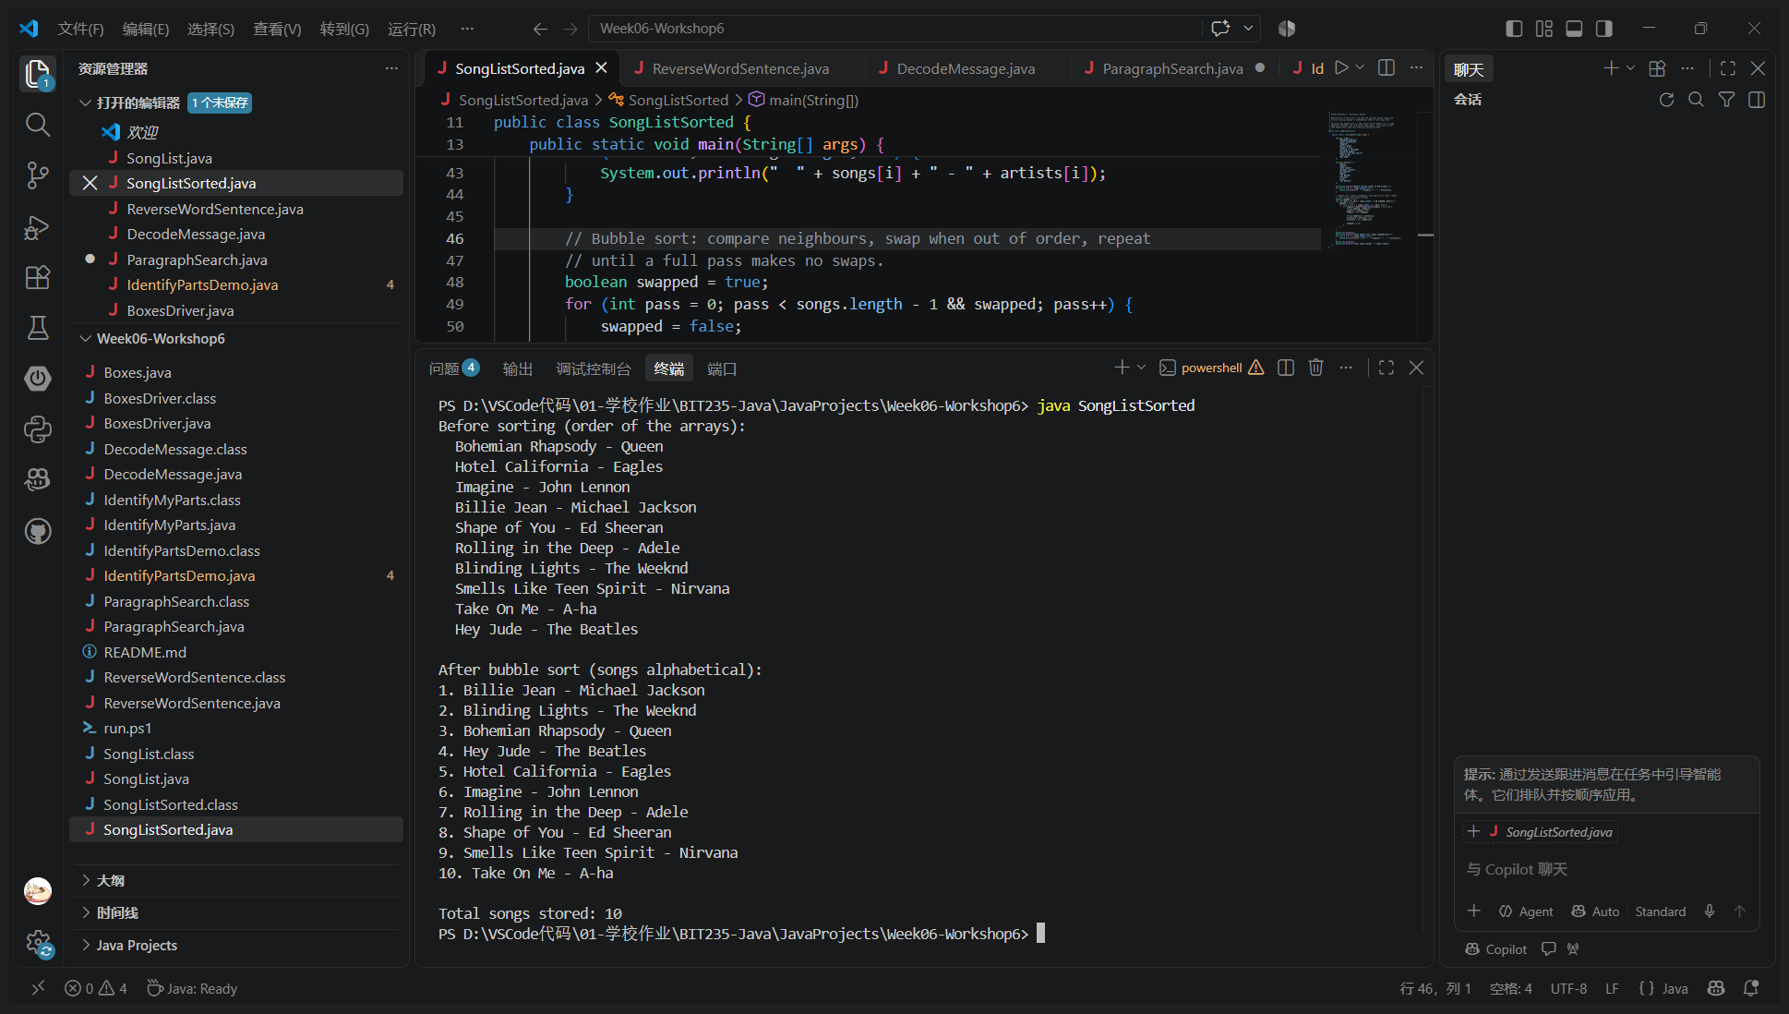
Program: SongListSorted.java
/*
* BIT235 Workshop 6 - Exercise 2 (Hard)
*
* Modification of Exercise 1: the same two parallel arrays (songs and
* artists) are now output in alphabetical order of the song title.
*
* The hint says bubble sort, so the classic O(n^2) bubble sort is used.
* Important: whenever two song titles swap places, the artists at the
* same indexes must swap too, otherwise the pairs break.
*/
public class SongListSorted {

public static void main(String[] args) {

String[] songs = {
"Bohemian Rhapsody",
"Hotel California",
"Imagine",
"Billie Jean",
"Shape of You",
"Rolling in the Deep",
"Blinding Lights",
"Smells Like Teen Spirit",
"Take On Me",
"Hey Jude"
};

String[] artists = {
"Queen",
"Eagles",
"John Lennon",
"Michael Jackson",
"Ed Sheeran",
"Adele",
"The Weeknd",
"Nirvana",
"A-ha",
"The Beatles"
};

System.out.println("Before sorting (order of the arrays):");
for (int i = 0; i < songs.length; i++) {
System.out.println(" " + songs[i] + " - " + artists[i]);
}

// Bubble sort: compare neighbours, swap when out of order, repeat
// until a full pass makes no swaps.
boolean swapped = true;
for (int pass = 0; pass < songs.length - 1 && swapped; pass++) {
swapped = false;
for (int i = 0; i < songs.length - 1 - pass; i++) {
if (songs[i].compareToIgnoreCase(songs[i + 1]) > 0) {
String tmpSong = songs[i];
songs[i] = songs[i + 1];
songs[i + 1] = tmpSong;

String tmpArtist = artists[i];
artists[i] = artists[i + 1];
artists[i + 1] = tmpArtist;

swapped = true;
}
}
}

System.out.println();
System.out.println("After bubble sort (songs alphabetical):");
for (int i = 0; i < songs.length; i++) {
System.out.println((i + 1) + ". " + songs[i] + " - " + artists[i]);
}
System.out.println();
System.out.println("Total songs stored: " + songs.length);
}
}
Output:
Before sorting (order of the arrays):
Bohemian Rhapsody - Queen
Hotel California - Eagles
Imagine - John Lennon
Billie Jean - Michael Jackson
Shape of You - Ed Sheeran
Rolling in the Deep - Adele
Blinding Lights - The Weeknd
Smells Like Teen Spirit - Nirvana
Take On Me - A-ha
Hey Jude - The Beatles

After bubble sort (songs alphabetical):
1. Billie Jean - Michael Jackson
2. Blinding Lights - The Weeknd
3. Bohemian Rhapsody - Queen
4. Hey Jude - The Beatles
5. Hotel California - Eagles
6. Imagine - John Lennon
7. Rolling in the Deep - Adele
8. Shape of You - Ed Sheeran
9. Smells Like Teen Spirit - Nirvana
10. Take On Me - A-ha

Total songs stored: 10
Exercise 3  Medium  Your answer (screenshot) | Write a program that uses loop(s) and array(s) to reverse the sequence of letters in each word of a sentence. For instance, "To be or not to be." Would become "oT eb ro ton ot eb.".
Exercise 3 - VS Code run (screenshot)
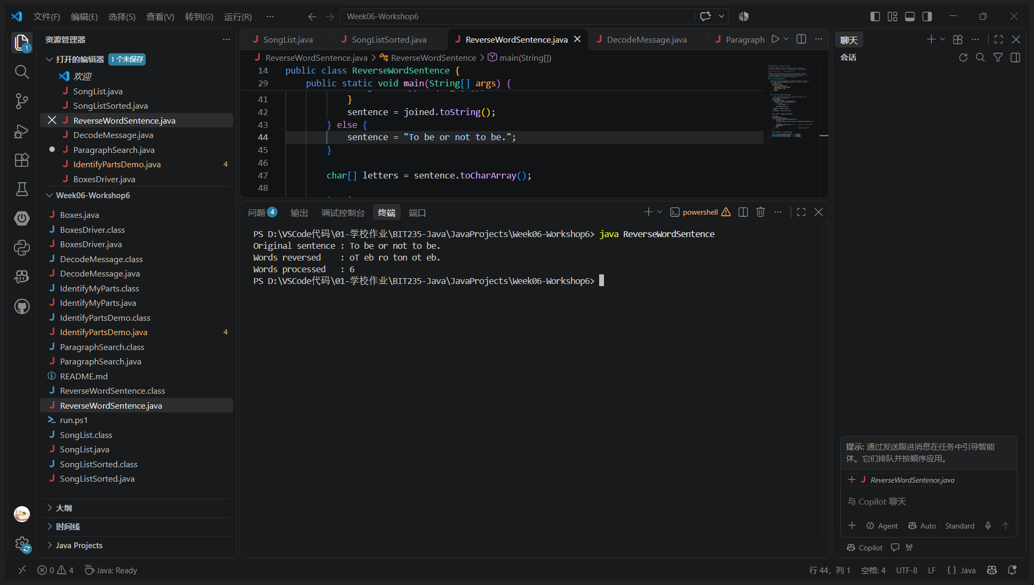
Program: ReverseWordSentence.java
/*
* BIT235 Workshop 6 - Exercise 3 (Medium)
*
* Reverse the sequence of letters inside every word of a sentence,
* using only loop(s) and array(s) - no String.split(), no StringBuilder.
*
* "To be or not to be." -> "oT eb ro ton ot eb."
*
* Method: copy the sentence into a char[] array, then walk it with two
* indexes. Every run of letters/digits is one word; the word is reversed
* in place by swapping its first and last char and moving inwards.
* Spaces and punctuation stay exactly where they are.
*/
public class ReverseWordSentence {

/** Reverses chars from index start to index end (inclusive), in place. */
private static void reverseRange(char[] letters, int start, int end) {
int left = start;
int right = end;
while (left < right) {
char tmp = letters[left];
letters[left] = letters[right];
letters[right] = tmp;
left++;
right--;
}
}

public static void main(String[] args) {

// Allow a different sentence on the command line, default is the
// one from the workshop question.
String sentence;
if (args.length > 0) {
StringBuffer joined = new StringBuffer();
for (int i = 0; i < args.length; i++) {
if (i > 0) {
joined.append(' ');
}
joined.append(args[i]);
}
sentence = joined.toString();
} else {
sentence = "To be or not to be.";
}

char[] letters = sentence.toCharArray();

int i = 0;
int wordCount = 0;
while (i < letters.length) {
if (Character.isLetterOrDigit(letters[i])) {
int start = i;
while (i < letters.length && Character.isLetterOrDigit(letters[i])) {
i++;
}
reverseRange(letters, start, i - 1); // end is i-1 == last letter
wordCount++;
} else {
i++; // space or punctuation
}
}

String reversed = new String(letters);

System.out.println("Original sentence : " + sentence);
System.out.println("Words reversed : " + reversed);
System.out.println("Words processed : " + wordCount);
}
}
Output:
Original sentence : To be or not to be.
Words reversed : oT eb ro ton ot eb.
Words processed : 6

Exercise 4  Easy  Your answer (screenshot) | Write a Java program that decodes a coded message. The coded message is "G tgsl Qefe." The key to the code is given by the following table:  For example 'a' decodes to 'c', 'b' decodes to 'r' and so on. You should be able to easily modify your program to decode a different message.
  a | b | c | d | e | f | g | h | i | j | k | l | m | n | o | p | q | r | s | t | u | v | w | x | y | z
  c | r | g | z | a | v | i | b | s | d | o | e | q | f | h | u | j | x | k | l | w | m | y | n | p | t
Exercise 4 - VS Code run (screenshot)
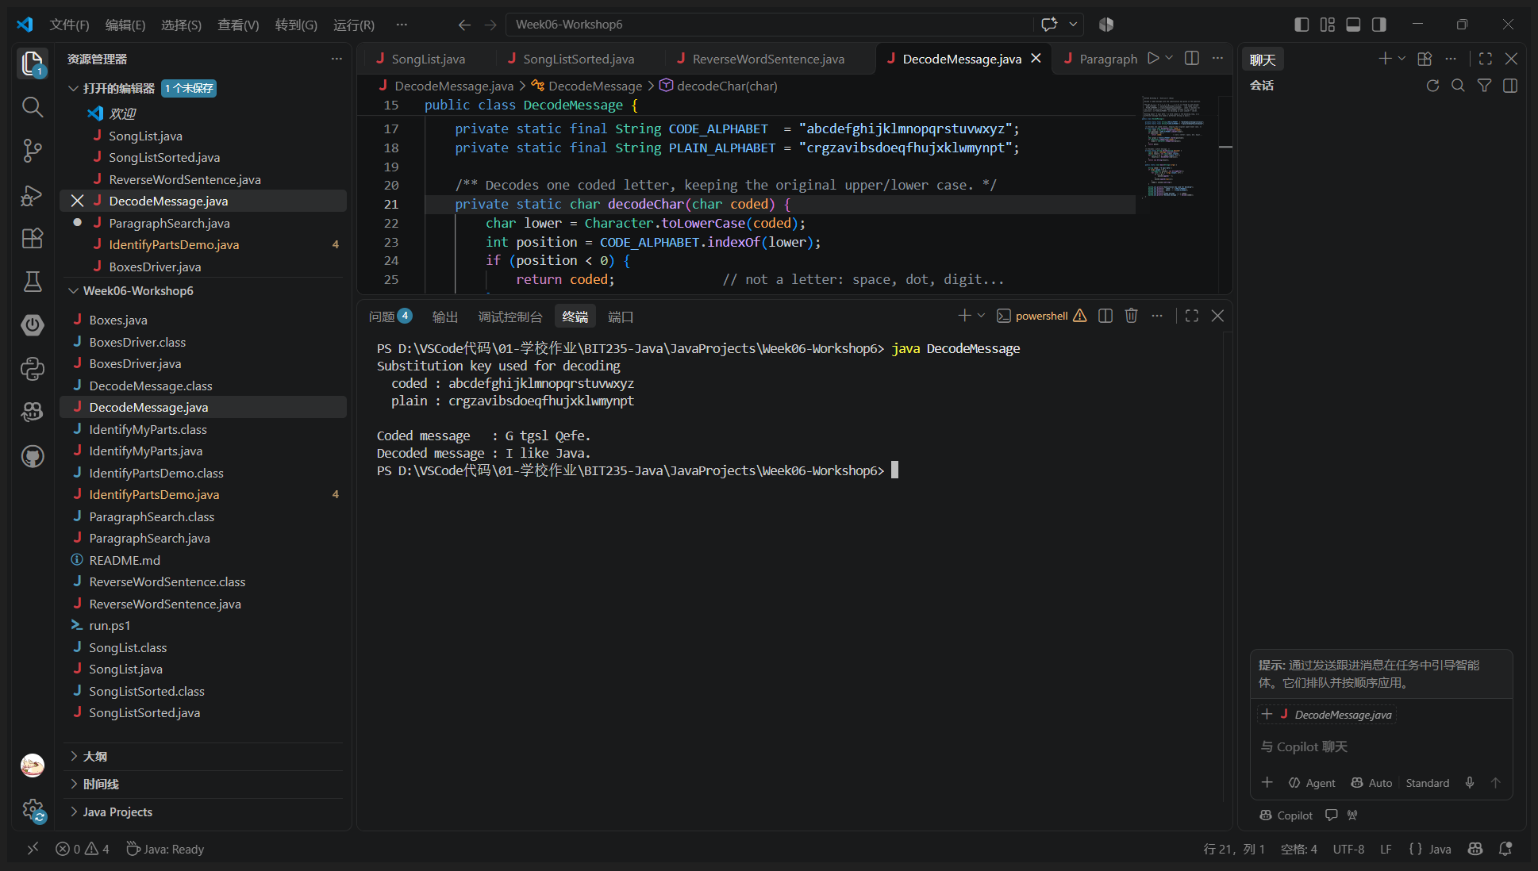
Program: DecodeMessage.java
/*
* BIT235 Workshop 6 - Exercise 4 (Easy)
*
* Decode a coded message with the substitution key given in the question.
*
* The key (a -> c, b -> r, c -> g, ... z -> t) is stored as one String:
* CODE_ALPHABET = "abcdefghijklmnopqrstuvwxyz" (the coded letter)
* PLAIN_ALPHABET = "crgzavibsdoeqfhujxklwmynpt" (what it decodes to)
* The letter at position i in CODE_ALPHABET decodes to the letter at
* position i in PLAIN_ALPHABET, so decoding is just indexOf + charAt.
*
* Nothing about "G tgsl Qefe." is hard coded in the decoding loop, so a
* different message only needs a different String in main().
*/
public class DecodeMessage {

private static final String CODE_ALPHABET = "abcdefghijklmnopqrstuvwxyz";
private static final String PLAIN_ALPHABET = "crgzavibsdoeqfhujxklwmynpt";

/** Decodes one coded letter, keeping the original upper/lower case. */
private static char decodeChar(char coded) {
char lower = Character.toLowerCase(coded);
int position = CODE_ALPHABET.indexOf(lower);
if (position < 0) {
return coded; // not a letter: space, dot, digit...
}
char plain = PLAIN_ALPHABET.charAt(position);
if (Character.isUpperCase(coded)) {
plain = Character.toUpperCase(plain);
}
return plain;
}

/** Decodes a whole message. */
private static String decode(String message) {
char[] chars = message.toCharArray();
char[] result = new char[chars.length];
for (int i = 0; i < chars.length; i++) {
result[i] = decodeChar(chars[i]);
}
return new String(result);
}

public static void main(String[] args) {

String coded = "G tgsl Qefe.";
if (args.length > 0) {
StringBuffer joined = new StringBuffer();
for (int i = 0; i < args.length; i++) {
if (i > 0) {
joined.append(' ');
}
joined.append(args[i]);
}
coded = joined.toString();
}

System.out.println("Substitution key used for decoding");
System.out.println(" coded : " + CODE_ALPHABET);
System.out.println(" plain : " + PLAIN_ALPHABET);
System.out.println();
System.out.println("Coded message : " + coded);
System.out.println("Decoded message : " + decode(coded));
}
}
Output:
Substitution key used for decoding
coded : abcdefghijklmnopqrstuvwxyz
plain : crgzavibsdoeqfhujxklwmynpt

Coded message : G tgsl Qefe.
Decoded message : I like Java.
Exercise 5  Medium  Your answer (screenshot) | Search Engine: Write a Java program that performs a search for a given phrase (make up any phrase you like). The program will search through an array of 10 paragraphs taken from a book of your choice. Your program should store the 10 paragraphs in an array of strings.  - If the phrase is not found output a message stating so.  - If the phrase is found output the array index(s) and the paragraph(s) that contained the phrase.  HINT: You can use the Java method String.contains() For example:  "I like Java Programming".contains("Java")  will return true.  This could be your 10 paragraphs:  paragraphs[0]="Lose all the weight you want.";  paragraphs[1]="I can't I must work";  paragraphs[2]="That would be like a keyword search.";  paragraphs[3]="This would be Victoria.";  paragraphs[4]="Join the party.";  paragraphs[5]="To be or not to be.";  paragraphs[6]="That is a question to test keyword search.";  paragraphs[7]="Can you find a needle in a hay stack?";  paragraphs[8]="This could be the last paragraph, but its not.";  paragraphs[9]="Ada Lovelace is the worlds first programmer as of 1860.";
Exercise 5 - VS Code run (screenshot)
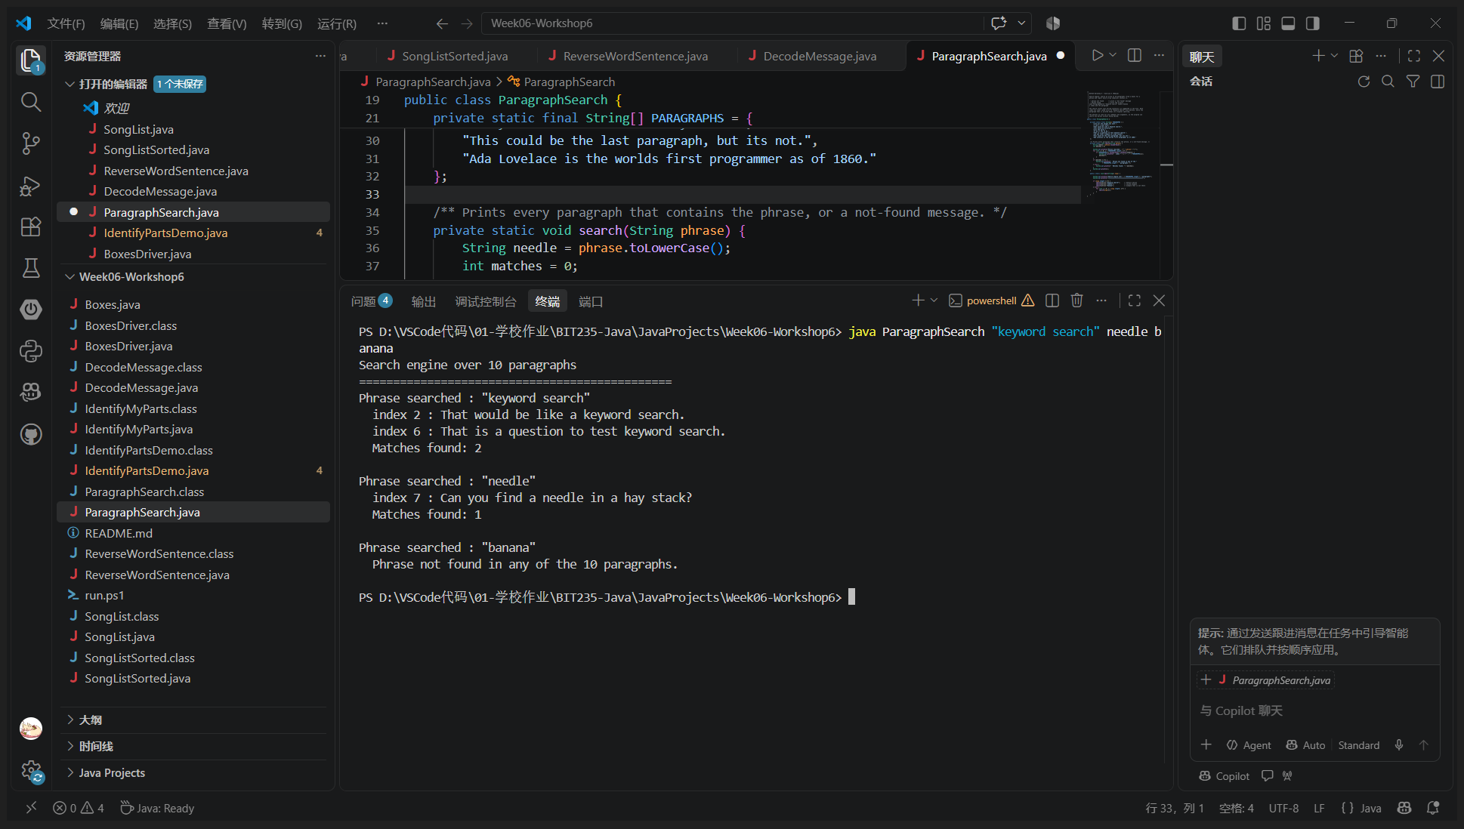
Program: ParagraphSearch.java
/*
* BIT235 Workshop 6 - Exercise 5 (Medium)
*
* Search engine: search an array of 10 paragraphs (from a book) for a
* phrase and report which array index(es) contain it.
*
* - phrase not found -> print a "not found" message
* - phrase found -> print the array index and the paragraph
*
* The search itself uses String.contains() as suggested in the hint. Both
* sides are lower cased first so "Keyword Search" also matches, while the
* paragraph that is printed keeps its original spelling.
*
* The phrases to look for are command line arguments, so the program can
* search any phrase without being edited.
*/
public class ParagraphSearch {

private static final String[] PARAGRAPHS = {
"Lose all the weight you want.",
"I can't I must work",
"That would be like a keyword search.",
"This would be Victoria.",
"Join the party.",
"To be or not to be.",
"That is a question to test keyword search.",
"Can you find a needle in a hay stack?",
"This could be the last paragraph, but its not.",
"Ada Lovelace is the worlds first programmer as of 1860."
};

/** Prints every paragraph that contains the phrase, or a not-found message. */
private static void search(String phrase) {
String needle = phrase.toLowerCase();
int matches = 0;

System.out.println("Phrase searched : \"" + phrase + "\"");
for (int i = 0; i < PARAGRAPHS.length; i++) {
if (PARAGRAPHS[i].toLowerCase().contains(needle)) {
System.out.println(" index " + i + " : " + PARAGRAPHS[i]);
matches++;
}
}
if (matches == 0) {
System.out.println(" Phrase not found in any of the "
+ PARAGRAPHS.length + " paragraphs.");
} else {
System.out.println(" Matches found: " + matches);
}
System.out.println();
}

public static void main(String[] args) {

System.out.println("Search engine over " + PARAGRAPHS.length + " paragraphs");
System.out.println("==============================================");

if (args.length == 0) {
search("keyword search"); // default phrase
search("needle"); // second example
search("banana"); // example that is not there
} else {
for (int i = 0; i < args.length; i++) {
search(args[i]);
}
}
}
}
Output:
Search engine over 10 paragraphs
==============================================
Phrase searched : "keyword search"
index 2 : That would be like a keyword search.
index 6 : That is a question to test keyword search.
Matches found: 2

Phrase searched : "needle"
index 7 : Can you find a needle in a hay stack?
Matches found: 1

Phrase searched : "banana"
Phrase not found in any of the 10 paragraphs.

Exercise 6  Easy  Your answer (screenshot) | Consider the following class:  public class IdentifyMyParts {  public static int x = 7;  public int y = 3;  }  - Identify and list the class variables?  - Identify and list the instance variables?  - What is the output of the following code:  IdentifyMyParts a = new IdentifyMyParts();  IdentifyMyParts b = new IdentifyMyParts();  a.y = 5;  b.y = 6;  a.x = 1;  b.x = 2;  System.out.println("a.y = " + a.y);  System.out.println("b.y = " + b.y);  System.out.println("a.x = " + a.x);  System.out.println("b.x = " + b.x);  System.out.println("IdentifyMyParts.x = " + IdentifyMyParts.x);
Exercise 6 - VS Code run (screenshot)
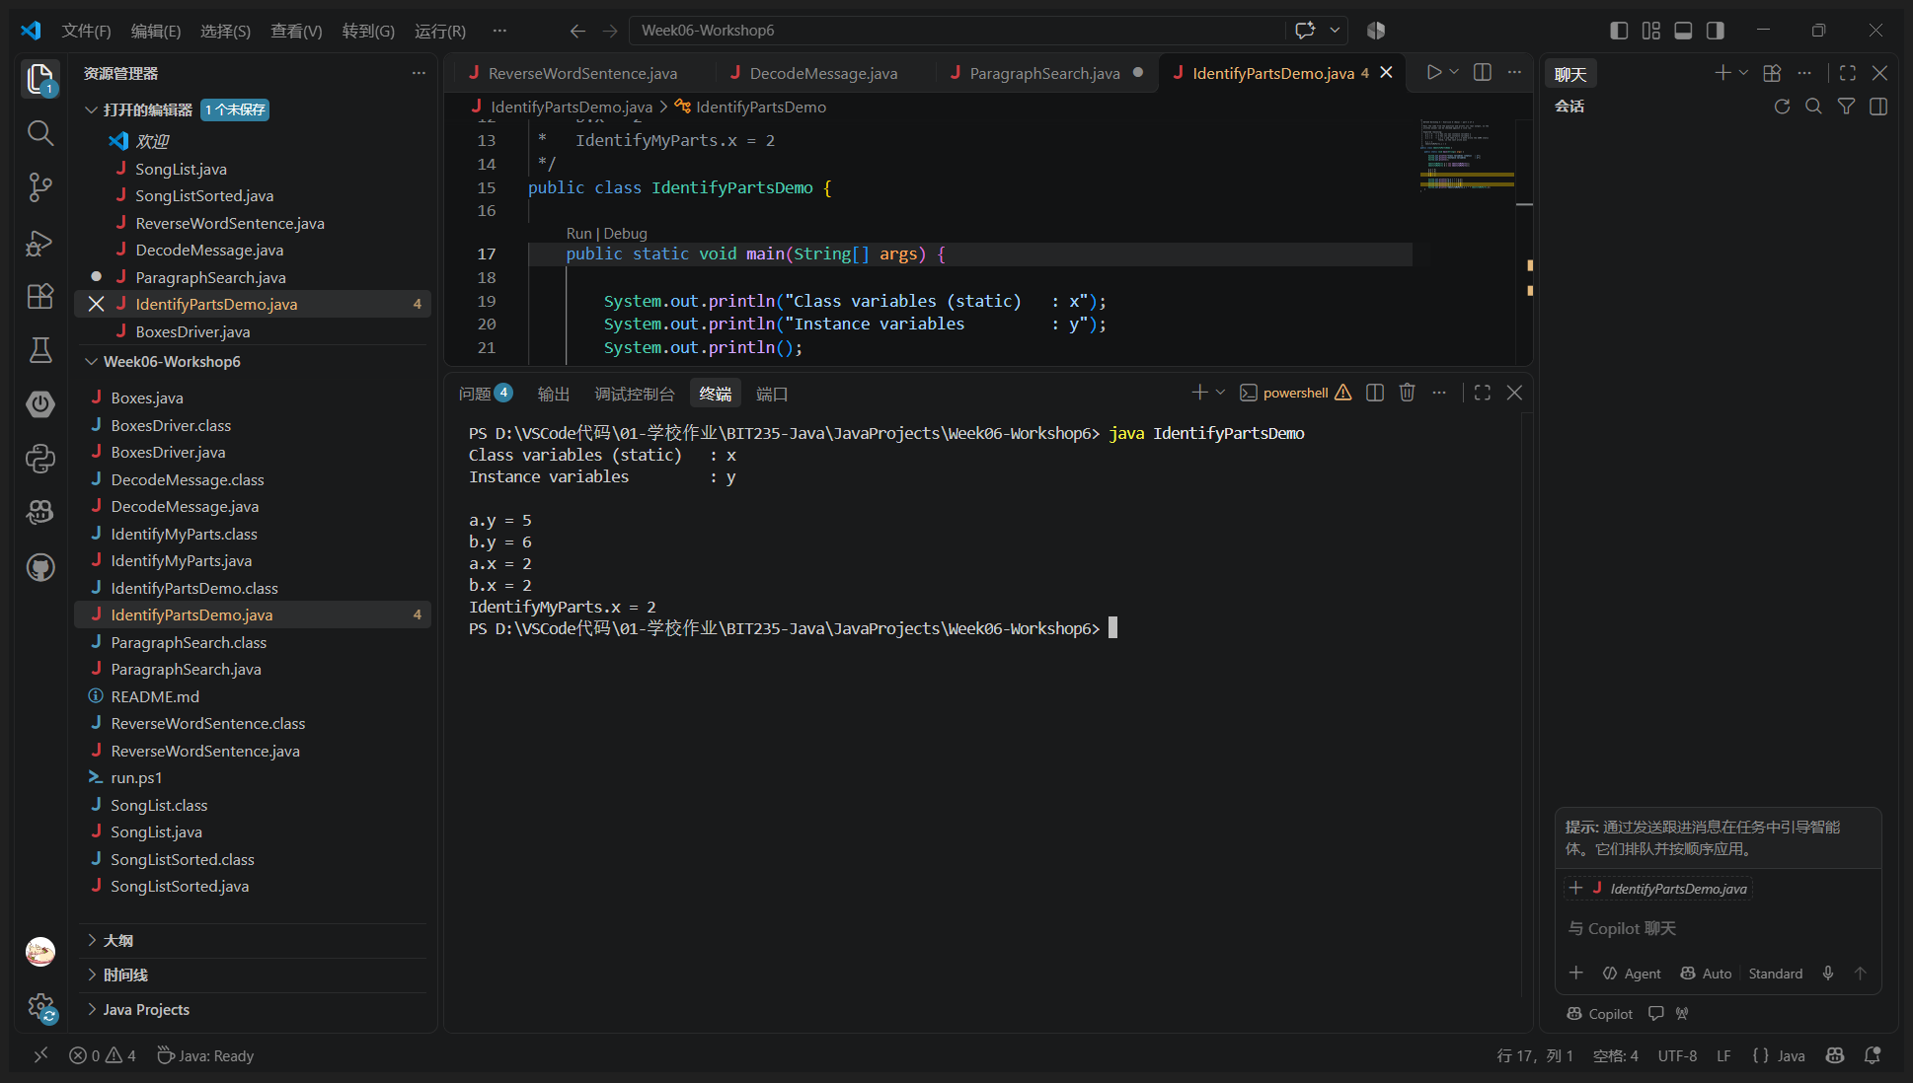
Program: IdentifyMyParts.java
/*
* BIT235 Workshop 6 - Exercise 6 (Easy) - part 1 of 2
*
* The class from the question, unchanged:
*
* public class IdentifyMyParts {
* public static int x = 7;
* public int y = 3;
* }
*
* x is a CLASS variable (static): one copy exists for the whole class,
* shared by every object and reachable as IdentifyMyParts.x.
* y is an INSTANCE variable (no static): every object made with "new"
* gets its own copy, so a.y and b.y are two different fields.
*
* IdentifyPartsDemo runs the code from the question to prove the answer.
*/
public class IdentifyMyParts {

public static int x = 7; // class variable - shared by all objects
public int y = 3; // instance variable - one per object
}
Program: IdentifyPartsDemo.java
/*
* BIT235 Workshop 6 - Exercise 6 (Easy) - part 2 of 2
*
* Runs the code from the question and prints its real output, so the
* written answer can be checked against a live run.
*
* Expected reasoning:
* a.y = 5 -> a has its own instance variable y
* b.y = 6 -> b has its own instance variable y
* a.x = 2 -> a.x = 1 and then b.x = 2 both write the SAME static
* field, so the last write wins
* b.x = 2
* IdentifyMyParts.x = 2
*/
public class IdentifyPartsDemo {

public static void main(String[] args) {

System.out.println("Class variables (static) : x");
System.out.println("Instance variables : y");
System.out.println();

IdentifyMyParts a = new IdentifyMyParts();
IdentifyMyParts b = new IdentifyMyParts();

a.y = 5;
b.y = 6;
a.x = 1;
b.x = 2;

System.out.println("a.y = " + a.y);
System.out.println("b.y = " + b.y);
System.out.println("a.x = " + a.x);
System.out.println("b.x = " + b.x);
System.out.println("IdentifyMyParts.x = " + IdentifyMyParts.x);
}
}
Output:
Class variables (static) : x
Instance variables : y

a.y = 5
b.y = 6
a.x = 2
b.x = 2
IdentifyMyParts.x = 2
Answer (written part):
Class variables : x - it is declared static, so there is exactly one copy for the whole class and every object shares it (also reachable as IdentifyMyParts.x).
Instance variables : y - it has no static modifier, so every object created with new gets its own copy of y.
Output: a.y = 5 and b.y = 6 because y belongs to the object. a.x = 1 and b.x = 2 both write the same static field x, so the second write wins and a.x, b.x and IdentifyMyParts.x all print 2.

Exercise 7  Medium  Your answer (screenshot) | Create a program that contains 2 classes:  - A class called Boxes that contains methods for displaying boxes on the console.  - A driver class. This class will contain the main() method and will make calls to the Boxes class  The purpose of this boxes class is to be able to output a square box of various sizes (up to a maximum of size 10). Use the hypen '-' character to draw the top and bottom of the box; and use the pipe ‘|’ character to draw the sides.  Extension: you can draw a longer horizontal line with the Unicode character \u2500 e.g.  String line = "\u2500";  System.out.println(line);  Your Boxes class must have the following:  - A constructor that accepts the size of the box  - A method that sets the size of the box  - A method called toString() that returns the size of the box as a String . For example, “10 x 10”  - A method to 'draw' the box to the screen. You could draw to the console or draw to a JOptionPane.showMessageDialog().  Use your driver class to test your Boxes class. For example, here it is being tested with 2 box sizes:  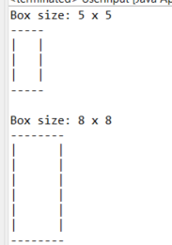
Exercise 7 - VS Code run (screenshot)
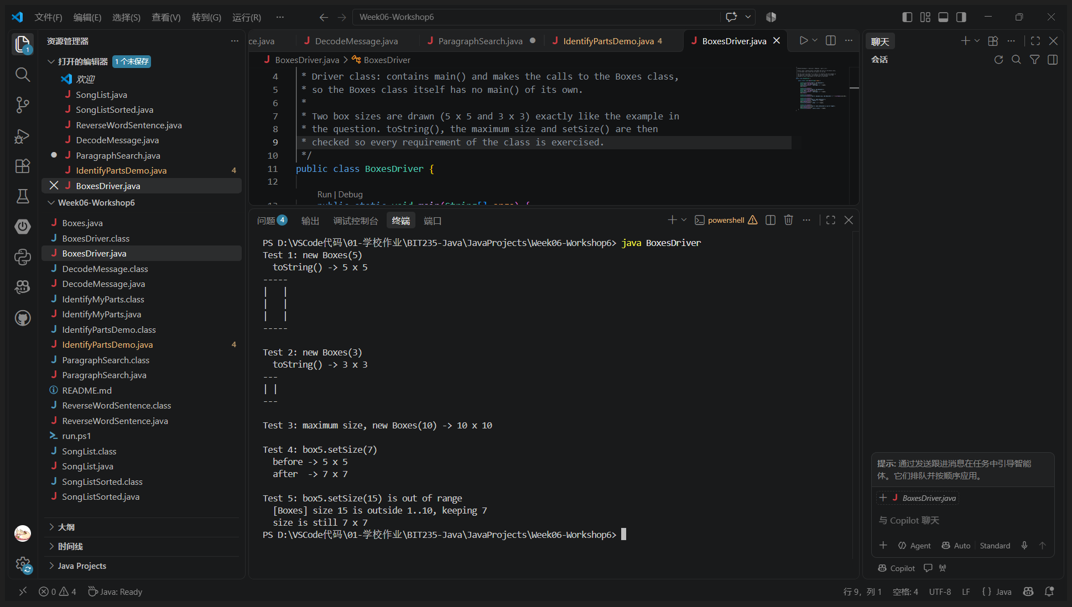
Program: Boxes.java
/*
* BIT235 Workshop 6 - Exercise 7 (Medium) - part 1 of 2
*
* Boxes: a class that draws a square box on the console.
*
* '-' top and bottom line
* '|' left and right side
* the box is a square, so size 5 means 5 columns and 5 rows
*
* The class provides everything the question asks for:
* - a constructor that accepts the size of the box
* - setSize(int) to change the size later
* - toString() that returns the size as a String, e.g. "10 x 10"
* - draw() that prints the box
*
* A size below 1 or above MAX_SIZE (10) is refused and the old size is
* kept, so the box can never be drawn larger than 10 x 10.
*/
public class Boxes {

public static final int MIN_SIZE = 1;
public static final int MAX_SIZE = 10;

private int size;

/** Constructor: accepts the size of the box (1..10). */
public Boxes(int size) {
this.size = 1; // safe default before validation
setSize(size);
}

/** Sets the size of the box; returns true when the size was accepted. */
public boolean setSize(int size) {
if (size < MIN_SIZE || size > MAX_SIZE) {
System.out.println(" [Boxes] size " + size + " is outside "
+ MIN_SIZE + ".." + MAX_SIZE + ", keeping " + this.size);
return false;
}
this.size = size;
return true;
}

public int getSize() {
return size;
}

/** Returns the size of the box as a String, for example "10 x 10". */
public String toString() {
return size + " x " + size;
}

/** Draws the box on the console. */
public void draw() {
drawLine(); // top
for (int row = 0; row < size - 2; row++) {
System.out.print('|');
for (int col = 0; col < size - 2; col++) {
System.out.print(' ');
}
System.out.println('|');
}
if (size > 1) {
drawLine(); // bottom
}
}

/** Helper: one horizontal border of 'size' hyphens. */
private void drawLine() {
for (int col = 0; col < size; col++) {
System.out.print('-');
}
System.out.println();
}
}
Program: BoxesDriver.java
/*
* BIT235 Workshop 6 - Exercise 7 (Medium) - part 2 of 2
*
* Driver class: contains main() and makes the calls to the Boxes class,
* so the Boxes class itself has no main() of its own.
*
* Two box sizes are drawn (5 x 5 and 3 x 3) exactly like the example in
* the question. toString(), the maximum size and setSize() are then
* checked so every requirement of the class is exercised.
*/
public class BoxesDriver {

public static void main(String[] args) {

System.out.println("Test 1: new Boxes(5)");
Boxes box5 = new Boxes(5);
System.out.println(" toString() -> " + box5);
box5.draw();

System.out.println();
System.out.println("Test 2: new Boxes(3)");
Boxes box3 = new Boxes(3);
System.out.println(" toString() -> " + box3);
box3.draw();

System.out.println();
System.out.println("Test 3: maximum size, new Boxes(10) -> " + new Boxes(10));

System.out.println();
System.out.println("Test 4: box5.setSize(7)");
System.out.println(" before -> " + box5);
box5.setSize(7);
System.out.println(" after -> " + box5);

System.out.println();
System.out.println("Test 5: box5.setSize(15) is out of range");
box5.setSize(15);
System.out.println(" size is still " + box5);
}
}
Output:
Test 1: new Boxes(5)
toString() -> 5 x 5
-----
| |
| |
| |
-----

Test 2: new Boxes(3)
toString() -> 3 x 3
---
| |
---

Test 3: maximum size, new Boxes(10) -> 10 x 10

Test 4: box5.setSize(7)
before -> 5 x 5
after -> 7 x 7

Test 5: box5.setSize(15) is out of range
[Boxes] size 15 is outside 1..10, keeping 7
size is still 7 x 7
Notes: Boxes.java is the class (constructor, setSize, toString, draw), BoxesDriver.java is the driver class with main(). Boxes refuses a size outside 1..10 and keeps the previous size, so a box can never be drawn larger than 10 x 10.

