SAE 4140
Quenched and Tempered Steel Iteration #66

Fatigue Behavior, Monotonic Properties and
Microstructural Data

Prepared by:

A.A. Rteil and
T.H. Topper

Department of Civil Engineering
University of Waterloo
Waterloo, Ontario Canada

Prepared for:
The AISI Bar Steel Applications Group

May 2005 (revised)

American Iron and Steel Institute
2000 Town Center, Suite 320
Southfield, Michigan 48075 tel: 248-945-4777 fax: 248-352-1740 www.autosteel.org

TABLE OF CONTENTS

SUMMARY 3
INTRODUCTION 4
EXPERIMENTAL PROCEDURE 4
Specimen Preparation 4
Test Equipment and Procedure 4
RESULTS 5
A) Microstructure Data 5
B) Strain-Life Data 6
C) Cyclic Stress-Strain Curves 6
D) Mechanical Properties 7
REFERENCES 7

SUMMARY

The required microstructure data, mechanical properties, cyclic stress-strain data and strain-controlled fatigue data for 4140 Quenched and Tempered steel (Iteration # 66) have been obtained. The material was provided by the American Iron and Steel Institute (AISI) in the form of 2" round bars. These bars were machined into smooth axial fatigue specimens. Two monotonic tensile tests were performed to measure the yield strength, the tensile strength and the reduction of area. Nineteen specimens were fatigue tested in laboratory air at room temperature to establish a strain-life curve.

INTRODUCTION

This report presents the results of tensile and fatigue tests performed on a group of 4140 Quenched and Tempered steel samples. The material was provided by the American Iron and
Steel Institute.
The objectives of this investigation were to obtain the chemical analysis, and microstructural data, mechanical properties, cyclic stress-strain data and strain-life fatigue data requested by the AISI bar group.

EXPERIMENTAL PROCEDURE

Specimen Preparation

The material for the study was received in the form of 2” round bars. Smooth cylindrical fatigue specimens, shown in Figure 1, were machined from the metal bars. The gauge sections of the fatigue specimens were mechanically polished in the loading direction using 240, 400, 500, and 600 emery paper. After polishing, a thin band of M-coat D acrylic coating was applied along the central gauge section. The purpose of the M-coat D application was to prevent scratching of the smooth surface by the knife-edges of the strain extensometer, thus reducing the incidence of knife-edge failures. In total, 19 fatigue data points were generated.

Test Equipment and Procedure

Two monotonic tension tests were performed to determine the yield strength, the tensile strength, the percent elongation and the percent reduction of area. Hardness tests were performed on the surface of three fatigue specimens using a Rockwell C scale. The hardness measurements were repeated three times for each specimen and the average value was recorded.
All fatigue tests were carried out in a laboratory environment at approximately 25 oC using an MTS servo-controlled closed loop electrohydraulic testing machine. A process control computer, controlled by FLEX software [1] was used to output constant strain and stress amplitudes in the form of a sinusoidal wave.
Axial, constant amplitude, fully reversed (R=-1) strain-controlled fatigue tests were performed on smooth specimens. The stress-strain limits for a given cycle of each specimen were recorded at logarithmic intervals throughout the test via a peak reading voltmeter. Failure of a specimen was defined as a 50 percent drop in tensile peak load from the peak load observed at one half the expected specimen life. For fatigue lives greater than 100,000 reversals, the specimens were tested in stress-control once the stress-strain loops had stabilized. For the stresscontrolled tests, failure was defined as the separation of the smooth specimen into two pieces. For strain-controlled tests the loading frequency varied from 0.03 Hz to 5 Hz while in stresscontrolled tests the frequency used was up to 110 Hz.
The first reversal of each fatigue test was recorded on a x-y plotter, allowing the elastic modulus (E) and the monotonic yield strength to be determined.

RESULTS

A) Microstructure Data

Figure 2 presents the martensite microstructure of the 4140 Quenched and Tempered steel. A Type D series inclusion severity level of 1.5 was obtained based on ASTM E45 (Method A). Inclusions of types A, B and C were not observed. Figure 3 shows the inclusions observed in the 4140 Quenched and Tempered steel. The inclusion area was measured using a JAVA image analysis system.

B) Strain-Life Data

The fatigue test data for 4140 Quenched and Tempered steel (iteration 66) obtained in this investigation are given in Table 1. The stress amplitude corresponding to each strain amplitude was calculated from the peak load amplitude at the specimen half-life.
A fatigue strain life curve for the 4140 Quenched and Tempered steel is shown in Figure 4, and is described by the following equation:

∆ε = σ′f b (2N f )c
(2N f ) +ε′f
2 E
where 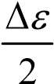 = True total strain amplitude
2N_{f} | = Number of reversals to failure
σ′_{f} | = Fatigue strength coefficient
b | = Fatigue strength exponent
ε'_{f} | = Fatigue ductility coefficient
c | = Fatigue ductility exponent

where σ′_{f} = 1684.2 MPa, b = -0.070, ε'_{f} = 0.874 and c = -0.677. These values of the strain-life parameters were determined from fatigue testing over the range: 0.00322 < 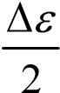< 0.01.

C) Cyclic Stress-Strain Curves

Stabilized and half-life stress data obtained from strain-life fatigue tests were used to obtain the companion cyclic stress-strain curve shown in Figure 5. The cyclic stress-strain curve is described by the following equation:
1 σ ⎛ σ ⎞ n′
ε= + ⎜ ⎟
E ⎝ K′⎠
where | ε | = True total strain amplitude
 | σ | = Cyclically stable true stress amplitude
 | K' | = Cyclic strength coefficient
 | n' | = Cyclic strain hardening exponent
where K' = 1590.8 MPa and n' = 0.0926.
The true monotonic and true cyclic stress-strain curves plotted together are given in Figure 6.

D) Mechanical Properties

The engineering monotonic tensile stress-strain curves are given in Figure 7. The monotonic and cyclic properties are included in Appendix 1. The Hardness of the 4140 Quenched and Tempered steel was taken as the average of three randomly chosen fatigue specimens and is given in Appendix 1. The individual hardness measurements are also given in Table 1.

REFERENCES
- Pompetzki, M.A., Saper, R.A., and Topper, T.H., "Software for High Frequency Control of Variable Amplitude Fatigue Tests," Canadian Metallurgical Quarterly, Vol. 25, No. 2, pp.
181-194, 198.

- J. A. Bannantine, J. J. Comer, and J. L. Handrock (1990), In :Fundamentals of Metal Fatigue Analysis, Prentice Hall, London.

" D
0.2
0.40
"
" R
0.75
" R
0.75
" R
3.75
DO NOT undercut
transition (Typ.)
SURFACE FINISH

8
µ
in OR BETTER
IN UNTHREADED
REGION
/64" centre drill.
5
Detail
"
0.40
4"

Figure 1 Smooth cylindrical fatigue specimen

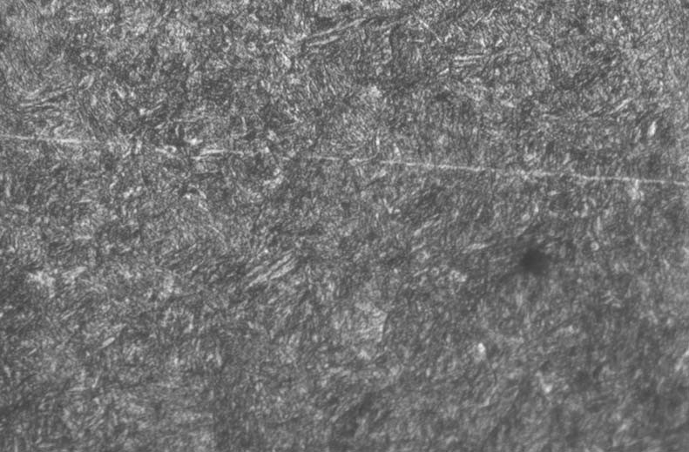

  - Longitudinal Direction

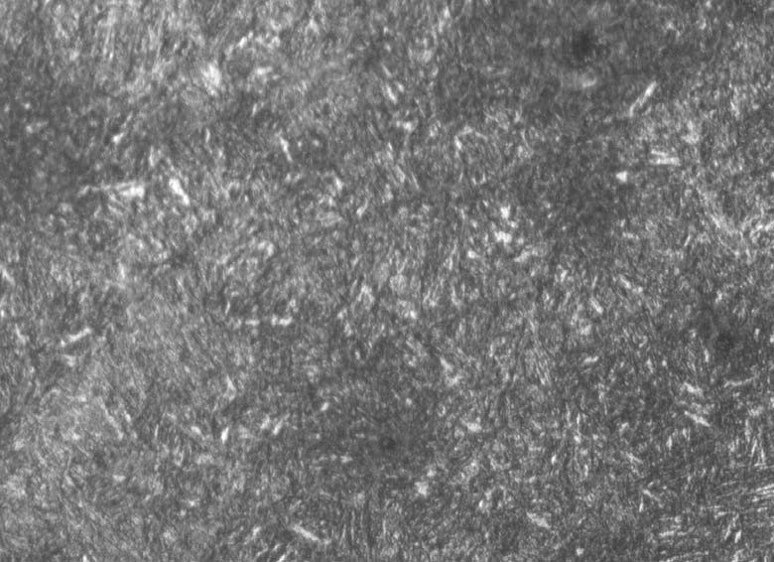
  - Transverse Direction

Figure 2 Photomicrographs of 4140 Quenched and Tempered steel (X500)

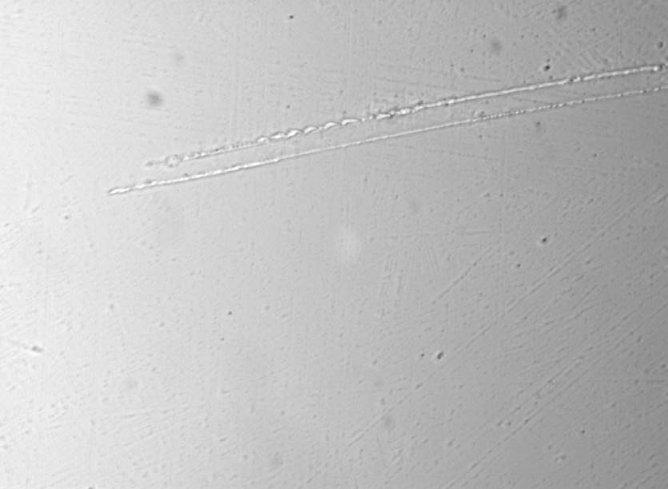

Figure 3 Inclusions photomicrograph of 4140 Quenched and Tempered steel (X100)

4140 Quenched and Tempered (Iteration 66)
True strain amplitude (%)
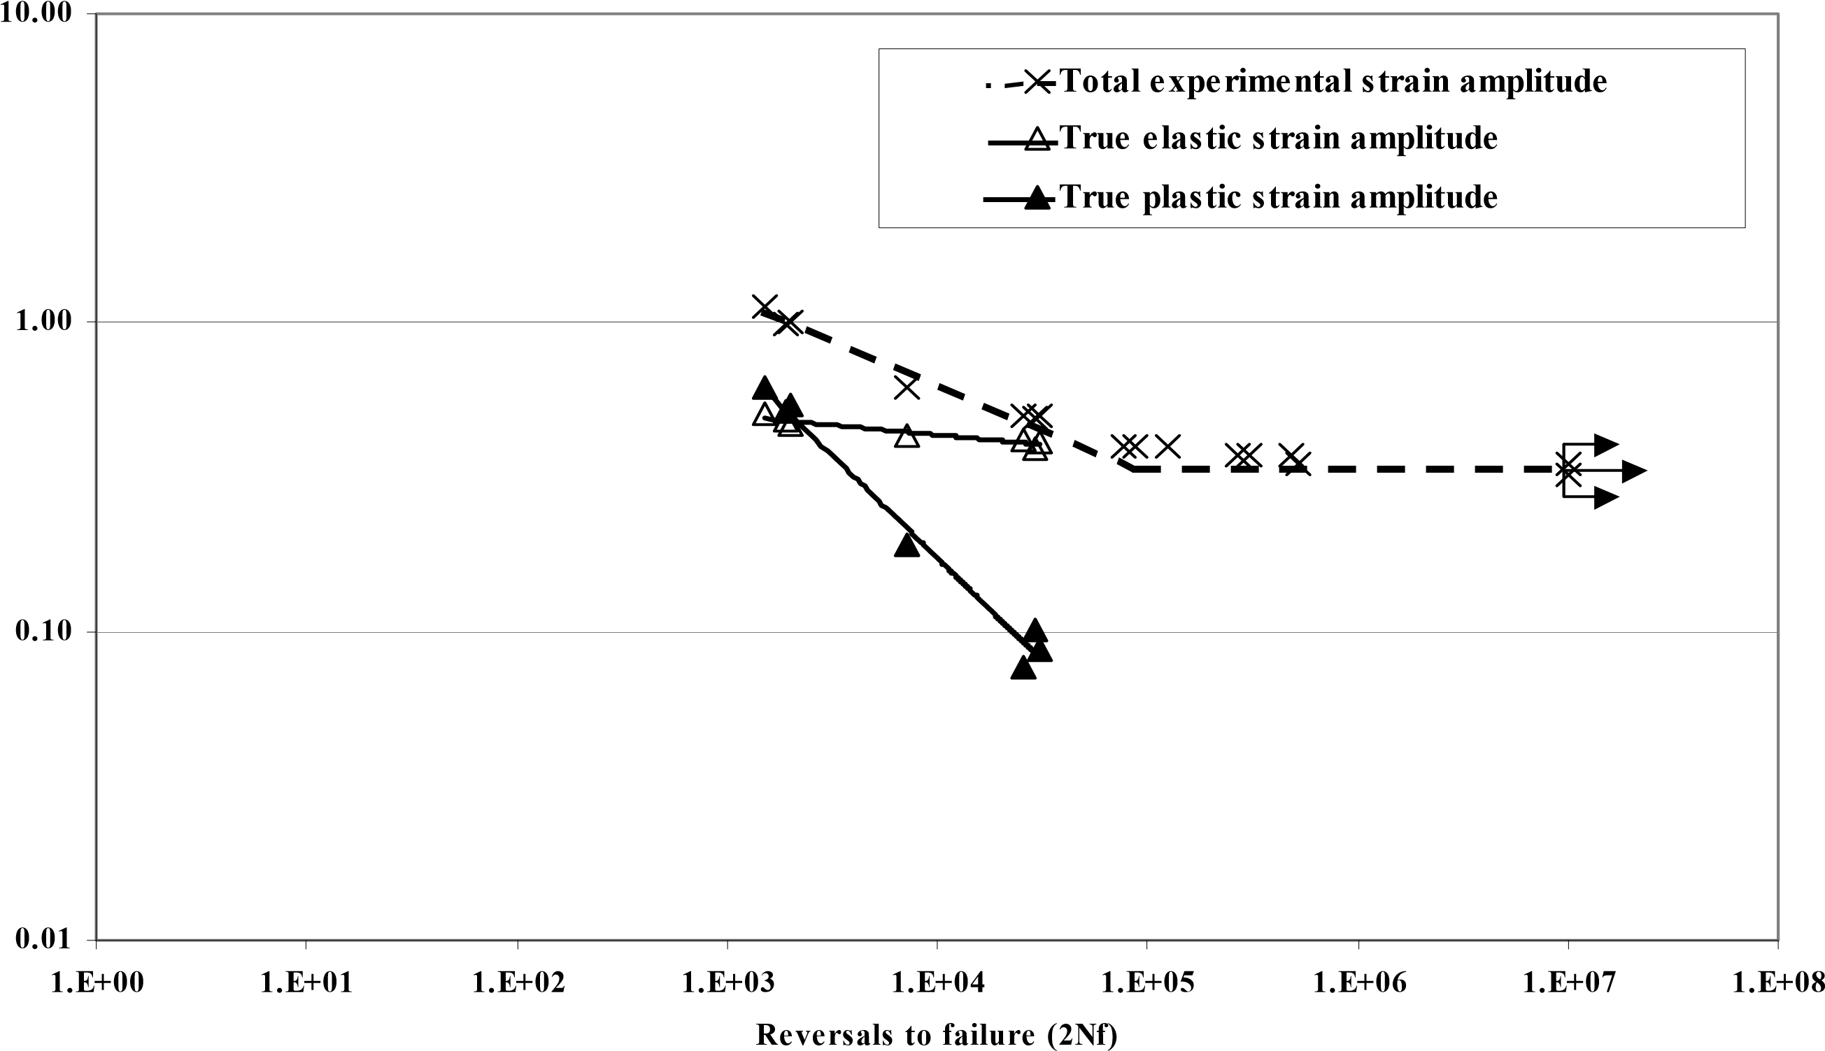

Figure 4. Constant amplitude fully reversed strain-life curve for 4140 Quenched and Tempered steel (Iteration 66).
4140 Quenched and Tempered (Iteration 66)
True cyclic stress (MPa)
0
200
400
600
800
1000
1200
0.2
0.4
0.6
0.8
1.0
1.2
1.4
0.0
1.6
True cyclic strain (%)
Experimental true stress-strain data
Calculated cyclic stress-strain curve

Figure 5. Cyclic stress-strain curve for 4140 Quenched and Tempered steel (Iteration 66).
4140 Quenched and Tempered (Iteration 66)
True stress (MPa)
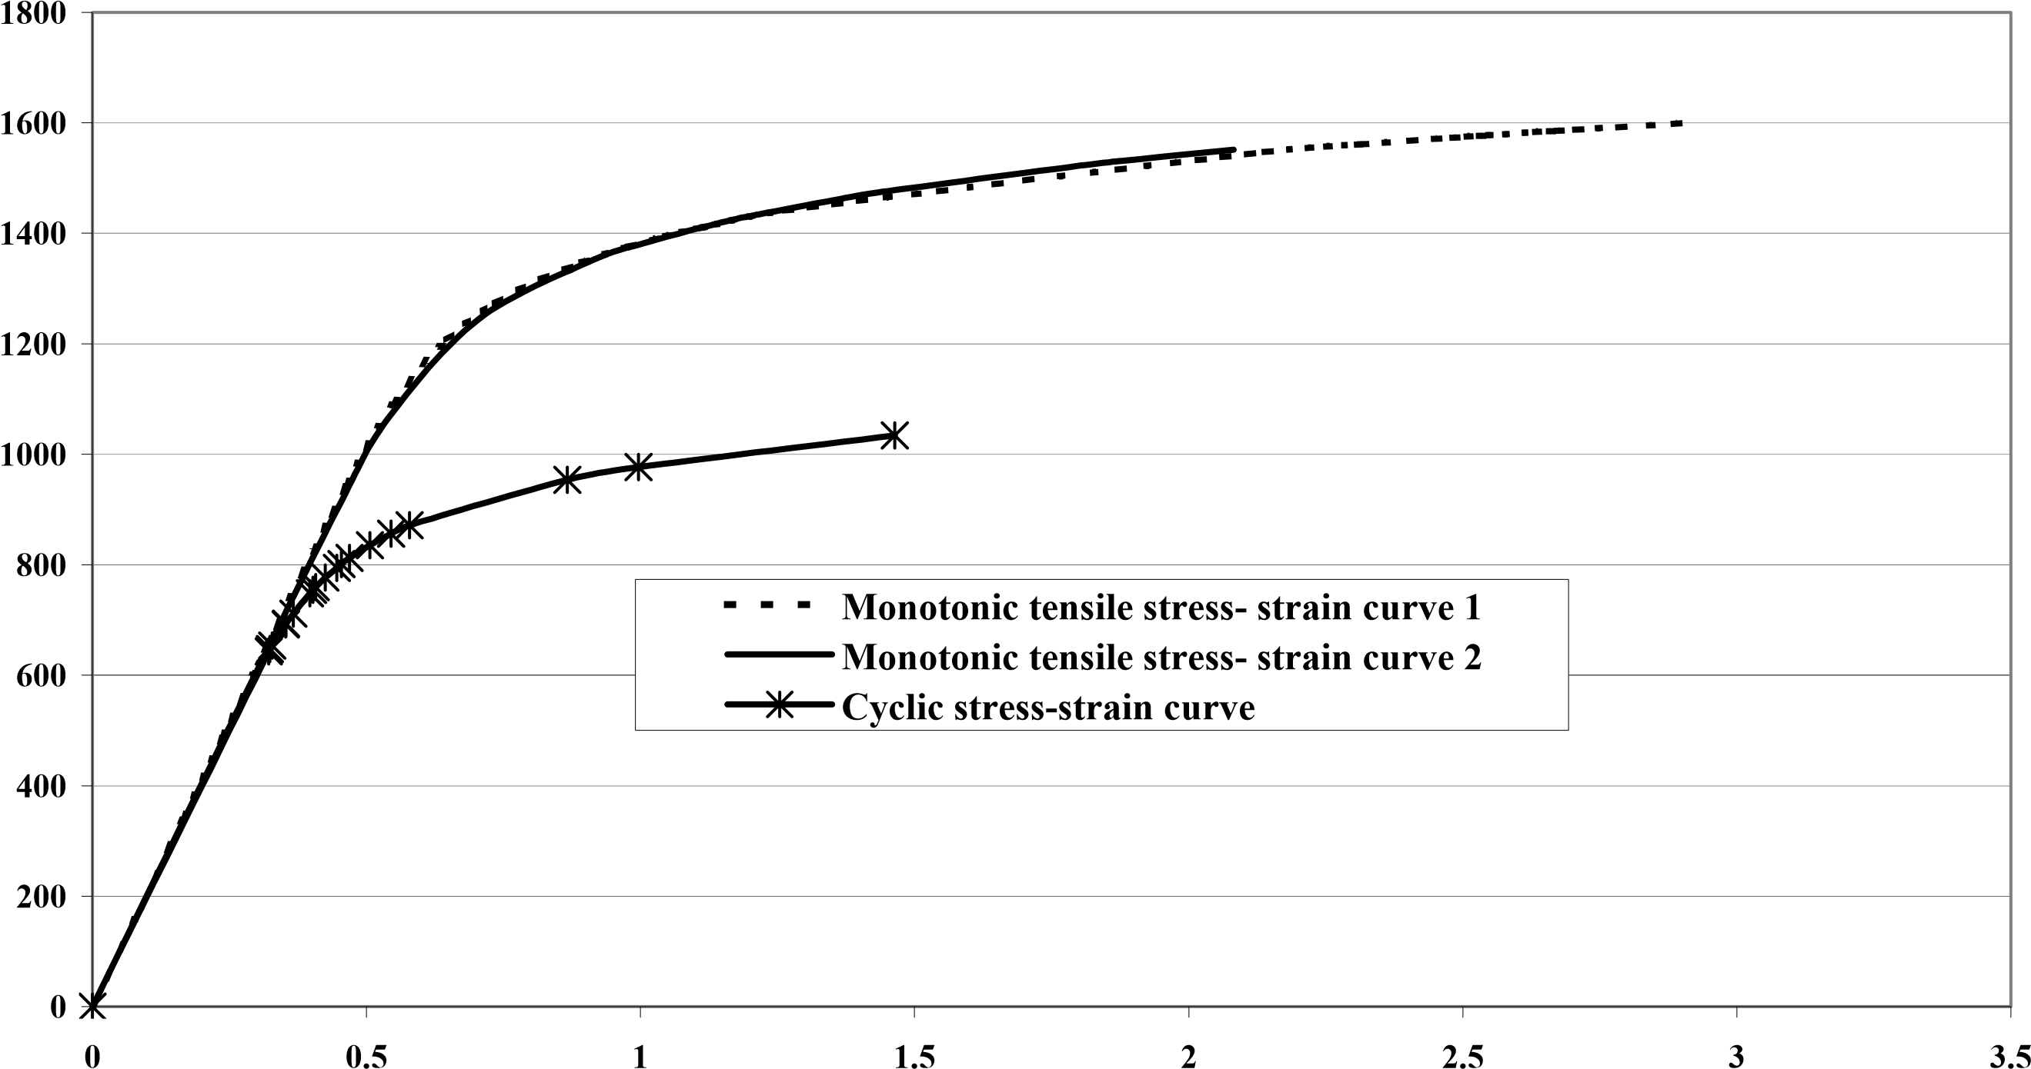
True strain (%)

Figure 6. Monotonic and Cyclic stress-strain curves for 4140 Quenched and Tempered steel (Iteration 66).

4140 Quenched and Tempered (Iteration 66)
Engineering stress (MPa)
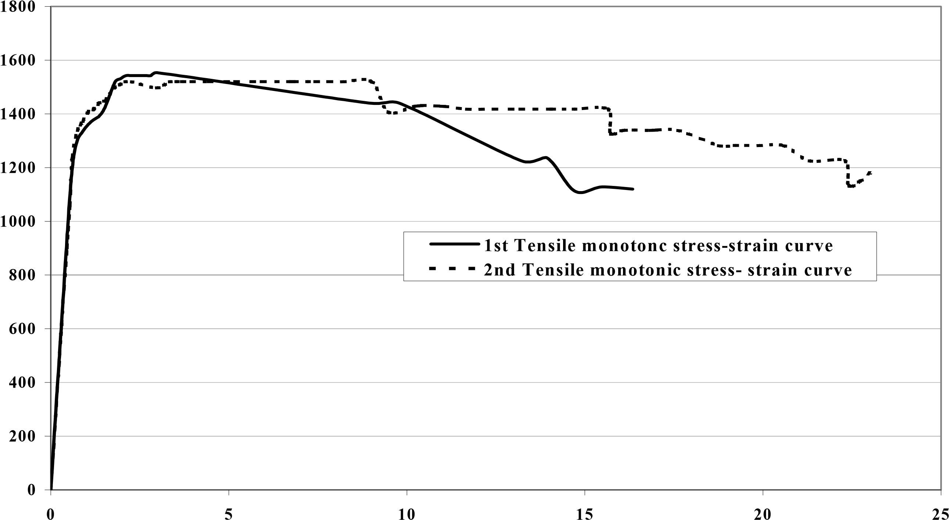
Engineering strain (%)

Figure 7. Tensile monotonic stress-strain curves for two 4140 Quenched and Tempered steel specimens (Iteration 66).
Table 1 Fatigue Data for the 4140 Quenched and Tempered steel (Iteration 66)
Sp# | Total Strain  Amplitude(%) | Stress  Amplitude  (MPa) | Plastic Strain Amplitude(%) | Elastic Strain Amplitude(%) | (50% load drop)  Fatigue Life (Reversals,  2Nf) | Hardness (Rockwell C) | Monotonic  Young’s  Modulus (GPa)
1 | 1.006 | 953.7 | 0.538 | 0.468 | 2000 | -- | 202.9
2 | 0.997 | 976.9 | 0.518 | 0.479 | 1900 | -- | 205.2
3 | 1.122 | 1034.2 | 0.614 | 0.508 | 1500 | -- | --
4 | 0.619 | 871.6 | 0.191 | 0.428 | 7266 | -- | 202.6
5 | 0.496 | 856.2 | 0.076 | 0.420 | 25580 | -- | 202.3
6 | 0.497 | 835.8 | 0.087 | 0.410 | 30388 | 41.67 | 202.0
7 | 0.495 | 801.6 | 0.102 | 0.393 | 29500 | -- | 201.3
8 | 0.399 | 812.4 | 0.000 | 0.399 | 123460 | -- | 207.2
9 | 0.399 | 794.7 | 0.000 | 0.399 | 87960 | -- | 206.5
10 | 0.399 | 777.1 | 0.000 | 0.399 | 76564 | -- | 203.3
11 | 0.374 | 759.8 | 0.000 | 0.374 | 306800 | 41.67 | 198.2
12 | 0.374 | 754.9 | 0.000 | 0.374 | 269776 | 42.33 | 208.1
13 | 0.374 | 748.8 | 0.000 | 0.374 | 479232 | -- | 200.9
14 | 0.349 | 693.5 | 0.000 | 0.349 | 527436 | -- | 203.7
15* | 0.348 | 711.7 | 0.000 | 0.348 | 10000000 | -- | 204.9
16* | 0.349 | 692.4 | 0.000 | 0.349 | 10000000 | -- | 202.7
17* | 0.322 | 647.6 | 0.000 | 0.322 | 10000000 | -- | 207.5
18* | 0.323 | 653.7 | 0.000 | 0.323 | 10000000 | -- | 205.7
19* | 0.323 | 643.2 | 0.000 | 0.323 | 10000000 | -- | 202.6
* Run out

Appendix 1

Monotonic Properties for 4140 Quenched and Tempered steel (Iteration 66).

Average Elastic Modulus, E |  |  | = 203.8 GPa
Yield Strength |  |  | = 1330 MPa
Ultimate tensile Strength |  |  | = 1537 MPa
% Elongation |  |  | = 19.7 %
% Reduction of Area |  |  | = 42.1 %
True fracture strain, Ln (A_{i} / A_{f} ) |  |  | = 54.6 %
P  True fracture stress, ^{f} |  | = | 1995 MPa
σ_{f =}
f
A
P
f
f
A
⎛ 4R ⎞ ⎛ D ^{f} ⎞
Bridgman correction, σ_{f} = ⎜⎜⎝1+ _{D} f ⎟⎠⎟Ln⎜⎝⎜1+ _{4R} ⎟⎟⎠=1705.2 MPa
Monotonic tensile strength coefficient, K = 2188 MPa
Monotonic tensile strain hardening exponent, n = 0.0802
Hardness, Rockwell C (HRC) = 42 Hardness, Brinell =

Cyclic Properties for 4140 Quenched and Tempered steel (Iteration 66).

Cyclic Yield Strength, (0.2% offset)= K ′ (0.002)^{n ′} = 894.7 MPa Cyclic strength coefficient, K' = 1591 MPa Cyclic strain hardening exponent, n' = 0.0926
Fatigue Strength Coefficient, σ'_{f} = 1684.2 MPa
Fatigue Strength Exponent, b = -0.070
Fatigue Ductility Coefficient, ε'_{f} = 0.874
Fatigue Ductility Exponent, c = -0.677

P_{f}: | Load at fracture.
A_{i} and A_{f}: | Specimen cross-section area before and after fracture.
R: | Specimen neck radius.
D_{f} | Specimen diameter at fracture.

