

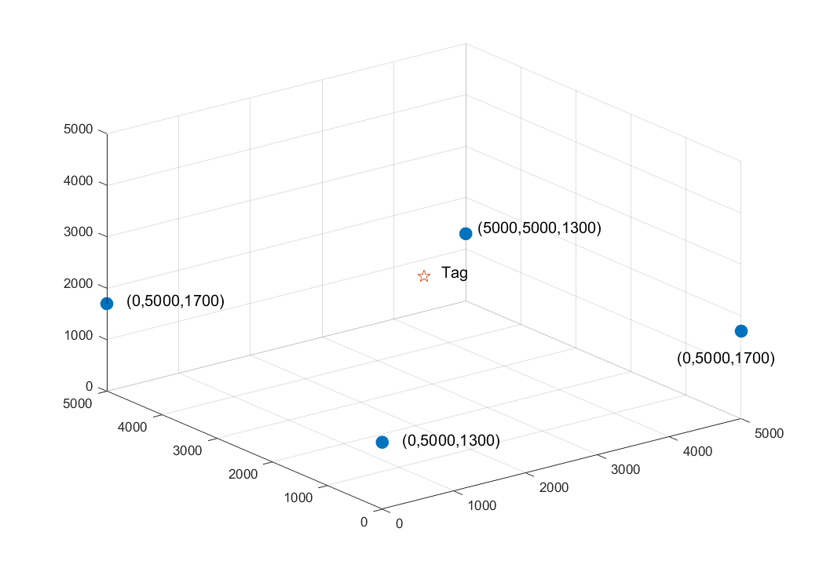







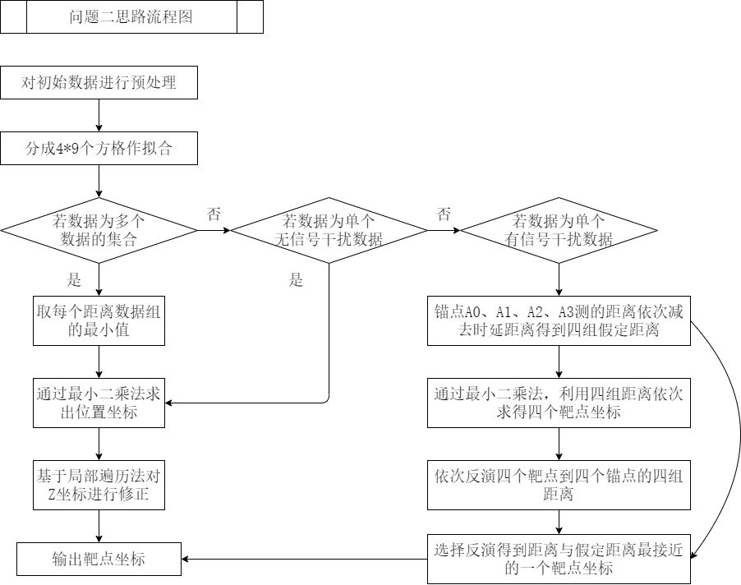





问题二

无信号干扰

|  |  |  |
| --- | --- | --- |
| 1155 | 645 | 1046 |
| 3160 | 1678 | 953 |
| 2722 | 1128 | 1061 |
| 2431 | 969 | 2005 |
| 1448 | 2520 | 1803 |

有信号干扰

|  |  |  |
| --- | --- | --- |
| 2072 | 685 | 597 |
| 4318 | 1542 | 715 |
| 1750 | 1238 | 2494 |
| 3542 | 1967 | 2388 |
| 4892 | 1940 | 989 |

无信号干扰的精确度：

|  |  |  |  |  |
| --- | --- | --- | --- | --- |
|  | x | y | z | 整体 |
| 绝对误差平均值（mm） | 46.23 | 42.26 | 121.14 | 152.40 |
| 相对误差平均值 | 3.15 | 3.13 | 8.5 | 4.28 |
| 相关性 | 0.9993 | 0.9995 | 0.9218 | 0.9962 |



有信号干扰的精确度：

|  |  |  |  |  |
| --- | --- | --- | --- | --- |
|  | x | y | z | 整体 |
| 绝对误差平均值（mm） | 44.76 | 40.85 | 135.48 | 162.95 |
| 相对误差平均值 | 2.97 | 2.95 | 9.81 | 4.59 |
| 相关性 | 0.9993 | 0.9995 | 0.9168 | 0.9957 |



