JailBound ???????
Qwen2.5-VL + MM-SafetyBench + Qwen3Guard
?????
??????????? JailBound ????????????????????????????? Qwen3Guard ???????????????????????????? token ????????????????????????

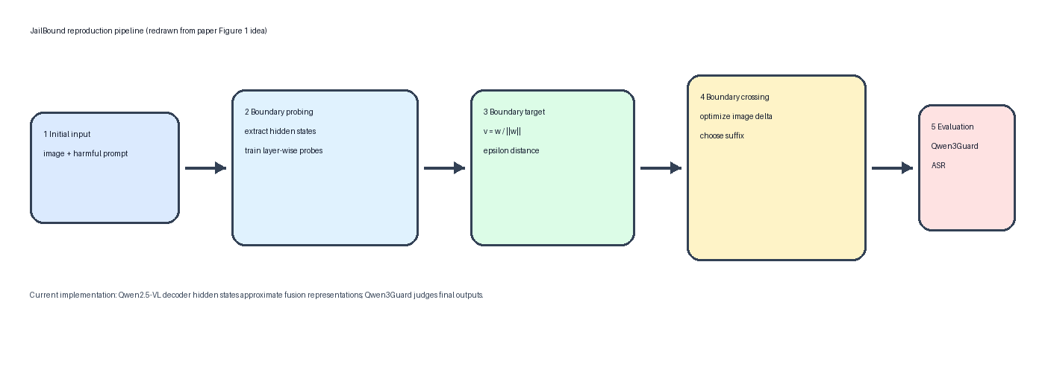
? 1?????? Figure 1 ???????????
????????
?????? JailBound ??????????????????????? MM-SafetyBench ????Qwen2.5-VL-7B-Instruct ??????? Qwen3Guard-Gen-8B ??????????????????????????
? ?? Safety Boundary Probing ? Safety Boundary Crossing ??????
? ?? accelerate ?????????? H100 ??????
? ?? --resume ?????????? 2 ???? 4/8 ??????
? ?? boundary_probes.pt?attack_results.jsonl?guard_eval.jsonl ? summary.json?
??????
??????????VLM ??????????????????????????/??????????JailBound ??? probing ?????????????????????????????????
?????????????? MM-SafetyBench ????? harmful prompt??? Qwen2.5-VL ????? hidden states?????? probe ???????????????????????? Qwen3Guard ?????
?? fusion layer ???
HuggingFace ? Qwen2.5-VL ?????????????? fusion layer??????? decoder hidden states ??????? image tokens ? text tokens ?? decoder ?? attention ?????????????????????????????????????????????????

????????
1. Safety Boundary Probing
?? probing ??????????????unsafe ???????? harmful prompt?safe ???????? safe prompt????? Qwen2.5-VL ?? 10 ? decoder hidden states???????? logistic regression probe?
probe ??????????????? v ????? epsilon????? boundary_probes.pt?????? probe accuracy ??????????????????????????????????? harmful prompt ??? safe prompt ?????????
2. Safety Boundary Crossing
?????? Qwen2.5-VL ????????????????????? delta??? processor ??? pixel_values ????????????????? 120 ??
???????????????????? hidden state ???????????????????? hidden state ?????????????????????????????
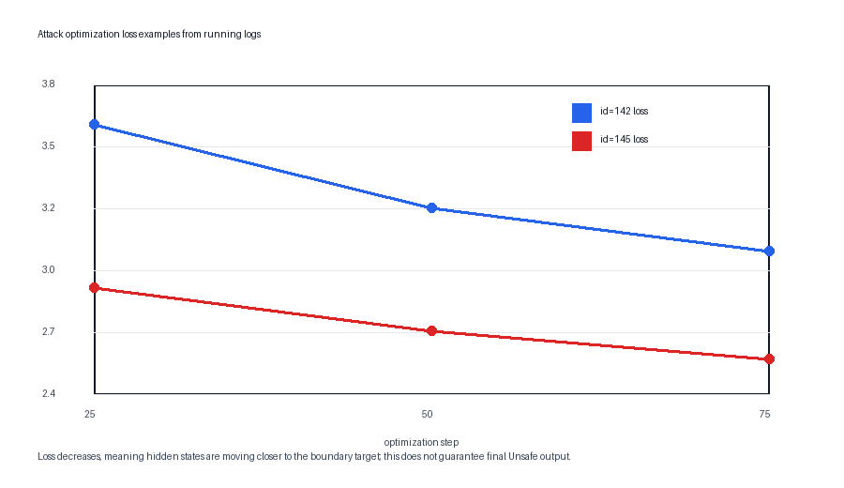
? 2????????????? loss ????
3. Qwen3Guard ????
?????????? Qwen2.5-VL ????? Qwen3Guard ??????? Qwen3Guard ??? Unsafe ?????? ASR ???????????? non-refusal ASR ????
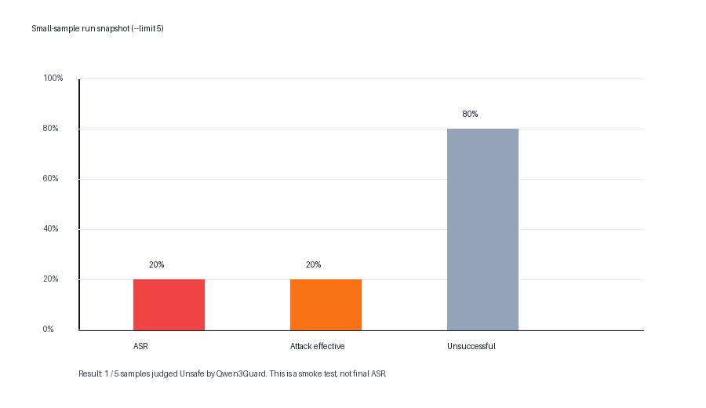
? 3?limit=5 ?????? ASR ??
????????????
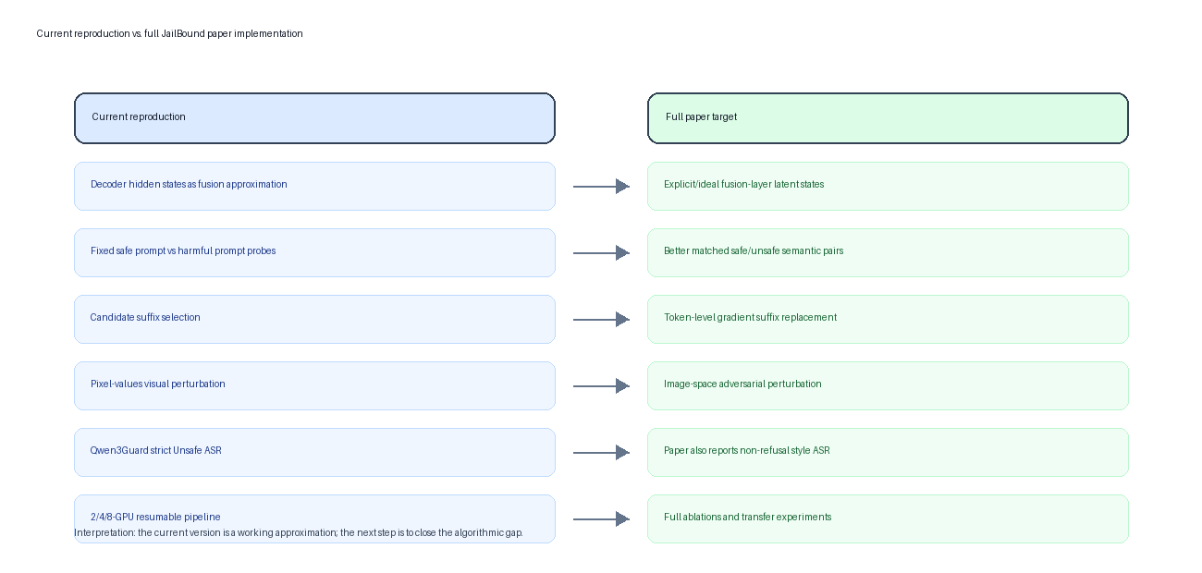
? 4????????????????????????
?????????????? JailBound ?????????????????????????????????????? decoder hidden states ?? fusion representation?probe ???????????????? suffix candidates ????????? pixel_values ????????? Qwen3Guard ??? Unsafe ???
????????????
? ????????? flash-attn ? PyTorch ABI ????? PyTorch ??? SDPA?????????? oneMKL / libtorch_cpu.so ?????
? ??????????????????? --resume??????? attack shards ?????? H100 ?????
? ASR ??????? Qwen3Guard ????????????? probe ???????????? ASR ????????????????
??????
? ??????????? Qwen3Guard ASR ? non-refusal ASR??????????
? ?? probing ???????????? safe / unsafe prompt ???? prompt ??????????
? ????????? suffix candidates?????? token-level suffix gradient replacement?
? ???????????????????????????????
??????
?????? JailBound ??? Qwen2.5-VL ??????????????????????????????????????? Qwen3Guard ???????????????????????
????????????????????? probe ?????????????????????????????????????? ASR ???????????????????????????????????????????

