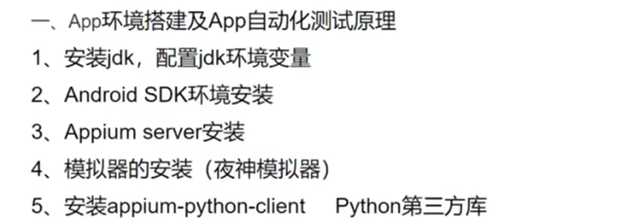

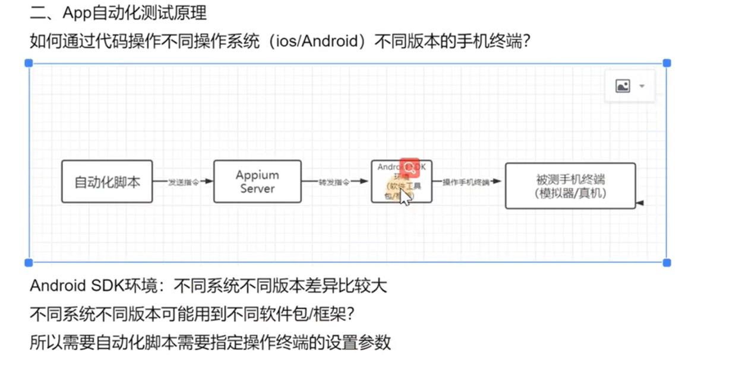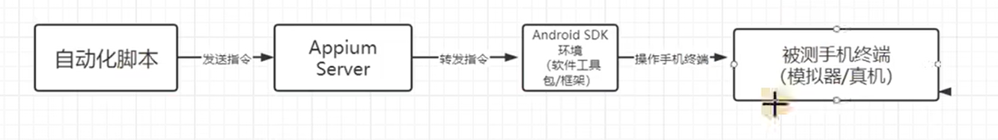配置网址：

<https://appium.io/docs/en/writing-running-appium/caps/#general-capabilities>

Appium-inspector常见错误：

https://zhuanlan.zhihu.com/p/484790166