HW4 Vital Visions Report
This report presents the phone heart rate measurement, PneumoniaMNIST model, and screen camera communication experiments for HW4. Results come from the recorded or executed experiments.

Part 1 Smartphone Based Heart Rate Monitoring

Method
Each frame was converted to grayscale and reduced to its mean intensity. The signal was mean centered, high pass filtered at 0.5 Hz, and analyzed with a Hann window FFT from 1.000 to 1.667 Hz. The FFT estimate gave 23.95 samples per beat, so the minimum peak distance was set to 18 samples.

Results
Metric | Measured Value
Duration and sampling rate | 34.33 s at 30.001 Hz
FFT peak | 1.252 Hz
FFT heart rate | 75.15 bpm
Peak interval heart rate | 75.00 bpm
Selected peaks | 42
Samples per beat | 23.95

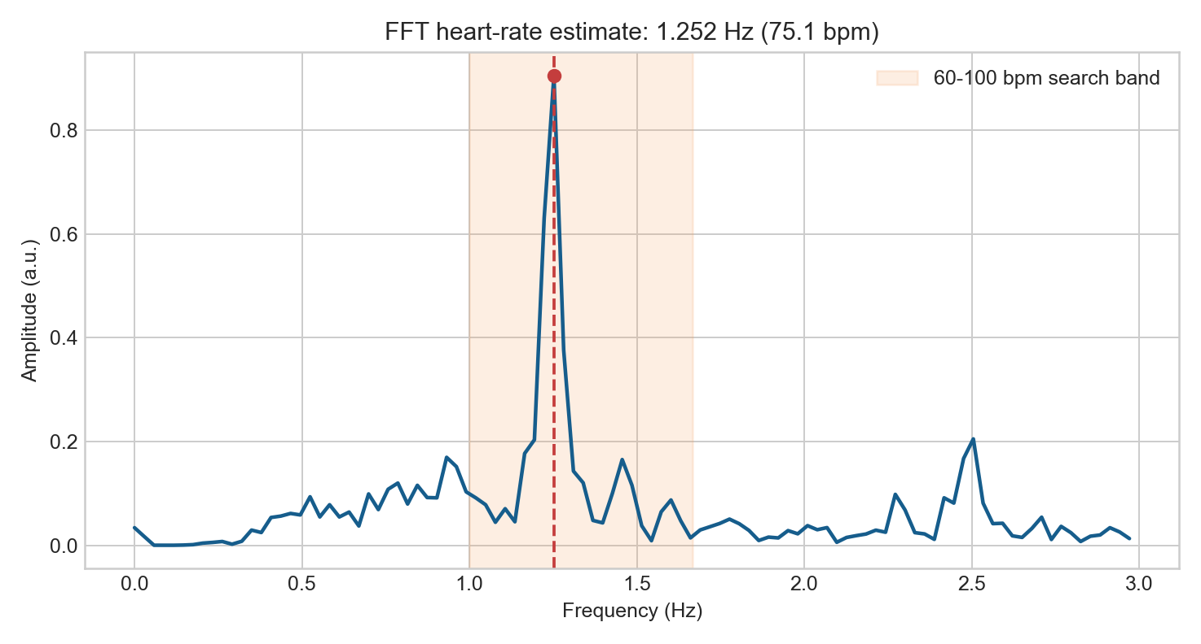
Figure 1 FFT amplitude spectrum from the phone recording

Part 1 Time Domain Result
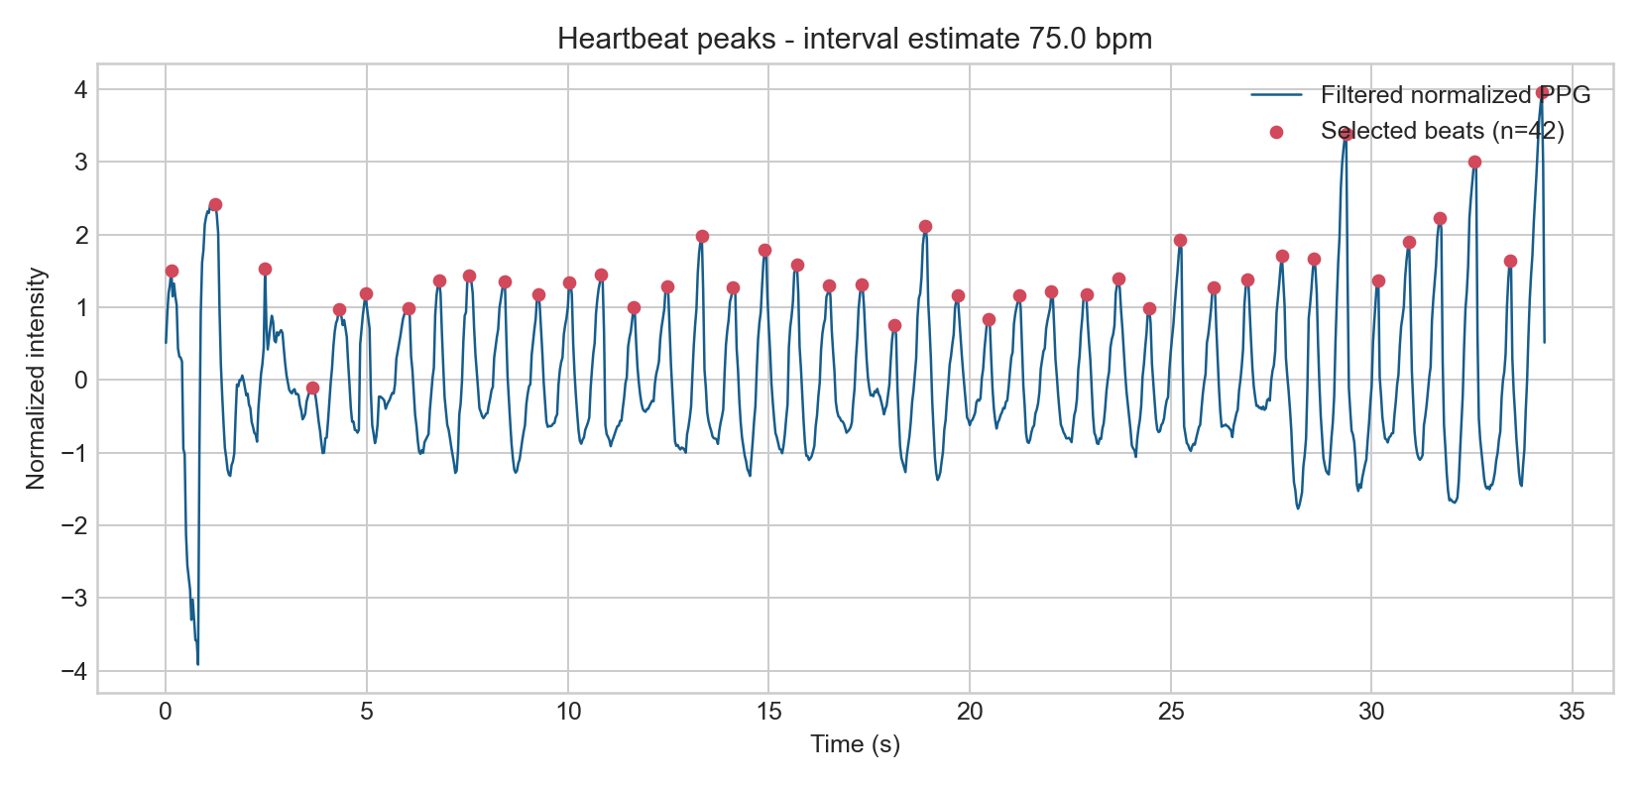
Figure 2 Filtered phone camera PPG with selected heartbeat peaks

Interpretation
The two estimates differ by 0.15 bpm. Motion, exposure control, finger pressure, and frame timing can affect this optical estimate.

Part 2 Medical Image Fine Tuning

Model and Dataset
An ImageNet pretrained ResNet 18 was trained on PneumoniaMNIST. Images were resized to 96 by 96, converted to three channels, and normalized with ImageNet statistics. The backbone was frozen and only the final classifier was trained.
Item | Configuration
Dataset sizes | 4708 training 524 validation 624 test
Optimizer | AdamW learning rate 1e-3 weight decay 1e-4
Epochs and batch size | 5 epochs batch size 64
Trainable parameters | ResNet 18 classification head
Execution device | mps
Model selection | Best validation accuracy

Results
Metric | Result
Best validation accuracy | 88.55%
Held out test accuracy | 79.17%
Pneumonia sensitivity | 92.31%
Normal image specificity | 57.26%
ROC AUC | 0.865
Confusion matrix | [[134, 100], [30, 360]]

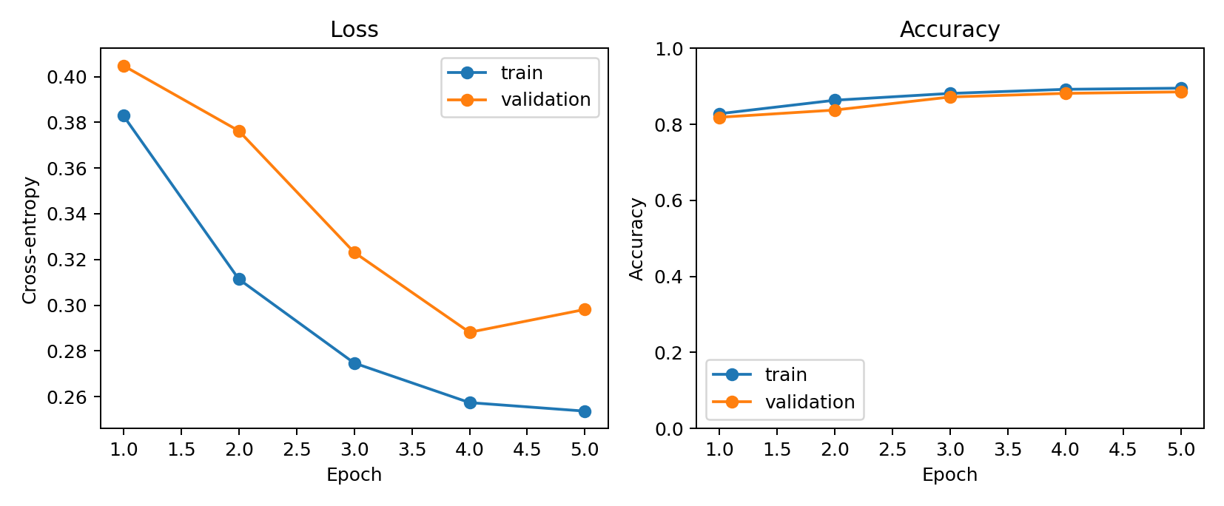
Figure 3 Five epoch training and validation histories

Part 2 Test Set Evaluation
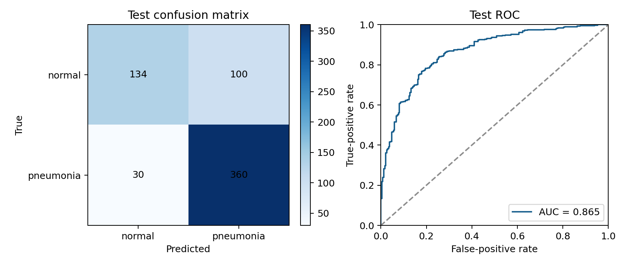
Figure 4 Confusion matrix and ROC curve on the held out test set

Interpretation
The model found 360 of 390 pneumonia images but classified 100 of 234 normal images as pneumonia. A validation threshold or class balancing could improve specificity.

Part 3 Alpha Channel Screen Camera BFSK

Method
A white overlay changed opacity over a static image. Bit 0 used frequency R and bit 1 used 2R. The 88 bit VITAL frame contained a preamble, payload length, message, and CRC 16. The experiment used alpha differences 0.1 and 0.5, rates 1, 2, 4, 6, 8, and 10 bit per second, and distances 20, 40, 80, and 120 cm. BER counted missing edge bits as errors.

Results
The experiment produced 48 recordings. 18 recordings passed CRC.
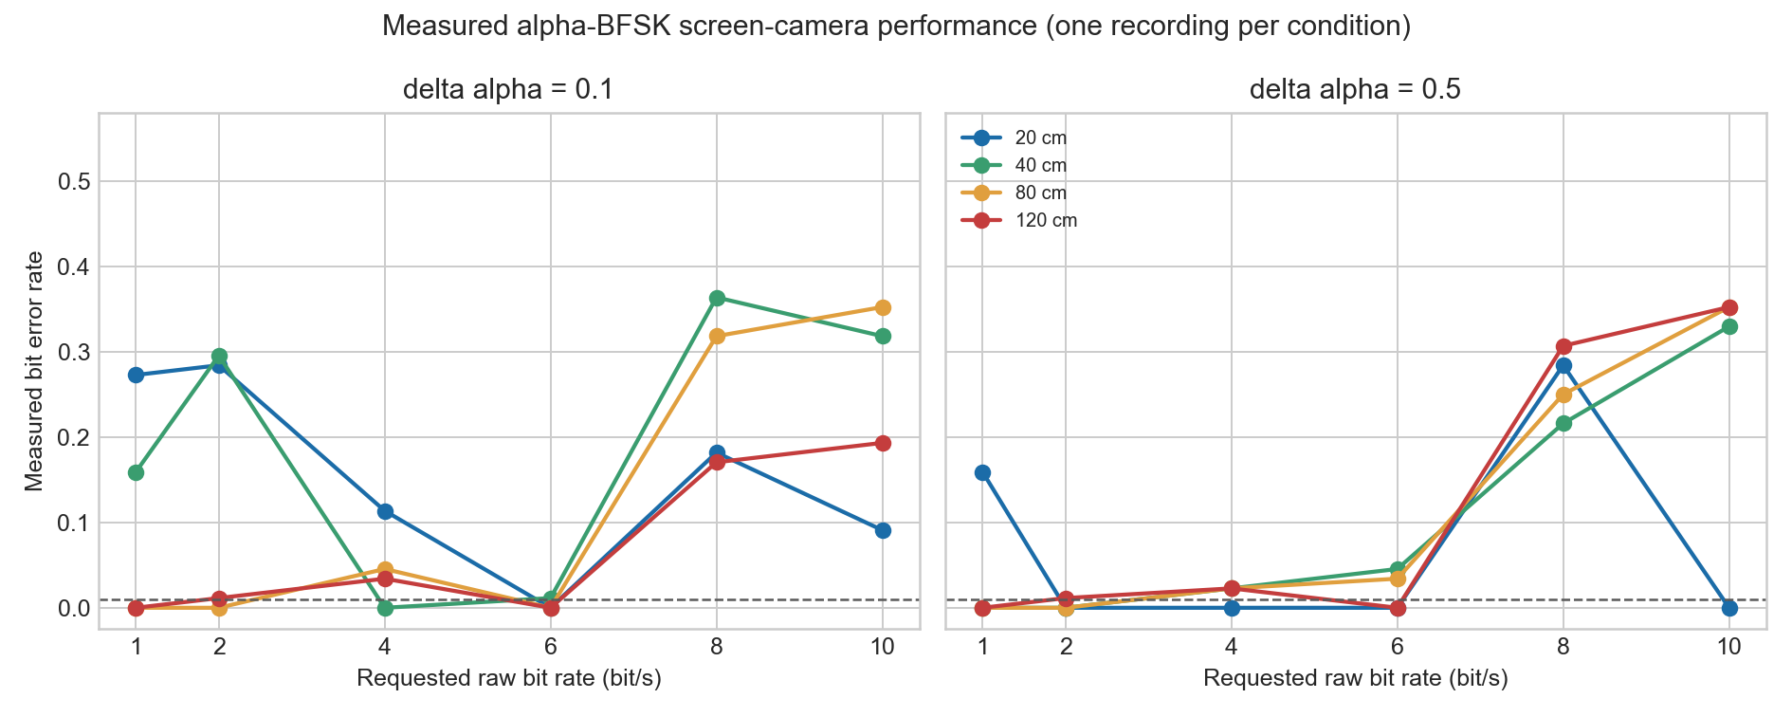
Figure 5 Measured BER for 48 phone recordings

Maximum Rate at or Below One Percent BER
Distance cm | Delta Alpha | Max Rate bit s | BER | CRC Passes
20 | 0.1 | 6 | 0.0000 | 1/6
20 | 0.5 | 10 | 0.0000 | 4/6
40 | 0.1 | 4 | 0.0000 | 2/6
40 | 0.5 | 2 | 0.0000 | 2/6
80 | 0.1 | 6 | 0.0000 | 3/6
80 | 0.5 | 2 | 0.0000 | 2/6
120 | 0.1 | 6 | 0.0000 | 2/6
120 | 0.5 | 6 | 0.0000 | 2/6

Part 3 Discussion
- Six bit per second often decoded better than slower rates because automatic exposure reduced slow intensity changes.
- Eight bit per second was weak because each symbol contained about 3.75 camera frames and was sensitive to sampling phase.
- Each condition has one recording, so the results do not include averages or error bars.

Appendix A Complete Part 3 Results
Correct bit rate equals requested rate multiplied by one minus BER.
Distance | Alpha | Rate | BER | Correct Rate | CRC
20 | 0.1 | 1 | 0.2727 | 0.727 | Fail
20 | 0.1 | 2 | 0.2841 | 1.432 | Fail
20 | 0.1 | 4 | 0.1136 | 3.545 | Fail
20 | 0.1 | 6 | 0.0000 | 6.000 | Pass
20 | 0.1 | 8 | 0.1818 | 6.545 | Fail
20 | 0.1 | 10 | 0.0909 | 9.091 | Fail
20 | 0.5 | 1 | 0.1591 | 0.841 | Fail
20 | 0.5 | 2 | 0.0000 | 2.000 | Pass
20 | 0.5 | 4 | 0.0000 | 4.000 | Pass
20 | 0.5 | 6 | 0.0000 | 6.000 | Pass
20 | 0.5 | 8 | 0.2841 | 5.727 | Fail
20 | 0.5 | 10 | 0.0000 | 10.000 | Pass
40 | 0.1 | 1 | 0.1591 | 0.841 | Fail
40 | 0.1 | 2 | 0.2955 | 1.409 | Fail
40 | 0.1 | 4 | 0.0000 | 4.000 | Pass
40 | 0.1 | 6 | 0.0114 | 5.932 | Pass
40 | 0.1 | 8 | 0.3636 | 5.091 | Fail
40 | 0.1 | 10 | 0.3182 | 6.818 | Fail
40 | 0.5 | 1 | 0.0000 | 1.000 | Pass
40 | 0.5 | 2 | 0.0000 | 2.000 | Pass
40 | 0.5 | 4 | 0.0227 | 3.909 | Fail
40 | 0.5 | 6 | 0.0455 | 5.727 | Fail
40 | 0.5 | 8 | 0.2159 | 6.273 | Fail
40 | 0.5 | 10 | 0.3295 | 6.705 | Fail
80 | 0.1 | 1 | 0.0000 | 1.000 | Pass
80 | 0.1 | 2 | 0.0000 | 2.000 | Pass
80 | 0.1 | 4 | 0.0455 | 3.818 | Fail
80 | 0.1 | 6 | 0.0000 | 6.000 | Pass
80 | 0.1 | 8 | 0.3182 | 5.455 | Fail
80 | 0.1 | 10 | 0.3523 | 6.477 | Fail
80 | 0.5 | 1 | 0.0000 | 1.000 | Pass
80 | 0.5 | 2 | 0.0000 | 2.000 | Pass
80 | 0.5 | 4 | 0.0227 | 3.909 | Fail
80 | 0.5 | 6 | 0.0341 | 5.795 | Fail
80 | 0.5 | 8 | 0.2500 | 6.000 | Fail
80 | 0.5 | 10 | 0.3523 | 6.477 | Fail
120 | 0.1 | 1 | 0.0000 | 1.000 | Pass
120 | 0.1 | 2 | 0.0114 | 1.977 | Fail
120 | 0.1 | 4 | 0.0341 | 3.864 | Fail
120 | 0.1 | 6 | 0.0000 | 6.000 | Pass
120 | 0.1 | 8 | 0.1705 | 6.636 | Fail
120 | 0.1 | 10 | 0.1932 | 8.068 | Fail
120 | 0.5 | 1 | 0.0000 | 1.000 | Pass
120 | 0.5 | 2 | 0.0114 | 1.977 | Fail
120 | 0.5 | 4 | 0.0227 | 3.909 | Fail
120 | 0.5 | 6 | 0.0000 | 6.000 | Pass
120 | 0.5 | 8 | 0.3068 | 5.545 | Fail
120 | 0.5 | 10 | 0.3523 | 6.477 | Fail

References
1. Jonathan E and Leahy M. Investigating a smartphone imaging unit for photoplethysmography. Physiological Measurement 31.11 2010 N79.
2. Gregoski M J et al. Development and validation of a smartphone heart rate acquisition application. International Journal of Telemedicine and Applications 2012.
3. Esteva A et al. Dermatologist level classification of skin cancer with deep neural networks. Nature 542.7639 2017 115 to 118.
4. Wang E J et al. HemaApp noninvasive blood screening of hemoglobin using smartphone cameras. UbiComp 2016.
5. Xuan Y et al. Ultra low cost mechanical smartphone attachment for no calibration blood pressure measurement. Scientific Reports 13.1 2023 8105.
6. HiLight Hiding Bits in Pixel Translucency Changes. MobiSys 2015.
7. Yang J et al. MedMNIST v2 A large scale lightweight benchmark for biomedical image classification. Scientific Data 10 2023 41.

