Running the Report Viewer “N1” Report

1. Double-click the ReportViewer.bat icon on your desktop:

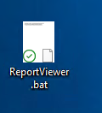

1. The ReportViewer main window will display. Select the options highlighted below, then click the “Run Report” button:

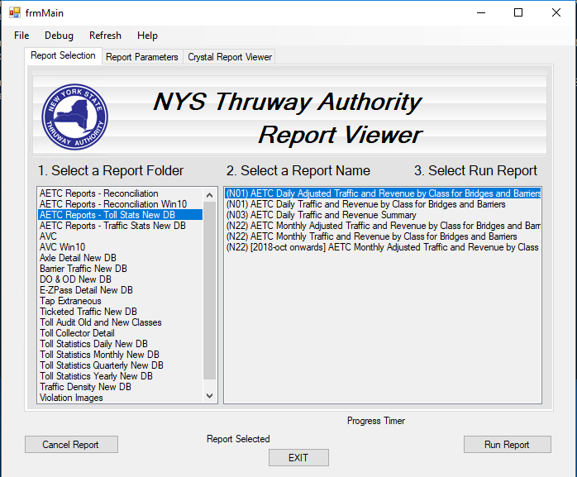

1. The LogOn window will appear. Enter trafficstats for both your username and password, then click OK:

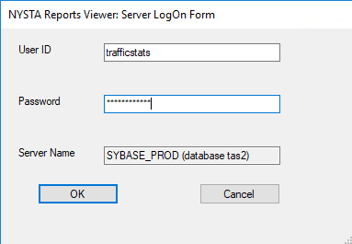

1. You will then get prompted to enter report parameters. Enter July 1, 2020 when prompted for the report date:

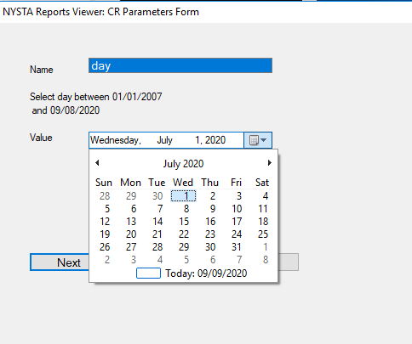

1. You will then be prompted the station (aka toll plaza) for which the report should be run. Select station 06, and then click the Finish button:

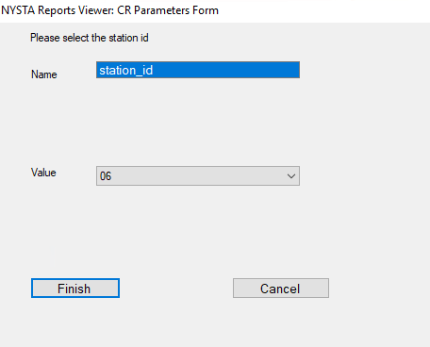

1. Shortly, the ReportViewer will display data for the requested report:

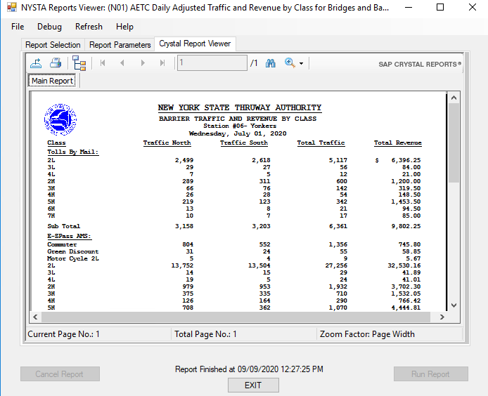

1. Click the Export Report button to export the report to Excel format:



1. A window will appear prompting you for the export filename and format to use. Be sure to select one of the Microsoft Excel export formats, then click the Save button:

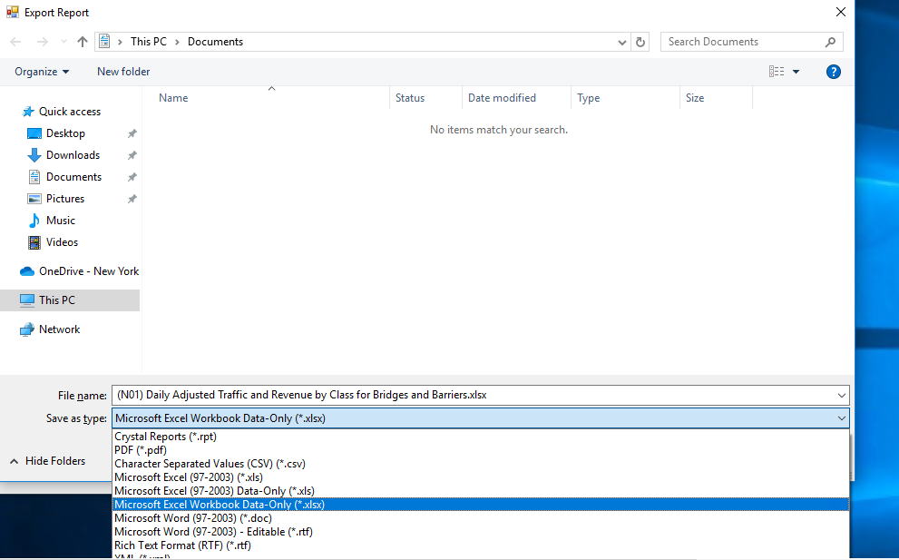

1. Once the report has been exported successfully, you’ll get an Export completed window:

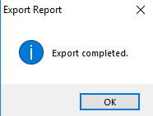

1. To run the report for additional stations, click the Report Selection tab in the Report Viewer, and go back to step # 2 in these instructions.