Nordic Build Setup Guide

Nordic Program
- Install the ‘nrfgostudio_win-64_1.21.2_installer.msi’ from the Nordic Homepage
- http://www.nordicsemi.com/eng/Products/Bluetooth-low-energy/nRF52832
- In the ‘Download’ tab select the software ‘nRFgo Studio-Win64’
- Install the ‘nRF5x-Command-Line-Tools_9_7_1_Installer.exe’ from the Nordic Homepage
- http://www.nordicsemi.com/eng/Products/Bluetooth-low-energy/nRF52832
- In the ‘Download’ tab select the software ‘nRF5x-Command-Line-Tools-Linux64’

Nordic SDK
- Download the ‘Thingy:52-SDK-zip’ from the Nordic Homepage
- http://www.nordicsemi.com/eng/Products/Nordic-Thingy-52
- In the ‘Download’ tab select the ‘Thingy:52-SDK-zip’
- SDK documentation
- https://nordicsemiconductor.github.io/Nordic-Thingy52-FW/documentation/index.html

Compile with GCC ARM
- Install the ‘gcc-arm-none-eabi-4_9-2015q3-20150921-win32.exe’
- Install the ‘Git’ program from Website
- https://git-scm.com/download/win
- Set the windows environment variable
  - Click on the environment variable
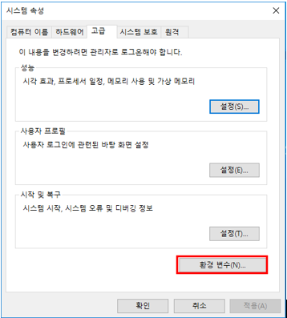

  - Click on the PATH
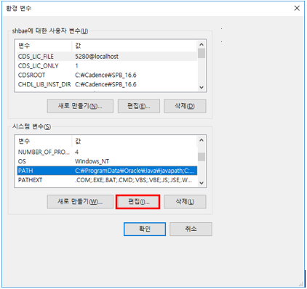

  - Click on the new
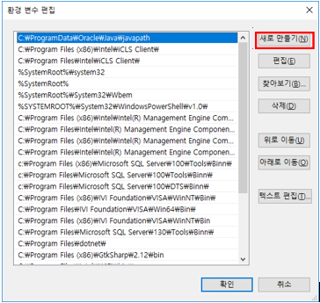

  - Add the directory
    - C:\Program Files (x86)\GNU Tools ARM Embedded\4.9 2015q3\bin
    - C:\Program Files (x86)\Nordic Semiconductor\nrf5x\bin\
    - C:\Program Files\GNU MCU Eclipse\Build Tools\bin\bin
    - C:\Users\user name\AppData\Local\sensiml\python
    - C:\Users\user name\AppData\Local\sensiml\python\Scripts

      - Ex. User name : shbae
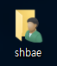

The GNU MCU Eclipse Windows Build Tools
- Install the ‘eclipse-inst-win64.exe’ from the Eclipse Homepage
- Windows Build Tools Install
- https://github.com/gnu-mcu-eclipse/windows-build-tools/releases
- https://gnu-mcu-eclipse.github.io/windows-build-tools/
- Setting up Eclipse the first time
- https://devzone.nordicsemi.com/tutorials/7/development-with-gcc-and-eclipse/
- Install the ‘gnu-mcu-eclipse-build-tools-2.9-20170629-1013-win64-setup’
- Install the ‘jre-8u151-windows-x64.exe’
Flashing Firmware to Nordic

Compile Hex File
- Open the Project file in a ‘Git’ program
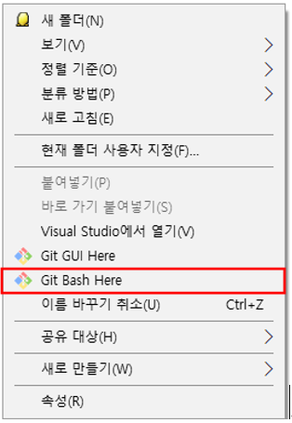

- Make compile project file

>> make

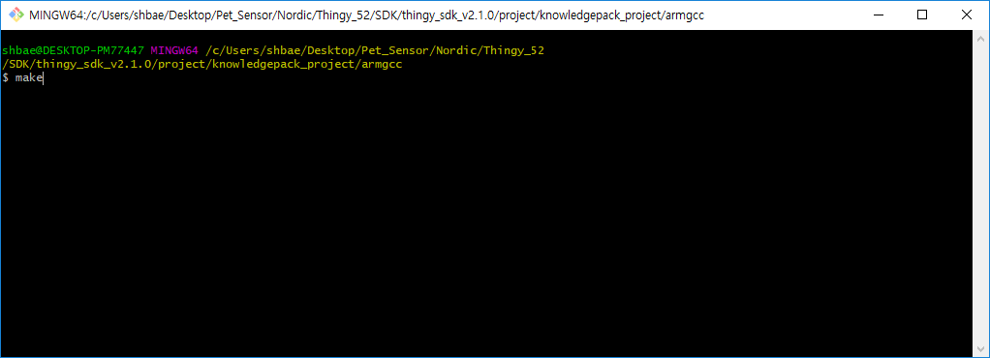

- Build successful.
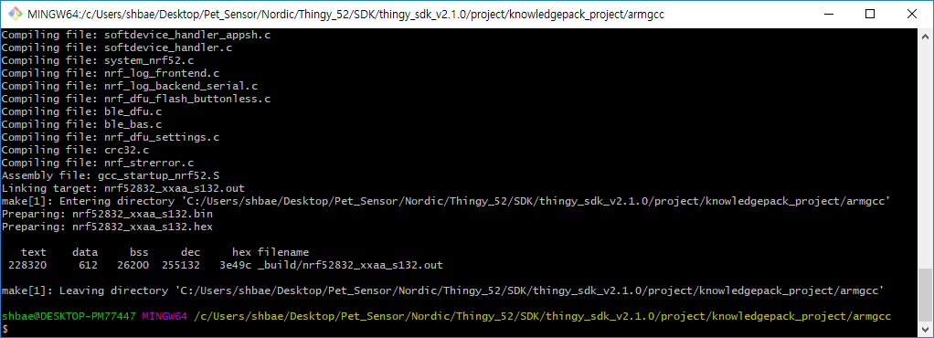

- Re build project file

>> make clean
>> make

- Create a bootloader setting file (bootloader_settings.hex)
- application.hex : application compile hex file
- bootloader_settings.hex : The name of the file to be created

>> nrfutil settings generate --family NRF52 --application application.hex --application-version 1 --bootloader-version 1 --bl-settings-version 1 bootloader_settings.hex

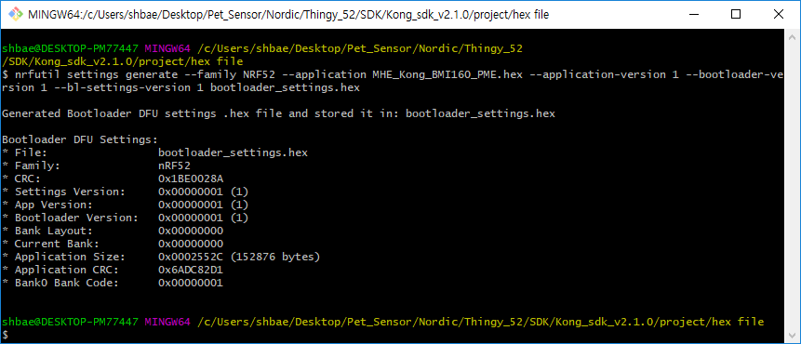

- Create a application and bootloader hex file
- bootloader_settings.hex : bootloader setting file
- application.hex : application compile hex file
- bootloader.hex : bootloader compile hex file
- Three files must be placed in one folder.
- nrf_bootloader_and_app.hex : The name of the file to be created

>> mergehex -m bootloader_settings.hex application.hex bootloader.hex -o nrf_bootloader_and_app.hex

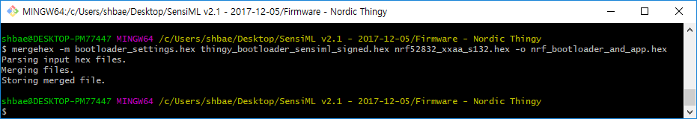

- Create a application and softdevice file
- s132_nrf52_4.0.2_softdevice.hex : softdevice hex file
- nrf_bootloader_and_app.hex : application and bootloader compile hex file
- MHE_Kong_FW.hex: The name of the file to be created

>> mergehex -m s132_nrf52_4.0.2_softdevice.hex nrf_bootloader_and_app.hex -o MHE_Kong_FW.hex

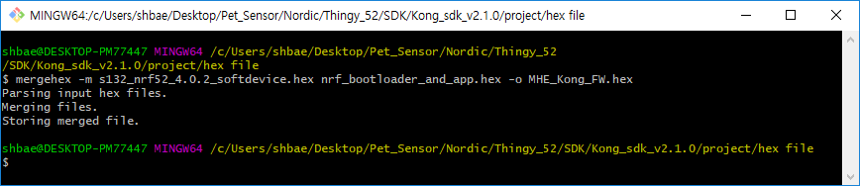

Compile zip File

>> nrfutil pkg generate --application _build/MHE_Kong_BMI160_PME.hex --sd-req 0x98 --hw-version 52 --application-version 1 --key-file /c/Users/shbae/AppData/Local /sensiml/python/Lib/site-packages/sensiml/widgets/sensiml_example_key.pem MHE_Kong_FreeRTOS_BMI160_flash_output.zip

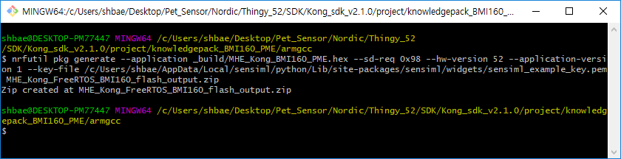

J-Link Flashing

J-Link flashing requires the NRF52 Development Kit (52832 or 52840 will work). You need to install the NRF Command line utilities for your platform (available in here: https://www.nordicsemi.com/eng/Products/Bluetooth-low-energy/nRF52-DK )
If you wish to perform rapid flashing, you need to remove the original bootloader (The original flash files are available for the Nordic Thingy in here: https://www.nordicsemi.com/eng/Products/Nordic-Thingy-52 ). Screenshots for the ‘Windows nRFGO Studio’ and the corresponding line commands will be given.

J-Link Serial Wire Mode Interface
The Serial Wire (SW) mode is a different operating mode for the JTAG port. Only two pins ‘TCLK and TMS’ are used for the communication. To trace the data third pin ‘TDO’ can be use optionally. ‘JTAG pins and SW pins’ can be shared.

- TCLK is SWCLK (Serial Wire Clock)
- TMS is SWDIO (Serial Wire debug Data Input/Output)
- TDO is SWO (Serial Wire trace Output)
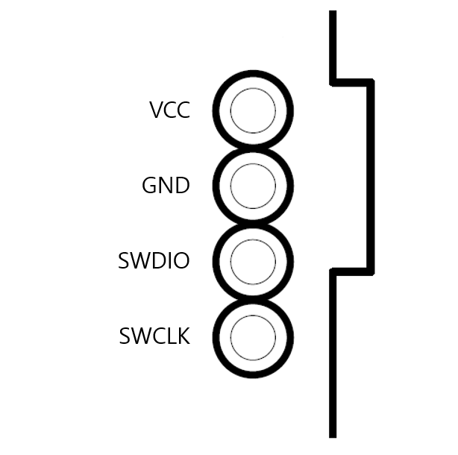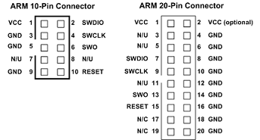
<Kong board 4-pin > <ARM 10-pin Connector> <ARM 20-pin Connector>

Signal | Connects to
SWDIO | Data I/O pin. Use 100K Ohm pull-up resistor to VCC.
SWO | Optional trace output pin.
SWCLK | Clock pin. Use 100K Ohm pull-down resistor to GND.
VCC | Positive Supply Voltage — Power supply for JTAG interface drivers.
GND | Digital ground.
RESET | RSTIN/ pin — Connect this pin to the (active low) reset input of the target CPU. This is an open-collector/open-drain output.

J-Link Flashing (DK Board)
- Start ‘nRFgo Studio’.
- Connect your board to the host.
- Select ‘nRF52’ development boards.
- Click ‘Erase all’.
- In the ‘Program SoftDevice tab’, browse for the ‘S132 v4.0.2’ HEX file and click Program.
- In the ‘Program Application’ tab, browse for your ‘application + bootloder’ HEX file and click Program.
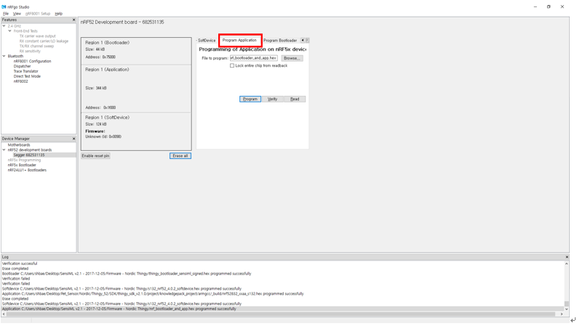

Prerequisites
- Install the Nordic Thingy application from the Apple App Store or the Google Play Store
- Open the Nordic Thingy application and connect to your Nordic Thingy device. *Important – If you rename your device make sure the device name has the word ‘Thingy’ in it

Over the Air (Android)
- Click on the menu icon in the top left corner

- Select the dropdown of your device

- Select ‘Device Firmware Update’

- Select the firmware that you want to flash by clicking ‘Custom’

- Select the DFU button in the bottom right corner

- Turn the Nordic Thingy on in ‘DFU mode’ (hold down the button in the center of the Nordic Thingy at the same time as turning on the device). After your ‘Thingy’ turned on, scan for devices and select your ‘Nordic Thingy’ from the list.

- The Nordic Thingy application will now flash your Thingy with the new firmware

Over the Air (iOS)

‘iOS’ adds another step, in that you must get the file to your device. The easiest way is to use a service such as Dropbox, Google Drive, OneDrive, or iCloud files.

- In ‘iOS 11’, you can use the files app, and choose a service:

- Navigate to your file:

- Click the ‘Share’ arrow:

- And scroll to ‘Copy to Thingy’

- This will open the app in DFU update mode, with a custom mode. Select your target.

- Turn the Nordic Thingy on in ‘DFU mode’ (hold down the button in the center of the Nordic Thingy at the same time as turning on the device). After your ‘Thingy’ turned on, it will show up in the target list.
- The Nordic Thingy application will now flash your Thingy with the new firmware

Firmware architecture

The ‘Kong board’ firmware has built on top of nRF5 Software Development Kit (SDK) v13.1.0 and utilizes many of its components, such as SDK peripheral drivers, ‘SDK HAL’, and the ‘Softdevice’.
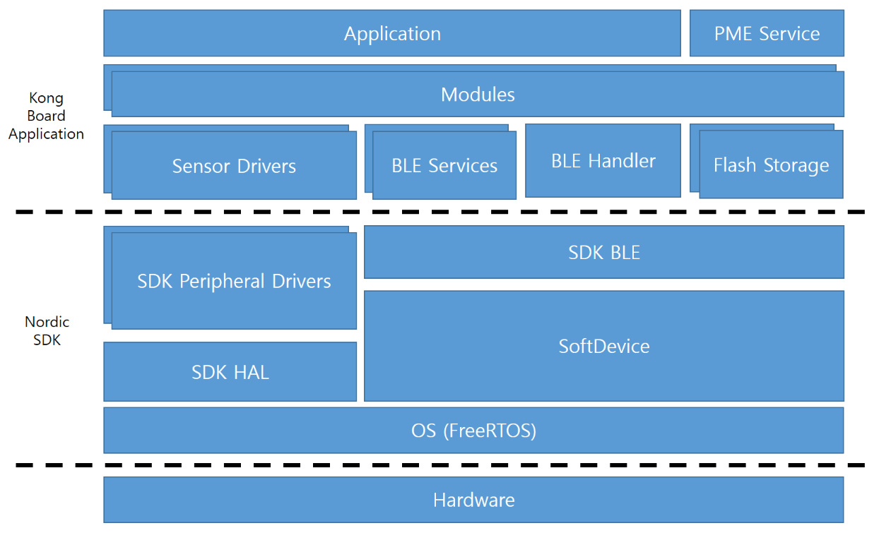
<Kong Board Firmware architecture framework>

‘Kong Board’ adds the following modules on top of the nRF5 SDK:

- Sensor drivers : Kong board uses the SDK peripheral drivers and hardware access layers (HALs) and implements its own sensor drivers on top of them. These drivers are used to perform any operations on the sensors, such as enabling or disabling them, changing their configuration, or fetching sensor data.
- BLE handler : Handles all bluetooth communication and dispatches events to the processes.
- Flash storage : Flash storage of configuration parameters.
- BLE services : Layer containing all the custom BLE services used by the modules. These services are discussed in detail in the BLE services section.
- Modules : Layer containing high level functionality and features. Controlls both the sensor drivers and the corresponding BLE services. Responsible for handling persistent storage of configuration and the default configuration.
- Application : User program.
- MHE services : MHE, Software pattern matching engine service.

nRF52 flash memory layout
Full layout
The following table shows the memory layout for the different chips with current SoftDevices:
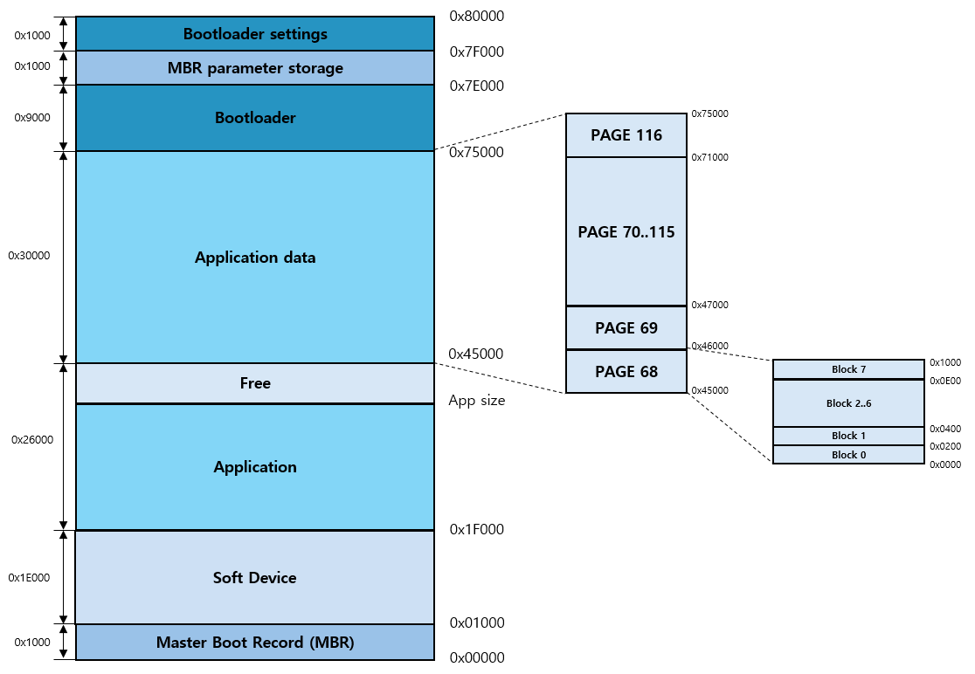
<Flash memory 512Kbyte layout>

Application data layout
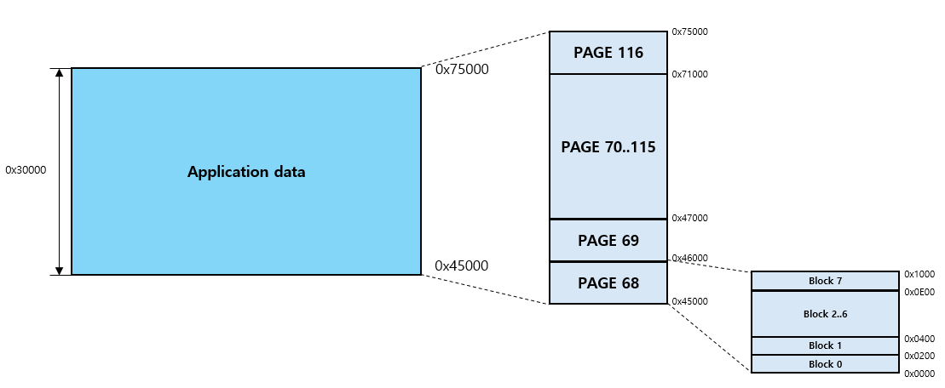
<Application data 192Kbyte layout >

Application storage format
Flash Data Storage stores data as records, which are grouped into files. In most use cases, you do not need to understand in detail how FDS stores the data in flash. The following information gives some insight about the data format that FDS uses, but if you are not interested in the details, you can skip this part.

Record layout
Records consist of a header (the record metadata) and the actual content. They are stored contiguously in flash in the order they are written.
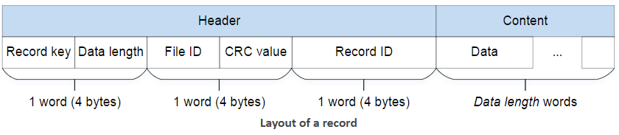

MHE record layout
- BLE flash
- VALID : 0x42
- File ID : 0x1000
- Record key: 0x1001
- Motion flash
  - VALID : 0x42
  - File ID : 0x2000
  - Record key : 0x2001
- UI flash
  - VALID : 0x42
  - File ID : 0x3000
  - Record key: 0x3001
- PME flash
- VALID : 0x42
- File ID : 0x4000
- Record key : 0x4001~0x402B
- Flash test flash
  - VALID : 0x42
  - File ID : 0x0500
  - Record key : 0x0501
- System information flash
  - VALID : 0x42
  - File ID : 0x6000
  - Record key : 0x6001

Record header
The record header consists of three words (12 bytes), which are used in the following way:

Field | Size | Description
Record key | 16 bits | Key that can be used to find the record. The value FDS_RECORD_KEY_DIRTY (0x0000) is reserved by the system to flag records that have been invalidated. See Restrictions on keys and IDs for further restrictions.
Data length | 16 bits | Length of the data that is stored in the record (in 4-byte words).
File ID | 16 bits | ID of the file that the record is associated with. The value FDS_FILE_ID_INVALID (0xFFFF) is used by the system to identify records that have not been written correctly. See Restrictions on keys and IDs for further restrictions.
CRC value | 16 bits | CRC value of the whole record (checks can be enabled by setting the FDS_CRC_ENABLED compile flag, see Configuration).
Record ID | 32 bits | Unique identifier of the record.

When writing the record header to flash, FDS writes the record key and data length first, followed by the record ID. The file ID and the CRC value are written last and finalize a successful write operation. When scanning through records, the FDS module ignores all records where the second word of the header has not been written, because a missing key indicates that the record was not stored completely.

Maximum length
The maximum length of a record depends on the size of a virtual flash page (defined in in fds_config.h, see FDS_VIRTUAL_PAGE_SIZE), the size of the page tag (2 words), and the size of the record header (3 words). By default, the virtual page size is set to the physical page size (1024 words), which results in a maximum data length of 1019 words

Page tag
Each virtual page that is used by FDS is marked with a page tag that is used by the system to store information about the page. The 2-word page tag contains information about what the page is used for (data storage or garbage collection) and what version of the file system is installed on the page.

The following page tags are used:

Word 0 | Word 1 | Description
0xDEADC0DE | 0xF11E01FF | Page used for swap during garbage collection.
0xDEADC0DE | 0xF11E01FE | Page used to store data.

The page tags are written when FDS is first initialized and updated only during garbage collection.

Firmware components
This firmware consists of the following components.

BLE services
- Configuration Service : Service that handles various configuration characteristics.
- Battery Service : Service that responsible for handling battery level information.
- Motion Service : GATT-based service with multiple characteristics for reading motion sensor data and configuring the sensors.
- Sound Service: GATT-based service that handles the microphone.
- UI (User interface) Service : Service that handles the RGB LED and button.
- DFU Service : Service for running Device Firmware Updates on Board.
- PME Service : GATT-based service for motion and Sound Pattern matching Data.

Drivers
- LED : LED Driver API, including the LP5562
- Flash Memory : Flash Memory API, including the MX25U12835F
- Temp & Humidity sensor : Temp & Humidity sensor API, including the SHTC1 sensor.
- Microphone : Microphone driver API.
- IMU sensor : IMU sensor API, including the BMI160 sensor.

Modules
- BLE handling : BLE handling module API, including its flash configuration.
- Battery measurement : Battery measurement module API, including its flash configuration.
- Motion : Motion module API, including its flash configuration.
- Sound : Sound module API
- UI: User interface module API, including its flash configuration.
- PME : Pattern Matching Engine module API

FW Overall Structure
ARM® Cortex®-M4
- System power off

- System power up

- Bootloader
  - Bootloader is a piece of code that runs before any operating system is running.
  - Bootloader are used to boot other operating systems, usually each operating system has a set of bootloaders specific for it.
  - Bootloaders usually contain several ways to boot the OS kernel and also contain commands for debugging and/or modifying the kernel environment.
- DFU mode
  - Over-the-air device firmware update
  - The application will flash your board with the new firmware.
- User mode
- Initialization
- Normal operation mode
- System sleep mode
- Low power mode
- BLE communication
  - Configuration service
  - Other service
- Error

Power controller
- MCU statuses check
  - Power on signal
    - MCU status low and push button 1 clink
  - Power off signal
    - Push button 2 second clink
    - MCU system off one clink signal of 600ms occurs. By this, MCU will make status be low.
-. In case that there is no pulse on MCU system off signal.
    - If the MCU status is low, a power off signal is generated
- MCU power on
  - MCU power load switch turns on
- MCU power off
  - MCU power load switch turns off
- Battery charge statuses check
  - LED on
    - USB detect signal High and battery charge status low
  - LED off
    - USB detect signal High and battery charge status High
- Battery charge LED on
  - Battery charge LED is brightly shine.
- Battery charge LED off
  - The battery charge LED turns off.
- Error check

Power

In general, and with the exception of ID 0, peripherals sharing an ID and base address may not be used simultaneously

Peripherals with shared ID

In general, and with the exception of ID 0, peripherals sharing an ID and base address may not be used simultaneously. The user can only enable one at the time on this specific ID. When switching between two peripherals that share an ID, the user should do the following to prevent unwanted behavior:
- Disable the previously used peripheral
- Remove any PPI connections set up for the peripheral that is being disabled
- Clear all bits in the INTEN register, i.e. INTENCLR = 0xFFFFFFFF.
- Explicitly configure the peripheral that you enable and do not rely on configuration values that may be
- Inherited from the peripheral that was disabled.
- Enable the now configured peripheral.

For each of the rows in the following table, the instance ID listed is shared by the peripherals in the same row.

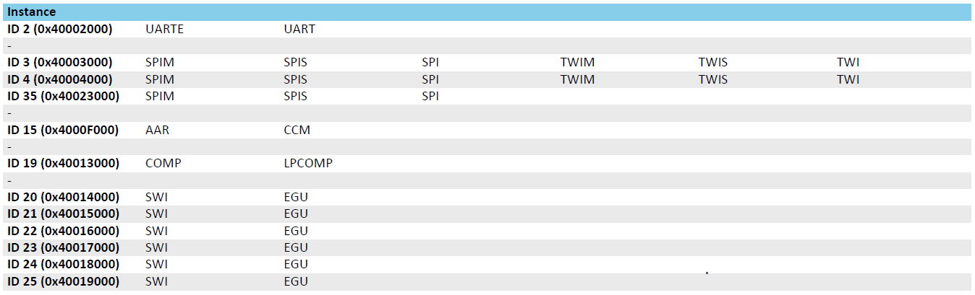
< Peripherals sharing an ID >

PDM — Pulse density modulation interface

The PDM module illustrated in PDM module is interfacing up to two digital microphones with the PDM interface. It implements EasyDMA, which relieves real-time requirements associated with controlling the PDM slave from a low priority CPU execution context. It also includes all the necessary digital filter elements to produce PCM samples. The PDM module allows continuous audio streaming.

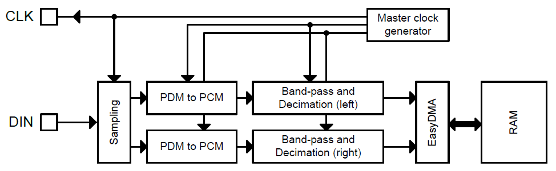
< PDM module >

Hardware
Power Sequence Diagram
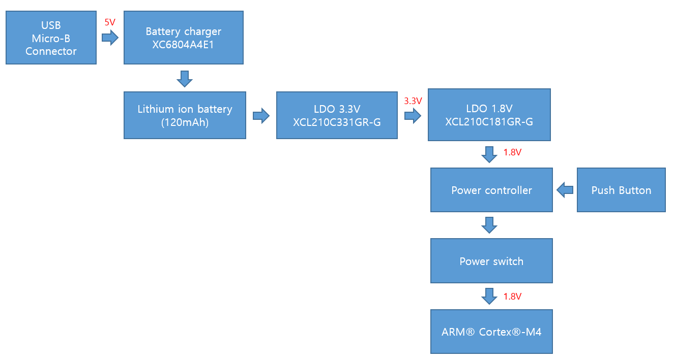
- USB Micro B Type connecter
  - Battery charger connecter
  - Operating voltage : 5V
- Battery charger
  - One Cell Li-ion/Li-polymer Linear Charger IC with Battery Temperature Detection.
- LDO 3.3V
  - Inductor Built-in Step-Down “micro DC/DC” Converters
  - Output Voltage : 3.3V
  - Output Current : 200mA
- LDO 1.8V
  - Inductor Built-in Step-Down “micro DC/DC” Converters
  - Output Voltage : 1.8V
  - Output Current : 200mA
- Power Controller
  - ARM® Cortex®-M4 power control
  - ARM® Cortex®-M4 statuses check
  - Battery charger statuses check
  - Battery charger LED control

MCU Block Diagram
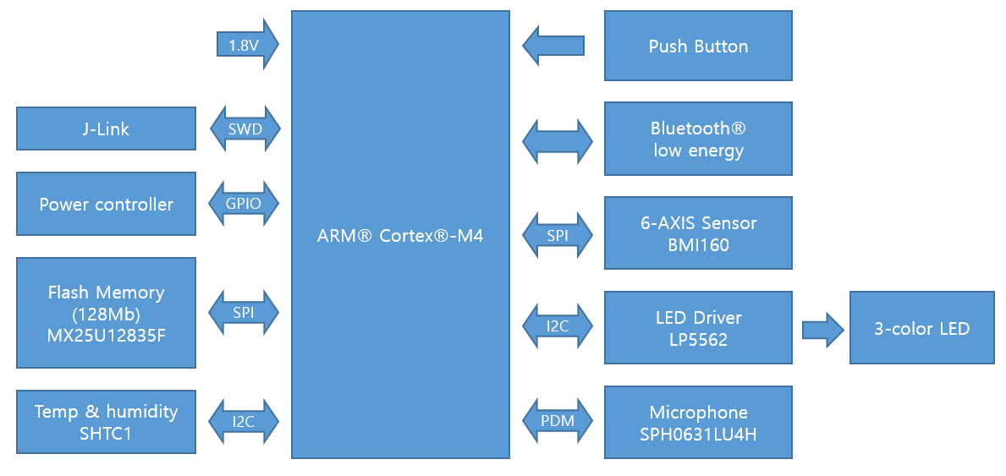
- ARM® Cortex®-M4 : Main Controller, operating voltage 1.8V.
- Push Button : Main Controller Hardware reset.
- J-Link : Main Controller Firmware Update with SWM Protocol.
- LED Driver : Four Independently Programmable LED Outputs With 8-Bit Current Setting (From 0 mA to 25.5 mA With 100-μA Steps) and 8-Bit PWM Control.
- Power Controller : Main controller on/off control and statuses check.
- Flash Memory : Stored the Device information, Stored the ‘Pattern Matching Engine result’ when BLE disconnection.
- 6-AXIS Sensor : 3-axis Accelerometer and 3-axis Gyroscope Motion sensor.
- Temp & humidity : Humidity and Temperature Sensor.
- Microphone : Digital Microphone.

MCU (nRF52832-CIAA)
Pin Configuration
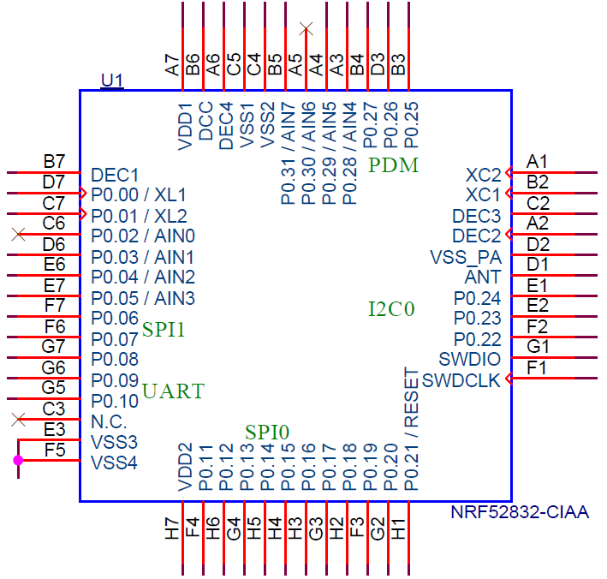
<NRF52832 CIAA Pin-map>

Pin name | Pin Description
P0.00/XL1 | XL1 | Crystal 32.768kHz
P0.01/XL2 | XL2 | Crystal 32.768kHz
P0.02/AIN0 | NC | -
P0.03/AIN1 | 6AXIS_INT2 | IMU Interrupt pin
P0.04/AIN2 | 6AXIS_INT1 | IMU Interrupt pin
P0.05/AIN3 | 6AXIS_MISO | IMU Interrupt SPI MISO Signal
P0.06 | 6AXIS_CS | IMU Interrupt SPI CS Signal
P0.07 | 6AXIS_SCLK | IMU Interrupt SPI SCLK Signal
P0.08 | 6AXIS_MOSI | IMU Interrupt SPI MOSI Signal
P0.09 | UART_1_RXD | UART RX Signal
P0.10 | UART_1_TXD | UART TX Signal
P0.11 | BUTTON | Switch Button (Low signal)
P0.12 | POR_B | Flash memory reset signal
P0.13 | USB DETECT | USB detect signal
P0.14 | SPI0_FLASH_SCK | Flash memory SPI SCK Signal
P0.15 | SPI0_FLASH_MOSI | Flash memory SPI MOSI Signal
P0.16 | SPI0_FLASH_MISO | Flash memory SPI MISO Signal
P0.17 | BAT CHG STAT | Battery Charge Status
P0.18 | SPI0_FLASH_CS2_N | Flash memory SPI CS Signal
P0.19 | nRF52_TP2 | Test pin
P0.20 | nRF52_TP1 | Test pin
P0.21 | MANUAL_RESET_N | Hardware reset signal
P0.22 | VDD_PWR_CTRL | Sensor Power control
P0.23 | I2C_SDA | LED Driver/ Temperature & Humidity I2C Data
P0.24 | I2C_SCL | LED Driver/ Temperature & Humidity I2C Clock
P0.25 | MIC DOUT | Digital Microphone data signal
P0.26 | MIC CLK | Digital Microphone clock signal
P0.27 | BAT_MON_EN | Battery monitoring enable
P0.28/AIN4 | BATTERY | Battery monitoring
P0.29/AIN5 | nRF52_PWR_STAT | nRF52832 power status
P0.30/AIN6 | NC | -
P0.31/AIN7 | nRF52_PWR_OFF | nRF52832 power off signal

Power controller (SLG4R42203)
Pin Configuration
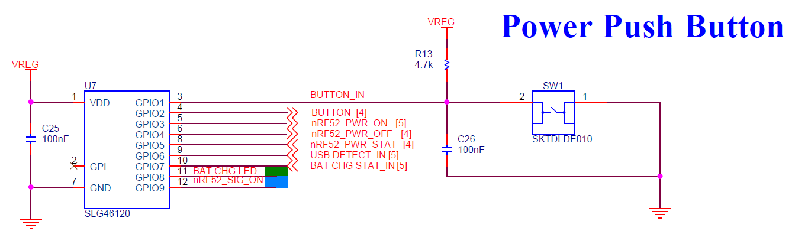
Pin name | Type | Pin Description
Button_IN | Digital input | Power push button input check
Button_OUT | Digital output | nRF52832 push button signal
nRF52_PWR_ON | Digital output | nRF52832 power turn on/off
nRF52_SYS_OFF | Digital output | nRF52832 power off
nRF52_STAT | Digital output | nRF52832 power status check
USB_DETECT | Digital input | USB detect check
BAT_CHG_STAT | Digital input | Battery charger status check
BAT_CHG_LED | Digital output | Battery charger LED turn on/off
nRF52_SIG_ON | Digital output | nRF52832 initial signal turn on/off

Timing Diagram
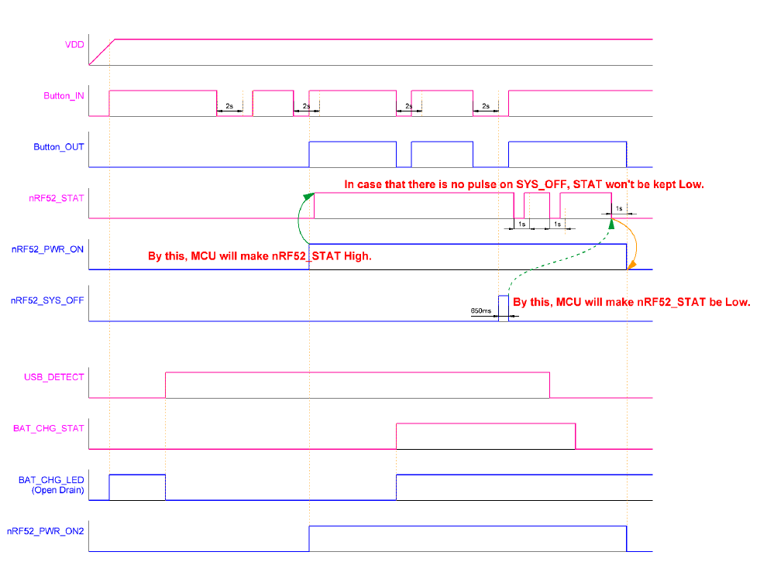

Specification

MHE Kong Board
Size | 27x37x12 [㎣]
Weight | 10.5 [g]
Storage | SPI Flash memory 128 [MB]
OS | FreeRTOS
Battery | Voltage | 3.7 [V]
Battery | Current | 115[㎃]
Charging time | 1 hour
Charging cycle | 2 days(T.B.D.)
Charge connecter | USB Micro B Type (5.0V)
Processor | Nordic nRF52832
Bluetooth | Bluetooth Low Energy
Sensor | 6 axis | Bosch BMI160
Sensor | Temp | -40 to +125 °C
Environmental | Operating: 0°C to 55°C
Microphone | High SNR of 64dB

BLE services
This section focuses on the custom services used in the Kong board firmware together with their configuration parameters.
- Base UUID : EF68xxxx-9B35-4933-9B10-52FFA9740042

Configuration service
The configuration service is responsible for handling all general configuration parameters that are not related to a particular module.
Name | UUID | Type | Data | Description
configuration service | 0100
Device name characteristic | 0101 | Write/Read | max 10 bytes | Device name as ASCII string.
Advertising param characteristic | 0102 | Write/Read | 3 bytes | Advertising parameters (in units):  - uint16_t - Adv interval in ms (unit 0.625 ms).  - min 32 -> 20 ms  - max 8000 -> 5 s  - uint8_t - Adv timeout in s (unit 1 s).  - min 0 -> 0 s  - max 180 s -> 3 min
Connection param characteristic | 0104 | Write/Read | 8 bytes | Connection parameters:  - uint16_t - Min connection interval (unit 1.25 ms).  - min 6 -> 7.5 ms  - max 3200 -> 4 s  - uint16_t - Max connection interval (unit 1.25 ms).  - Same as above.  - uint16_t - Slave latency (number of connection events).  - Range 0-499  - uint16_t - Supervision timeout (unit 10 ms).  - Min 10 -> 100 ms  - Max 3200 -> 32 s  The following constraint applies: conn_sup_timeout * 4 > (1 + slave_latency) * max_conn_interval that corresponds to the following Bluetooth Spec requirement: The Supervision_Timeout in milliseconds must be larger than (1 + Conn_Latency) * Conn_Interval_Max * 2, where Conn_Interval_Max is given in milliseconds.
Eddystone URL | 0105 | Write/Read | 3-17 bytes | Eddystone URL. Data format:  - Byte 0: URL Scheme Prefix  - Bytes 1+: The rest of the URL using Eddystone URL encoding  Write 0 bytes to disable Eddystone advertising.  See Eddystone-URL for more information.
Cloud token | 0106 | Write/Read | max 250 bytes | Cloud token to be used for identification against cloud services.
FW version | 0107 | Read | 3 bytes | - uint8_t - major  - uint8_t - minor  - uint8_t - patch
MTU request | 0108 | Write/Read req | 3 bytes | MTU request. Not retained.  - uint8_t - Peripheral exchange request  - 0x00 - Peripheral does not send an MTU exchange request. (Default behavior)  - 0x01 - Peripheral sends an MTU exchange request, when written to 0x01.  - uint16_t - MTU size requested (23 - 276 bytes).

Environment service
The environment module is responsible for reading the temperature, pressure, humidity, air quality/gas, and light intensity/color sensors, as well as for sending data and configuration. It is running on top of the environment BLE service (ble_tes), the environment sensor drivers, and the environment flash storage with base UUID EF68xxxx-9B35-4933-9B10-52FFA9740042. The configuration is stored in flash. To turn on sensor reading, enable notifications from the desired characteristic by writing 0x0001 to the Client Characteristic Configuration Descriptor (CCCD) for that characteristic.
Name | UUID | Type | Data | Description
Weather station service | 0200
Temperature characteristic | 0201 | Notify | 2 bytes | Temperature in Celsius  - int8_t – integer  - uint8_t - decimal
Humidity characteristic | 0203 | Notify | 1 bytes | Relative humidity in %  - uint8_t - RH

User interface service
The UI module handles the onboard LEDs, buttons, and other potential UI components like a quadrature decoder, touchscreen etc. The UI module runs on top of the UI BLE Service (ble_uis), the LED and button drivers, and the UI flash storage with base UUID EF68xxxx-9B35-4933-9B10-52FFA9740042. This module enables RGB LED value setting and button event notifications via BLE. Button notification is enabled by writing 0x0001 to the CCCD of the button characteristic..
Name | UUID | Type | Data | Description
UI service | 0300 | Notify/Read
LED characteristic | 0301 | Write req/Read | Max 5 bytes | RGB Value:  - uint8_t - Mode (retained for BLE connected and disconnected):  - 0 = Off  - 1 = Constant  - 2 = Breathe  - 3 = One Shot  Constant mode (retained for BLE connected):  - uint8_t - R intensity (0 - 255)  - uint8_t - G intensity (0 - 255)  - uint8_t - B intensity (0 - 255)  Breathe mode (retained for BLE connected):  - uint8_t - color:  - 0x01 – RED  - 0x02 – GREEN  - 0x03 – YELLOW  - 0x04 – BLUE  - 0x05 – PURPLE  - 0x06 – CYAN  - 0x07 - WHITE  - uint8_t - intensity (1-100) [%]  - uint16_t - delay [ms] (50 ms - 10 s)  One shot mode (retained for BLE connected):  - uint8_t - color:  - 0x01 – RED  - 0x02 – GREEN  - 0x03 – YELLOW  - 0x04 – BLUE  - 0x05 – PURPLE  - 0x06 – CYAN  - 0x07 - WHITE  - uint8_t - intensity (1-100) [%]  Default connected behavior:  - Mode: Breathe  - Color: CYAN  - Intensity: 20%  - Delay: 3500 ms
Button characteristic | 0302 | Notify | 1 byte | Boolean button state:  - 0 : Button released  - 1 : Button pressed

Battery service
This module is responsible for handling battery level information.
Name | UUID | Type | Data | Description
UUID | 180F | Notify/Read | 1 byte | - uint8_t State of charge [%] (0-100)  Uses a lookup table to convert from battery voltage to state of charge (SoC). Due to the ADC configuration and battery model, certain percentage values are skipped. Will only update/notify if there is a change in remaining battery level.

DFU service
This module is responsible for running device firmware updates on board
Name | UUID | Type | Data | Description
Secure DFU Service | FE59
Base UUID | EF68xxxx-9B35-4933-9B10-52FFA9740042
DFU Control Point characteristic | 8EC90001-F315-4F60-9FB8-838830DAEA50 | Notify/Write | 1 byte | Steps to put Thingy into Buttonless DFU mode:  - Enable notifications for the DFU Control point characteristic  - Write 0x01 to the characteristic

MHE service
This module is responsible for running MHE result data.
Name | UUID | Type | Data | Description
Secure MHE Service | 0400
Motion config characteristic | 0401 | Write/Read | 9 bytes | Motion configuration:  - uint16_t - Step counter interval in ms (100 ms - 5 s).  - uint16_t - Temperature compensation interval in ms (100 ms - 5 s).  - uint16_t - Magnetometer compensation interval in ms (100 ms - 1 s).  - uint16_t - Motion processing unit frequency in Hz (5 - 200 Hz).  - uint8_t - Wake-on-motion  - 0x00 = Off  - 0x01 = On
Motion Raw data characteristic | 0406 | Notify | 18 bytes | Motion sensor raw data:  - Accelerometer  - int16_t - x [G] (6Q10 fixed point)  - int16_t - y [G] (6Q10 fixed point)  - int16_t - z [G] (6Q10 fixed point)  - Gyroscope  - int16_t - x [deg/s] (11Q5 fixed point)  - int16_t - y [deg/s] (11Q5 fixed point)  - int16_t - z [deg/s] (11Q5 fixed point)  - Compass  - int16_t - x [µT] (12Q4 fixed point)  - int16_t - y [µT] (12Q4 fixed point)  - int16_t - z [µT] (12Q4 fixed point)
PME classification characteristic | 040B | Notify | 4 bytes | sends class and model number
Feature vector characteristic | 040C | Notify | 4 bytes | must be built in debug
Segment data characteristic | 040D | Read | - | -
BLE TX Output power | 040E | Read | 2 bytes | Output power in number of dBm  - Pos4dBm 0x04 +4 dBm  - Pos3dBm 0x03 +3 dBm  - 0dBm 0x00 0 dBm  - Neg4dBm 0xFC -4 dBm  - Neg8dBm 0xF8 -8 dBm  - Neg12dBm 0xF4 -12 dBm  - Neg16dBm 0xF0 -16 dBm  - Neg20dBm 0xEC -20 dBm  - Neg30dBm 0xD8 -40 dBm Deprecated  - Neg40dBm 0xD8 -40 dBm
BLE Frequency | 040F | Read | 2 bytes | Radio channel frequency [0..100]  Frequency = 2400 + FREQUENCY (MHz).
BLE RSSI sample | 0410 | Read | 2 bytes | RSSI sample [0..127]  RSSI sample result. The value of this register is read as a positive  value while the actual received signal strength is a negative  value. Actual received signal strength is therefore as follows:  received signal strength = -A dBm
Flash memory | 0411 | Write/ Read | 20 bytes | Flash memory 20 bytes test data write / Read
BMI160 interrupt characteristic | 0412 | Notify | 1 bytes | MHE test function
BMI160 interrupt count characteristic | 0413 | Notify | 1 bytes | MHE test function
BMI160 interrupt 1min algorithm results | 0414 | Notify | 1 bytes | MHE test function
PME 1min algorithm results characteristic | 0415 | Notify | 1 bytes | MHE test function
PME results BLE flash read characteristic | 0416 | Notify | 16 bytes | 4 byte : Timestemp  1 byte : PME model  1 byte : PME result  10 byte : Feature vector
Flash memory time | 0417 | Write/ Read | 6 bytes | 2 byte : year  1 byte : month  1 byte : day  1 byte : hour  1 byte : minute
System off | 0418 | Write/ Read | 1 bytes | 0x55 = default (read)  0xAA = off

Sound service
The sound module is responsible for handling both the speaker and the microphone. The sound module is built on top of the sound BLE service (ble_tss) with base UUID EF68xxxx-9B35-4933-9B10-52FFA9740042. The configuration is stored in flash.

Name | UUID | Type | Data | Description
Sound Service | 0500
Microphone characteristic | 0504 | Notify | Max 273 byte | ADCPM mode  - ADPCM frame

