command

openvpn
sudo openvpn universal.ovpn

quit : ctrl + C

***create a folder

Sanity Check- double check can connect target ?
ping the target IP
ping 192.168.112.130 -c 4

Nmap
nmap -sC -sV -p- IP address
-sC
-sV
-p-

-
-
-
= Run default scripts (safe scripts for service detection)
= Detect service versions
= Scan ALL 65,535 ports (this takes time)

**TCP - 3ways handshake
nmap -sVC -p- -v -T4 -sT --open IP_ADDRESS -oN results

UDP - send message :video
sudo nmap -sU -p 1-1024 -v IP_ADDRESS -oA results_UDP

port 21 check anonymous
***ftp-anon: Anonymous FTP login allowed (FTP code 230) ftp anonymous@192.168.112.130
- exit ftp
- check have downloaded the victim folder
- change permission
chmod 600 id_rsa

**need username and pw or username and key

- go in ssh
ssh hannah@192.168.112.130 -i id_rsa
becasue its show port 22 and its closed, so try open port 61000 ssh hannah@192.168.112.130 -i id_rsa -p 61000
- find local.txt (inside the victim machine)

**find out:
ls -la and ls compare
ls = show the file name
ls -la = All files (include hidden files) and details (size, permissions, date)

how to download file in ftp
1= get filename.txt
multiple=mget *.txt

chmod 600 id_rsa
change mode 600 (user: full permission and group and public are no permission) to file(id_rsa)
compare:
drwxrwxr-x 2 kali kali 4096 Jan 14 09:11 .
drwx 18 kali kali 4096 Jan 14 08:43 ..
-rw-rw-r-- 1 kali kali 1823 Aug 6 2020 id_rsa

total 12
drwxrwxr-x 2 kali kali 4096 Jan 14 09:11 .
drwx------ 18 kali kali 4096 Jan 14 08:43 ..
-rw 1 kali kali 1823 Aug 6 2020 id_rsa
Permission | Symbol | Math | Effect on a FILE | Effect on a DIRECTORY
Read | r | 4 | can open and view the content | can list the files (ls).
Write | w | 2 | can change or delete the content | can manage files inside this folder.
Execute | x | 1 | can run the file as a program | run cd to access the files
No permission | - | 0

1st is me ,2nd group, 3rd public
d at front is: directory(can use cd to go inside)
Full access: rwx
No permission at all ---

no. of folder:
1=file
2=is referring own self (1. Is from outside folder, 2. own self)
3 = 2(outside + own) + 1 (subfolder inside)

Kali = the user, 1st permission
Kali = the group, second permission

4096 mean the file MB

Date and time

Folder name
. = mean current directory (when am I )
.. = the parent directory (the folder above me)

The reason changed form -rw-rw-r-- to -rw------ (600):-
to satisfy the security requirements of SSH keys, others will easily to copy my private key if too open.

Why key is id_rsa?:-
id_rsa is private key
the file name is call id_rsa from a hacking challenge:
-I represent hacker
-the file is victim key

---
change math to bit
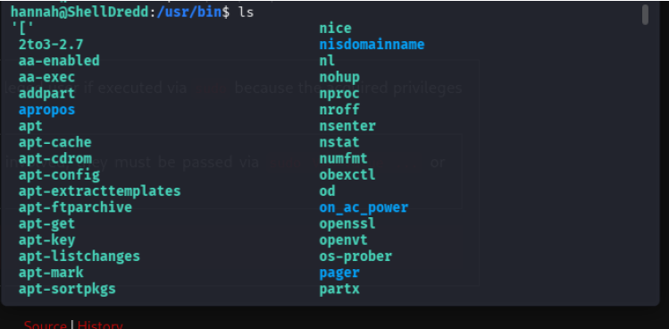
./ = execute

to understand

./cpulimit = a program. A system administration tool to slow down program to prevent freezing.

-l 100 = limit to 100%. Run all. No limit

-f = foreground. While running at front can forcing to take over terminal run command

/bin/sh = a command to allow program (cpulimit) execute a shell inside itself

Menu:
Target must run:
-p = process ID. Need program Id to run.
command: cpulimit -p 1234. Find the program holding ID card #1234 and slow it down.

-e = the name of files, without folder location.
command: cpulimit -e firefox. Find any program named 'firefox' and slow it down. (best work in root)

-P = full path address
Command: cpulimit -P /usr/bin/firefox. Go to the folder /usr/bin, find the file 'firefox', and slow that specific one down.

**this command wrong because also ask for -p(process ID) but nvr give the ID no.
***correct is .\cpulimit -l 100 -f /bin/sh

root and cd /root
root = the admin
cd /root = admin folder

learn the link https://www.geeksforgeeks.org/linux-unix/linux-file-hierarchy-structure/

what is usr/bin
usr = User System Resources (historically "User").
bin = Binaries (Executable programs).
A folder of your whole installed lives app

what is cp= copy
ps= to find program id

temp file very useful.. can put anything inside
allow to write, and delete after reboot

mkdir /tmp/ myfolder
mkdir = make a folder
tmp = go to temp folder
myfolder = folder name

google linpeas
***save files: https://github.com/peass-ng/PEASS-ng/tree/master/linPEAS
linpeas is scan victim machine
when ./ to run

port 1-1024 +well known
<1024 = dynamic
Port Number | Name | Who can use it? | Example
0 - 1023 | Well-Known (strictly reserved) | ROOT Only | 80 (Web), 22 (SSH)
1024 - 49151 | Registered (Open for Business) | Anyone | 8080 (Alt Web), 3306 (MySQL)
49152+ | Dynamic (Temporary) | System (Automatic) | Random temporary connections

