Fiscal Policy and the Coffee Cycle in El Salvador, 1948–1979: Working Notes
Compendium of the latest working notes — 12 November 2026
This compendium brings together, unchanged, the working notes produced in November 2026 on the revenue and fiscal series, the 1948–1960 period, the three pillars of the budget and the preliminary paper. Each part is a separate note, with its own sources. Later notes supersede earlier ones where they differ (for example, the pillar notes qualify the provisional pillar results in Parts 3 and 4).
Contents
- Preliminary Research Paper: Proposed Outline for Discussion
- Modernization from Above: Coffee, the State and the Forces Beneath the Stability, El Salvador 1948–1960
- The Revenue Series from the Memorias, 1952–1979: Design, First Findings and Next Steps
- The Combined Fiscal Accounts, 1952–1979: Expenditure, Interest and Debt — First Version and First Results
- From the Revenue Series to Expenditure, Econometrics and a Retrospective Fiscal Framework: Ideas for Discussion
- Validating the Three Pillars: What to Check, Where, and How
- Balancing the Pillars: The Coalition Pillar, in Spending and in Tax Spending
- Unit-Level Review of the Pillars: Pilot Year 1977

Part 1. Preliminary Research Paper: Proposed Outline for Discussion
Working note — 12 November 2026 (updated the same day: the three pillars adopted as the organizing frame). First step for the rough draft requested today: a preliminary academic report for a professor, summarizing this first research effort. Nothing is drafted yet. This note proposes the title, the argument, the structure and the evidence for each section, and asks the questions to settle before writing.

1. Working title and framing
Proposed title: Riding the Coffee Cycle: Fiscal Policy and the Road to Polarization in El Salvador, 1950–1979. A Preliminary Report.
Alternatives:
- Coffee, the Budget and the Closing of the Political Space: El Salvador’s Fiscal Accounts, 1952–1979
- The Fiscal Bargain of a Military Developmental State: El Salvador, 1950–1979
Reader. A professor in public economics, development or political economy, who needs to judge:
- what question the project asks;
- what evidence exists;
- what the first results are;
- how solid they are;
- what comes next.
Register. An academic working paper, not a policy note:
- a literature section;
- explicit hypotheses;
- a data and methods section;
- results with their limits;
- an agenda.
Length. About 25–30 pages with tables and figures, plus appendices.

2. The argument in one paragraph (to be tested in the draft)
Between 1950 and 1979, El Salvador’s military governments built a developmental State on a narrow fiscal base: coffee and trade, with light taxation of wealth and corporate income. The fiscal system transmitted the coffee cycle instead of smoothing it:
- Booms: windfalls were spent almost in full.
- Busts: spending was cut in the 1950s and 1960s, and from 1971 it was financed with debt.
The windfalls of the 1970s built the civilian State, mainly education, health and public works. But the bargain behind it excluded the groups that the State’s own modernization created:
- teachers;
- students;
- urban workers;
- landless rural families no longer able to migrate to Honduras.
When the 1978 bust came, after the safety valve of emigration and the political opening had closed, the State protected security spending and squeezed education. The fiscal accounts do not cause the war. They show how the regime chose to manage scarcity, and whom it chose to protect.

3. Proposed structure

1. Introduction (2 pages)
- The question: did the military governments’ management of the coffee cycle deepen the polarization that led to the civil war?
- Why the fiscal accounts: they record the regime’s choices year by year, where the political literature mostly infers them.
- The contribution:
  - a new annual fiscal dataset built from the Memorias de Hacienda, 1952–1979;
  - a first reading of it against the political sequence.
- The main findings in five bullets.

2. Literature and framework (4–5 pages)
- Development thought after 1945: ECLA structuralism (Prebisch), import substitution and Central American integration; the Hoselitz report as “the bible” of the Lemus government.
- Commodity regimes:
  - the coffee economy and its institutions;
  - the International Coffee Agreement (1962–), which supported prices in the 1960s;
  - the price boom of 1976–77.
- Fiscal procyclicality in Latin America: Gavin and Perotti (1997); Kaminsky, Reinhart and Végh (2004).
- Taxation and state formation:
  - Schneider on Central American tax systems and elites;
  - Besley and Persson on fiscal capacity;
  - Acemoglu and Robinson on elites, institutions and redistribution.
- El Salvador’s road to war:
  - Stanley, the “protection racket” State;
  - Almeida, protest waves under opening and threat;
  - Lindo-Fuentes and Ching, the education reform and the teachers;
  - Durham, land scarcity and Honduras;
  - Wood;
  - Dada Hirezi and Pleitez on the model and its coalition;
  - Turcios on the 1950s;
  - Gordon on the crisis of the 1970s.
- The framework: a fiscal bargain between the military, the coffee and industrial elite, and the new middle groups, tested through who paid, who was paid, and who was protected when money was scarce.
- The three pillars of the budget (author’s decision, 12 November 2026), the organizing frame of the paper:
  - Development (Education, Health, Public Works) buys legitimacy and builds the new middle groups;
  - Security (Defensa, Seguridad Pública) buys control;
  - Agro-export support (Agricultura) serves the coalition.
  - The balance among the pillars, and how it moves with the coffee cycle, is the budget’s record of whom the regime served.
  - Provisional: the pillars are ministry-based. The paper states their limits and treats the 1970s turning points with care until they are validated with Diario Oficial and other micro data (Note on Validating the Three Pillars).
  - Long-run benchmark (Pleitez): in the agro-export State (averages 1827–1948), security took 31.1% of spending, debt service 25.6% and development 20.5%. In 1948–1979 the shares were security 11.3%, debt 3.6% and development 45.6%. The 1950s were the shift from a security State to a development State.
- Hypotheses H1–H5 and Tracks A–D, stated as in the project.

3. Historical context in three periods (3–4 pages)
The periodization is the author’s, based on government periods:
- 1948–1960, modernization from above (Osorio, Lemus):
  - the 1950 Constitution;
  - the coffee tax of 1950 and the income tax of 1951;
  - the industrial promotion law of 1952;
  - the 1960 crisis.
- 1961–1967, opening and growth (Junta and Directorio, Rivera):
  - the Directorio’s reforms and their dilution;
  - the Common Market;
  - proportional representation (1964);
  - the founding of ANDES (1965).
- 1967–1972, the transition (Sánchez Hernández):
  - the education reform;
  - the strikes of 1968 and 1971;
  - the war with Honduras and the end of the safety valve;
  - the first guerrilla groups;
  - the 1972 fraud.
- 1972–1979, closure (Molina, Romero):
  - the University takeover;
  - the 1976 agrarian transformation and its withdrawal;
  - the 1977 fraud;
  - the Public Order law;
  - the October 1979 coup.

4. Data and methods (3 pages)
- The source: the Memoria de Hacienda (Informe Complementario Constitucional), read year by year, 1952–1979. Typewritten, sideways scans; figures read on the page image and checked by arithmetic.
- The conventions:
  - current revenue excludes loans and bonds;
  - spending on a credits-used basis;
  - the underlying result;
  - the classification of 1950s revenue into modern categories.
- The datasets:
  - revenue by source (about 30 lines);
  - expenditure by ministry, by pillar and, where available, by economic class;
  - interest, amortization and debt;
  - loan-financed projects;
  - the cost of the 1969 war.
- Methods: descriptive accounting by year and by government; boom and bust comparisons; shares and decompositions. No econometrics at this stage, and the paper says why: about 26 annual changes.
- Limits:
  - gaps (1957–59 detail; 1971–72 revenue detail; GDP before 1968; prices before 1974);
  - breaks in basis.

5. Results I: who paid — the revenue system (5 pages)
- A State financed at the border:
  - border taxes were 61% of revenue under Osorio, 44% under Rivera, 36% under Sánchez Hernández and 43–44% under Molina and Romero;
  - coffee alone was 27%, then 14%, then 23–26% in the 1970s.
- The 1960s reform:
  - income tax doubled its share (7% to 16%);
  - consumption taxes rose to 23%;
  - import duties were eroded by the Common Market.
- Light taxation of capital:
  - corporate income tax never passed 7% of revenue;
  - the net wealth tax (Vialidad Serie A) was about 2% until 1968;
  - coffee was exempt from income tax from 1950.
- Mass taxes: until 1961 alcohol and cigarettes yielded more than all direct taxes together.
- Figures:
  - composition by government (stacked bars);
  - the annual composition with governments shaded;
  - direct against border taxes.

6. Results II: who was paid — the three pillars, the cycle and debt (7 pages)
- The pillars over time (central figure: the three pillars, 1952–1979, against the 1827–1948 benchmark):
  - development rose from 38% (1952) to about half of spending in 1968–1973;
  - education peaked at 27% in 1971 and fell to 20% by 1979;
  - security fell from 16% (1954) to 6.5% (1976);
  - agro-export support overtook security in 1974–1977;
  - security doubled to 12.7% in 1979.
- The pillars in booms and busts: the 1959 adjustment cut public works and Defence; the 1978 bust raised security and cut education.
- Spending followed revenue up and did not follow it down. In booms, 94 centavos of each extra colón were spent. In busts, cuts in 1958–59, 1962 and 1968; deficit financing in 1971, 1975 and 1978.
- Debt took the strain from the late 1960s:
  - 15–27% of revenue up to 1962;
  - 39% at the end of Rivera;
  - 63% under Sánchez Hernández;
  - 71% in 1979.
  - Debt was cheap (2–5% interest), so the stress was in financing, not in the interest bill.
- Where the money went:
  - development rose to about half of spending;
  - education peaked in 1971 (27% on our basis; Pleitez gives 30.4%) and declined after;
  - security fell to 6.5% in 1976 and doubled to 12.7% by 1979.
- The 1978 bust as the turning point: security up ₡29.7M, education down ₡2.1M; current transfers and wages rose while real investment fell.
- The cost of the 1969 war and how it was paid:
  - war bonds;
  - the emergency tax;
  - the 1970 coffee windfall.
- Figures:
  - the three pillars, 1952–1979;
  - the underlying result and debt;
  - the boom and bust table.

7. Reading the evidence against the hypotheses (3–4 pages)
A table, H1–H5 and Tracks A–D, with three columns:
- what the data show;
- the strength of the evidence (strong, suggestive, untested);
- what is missing.
A first assessment:
Hypothesis | Preliminary verdict
H1 Education and University squeezed | Suggestive: a relative decline from 1971, a cut in 1978; the University series is still to build
H2 Teachers’ wages contained | Suggestive (1971 strike; refused salary scale); the payroll series is still to build
H3 Investment cut first | Supported in 1966–67 and 1978
H4 Central Bank financing | Partial: borrowing replaced cuts from 1971; Central Bank detail to assemble
H5 IRA food subsidies cut | Untested
A Tax bargain | Strongly supported (light taxation of capital; coffee exemption; reforms diluted)
B Honduras safety valve | Supported qualitatively; the fiscal trace is small at the border; the economic cost is unestimated
C Protection bargain | Supported from 1978–79 (security pillar doubles); not visible in the 1950s
D Reforms announced, then diluted | Supported (1961 income tax; 1974 land law; 1976 agrarian transformation)

8. Discussion: what the fiscal record adds (2 pages)
- The regime’s choice was not austerity but inclusion through spending without a tax bargain. It built schools and hospitals with coffee money and loans, not with taxes on wealth.
- This made the civilian State hostage to coffee and debt. When both failed in 1978, the protection bargain took precedence.
- The fiscal accounts complement Stanley’s and Almeida’s accounts: they date the turn (1971 for education, 1978 for security) and price it.
- Caveats:
  - association, not causation;
  - the danger of reading history backward;
  - growth in the 1960s was real.

9. Research agenda (2 pages)
Data:
- the 1957–59 detail;
- the economic classification for 1957–69;
- the teachers’ and University series;
- GDP and prices before 1968/1974;
- the Diario Oficial tax laws.
Analysis:
- windfall-allocation regressions;
- event studies;
- a retrospective medium-term fiscal framework with stress tests (a coffee stabilization fund counterfactual).
Outputs:
- the 1948–1960 note;
- a synthesis on the cost of the war;
- Spanish and Portuguese versions.

Appendices
- A. Sources and the conventions of the Memorias.
- B. The revenue mapping (1950s Títulos and subclasses to modern categories).
- C. Main tables: revenue by source, fiscal accounts, spending by pillar, 1952–79.
- D. Tax-law checklist (Diario Oficial).

4. Inputs and how they will be used
- Figures: only from the Memorias, via the verified yearly notes and the two workbooks.
- Context and literature: from the notes and the bibliography already in the repository. Any new source is read before it is cited, and added to the Bibliography note.
- No unverified claims. Statements such as “the first time” or “the largest” are used only where the series has been checked.

5. Decisions recorded (12 November 2026)
Question | Decision
Title | Riding the Coffee Cycle: Fiscal Policy and the Road to Polarization in El Salvador, 1950–1979. A Preliminary Report
The 1950s | The 1948–1960 note is drafted first; the paper draws on it
Literature review | Full, 5–6 pages
Voice | “This study”
Honduras | Included, as a case study
Organizing frame | The three pillars of the budget (development, security, agro-export support), carried from 1952 to 1979

6. Questions for the author before drafting (answered; kept for the record)
- Title and tone: which title, or another? Should the paper state the argument (section 2) as a thesis, or as a set of propositions to be tested?
- Coverage of the 1950s: the 1948–1960 note is not yet written. Should the paper cover the 1950s from the yearly notes and the revenue series only, or wait for that note?
- Length and depth of the literature section: a short review (2–3 pages) or a fuller one (5–6 pages) that positions the project?
- Authorship and voice: single author, first person (“I”) or “this study”? Any affiliation line (Andrew Young School)?
- Sections to drop or add: for example, a section on monetary policy (H4), or one on the war with Honduras as a case study.
On your answers, the next step is the draft of sections 1–4, sent in Word for review, before the results sections.

Part 2. Modernization from Above: Coffee, the State and the Forces Beneath the Stability, El Salvador 1948–1960
Working note — first draft for discussion, 12 November 2026. This note covers the founding decade of the project of modernization, from the coup of December 1948 to the fall of President Lemus in October 1960. It is written to feed the preliminary paper (Riding the Coffee Cycle). Figures come from the Memorias de Hacienda, through the verified yearly notes and the revenue and fiscal workbooks, and from the three works that frame the decade:
- Roberto Turcios, Autoritarismo y modernización (1993) and Rebelión: San Salvador 1960 (2017);
- William Pleitez, chapters 1–2 of his history of El Salvador’s development models;
- Héctor Dada Hirezi, La economía de El Salvador y la integración centroamericana, 1945–1960 (1978).
Page numbers are the printed pages of each work. Points still to verify are marked as such.

Summary
- The point of departure was a coffee economy and a coffee State. Around 1950 coffee was more than 80% of exports (88–89% in 1945–1954). The State’s tax base rested on trade.
- The modernization of 1948–1960 was financed by a windfall. The coffee price per quintal multiplied 4.6 times between 1945 and 1954. The new government captured part of it with a progressive export tax (1950), and tax revenue roughly tripled between 1946 and 1951.
- The money went to a developmental State:
  - schools, health and public works took 38–46% of spending;
  - the security apparatus took 13–16%, a share that drifted down;
  - large infrastructure (the Lempa dam, the Litoral highway, the port of Acajutla) was financed with foreign loans and State guarantees.
- The tax bargain was written for the coffee and commercial elite. Coffee paid at the border but was exempt from income tax. Companies paid 2.5–5% against up to 44% for individuals. The 1952 industrial law added exemptions. Taxes on alcohol and cigarettes yielded more than all direct taxes together.
- Diversification began but stayed thin. Cotton rose from 1% to 11% of exports (1945–1957); coffee’s share fell from 88% to 66% by 1960. Industry was small: in the early 1950s only 14 factories employed more than 100 workers.
- The 1958–59 coffee fall was managed without a fiscal crisis. The surplus built in the boom absorbed the first year. New consumption taxes and cuts in public works and Defence handled the second. Education was protected.
- The stability was partly superficial. The regime combined social reform with repression:
  - a state of siege in 1951;
  - the mass arrests of September 1952;
  - the 1952 law “in defence of the democratic order”;
  - an imposed election in 1956. It built a State that created new groups (teachers, students, State employees, professionals, urban workers) without giving them political voice. The crisis of 1960 was political, and these groups were at its centre.
Proposition for the paper: the 1950s built both the expectations (a developmental State, education, a middle class) and the fiscal model (coffee, trade and a light tax on capital) whose collision would define the 1970s.

1. Introduction
The author’s reading is that, until the end of the Rivera administration (1967), El Salvador was guided by the project of modernization begun by Colonel Óscar Osorio after the coup of 14 December 1948. The decade looked stable:
- one official party, the PRUD, governed continuously;
- the economy grew on high coffee prices;
- the State built roads, schools, hospitals, a dam and a port.
But forces were born and built up under that surface, and they would become decisive in the 1970s:
- a technical cadre;
- a middle class;
- organized students and workers;
- and a habit of repressing them.
This note asks three questions:
- What were the economy and the State at the start?
- What did the reforms try to change, and how were they financed?
- What was building up beneath the stability?
It adds three things to the existing narrative literature:
- the fiscal record, verified year by year from the Memorias de Hacienda (1952–1960);
- the international setting: development thought and the coffee market;
- a first, descriptive look at diversification.

2. The point of departure, c. 1948

2.1 A coffee economy
On the eve of the 1948 coup, El Salvador was a small, densely populated, rural economy built around one export.
- Coffee was the economy’s link to the world. It was 87.6% of exports in 1945 and 86.8% in 1948 (Dada Hirezi, Cuadro 2-1, pp. 28–29).
- Production grew slowly; prices did the work. Coffee export volume rose only from 57.7 thousand tonnes (1945) to 60.3 (1948) and 65.9 (1951). Export value doubled between 1945 and 1948 (₡46.7M to ₡90.4M), and doubled again by 1951 (₡190.1M).
- Output rose through labour, not land. Dada Hirezi stresses that the coffee frontier was closed; higher output came from more labour per hectare and from fertilizer (pp. 29–30).

2.2 A State shaped by 1932
The rural rebellion of January 1932 and its repression left two legacies that matter here.
- A military regime allied to the coffee elite. Martínez governed until 1944, and the army remained the arbiter of politics afterwards.
- A policy of containing change. Dada Hirezi argues that the Martínez regime protected artisans and small workshops, to avoid the unemployment that had fed the 1932 alliance. Examples:
  - a 1939 decree prohibited factories with capital above ₡20,000 in several lines;
  - machinery for sugar mills and cotton gins was banned (DH 1A, ch. 1).
  - Economic policy was used to contain a political threat. This mechanism is the subject of this project.

2.3 Instability, 1944–1948
- Between 1940 and 1948 strikes, mobilizations and military revolts ended the Martínez dictatorship and kept the country unstable (Pleitez, p. 188).
- The coup of 14 December 1948 brought a Consejo de Gobierno Revolucionario (CGR) to power. Its members called it not a “golpe” but “a movement of renewal, to achieve the new organization of the State” (Pleitez, p. 188, citing Turcios).
- The CGR’s Proclama de principios y objetivos (25 December 1948) promised, among other things:
  - higher living standards, “guaranteeing the growth of production, under the protection of technique”;
  - stimulus to private enterprise;
  - social justice;
  - Central American economic ties (Pleitez, p. 189).

2.4 The State’s finances before the Memorias
Our series of Memorias starts in 1952. For the late 1940s, a United Nations study of 1957, reproduced by Dada Hirezi (Cuadro 2-6, p. 38), gives central-government tax revenue.
Table 1. Tax revenue of the central government, 1946–1954 (₡ millions)
Tax | 1946 | 1949 | 1951 | 1954
Income tax | 2.66 | 5.14 | 5.95 | 10.62
Property | 0.46 | 0.86 | 0.96 | 2.85
Property transfers | 1.48 | 1.01 | 2.45 | 10.13*
Export duties | 4.50 | 11.80 | 34.27 | 46.24
Import duties | 15.03 | 28.20 | 42.85 | 53.51
Internal consumption taxes | 8.64 | 13.03 | 17.99 | 26.67
Other | 3.95 | 4.00 | 5.20 | 6.89
Total | 36.72 | 64.04 | 109.67 | 156.91
Export duties, % of total | 12.3% | 18.4% | 31.2% | 29.5%
Source: United Nations, La política tributaria y el desarrollo económico en Centroamérica* (1957), p. 123, as reproduced by Dada Hirezi, Cuadro 2-6. The table was read from a scanned copy. The components add to the totals for 1946–1951. *The 1954 transfers figure is derived from the printed total (the scan is illegible). It reflects a large succession tax that year, which the 1954 Memoria confirms (₡8.8M). Shares computed here.*
Three points stand out:
- Tax revenue tripled in five years (1946–1951), and rose fourfold by 1954.
- The export tax was the engine. Export duties rose sevenfold between 1946 and 1951, from 12% to 31% of tax revenue. Pleitez gives the same order of magnitude: 14.3% in 1948 and an average of 29.8% in 1951–1957 (p. 200).
- The income tax was marginal: 7% of tax revenue in 1946, and still 5.4% in 1951.
The Memorias’ own ten-year series begins in 1950. Ordinary revenue was ₡83.4M in 1950 and ₡117.7M in 1951, a jump of 41% in the first year of the new coffee tax (MH 1959 and MH 1960).
A fuller picture of the State’s finances at the start of the decade is in Wallich and Adler’s study for the Salvadoran government (Public Finance in a Developing Country: El Salvador — A Case Study, Harvard University Press, 1951; Spanish edition by the Fondo de Cultura Económica). The author holds a copy; it will be added when scanned.

3. The international setting

3.1 Development thought: ECLA, Prebisch and the Hoselitz mission
The modernization project drew explicitly on the new development economics.
ECLA’s structuralism. Under Raúl Prebisch, ECLA divided the world economy into a centre and a periphery:
- The centre had homogeneous, diversified productive structures.
- The periphery was heterogeneous and specialized: technical progress was confined to export activities in unstable markets.
Because productivity grew faster at the centre, and the periphery’s terms of trade tended to deteriorate, ECLA concluded that “average incomes diverge over time more intensely than productivities”. It prescribed:
- industrialization;
- a larger domestic market;
- regional integration;
- growth poles;
- gradual import substitution, beginning with consumer goods (Pleitez, pp. 194–195, citing Prebisch [1949] and Rodríguez).
The studies commissioned by the government. The government commissioned studies that shaped both its organization and its policies (Pleitez, pp. 192–194). The most influential was by the UN industrial expert Bert F. Hoselitz, Industrial Development of El Salvador (1954). President Lemus later called it “the bible” of his economic policy (Pleitez, p. 194).
Hoselitz started from the observation that El Salvador’s main resource was its population. He named the main problems:
- the low standard of living of the majority;
- strong seasonal variation in employment;
- heavy dependence on coffee;
- scarce skilled labour;
- a small domestic market.
Industrialization would:
- create more stable jobs;
- diversify production away from coffee;
- prepare Central American integration;
- reduce dependence on imported consumer goods;
- raise skills and wages.
His prescription was:
- light industry: food, textiles, leather, building materials;
- an input–output study of the links between industries;
- an aggressive education and training plan;
- a Central American free-trade area with a common external tariff;
- a development corporation (Pleitez, pp. 195–196).
The size of the challenge. Hoselitz counted only 14 factories employing more than 100 workers, and at most 32 employing more than 50 (Turcios, Autoritarismo, p. 43). He also noted the prevailing business maxim that an enterprise was worthwhile only if it promised a 50% profit within a year.
Integration. Integration became the strategy’s centrepiece. On 16 June 1951, at ECLA’s fourth session, the Central American ministers of economy agreed a three-point programme:
- wider markets;
- coordinated investment;
- trade liberalization.
El Salvador’s minister, Jorge Sol Castellanos, was among its strongest promoters. He said that for El Salvador the Common Market was not an ideal but “part of our vital and economic needs” (Turcios, Autoritarismo, pp. 44–45). Bilateral free-trade treaties followed. They led to the multilateral treaties of 1958 and the General Treaty of 1960.
Dada Hirezi’s reading of the outcome. He notes that the form integration finally took (broad free trade with a high common external tariff, rather than ECLA’s planned, reciprocal model) suited the Salvadoran agro-export and import groups. In his reading it consolidated the existing class structure.

3.2 The coffee regime: controls, decontrol and the producers’ agreements
The author’s view is that commodity exporters operated under arrangements in which prices were set by oligopoly, and that these favoured small countries like El Salvador. The sources support this view for the 1940s and the 1960s. They qualify it for the 1950s.
- The war years: an assured market, at a capped price. The Inter-American Coffee Agreement of 1940, backed by the United States, gave Latin American producers export quotas in the US market (ICO, History). During the war prices were controlled and the United States was practically the only buyer of Salvadoran coffee (Dada Hirezi, p. 29). The Salvadoran price rose only from ₡23.31 per quintal (1941) to ₡37.24 (1945) (Dada Hirezi, p. 29, n. 2).
- Decontrol and the post-war boom. After 1945 world trade shed its wartime restrictions and demand grew faster than supply. Producers organized:
  - the Federación Cafetalera Centroamérica–México (FEDECAME), founded in 1946 under the leadership of the Salvadoran Roberto Canessa, pressed to end the “price ceilings” agreed with the United States (Pleitez, pp. 190–191);
  - Canessa’s line in 1954: “If the North Americans want to pay less for a cup of coffee, the Latin American countries … also want to pay less for automobiles, refrigerators and other goods from the United States” (Pleitez, p. 191, n. 9).
- How far prices rose. The price of Salvadoran coffee went from ₡37.24 per quintal in 1945 to ₡102.53 in 1950 and ₡170.09 in 1954: an index of 100, 275 and 457 (Dada Hirezi, p. 29; Turcios, Autoritarismo, p. 33). Coffee export value rose from ₡46.7M (1945) to ₡230.0M (1954), while production rose only 24% (1945–1955).
- The 1950s boom was a market windfall, not a cartel price. The producers’ attempts to support prices came as prices fell after 1954, not before:
  - a “gentleman’s agreement” on minimum prices among Latin American producers (1954);
  - the Mexico Agreement (1957);
  - the Latin American Coffee Agreement (1958);
  - the first short-term International Coffee Agreement (1959/60), which brought in the African producers (ICO, History).
  - These agreements slowed the fall but did not stop it. Turcios’s price for Central American milds fell from US$65.20 per quintal (1956–57) to US$41.72 (1959–60) (Autoritarismo, p. 145). Dada Hirezi’s export price index (1953 = 100) fell from 125 in 1954 to 91 in 1958 and 74 in 1959 (p. 62).
- The effective cartel came in the 1960s. The 1962 International Coffee Agreement, with the United States as a member after the policy shift of the Alliance for Progress, set export quotas for all members. It entered into force in 1963 (ICO, History). This fits the author’s view that prices were supported in the Rivera years.
To verify: whether the United States paid premium prices for Latin American agricultural commodities in the early 1950s (the Korean War years, and any US price ceilings on coffee in 1951). The sources consulted so far describe the reverse in the 1940s (ceilings), and a market-driven boom in the early 1950s.

3.3 The Cold War in the isthmus
The decade’s politics were shaped by the Guatemalan revolution (1944–1954) and its overthrow in 1954.
- Turcios shows how the Osorio government read Guatemala as a threat.
- In late 1952 El Salvador began to press in the Organization of Central American States (ODECA) for regional action against communism, which “did not need much acuity to be read as an initiative against the Guatemalan government” (Autoritarismo, p. 81).
- Anti-communism became a frame for internal repression (section 6).

4. The modernization project, 1948–1960

4.1 The 1950 Constitution: a State with a social mandate
The Constitution of 1950 made the State the promoter of national development (Pleitez, pp. 189–190, citing Guidos Véjar).
- Article 2 obliged the State to ensure “liberty, health, culture, economic well-being and social justice”.
- Article 135 required the economic regime to respond “essentially to principles of social justice”.
- Article 137 guaranteed private property “in its social function”.
- Article 182 declared labour a social function and committed the State to “employ all the resources within its reach” to provide employment.

4.2 Institutions
The decade created or activated most of the institutions of the developmental State:
Area | Institution | Date
Electricity | CEL, the Lempa hydroelectric commission (the 5 de Noviembre dam) | Created by decree in 1945; operating from September 1948 (Pleitez, p. 215, n. 58)
Social security | ISSS | Social security law of 1949; new law of 1953 (DO 226, t. 161); first clinics from 1954 (Pleitez, p. 225)
Housing | IVU (urban housing) and the Instituto de Colonización Rural, replacing Mejoramiento Social | Early 1950s; Constitution art. 148 declared housing of social interest (Pleitez, p. 220)
Industrial credit | INSAFOP (Instituto Salvadoreño de Fomento de la Producción) | 1950s. Pleitez notes it limited itself to medium-term credit for low-risk projects (p. 210)
Integration | Bilateral treaties, then the multilateral treaties of 1958 and the General Treaty of 1960 | 1951–1960
The technical cadre came from the University and the 1944 generation.
- Reynaldo Galindo Pohl: a student leader in 1944, member of the CGR and Minister of Education.
- Jorge Sol Castellanos: Minister of Economy.
- Enrique Porras and Humberto Costa: Finance.
- Businessmen in office: Roberto Canessa and Víctor de Sola, president of CEL from 1950 to 1978 (Pleitez, pp. 198–199; Turcios, Autoritarismo, ch. 1).
The University’s support for the 1948 movement was explicit at the start. The students’ newspaper wrote that “the University Youth has traditionally been combative” (Turcios, Autoritarismo, ch. 1). That support did not last (section 6).

4.3 The fiscal reforms
The reforms of 1950–1953 built the tax system that would last, with changes, until 1961.
Decree | Content | Reading
D. 836 (CGR), 13 Sep 1950 | Coffee export tax made ad valorem and progressive (10% up to US$30 per quintal, rising to 30% on the excess above US$40). Coffee producers exempted from income tax on income from coffee land while the tax applies | Captures the windfall at the border; builds an income-tax exemption for coffee into the system; makes revenue more sensitive to the coffee price
D. 510, 10 Dec 1951 | Income tax: 28 brackets for individuals (3–44%); two for companies (2.5% and 5%); withholding on wages | A wide gap between individuals and companies
D.L. 661, 22 May 1952 | Ley de Fomento de Industrias de Transformación: duty-free imports for 5–10 years; income and local tax exemptions | The origin of industrial tax expenditures
D.L. 1308, 22 Dec 1953 | Ley de Vialidad: “Serie A”, a tax on net wealth | A wealth tax at very low rates (about 2% of revenue in the 1950s)
February 1959 | New taxes on beer and soft drinks, matches and liquor | Response to the coffee fall; also to offset revenue lost to the new protective tariff (Turcios, Autoritarismo, p. 143)
Sources: Pleitez, pp. 200–207; Note on the revenue series; Turcios.
Dada Hirezi summarizes the economic policy of the 1948 regime in nine measures (pp. 37–38):
- the end of wage payment in kind;
- repeal of the restrictions on capital accumulation;
- the higher coffee export tax, “allowing a transfer of the surplus from the agro-export sector to other sectors”;
- reform of the income tax;
- roads that opened land to cotton;
- incentives through credit and fiscal advantages;
- a dam that cut electricity prices by 25%;
- bilateral free-trade treaties;
- social security and urban unions under government control.
His summary: a State that took greater responsibility for capital accumulation, seeking “industrialization without breaking the internal social equilibrium”, the result of “a renewed hegemonic alliance” (p. 38).

4.4 Spending and the large works
The government spent the windfall on a developmental State (section 5.2). The largest works were financed outside the current budget:
- The 5 de Noviembre dam (CEL): through the autonomous agency, with State guarantees.
- The Litoral highway: an IBRD loan from 1954 (D.L. 1702), with the General Fund paying 57% of the cost over 1955–1962.
- The port of Acajutla (CEPA): through the port authority.
See Note on Loan-Financed Investment 1955–1962; Turcios, Autoritarismo, pp. 93–94.
The boom paid for the current budget and the counterpart funds; the big investments were financed by debt.

5. The fiscal record, 1950–1960

5.1 Revenue: a State financed at the border
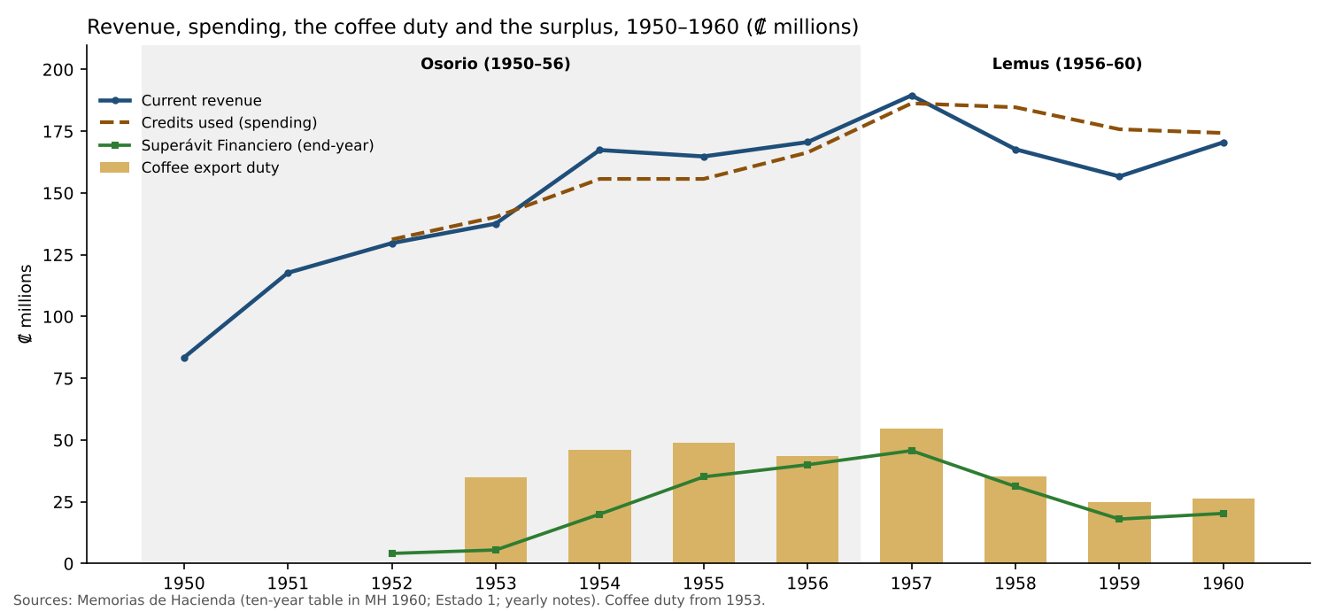
Revenue, spending, coffee duty and surplus
Ordinary revenue doubled in the decade, from ₡83.4M (1950) to ₡170.5M (1960), about 7.4% a year. The path followed coffee:
- a jump in 1951, the first year of the new coffee tax;
- a peak of ₡189.5M in 1957;
- a fall of 12% in 1958 and 7% in 1959;
- recovery in 1960.
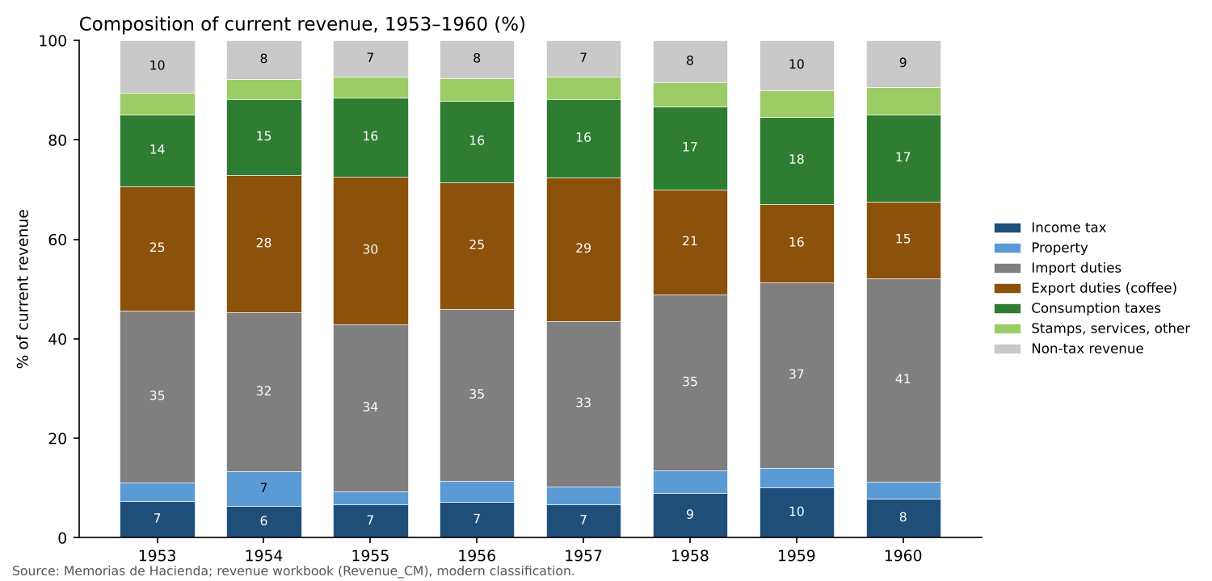
Revenue composition 1953–1960
Table 2. Composition of current revenue, 1953–1960 (%)
 | 1953 | 1954 | 1955 | 1956 | 1957 | 1958 | 1959 | 1960
Income tax | 7.4 | 6.4 | 6.7 | 7.2 | 6.8 | 9.0 | 10.1 | 7.9
Property | 3.6 | 7.0 | 2.6 | 4.2 | 3.5 | 4.5 | 3.9 | 3.4
Import duties | 34.7 | 32.0 | 33.6 | 34.6 | 33.3 | 35.4 | 37.3 | 40.9
Export duties (coffee) | 25.0 | 27.6 | 29.7 | 25.5 | 28.8 | 21.1 | 15.8 | 15.4
Consumption taxes | 14.4 | 15.4 | 15.8 | 16.4 | 15.7 | 16.7 | 17.5 | 17.4
Stamps, services, other | 4.4 | 4.0 | 4.2 | 4.6 | 4.5 | 4.8 | 5.4 | 5.6
Non-tax revenue | 10.4 | 7.7 | 7.3 | 7.5 | 7.4 | 8.5 | 10.0 | 9.3
Source: revenue workbook (Revenue_CM), Memorias de Hacienda, mapped to modern categories. Income tax excludes the Vialidad net wealth tax, which is in property. Export duties are almost entirely coffee: cotton paid no export duty.
What the composition shows:
- Border taxes were 60% of revenue (import and export duties together): 61% under Osorio and 57% under Lemus.
- Coffee alone was 25–30% of revenue in the boom. It fell to 15–16% in 1959–60.
- Direct taxes were small. Income tax was 6–10% of revenue. The net wealth tax (Vialidad) brought in ₡1.2–3.8M a year. Successions were the only property tax of weight, and erratic (₡8.8M in 1954, against ₡1.6–4.3M in the other years).
- Mass taxes outweighed direct taxes. Alcohol and cigarettes together (₡23–27M a year) yielded more than income and property taxes combined in every year with data (1954–1960).
- Cotton was almost untaxed. The second export crop paid no export duty. The only trace is a small tax “Sobre el Algodón” recorded under consumption taxes (₡0.29M in 1956, ₡0.35M in 1957, ₡0.03M in 1958). Cotton exports were then worth ₡39–44M a year.
The exposure. With the colón fixed at ₡2.50 per dollar since 1935, the coffee price passed directly into revenue. Turcios estimates that each dollar off the coffee price cost the State about ₡1.19M (Autoritarismo, p. 147). The coffee duty fell from ₡54.6M (1957) to ₡35.4M (1958) and ₡24.8M (1959), a loss of ₡29.8M, or 16% of 1957 revenue.

5.2 Spending: the three pillars of the regime’s bargain
The frame (author’s decision, 12 November 2026). This study reads the budget as the three pillars of the bargain on which the military regime rested:
- Development (Education, Health and Public Works) buys legitimacy and builds the new middle groups: teachers, students, State employees, professionals.
- Security (Defensa and Seguridad Pública, the Defence-controlled apparatus) buys control.
- Agro-export support (Agricultura y Ganadería) serves the coalition: research, extension and credit for coffee and cotton.
The balance among the three pillars, and how it changes when coffee rises or falls, is the budget’s record of whom the regime chose to serve.
The pillars are measured here from ministry totals and are provisional. They are to be validated with unit-level and off-budget data from the Diario Oficial and other sources (see Note on Validating the Three Pillars).
The long-run benchmark: from a security State to a development State. Pleitez’s averages for the agro-export State, 1827–1948 (Tabla 1.15, p. 165), against the import-substitution model, 1948–1979 (Tabla 2.10, pp. 247–248):
Share of central-government spending | Agro-export State, 1827–1948 (average) | 1948–1979 (average) | This study, 1952–1960 (range)
Security (defence and security) | 31.1% | 11.3% | 12.6–15.9%
Development (education + health + public works) | 20.5% | 45.6% | 37.7–45.7%
— education | 6.1% | 20.2% | 13.2–19.5%
— health | 4.2% | 10.8% | 9.4–11.0%
— public works | 10.2% | 14.6% | 14.7–17.7%
Agro-export support (agriculture) | 0.3% | 6.2% | 2.6–3.1%
Debt service | 25.6% | 3.6% | about 2% (1958)
Sources: Pleitez, as cited (his averages draw on the Memorias, the Diario Oficial and Wallich and Adler); this study, Table 3 below. The 1827–1948 figures are long-run averages, not the situation of 1948, and should be read as an order of magnitude.
The 1950s were the turning point. The old State spent close to six of every ten colones on security and debt. The new one spent more than four on schools, health and roads, and between 13% and 16% on security. The budget changed its pillars in one decade.
The rest of the period (figure 5) shows when the balance turns again:
- development peaks at about half of spending around 1968–1973;
- education peaks at 27% in 1971;
- agro-export support overtakes security in 1974–1977, the years of the ISTA and the agrarian programmes;
- security doubles from 6.5% (1976) to 12.7% (1979), back to the level of the late 1950s.
That is the subject of the preliminary paper.
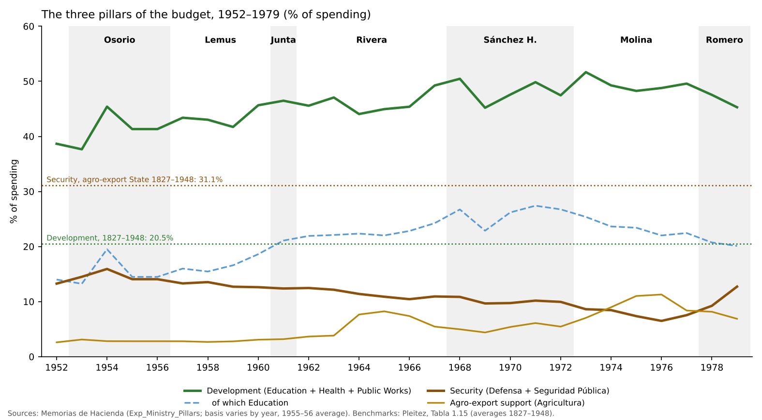
The three pillars, 1952–1979
The 1950s in detail.
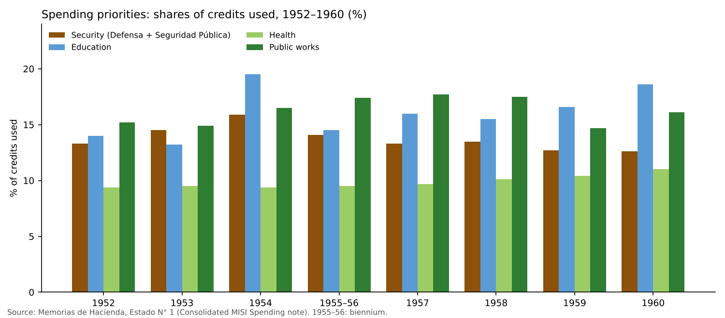
Spending shares 1952–1960
Table 3. Spending priorities, shares of credits used (%)
 | 1952 | 1953 | 1954 | 1955–56 | 1957 | 1958 | 1959 | 1960
Security (Defensa + Seguridad Pública) | 13.3 | 14.5 | 15.9 | 14.1 | 13.3 | 13.5 | 12.7 | 12.6
Education | 14.0 | 13.2 | 19.5 | 14.5 | 16.0 | 15.5 | 16.6 | 18.6
Health | 9.4 | 9.5 | 9.4 | 9.5 | 9.7 | 10.1 | 10.4 | 11.0
Public works | 15.2 | 14.9 | 16.5 | 17.4 | 17.7 | 17.5 | 14.7 | 16.1
Development (education + health + public works) | 38.7 | 37.7 | 45.4 | 41.3 | 43.4 | 43.0 | 41.7 | 45.7
Agriculture (memo) | 2.6 | 3.1 | 2.8 | 2.8 | 2.8 | 2.7 | 2.8 | 3.1
Source: Consolidated MISI Spending note, from Estado N° 1 of each Memoria. 1955–56 was a single biennial fiscal period.
- Development dominated from the start. It took about three times the share of security in every year (2.6–3.6 times), and rose with the boom.
- Education grew fastest, from 14% to 19% of spending. Turcios gives the education budget as ₡20.8M in 1956 and ₡32.9M in 1960 (Rebelión, p. 168).
- Security drifted down, from a peak of 15.9% (1954) to 12.6% (1960), already close to Pleitez’s average of 11.3% for 1948–1979.
- Agro-export support got little: 3% of spending, in an agricultural country. The coalition was served mainly on the revenue side (the coffee income-tax exemption, untaxed cotton), not through the budget.

5.3 The 1958–59 coffee fall: a managed adjustment
The fall in coffee prices was the decade’s one serious shock. It was met in three steps (Consolidated MISI note; Narrative Exercise):
- 1958, the surplus. Revenue fell 11.5% and export duties 35%, but spending was held (credits used −0.9%). The ₡17.0M deficit was financed from the Superávit Financiero accumulated in the boom, which fell from ₡45.7M to ₡31.2M.
- February 1959, new taxes. Taxes on beer, soft drinks, matches and liquor, “to maintain the pace of spending” (Turcios, Autoritarismo, p. 143).
- 1959, cuts:
  - public works −19.9%;
  - Defence −13.3%;
  - education +2.2% and health −1.7%.
  - The Ministry described an “orderly restriction” of spending (Turcios, Rebelión, p. 128).
By 1960 revenue had recovered (+8.9%), led by import duties. The surplus rose again to ₡20.3M.
What the adjustment reveals:
- The regime cut investment and the army, not schools. This is the opposite of the “security protected, development cut” pattern the project looks for. It appears only later (1978).
- It did not borrow: direct debt fell from ₡45.8M (1958) to ₡35.6M (1960).
- It did not tax capital. The new taxes of 1959 were on mass consumption.

5.4 Debt
Public debt was small and stable:
- ₡30.6M in 1952;
- a peak of ₡45.8M in 1958;
- ₡35.6M in 1960.
That is 15–27% of a year’s revenue, with interest about 1% of revenue. The large works were financed with IBRD loans and State guarantees to the autonomous agencies, and their service was paid from the ordinary budget. By 1961–62 the Litoral loans alone cost ₡4.3–4.5M a year (Note on Loan-Financed Investment).

6. Diversification and complexity

6.1 The idea
A recent literature measures development by what a country knows how to make.
- Hausmann, Hwang and Rodrik (2007), “What You Export Matters”: the productivity level of a country’s export basket predicts its growth.
- Hidalgo and Hausmann (2009), “The Building Blocks of Economic Complexity”, and The Atlas of Economic Complexity (2011): they treat development as the accumulation of productive capabilities, visible in the variety (diversity) and rarity (ubiquity) of a country’s exports.
In that language, the project of 1948–1960 was an attempt to make El Salvador’s economy more complex: to move from one crop to a wider basket of agriculture, light industry and regional trade. The idea is close to ECLA’s (heterogeneity, the spread of technical progress) and to Hoselitz’s (skills, linkages, an input–output study).

6.2 What the data show (descriptive)
The formal indices need detailed trade data that start in the 1960s. For the 1950s, export concentration is the simplest available measure.
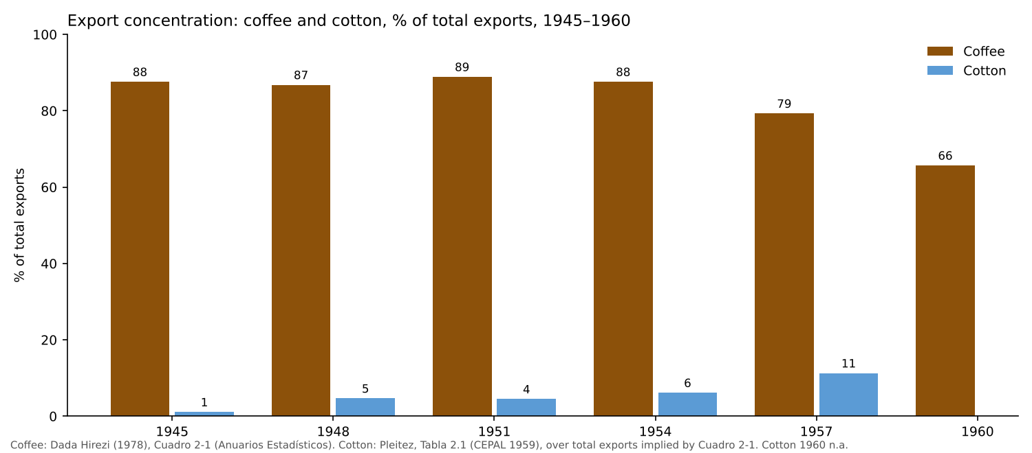
Export concentration
Table 4. Coffee and cotton in total exports, 1945–1960
 | 1945 | 1948 | 1951 | 1954 | 1957 | 1960
Coffee exports (₡M) | 46.7 | 90.4 | 190.1 | 230.0 | 274.6 | 191.7
Coffee, % of total exports | 87.6 | 86.8 | 88.9 | 87.6 | 79.3 | 65.7
Total exports (₡M, implied) | 53.3 | 104.1 | 213.8 | 262.6 | 346.3 | 291.8
Cotton exports (₡M) | 0.58 | 4.87 | 9.59 | 16.14 | 39.05 | n.a.
Cotton, % of total exports | 1.1 | 4.7 | 4.5 | 6.1 | 11.3 | n.a.
Sources: coffee, Dada Hirezi, Cuadro 2-1 (Anuarios Estadísticos); cotton, Pleitez, Tabla 2.1 (CEPAL, 1959). Total exports are implied by coffee’s value and share. Pleitez’s text gives total exports in 1945 as “USD 53.3 million”; the match with the implied ₡53.3M suggests the figure is in colones.
- Coffee’s dominance held through the boom. It was 87–89% of exports until 1954, and fell to 79% in 1957 and 66% in 1960, mainly because the coffee price fell.
- Cotton was the one new export of weight. Area tripled (12.9 to 39.7 thousand hectares, 1945–1957), yields almost tripled and export value rose 55 times (Pleitez, pp. 190–191).
- The new crop was agricultural, not industrial. It reorganized the coastal plain and the agrarian structure (Dada Hirezi, p. 29). It was also capital-intensive and seasonal, and it displaced tenants and sharecroppers.
- Industry remained small (14 factories with more than 100 workers). Its expansion came after 1960 with the Common Market.
Reading. By 1960 the economy had moved from one crop to two, both agricultural and both exposed to world prices. Diversification in the sense of new capabilities (industry, skills, regional trade) was planned in the 1950s and delivered, partly, in the 1960s. A formal complexity measure for 1962–1979 is possible with SITC trade data (UN Comtrade; the Atlas). It belongs to the research agenda.

7. Forces building beneath the stability

7.1 A regime that reformed and repressed
The PRUD governed as a single dominant party. It saw itself as “the depository of the revolutionary energies” of 1948 (Turcios, Autoritarismo, p. 70). Its record combined social reform with repression:
- 9 March 1951: the Assembly decreed a state of siege. The Comité de Reorganización Obrero Sindical (CROS) was dissolved, and union leaders were jailed and expelled (p. 73).
- 26 September 1952: a second state of siege. The Guardia and the Policía Nacional arrested workers, students and democrats; a union historian puts the number above two thousand. It was “one of the largest mass arrests on record” and broke up most of the opposition (pp. 76–80).
- 27 November 1952: the Ley de Defensa del Orden Democrático y Constitucional “institutionalized the political and legal irregularity of the country” (p. 81).
- 1956: Lemus was elected with 477,000 votes against 11,000 for the PAR and 22,000 for the PAC, in an election marked by imposition. Afterwards the opposition was harassed (p. 72).
Turcios calls September 1952 the turning point: the anti-communist turn of the Osorio government, and the start of a process of loss of social legitimacy (p. 81).

7.2 The new groups the State created
The modernization created the groups that would later oppose the regime:
- State employees, teachers and professionals, in a budget where education went from 14% to 19% of spending.
- Students and the University, which had supported the 1948 movement and whose leaders had entered the government.
- Urban workers, organized in unions under government control (Dada Hirezi, p. 38).
- The rural poor:
  - a seasonal labour force for coffee and cotton;
  - tenants displaced by cotton;
  - outside the minimum wage, which the landowners resisted when it was proposed in 1960 (Turcios).
  - For many, emigration to Honduras was the outlet (Dada Hirezi). That outlet would close in 1969.

7.3 The 1960 crisis
The crisis that ended the Lemus government was political (Narrative Exercise, drawing on Turcios, Rebelión):
- the split between Osorio and Lemus within the PRUD;
- an opposition front (the Frente Nacional de Orientación Cívica);
- disputed municipal and legislative elections;
- cases of police torture;
- the influence of the Cuban revolution;
- the regime’s own repression in August–September 1960, which turned protest into rebellion.
The protests demanded democracy, not an end to austerity. 1960 was a year of economic recovery: a record coffee harvest and manufacturing at its decade high (Rebelión, pp. 48–49). The fiscal accounts agree: the deficit nearly closed and the surplus rose in 1960.
The fiscal squeeze of 1958–59 was background, not the trigger. The longer-run link is different. Turcios argues that the opposition of 1960 reflected the social changes produced by the decade’s modernization (Rebelión, p. 320). Those were the groups in section 7.2.

8. Reading the decade against the thesis
Claim | Verdict for 1948–1960 | Evidence
Coffee financed modernization | Supported | Tax revenue tripled 1946–1951 on the export tax; development spending 38–46%
Revenue was exposed to coffee | Supported | Border taxes 60% of revenue; coffee duty −55% from 1957 to 1959
Security was protected in downturns | Not supported | Security share drifted down; Defence cut 13% in 1959
Adjustment fell on development | Partly | On public works (−20% in 1959), not on education or health
The fiscal squeeze caused the 1960 crisis | Not supported | 1960 was a recovery year; the crisis was political
The tax bargain favoured coffee and capital | Supported | Coffee exempt from income tax; companies 2.5–5%; cotton untaxed at the border; mass consumption taxes larger than direct taxes
ISI and integration changed the economy | Begun, thin | Cotton to 11% of exports; few factories; integration treaties signed
Repression accompanied reform | Supported | 1951 and 1952 states of siege; the 1952 law; the 1956 imposition; 1960
Track A (the tax bargain): the starting point. The fiscal system of the 1950s was designed to capture the coffee windfall at the border without touching the income or wealth of the coffee and commercial elite. That design left the State’s finances hostage to the coffee price, and it made the next step (taxing capital) politically costly. The Directorio tried that step in 1961 and partly undid it within months.
H3 (investment adjusts first): confirmed early. In the decade’s only downturn, public works were cut first.
The three pillars in the 1950s. Development rose, security fell and agro-export support stayed small. The bargain was paid for in legitimacy, not in control, and the coalition was served through the tax system.
The protection bargain (Track C) is not visible in the budget yet. The army was the regime’s political base, but it did not have a protected budget share. Repression was carried out by the regular police and the Guardia, at modest cost.

9. Implications for the paper
- The 1950s built the expectations. A State constitutionally committed to social justice, that spent most of its budget on schools, health and roads and that trained a technical cadre, created new groups with new claims.
- The 1950s also built the fiscal model. A tax system based on coffee and trade, with a light tax on capital and mass consumption taxes larger than direct taxes, financed those expectations only as long as coffee paid.
- The decade’s politics set the pattern of response. States of siege, laws “in defence of order” and imposed elections were the regime’s answer to opposition, even in good years.
- The collision came later. The 1958–59 downturn was absorbed by a surplus and a selective cut. The question for the 1960s and 1970s is what happened when the buffers were thinner, the coffee cycle wilder and the new groups larger and organized.

10. Data gaps and next steps
Gap | Why it matters | Source
Memorias 1948–1951 | The first years of the project are covered only by secondary sources | Archivo General de la Nación; Ministry of Finance library
Wallich and Adler (1951) | The best contemporary picture of the State’s finances at the start | Author’s copy (to scan)
Annual coffee price and volume, 1945–1960 | Only selected years so far | Anuarios Estadísticos; ICO; FAO
Total exports by product, 1948–1960 | To compute a full concentration index | BCR, Revista Mensual; Anuarios Estadísticos
GDP and prices | To express everything in real terms and as shares of GDP | CEPAL (1959), El desarrollo económico de El Salvador
The 1959 Tarifa de Aforos and the cotton tax | To date the protective tariff and the cotton levy | Diario Oficial
US commodity premiums in the early 1950s | To verify the author’s recollection | US Department of State; FRUS; USDA

Sources
Primary
- Ministerio de Hacienda, Memorias de Hacienda (Informe Complementario Constitucional), 1952–1960, via the verified yearly notes, the Consolidated MISI Spending note (1952–1960), the Narrative Exercise (1952–1960) and the revenue and fiscal workbooks of this project.
Secondary (in the repository)
- Dada Hirezi, Héctor. La economía de El Salvador y la integración centroamericana, 1945–1960. San Salvador: UCA Editores, 1978. Read from a scanned copy (OCR); figures were checked by arithmetic where possible.
- Pleitez, William. Chapters 1–2 of his history of El Salvador’s development models (full reference to be confirmed); chapter 2, “El modelo de industrialización por sustitución de importaciones”, pp. 187–270.
- Turcios, Roberto. Autoritarismo y modernización: El Salvador 1950–1960. San Salvador, 1993 (2003 edition).
- Turcios, Roberto. Rebelión: San Salvador 1960. San Salvador: CENICSH/MINED, 2017.
Other
- Hausmann, R., J. Hwang and D. Rodrik (2007). “What You Export Matters.” Journal of Economic Growth 12(1).
- Hausmann, R., C. Hidalgo et al. (2011). The Atlas of Economic Complexity. Harvard CID / MIT Media Lab.
- Hidalgo, C. and R. Hausmann (2009). “The Building Blocks of Economic Complexity.” PNAS 106(26).
- Hoselitz, Bert F. (1954). Industrial Development of El Salvador. New York: United Nations (cited through Pleitez and Turcios).
- International Coffee Organization. History of the ICO: 50 years. https://ico.org/documents/history-ico-50-years-e.pdf
- Prebisch, Raúl ([1949] 1950). El desarrollo económico de la América Latina y algunos de sus principales problemas. ECLA.
- United Nations (1957). La política tributaria y el desarrollo económico en Centroamérica. Mexico (cited through Dada Hirezi).
- Wallich, Henry C. and John H. Adler (1951). Public Finance in a Developing Country: El Salvador — A Case Study. Cambridge, Mass.: Harvard University Press.

Part 3. The Revenue Series from the Memorias, 1952–1979: Design, First Findings and Next Steps
Working note for discussion — November 2026 (updated 11 November 2026 with the detailed series). Companion to the workbook El_Salvador_Revenue_Memorias_1952_1979.xlsx. It records the discussion so far on charts, periodization and disaggregation, what the detailed series shows, and the decisions pending.

1. What the workbook contains now
- One row per year, 1952–1979, in millions of colones at current prices.
- All figures come from the Memorias de Hacienda as verified in the yearly notes, and are mapped into one modern classification:
  - income tax (personal, corporate, other);
  - property and wealth;
  - import duties;
  - export duties (coffee, other);
  - consumption of goods;
  - services, stamps and other taxes;
  - the 1969–70 emergency tax;
  - non-tax revenue.
- From 1953, the categories add up to the printed tax and current-revenue totals in every year, within ±0.02.
- Limits:
  - 1952 has totals only (old classification, customs not split);
  - in 1970, “services, stamps and other” is a residual;
  - in 1971–72, the coffee duty and the personal/corporate split are not available;
  - there is no annual coffee price before 1960;
  - real values can be computed only from 1974.
New sheets (11 November 2026).
- Revenue_Detail: about 30 lines inside the same groups (section 4). Every group has a “not itemized” column, so each group ties to Revenue_CM and the tax total ties to the printed total in every year.
- Periods: composition by government, weighted averages, with a stacked-bar chart.
- Charts_Detail: the four recommended charts of section 2, plus consumption and property taxes over time.
- Charts_Shaded: the annual composition with each government shaded, and the period bars (images).
- Tax_Laws: five new items (the 1953 Ley de Vialidad; the cotton tax; the cosmetics tax; the selective consumption tax; the 1977 doubling of the net wealth tax).
Conventions adopted (11 November 2026).
- “Corporate income tax” (renta de empresas), not “company tax”.
- The 1950s Títulos and subclasses are mapped into the modern categories, with the mapping explained in the workbook.

2. Recommended additional charts
From the data already in the workbook
- Direct taxes against export and import duties, as shares of revenue (1953–79). It shows the “who paid” question directly: a State financed at the border, with direct taxes rising mainly in busts (1962, 1975, 1978).
- Corporate income tax as a share of the coffee duty (1964–79). It swings from about 61% in busts to 13% in booms: how lightly capital was taxed relative to coffee.
- Revenue growth against the change in the coffee price (1960–79). Paired bars showing revenue sensitivity to coffee, and the years when volume rather than price drove the duty (1975, 1978–79).
- Change in each revenue source in boom and bust years (1976–77 against 1978). It shows that the coffee duty carries the cycle while the other taxes barely move.
Needing one more series
- Tax revenue as a share of GDP, 1952–79, with markers for major tax laws. It needs GDP before 1968 (CEPAL, Estudio Económico de América Latina).
- Real revenue per person. It needs a price index before 1974 and population (DIGESTYC; censuses).
With the expenditure workbook
- Coffee duty against security and development spending.

3. Periodization by government

3.1 The proposal
The author proposes reading the evolution of the tax system by period:
- 1948–1960: the modernization begun by Osorio.
- 1960–1967: the opening and rapid growth of the Rivera years, driven by the Common Market, with coffee prices lower and more stable than in the 1970s.
- The Molina and Romero periods.
This note suggests one addition: the Sánchez Hernández period (1967–1972) as a period of its own. It is where the turn happens:
- the 1969 war and the end of the Common Market’s dynamism;
- the education reform and the ANDES strikes of 1968 and 1971;
- the 1972 electoral fraud.
It also has a distinct tax signature: the 1969 emergency tax, and property taxes doubling after the 1968 increase in the net wealth tax.

3.2 Results by government
Shares of current revenue, weighted by revenue (period sum of each source over period sum of current revenue). Years are assigned to the president inaugurated the previous July (e.g. 1962 to Rivera).
% of current revenue | Osorio 1953–56 | Lemus 1957–60 | Junta 1961 | Rivera 1962–67 | Sánchez H. 1968–72 | Molina 1973–77 | Romero 1978–79
Income tax | 6.9 | 8.4 | 9.7 | 15.5 | 15.8 | 16.4 | 17.6
— personal | n.a. | n.a. | n.a. | 8.8* | 9.7* | 7.6 | 8.4
— corporate | n.a. | n.a. | n.a. | 5.3* | 4.4* | 6.0 | 6.7
Net wealth tax (Vialidad A) | 1.5 | 2.1 | 2.3 | 2.3 | 6.1* | 4.1 | 4.7
Other property taxes | 3.1 | 2.5 | 2.5 | 2.2 | 2.4* | 2.2 | 2.8
Import duties | 33.7 | 36.6 | 36.6 | 29.9 | 22.6 | 15.7 | 15.0
Export duty: coffee | 27.0 | 20.6 | 14.1 | 13.8 | 12.4* | 25.6 | 22.6
Other export duties | 0.0 | 0.0 | 0.4 | 0.5 | 0.9* | 2.8 | 5.8
Alcohol and cigarettes | 13.9* | 15.0 | 16.8 | 15.5 | 13.6* | 10.7 | 9.8
Other consumption taxes | 1.7* | 1.8 | 2.0 | 7.4 | 9.8* | 6.8 | 6.4
— of which petroleum products | – | – | – | 4.9* | 6.9* | 3.5 | 3.0
Stamps, services, other, emergency | 4.1 | 4.3 | 4.9 | 6.0 | 9.8 | 10.4 | 10.6
Non-tax revenue | 8.2 | 8.7 | 10.5 | 6.8 | 6.4 | 5.4 | 4.8
Memo: direct taxes | 11.5 | 12.9 | 14.6 | 20.0 | 24.4 | 22.6 | 25.1
Memo: border taxes (imports + exports) | 60.7 | 57.3 | 51.1 | 44.2 | 36.0 | 44.1 | 43.4
Revenue growth per year | 7.1% | 0.0% | −7.3% | 6.2% | 7.5% | 29.3% | 1.4%
Coffee price (US$/kg) | n.a. | 0.92 (1960) | 0.90 | 0.91 | 1.00 | 2.52 | 3.71
*Split within the group missing in some years; the group’s share is for the whole period and is divided using the years available (personal/corporate from 1964, not 1971–72; coffee not 1971–72; alcohol and cigarettes from 1954; property detail not 1971–72; petroleum from 1963).
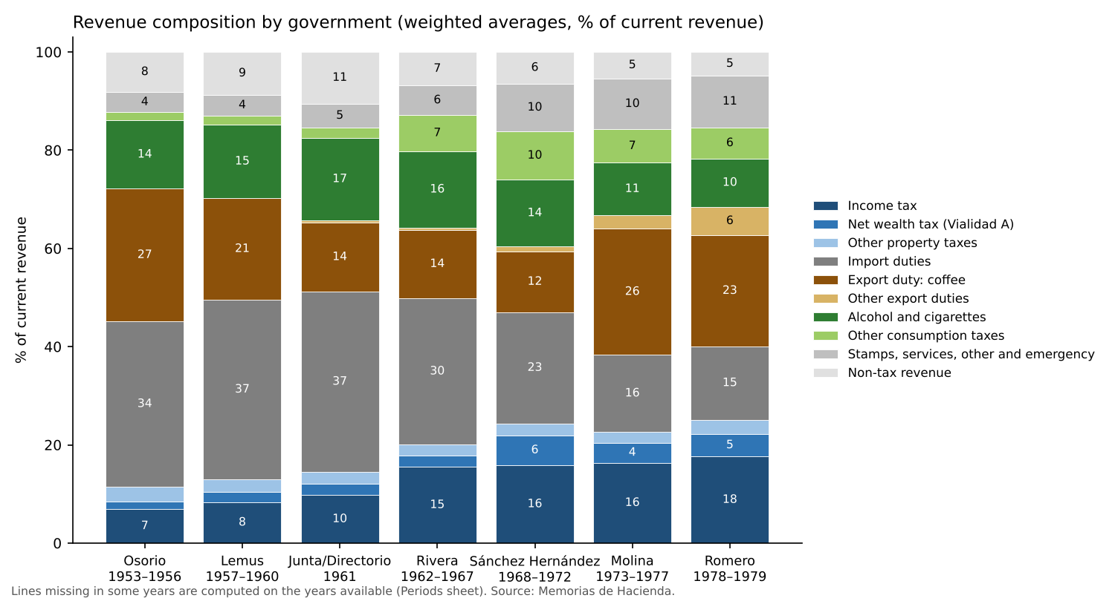
Revenue composition by government
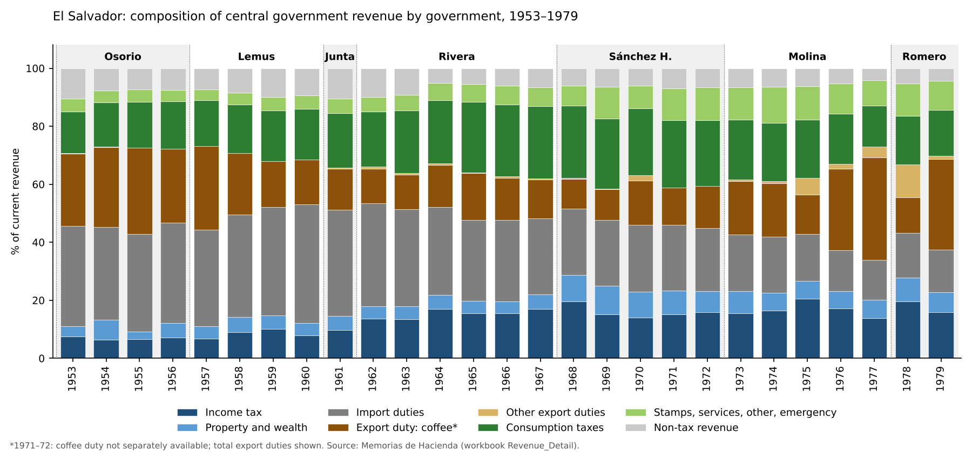
Annual composition with governments shaded

3.3 What the table suggests
- The 1960s changed the tax base. Under Rivera the share of direct taxes nearly doubled (12% to 20%) after the 1961 and 1963 income-tax laws, coffee’s share halved (about 27% to 14%), and consumption taxes rose to 23%. On the revenue side this was the most diversified period of the series.
- The Common Market eroded import duties: from 37% of revenue under Lemus to 23% under Sánchez Hernández and 15% in the 1970s, through regional free trade and industrial exemptions.
- The 1970s coffee boom reversed the 1960s. Under Molina and Romero, coffee’s share returned to the Osorio level (23–26%), while direct taxes stayed around 23–25%. The State went back to riding coffee.
- Coffee prices confirm the author’s recollection. They were low and stable in 1960–67 (US$0.81–1.01/kg), supported from 1963 by the International Coffee Agreement. They were US$1.37–1.45 in 1973–75 and US$3.15–5.17 in 1976–77. Revenue growth in the Rivera years came from income and consumption taxes, not from coffee.

3.4 Charts for the periodization
- A 100%-stacked bar of revenue composition, one bar per government.
- The annual composition chart with each government shaded as a band, so that within-period swings (1958–59, 1978) stay visible.
- A summary table of period averages with growth and the coffee price.

3.5 Decisions pending (the workbook uses the first option in each case)
- Treat Sánchez Hernández as a separate period? Decided (12 November 2026): yes — see section 7. Still open: keep the 1961 Junta/Directorio year apart or join it to Rivera?
- Transition years. Presidents took office on 1 July, but each year’s budget was enacted the previous December by the outgoing government. Options:
  - the year after inauguration goes to the new president (used above);
  - split those years, or mark them as transition years.
- Weighted averages (used) or simple averages of annual shares?
- A 1948 benchmark bar from Pleitez? He gives export taxes at 14.3% of tax revenue in 1948 (29.8% on average in 1951–57) and income tax at 5.7% in 1948. Our Memorias start in 1953.

4. Disaggregation: the proposed detail
The broad categories hide the distinctions the argument needs. The proposed structure has about 25 lines.

4.1 Income tax
Lines: personal, corporate, other income.
- 1964–1979: the split is available, except 1971–72 (statements missing from the scans).
- 1953–1963: the Memorias give only the total; the split would have to come from the Dirección General de Contribuciones Directas. The income tax law of December 1963 (D. 479) introduced the separate reporting.
- Fines are included in 1964–68 and excluded from 1969. From 1975 the statements show income-tax fines separately, as non-tax revenue.

4.2 Property and wealth: what Vialidad is
Vialidad Serie “A” is a net wealth tax.
- It was created by the Ley de Vialidad, D.L. 1308 of 22 December 1953 (Diario Oficial No. 233, Tomo 161).
- The law that replaced it in 1986 (Ley del Impuesto sobre el Patrimonio, D.L. 553 of 18 December 1986) states that the tax “recae sobre el capital o patrimonio de los sujetos pasivos” and that its rates were “mínimas”.
- The 1975–79 statements call it “Impuesto sobre el Capital (Vialidad Serie ‘A’)”.
Proposed name: “Net wealth tax (Vialidad Serie A)”. Its jump in 1968 (₡5.7M to ₡15.4M) is then a wealth-tax increase, which matters for the tax-bargain argument.
Proposed lines:
- net wealth tax (Vialidad A);
- property-transfer tax (alcabala; under “other taxes” in the 1950s);
- succession tax;
- gift tax;
- agricultural land tax (1978–79);
- paving levy.

4.3 Exports: coffee, sugar, shrimp and cotton
Lines: coffee, sugar, shrimp, cotton (if any), other merchandise.
- Coffee dominates throughout.
- Shrimp: taxed from 1961 (D. 154).
- Sugar: a progressive export tax from November 1974 (D.L. 135), yielding ₡25.6M in 1975 and falling to almost nothing by 1978.
- “Other merchandise” reached ₡116.6M in 1978 and fell back to ₡12.5M in 1979; its legal basis is still to be identified.
- Cotton is the notable case. It reached about 15% of exports by 1960 (Acevedo, 2003), but the Memorias show no cotton export duty. The only trace is a small tax “Sobre el Algodón” recorded under consumption taxes: ₡0.29M (1956), ₡0.35M (1957), ₡0.03M (1958), then nothing. The second export crop of the 1950s appears to have been almost untaxed at the border. To verify in the Diario Oficial, and in the 1960s–70s statements, where a cotton levy could sit in “other merchandise”.

4.4 Consumption taxes: how they evolve
- 1950s: alcohol (liquor and beer), cigarettes, sugar for domestic consumption, soft drinks; cotton (1956–58).
- 1963: new taxes on petroleum products refined in the country and on flour. Petroleum became the second consumption tax by the late 1960s.
- 1975–79: the statements add a selective consumption tax (Impuesto Selectivo al Consumo, ₡9.2M in 1975, ₡22.7M in 1977) and a tax on matches (introduced in 1959).
Proposed lines: alcohol; cigarettes; petroleum products; sugar; beverages; selective consumption tax; flour, matches and other.

4.5 Stamps and services
- Stamp duties (timbres fiscales and sealed paper) are separated. They are the largest piece of this group: ₡87.8M of stamps in 1979, and they doubled in 1971.
- Services and other taxes:
  - taxes on the use of services (vehicle registration, air and sea passages, insurance premiums, public shows);
  - business licences and levies;
  - other taxes (migration, etc.).

4.6 Where the detail is (as built)
Years | Itemized lines | Source
1953 | Net wealth tax, successions and gifts | MH 1954 comparatives
1954–1955 | Also alcohol and cigarettes (1955: sugar and beverages) | MH 1954, MH 1955–56
1956–1963 | All lines except the income-tax split | Item detail, checked against subclass totals
1964–1969 | All lines | Estado II-5 in MH 1964–1970, cross-checked across the three-year statements
1970 | Net wealth tax, successions and gifts, shrimp, alcohol, stamps | Memoria groupings
1971–1972 | Stamp duties only | MH 1972 Cuadro 10
1973 | All lines | MH 1973 Estado I-4 (page image)
1974–1979 | All lines | MH 1978 and MH 1979, Estado II-1
Two corrections were found while checking the 1975–79 detail against the printed subtotal: 1977 alcohol is ₡73.28M (not ₡75.28M) and 1979 sugar is ₡2.77M. Neither changes any group total or any figure in the yearly notes.

5. What the detailed series shows
- The 1960s reform was a turn to consumption and income, not to wealth. Under Rivera, income tax rose from 8–10% to 15.5% of revenue and the new petroleum and flour taxes (1963) added about 5 points. The net wealth tax stayed at about 2%: the base the elite held in land and capital was barely touched.
- The wealth tax moved twice. Its share tripled under Sánchez Hernández (₡5.7M in 1967 to ₡15.4M in 1968, before the war) and its yield doubled again in 1977 (₡25.9M to ₡54.0M), at the peak of the coffee boom. The 1977 increase is not yet explained; it is now in the Diario Oficial checklist.
- Corporate income tax never passed 7% of revenue. Personal income tax was larger in every period with data. Corporate income tax was 13–61% of the coffee duty (Charts_Detail).
- Alcohol and cigarettes carried a sixth of the budget until the late 1960s (14–17% of revenue), falling to about 10% in the 1970s. Until 1961 these two excises yielded more than all direct taxes together.
- Cotton was not taxed at the border. The only trace is a small tax “Sobre el Algodón” in 1956–58 (₡0.29M at most). The 1975 sugar export tax (₡25.6M) was the only other agro-export levy of weight, and it yielded mainly in that one year (₡3.3M in 1976).
- “Other merchandise” export duties are the puzzle of 1977–78 (₡41.9M and ₡116.6M, 5.8% of revenue under Romero). Their legal basis is still to be identified.
- Stamps grew into a mass tax. Stamp duties rose from ₡2.8M (1.6% of revenue) in 1956 to ₡87.8M (7.2%) in 1979; they doubled in 1971.
- The agricultural land tax yielded ₡10.1M in 1978 and ₡7.7M in 1979, about 1% of revenue: the only tax on land of the period, decreed in December 1977, a year after the 1976 agrarian transformation was withdrawn.
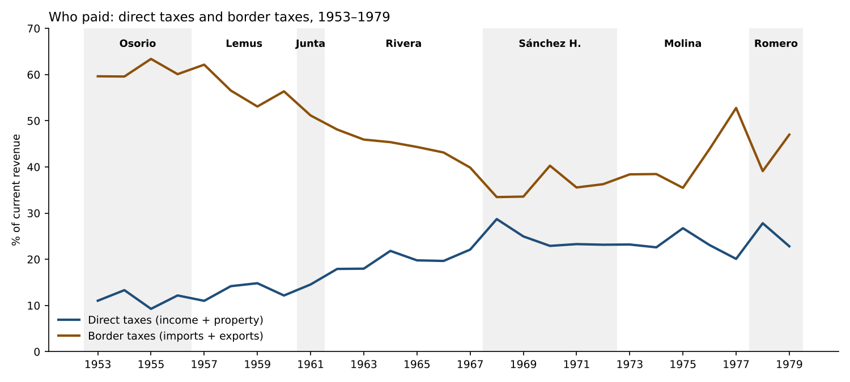
Who paid: direct and border taxes

6. Next steps
- Fill the remaining gaps: 1953–55 consumption and stamps (Memorias 1953–55, Estado 2); 1970–72 detail (MH 1971 and 1972 statements, if other scans exist); the income-tax split before 1964 (Dirección General de Contribuciones Directas).
- Decide the pending period choices (section 3.5).
- Expenditure workbook on the same design, then the financing and execution of infrastructure.
- Diario Oficial checklist (Tax_Laws sheet), now including:
  - the base and rates of the net wealth tax;
  - any cotton levy;
  - the selective consumption tax;
  - the “other merchandise” export duty;
  - the 1977 increase in the net wealth tax.

7. The Sánchez Hernández period (author’s decision, 12 November 2026)

7.1 The decision and the author’s reasoning
Sánchez Hernández (1967–1972) stays a period of its own. The author reads it as the transition between the modernization project with political opening (Osorio to Rivera) and the most authoritarian administration, General Romero’s:
- the war with Honduras (1969) unravels the import-substitution (ISI) experiment built on the Common Market;
- coffee becomes less stable;
- there is no programme to resettle the Salvadorans expelled from Honduras (recorded in the annual notes);
- the opposition grows and the first guerrilla groups form;
- the fiscal cost of the war is paid with coffee windfalls; its economic cost is significant but has not been estimated;
- the 1972 electoral fraud is the official end of the political opening of the early 1960s, and Molina closes the phase with the military takeover of the National University.
The author also suggests that the tax expenditures of the Molina and Romero years may have been designed to compensate the firms of the incipient ISI sector.

7.2 What the series says about this reading
Coffee prices. The data support “less stable than under Rivera”, but not yet wild swings: those come in 1976–78.
Annual change in the coffee price (Pink Sheet) | Largest rise | Largest fall
Rivera 1962–67 | +25% (1964) | −7% (1962, 1966)
Sánchez Hernández 1968–72 | +31% (1970) | −13% (1971)
Molina 1973–77 | +118% (1976) | −1% (1975)
Romero 1978–79 | +7% (1979) | −31% (1978)
The 1970 windfall. The price rise of 1970 raised the coffee duty by 63% (from ₡26.5M to ₡43.1M). Together with the 1969 emergency tax, that is the money that paid for the war: the annual notes show that the war was financed with war bonds (₡34.3M sold in 1968–70) and the emergency tax (₡9.6M), and that the 1970 windfall wiped out the 1969 financial deficit and repaid ₡10M to the Central Bank (Note_MH_1970). This fits the author’s reading.
Import duties. They had already fallen before the war: ₡59.4M in 1967, ₡52.9M in 1968. Their share of current revenue went from 26% (1967) to 23% in 1968–71 and 22% in 1972. The war does not show up as a break in import duties. The reason is probably structural: trade with Honduras and the rest of the Common Market was mostly duty-free, so the war cut trade that paid little tax anyway. The 1968 fall comes first and needs its own explanation. A candidate is the 1968 San José Protocol of the Common Market (emergency measures for the balance of payments); this is to verify, not assumed.

7.3 Estimating the loss of taxable imports: a proposal
Three steps, from the simplest:
- Counterfactual import duties. Project the duties of 1969–72 with the 1960–67 relation between import duties and imports (or GDP), and compare with the actual figures. This needs annual imports by origin (BCR, Revista Mensual; SIECA) and the effective duty rate.
- Split by origin. Separate extra-regional imports (taxable) from Central American imports (duty-free). Only the first carry fiscal loss. The economic loss lies more in exports to Honduras and in transit across Honduras to Nicaragua and Costa Rica, closed from 1969.
- Exemptions. Industrial-promotion exemptions on imported inputs (Ley de Fomento Industrial) cut the tax base further. The Memorias do not report them, so the size of the taxable base after exemptions needs another source (CEPAL, World Bank 1974).
Expected result. The direct loss of import duties is probably small. The large cost of the war is economic (exports, industrial employment, the returnees), not fiscal at the border. That itself supports the author’s point that the war’s economic cost was never accounted for.

7.4 Tax expenditures as compensation (Molina and Romero): what is needed
The hypothesis is worth testing, but the Memorias do not measure tax expenditures. We need:
- The laws: the export-promotion and industrial-promotion laws of the 1970s, and any free zones, with dates and beneficiaries (Diario Oficial). These are added to the checklist; none is assumed here.
- A size: registered exemptions by firm or sector (Ministerio de Economía; World Bank 1979 report).
- The link to ISI firms: whether the beneficiaries were the firms hit by the loss of the Honduran market.

7.5 A timing point for the periods (corrected 12 November 2026)
The 1972 events split across the change of government:
- Under Sánchez Hernández: the fraudulent presidential election of 20 February 1972, which made Molina president, the contested legislative and municipal elections of 12 March, and the failed coup of 25 March.
- Under Molina: he took office on 1 July 1972. The military takeover of the National University followed on 19 July 1972, three weeks later.
Our rule assigns the fiscal year 1972 to Sánchez Hernández: its budget was enacted in December 1971, and he governed the first half of the year. The fraud is therefore inside his period, as the author’s reading requires. The University takeover is Molina’s act, although it happened in the 1972 fiscal year. It opens his period politically; in the revenue series, his period starts with the 1973 budget.
Sources: 1972 Salvadoran presidential election; 1972 Salvadoran coup attempt; The 1972 Elections, Library of Congress country study; 50 años de la intervención militar del 19 de julio en la UES, El Diario de Hoy.

Sources: Memorias de Hacienda 1952–1979 (Estados 2, II-5, I-4 and II-1) via the yearly notes and the revenue workbook; MH 1979, part B, Estado II-1 (1975–1979); item-level revenue file 1952–1964 (co-authored dataset); Ley del Impuesto sobre el Patrimonio, D.L. 553 (1986), recitals (https://www.jurisprudencia.gob.sv/DocumentosBoveda/D/2/1980-1989/1986/12/888FB.PDF); Pleitez, chapter 2; Acevedo (2003), IDB; World Bank Pink Sheet.

Part 4. The Combined Fiscal Accounts, 1952–1979: Expenditure, Interest and Debt — First Version and First Results
Working note for discussion — 12 November 2026. Companion to the workbook El_Salvador_Fiscal_Accounts_Memorias_1952_1979.xlsx (folder “Fiscal Accounts 1952-1979”). It is the first version of the building blocks agreed this morning:
- revenue, expenditure and interest on the debt in one workbook;
- credits used as the main basis, with gastos alongside;
- national analysis.
Everything is built from figures already verified in the yearly notes and the Spending Data files. No new extraction yet; the 1957–59 extraction is the next step.

1. What the workbook contains
The revenue sheets are kept unchanged and seven sheets are added.
Sheet | Content | Coverage
Fiscal_Accounts | Current revenue (linked), credits used, gastos, commitments; commitment-basis and underlying results; interest; primary result; amortization; gross financing need; direct public debt; Superávit Financiero; ratios | 1952–79 (interest and amortization with gaps)
Exp_Ministry_Pillars | Defensa, Seguridad Pública, Educación, Salud, Obras Públicas, Agricultura, Interior, other; security and development pillars; shares | 1952–79, one basis per year, marked
Exp_Economic | Wages, goods and services, interest, current transfers, real investment, financial investment, capital transfers, amortization | 1952–56, 1970–72, 1974–79
Periods_Fiscal | The same governments as the revenue series | 1953–79
Analytics_Cycle | Year-on-year changes classified by the coffee cycle (boom, bust, neutral), with a summary by phase | 1954–79
Charts_Fiscal | Underlying result; interest and debt; spending shares; revenue against spending and the coffee duty | 1952–79
Every total ties to the figure printed in the Memoria, as cited in the notes. Where a basis changes between years (1955–57, 1964, 1967, 1970, 1973), the row is marked and left out of the year-on-year analytics.

2. First results
All shares are of current revenue or of spending, as stated. Periods assign each year to the president inaugurated the previous July.

2.1 Spending followed revenue up and did not follow it down
Phase of the coffee cycle (1954–79) | Years | Change in revenue (₡M) | Change in credits used (₡M)
Boom (coffee duty up 10% or more) | 12 | +1,119.0 | +1,046.4
Bust (coffee duty down 10% or more) | 9 | −69.4 | +264.4
Neutral | 5 | +25.5 | +2.3
- Windfalls were spent almost in full: 94 centavos of spending for each extra colón of revenue in boom years.
- In busts, spending kept rising. The growth of revenue and of credits used is strongly correlated (0.71, 1954–79).
- The way the State met busts changed:
  - Cutting. In 1958–59, 1962 and 1968 credits used fell (by ₡1.6M, ₡8.9M, ₡2.5M and ₡2.2M).
  - Borrowing. In the busts of 1971, 1975 and 1978 credits used rose by ₡52.8M, ₡115.1M and ₡92.7M.
- This is the pattern the literature calls procyclical with a ratchet: spending rises with the boom and is not reversed in the bust.

2.2 Debt took the strain from the late 1960s
 | Osorio 1953–56 | Lemus 1957–60 | Junta 1961 | Rivera 1962–67 | Sánchez H. 1968–72 | Molina 1973–77 | Romero 1978–79
Revenue growth per year | 7.1% | 0.0% | −7.3% | 6.2% | 7.5% | 29.3% | 1.4%
Credits used growth per year | 6.1% | 1.2% | 4.7% | 4.4% | 10.1% | 26.5% | 8.2%
Underlying result / revenue | +3.9% | −5.3% | −15.4% | −5.0% | −3.7% | −3.0% | −15.1%
Interest / revenue | 0.6%* | 1.1% | 1.0% | 1.0% | 1.7%* | 1.8% | 2.1%
Debt / revenue, end of period | 19.1% | 20.9% | 22.8% | 39.2% | 63.0% | 39.4% | 70.6%
Increase in debt (₡M) | +2.0 | +3.0 | +0.5 | +52.8 | +116.8 | +260.5 | +391.5
*Years with interest data only (1953–55; 1969–72).
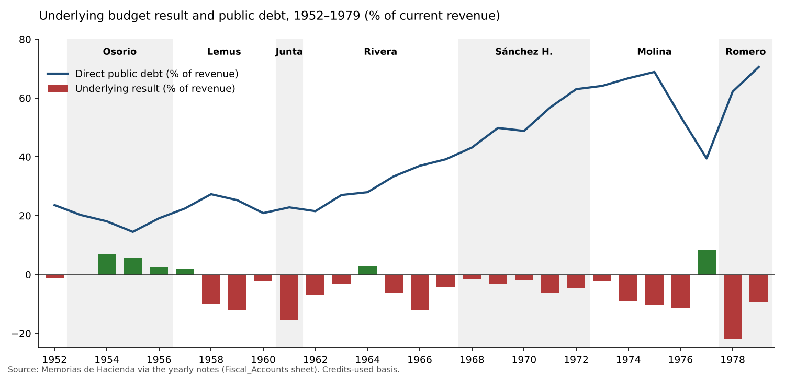
Underlying result and debt
- Sánchez Hernández is where debt turns. Spending grew 10% a year against 7.5% for revenue, and debt rose from 39% to 63% of revenue. This supports the decision to treat the period separately.
- Molina’s deficits were hidden by the boom. Debt more than doubled in money (₡205.7M to ₡466.2M), but revenue tripled, so the ratio fell. The 1977 surplus (+8.3% of revenue) is the only one after 1964.
- Romero inherited spending set by the boom. In two years debt rose by ₡391.5M, more than in Molina’s five years (₡260.5M), and reached 71% of revenue in 1979.
- Debt was cheap. The implicit interest rate was 2–5% (loans from official development lenders such as the IBRD, IDB and AID, and low-rate domestic bonds). Interest never passed 2.3% of revenue. The stress was in financing, not in the interest bill. That matters for the stress tests: the binding constraint is access to new loans and the Central Bank, not debt service.

2.3 Where the money went: development grew, security fell until 1977, then the turn
Share of spending | Osorio | Lemus | Junta | Rivera | Sánchez H. | Molina | Romero
Security (Defensa + Seguridad Pública) | 14.6% | 13.1% | 12.4% | 11.3% | 10.0% | 7.5% | 11.1%
Development (Education, Health, Public Works) | 41.5% | 43.4% | 46.5% | 46.1% | 48.0% | 49.3% | 46.4%
Education | 15.5% | 16.6% | 21.1% | 22.6% | 26.0% | 23.0% | 20.4%
Agriculture | 2.9% | 2.8% | 3.2% | 6.1% | 5.3% | 9.5% | 7.5%
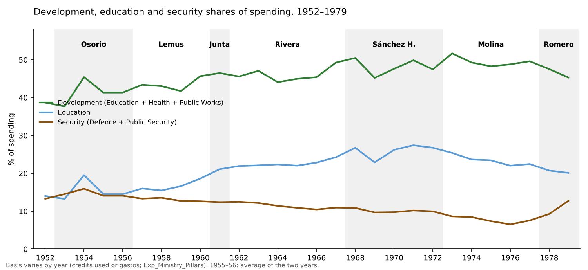
Spending shares
- The windfalls were not spent on security. In boom years (with a comparable basis), the extra spending went:
  - 44% to development;
  - 20% to education;
  - 14% to security.
  - This is close to average shares. The coffee money of the 1970s financed the expansion of the civilian State.
- Education peaked in 1971 (27.4% of spending), the year of the second ANDES strike. It declined in almost every year after, to 20.1% in 1979. This is consistent with H1: education was squeezed in relative terms from the moment the teachers’ union became a leading organized opposition.
- Security fell to 6.5% of spending in 1976 and doubled to 12.7% in 1979. In money it went from ₡93.7M (1977) to ₡185.0M (1979).
  - In the 1978 bust, security rose ₡29.7M while education fell ₡2.1M.
  - This is the largest such shift in the series; the only precedent, 1958, was tiny (security +₡0.2M, education −₡1.2M). It is the Romero turn, and it shows up clearly in the accounts.
- Agriculture tripled its share between the 1950s and Molina (9.5%), including the agrarian programmes and the ISTA (created in 1975).

2.4 Economic classification: what the available years show
- Wages were 48% of gastos in the 1950s and 41% in 1979. Their weight fell as transfers and investment grew.
- Real investment was 5% of gastos in 1952, 16% in 1954, 11–17% in 1970–71 and 11–14% in 1976–79.
- In the 1978 bust, current transfers rose 46% and wages 18%, while real investment fell 3%. Investment again absorbed the adjustment (H3).
- Capital transfers to the public sector (autonomous institutions) became large in 1976–79: ₡100–131M a year, 11–14% of gastos.

3. Reading against the thesis
- The regime did not stabilize the coffee cycle; it transmitted it. Spending rose with every boom and was not cut in the busts of the 1970s. This made the State’s growth dependent on coffee prices, as the revenue series already suggested.
- The response to busts changed from cutting (1950s–60s) to borrowing (1970s). That postponed conflict over who would bear the adjustment, at the cost of debt. By 1978–79 the room was gone.
- The coffee windfalls built the civilian State, not the repressive one, until 1977. The security turn of 1978–79 came with a bust, not a boom. When money became scarce, security was protected and education was not.
- The education squeeze starts in 1971, not 1978, and coincides with the teachers’ mobilization. This needs the unit lines (teachers’ salaries, University subsidy) to confirm (next step).
These are descriptive results from about 26 annual changes. They show timing and direction; they do not establish causation.

4. Limits of this first version
Limit | Effect | Remedy
Ministry basis changes (credits used, gastos, final execution) | Shares are comparable within each basis; year-on-year changes at the switches are excluded | Extract credits used by ramo for 1964–66 and 1970–72 (Estado II-8, where scanned)
1955–56 combined volume | Ministry shares are the 1955–56 average for both years | Split using the 1955 final gastos (Note_MH_1955)
Economic classification missing for 1957–69 and 1973 | No continuous series of wages, transfers and investment | Extract MH 1957–59 object classes; MH 1960–69 economic tables; MH 1973 Cuadro 15
Interest missing in 1952, 1956 and 1968; 1955 understated | Small gaps in interest and the primary result | Debt-service statements of those years
Amortization missing for 1952–56 and 1968–69 | Gross financing need incomplete | Same
Unit lines (teachers, University) not yet assembled | H1–H2 not tested in money | Assemble from ministry_class units and the notes
No deflator before 1974, no GDP before 1968 | Everything is nominal or in shares | Data search (see the Data Gaps note)

5. Next steps (on your go-ahead)
- Extract 1957–59: ministry by object class, credits used and gastos.
- Fill interest and amortization for the missing years, so the debt-service series is complete from 1952.
- Economic classification for 1957–69 and 1973, reconciled with the object classes.
- Unit lines: a teachers’ and University series, 1956–79.
- Then the data blocks for the medium-term framework: coffee volumes, GDP, the deflator, population and loan terms.

Sources: Memorias de Hacienda 1952–1979, via the yearly notes (Note_MH_1952–1979) and the files in Spending Data and Revenue Data; World Bank Pink Sheet (coffee prices).

Part 5. From the Revenue Series to Expenditure, Econometrics and a Retrospective Fiscal Framework: Ideas for Discussion
Working note for discussion — 12 November 2026. It answers the author’s three ideas:
- an expenditure workbook that mirrors the revenue series;
- an econometric analysis of the impact of fiscal policy;
- a medium-term fiscal framework (MTFF) to run fiscal stress tests for the period.
Nothing is built yet. The note proposes designs, flags what the data allow, and lists the decisions needed.

1. The expenditure workbook

1.1 What we already have
Data | Years | Where
Spending by ministry (ramo) and object class (wages, goods, transfers, equipment…) | 1952–56, 1960, 1961–79 (1957–59 not yet extracted) | Spending Data/ministry_class_*.csv
Credits used, gastos and commitments | 1961–79; 1950s on the old basis | Same files; yearly notes
Pillars (development, security, agriculture, interior) | 1952–79 | pillars_*.csv
Unit lines (teachers, University subsidy, Fuerza Armada, Presidency and Defence lump sums, IRA) | Most years from the 1960s | ministry_class (unit column); notes
Economic classification (Cuadro 15, gastos basis) | 1968–79 | Yearly notes
Loan-financed projects (lender, instrument, amounts) | 1955–79 | Loans and Investment/loan_financed_projects_1955_1979.csv
Cost of the war | 1968–80 | War and Security Data/war_cost_1968_1980.csv
Balances, financing and debt | Every year | Yearly notes (not yet in one table)
The expenditure side is in better shape than the revenue side was: most figures are already extracted and verified. The work is mostly assembly and harmonization.

1.2 Proposed structure (mirroring the revenue workbook)
- README and Mapping: the basis of each year and how the ministries and classes are harmonized. The ramos change name and scope: Cultura Popular becomes Educación; security bodies sit inside Defence in some years; the Presidency’s units vary.
- Exp_Ministry: credits used by ministry, 1952–79, with checks against the printed totals. One column per harmonized ministry, plus “other organs” (Legislative, Judicial, Corte de Cuentas, elections).
- Exp_Economic: an economic classification built in the modern style, from the object classes for 1952–67 and Cuadro 15 for 1968–79:
  - wages and salaries;
  - goods and services;
  - current transfers (University, municipalities, autonomous institutions, pensions);
  - interest;
  - capital: real investment, capital transfers, and financial investment (on-lending, e.g. to CEL);
  - amortization (below the line).
- Exp_Function: the pillars (development, security, agro-export support, administration), using the definitions already decided.
- Exp_Units: the unit lines that test the hypotheses (H1 education and University; H2 teachers’ wages; H5 IRA).
- Investment: loan-financed and locally financed investment, with execution rates (budgeted against executed) and the lenders. This is where the financing and execution of infrastructure goes.
- Balances_Financing: current revenue (linked to the revenue workbook) minus credits used, giving:
  - the commitment-basis result;
  - the underlying result (our convention);
  - financing: Central Bank, domestic bonds, external loans, use of deposits;
  - debt stock and interest.
- Periods and Indicators: the same governments as the revenue series; shares; real values; per-person values when the deflator and population exist.
- Charts:
  - development against security;
  - wages as a share of spending;
  - investment against the coffee duty;
  - a scatter of the change in spending against the change in revenue (procyclicality);
  - executed against budgeted investment.
Decided (author, 12 November 2026): one fiscal workbook combining revenue, expenditure and interest on the debt. Section 1.4 sets out how the three fit together.

1.3 Problems to solve
- Basis. Credits used (gastos + commitments) is our main basis; Cuadro 15 is on gastos. The workbook should carry both, and say which each chart uses.
- Breaks in the classification. The 1950s object classes differ from the 1960s ones and from Cuadro 15. Each mapping goes in a Mapping sheet, as for revenue.
- 1957–59. Ministry detail still to be extracted from MH 1957–1959 (A–D).
- Coverage. Central government only. The autonomous institutions (CEL, ANTEL, ISSS, IRA, ISTA) enter only through transfers and on-lending. A consolidated public sector is not possible from the Memorias.

1.4 How revenue, expenditure and interest fit together
The core sheet is a fiscal accounts table, one row per year, 1952–79, in the format of a modern fiscal summary:
Line | Source
Current revenue (tax and non-tax, by source) | Revenue_CM and Revenue_Detail (existing)
Primary spending: wages; goods and services; transfers; capital | Exp_Economic
Interest on the public debt, split domestic and external, and war bonds from 1968 | Public-debt service in each Memoria (Ramo de Hacienda, Deuda Pública)
Primary balance = current revenue − primary spending | Formula
Overall balance = primary balance − interest | Formula; checked against our commitment-basis result
Amortization, and gross financing needs = −overall balance + amortization | Debt service lines
Financing: external loans, domestic bonds, Central Bank, deposits | Yearly notes
Debt stock (domestic, external, war bonds) and the implicit interest rate (interest / previous year’s debt) | Debt tables in the notes
Why interest deserves its own line:
- Primary against overall balance. This separates what each government decided from what it inherited.
- The cost of borrowing. The implicit interest rate shows how this cost changed as lending shifted: from the IBRD, the IDB and AID, to commercial borrowing and domestic bonds.
- The framework and the stress tests in section 3 run on the debt dynamics: interest = rate × debt.
- Interest against spending. Interest can be set against education or security spending. That makes it a political-economy indicator in its own right: who was paid first in a bust.
Data to assemble: interest and amortization by year are in the debt-service lines of each Memoria and partly in the notes. They have not yet been put into one series, and the 1950s will need checking line by line.

2. Econometric analysis of fiscal policy

2.1 The constraint
We have about 27 annual observations (1953–79), with structural breaks (1961–63 tax reforms, 1969 war, 1976–78 boom) and some measurement gaps. That rules out the standard large models (e.g., a structural VAR of the Blanchard–Perotti type) as a credible stand-alone exercise. It still allows well-chosen, transparent tests. El Salvador has one advantage: an exogenous shock that is measured well, the world coffee price. It works as a natural experiment.

2.2 Options, from the most robust to the most ambitious
- Cyclicality of fiscal policy (descriptive and simple regressions).
  - Regress the change in real spending (total and by component) on the change in output, or directly on the coffee price or coffee duty.
  - Test asymmetry: do booms raise spending more than busts cut it? This is the “ratchet” and “when it rains, it pours” literature on Latin America (Gavin and Perotti, 1997; Kaminsky, Reinhart and Végh, 2004).
  - This answers a core question of the project: did the regime spend windfalls and cut in busts?
- Where the windfalls went. Regress each component’s change on the change in coffee revenue:
  - security; education; University; investment; wages; debt repayment.
  - The coefficients say what share of each extra colón of coffee revenue went to each use. This is the cleanest quantitative test of H1–H5.
- Event studies around the shocks: the 1958–59 bust, the 1969 war, the 1970 windfall, the 1976–77 boom and the 1978 bust. Each component’s path from two years before to two years after, against its trend. This is transparent and suited to policy readers.
- Revenue and spending dynamics. Test whether revenue drives spending or the reverse (“tax-and-spend” against “spend-and-tax”), with an error-correction model. It checks whether the regime adjusted spending to revenue or ran deficits and financed them.
- Impact on growth (the fiscal multiplier). Use local projections (Jordà, 2005), with the coffee price shock as an instrument for revenue and spending, and output as the outcome. This is the most ambitious option and the least precise with 27 observations.
  - A way to gain power: a Central American panel (Guatemala, Honduras, Nicaragua, Costa Rica; all coffee exporters, with similar regimes) from CEPAL and IMF data. It turns the national story into a comparative test and gives about five times the observations.
- The link to polarization. Relate fiscal variables (education spending per student, teachers’ real wages, security share) to measures of mobilization and repression: strikes, protest events, political killings. The best-known event data are in Almeida, Waves of Protest: Popular Struggle in El Salvador, 1925–2005 (2008). This can show timing and association, not causation; the note would say so.

2.3 Data needed
Series | Years needed | Source
GDP (nominal and real) | 1950–79 | CEPAL, Estudio Económico; BCR; Penn World Table (to check coverage)
GDP deflator or CPI before 1974 | 1950–73 | BCR; ILO; CEPAL
Population | 1950–79 | Censuses 1950, 1961, 1971; CELADE
Coffee export volume and price received | 1950–79 | BCR; Compañía Salvadoreña de Café; ICO
Protest and repression events | 1960–79 | Almeida (2008); newspapers
Central American fiscal series (panel option) | 1960–79 | CEPAL; IMF Government Finance Statistics (from the 1970s)

3. A retrospective medium-term fiscal framework and stress tests

3.1 The idea
Build a simple MTFF of the kind a finance ministry would use today, and run it as if prepared at key dates with the information then available (for example 1962, 1968, 1973, 1977). Then shock it. It answers: how exposed was the State, what would a prudent rule have required, and what did the regime actually do?

3.2 A model small enough to calibrate
- Revenue:
  - coffee duty = price × volume × the duty schedule;
  - other taxes = elasticity × GDP growth (elasticities estimated from the series);
  - non-tax revenue as a share.
- Spending:
  - wages and transfers with inertia (the rigid part);
  - investment as the adjustment variable, as observed;
  - interest = average rate × debt.
- Financing:
  - external loans (by lender, from the loan register);
  - domestic bonds;
  - Central Bank credit.
- Outputs:
  - balance;
  - debt path;
  - gross financing needs;
  - the adjustment required to keep debt or the deficit within a limit.

3.3 Stress tests (historical, so they are realistic)
Shock | Calibration
Coffee price fall | −30% (1978), −13% (1971), and a bootstrapped distribution of 1950–79 price changes for fan charts
Coffee volume shock (frost, rust, labour) | One bad harvest
Loss of the Common Market | The 1969 war: exports and transit to Honduras
War or security spending shock | The 1968–70 war costs
Interest-rate and external-credit shock | 1979–80
Combined | Coffee bust with an interest-rate shock (1978–80)

3.4 Policy counterfactuals the framework allows
- A coffee stabilization fund: save the duty above a reference price in 1976–77, and spend it in 1978–79. How much of the 1978 deficit would it have covered?
- A spending rule: for example, current spending growing with trend revenue, not with the coffee duty.
- Protecting development spending: what the 1978 bust would have required if education and health had been protected.
These follow the logic of the modern fiscal-risk tools (IMF, Analyzing and Managing Fiscal Risks: Best Practices, 2016; the IMF debt sustainability framework). They are applied with modest, transparent calibration.

4. Proposed sequence
- Expenditure, interest and debt sheets in the combined fiscal workbook (sections 1.2–1.4), around the fiscal accounts table. Everything else needs this.
- GDP, deflator and population, 1950–79. These are also needed for the revenue charts (tax/GDP; real revenue).
- Descriptive cyclicality and event studies (options 2.2-1 to 2.2-3). They give results quickly and suit the policy notes.
- The retrospective MTFF and stress tests (section 3), built on the same workbook.
- The more ambitious econometrics (options 2.2-4 to 2.2-6), and the Central American panel if the author wants the comparative angle.

5. Decisions for the author
- One fiscal workbook or two? Decided: one workbook combining revenue, expenditure and interest on the debt.
- Basis? Decided: credits used as the main basis, with gastos alongside.
- 1957–59? Decided: extract.
- Panel? Decided: national analysis.
- MTFF dates Set aside. This question was about which years to run the framework from, as if a ministry had prepared it then. It is not needed now. The present task is to build the data series and prepare the data the framework will need.

6. Work plan agreed (12 November 2026): the building blocks
Scope. Build the expenditure series to mirror the revenue series: verified against printed totals, harmonized across years, documented, with periods by government and charts. Combine them with revenue and interest in one fiscal workbook. At the same time, assemble the series a medium-term fiscal framework will need. No econometrics and no framework model yet.

6.1 Steps
- Inventory and gap table. A year-by-sheet grid showing what we already hold (from the CSVs and notes) and what is missing. We already know:
  - ministry totals exist for every year;
  - ministry-by-class detail is missing for 1957–59;
  - 1955–56 is one combined volume (a 1955–56 fiscal period): this needs a rule (keep it as one observation, or split it).
- Extract 1957–59 (MH 1957 A–C, 1958 A–D, 1959 A–D): spending by ministry and object class, credits used and gastos. Check against the printed totals, as for the other years.
- Interest and debt service, 1952–79: interest and amortization by creditor, from the public-debt lines of each Memoria. Debt stocks at year-end by creditor (domestic, external, war bonds).
- Economic classification, 1952–79:
  - 1952–67: built from the object classes (wages, goods and services, transfers, capital), with interest taken from step 3;
  - 1968–79: Cuadro 15.
  - The overlap years are reconciled, as was done for revenue in 1962–63.
- Assemble the fiscal workbook:
  - the fiscal accounts table (section 1.4);
  - expenditure by ministry, by economic class and by pillar;
  - unit lines;
  - interest and debt;
  - checks;
  - periods by government;
  - charts.
- A Word note on the expenditure series: design, first findings and decisions, like the revenue note.

6.2 Data for the future framework: what each series needs and where it stands
Series | Status | To do
Revenue by source, 1952–79 | Done | Link
Coffee duty, and duty per unit of price | Done 1960–79 (1971–72 gap) | Fill 1971–72
Coffee price | Pink Sheet 1960–79 | 1950–59 (ICO; FAO; BCR)
Coffee export volume and value | Not held | BCR, Revista Mensual; ICO
Spending by economic class | Partial | Steps 2 and 4
Interest, amortization, debt stock by creditor | In the notes, scattered | Step 3
Terms of loans (rate, maturity, grace) | Partly in the loan register | Add from the loan contracts cited in the Memorias
GDP, nominal and real | Memoria from 1968 | 1950–67 (CEPAL; BCR)
Price index | 1974–79 only | 1950–73 (BCR; CEPAL)
Population | Not held | Censuses 1950, 1961, 1971; CELADE
Exchange rate | Fixed at ₡2.50 per US$ | —

6.3 Points of judgement to flag now
- The 1950s basis. In the 1950s Memorias the concept of commitments may differ from the 1960s créditos utilizados. Each year’s basis will be recorded in a Basis column, as in the revenue workbook.
- On-lending and loan money. Spending financed by loans stays inside credits used (it is spending). Loan proceeds stay out of revenue (they are financing), consistent with the conventions.
- Interest inside the ministries. Interest is paid from the Ramo de Hacienda (Deuda Pública). It is taken out of primary spending and shown on its own line, so the totals are not double-counted.
- Real terms. Real values before 1974 wait for a deflator. Until then, the series are shown at current prices and as shares.
Suggested first step on your go-ahead: step 1 (the inventory and gap table). It is quick, and it will show exactly how much new extraction steps 2 and 3 require.

References: Gavin, M. and R. Perotti (1997), “Fiscal Policy in Latin America”, NBER Macroeconomics Annual; Kaminsky, G., C. Reinhart and C. Végh (2004), “When It Rains, It Pours: Procyclical Capital Flows and Macroeconomic Policies”, NBER Macroeconomics Annual; Jordà, Ò. (2005), “Estimation and Inference of Impulse Responses by Local Projections”, American Economic Review; Blanchard, O. and R. Perotti (2002), Quarterly Journal of Economics; Almeida, P. (2008), Waves of Protest: Popular Struggle in El Salvador, 1925–2005, University of Minnesota Press; IMF (2016), Analyzing and Managing Fiscal Risks: Best Practices.

Part 6. Validating the Three Pillars: What to Check, Where, and How
Working note for discussion — 12 November 2026. The author’s point: the three pillars (development, security, agro-export support) are built from ministry totals in the Memorias. Before they carry the argument of the paper, they need validation with micro data from the Diario Oficial and other sources. This note sets out where the current measure can mislead, the tests that would validate or correct it, the sources, and a sequence.

1. How the pillars are measured now, and why that is not enough
Current measure. Ministry (ramo) totals from the Memorias, on a credits-used basis where available:
- Development = Educación + Salud Pública + Obras Públicas;
- Security = Defensa + Seguridad Pública;
- Agro-export support = Agricultura y Ganadería.
Where it can mislead:
Risk | Example | Direction of error
Security spending outside Defensa and Seguridad Pública | Police or paramilitary units in Interior; the rural network ORDEN; Presidency lump sums (partidas for “security” or “special expenses”); military pensions in Clases Pasivas; war-bond service in Deuda Pública | Security understated
Security inside other lines of Defensa | Guardia Nacional, Policía de Hacienda and Policía Nacional moved between Defensa and Seguridad Pública across years | Shifts within the pillar; breaks in the series
Spending outside the ordinary budget | Extraordinary budgets and special decrees (créditos extraordinarios, refuerzos); arms purchases financed by loans or special bonds (1969); military aid in kind | Security understated, especially in crisis years
Development lines that serve the coalition | Roads to coffee and cotton zones; the port of Acajutla; electricity for industry | Development overstated as “legitimacy”; agro-export support understated
Agro-export support through the tax system and credit, not the budget | The coffee income-tax exemption (1950); untaxed cotton; credit to the coffee sector (the ₡30M General Fund loan to the Compañía Salvadoreña de Café, 1975) | Agro-export support badly understated
Autonomous institutions off-budget | CEL, IRA, ISTA, ISSS, the University (only the subsidy is in the budget) | All pillars understated; agrarian and food programmes especially
Basis changes | Credits used against gastos against final execution | Artificial jumps (marked in the workbook)
Nominal shares | Shares can rise while real spending per teacher or per student falls | Development’s “legitimacy” overstated in inflationary years (1974–79)
The 1950s results (security 13–16%, development 38–46%) are probably robust in direction. The 1970s results, especially the security doubling of 1978–79 and the agro-export overtaking of 1974–77, are the ones most exposed to these errors.

2. Validation tests, pillar by pillar

2.1 Security
- Unit-level reconstruction. Use the Ley de Salarios (posts and salaries by unit, published in the Diario Oficial with each budget) and the Memorias’ unit tables (Estado N° 5 / IV-2). Count every armed or police unit wherever it sits:
  - Fuerza Armada;
  - Guardia Nacional;
  - Policía Nacional;
  - Policía de Hacienda;
  - Policía de Aduanas;
  - any security units in Interior or the Presidency.
- Posts, not only colones. The number of security posts (soldiers, guards, police) against teachers and health workers, from the Ley de Salarios. Posts are less affected by inflation and basis changes.
- Off-budget and extraordinary items:
  - decrees of extraordinary credits and budget transfers to Defensa (Diario Oficial);
  - the 1969 war bonds and arms purchases;
  - military assistance from the United States, from the US foreign-aid record (the “Greenbook”) and from arms-transfer registers (SIPRI, from 1950).
- ORDEN. Its founding decree or legal status, and any budget line that funded it (Interior, Defensa or the Presidency).
- Military pensions (Clases Pasivas, military part) as a memo line.

2.2 Development
- Teachers and the University:
  - teaching posts and salary scales by year (Ley de Salarios; the teachers’ salary laws, including the scale demanded in 1971);
  - the University subsidy (Memoria unit lines; University budgets).
- Real terms per user. Education spending per enrolled student, and teachers’ real salaries, once a price index before 1974 is found. Enrolment is in the Education note (1967–74) and the Anuarios Estadísticos.
- Public works by purpose. Separate roads and works that mainly serve export zones (coffee and cotton roads, the Litoral highway, Acajutla) from schools, water, health posts and urban works. Sources: the loan register; the extraordinary budgets; the project lists in the Memorias.

2.3 Agro-export support
- The tax side. Estimate the main tax expenditures for the coalition:
  - the coffee income-tax exemption (1950);
  - cotton’s freedom from export duty;
  - industrial and export promotion exemptions (1952, 1961, 1970, 1974).
  - Sources: the laws (Diario Oficial); CEPAL and World Bank estimates (the 1979 World Bank report has tax-expenditure material).
- The credit side:
  - General Fund loans and guarantees to the coffee sector (Compañía Salvadoreña de Café; INCAFE from 1979);
  - BCR credit lines to agro-export (BCR reports).
- The budget side, unit by unit: Agricultura’s units for coffee and cotton research, extension and credit, against its units for basic grains, colonization and the agrarian reform (ISTA from 1975).

3. Sources
Source | What it gives | Access (to check)
Diario Oficial: Ley de Presupuesto General and Ley de Salarios (each year) | Appropriations and posts by unit and line; security units wherever they sit | Imprenta Nacional digital archive; Biblioteca de la Asamblea Legislativa; Archivo General de la Nación
Diario Oficial: decrees of extraordinary credits, transfers and refuerzos | Spending added during the year, and for what | Same
Diario Oficial: tax laws and promotion laws | The tax side of agro-export support | Same; jurisprudencia.gob.sv for some decrees
Memorias, unit tables (Estado N° 5; IV-2) | Executed spending by unit | In the repository (1952–1979)
Memorias, extraordinary budgets and loan register | Off-ordinary-budget spending | In the repository
BCR annual reports and Revista Mensual | Credit to coffee and agro-export; Central Bank financing | BCR library
US foreign-aid record (“Greenbook”); SIPRI arms-transfer database | Military assistance and arms imports | Public online
World Bank reports (1974, 1979, 1983) | Tax expenditures, public enterprises, agrarian programmes | In the repository
Anuarios Estadísticos (DIGESTYC) | Enrolment, prices, employment | Libraries

4. Method and sequence
- Benchmark years first, not all years. Validate eight years that mark the turns:
  - 1954 (the boom);
  - 1959 (the 1950s adjustment);
  - 1965 (Rivera’s peak);
  - 1969 (the war);
  - 1971 (the education peak and the strike);
  - 1976 (the security low and the agrarian transformation);
  - 1978 (the bust);
  - 1979 (the security peak).
- For each year, read the Ley de Presupuesto and the Ley de Salarios in the Diario Oficial, and the extraordinary-credit decrees.
- Two measures side by side. Keep the current “ministry pillars”, and build “adjusted pillars” that reassign units by function and add the off-budget and tax-side items. Report both, and how far they differ.
- A posts-based measure. Security posts against teaching and health posts, from the Ley de Salarios, as a check that does not depend on prices or basis.
- Decide on the result. If the adjusted pillars confirm the turning points (1950s shift; 1971 education peak; 1974–77 agro-export overtaking; 1978–79 security doubling), the paper uses them with confidence. If not, the paper reports the correction.

5. What this means for the paper now
- The preliminary paper presents the pillars as ministry-based and provisional, with the risks in section 1 stated plainly. The validation programme goes in the research agenda.
- Claims to word carefully until validated:
  - “security doubled in 1978–79”;
  - “agro-export support overtook security in 1974–77”;
  - any statement that the coalition was served “through the tax system rather than the budget”.
- The 1950s benchmark (Pleitez’s 1827–1948 averages) stays as an order of magnitude.

6. Questions for the author
- Diario Oficial access: which years can you obtain, and in what form (scans, the Imprenta Nacional website, library copies)? The Ley de Presupuesto and the Ley de Salarios for the eight benchmark years would be the priority.
- Benchmark years: are these the right eight, or would you add or swap any (for example 1961 for the Directorio, or 1972 for the University intervention)?
- Security definition: should Interior (Gobernación) be reviewed unit by unit for the 1970s, given ORDEN and the rural network?
- Agro-export support: should the pillar include tax expenditures and credit (a broader “coalition pillar”), or stay a budget measure, with the tax side reported separately?

Part 7. Balancing the Pillars: The Coalition Pillar, in Spending and in Tax Spending
Working note for discussion — 12 November 2026. It records the author’s decisions on the validation of the three pillars and sets out how to build the third pillar as a coalition pillar: everything the State gave the coffee, agro-export and industrial coalition, through the budget, the tax system or credit. It includes a first, partial estimate that shows why the change matters.

1. Decisions recorded (12 November 2026)
Question | Decision
Balance of the pillars | The third pillar becomes a coalition pillar, combining spending and tax spending (tax expenditures), and credit
Diario Oficial | The author has access to all issues
Benchmark years | 1954, 1959, 1965, 1969, 1971, 1976, 1978, 1979
Interior (Gobernación) | Reviewed unit by unit for the 1970s (ORDEN; rural network)
Agro-export support | Broadened to include tax breaks and credit

2. Why the balance needs the tax side
A budget-only comparison is lopsided:
- Development and security are delivered mainly through spending. The pillar measures capture most of them.
- The coalition was served mainly through the tax system and credit. The main instruments:
  - the coffee income-tax exemption (1950);
  - cotton’s freedom from export duty;
  - the duty-free imports and income-tax holidays of industrial promotion (1952, 1961, the Central American Agreement on Fiscal Incentives ratified in 1969);
  - export promotion and free zones (1970, 1974);
  - bank credit: coffee and cotton were about 80% of the banks’ agricultural portfolio in the early 1970s (World Bank, 1974).
- None of these appears in the budget.
Comparing a spending-only coalition pillar with a security pillar therefore understates the coalition by design. The measure of the bargain should put all three pillars on the same footing: resources the State committed to each group, whether spent or forgone.

3. The coalition pillar: components
Component | Instrument | Measure | Source
A. Budget | Agricultura y Ganadería units serving export crops (coffee and cotton research, extension, credit, plant health); export-promotion bodies | Credits used by unit | Memorias, unit tables (Estado N° 5, IV-2); Ley de Presupuesto and Ley de Salarios (DO)
B. Tax spending | (1) Coffee income-tax exemption (D. 836, 1950) | Coffee profits × applicable income-tax rate, less the export duty treated as a substitute (two variants) | DO (law and any amendments); coffee value added and costs (BCR; CEPAL; World Bank)
 | (2) Untaxed cotton (and sugar before November 1974) | Cotton exports × a counterfactual duty rate (range) | Export values (CEPAL; World Bank; BCR); duty laws (DO)
 | (3) Industrial promotion: import-duty and income-tax exemptions | Exempted imports × tariff; exempted profits × rate | DO: the executive agreements (acuerdos) that classified each firm under the promotion laws; Ministry of Economy; World Bank (1979)
 | (4) Export promotion and free zones (1970, 1974) | Same method | DO; World Bank (1979)
C. Credit and guarantees | General Fund loans and State guarantees to the coffee sector (e.g. ₡30M to the Compañía Salvadoreña de Café, 1975); BCR rediscount lines for coffee and cotton | New lending each year; the implicit subsidy (rate gap) where terms are known | Memorias (General Fund balance sheet; guarantees); BCR reports; DO (loan decrees)
Memo (not in the pillar) | Public works serving export zones (coffee and cotton roads, the Litoral highway, Acajutla) | Shown separately, so development is not overstated | Loan register; extraordinary budgets
The other two pillars, validated in the same way:
- Security:
  - all armed and police units wherever they sit, including Interior and the Presidency;
  - ORDEN;
  - extraordinary credits to Defence;
  - the 1969 war bonds;
  - military aid (memo).
- Development: Education, Health and Public Works. Public works serving export zones moves to the memo line.
The common denominator. Shares of total public effort: credits used plus the coalition’s tax spending plus net new credit. Each pillar is then shown as a share of that total, so that a colón forgone counts the same as a colón spent.

4. A first, partial estimate: untaxed cotton
Only one component can be estimated now from data in hand. It shows the order of magnitude.
Method. Cotton exports times a counterfactual duty:
- Upper bound: the effective rate actually paid by coffee that year (coffee duty / coffee export value).
- Lower bound: a flat 5%, a modest export levy of the kind the government considered for cotton in 1973–74. The World Bank’s 1974 memorandum reports that the authorities were “considering … export duties on cotton and sugar which will vary on a progressive basis”. Sugar was taxed from November 1974; cotton was not.
Table 1. Revenue forgone on cotton, and the coalition pillar against security (selected years)
Year | Cotton exports (₡M) | Coffee’s effective duty rate | Forgone, lower–upper (₡M) | Forgone, % of revenue | Coalition pillar: Agricultura + forgone cotton duty, % of effort | Security, % of spending
1957 | 39.1 | 19.9% | 2.0–7.8 | 1.0–4.1% | 3.8–6.7% | 13.3%
1960 | 39.5 | 13.7% | 2.0–5.4 | 1.2–3.2% | 4.2–6.0% | 12.6%
1965 | 94.5 | 15.0% | 4.7–14.2 | 2.1–6.3% | 10.1–13.7% | 10.9%
1978 | 245.0 | 13.1% | 12.2–32.2 | 1.2–3.1% | 9.0–10.3% | 9.2%
1979 | 212.5 | 22.5% | 10.6–47.8 | 0.9–3.9% | 7.6–9.8% | 12.7%
Sources and notes:
- Cotton exports: 1957, Pleitez Tabla 2.1 (CEPAL); 1960 and 1965, World Bank (1974) Table 3, US$15.8M and US$37.8M; 1978–79, World Bank (1983) Table 4, US$98M and US$85M. Converted at ₡2.50.
- Coffee export value: 1957 and 1960, Dada Hirezi Cuadro 2-1; 1978–79, World Bank (1983); 1965 derived from the export shares in World Bank (1979) Table 3.
- Coffee duty and revenue: fiscal workbook.
- Agricultura and security: Exp_Ministry_Pillars (whole ministry, so it overstates agro-export support in the 1970s, when Agricultura also funded basic grains and the agrarian programmes).
- These are illustrative, not final.
What the partial estimate already shows:
- Cotton alone is worth 1–6% of revenue in forgone duty. That is comparable to the whole Agriculture budget in the 1950s (₡5.2M in 1957).
- The coalition pillar reaches the size of the security pillar by 1965, even before the two largest items are counted: the coffee income-tax exemption and the industrial exemptions.
- The 1950s reading changes. On the budget alone, the coalition got 3%. With one tax item added, it got 4–7%. With the coffee exemption, it is likely to be larger still. This supports the hypothesis that the coalition was served mainly through the tax system.
- The 1970s turning points must be re-read. Agriculture “overtaking” security in 1974–77 partly reflects the agrarian programmes, which are not coalition spending. After the unit review, the coalition pillar may be smaller in the budget and larger in tax spending.

5. What to extract from the Diario Oficial
The author has access to all issues. For each benchmark year (1954, 1959, 1965, 1969, 1971, 1976, 1978, 1979), in order of priority:
- Ley de Presupuesto General and Ley de Salarios for the year: all units of Defensa, Seguridad Pública, Interior (Gobernación), the Presidency, Agricultura and Educación, with posts and appropriations.
- Decrees of extraordinary credits, transfers and refuerzos during the year, for Defensa, Seguridad Pública, Interior and the Presidency.
- Executive agreements under the industrial promotion laws (classification of firms and the exemptions granted). Even a count by year, with the firm and the sector, is valuable.
- Tax laws affecting the coalition:
  - D. 836 (1950) and any amendment of the coffee tax or the income-tax exemption;
  - any cotton levy;
  - D.L. 135 (1974, sugar);
  - the export laws of 1970 and 1974.
- ORDEN: any decree or budget line that created or funded it, and its legal status.
- Loan and guarantee decrees in favour of the coffee sector (Compañía Salvadoreña de Café; INCAFE).
Scans or photographs of the relevant pages are enough. Section 6 proposes where to start.

6. Proposed sequence
- What can be done now, from the Memorias in the repository:
  - review Interior and the Presidency unit by unit for 1970–1979, looking for security units and lump sums;
  - review Agricultura’s units, to separate export-crop support from basic grains and agrarian reform.
- With the Diario Oficial pages from the author: rebuild the three pillars for the eight benchmark years, with posts and colones.
- Tax spending:
  - the cotton estimate refined with annual export data;
  - the coffee income-tax exemption estimated with coffee value added;
  - industrial exemptions from the register of DO agreements.
- Report: a table and figure of the three balanced pillars (development, security, coalition) as shares of total public effort, for the benchmark years. Then interpolation for the series where the data allow.
A suggested first step: start with step 1 (Interior, the Presidency and Agricultura in the 1970s Memorias) while the author gathers the Diario Oficial pages for 1976, 1978 and 1979, the years where the security turn is sharpest.

Sources: World Bank, El Salvador Economic Memorandum (1974), paras. on tax policy and Table 3 (exports), and on bank credit to coffee and cotton; World Bank, Report on El Salvador (May 1979), Table 3 (exports, shares) and paras. on the Central American Agreement on Fiscal Incentives; World Bank, El Salvador Economic Memorandum (1983), Table 4 (main exports); Pleitez, Tabla 2.1; Dada Hirezi, Cuadro 2-1; the fiscal workbook of this project.

Part 8. Unit-Level Review of the Pillars: Pilot Year 1977
Working note for discussion — 12 November 2026. This note is the first step of the validation agreed today. It reviews Interior, the Presidency and Agriculture unit by unit, plus the coalition items found in other ministries, for one pilot year. It then rebuilds the three pillars for that year with the coalition pillar balanced (spending plus tax spending).
Pilot year: 1977. That year’s units are reported in Estado IV-2 of the 1978 Memoria (Estado de gastos con especificación de unidades de organización y clases generales del Presupuesto General de 1977). The 1977 budget was executed half under Molina and half under Romero, who took office on 1 July. Every figure below was read on the page image.
Basis. Estado IV-2 records budget execution by unit. Its grand total for 1977 is ₡1,010.54M, which differs from the credits used of the fiscal workbook (₡1,241.9M). Shares in this note are of the IV-2 total, so they are internally consistent but not identical to the workbook’s pillar shares.

1. Interior: no police, one coalition item
Interior spent ₡33.80M in 1977. Its units are civil:
- central administration;
- regional development and governors’ offices;
- the national printing office and the Diario Oficial;
- the postal service;
- communications operations;
- migration control, which includes an “Investigaciones” sub-unit of ₡0.14M;
- transfers to municipalities;
- the construction of the ministry’s building (₡4.23M).
No police, paramilitary or ORDEN unit appears in Interior in 1977. The security apparatus is not hidden in this ministry’s budget.
A coalition item. Interior paid ₡6.96M “to the municipalities of the Republic to compensate for the suppression of taxes on the cultivation of coffee”. Municipal taxes on coffee had been abolished, and the central government replaced the lost revenue from the general budget. In effect, all taxpayers paid the coffee growers’ former local taxes. The 1950 coffee decree (D. 836) already assigned part of the coffee tax to coffee municipalities; the date of the suppression and of this compensation is to be checked in the Diario Oficial.

2. The Presidency: large, opaque lump sums
The Presidency spent ₡33.46M in 1977:
Unit | ₡
101 Administración Superior | 13,107,092.12
— of which non-personal services | 12,844,450.00
102 Servicios Administrativos Generales (Secretaría de la Presidencia) | 8,004,328.36
— of which non-personal services | 6,533,955.84
103 Servicios de Información y Divulgación (Secretaría de Información) | 3,038,454.25
104 Servicio de Becas | 737,061.78
301 Fomento y Cooperación Comunal (investment) | 8,573,457.20
Total | 33,460,393.71
- The opaque lump sums. ₡19.38M of “non-personal services” in the first two units carries no further detail. It is almost 2% of all spending, and almost a quarter of the Defence-plus-Public-Security budget. Its content is unknown. Candidates include:
  - discretionary political spending;
  - intelligence;
  - the financing of the rural network.
  - The Diario Oficial (budget law and any regulations) and the Presidency’s own accounts are the place to look.
- Fomento y Cooperación Comunal (₡8.57M) is the community-development programme run from the Presidency. It is development spending, but delivered directly by the President’s office in the countryside, where ORDEN also operated. Whether it served legitimacy, patronage or both is a question for the sources.

3. Agriculture: three different things
Agricultura y Ganadería spent ₡95.63M in 1977. Its units fall into three groups.
Group | Units (examples) | ₡M
Coalition (export crops) | Transfer to the Instituto Salvadoreño de Investigaciones del Café (ISIC) 3.42; promotion of agro-industrial crops 0.82 | 4.24
Food and agrarian | Transfer to the Instituto Regulador de Abastecimientos (IRA, food prices) 13.16; transfer to ISTA (agrarian transformation) 5.33; promotion of basic grains 3.04 | 21.53
General agricultural services | Administration, planning, plant and animal health (defensa agropecuaria), statistics, livestock, natural resources, fisheries, technology and extension, irrigation, agricultural schools | about 69.9
The transfers to ISIC, ISTA and IRA add to the printed total of the transfer line (₡21,910,376.07). The “general” group is the remainder of the ministry’s total and is shown approximately.
Only a small part of Agriculture is coalition spending. Using the whole ministry as “agro-export support” (as the provisional pillar did) overstates the coalition pillar on the budget side. The rise of Agriculture in 1974–77 was driven partly by IRA and ISTA. IRA subsidized food for consumers (relevant to H5); ISTA was the agrarian reform the coalition defeated in 1976.

4. Coalition items in other ministries
Ministry | Item | ₡M
Planning | Establishment of the first industrial and commercial export free zone (San Bartolo) | 4.77
Economy | Capital transfer to INSAFI (industrial promotion) | 1.00
Economy | Transfer to the Instituto Salvadoreño de Comercio Exterior | 0.15
Interior | Compensation to municipalities for the suppression of coffee taxes | 6.96
Agriculture | ISIC (coffee research); agro-industrial crops | 4.24
Total coalition, budget side |  | 17.12
Memo (not counted in the coalition):
- Economy’s transfers to the Instituto Salvadoreño de Turismo (₡13.3M);
- the State textile mill of San Miguel (₡0.58M);
- small-enterprise credit (FIGAPE, ₡4.4M);
- the ports authority (CEPA, ₡4.13M) and CEL (₡0.65M).

5. The three pillars in 1977, balanced
Pillar | ₡M | % of spending (IV-2 total ₡1,010.5M) | % of total effort, with cotton tax spending (low–high)
Development (Educación 239.10; Salud 110.28; Obras Públicas 160.89) | 510.27 | 50.5% | 50.0–47.9%
Security (Defensa 61.38; Seguridad Pública 22.95) | 84.34 | 8.3% | 8.3–7.9%
Memo: Presidency opaque lump sums | 19.38 | 1.9%
Coalition, budget side (section 4) | 17.12 | 1.7%
Coalition, tax side: untaxed cotton (forgone duty, 5% to coffee’s effective rate of 27%) | 10.1–55.0
Coalition, total (partial) | 27.2–72.1 |  | 2.7–6.8%
Memo: food and agrarian (IRA, ISTA, basic grains) | 21.53 | 2.1%
Cotton: exports estimated at US$80.9M in 1977, from the 7.7% share of exports of goods and services in World Bank (1979), Table 3; to refine with BCR data. The coffee income-tax exemption and the industrial and export exemptions are not yet estimated, so the coalition total is a lower bound.

6. What the pilot shows
- Security is not hidden in Interior. In 1977 the police were in Seguridad Pública and Defensa, as assumed. The security pillar holds, but the Presidency’s ₡19.4M of opaque lump sums is the main uncertainty. If even half of it served security, the security pillar would rise from 8.3% to about 9.3%.
- The coalition is served on the tax side. On the budget, the coalition received 1.7% of spending in 1977, much less than the provisional “Agriculture” pillar suggested. With untaxed cotton alone, it reaches 2.7–6.8% of total effort. The coffee and industrial exemptions are still missing, so the true figure is higher.
- Some coalition spending is hidden in other ministries. The best example is Interior’s ₡6.96M to replace the municipal coffee taxes, a transfer from general taxpayers to the coffee municipalities, booked as municipal finance.
- The “agro-export overtakes security” result of 1974–77 does not survive as stated. It came from counting all of Agriculture, including IRA and ISTA. On a unit basis, the coalition’s budget share is small. Its weight lies in tax spending.

7. Next steps
- The same review for 1975, 1976 and 1978. The unit tables are already read for those years (Memorias 1976, 1977 and 1979). Then 1979 and the earlier benchmark years.
- Diario Oficial (author):
  - the decree that suppressed the municipal coffee taxes and created the compensation;
  - the Presidency’s lump sums in the budget law and any regulation of their use;
  - the 1977 extraordinary credits to Defensa and Seguridad Pública.
- Tax side:
  - annual cotton exports (BCR);
  - an estimate of the coffee income-tax exemption;
  - the register of industrial-promotion agreements.

Source: Ministerio de Hacienda, Memoria de Hacienda 1978, Estado N° IV-2 (pages for the Presidency, Interior, Defensa, Seguridad Pública, Planning, Economy and Agriculture), read on the page images; World Bank, Report on El Salvador (May 1979), Table 3.

