Riding the Coffee Cycle: Fiscal Policy and the Road to Polarization in El Salvador, 1950–1979
Test draft of an article — 12 November 2026. Preliminary; not for citation.
Abstract. This study asks whether the way El Salvador’s military governments managed the coffee cycle helped produce the polarization that ended in civil war. It builds a new annual fiscal dataset from the Memorias de Hacienda for 1952–1979, verified line by line, and reads it against the political record. It finds four things:
- A narrow tax base. The State financed a developmental project on coffee and trade taxes and taxed capital lightly: corporate income tax never exceeded 7% of revenue, and coffee was exempt from income tax from 1950.
- Spending followed the cycle. Windfalls were spent almost in full. Busts were met by cuts until 1968 and by debt from 1971.
- Three pillars. Read as the pillars of a bargain, the budget shifted in the 1950s from security to development: development took about half of spending by the late 1960s, while security fell to 6.5% in 1976. The coalition of coffee and industrial interests was served mainly through the tax system rather than the budget.
- A late turn. Education’s share peaked in 1971, the year of the teachers’ strike, and declined thereafter. When the coffee boom broke in 1978, security spending rose while education was cut.
The fiscal record does not show that the budget caused the war. It shows when and how the regime chose whom to protect.

1. Introduction
Between 1950 and 1979, El Salvador was governed by a succession of military presidents allied to a powerful coffee elite. In these three decades the country built roads, a hydroelectric system, a port, schools and hospitals, and its economy grew. By 1980 it was at war. The literature on the origins of that war has explained the path through land and population (Durham, 1979), the protection bargain between the army and the oligarchy (Stanley, 1996), waves of protest under opening and closure (Almeida, 2008), the education reform and the teachers (Lindo-Fuentes and Ching, 2012), and the agrarian class structure (Paige, 1997; Wood, 2003).
The State’s own accounts have received less attention. This study asks a narrower question: did the military governments’ fiscal and monetary management of the coffee cycle deepen the polarization that led to the civil war?
The fiscal accounts are useful because they record choices year by year. When coffee rose, the State had to decide what to do with the windfall. When it fell, it had to decide who would bear the cost. The budget records those decisions, in colones.
The study makes two contributions.
- A dataset. An annual series of central-government revenue, expenditure, interest and debt, 1952–1979, built from the Memorias de Hacienda (Informes Complementarios Constitucionales). Every figure is read on the page image and checked against printed totals. The 1950s revenue categories are mapped into a modern classification.
- A frame. The budget is read as three pillars of the regime’s bargain:
  - development (education, health, public works) buys legitimacy and builds new middle groups;
  - security buys control;
  - a coalition pillar serves the coffee, agro-export and industrial interests. This pillar includes not only spending but tax spending (exemptions and untaxed exports) and credit.
The study is preliminary. The pillars are being validated with unit-level data from the Diario Oficial, and no econometric estimate is attempted with 27 annual observations. The results are descriptive, and they show timing and direction rather than causation.

2. Literature and framework

2.1 Development thought and the coffee regime
The modernization project that began with the coup of December 1948 drew directly on ECLA’s structuralism.
- Prebisch (1950) argued that the periphery’s specialization in primary exports, with unstable prices and a tendency for the terms of trade to deteriorate, condemned it to slower growth unless it industrialized.
- The Hoselitz mission (1954) applied this view to El Salvador: light industry, training, an input–output study, and a Central American free-trade area. President Lemus later called the report “the bible” of his economic policy (Pleitez, p. 194).
Central American integration, promoted from 1951 by the Salvadoran minister Jorge Sol Castellanos, became the strategy’s centrepiece (Turcios, 1993, pp. 44–45).
The coffee market changed in each period.
- The 1940s. During the Second World War, an Inter-American Coffee Agreement backed by the United States gave Latin American producers quotas in the US market, at controlled prices.
- The 1950s boom. After the war, the Central American and Mexican producers’ federation (FEDECAME), led by the Salvadoran Roberto Canessa, pushed to end the price ceilings (Pleitez, pp. 190–191). The price of Salvadoran coffee rose 4.6 times between 1945 and 1954 (Dada Hirezi, 1978, p. 29). This was a market windfall. The producers’ agreements of 1954–1959 came only as prices fell.
- The 1960s. The effective cartel came with the 1962 International Coffee Agreement, which supported prices from 1963 (ICO, n.d.).
- The 1970s. The frost-driven boom of 1976–77 and the collapse of 1978 dominated the decade.
These phases matter for the fiscal story, because each produced a different kind of shock.

2.2 Fiscal procyclicality and taxation in commodity exporters
Procyclicality. A large literature finds that fiscal policy in Latin America is procyclical: governments spend windfalls and cut in busts, amplifying the cycle instead of smoothing it (Gavin and Perotti, 1997; Kaminsky, Reinhart and Végh, 2004). In commodity exporters the mechanism is direct, because export taxes link revenue to world prices.
Taxation and state capacity.
- Besley and Persson (2011) treat fiscal capacity, the ability to tax income and wealth, as a choice shaped by political cohesion and conflict.
- Acemoglu and Robinson (2006) model dictatorship as an elite’s choice to concede or repress when the threat of revolution rises. The cost of redistribution shapes the choice.
- Schneider (2012), on Central America, links tax regimes to the cohesion of elites and to the transnational coalitions that shaped them. Weak, fragmented tax states rely on trade taxes and exemptions.

2.3 The Salvadoran road to war
The economic historians:
- Dada Hirezi (1978) reads the 1948 regime as a “renewed hegemonic alliance”. Its industrialization proceeded “without breaking the internal social equilibrium”. It transferred part of the coffee surplus to industry for the same propertied groups, and controlled urban unions.
- Pleitez documents the import-substitution model’s achievements in education, health and infrastructure, together with its failure to include. Income concentration rose, landlessness grew from 20% to 41% of rural families between 1961 and 1975, and real minimum wages fell.
- Turcios (1993; 2017) shows how reform and repression went together in the 1950s, and how the 1960 crisis grew from the decade’s own social changes.
The political literature:
- Stanley (1996) describes a “protection racket” State, in which the army protected the agro-export elite in exchange for control of the State.
- Almeida (2008) shows how protest moved from institutional channels in the 1960s to revolutionary coalitions in the 1970s, as fraud and repression closed the openings.
- Lindo-Fuentes and Ching (2012) show how the 1968 education reform, designed without the teachers, turned the regime’s most loyal employees into one of its strongest opponents.
- Durham (1979) shows how land concentration pushed the landless into Honduras until the 1969 war closed that outlet.

2.4 The framework: three pillars of a fiscal bargain
This study reads the budget as the pillars of a bargain among three groups:
- the military;
- the coffee and industrial elite;
- the middle and popular groups that modernization created (teachers, students, State employees, urban workers) and the rural poor.
Each pillar corresponds to one side of the bargain:
- Development pays for legitimacy and for the State’s promise of progress.
- Security pays for control.
- The coalition pillar pays the elite, mainly through the tax system and credit.
The questions are then concrete:
- Who paid the taxes?
- Who received the spending and the exemptions?
- When coffee fell, which pillar was protected?
The study tests five hypotheses:
- H1: education and the University were squeezed in downturns;
- H2: wages, especially teachers’, were contained;
- H3: public investment was cut first;
- H4: the Treasury turned to Central Bank financing;
- H5: food subsidies were cut.
It also follows four tracks:
- A. The tax bargain.
- B. The Honduran safety valve.
- C. The protection bargain.
- D. Reforms announced and then diluted.

3. Data and method
The source. The Memoria de Hacienda is the Finance Ministry’s annual report to the Legislative Assembly. For 1952–1979 the scanned volumes are typewritten and often turned sideways. Every figure used here was read on the page image and checked by arithmetic against the printed totals.
Revenue. Current revenue (rentas percibidas y devengadas) excludes bond proceeds and loans. It is mapped into modern categories:
- income tax (personal, corporate, other);
- property and wealth (including the Vialidad “Serie A” tax, a tax on net wealth from 1953);
- import duties;
- export duties (coffee, sugar, shrimp, other);
- consumption taxes;
- stamps and services;
- non-tax revenue.
From 1953 the categories add to the printed totals in every year.
Spending. The main basis is credits used: payments plus commitments outstanding at year-end. The underlying result is the commitment-basis balance excluding loan-financed capital commitments and on-lending. Interest, amortization and debt come from the debt statements.
Periods. Each year is assigned to the president inaugurated the previous 1 July:
- Osorio, 1953–56;
- Lemus, 1957–60;
- the Junta and Directorio, 1961;
- Rivera, 1962–67;
- Sánchez Hernández, 1968–72;
- Molina, 1973–77;
- Romero, 1978–79.
Period shares are weighted by revenue.
Limits.
- Detail is thinner in 1953–55, 1970–72 and 1957–59 (ministry by class).
- GDP before 1968 and prices before 1974 are not yet in the dataset, so most results are nominal shares.
- The pillars are measured from ministry totals and are provisional (section 6).

4. Who paid: the revenue system
Table 1. Revenue composition by government, % of current revenue (weighted)
 | Osorio 1953–56 | Lemus 1957–60 | Junta 1961 | Rivera 1962–67 | Sánchez H. 1968–72 | Molina 1973–77 | Romero 1978–79
Income tax | 6.9 | 8.4 | 9.7 | 15.5 | 15.8 | 16.4 | 17.6
Direct taxes (income + property) | 11.5 | 12.9 | 14.6 | 20.0 | 24.4 | 22.6 | 25.1
Import duties | 33.7 | 36.6 | 36.6 | 29.9 | 22.6 | 15.7 | 15.0
Coffee export duty | 27.0 | 20.6 | 14.1 | 13.8 | 12.4* | 25.6 | 22.6
Border taxes (imports + exports) | 60.7 | 57.3 | 51.1 | 44.2 | 36.0 | 44.1 | 43.4
Alcohol and cigarettes | 13.9* | 15.0 | 16.8 | 15.5 | 13.6* | 10.7 | 9.8
Non-tax revenue | 8.2 | 8.7 | 10.5 | 6.8 | 6.4 | 5.4 | 4.8
Revenue growth per year | 7.1% | 0.0% | −7.3% | 6.2% | 7.5% | 29.3% | 1.4%
*Split estimated from the years available. Source: revenue workbook (Memorias de Hacienda).
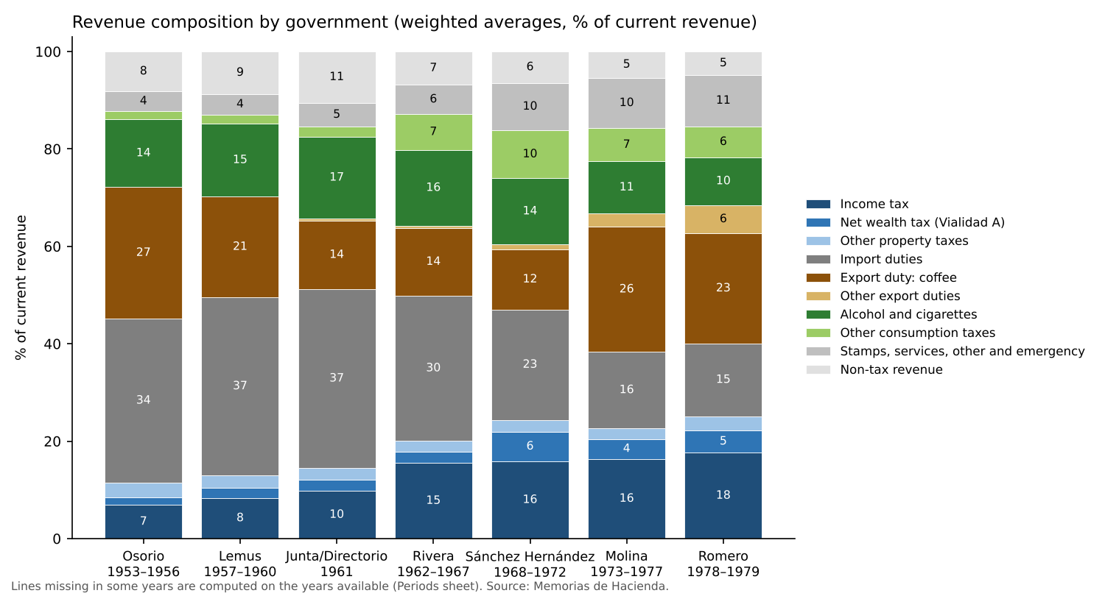
Revenue composition by government
The 1950s: a State financed at the border.
- Border taxes were 61% of revenue under Osorio. Coffee alone was 27%.
- The 1950 coffee decree (D. 836) made the export tax progressive. It also exempted coffee growers from income tax on income from coffee land.
- Tax revenue tripled between 1946 and 1951, and export duties rose from 12% to 31% of tax revenue (UN, 1957, in Dada Hirezi, 1978, p. 38).
- The 1951 income tax charged individuals up to 44% and companies 2.5–5%.
- Cotton, the second export crop, paid no export duty.
- Until 1961, taxes on alcohol and cigarettes yielded more than all direct taxes together.
The 1960s: a real change in the base.
- The Directorio’s income-tax reform of 1961 raised the top rate to 76.5%. It was partly reversed within three months by an exemption for reinvested industrial profits (Pleitez, pp. 203–205).
- The 1963 law, petroleum and flour taxes, and the Common Market’s erosion of import duties nonetheless changed the structure. Under Rivera, direct taxes rose to 20% of revenue and coffee’s share halved, to 14%.
- Coffee prices were low and stable, supported by the International Coffee Agreement. Revenue growth came from income and consumption taxes, not from coffee.
The 1970s: back to riding coffee.
- The boom of 1976–77 restored coffee to a quarter of revenue.
- Direct taxes stayed at 23–25%.
- Corporate income tax never exceeded 7% of revenue in any period; personal income tax was always larger.
- The net wealth tax was about 2% of revenue until 1968, when its yield nearly tripled, and it doubled again in 1977.
- A progressive sugar export tax (1974) yielded ₡25.6M in 1975 and almost nothing after.
- A cotton duty, considered by the government in 1973–74, was never imposed.
Reading. The tax system of 1950–1979 captured windfalls at the border and spared the income and wealth of the coffee and commercial elite. The one serious attempt to change this, in 1961, was diluted within months. This is the core of the tax bargain (Track A). It also left the State’s finances exposed to the coffee price throughout.

5. Who was paid: spending, the cycle and debt

5.1 Spending followed the cycle
Table 2. The coffee cycle and spending, 1954–1979 (sums of annual changes)
Phase | Years | Change in revenue (₡M) | Change in credits used (₡M)
Boom (coffee duty up 10% or more) | 12 | +1,119.0 | +1,046.4
Bust (coffee duty down 10% or more) | 9 | −69.4 | +264.4
Neutral | 5 | +25.5 | +2.3
Source: fiscal workbook (Analytics_Cycle).
- In booms, 94 centavos of each extra colón of revenue were spent. The growth of revenue and of spending was strongly correlated (0.71).
- Busts were handled in two different ways:
  - By cutting, until 1968. Credits used fell in 1958, 1959, 1962 and 1968. In the 1958–59 coffee fall the surplus built in the boom covered the first year; new consumption taxes and cuts in public works (−20%) and Defence (−13%) covered the second. Education was protected.
  - By borrowing, from 1971. In the busts of 1971, 1975 and 1978, spending rose by ₡52.8M, ₡115.1M and ₡92.7M.

5.2 Debt took the strain
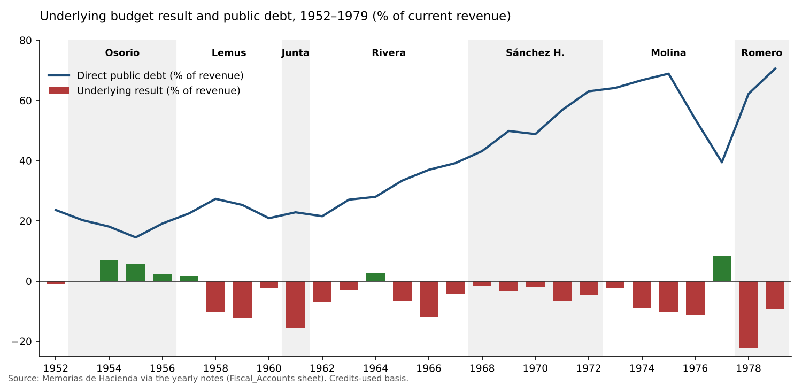
Underlying result and debt
Debt as a share of revenue rose in three steps:
- 15–27% through 1962;
- 39% at the end of Rivera’s term;
- 63% at the end of Sánchez Hernández’s term.
Molina’s deficits were hidden by the boom. Debt more than doubled in colones (₡205.7M to ₡466.2M), but the ratio fell to 39% because revenue tripled. The underlying surplus of 1977 (+8.3% of revenue) is the only one after 1964.
Romero inherited spending set by the boom. In two years debt rose by ₡391.5M, to 71% of revenue. The underlying deficit of 1978 was 22% of revenue.
The binding constraint was financing, not interest. Debt was cheap: the implicit interest rate was 2–5%, and interest never exceeded 2.3% of revenue. What ran out was new lending and the Central Bank’s room. Treasury notes held by the Central Bank were a standing facility from 1969 (H4).

5.3 The three pillars
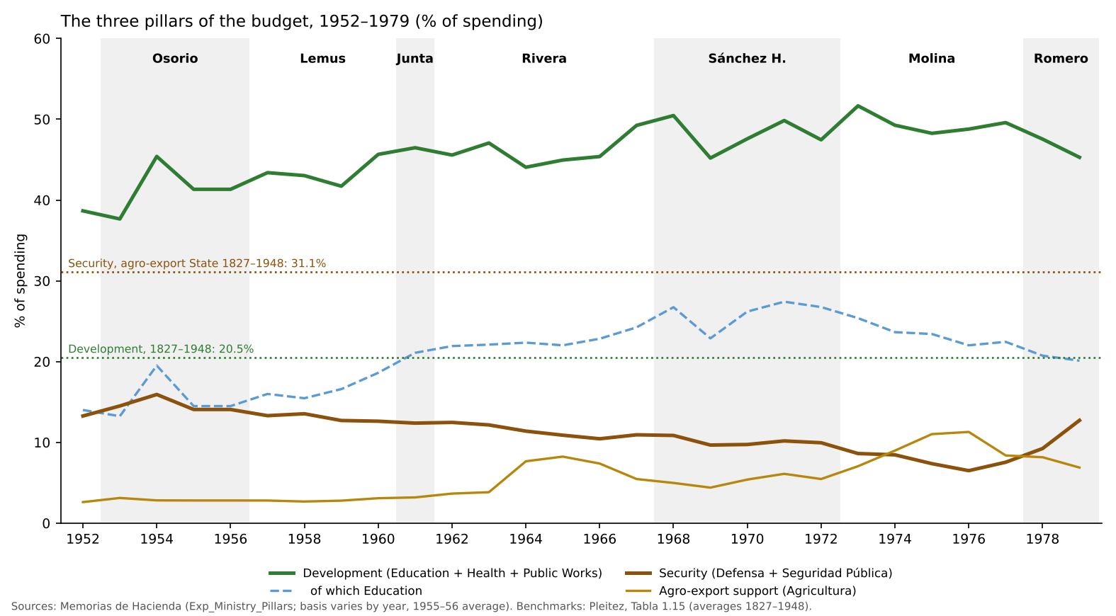
The three pillars of the budget, 1952–1979
The long-run shift. Pleitez’s averages for the agro-export State, 1827–1948, give:
- security, 31.1% of spending;
- debt service, 25.6%;
- education, health and public works together, 20.5%.
For 1948–1979 his averages are 11.3%, 3.6% and 45.6%. Our series shows the shift happening in the 1950s: development took 38–46% of spending, and security 13–16%, drifting down.
From then on (figure above):
- Development rose to about half of spending in 1968–1973.
- Education peaked at 27% of spending in 1971 (30.4% on Pleitez’s basis), the year of the 53-day strike by the teachers’ union ANDES. That strike was declared illegal and broken by the National Guard. Education’s share then declined almost every year, to 20% in 1979.
- Security fell to 6.5% of spending in 1976. It then doubled to 12.7% in 1979: from ₡93.7M in 1977 to ₡185.0M in 1979.
- In the 1978 bust, security rose ₡29.7M while education fell ₡2.1M. It is the largest such shift in the series. Current transfers and wages rose, while real investment fell 3% (H3).
Where the windfalls went. In boom years, of the extra spending:
- 44% went to development;
- 20% to education;
- 14% to security.
That is roughly the average shares. The coffee money of the 1970s built the civilian State, not the repressive one. The security turn came with the bust, when money became scarce.

6. Balancing the pillars: the coalition on the tax side
A budget-only comparison is lopsided. Development and security are delivered through spending, but the coalition was served mainly through:
- the coffee income-tax exemption;
- untaxed cotton;
- industrial and export exemptions (1952, 1961, the Central American Agreement on Fiscal Incentives of 1969, 1970 and 1974);
- bank credit. Coffee and cotton were about 80% of the banks’ agricultural portfolio in the early 1970s (World Bank, 1974).
A unit-level review of 1977 (Estado IV-2 of the 1978 Memoria) shows how much this matters.
Table 3. The three pillars in 1977, unit basis (₡M and %)
Pillar | ₡M | % of spending | % of total effort, with cotton tax spending
Development (Education, Health, Public Works) | 510.3 | 50.5% | 50.0–47.9%
Security (Defensa, Seguridad Pública) | 84.3 | 8.3% | 8.3–7.9%
Memo: Presidency’s unspecified lump sums | 19.4 | 1.9%
Coalition, budget side | 17.1 | 1.7%
Coalition, untaxed cotton (forgone duty) | 10.1–55.0
Coalition, total (partial) | 27.2–72.1 |  | 2.7–6.8%
Source: MH 1978, Estado IV-2; World Bank (1979) for cotton exports. The coffee income-tax exemption and the industrial exemptions are not yet estimated, so the coalition figure is a lower bound.
What the review shows:
- Interior contained no police or paramilitary units. The security pillar holds, except for ₡19.4M of unspecified lump sums in the Presidency, whose content is unknown.
- Most of Agriculture was not coalition spending. Of its ₡95.6M, coffee research and agro-industrial crops took ₡4.2M. The food-price institute (IRA), the agrarian reform institute (ISTA) and basic grains took ₡21.5M. The earlier impression that agro-export support “overtook” security in 1974–77 does not survive.
- Coalition spending also sits in other ministries. Examples:
  - Interior paid ₡6.96M to the municipalities “to compensate for the suppression of taxes on the cultivation of coffee”. General taxpayers replaced the growers’ former local taxes.
  - Planning financed the San Bartolo export free zone (₡4.8M).
On the tax side, untaxed cotton alone cost 1–6% of revenue in the years examined (1957, 1960, 1965, 1978, 1979). In the 1950s that was about as much as the whole Agriculture budget. The coalition was served through the tax system more than through the budget. That is why the tax bargain (Track A) and the pillars belong together.

7. A case study: the war with Honduras, 1969
The war of July 1969 shows the three pillars and the bargain under stress.
The military cost was paid outside the ordinary budget.
- In March 1968 an extraordinary Defence budget (D.L. 609) bought equipment for the armed forces, financed with ₡10M of 7% Treasury bonds.
- On 2 July 1969, twelve days before hostilities began, the Assembly approved a one-time emergency tax and an emergency provision.
- In July and August, ₡30M of “National Dignity” bonds were authorized; ₡22.1M were sold.
- Emergency spending reached ₡41.0M in 1969: one and a half times the ordinary Defence budget. Of the part paid that year, about 90% was machinery and equipment.
- Including 1968, the military effort was about ₡51M, financed:
  - 63% with domestic bonds;
  - 18% with the emergency tax;
  - 19% with ordinary funds, in practice Central Bank notes.
- Four-fifths of the war was borrowed. Coffee, companies and customs contributed nothing beyond their ordinary taxes.
The coffee windfall cleared the accounts. The price rise of 1970 raised the coffee duty by 63%, to ₡43.1M. The windfall wiped out the 1969 deficit and repaid ₡10M to the Central Bank. But the Central Bank facility became permanent: a new ₡10M advance replaced the last one in 1971.
The social cost was left off the budget.
- Between 60,000 and 130,000 Salvadorans were expelled from or fled Honduras.
- The Memorias record no spending on their resettlement: no lines for housing, land or employment.
- They returned to a country where landless families were already about a third of rural families.
- The Honduran market, and transit to the rest of the Common Market, closed.
The war also shows the limits of the pillar measure. Because the war was financed through extraordinary budgets and emergency provisions, the security pillar measured from ministry totals actually fell in 1969 (9.7% of spending). The true security effort that year was about ₡51M higher.
Reading. The war closed the safety valve that had absorbed the landless (Track B). Its fiscal cost went into debt and Central Bank credit, and its social cost was not budgeted. The 1972 fraud, the military occupation of the University in July 1972 and the education squeeze after 1971 followed in the same years. The State had found money for arms in weeks. It found none for the returnees.

8. Reading the evidence against the hypotheses
Table 4. Preliminary verdicts
Hypothesis | Verdict | Evidence
H1 Education and University squeezed | Suggestive | Relative decline from 1971; cut in the 1978 bust. University series not yet built
H2 Teachers’ wages contained | Suggestive | 1971 strike over the salary scale, refused and repressed; payroll series not yet built
H3 Investment cut first | Supported | Public works cut in 1959 and 1966–67; real investment fell in 1978
H4 Central Bank financing | Partly supported | Treasury notes held by the Central Bank from 1969; borrowing replaced cuts from 1971
H5 Food subsidies cut | Open | IRA transfers fell in the late 1960s; series to complete
A Tax bargain | Strongly supported | Coffee exempt from income tax; corporate tax ≤7% of revenue; untaxed cotton; the 1961 reform diluted
B Honduran safety valve | Supported | No budget for 60,000–130,000 returnees; the war financed by debt
C Protection bargain | Supported from 1978 | Security doubled in 1978–79; extraordinary military budgets in 1968–69; not visible in the 1950s
D Reforms diluted | Supported | 1961 income tax; 1974 land law not enforced; 1976 agrarian transformation withdrawn

9. Discussion
The fiscal record adds three things to the existing accounts of El Salvador’s road to war.
First, it dates the turns.
- The shift from a security State to a development State happened in the 1950s.
- The relative squeeze of education began in 1971, the year the teachers’ union became a leading opposition.
- The security turn came with the coffee bust of 1978.
- The regime’s response to busts changed in 1971, from cutting to borrowing.
These dates line up with the political sequence that Almeida and Stanley describe: opening in the 1960s, closure and repression in the 1970s.
Second, it shows the shape of the bargain. The regime did not choose austerity. It chose inclusion through spending without a tax bargain: schools, health posts and roads paid for with coffee money and loans, not with taxes on income and wealth.
- The coffee and industrial elite were served by exemptions, which do not appear in the budget.
- The new middle groups were served by the budget, which moved with coffee.
When coffee and credit failed together, in 1978, the pillar that was protected was security.
Third, it qualifies some common claims.
- The 1958–59 squeeze did not cause the 1960 crisis, which was political.
- The army’s budget share was not protected in the 1950s or 1960s.
- The 1970s windfalls financed civilian spending, not repression.
The repression of the 1970s did not need a large budget until 1978. The protection bargain was, for most of the period, cheap.
Caveats.
- The results are shares and changes in nominal colones, from about 26 annual observations. They show association, not causation.
- The pillars are provisional until validated with the Diario Oficial.
- The 1960s were years of real growth and reform. The argument is not that the economy failed, but that the way the State shared the gains and the losses narrowed the paths open to the groups it had created.

10. Research agenda
- Validate the pillars for eight benchmark years with the Ley de Presupuesto, the Ley de Salarios and the extraordinary-credit decrees in the Diario Oficial.
- Estimate the coalition’s tax spending: the coffee income-tax exemption, and the register of industrial-promotion agreements.
- Complete the series:
  - the 1957–59 ministry detail;
  - the economic classification for 1957–69;
  - the teachers’ and University series;
  - GDP and prices before 1968 and 1974.
- Estimate where windfalls went with simple regressions and event studies, and build a retrospective medium-term fiscal framework to test the State’s exposure to coffee shocks, including a coffee stabilization fund counterfactual for 1976–78.

References
Acemoglu, D. and J. Robinson (2006). Economic Origins of Dictatorship and Democracy. Cambridge University Press.
Almeida, P. (2008). Waves of Protest: Popular Struggle in El Salvador, 1925–2005. University of Minnesota Press.
Besley, T. and T. Persson (2011). Pillars of Prosperity: The Political Economics of Development Clusters. Princeton University Press.
Dada Hirezi, H. (1978). La economía de El Salvador y la integración centroamericana, 1945–1960. UCA Editores.
Durham, W. (1979). Scarcity and Survival in Central America: Ecological Origins of the Soccer War. Stanford University Press.
Gavin, M. and R. Perotti (1997). “Fiscal Policy in Latin America.” NBER Macroeconomics Annual 12.
Hoselitz, B. F. (1954). Industrial Development of El Salvador. United Nations.
International Coffee Organization (n.d.). History of the ICO: 50 years.
Kaminsky, G., C. Reinhart and C. Végh (2004). “When It Rains, It Pours: Procyclical Capital Flows and Macroeconomic Policies.” NBER Macroeconomics Annual 19.
Lindo-Fuentes, H. and E. Ching (2012). Modernizing Minds in El Salvador: Education Reform and the Cold War, 1960–1980. University of New Mexico Press.
Ministerio de Hacienda, El Salvador. Memorias de Hacienda (Informes Complementarios Constitucionales), 1952–1979.
Paige, J. (1997). Coffee and Power: Revolution and the Rise of Democracy in Central America. Harvard University Press.
Pleitez, W. Chapters 1–2 of a history of El Salvador’s development models (full reference to be confirmed).
Prebisch, R. (1950). El desarrollo económico de la América Latina y algunos de sus principales problemas. CEPAL.
Schneider, A. (2012). State-Building and Tax Regimes in Central America. Cambridge University Press.
Stanley, W. (1996). The Protection Racket State: Elite Politics, Military Extortion, and Civil War in El Salvador. Temple University Press.
Turcios, R. (1993). Autoritarismo y modernización: El Salvador 1950–1960. San Salvador.
Turcios, R. (2017). Rebelión: San Salvador 1960. CENICSH/MINED.
United Nations (1957). La política tributaria y el desarrollo económico en Centroamérica. Mexico.
Wood, E. J. (2003). Insurgent Collective Action and Civil War in El Salvador. Cambridge University Press.
World Bank (1974). El Salvador: Economic Memorandum. World Bank (1979). Report on El Salvador (May). World Bank (1983). El Salvador: Economic Memorandum.

