Import libraries

import matplotlib.pyplot as plt

from sklearn.linear_model import LinearRegression

We can Fit a linear regression model using the longitude feature 'long' and

caculate the R^2.

X = df[['long']]

Y = df['price']

lm = LinearRegression()

lm

lm.fit(X,Y)

lm.score(X, Y)

|  | **floors** |
| --- | --- |
| **1.0** | 10680 |
| **2.0** | 8241 |
| **1.5** | 1910 |
| **3.0** | 613 |
| **2.5** | 161 |
| **3.5** | 8 |

ns.boxplot(x='waterfront', y='price', data=df)

<matplotlib.axes._subplots.AxesSubplot at 0x7f9c22dc9b70>

[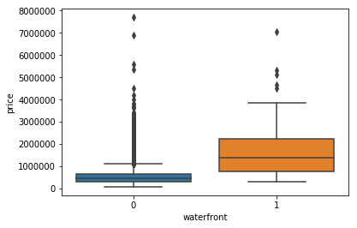](https://github.com/calistus-igwilo/House-sale-price-prediction-using-python/blob/master/output_29_1.png)