Precision Farming: A Machine Learning-Based Crop Recommender
ABSTRACT: -
Agriculture and its allied sectors are undoubtedly the largest providers of livelihoods in rural India. The agriculture sector is also a significant contributor factor to the country’s Gross Domestic Product (GDP). Blessing to the country is the overwhelming size of the agricultural sector. However, regrettable is the yield per hectare of crops in comparison to international standards. This is one of the possible causes for a higher suicide rate among marginal farmers in India. This paper proposes a viable and user-friendly yield prediction system for the farmers. The proposed system provides connectivity to farmers and helps the user provides the area & soil type as input. Machine learning algorithms allow choosing the most profitable crop list or predicting the crop yield for a user-selected crop. To predict the crop yield, selected Machine Learning algorithms such as Support Vector Machine (SVM), Artificial Neural Network (ANN), Random Forest (RF), Multivariate Linear Regression (MLR), and K-Nearest Neighbour (KNN) are used. Among them, the Random Forest showed the best results with 95% accuracy. Additionally, the system also suggests the best time to use the fertilizers to boost up the yield.

EXSISTING SYSTEM | PROPOSED SYSTEM
- we all know that Agriculture is the backbone of the country. This paper predicts the yield of almost all kinds of crops that are planted in India. This script makes novel by the usage of simple parameters like State, district, season, area and the user can predict the yield of the crop in which year he or she wants to.  - The paper uses advanced regression techniques like Kernel Ridge, Lasso and ENet algorithms to predict the yield and uses the concept of Stacking Regression for enhancing the algorithms to give a better prediction. | - proposed system provides connectivity to farmers and helps to includes multiple features that users can leverage for the selection of a crop. The inbuilt predictor system helps the farmers to predict the yield of a given crop. The inbuilt recommender system allows a user exploration of the possible crops and their yield to take more educated decisions.  - For yield to accuracy, various machine learning algorithms such as Random Forest, ANN, SVM, MLR, and KNN were implemented and tested on the given datasets from the Maharashtra and Karnataka states. The various algorithms are compared with their accuracy. The results obtained indicate that Random Forest Regression is the best among the set of standard algorithms used on the given datasets with an accuracy of 95%.
EXISTING ALGORITHM  - Regression techniques | PROPOSED ALGORITHM: -  - Random Forest Algorithm
ALGORITHM DEFINITION: -  - In Pre-processing, For the given data set, there are quite a few ‘NA’ values which are filtered in python. Furthermore, as the data set consists of numeric data, we used robust scaling, which is quite similar to normalization, but it instead uses the interquartile range whereas normalization is something which normalization shrinks the data in terms of 0 to 1.  - In Stacked Regression: the total training set is again divided into two different sets (train and holdout) train the selected base models with first part (train). Test them with the second part. Now, the predictions obtained from test part are inputs to the train higher level learner called meta-model. | ALGORITHM DEFINITION: -  - The machine learning approach is used for crop yield prediction. The patterns and correlations are discovered using ML approach. The model is trained using historical data sets where the past experience is used to represent the outcome. Various standard machine learning algorithms are used to predict yield. Among the selected algorithms, the Random Forest regression provided the best accuracy. Random Forest builds many decision trees and then blends them together to make the most accurate and stable predictions.  - The user upfront knows the crop to be planned for this season and interested to understand the possible yield. A user will select a crop along with associated parameters such as soil type and area. The predictor block internally uses the Random Forest Algorithm to predict the crop yield for a user decided crop.
DRAWBACKS: -  - This model cannot work properly if the input data has errors (that is poor quality data).  - As the number of variables increases the reliability of the regression models decreases. | ADVANTAGES: -  - It is less prone to overfitting than Decision Tree and other algorithms.  - In this output the importance of features which is a very useful.

SYSTEM ARCHITECTURE
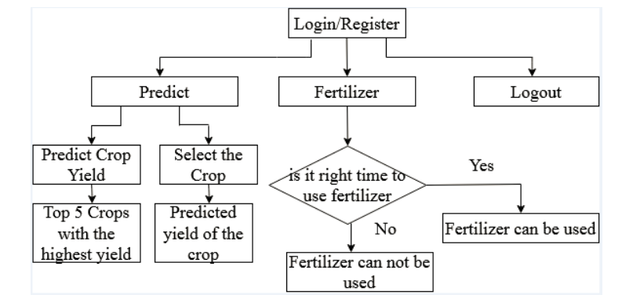
Fig. Proposed Methodology

MINIMUMSYSTEM REQUIREMENTS
HARDWARE REQUIREMENTS
- PROCESSOR : Pentium i3 Processor
- RAM : 2GB DD RAM
- HARD DISK : 250 GB

SOFTWARE REQUIREMENTS
- BACK END : PYTHON
- OPERATING SYSTEM : WINDOWS 7
- IDE : Spider3

