RAJALAKSHMI ENGINEERING COLLEGE
RAJALAKSHMI NAGAR, THANDALAM – 602 105


CD23621
MOBILE APPLICATION DESIGN AND DEVELOPMENT LABORATORY

Laboratory Observation Note Book

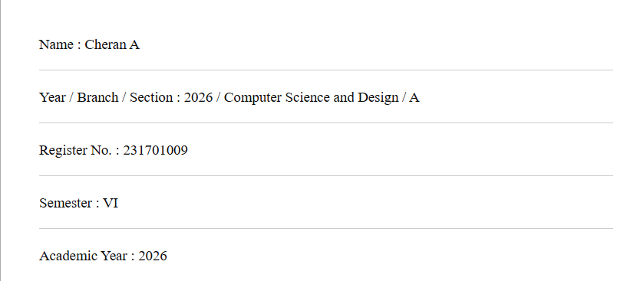

List of Experiments

Develop a mobile application that adapts to different screen sizes and orientations using Constraint Layout. Focus on aesthetic design, typography, and responsive UI. Handling different data formats. Design Focus: Layout adaptability, visual hierarchy.

Design a scientific calculator with custom UI components. The app should handle user input and offer visual feedback for button presses. Design Focus: Interaction design, visual feedback, aesthetics.

Create wireframes and a functional prototype for a mobile app using Figma. Convert the prototype into a basic Android application. Design Focus: Prototyping, flow consistency.

Implement gesture-based interactions such as swiping, pinch-to-zoom, and double-tap to navigate different screens or trigger actions in the app. Design Focus: Gesture interaction, smooth transitions.

Design and develop a mobile app that displays user data (e.g., steps, expenses) using custom-designed charts and graphs. Design Focus: Data visualization, clarity.

Design the UI for a chat application with message bubbles, avatars, and a responsive input field. Design Focus: Seamless interaction, UI consistency.

Create a mobile app that incorporates custom animations for user actions, such as button clicks or transitions between screens. Design Focus: Animation, user feedback.

Develop a location-based app that displays the user's current location on a map with interactive features such as markers and routes. Design Focus: Location-based UI, map interactivity.

Design custom notifications and alerts, integrating both visual and auditory feedback, and aligning the notification design with the app’s theme. Design Focus: Notification design, feedback.

Create an app that captures images, applies filters, crops, and edits photos with a visually appealing UI. Design Focus: Image editing tools, intuitive interface.

Design and develop a complete mobile application, integrating multiple concepts learned during the course. Design Focus: End-to-end design, creativity, functional app architecture.

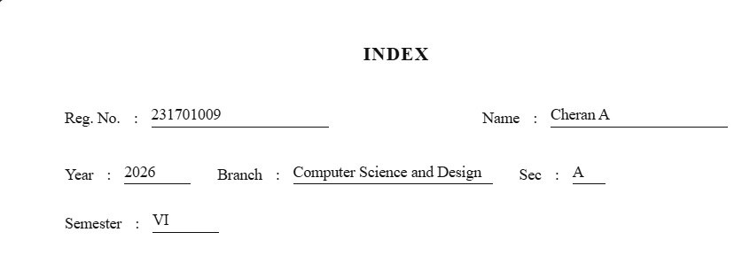
S.  No. | Date | Title | Page  No. | Teacher’s Signature /  Remarks
1 | 21.01.26 | Adaptive UI Design | 5
2 | 28.01.26 | Custom Calculator Design | 15
3 | 18.02.26 | Wire framing and Prototyping with Figma | 29
4 | 25.02.26 | Gesture-Based Interaction App | 33
5 | 04.03.26 | Data Visualization App | 43
6 | 11.03.26 | Chat Application UI | 55
7 | 18.03.26 | Custom Animation for User Feedback | 65
8 | 01.04.26 | Location-Based App Design | 71
9 | 08.04.26 | Notifications and Alerts Design | 79
10 | 22.04.26 | Camera and Image Editing App | 87

Ex. No. : 1 Date:
Register No.: Name:

Adaptive UI Design
Aim
Develop a mobile application that adapts to different screen sizes and orientations using Constraint Layout. Focus on aesthetic design, typography, and responsive UI. Handling different data formats. Design Focus: Layout adaptability, visual hierarchy.

Procedure
- Requirement Analysis
Identify the objective of designing an adaptive mobile UI that supports multiple screen sizes (small, medium, large devices) and different orientations (portrait and landscape). Analyze the layout adaptability and visual hierarchy requirements.
- Create a New Android Studio Project
  - Open Android Studio.
  - Select New Project → Empty Activity.
  - Choose Kotlin/Java as the programming language.
  - Set the Minimum SDK as required (API 21 or above recommended).
- Design the Base Layout using ConstraintLayout
  - Open activity_main.xml.
  - Set the root layout as ConstraintLayout.
  - Add UI components such as:
    - TextView (Title/Header)
    - ImageView (Optional banner or icon)
    - EditText / RecyclerView / CardView
    - Button elements
  - Apply constraints (Top, Bottom, Start, End) properly to avoid fixed positioning.
- Apply Responsive Design Principles
  - Use wrap_content and match_constraint (0dp) instead of fixed dimensions.
  - Utilize Guidelines and Barriers in ConstraintLayout for better alignment.
  - Maintain proper margins and padding for spacing consistency.
- Create Alternative Layout for Landscape Mode
  - Right-click res → Create layout-land resource folder.
  - Copy activity_main.xml into layout-land.
  - Redesign the layout to arrange components horizontally for landscape view.
- Support Different Screen Sizes
  - Create resource folders such as:
    - layout-sw600dp (for tablets)
  - Adjust UI elements (e.g., increase text size, multi-column layout).
- Typography and Styling
  - Define text sizes in res/values/dimens.xml.
  - Use styles.xml to maintain consistent theme and typography.
  - Maintain visual hierarchy using:
    - Large bold font for headings
    - Medium font for subheadings
    - Standard size for body text
- Handle Different Data Formats
  - Display text, images, and formatted numeric values.
  - Use string resources (strings.xml) instead of hardcoding values.
  - Ensure proper formatting using placeholders if needed.
- Testing the Application
  - Run the app in Emulator.
  - Test on different virtual devices (Phone, Tablet).
  - Rotate the device to verify adaptive behavior.
  - Ensure no overlapping or distortion of UI elements.
- Optimization and Refinement
- Check alignment warnings in Layout Inspector.
- Remove hardcoded dimensions.
- Improve spacing and consistency.
- Build and Run the Application
- Clean and Rebuild the project.
- Execute the app and verify functionality.

AndroidManifest.xml
<?xml version="1.0" encoding="utf-8"?>
<manifest xmlns:android="http://schemas.android.com/apk/res/android"
xmlns:tools="http://schemas.android.com/tools">
<application
android:allowBackup="true"
android:dataExtractionRules="@xml/data_extraction_rules"
android:fullBackupContent="@xml/backup_rules"
android:icon="@mipmap/ic_launcher"
android:label="@string/app_name"
android:roundIcon="@mipmap/ic_launcher_round"
android:supportsRtl="true"
android:theme="@style/Theme.Ex1"
tools:targetApi="31">
<activity
android:name=".MainActivity"
android:exported="true">
<intent-filter>
<action android:name="android.intent.action.MAIN" />
<category android:name="android.intent.category.LAUNCHER" />
</intent-filter>
</activity>
</application>
</manifest>

activity_main.xml
<?xml version="1.0" encoding="utf-8"?>
<androidx.constraintlayout.widget.ConstraintLayout
xmlns:android="http://schemas.android.com/apk/res/android"
xmlns:app="http://schemas.android.com/apk/res-auto"
android:id="@+id/rootLayout"
android:layout_width="match_parent"
android:layout_height="match_parent"
android:padding="16dp">
<TextView
android:id="@+id/tvTitle"
android:layout_width="0dp"
android:layout_height="wrap_content"
android:text="Adaptive UI Design"
android:textStyle="bold"
android:textSize="@dimen/title_text"
android:textAlignment="center"
app:layout_constraintTop_toTopOf="parent"
app:layout_constraintStart_toStartOf="parent"
app:layout_constraintEnd_toEndOf="parent"/>
<TextView
android:id="@+id/tvSubTitle"
android:layout_width="0dp"
android:layout_height="wrap_content"
android:text="Responsive layout • Typography • Data Formats"
android:textAlignment="center"
android:textSize="@dimen/subtitle_text"
android:layout_marginTop="6dp"
app:layout_constraintTop_toBottomOf="@id/tvTitle"
app:layout_constraintStart_toStartOf="parent"
app:layout_constraintEnd_toEndOf="parent"/>
<!-- Left Card -->
<androidx.cardview.widget.CardView
android:id="@+id/cardInfo"
android:layout_width="0dp"
android:layout_height="0dp"
app:cardCornerRadius="16dp"
app:cardElevation="6dp"
android:layout_marginTop="14dp"
app:layout_constraintTop_toBottomOf="@id/tvSubTitle"
app:layout_constraintBottom_toBottomOf="parent"
app:layout_constraintStart_toStartOf="parent"
app:layout_constraintEnd_toStartOf="@id/btnChangeData"
app:layout_constraintWidth_percent="0.55">
<LinearLayout
android:layout_width="match_parent"
android:layout_height="match_parent"
android:orientation="vertical"
android:gravity="center"
android:padding="16dp">
<TextView
android:id="@+id/tvCollege"
android:layout_width="match_parent"
android:layout_height="wrap_content"
android:text="Rajalakshmi Engineering College"
android:textStyle="bold"
android:textSize="@dimen/body_text"
android:textAlignment="center"/>
<TextView
android:id="@+id/tvAmount"
android:layout_width="match_parent"
android:layout_height="wrap_content"
android:text="Amount: ₹0.00"
android:textSize="@dimen/body_text"
android:textAlignment="center"
android:layout_marginTop="10dp"/>
<TextView
android:id="@+id/tvDate"
android:layout_width="match_parent"
android:layout_height="wrap_content"
android:text="Date: --"
android:textSize="@dimen/body_text"
android:textAlignment="center"
android:layout_marginTop="8dp"/>
</LinearLayout>
</androidx.cardview.widget.CardView>
<!-- Right Buttons -->
<Button
android:id="@+id/btnChangeData"
android:layout_width="0dp"
android:layout_height="wrap_content"
android:text="Change Data Format"
android:layout_marginTop="14dp"
app:layout_constraintTop_toBottomOf="@id/tvSubTitle"
app:layout_constraintStart_toEndOf="@id/cardInfo"
app:layout_constraintEnd_toEndOf="parent"
app:layout_constraintWidth_percent="0.42"/>
<Button
android:id="@+id/btnChangeTheme"
android:layout_width="0dp"
android:layout_height="wrap_content"
android:text="Toggle Theme Colors"
android:layout_marginTop="10dp"
app:layout_constraintTop_toBottomOf="@id/btnChangeData"
app:layout_constraintStart_toStartOf="@id/btnChangeData"
app:layout_constraintEnd_toEndOf="@id/btnChangeData"/>
<TextView
android:id="@+id/tvNote"
android:layout_width="0dp"
android:layout_height="wrap_content"
android:text="Landscape layout adapts into two columns."
android:textAlignment="center"
android:textSize="@dimen/caption_text"
android:layout_marginTop="10dp"
app:layout_constraintTop_toBottomOf="@id/btnChangeTheme"
app:layout_constraintStart_toStartOf="@id/btnChangeData"
app:layout_constraintEnd_toEndOf="@id/btnChangeData"/>
</androidx.constraintlayout.widget.ConstraintLayout>

layout-land/activity_main.xml:
<?xml version="1.0" encoding="utf-8"?>
<androidx.constraintlayout.widget.ConstraintLayout
xmlns:android="http://schemas.android.com/apk/res/android"
xmlns:app="http://schemas.android.com/apk/res-auto"
android:id="@+id/rootLayout"
android:layout_width="match_parent"
android:layout_height="match_parent"
android:padding="16dp">
<!-- Header -->
<TextView
android:id="@+id/tvTitle"
android:layout_width="0dp"
android:layout_height="wrap_content"
android:text="Adaptive UI Design"
android:textAlignment="center"
android:textStyle="bold"
android:textSize="@dimen/title_text"
app:layout_constraintTop_toTopOf="parent"
app:layout_constraintStart_toStartOf="parent"
app:layout_constraintEnd_toEndOf="parent"/>
<!-- Subtitle -->
<TextView
android:id="@+id/tvSubTitle"
android:layout_width="0dp"
android:layout_height="wrap_content"
android:text="Responsive layout • Typography • Data Formats"
android:textAlignment="center"
android:textSize="@dimen/subtitle_text"
app:layout_constraintTop_toBottomOf="@id/tvTitle"
app:layout_constraintStart_toStartOf="parent"
app:layout_constraintEnd_toEndOf="parent"
android:layout_marginTop="8dp"/>
<!-- Card-like container -->
<androidx.cardview.widget.CardView
android:id="@+id/cardInfo"
android:layout_width="0dp"
android:layout_height="wrap_content"
app:cardCornerRadius="16dp"
app:cardElevation="6dp"
android:layout_marginTop="16dp"
app:layout_constraintTop_toBottomOf="@id/tvSubTitle"
app:layout_constraintStart_toStartOf="parent"
app:layout_constraintEnd_toEndOf="parent">
<LinearLayout
android:layout_width="match_parent"
android:layout_height="wrap_content"
android:orientation="vertical"
android:padding="16dp">
<TextView
android:id="@+id/tvCollege"
android:layout_width="match_parent"
android:layout_height="wrap_content"
android:text="Rajalakshmi Engineering College"
android:textStyle="bold"
android:textSize="@dimen/body_text"
android:textAlignment="center"/>
<TextView
android:id="@+id/tvAmount"
android:layout_width="match_parent"
android:layout_height="wrap_content"
android:text="Amount: ₹0.00"
android:textSize="@dimen/body_text"
android:textAlignment="center"
android:layout_marginTop="8dp"/>
<TextView
android:id="@+id/tvDate"
android:layout_width="match_parent"
android:layout_height="wrap_content"
android:text="Date: --"
android:textSize="@dimen/body_text"
android:textAlignment="center"
android:layout_marginTop="6dp"/>
</LinearLayout>
</androidx.cardview.widget.CardView>
<!-- Buttons -->
<Button
android:id="@+id/btnChangeData"
android:layout_width="0dp"
android:layout_height="wrap_content"
android:text="Change Data Format"
android:layout_marginTop="16dp"
app:layout_constraintTop_toBottomOf="@id/cardInfo"
app:layout_constraintStart_toStartOf="parent"
app:layout_constraintEnd_toEndOf="parent"/>
<Button
android:id="@+id/btnChangeTheme"
android:layout_width="0dp"
android:layout_height="wrap_content"
android:text="Toggle Theme Colors"
android:layout_marginTop="10dp"
app:layout_constraintTop_toBottomOf="@id/btnChangeData"
app:layout_constraintStart_toStartOf="parent"
app:layout_constraintEnd_toEndOf="parent"/>
<!-- Bottom note -->
<TextView
android:id="@+id/tvNote"
android:layout_width="0dp"
android:layout_height="wrap_content"
android:text="Rotate screen / try tablet emulator to see adaptability."
android:textSize="@dimen/caption_text"
android:textAlignment="center"
android:layout_marginTop="12dp"
app:layout_constraintTop_toBottomOf="@id/btnChangeTheme"
app:layout_constraintStart_toStartOf="parent"
app:layout_constraintEnd_toEndOf="parent"/>
</androidx.constraintlayout.widget.ConstraintLayout>

dimes.xml
<?xml version="1.0" encoding="utf-8"?>
<resources>
<dimen name="title_text">22sp</dimen>
<dimen name="subtitle_text">14sp</dimen>
<dimen name="body_text">18sp</dimen>
<dimen name="caption_text">12sp</dimen>
</resources>

MainActivity.kt
package com.example.ex1
import android.graphics.Color
import android.os.Bundle
import android.widget.Button
import android.widget.TextView
import androidx.appcompat.app.AppCompatActivity
import androidx.constraintlayout.widget.ConstraintLayout
import java.text.NumberFormat
import java.text.SimpleDateFormat
import java.util.Date
import java.util.Locale
class MainActivity : AppCompatActivity() {
private var themeIndex = 0
private var dataIndex = 0
override fun onCreate(savedInstanceState: Bundle?) {
super.onCreate(savedInstanceState)
setContentView(R.layout.activity_main)
val rootLayout: ConstraintLayout = findViewById(R.id.rootLayout)
val tvAmount: TextView = findViewById(R.id.tvAmount)
val tvDate: TextView = findViewById(R.id.tvDate)
val btnChangeData: Button = findViewById(R.id.btnChangeData)
val btnChangeTheme: Button = findViewById(R.id.btnChangeTheme)
// Initial values
updateData(tvAmount, tvDate)
btnChangeData.setOnClickListener {
dataIndex++
updateData(tvAmount, tvDate)
}
btnChangeTheme.setOnClickListener {
themeIndex++
when (themeIndex % 3) {
0 -> {
rootLayout.setBackgroundColor(Color.WHITE)
tvAmount.setTextColor(Color.DKGRAY)
tvDate.setTextColor(Color.DKGRAY)
}
1 -> {
rootLayout.setBackgroundColor(Color.parseColor("#FFF3E0")) // light orange
tvAmount.setTextColor(Color.BLACK)
tvDate.setTextColor(Color.BLACK)
}
2 -> {
rootLayout.setBackgroundColor(Color.parseColor("#E3F2FD")) // light blue
tvAmount.setTextColor(Color.BLACK)
tvDate.setTextColor(Color.BLACK)
}
}
}
}
private fun updateData(tvAmount: TextView, tvDate: TextView) {
val amountValue = when (dataIndex % 3) {
0 -> 1250.5
1 -> 98765.75
else -> 499.0
}
// Different data formats: Currency in Indian locale + Date formats
val currency = NumberFormat.getCurrencyInstance(Locale("en", "IN")).format(amountValue)
val dateText = when (dataIndex % 3) {
0 -> SimpleDateFormat("dd/MM/yyyy", Locale.getDefault()).format(Date())
1 -> SimpleDateFormat("MMM dd, yyyy", Locale.getDefault()).format(Date())
else -> SimpleDateFormat("EEEE, dd MMM yyyy", Locale.getDefault()).format(Date())
}
tvAmount.text = "Amount: $currency"
tvDate.text = "Date: $dateText"
}
}

Output

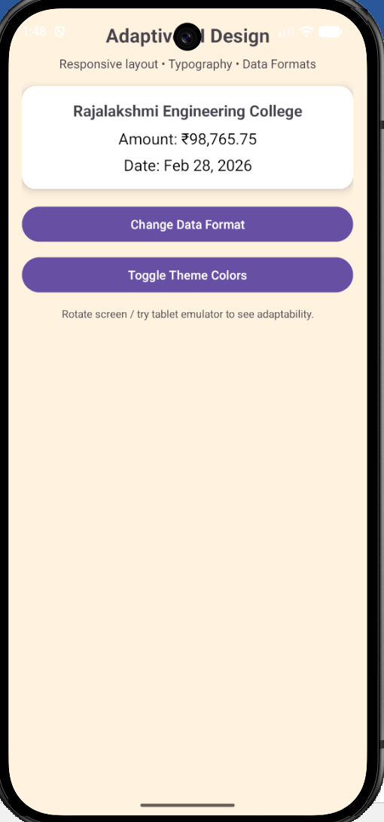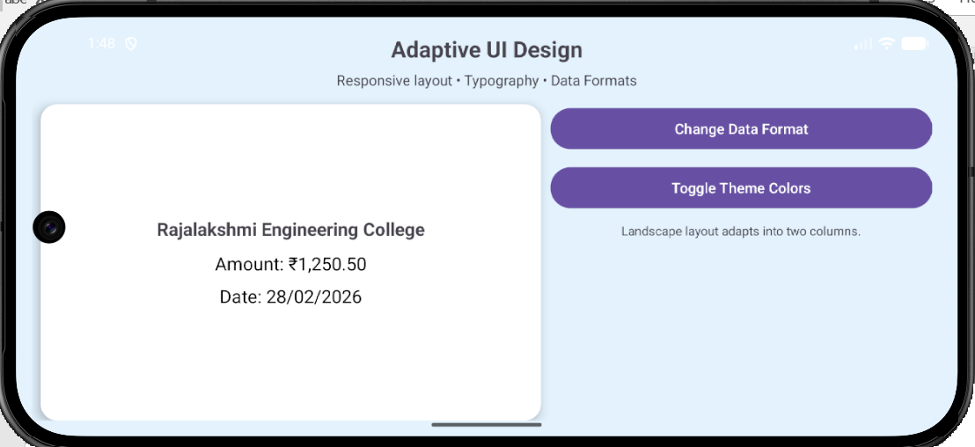

Result
The mobile application UI successfully adapts to different screen sizes and orientations using ConstraintLayout. The design maintains visual hierarchy, responsive behavior, and aesthetic consistency across devices.

Ex. No. : 2 Date:
Register No.: Name:

Custom Calculator Design
Aim
Design a scientific calculator with custom UI components. The app should handle user input and offer visual feedback for button presses. Design Focus: Interaction design, visual feedback, aesthetics.

Procedure
- Requirement Analysis
Identify the objective of developing a scientific calculator application with custom UI components that supports numeric input, arithmetic operations, and scientific functions such as sin, cos, tan, log, and square root. Ensure proper interaction design and visual feedback for button presses.
- Create an Android Studio Project
  - Open Android Studio.
  - Select New Project → Empty Activity.
  - Enter the application name as Custom Scientific Calculator Design.
  - Choose Kotlin as the programming language.
  - Select Minimum SDK (API 21 or above).
- Design the User Interface
  - Open the layout file activity_main.xml.
  - Use ConstraintLayout or LinearLayout as the root layout.
  - Create a TextView at the top to display the calculator input and results.
  - Add calculator buttons using GridLayout or LinearLayout rows.
- Add Calculator Buttons
  - Insert buttons for numeric values 0 – 9.
  - Add arithmetic operator buttons +, −, ×, ÷.
  - Include additional buttons such as Decimal (.), Clear (C), and Equal (=).
  - Add scientific function buttons like sin, cos, tan, log, and √.
- Apply Custom UI Styling
  - Define custom button styles in styles.xml.
  - Apply different colors for:
    - Numeric buttons
    - Operator buttons
    - Scientific buttons
  - Use background tint, rounded corners, margins, and padding to enhance the visual appearance.
- Implement Button Click Handling
  - Open the MainActivity.kt file.
  - Use View Binding or findViewById() to connect UI components.
  - Implement click listeners for numeric buttons to append numbers to the display.
  - Implement click listeners for operators to perform arithmetic calculations.
- Implement Scientific Functions
  - Write functions to perform sin(), cos(), tan(), log(), and sqrt() calculations.
  - Use Kotlin Math functions to compute the results.
  - Display the result in the calculator display area.
- Provide Visual Feedback for Button Presses
  - Add animation effects such as button scaling or ripple effects when buttons are pressed.
  - Change button color or opacity during touch events to improve user interaction.
- Handle Errors and Input Validation
  - Prevent invalid operations such as division by zero.
  - Display Error messages for invalid calculations.
  - Reset the calculator using the Clear button.
- Test the Application
- Run the application in the Android Emulator or on a physical device.
- Verify all numeric, arithmetic, and scientific functions.
- Ensure buttons respond correctly with visual feedback.
- Build and Run the Application
- Clean and rebuild the project.
- Execute the application and verify that the custom calculator interface works correctly.

AndroidManifest.xml
<?xml version="1.0" encoding="utf-8"?>
<manifest xmlns:android="http://schemas.android.com/apk/res/android"
xmlns:tools="http://schemas.android.com/tools">
<application
android:allowBackup="true"
android:dataExtractionRules="@xml/data_extraction_rules"
android:fullBackupContent="@xml/backup_rules"
android:icon="@mipmap/ic_launcher"
android:label="@string/app_name"
android:roundIcon="@mipmap/ic_launcher_round"
android:supportsRtl="true"
android:theme="@style/Theme.CustomScientificCalculatorDesign">
<activity
android:name=".MainActivity"
android:exported="true"
android:label="@string/app_name"
android:theme="@style/Theme.CustomScientificCalculatorDesign">
<intent-filter>
<action android:name="android.intent.action.MAIN" />
<category android:name="android.intent.category.LAUNCHER" />
</intent-filter>
</activity>
</application>
</manifest>

activity_main.xml
<?xml version="1.0" encoding="utf-8"?>
<LinearLayout xmlns:android="http://schemas.android.com/apk/res/android"
xmlns:tools="http://schemas.android.com/tools"
android:layout_width="match_parent"
android:layout_height="match_parent"
android:orientation="vertical"
android:background="@color/black"
android:padding="8dp"
tools:context=".MainActivity">
<TextView
android:id="@+id/tvDisplay"
android:layout_width="match_parent"
android:layout_height="0dp"
android:layout_weight="2"
android:background="@color/gray_dark"
android:gravity="bottom|end"
android:padding="16dp"
android:text="0"
android:textColor="@color/white"
android:textSize="42sp"
android:textStyle="bold" />
<LinearLayout
android:layout_width="match_parent"
android:layout_height="0dp"
android:layout_weight="5"
android:orientation="vertical"
android:layout_marginTop="8dp">
<!-- Row 1 -->
<LinearLayout
android:layout_width="match_parent"
android:layout_height="0dp"
android:layout_weight="1"
android:orientation="horizontal">
<Button
android:id="@+id/btnClear"
style="@style/CalcButton.Operator"
android:layout_width="0dp"
android:layout_height="match_parent"
android:layout_weight="1"
android:text="C" />
<Button
android:id="@+id/btnSin"
style="@style/CalcButton.Scientific"
android:layout_width="0dp"
android:layout_height="match_parent"
android:layout_weight="1"
android:text="sin" />
<Button
android:id="@+id/btnCos"
style="@style/CalcButton.Scientific"
android:layout_width="0dp"
android:layout_height="match_parent"
android:layout_weight="1"
android:text="cos" />
<Button
android:id="@+id/btnTan"
style="@style/CalcButton.Scientific"
android:layout_width="0dp"
android:layout_height="match_parent"
android:layout_weight="1"
android:text="tan" />
</LinearLayout>
<!-- Row 2 -->
<LinearLayout
android:layout_width="match_parent"
android:layout_height="0dp"
android:layout_weight="1"
android:orientation="horizontal">
<Button
android:id="@+id/btnLog"
style="@style/CalcButton.Scientific"
android:layout_width="0dp"
android:layout_height="match_parent"
android:layout_weight="1"
android:text="log" />
<Button
android:id="@+id/btnSqrt"
style="@style/CalcButton.Scientific"
android:layout_width="0dp"
android:layout_height="match_parent"
android:layout_weight="1"
android:text="√" />
<Button
android:id="@+id/btnDiv"
style="@style/CalcButton.Operator"
android:layout_width="0dp"
android:layout_height="match_parent"
android:layout_weight="1"
android:text="÷" />
<Button
android:id="@+id/btnMul"
style="@style/CalcButton.Operator"
android:layout_width="0dp"
android:layout_height="match_parent"
android:layout_weight="1"
android:text="×" />
</LinearLayout>
<!-- Row 3 -->
<LinearLayout
android:layout_width="match_parent"
android:layout_height="0dp"
android:layout_weight="1"
android:orientation="horizontal">
<Button
android:id="@+id/btn7"
style="@style/CalcButton.Numeric"
android:layout_width="0dp"
android:layout_height="match_parent"
android:layout_weight="1"
android:text="7" />
<Button
android:id="@+id/btn8"
style="@style/CalcButton.Numeric"
android:layout_width="0dp"
android:layout_height="match_parent"
android:layout_weight="1"
android:text="8" />
<Button
android:id="@+id/btn9"
style="@style/CalcButton.Numeric"
android:layout_width="0dp"
android:layout_height="match_parent"
android:layout_weight="1"
android:text="9" />
<Button
android:id="@+id/btnSub"
style="@style/CalcButton.Operator"
android:layout_width="0dp"
android:layout_height="match_parent"
android:layout_weight="1"
android:text="−" />
</LinearLayout>
<!-- Row 4 -->
<LinearLayout
android:layout_width="match_parent"
android:layout_height="0dp"
android:layout_weight="1"
android:orientation="horizontal">
<Button
android:id="@+id/btn4"
style="@style/CalcButton.Numeric"
android:layout_width="0dp"
android:layout_height="match_parent"
android:layout_weight="1"
android:text="4" />
<Button
android:id="@+id/btn5"
style="@style/CalcButton.Numeric"
android:layout_width="0dp"
android:layout_height="match_parent"
android:layout_weight="1"
android:text="5" />
<Button
android:id="@+id/btn6"
style="@style/CalcButton.Numeric"
android:layout_width="0dp"
android:layout_height="match_parent"
android:layout_weight="1"
android:text="6" />
<Button
android:id="@+id/btnAdd"
style="@style/CalcButton.Operator"
android:layout_width="0dp"
android:layout_height="match_parent"
android:layout_weight="1"
android:text="+" />
</LinearLayout>
<!-- Row 5 -->
<LinearLayout
android:layout_width="match_parent"
android:layout_height="0dp"
android:layout_weight="1"
android:orientation="horizontal">
<Button
android:id="@+id/btn1"
style="@style/CalcButton.Numeric"
android:layout_width="0dp"
android:layout_height="match_parent"
android:layout_weight="1"
android:text="1" />
<Button
android:id="@+id/btn2"
style="@style/CalcButton.Numeric"
android:layout_width="0dp"
android:layout_height="match_parent"
android:layout_weight="1"
android:text="2" />
<Button
android:id="@+id/btn3"
style="@style/CalcButton.Numeric"
android:layout_width="0dp"
android:layout_height="match_parent"
android:layout_weight="1"
android:text="3" />
<Button
android:id="@+id/btnEqual"
style="@style/CalcButton.Operator"
android:layout_width="0dp"
android:layout_height="match_parent"
android:layout_weight="1"
android:text="=" />
</LinearLayout>
<!-- Row 6 -->
<LinearLayout
android:layout_width="match_parent"
android:layout_height="0dp"
android:layout_weight="1"
android:orientation="horizontal">
<Button
android:id="@+id/btn0"
style="@style/CalcButton.Numeric"
android:layout_width="0dp"
android:layout_height="match_parent"
android:layout_weight="2"
android:text="0" />
<Button
android:id="@+id/btnDot"
style="@style/CalcButton.Numeric"
android:layout_width="0dp"
android:layout_height="match_parent"
android:layout_weight="1"
android:text="." />
<Button
android:id="@+id/btnPercent"
style="@style/CalcButton.Operator"
android:layout_width="0dp"
android:layout_height="match_parent"
android:layout_weight="1"
android:text="%" />
</LinearLayout>
</LinearLayout>
</LinearLayout>

MainActivity.kt
package com.example.customscientificcalculatordesign
import android.os.Bundle
import android.view.MotionEvent
import android.widget.Button
import androidx.appcompat.app.AppCompatActivity
import com.example.customscientificcalculatordesign.databinding.ActivityMainBinding
import java.text.DecimalFormat
import kotlin.math.*
class MainActivity : AppCompatActivity() {
private lateinit var binding: ActivityMainBinding
private var lastNumeric: Boolean = false
private var stateError: Boolean = false
private var lastDot: Boolean = false
private val decimalFormat = DecimalFormat("#.#######")
override fun onCreate(savedInstanceState: Bundle?) {
super.onCreate(savedInstanceState)
binding = ActivityMainBinding.inflate(layoutInflater)
setContentView(binding.root)
setNumericOnClickListeners()
setOperatorOnClickListeners()
setScientificOnClickListeners()
val allButtons = listOf(
binding.btn0, binding.btn1, binding.btn2, binding.btn3,
binding.btn4, binding.btn5, binding.btn6, binding.btn7,
binding.btn8, binding.btn9, binding.btnAdd, binding.btnSub,
binding.btnMul, binding.btnDiv, binding.btnDot, binding.btnEqual,
binding.btnClear, binding.btnSin, binding.btnCos, binding.btnTan,
binding.btnLog, binding.btnSqrt
)
for (button in allButtons) {
applyPressEffect(button)
}
binding.btnClear.setOnClickListener {
binding.tvDisplay.text = "0"
lastNumeric = false
stateError = false
lastDot = false
}
binding.btnDot.setOnClickListener {
if (lastNumeric && !stateError && !lastDot) {
binding.tvDisplay.append(".")
lastNumeric = false
lastDot = true
} else if (!lastNumeric && !stateError && !lastDot) {
binding.tvDisplay.append("0.")
lastNumeric = false
lastDot = true
}
}
binding.btnEqual.setOnClickListener {
onEqual()
}
}
private fun applyPressEffect(button: Button) {
button.setOnTouchListener { v, event ->
when (event.action) {
MotionEvent.ACTION_DOWN -> {
v.animate().scaleX(0.92f).scaleY(0.92f).setDuration(80).start()
v.alpha = 0.8f
}
MotionEvent.ACTION_UP, MotionEvent.ACTION_CANCEL -> {
v.animate().scaleX(1f).scaleY(1f).setDuration(80).start()
v.alpha = 1f
}
}
false
}
}
private fun setNumericOnClickListeners() {
val buttons = listOf(
binding.btn0, binding.btn1, binding.btn2, binding.btn3,
binding.btn4, binding.btn5, binding.btn6, binding.btn7,
binding.btn8, binding.btn9
)
for (button in buttons) {
button.setOnClickListener {
if (stateError) {
binding.tvDisplay.text = (it as Button).text
stateError = false
} else {
val currentText = binding.tvDisplay.text.toString()
if (currentText == "0") {
binding.tvDisplay.text = (it as Button).text
} else {
binding.tvDisplay.append((it as Button).text)
}
}
lastNumeric = true
}
}
}
private fun setOperatorOnClickListeners() {
val buttons = listOf(
binding.btnAdd, binding.btnSub, binding.btnMul, binding.btnDiv
)
for (button in buttons) {
button.setOnClickListener {
if (lastNumeric && !stateError) {
binding.tvDisplay.append(" " + (it as Button).text + " ")
lastNumeric = false
lastDot = false
}
}
}
}
private fun setScientificOnClickListeners() {
binding.btnSin.setOnClickListener { calculateScientific { sin(Math.toRadians(it)) } }
binding.btnCos.setOnClickListener { calculateScientific { cos(Math.toRadians(it)) } }
binding.btnTan.setOnClickListener {
calculateScientific {
if (it % 180 == 90.0 || it % 180 == -90.0) Double.NaN
else tan(Math.toRadians(it))
}
}
binding.btnLog.setOnClickListener { calculateScientific { if (it > 0) log10(it) else Double.NaN } }
binding.btnSqrt.setOnClickListener { calculateScientific { if (it >= 0) sqrt(it) else Double.NaN } }
}
private fun calculateScientific(operation: (Double) -> Double) {
if (!stateError) {
try {
val currentText = binding.tvDisplay.text.toString()
if (!lastNumeric) {
binding.tvDisplay.text = "Error"
stateError = true
lastNumeric = false
return
}
val valueToProcess = evaluate(currentText)
val result = operation(valueToProcess)
if (result.isNaN() || result.isInfinite()) {
binding.tvDisplay.text = "Error"
stateError = true
lastNumeric = false
} else {
binding.tvDisplay.text = decimalFormat.format(result)
lastNumeric = true
stateError = false
lastDot = binding.tvDisplay.text.contains(".")
}
} catch (e: Exception) {
binding.tvDisplay.text = "Error"
stateError = true
lastNumeric = false
}
}
}
private fun onEqual() {
if (lastNumeric && !stateError) {
val text = binding.tvDisplay.text.toString()
try {
val result = evaluate(text)
if (result.isInfinite() || result.isNaN()) {
binding.tvDisplay.text = "Error"
stateError = true
lastNumeric = false
} else {
binding.tvDisplay.text = decimalFormat.format(result)
lastDot = binding.tvDisplay.text.contains(".")
lastNumeric = true
stateError = false
}
} catch (e: Exception) {
binding.tvDisplay.text = "Error"
stateError = true
lastNumeric = false
}
}
}
private fun evaluate(expression: String): Double {
val tokens = expression.trim().split("\\s+".toRegex())
if (tokens.isEmpty()) return 0.0
if (tokens.size == 1) return tokens[0].toDouble()
val values = mutableListOf<Double>()
val ops = mutableListOf<String>()
fun precedence(op: String): Int {
return when (op) {
"+", "−" -> 1
"×", "÷" -> 2
else -> 0
}
}
fun applyOperation() {
if (values.size < 2 || ops.isEmpty()) return
val b = values.removeAt(values.lastIndex)
val a = values.removeAt(values.lastIndex)
val op = ops.removeAt(ops.lastIndex)
val result = when (op) {
"+" -> a + b
"−" -> a - b
"×" -> a * b
"÷" -> if (b == 0.0) Double.NaN else a / b
else -> 0.0
}
values.add(result)
}
for (token in tokens) {
if (token.toDoubleOrNull() != null) {
values.add(token.toDouble())
} else {
while (ops.isNotEmpty() && precedence(ops.last()) >= precedence(token)) {
applyOperation()
}
ops.add(token)
}
}
while (ops.isNotEmpty()) {
applyOperation()
}
return values.firstOrNull() ?: 0.0
}
}

Colors.xml
<?xml version="1.0" encoding="utf-8"?>
<resources>
<color name="black">#FF000000</color>
<color name="white">#FFFFFFFF</color>
<color name="gray_dark">#212121</color>
<color name="gray_medium">#424242</color>
<color name="gray_light">#616161</color>
<color name="accent_blue">#2196F3</color>
<color name="accent_orange">#FF9800</color>
</resources>
Themes.xml
<?xml version="1.0" encoding="utf-8"?>
<resources xmlns:tools="http://schemas.android.com/tools">
<style name="Theme.CustomScientificCalculatorDesign" parent="Theme.MaterialComponents.DayNight.NoActionBar">
<item name="colorPrimary">@color/gray_dark</item>
<item name="colorPrimaryVariant">@color/black</item>
<item name="colorOnPrimary">@color/white</item>
<item name="colorSecondary">@color/accent_blue</item>
<item name="colorSecondaryVariant">@color/accent_blue</item>
<item name="colorOnSecondary">@color/white</item>
<item name="android:statusBarColor">@color/black</item>
<item name="android:navigationBarColor">@color/black</item>
</style>
<style name="CalcButton" parent="Widget.MaterialComponents.Button">
<item name="android:layout_width">0dp</item>
<item name="android:layout_height">0dp</item>
<item name="android:layout_margin">4dp</item>
<item name="android:layout_gravity">fill</item>
<item name="android:minHeight">64dp</item>
<item name="android:textSize">18sp</item>
<item name="android:textStyle">bold</item>
<item name="android:textColor">@color/white</item>
<item name="android:insetTop">0dp</item>
<item name="android:insetBottom">0dp</item>
<item name="cornerRadius">16dp</item>
<item name="backgroundTint">@color/gray_medium</item>
<item name="rippleColor">@color/accent_blue</item>
</style>
<style name="CalcButton.Numeric" parent="CalcButton">
<item name="backgroundTint">@color/accent_orange</item>
<item name="android:textColor">@color/white</item>
</style>
<style name="CalcButton.Operator" parent="CalcButton">
<item name="backgroundTint">@color/accent_orange</item>
<item name="android:textColor">@color/white</item>
</style>
<style name="CalcButton.Scientific" parent="CalcButton">
<item name="backgroundTint">@color/gray_dark</item>
<item name="android:textColor">@color/white</item>
</style>
<style name="CalcButton.Equal" parent="CalcButton">
<item name="backgroundTint">@color/accent_blue</item>
<item name="android:textColor">@color/white</item>
</style>
</resources>

Output

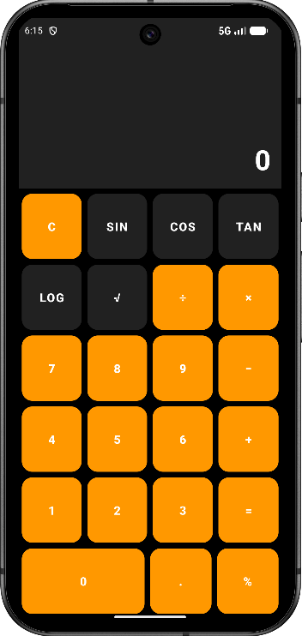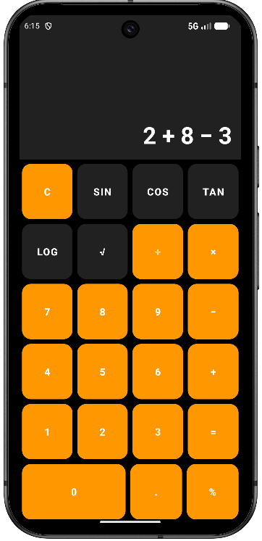

Result

Thus, a custom scientific calculator application was successfully designed and developed with user input handling, scientific functions, and visual feedback for button presses.

Ex. No. : 3 Date:
Register No.: Name:

Wire framing and Prototyping with Figma
Aim
Create wireframes and a functional prototype for a mobile app using Figma. Convert the prototype into a basic Android application. Design Focus: Prototyping, flow consistency.

- Requirement Analysis
  - Identified the essential features required for the Learning Hub app:
a. Course category selection
b. Course details page
c. Video lessons and study materials
d. Progress tracking dashboard
e. Quiz and assessment section
f. Profile and back navigation
- Creating Frames in Figma
- Opened Figma and selected the iPhone 14 & 15 Pro Max frame size.
  - Designed multiple key screens:
a. Home / Course Categories Screen
b. Course Details Screen
c. Learning Module (Video/Content) Screen
d. Quiz Screen
e. Progress Dashboard Screen
- Wireframing
- Created low-fidelity wireframes using simple shapes like rectangles and placeholders for images and text.
- Organized content sections clearly, including course cards, navigation bar, and action buttons.
- Ensured proper spacing, alignment, and touch-friendly button sizes for better usability.
- High-Fidelity Design
- Applied a consistent color palette and modern UI theme suitable for an educational platform.
- Added rounded cards, icons, illustrations, and clear typography for better readability.
- Established strong visual hierarchy by highlighting important elements like “Start Learning,” “Continue,” and “Submit Quiz.”
- Maintained uniform spacing, consistent fonts, and cohesive design components across all screens.
- Prototyping
- Used the Prototype tab in Figma to add interactivity.
  - Configured interactions such as:
a. Course card → Navigate to Course Details Screen
b. Start Learning button → Navigate to Learning Module Screen
c. Take Quiz button → Navigate to Quiz Screen
d. Back button → Return to previous screen
- Added smooth transition animations and tested the flow using Present mode.
- Testing and Refinement
- Reviewed layout alignment and overall design consistency.
- Improved text readability, color contrast, and accessibility.
- Verified seamless navigation between screens to ensure a smooth user experience.

Output

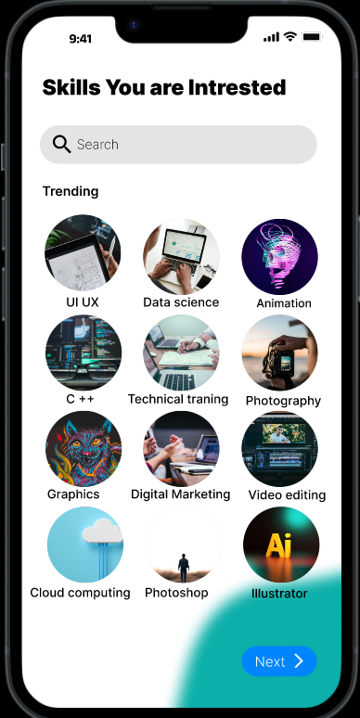
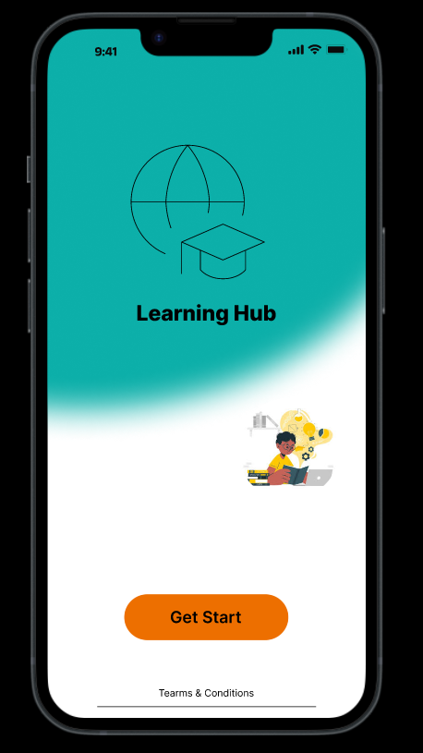

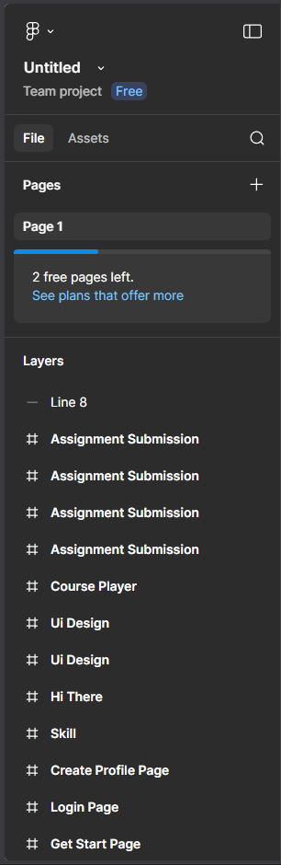
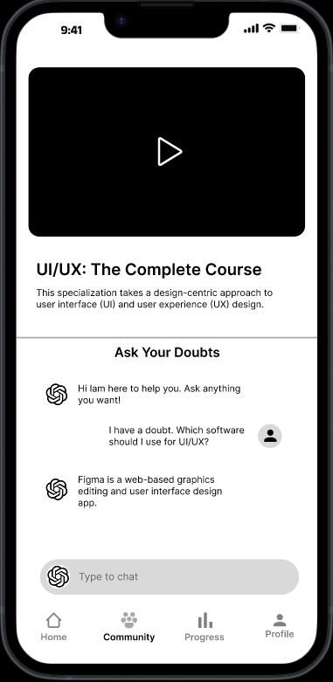

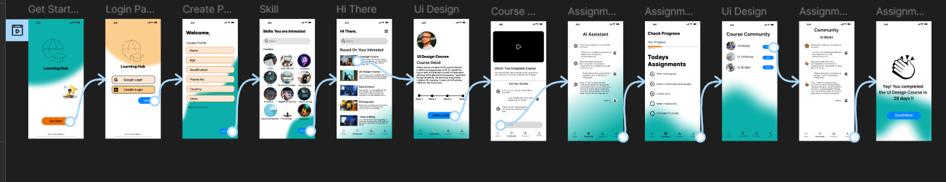

Result:
The TV Remote Mobile Application was successfully wireframed and prototyped using Figma. The application includes interactive screens for brand selection, remote control functions, and numeric input. The prototype demonstrates effective UI design principles, smooth navigation flow, and a user-friendly interface.

Ex. No. : 4 Date:
Register No.: Name:

Gesture-Based Interaction App
Aim
Implement gesture-based interactions such as swiping, pinch-to-zoom, and double-tap to navigate different screens or trigger actions in the app. Design Focus: Gesture interaction, smooth transitions.

Procedure
- Requirement Analysis
Identify the objective of developing a mobile application that demonstrates gesture-based interactions such as swipe, double-tap, and pinch-to-zoom. These gestures will be used to trigger actions such as navigating between screens, zooming UI elements, and displaying feedback messages.
- Create an Android Studio Project
  - Open Android Studio.
  - Select New Project → Empty Activity.
  - Enter the application name as Gesture-Based Interaction App.
  - Choose Kotlin as the programming language.
  - Select Minimum SDK (API 21 or above).
- Design the User Interface for Main Screen
  - Open the layout file activity_main.xml.
  - Use ConstraintLayout as the root layout.
  - Add a TextView to display gesture messages and instructions.
  - Add an ImageView that will respond to pinch-to-zoom and double-tap gestures.
  - Align UI components properly using constraints.
- Design the Second Screen Layout
  - Create another layout file activity_second.xml.
  - Add a TextView to indicate that the user has navigated to the second screen.
  - Position the TextView at the center using ConstraintLayout constraints.
- Implement Gesture Detection in MainActivity
  - Open the MainActivity.kt file.
  - Create objects of GestureDetector to detect gestures like swipe and double-tap.
  - Create an object of ScaleGestureDetector to detect pinch-to-zoom gestures.
- Implement Double Tap Gesture
  - Override the onDoubleTap() method of GestureDetector.SimpleOnGestureListener.
  - Trigger navigation to the SecondActivity using an Intent when the user performs a double tap.
- Implement Swipe Gesture
  - Override the onFling() method of the gesture listener.
  - Detect swipe directions such as swipe left, swipe right, swipe up, and swipe down.
  - Perform actions such as navigating to the second screen or resetting UI elements based on swipe direction.
- Implement Pinch-to-Zoom Gesture
  - Use ScaleGestureDetector.SimpleOnScaleGestureListener.
  - Override the onScale() method to detect pinch gestures.
  - Adjust the scale of the ImageView or change the text size dynamically during zoom gestures.
- Handle Touch Events
  - Override the setOnTouchListener() method for the TextView and ImageView.
  - Pass touch events to the GestureDetector and ScaleGestureDetector to process gestures correctly.
- Provide Visual Feedback
- Update the TextView text or display Toast messages when gestures are detected.
- Apply smooth transitions between screens using animation methods such as overridePendingTransition().
- Test the Application
- Run the application in the Android Emulator or on a physical device.
- Test the following gestures:
  - Swipe gestures for navigation or actions.
  - Double-tap gesture to open the second screen.
  - Pinch-to-zoom gesture to zoom text or images.
- Build and Run the Application
- Clean and rebuild the project.
- Execute the application and verify that all gesture-based interactions work smoothly.
AndroidManifest.xml
<?xml version="1.0" encoding="utf-8"?>
<manifest xmlns:android="http://schemas.android.com/apk/res/android"
xmlns:tools="http://schemas.android.com/tools">
<application
android:allowBackup="true"
android:dataExtractionRules="@xml/data_extraction_rules"
android:fullBackupContent="@xml/backup_rules"
android:icon="@mipmap/ic_launcher"
android:label="@string/app_name"
android:roundIcon="@mipmap/ic_launcher_round"
android:supportsRtl="true"
android:theme="@style/Theme.Ex4Demo"
>
<activity
android:name=".SecondActivity"
android:exported="false" />
<activity
android:name=".MainActivity"
android:exported="true">
<intent-filter>
<action android:name="android.intent.action.MAIN" />
<category android:name="android.intent.category.LAUNCHER" />
</intent-filter>
</activity>
</application>
</manifest>

activity_main.xml
<?xml version="1.0" encoding="utf-8"?>
<androidx.constraintlayout.widget.ConstraintLayout xmlns:android="http://schemas.android.com/apk/res/android"
xmlns:app="http://schemas.android.com/apk/res-auto"
xmlns:tools="http://schemas.android.com/tools"
android:id="@+id/main"
android:layout_width="match_parent"
android:layout_height="match_parent"
android:padding="16dp"
tools:context=".MainActivity">
<TextView
android:id="@+id/tv"
android:layout_width="0dp"
android:layout_height="wrap_content"
android:text="Use swipe, double tap, and pinch gestures"
android:textAlignment="center"
android:textSize="24sp"
android:textStyle="bold"
app:layout_constraintTop_toTopOf="parent"
app:layout_constraintBottom_toTopOf="@+id/gesture_image"
app:layout_constraintStart_toStartOf="parent"
app:layout_constraintEnd_toEndOf="parent"
app:layout_constraintVertical_bias="0.3" />
<ImageView
android:id="@+id/gesture_image"
android:layout_width="220dp"
android:layout_height="220dp"
android:layout_marginTop="24dp"
android:contentDescription="Gesture interaction image"
android:src="@mipmap/image_0"
app:layout_constraintTop_toBottomOf="@id/tv"
app:layout_constraintStart_toStartOf="parent"
app:layout_constraintEnd_toEndOf="parent" />
<TextView
android:id="@+id/tvHint"
android:layout_width="0dp"
android:layout_height="wrap_content"
android:layout_marginTop="24dp"
android:text="Swipe left: Open second screen | Swipe right: Reset | Double tap: Open/Zoom | Pinch: Zoom"
android:textAlignment="center"
android:textSize="16sp"
app:layout_constraintTop_toBottomOf="@id/gesture_image"
app:layout_constraintStart_toStartOf="parent"
app:layout_constraintEnd_toEndOf="parent" />
</androidx.constraintlayout.widget.ConstraintLayout>

activity_second.xml
<?xml version="1.0" encoding="utf-8"?>
<androidx.constraintlayout.widget.ConstraintLayout xmlns:android="http://schemas.android.com/apk/res/android"
xmlns:app="http://schemas.android.com/apk/res-auto"
xmlns:tools="http://schemas.android.com/tools"
android:id="@+id/secondRoot"
android:layout_width="match_parent"
android:layout_height="match_parent"
android:padding="16dp"
tools:context=".SecondActivity">
<TextView
android:id="@+id/tv2"
android:layout_width="0dp"
android:layout_height="wrap_content"
android:text="Second Screen\nSwipe right to go back"
android:textAlignment="center"
android:textSize="26sp"
android:textStyle="bold"
app:layout_constraintTop_toTopOf="parent"
app:layout_constraintBottom_toBottomOf="parent"
app:layout_constraintStart_toStartOf="parent"
app:layout_constraintEnd_toEndOf="parent" />
</androidx.constraintlayout.widget.ConstraintLayout>

MainActivity.kt
package com.example.ex4demo
import android.annotation.SuppressLint
import android.content.Intent
import android.os.Bundle
import android.util.TypedValue
import android.view.GestureDetector
import android.view.MotionEvent
import android.view.ScaleGestureDetector
import android.widget.ImageView
import android.widget.TextView
import android.widget.Toast
import androidx.activity.enableEdgeToEdge
import androidx.appcompat.app.AppCompatActivity
import androidx.constraintlayout.widget.ConstraintLayout
import androidx.core.view.ViewCompat
import androidx.core.view.WindowInsetsCompat
class MainActivity : AppCompatActivity() {
private lateinit var textGestureDetector: GestureDetector
private lateinit var textScaleDetector: ScaleGestureDetector
private lateinit var imageGestureDetector: GestureDetector
private lateinit var imageScaleDetector: ScaleGestureDetector
private lateinit var swipeGestureDetector: GestureDetector
private var currentTextSizeSp = 24f
private var imageScale = 1.0f
private val minScale = 0.5f
private val maxScale = 4.0f
@SuppressLint("ClickableViewAccessibility")
override fun onCreate(savedInstanceState: Bundle?) {
super.onCreate(savedInstanceState)
enableEdgeToEdge()
setContentView(R.layout.activity_main)
ViewCompat.setOnApplyWindowInsetsListener(findViewById(R.id.main)) { v, insets ->
val systemBars = insets.getInsets(WindowInsetsCompat.Type.systemBars())
v.setPadding(systemBars.left, systemBars.top, systemBars.right, systemBars.bottom)
insets
}
val root = findViewById<ConstraintLayout>(R.id.main)
val tv = findViewById<TextView>(R.id.tv)
val tvHint = findViewById<TextView>(R.id.tvHint)
val img = findViewById<ImageView>(R.id.gesture_image)
// Swipe detector for whole screen
swipeGestureDetector = GestureDetector(this,
object : GestureDetector.SimpleOnGestureListener() {
private val swipeThreshold = 100
private val swipeVelocityThreshold = 100
override fun onFling(
e1: MotionEvent?,
e2: MotionEvent,
velocityX: Float,
velocityY: Float
): Boolean {
if (e1 == null) return false
val diffX = e2.x - e1.x
val diffY = e2.y - e1.y
return if (kotlin.math.abs(diffX) > kotlin.math.abs(diffY)) {
if (kotlin.math.abs(diffX) > swipeThreshold &&
kotlin.math.abs(velocityX) > swipeVelocityThreshold
) {
if (diffX > 0) {
tv.text = "Swipe Right Detected"
tvHint.text = "Image and text reset"
resetUI(tv, img)
} else {
tv.text = "Swipe Left Detected"
tvHint.text = "Opening second screen"
Toast.makeText(
this@MainActivity,
"Opening Second Screen",
Toast.LENGTH_SHORT
).show()
startActivity(Intent(this@MainActivity, SecondActivity::class.java))
overridePendingTransition(
android.R.anim.slide_in_left,
android.R.anim.slide_out_right
)
}
true
} else {
false
}
} else {
if (kotlin.math.abs(diffY) > swipeThreshold &&
kotlin.math.abs(velocityY) > swipeVelocityThreshold
) {
if (diffY > 0) {
tv.text = "Swipe Down Detected"
tvHint.text = "Image zoom reset"
imageScale = 1.0f
img.animate().scaleX(imageScale).scaleY(imageScale).setDuration(200).start()
} else {
tv.text = "Swipe Up Detected"
tvHint.text = "Image enlarged slightly"
imageScale = (imageScale + 0.2f).coerceIn(minScale, maxScale)
img.animate().scaleX(imageScale).scaleY(imageScale).setDuration(200).start()
}
true
} else {
false
}
}
}
})
// Text double tap detector
textGestureDetector = GestureDetector(this,
object : GestureDetector.SimpleOnGestureListener() {
override fun onDoubleTap(e: MotionEvent): Boolean {
tv.text = "Double Tap Detected"
tvHint.text = "Opening second screen"
startActivity(Intent(this@MainActivity, SecondActivity::class.java))
overridePendingTransition(android.R.anim.fade_in, android.R.anim.fade_out)
return true
}
})
// Text pinch detector
textScaleDetector = ScaleGestureDetector(this,
object : ScaleGestureDetector.SimpleOnScaleGestureListener() {
override fun onScale(detector: ScaleGestureDetector): Boolean {
currentTextSizeSp *= detector.scaleFactor
currentTextSizeSp = currentTextSizeSp.coerceIn(16f, 60f)
tv.setTextSize(TypedValue.COMPLEX_UNIT_SP, currentTextSizeSp)
tvHint.text = "Pinch detected on text"
return true
}
})
tv.setOnTouchListener { _, event ->
textGestureDetector.onTouchEvent(event)
textScaleDetector.onTouchEvent(event)
swipeGestureDetector.onTouchEvent(event)
true
}
// Image pinch detector
imageScaleDetector = ScaleGestureDetector(this,
object : ScaleGestureDetector.SimpleOnScaleGestureListener() {
override fun onScale(detector: ScaleGestureDetector): Boolean {
val newScale = (imageScale * detector.scaleFactor).coerceIn(minScale, maxScale)
img.pivotX = detector.focusX
img.pivotY = detector.focusY
imageScale = newScale
img.animate()
.scaleX(imageScale)
.scaleY(imageScale)
.setDuration(100)
.start()
tvHint.text = "Pinch detected on image"
return true
}
})
// Image double tap detector
imageGestureDetector = GestureDetector(this,
object : GestureDetector.SimpleOnGestureListener() {
override fun onDoubleTap(e: MotionEvent): Boolean {
img.pivotX = e.x
img.pivotY = e.y
imageScale = if (imageScale < 2f) 2.5f else 1.0f
img.animate()
.scaleX(imageScale)
.scaleY(imageScale)
.setDuration(250)
.start()
tvHint.text = "Double tap detected on image"
return true
}
})
img.setOnTouchListener { _, event ->
imageGestureDetector.onTouchEvent(event)
imageScaleDetector.onTouchEvent(event)
swipeGestureDetector.onTouchEvent(event)
true
}
root.setOnTouchListener { _, event ->
swipeGestureDetector.onTouchEvent(event)
true
}
}
private fun resetUI(tv: TextView, img: ImageView) {
currentTextSizeSp = 24f
tv.setTextSize(TypedValue.COMPLEX_UNIT_SP, currentTextSizeSp)
tv.text = "Use swipe, double tap, and pinch gestures"
imageScale = 1.0f
img.animate()
.scaleX(imageScale)
.scaleY(imageScale)
.setDuration(200)
.start()
}
}

SecondActivity.kt
package com.example.ex4demo
import android.os.Bundle
import android.view.GestureDetector
import android.view.MotionEvent
import android.widget.TextView
import android.widget.Toast
import androidx.appcompat.app.AppCompatActivity
import androidx.constraintlayout.widget.ConstraintLayout
class SecondActivity : AppCompatActivity() {
private lateinit var swipeDetector: GestureDetector
override fun onCreate(savedInstanceState: Bundle?) {
super.onCreate(savedInstanceState)
setContentView(R.layout.activity_second)
val root = findViewById<ConstraintLayout>(R.id.secondRoot)
val tv2 = findViewById<TextView>(R.id.tv2)
swipeDetector = GestureDetector(this,
object : GestureDetector.SimpleOnGestureListener() {
private val swipeThreshold = 100
private val swipeVelocityThreshold = 100
override fun onDoubleTap(e: MotionEvent): Boolean {
Toast.makeText(
this@SecondActivity,
"Double Tap on Second Screen",
Toast.LENGTH_SHORT
).show()
return true
}
override fun onFling(
e1: MotionEvent?,
e2: MotionEvent,
velocityX: Float,
velocityY: Float
): Boolean {
if (e1 == null) return false
val diffX = e2.x - e1.x
return if (kotlin.math.abs(diffX) > swipeThreshold &&
kotlin.math.abs(velocityX) > swipeVelocityThreshold
) {
if (diffX > 0) {
tv2.text = "Swipe Right Detected\nReturning to Main Screen"
finish()
overridePendingTransition(
android.R.anim.slide_in_left,
android.R.anim.slide_out_right
)
}
true
} else {
false
}
}
})
root.setOnTouchListener { _, event ->
swipeDetector.onTouchEvent(event)
true
}
tv2.setOnTouchListener { _, event ->
swipeDetector.onTouchEvent(event)
true
}
}
}
Output

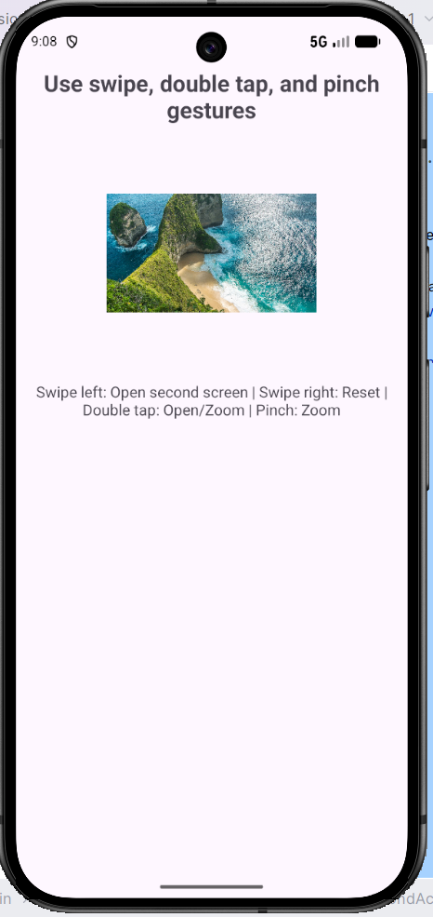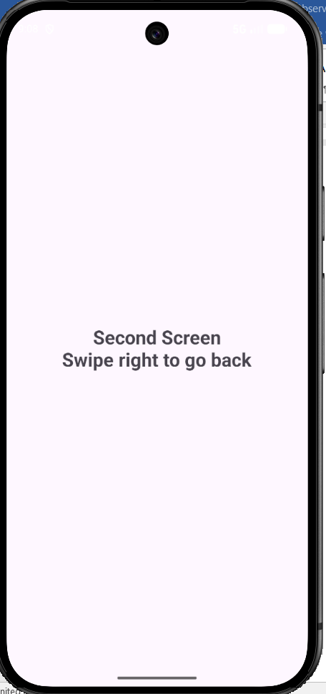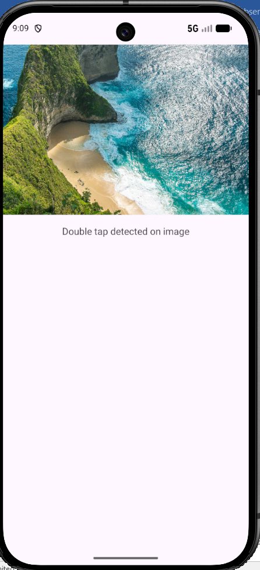
Result

Thus, a gesture-based interaction application was successfully developed to detect swipe, double-tap, and pinch-to-zoom gestures and trigger corresponding actions with smooth transitions.

Ex. No. : 5 Date:
Register No.: Name:

Data Visualization App
Aim
Design and develop a mobile app that displays user data (e.g., steps, expenses) using custom-designed charts and graphs. Design Focus: Data visualization, clarity.

Procedure
- Requirement Analysis
Identify the objective of developing a mobile application that displays user financial data such as daily expenses using multiple charts and graphs. The aim is to represent the data clearly through visual components such as bar chart, line chart, and pie chart.
- Create an Android Studio Project
  - Open Android Studio.
  - Select New Project → Empty Activity.
  - Enter the application name as Data Visualization App.
  - Choose Kotlin as the programming language.
  - Select Minimum SDK (API 21 or above).
- Add Required Library Dependency
  - Open the build.gradle (Module: app) file.
  - Add the dependency for MPAndroidChart library.
  - Sync the project to download and configure the chart library.
- Design the User Interface
  - Open the layout file activity_main.xml.
  - Use a ScrollView as the root layout to support vertical scrolling.
  - Add a ConstraintLayout inside the ScrollView.
  - Place a TextView for the dashboard title.
  - Add summary TextViews to display:
    - Total Expense
    - Highest Spending Day
  - Add a Spinner to select the day of the week.
  - Add a TextInputEditText to enter the expense amount.
  - Add a Button to update the dashboard.
  - Add BarChart, LineChart, and PieChart components to visualize the expense data.
- Initialize the Dataset
  - In the MainActivity.kt file, create a list of day labels such as Mon, Tue, Wed, Thu, Fri, Sat, Sun.
  - Initialize a mutable list of sample expense values for the seven days.
  - Use these sample values to display charts immediately when the app starts.
- Configure the Spinner
  - Create an ArrayAdapter using the list of day labels.
  - Set the adapter to the Spinner so that the user can choose a day for updating the expense value.
- Configure the Chart Components
  - Initialize the BarChart, LineChart, and PieChart in the activity.
  - Disable unnecessary chart descriptions.
  - Configure X-axis labels using the list of days.
  - Disable the right Y-axis where required.
  - Set minimum axis values and enable chart animations for better presentation.
- Implement Data Update Logic
  - Read the amount entered by the user from the input field.
  - Validate the input to ensure:
    - the field is not empty
    - the entered value is numeric
    - the amount is not negative
  - Get the selected day from the Spinner.
  - Update the corresponding expense value in the dataset.
- Populate the Bar Chart
  - Convert the expense values into BarEntry objects.
  - Create a BarDataSet and apply suitable colors and value labels.
  - Set the dataset to the BarChart using BarData.
  - Refresh the chart using invalidate().
- Populate the Line Chart
- Convert the expense values into Entry objects.
- Create a LineDataSet to represent the weekly expense trend.
- Customize the line chart with colors, circle markers, filled area, and value labels.
- Set the dataset to the LineChart using LineData.
- Refresh the chart using invalidate().
- Populate the Pie Chart
- Convert non-zero expense values into PieEntry objects.
- Create a PieDataSet to represent spending distribution.
- Apply suitable colors, slice spacing, and value text size.
- Set the dataset to the PieChart using PieData.
- If no data is available, display No Data Available in the chart center.
- Refresh the chart using invalidate().
- Update Dashboard Summary
- Calculate the total weekly expense by summing all values in the dataset.
- Find the highest spending day by identifying the maximum expense value.
- Display these details in the summary TextViews at the top of the dashboard.
- Provide User Feedback
- Clear the input field after updating the data.
- Display a Toast message to confirm that the dashboard has been updated successfully.
- Test the Application
- Run the application in the Android Emulator or on a physical device.
- Enter different expense values for various days.
- Verify that all three charts and summary details update correctly.
- Build and Run the Application
- Clean and rebuild the project.
- Execute the application and confirm that the dashboard displays expense data clearly using charts and summary information.
AndroidManifest.xml
<?xml version="1.0" encoding="utf-8"?>
<manifest xmlns:android="http://schemas.android.com/apk/res/android">
<application
android:allowBackup="true"
android:dataExtractionRules="@xml/data_extraction_rules"
android:fullBackupContent="@xml/backup_rules"
android:icon="@mipmap/ic_launcher"
android:label="@string/app_name"
android:roundIcon="@mipmap/ic_launcher_round"
android:supportsRtl="true"
android:theme="@style/Theme.DATAVISUALIZATIONAPP">
<activity
android:name=".MainActivity"
android:exported="true"
android:label="@string/app_name"
android:theme="@style/Theme.DATAVISUALIZATIONAPP">
<intent-filter>
<action android:name="android.intent.action.MAIN" />
<category android:name="android.intent.category.LAUNCHER" />
</intent-filter>
</activity>
</application>
</manifest>

activity_main.xml
<?xml version="1.0" encoding="utf-8"?>
<ScrollView xmlns:android="http://schemas.android.com/apk/res/android"
xmlns:app="http://schemas.android.com/apk/res-auto"
android:layout_width="match_parent"
android:layout_height="match_parent"
android:fillViewport="true">
<androidx.constraintlayout.widget.ConstraintLayout
android:layout_width="match_parent"
android:layout_height="wrap_content"
android:padding="16dp">
<TextView
android:id="@+id/tvTitle"
android:layout_width="wrap_content"
android:layout_height="wrap_content"
android:text="Financial Dashboard"
android:textColor="@android:color/black"
android:textSize="24sp"
android:textStyle="bold"
app:layout_constraintEnd_toEndOf="parent"
app:layout_constraintStart_toStartOf="parent"
app:layout_constraintTop_toTopOf="parent" />
<TextView
android:id="@+id/tvSummary"
android:layout_width="0dp"
android:layout_height="wrap_content"
android:layout_marginTop="12dp"
android:text="Total Expense: $0.00"
android:textColor="@android:color/black"
android:textSize="16sp"
android:textStyle="bold"
app:layout_constraintEnd_toEndOf="parent"
app:layout_constraintStart_toStartOf="parent"
app:layout_constraintTop_toBottomOf="@id/tvTitle" />
<TextView
android:id="@+id/tvHighest"
android:layout_width="0dp"
android:layout_height="wrap_content"
android:layout_marginTop="4dp"
android:text="Highest Spending Day: -"
android:textColor="@android:color/black"
android:textSize="15sp"
app:layout_constraintEnd_toEndOf="parent"
app:layout_constraintStart_toStartOf="parent"
app:layout_constraintTop_toBottomOf="@id/tvSummary" />
<LinearLayout
android:id="@+id/inputLayout"
android:layout_width="0dp"
android:layout_height="wrap_content"
android:layout_marginTop="16dp"
android:orientation="horizontal"
app:layout_constraintEnd_toEndOf="parent"
app:layout_constraintStart_toStartOf="parent"
app:layout_constraintTop_toBottomOf="@id/tvHighest">
<Spinner
android:id="@+id/spinnerDays"
android:layout_width="0dp"
android:layout_height="48dp"
android:layout_weight="1" />
<com.google.android.material.textfield.TextInputLayout
android:layout_width="0dp"
android:layout_height="wrap_content"
android:layout_marginStart="8dp"
android:layout_weight="1"
android:hint="Amount ($)">
<com.google.android.material.textfield.TextInputEditText
android:id="@+id/etAmount"
android:layout_width="match_parent"
android:layout_height="wrap_content"
android:inputType="numberDecimal" />
</com.google.android.material.textfield.TextInputLayout>
</LinearLayout>
<Button
android:id="@+id/btnUpdate"
android:layout_width="match_parent"
android:layout_height="wrap_content"
android:layout_marginTop="8dp"
android:text="Update All Charts"
app:layout_constraintTop_toBottomOf="@id/inputLayout" />
<TextView
android:id="@+id/labelBar"
android:layout_width="wrap_content"
android:layout_height="wrap_content"
android:layout_marginTop="24dp"
android:text="1. Bar Chart: Daily Comparison"
android:textStyle="bold"
app:layout_constraintStart_toStartOf="parent"
app:layout_constraintTop_toBottomOf="@id/btnUpdate" />
<com.github.mikephil.charting.charts.BarChart
android:id="@+id/barChart"
android:layout_width="match_parent"
android:layout_height="250dp"
android:layout_marginTop="8dp"
app:layout_constraintTop_toBottomOf="@id/labelBar" />
<TextView
android:id="@+id/labelLine"
android:layout_width="wrap_content"
android:layout_height="wrap_content"
android:layout_marginTop="24dp"
android:text="2. Line Chart: Weekly Trend"
android:textStyle="bold"
app:layout_constraintStart_toStartOf="parent"
app:layout_constraintTop_toBottomOf="@id/barChart" />
<com.github.mikephil.charting.charts.LineChart
android:id="@+id/lineChart"
android:layout_width="match_parent"
android:layout_height="250dp"
android:layout_marginTop="8dp"
app:layout_constraintTop_toBottomOf="@id/labelLine" />
<TextView
android:id="@+id/labelPie"
android:layout_width="wrap_content"
android:layout_height="wrap_content"
android:layout_marginTop="24dp"
android:text="3. Pie Chart: Spending Distribution"
android:textStyle="bold"
app:layout_constraintStart_toStartOf="parent"
app:layout_constraintTop_toBottomOf="@id/lineChart" />
<com.github.mikephil.charting.charts.PieChart
android:id="@+id/pieChart"
android:layout_width="match_parent"
android:layout_height="300dp"
android:layout_marginTop="8dp"
android:layout_marginBottom="16dp"
app:layout_constraintBottom_toBottomOf="parent"
app:layout_constraintTop_toBottomOf="@id/labelPie" />
</androidx.constraintlayout.widget.ConstraintLayout>
</ScrollView>

MainActivity.kt
package com.example.datavisualizationapp
import android.graphics.Color
import android.os.Bundle
import android.widget.ArrayAdapter
import android.widget.Toast
import androidx.appcompat.app.AppCompatActivity
import com.example.datavisualizationapp.databinding.ActivityMainBinding
import com.github.mikephil.charting.components.Legend
import com.github.mikephil.charting.components.XAxis
import com.github.mikephil.charting.data.BarData
import com.github.mikephil.charting.data.BarDataSet
import com.github.mikephil.charting.data.BarEntry
import com.github.mikephil.charting.data.Entry
import com.github.mikephil.charting.data.LineData
import com.github.mikephil.charting.data.LineDataSet
import com.github.mikephil.charting.data.PieData
import com.github.mikephil.charting.data.PieDataSet
import com.github.mikephil.charting.data.PieEntry
import com.github.mikephil.charting.formatter.IndexAxisValueFormatter
import com.github.mikephil.charting.formatter.ValueFormatter
import com.github.mikephil.charting.utils.ColorTemplate
import java.util.Locale
class MainActivity : AppCompatActivity() {
private lateinit var binding: ActivityMainBinding
private val labels = listOf("Mon", "Tue", "Wed", "Thu", "Fri", "Sat", "Sun")
// Default sample data for immediate chart display
private val expenses = mutableListOf(120f, 180f, 90f, 250f, 300f, 140f, 200f)
override fun onCreate(savedInstanceState: Bundle?) {
super.onCreate(savedInstanceState)
binding = ActivityMainBinding.inflate(layoutInflater)
setContentView(binding.root)
setupSpinner()
setupCharts()
updateSummary()
binding.btnUpdate.setOnClickListener {
updateData()
}
}
private fun setupSpinner() {
val adapter = ArrayAdapter(this, android.R.layout.simple_spinner_item, labels)
adapter.setDropDownViewResource(android.R.layout.simple_spinner_dropdown_item)
binding.spinnerDays.adapter = adapter
}
private fun updateData() {
val amountStr = binding.etAmount.text.toString().trim()
if (amountStr.isEmpty()) {
Toast.makeText(this, "Please enter an amount", Toast.LENGTH_SHORT).show()
return
}
val amount = amountStr.toFloatOrNull()
if (amount == null) {
Toast.makeText(this, "Enter a valid amount", Toast.LENGTH_SHORT).show()
return
}
if (amount < 0f) {
Toast.makeText(this, "Amount cannot be negative", Toast.LENGTH_SHORT).show()
return
}
val dayIndex = binding.spinnerDays.selectedItemPosition
expenses[dayIndex] = amount
updateCharts()
updateSummary()
binding.etAmount.text?.clear()
Toast.makeText(this, "Dashboard Updated", Toast.LENGTH_SHORT).show()
}
private fun setupCharts() {
val xAxisFormatter = IndexAxisValueFormatter(labels)
// Bar Chart Setup
binding.barChart.apply {
description.isEnabled = false
setFitBars(true)
animateY(1000)
legend.apply {
isEnabled = true
textSize = 12f
form = Legend.LegendForm.SQUARE
}
xAxis.apply {
valueFormatter = xAxisFormatter
position = XAxis.XAxisPosition.BOTTOM
setDrawGridLines(false)
granularity = 1f
textSize = 12f
}
axisRight.isEnabled = false
axisLeft.axisMinimum = 0f
axisLeft.textSize = 12f
}
// Line Chart Setup
binding.lineChart.apply {
description.isEnabled = false
animateX(1000)
legend.apply {
isEnabled = true
textSize = 12f
}
xAxis.apply {
valueFormatter = xAxisFormatter
position = XAxis.XAxisPosition.BOTTOM
setDrawGridLines(false)
granularity = 1f
textSize = 12f
}
axisRight.isEnabled = false
axisLeft.axisMinimum = 0f
axisLeft.textSize = 12f
}
// Pie Chart Setup
binding.pieChart.apply {
description.isEnabled = false
setUsePercentValues(true)
setEntryLabelColor(Color.BLACK)
setEntryLabelTextSize(12f)
animateY(1400)
centerText = "Weekly Expense %"
setCenterTextSize(18f)
holeRadius = 45f
transparentCircleRadius = 50f
legend.apply {
isEnabled = true
textSize = 12f
}
}
updateCharts()
}
private fun updateCharts() {
updateBarChart()
updateLineChart()
updatePieChart()
}
private fun updateBarChart() {
val barEntries = ArrayList<BarEntry>()
for (i in expenses.indices) {
barEntries.add(BarEntry(i.toFloat(), expenses[i]))
}
val barDataSet = BarDataSet(barEntries, "Daily Expense").apply {
colors = ColorTemplate.MATERIAL_COLORS.toList()
valueTextSize = 11f
valueTextColor = Color.BLACK
setDrawValues(true)
}
val barData = BarData(barDataSet).apply {
barWidth = 0.6f
setValueFormatter(CurrencyValueFormatter())
}
binding.barChart.data = barData
binding.barChart.invalidate()
}
private fun updateLineChart() {
val lineEntries = ArrayList<Entry>()
for (i in expenses.indices) {
lineEntries.add(Entry(i.toFloat(), expenses[i]))
}
val lineDataSet = LineDataSet(lineEntries, "Weekly Expense Trend").apply {
color = Color.BLUE
setCircleColor(Color.BLUE)
valueTextColor = Color.BLACK
valueTextSize = 11f
lineWidth = 3f
mode = LineDataSet.Mode.CUBIC_BEZIER
setDrawFilled(true)
fillColor = Color.CYAN
fillAlpha = 50
setDrawValues(true)
}
val lineData = LineData(lineDataSet).apply {
setValueFormatter(CurrencyValueFormatter())
}
binding.lineChart.data = lineData
binding.lineChart.invalidate()
}
private fun updatePieChart() {
val pieEntries = ArrayList<PieEntry>()
for (i in expenses.indices) {
if (expenses[i] > 0f) {
pieEntries.add(PieEntry(expenses[i], labels[i]))
}
}
if (pieEntries.isEmpty()) {
binding.pieChart.clear()
binding.pieChart.centerText = "No Data Available"
binding.pieChart.invalidate()
return
}
val pieDataSet = PieDataSet(pieEntries, "Expense Share").apply {
colors = ColorTemplate.JOYFUL_COLORS.toList()
sliceSpace = 3f
valueTextSize = 12f
valueTextColor = Color.BLACK
}
val pieData = PieData(pieDataSet)
binding.pieChart.data = pieData
binding.pieChart.centerText = "Weekly Expense %"
binding.pieChart.invalidate()
}
private fun updateSummary() {
val total = expenses.sum()
val maxExpense = expenses.maxOrNull() ?: 0f
val highestDayIndex = expenses.indexOf(maxExpense)
val highestDay = if (highestDayIndex >= 0) labels[highestDayIndex] else "-"
binding.tvSummary.text = "Total Expense: ${formatCurrency(total)}"
binding.tvHighest.text = "Highest Spending Day: $highestDay (${formatCurrency(maxExpense)})"
}
private fun formatCurrency(value: Float): String {
return String.format(Locale.US, "$%.2f", value)
}
private class CurrencyValueFormatter : ValueFormatter() {
override fun getFormattedValue(value: Float): String {
return String.format(Locale.US, "$%.0f", value)
}
}
}

Output

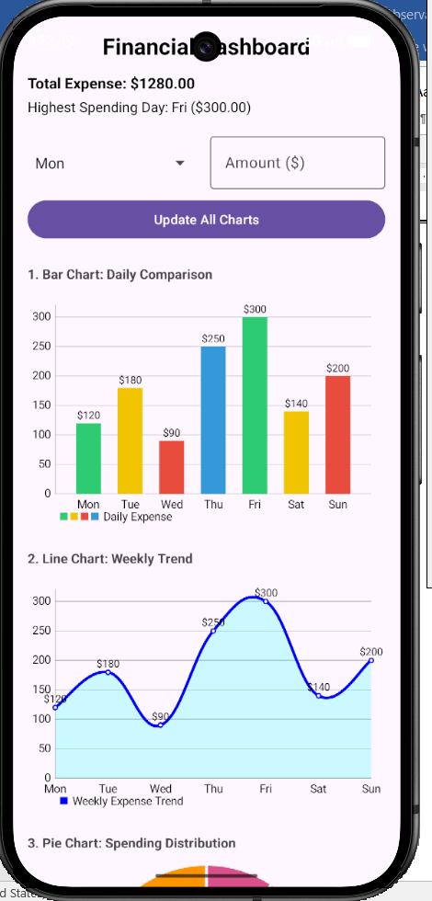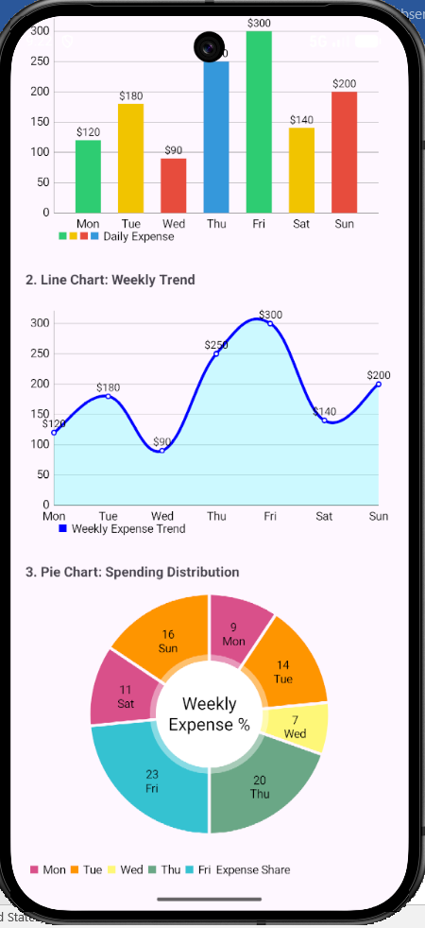

Result
Thus, a Data Visualization App was successfully designed and developed to display user data using charts and graphs, providing clear and effective graphical representation of the information.

Ex. No. : 6 Date:
Register No.: Name:

Chat Application UI
Aim
Design the UI for a chat application with message bubbles, avatars, and a responsive input field. Design Focus: Seamless interaction, UI consistency.

Procedure

Procedure
- Requirement Analysis
Identify the objective of designing a chat application user interface that includes message bubbles, user avatars, and an input field. The UI should support smooth interaction, clear message display, and consistent visual design.
- Create an Android Studio Project
  - Open Android Studio.
  - Select New Project → Empty Activity.
  - Enter the application name as Chat Application UI.
  - Choose Kotlin as the programming language.
  - Select Minimum SDK (API 21 or above).
- Design the Main Layout
  - Open activity_main.xml.
  - Use ConstraintLayout or LinearLayout as the root layout.
  - Divide the screen into:
    - Chat message area (top section)
    - Input area (bottom section)
- Add Message Display Area
  - Use a RecyclerView or ScrollView with LinearLayout to display messages.
  - Set vertical orientation to display messages one below the other.
  - Ensure the layout supports scrolling for long conversations.
- Design Message Bubble Layouts
  - Create separate XML layouts for:
    - Sender message bubble (aligned to the right)
    - Receiver message bubble (aligned to the left)
  - Use background shapes with rounded corners to resemble chat bubbles.
  - Apply different colors for sender and receiver messages.
- Add User Avatars
  - Include ImageView elements in the message layouts.
  - Display avatars next to message bubbles.
  - Position avatars:
    - Left side for received messages
    - Right side for sent messages (optional)
- Design the Input Section
  - Add an EditText or TextInputEditText for typing messages.
  - Add a Send Button next to the input field.
  - Align the input section at the bottom of the screen.
  - Ensure the input field expands properly and remains responsive.
- Implement Message Handling Logic
  - In MainActivity.kt, initialize the message list.
  - Capture user input from the input field.
  - Append new messages to the message list when the send button is clicked.
  - Clear the input field after sending a message.
- Bind Data to the Message View
  - If using RecyclerView:
    - Create an adapter class.
    - Bind messages dynamically to the chat UI.
  - Differentiate between sender and receiver messages using view types.
- Apply UI Styling and Consistency
- Use consistent colors, fonts, and spacing across the UI.
- Maintain uniform padding and margins for message bubbles.
- Ensure proper alignment of text and avatars.
- Handle Keyboard Interaction
- Ensure the input field remains visible when the keyboard is opened.
- Adjust layout using appropriate attributes like adjustResize.
- Test the Application
- Run the application in the Android Emulator or on a physical device.
- Send messages and verify:
  - Proper alignment of message bubbles
  - Smooth scrolling of chat messages
  - Correct input handling
- Build and Run the Application
- Clean and rebuild the project.
- Execute the application and verify that the chat UI functions correctly.

AndroidManifest.xml
<?xml version="1.0" encoding="utf-8"?>
<manifest xmlns:android="http://schemas.android.com/apk/res/android"
xmlns:tools="http://schemas.android.com/tools">
<application
android:allowBackup="true"
android:dataExtractionRules="@xml/data_extraction_rules"
android:fullBackupContent="@xml/backup_rules"
android:icon="@mipmap/ic_launcher"
android:label="@string/app_name"
android:roundIcon="@mipmap/ic_launcher_round"
android:supportsRtl="true"
android:theme="@style/Theme.ChatApplicationUI">
<activity
android:name=".MainActivity"
android:exported="true"
android:label="@string/app_name"
android:windowSoftInputMode="adjustResize"
android:theme="@style/Theme.ChatApplicationUI">
<intent-filter>
<action android:name="android.intent.action.MAIN" />
<category android:name="android.intent.category.LAUNCHER" />
</intent-filter>
</activity>
</application>
</manifest>

activity_main.xml
<?xml version="1.0" encoding="utf-8"?>
<androidx.constraintlayout.widget.ConstraintLayout xmlns:android="http://schemas.android.com/apk/res/android"
xmlns:app="http://schemas.android.com/apk/res-auto"
xmlns:tools="http://schemas.android.com/tools"
android:layout_width="match_parent"
android:layout_height="match_parent"
android:background="#ECE5DD"
tools:context=".MainActivity">
<com.google.android.material.appbar.AppBarLayout
android:id="@+id/appBarLayout"
android:layout_width="match_parent"
android:layout_height="wrap_content"
app:layout_constraintTop_toTopOf="parent">
<androidx.appcompat.widget.Toolbar
android:id="@+id/toolbar"
android:layout_width="match_parent"
android:layout_height="?attr/actionBarSize"
android:background="?attr/colorPrimary"
app:contentInsetStartWithNavigation="0dp">
<LinearLayout
android:layout_width="match_parent"
android:layout_height="match_parent"
android:gravity="center_vertical"
android:orientation="horizontal">
<com.google.android.material.imageview.ShapeableImageView
android:id="@+id/profileImage"
android:layout_width="40dp"
android:layout_height="40dp"
android:layout_marginStart="8dp"
android:padding="2dp"
android:src="@android:drawable/sym_def_app_icon"
app:shapeAppearanceOverlay="@style/ShapeAppearance.ChatApp.Circle"
app:strokeColor="@color/white"
app:strokeWidth="1dp" />
<LinearLayout
android:layout_width="wrap_content"
android:layout_height="wrap_content"
android:layout_marginStart="12dp"
android:orientation="vertical">
<TextView
android:id="@+id/chatTitle"
android:layout_width="wrap_content"
android:layout_height="wrap_content"
android:text="John Doe"
android:textColor="@color/white"
android:textSize="18sp"
android:textStyle="bold" />
<TextView
android:layout_width="wrap_content"
android:layout_height="wrap_content"
android:text="Online"
android:textColor="#B3FFFFFF"
android:textSize="12sp" />
</LinearLayout>
</LinearLayout>
</androidx.appcompat.widget.Toolbar>
</com.google.android.material.appbar.AppBarLayout>
<androidx.recyclerview.widget.RecyclerView
android:id="@+id/rvChat"
android:layout_width="0dp"
android:layout_height="0dp"
android:clipToPadding="false"
android:padding="8dp"
app:layout_constraintBottom_toTopOf="@+id/inputLayout"
app:layout_constraintEnd_toEndOf="parent"
app:layout_constraintStart_toStartOf="parent"
app:layout_constraintTop_toBottomOf="@id/appBarLayout"
tools:listitem="@layout/item_message_received" />
<LinearLayout
android:id="@+id/inputLayout"
android:layout_width="0dp"
android:layout_height="wrap_content"
android:background="@color/white"
android:elevation="8dp"
android:gravity="center_vertical"
android:orientation="horizontal"
android:padding="8dp"
app:layout_constraintBottom_toBottomOf="parent"
app:layout_constraintEnd_toEndOf="parent"
app:layout_constraintStart_toStartOf="parent">
<EditText
android:id="@+id/etMessage"
android:layout_width="0dp"
android:layout_height="wrap_content"
android:layout_weight="1"
android:background="@drawable/bg_input_field"
android:hint="Type a message..."
android:importantForAutofill="no"
android:inputType="textMultiLine"
android:maxLines="4"
android:minHeight="48dp"
android:paddingHorizontal="16dp"
android:paddingVertical="8dp"
android:textSize="16sp" />
<com.google.android.material.floatingactionbutton.FloatingActionButton
android:id="@+id/btnSend"
android:layout_width="wrap_content"
android:layout_height="wrap_content"
android:layout_marginStart="8dp"
android:contentDescription="Send"
android:src="@android:drawable/ic_menu_send"
app:fabCustomSize="48dp"
app:tint="@color/white" />
</LinearLayout>
</androidx.constraintlayout.widget.ConstraintLayout>

item_message_received
<?xml version="1.0" encoding="utf-8"?>
<androidx.constraintlayout.widget.ConstraintLayout xmlns:android="http://schemas.android.com/apk/res/android"
xmlns:app="http://schemas.android.com/apk/res-auto"
android:layout_width="match_parent"
android:layout_height="wrap_content"
android:padding="4dp">
<com.google.android.material.imageview.ShapeableImageView
android:id="@+id/ivAvatar"
android:layout_width="32dp"
android:layout_height="32dp"
android:src="@android:drawable/sym_def_app_icon"
app:layout_constraintBottom_toBottomOf="@+id/tvMessage"
app:layout_constraintStart_toStartOf="parent"
app:shapeAppearanceOverlay="@style/ShapeAppearance.ChatApp.Circle" />
<TextView
android:id="@+id/tvMessage"
android:layout_width="wrap_content"
android:layout_height="wrap_content"
android:layout_marginStart="8dp"
android:layout_marginEnd="64dp"
android:background="@drawable/bg_received_bubble"
android:elevation="1dp"
android:maxWidth="280dp"
android:paddingHorizontal="12dp"
android:paddingVertical="8dp"
android:text="I am doing great, thanks!"
android:textColor="#000000"
android:textSize="16sp"
app:layout_constraintBottom_toBottomOf="parent"
app:layout_constraintStart_toEndOf="@id/ivAvatar"
app:layout_constraintTop_toTopOf="parent" />
<TextView
android:id="@+id/tvTime"
android:layout_width="wrap_content"
android:layout_height="wrap_content"
android:layout_marginEnd="4dp"
android:layout_marginBottom="4dp"
android:text="10:01 AM"
android:textColor="#80000000"
android:textSize="10sp"
app:layout_constraintBottom_toBottomOf="@id/tvMessage"
app:layout_constraintEnd_toEndOf="@id/tvMessage" />
</androidx.constraintlayout.widget.ConstraintLayout>

item_message_sent

<?xml version="1.0" encoding="utf-8"?>
<androidx.constraintlayout.widget.ConstraintLayout xmlns:android="http://schemas.android.com/apk/res/android"
xmlns:app="http://schemas.android.com/apk/res-auto"
android:layout_width="match_parent"
android:layout_height="wrap_content"
android:padding="4dp">
<TextView
android:id="@+id/tvMessage"
android:layout_width="wrap_content"
android:layout_height="wrap_content"
android:layout_marginStart="64dp"
android:background="@drawable/bg_sent_bubble"
android:elevation="1dp"
android:maxWidth="280dp"
android:paddingHorizontal="12dp"
android:paddingVertical="8dp"
android:text="Hello, how are you?"
android:textColor="#000000"
android:textSize="16sp"
app:layout_constraintBottom_toBottomOf="parent"
app:layout_constraintEnd_toEndOf="parent"
app:layout_constraintTop_toTopOf="parent" />
<TextView
android:id="@+id/tvTime"
android:layout_width="wrap_content"
android:layout_height="wrap_content"
android:layout_marginEnd="4dp"
android:layout_marginBottom="4dp"
android:text="10:00 AM"
android:textColor="#80000000"
android:textSize="10sp"
app:layout_constraintBottom_toBottomOf="@id/tvMessage"
app:layout_constraintEnd_toEndOf="@id/tvMessage" />
</androidx.constraintlayout.widget.ConstraintLayout>

MainActivity.kt
package com.example.chatapplicationui
import android.os.Bundle
import androidx.appcompat.app.AppCompatActivity
import androidx.recyclerview.widget.LinearLayoutManager
import com.example.chatapplicationui.databinding.ActivityMainBinding
class MainActivity : AppCompatActivity() {
private lateinit var binding: ActivityMainBinding
private lateinit var adapter: ChatAdapter
private val messages = mutableListOf<Message>()
override fun onCreate(savedInstanceState: Bundle?) {
super.onCreate(savedInstanceState)
binding = ActivityMainBinding.inflate(layoutInflater)
setContentView(binding.root)
setupRecyclerView()
loadDummyMessages()
binding.btnSend.setOnClickListener {
val text = binding.etMessage.text.toString().trim()
if (text.isNotEmpty()) {
sendMessage(text)
}
}
}
private fun setupRecyclerView() {
adapter = ChatAdapter(messages)
binding.rvChat.layoutManager = LinearLayoutManager(this).apply {
stackFromEnd = true
}
binding.rvChat.adapter = adapter
}
private fun loadDummyMessages() {
messages.add(Message("Hey there!", "10:00 AM", false))
messages.add(Message("Hi! How's it going?", "10:01 AM", true))
messages.add(Message("Everything is going well. I'm working on the new UI design.", "10:02 AM", false))
messages.add(Message("That sounds exciting! Can't wait to see it.", "10:03 AM", true))
messages.add(Message("I'll share some screenshots once it's ready.", "10:05 AM", false))
messages.add(Message("Awesome!", "10:06 AM", true))
adapter.notifyDataSetChanged()
binding.rvChat.scrollToPosition(messages.size - 1)
}
private fun sendMessage(text: String) {
val newMessage = Message(text, "10:07 AM", true)
messages.add(newMessage)
adapter.notifyItemInserted(messages.size - 1)
binding.rvChat.scrollToPosition(messages.size - 1)
binding.etMessage.text.clear()
}
}

ChatAdapter.kt
package com.example.chatapplicationui
import android.view.LayoutInflater
import android.view.View
import android.view.ViewGroup
import android.widget.TextView
import androidx.recyclerview.widget.RecyclerView
import com.example.chatapplicationui.databinding.ItemMessageReceivedBinding
import com.example.chatapplicationui.databinding.ItemMessageSentBinding
class ChatAdapter(private val messages: List<Message>) : RecyclerView.Adapter<RecyclerView.ViewHolder>() {
private val TYPE_SENT = 1
private val TYPE_RECEIVED = 2
override fun getItemViewType(position: Int): Int {
return if (messages[position].isSent) TYPE_SENT else TYPE_RECEIVED
}
override fun onCreateViewHolder(parent: ViewGroup, viewType: Int): RecyclerView.ViewHolder {
return if (viewType == TYPE_SENT) {
val binding = ItemMessageSentBinding.inflate(LayoutInflater.from(parent.context), parent, false)
SentViewHolder(binding)
} else {
val binding = ItemMessageReceivedBinding.inflate(LayoutInflater.from(parent.context), parent, false)
ReceivedViewHolder(binding)
}
}
override fun onBindViewHolder(holder: RecyclerView.ViewHolder, position: Int) {
val message = messages[position]
if (holder is SentViewHolder) {
holder.bind(message)
} else if (holder is ReceivedViewHolder) {
holder.bind(message)
}
}
override fun getItemCount(): Int = messages.size
inner class SentViewHolder(private val binding: ItemMessageSentBinding) : RecyclerView.ViewHolder(binding.root) {
fun bind(message: Message) {
binding.tvMessage.text = message.text
binding.tvTime.text = message.time
}
}
inner class ReceivedViewHolder(private val binding: ItemMessageReceivedBinding) : RecyclerView.ViewHolder(binding.root) {
fun bind(message: Message) {
binding.tvMessage.text = message.text
binding.tvTime.text = message.time
}
}
}

Message.kt
package com.example.chatapplicationui
data class Message(
val text: String,
val time: String,
val isSent: Boolean
)

Output

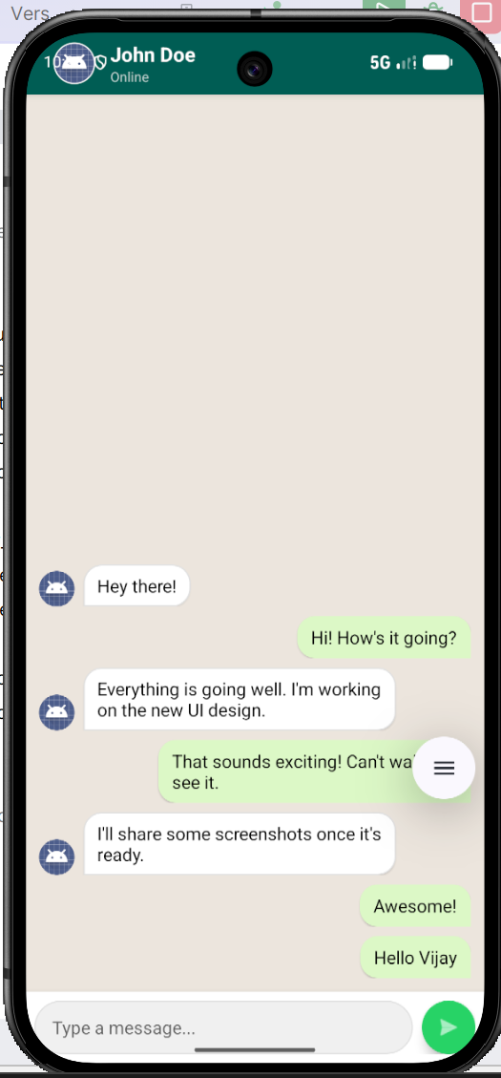

Result

Thus, a Chat Application UI was successfully designed and developed with message bubbles, user avatars, and a responsive input field, ensuring seamless interaction and consistent user interface design.

Ex. No. : 7 Date:
Register No.: Name:

Custom Animation for User Feedback
Aim
Create a mobile app that incorporates custom animations for user actions, such as button clicks or transitions between screens. Design Focus: Animation, user feedback.

Procedure
- Requirement Analysis
Identify the objective of developing a mobile application that uses custom animations to provide user feedback for actions such as button clicks and screen transitions.
- Create an Android Studio Project
Open Android Studio, create a new Empty Activity project, enter the name as Custom Animation for User Feedback, and choose Kotlin as the programming language.
- Design the Main Screen UI
Open activity_main.xml and design a simple interface using ConstraintLayout or LinearLayout. Add components such as:
  - TextView for title/instruction
  - Button for animation action
  - Button for screen transition
  - ImageView or CardView for animation demonstration
- Create Animation Resource Files
Create animation XML files inside the res/anim folder such as:
  - scale_animation.xml
  - fade_animation.xml
  - slide_in.xml
  - slide_out.xml
- Implement Button Click Animation
In MainActivity.kt, apply animation to a button or image using AnimationUtils.loadAnimation() when the user clicks the button.
- Implement User Feedback Animation
Add animations such as:
  - Scaling effect on button press
  - Fade-in/fade-out effect
  - Rotation or translation effect
  - Toast message after animation completion
- Create Second Activity for Transition
Create a new activity named SecondActivity. Design activity_second.xml with a TextView and Button to return to the main screen.
- Apply Screen Transition Animation
Use Intent to move from MainActivity to SecondActivity. Apply transition animations using:
overridePendingTransition(R.anim.slide_in, R.anim.slide_out)
- Handle Return Transition
In SecondActivity.kt, add a back button and apply reverse animation while returning to the main screen.
- Test the Application
Run the app in the emulator or physical device. Test:
- Button click animation
- Image/Card animation
- Screen transition animation
- User feedback messages
- Build and Run the Application
Clean and rebuild the project. Execute the application and verify that animations are smooth and provide clear feedback to the user.

AndroidManifest.xml
<?xml version="1.0" encoding="utf-8"?>
<manifest xmlns:android="http://schemas.android.com/apk/res/android">
<application
android:allowBackup="true"
android:label="Animation App"
android:supportsRtl="true"
android:theme="@style/Theme.AppCompat.Light.DarkActionBar">
<activity android:name=".SecondActivity" />
<activity
android:name=".MainActivity"
android:exported="true">
<intent-filter>
<action android:name="android.intent.action.MAIN"/>
<category android:name="android.intent.category.LAUNCHER"/>
</intent-filter>
</activity>
</application>
</manifest>

activity_main.xml
<?xml version="1.0" encoding="utf-8"?>
<LinearLayout xmlns:android="http://schemas.android.com/apk/res/android"
android:layout_width="match_parent"
android:layout_height="match_parent"
android:orientation="vertical"
android:gravity="center"
android:padding="20dp">
<TextView
android:id="@+id/tvTitle"
android:layout_width="wrap_content"
android:layout_height="wrap_content"
android:text="Custom Animation Demo"
android:textSize="26sp"
android:textStyle="bold"
android:layout_marginBottom="30dp"/>
<ImageView
android:id="@+id/imageView"
android:layout_width="120dp"
android:layout_height="120dp"
android:src="@mipmap/ic_launcher"
android:layout_marginBottom="30dp"/>
<Button
android:id="@+id/btnAnimate"
android:layout_width="match_parent"
android:layout_height="wrap_content"
android:text="Apply Animation"/>
<Button
android:id="@+id/btnNext"
android:layout_width="match_parent"
android:layout_height="wrap_content"
android:text="Go To Next Screen"
android:layout_marginTop="15dp"/>
</LinearLayout>

activity_second.xml
<?xml version="1.0" encoding="utf-8"?>
<LinearLayout xmlns:android="http://schemas.android.com/apk/res/android"
android:layout_width="match_parent"
android:layout_height="match_parent"
android:gravity="center"
android:orientation="vertical"
android:padding="20dp">
<TextView
android:id="@+id/tvSecond"
android:layout_width="wrap_content"
android:layout_height="wrap_content"
android:text="Second Screen"
android:textSize="28sp"
android:textStyle="bold"
android:layout_marginBottom="30dp"/>
<Button
android:id="@+id/btnBack"
android:layout_width="match_parent"
android:layout_height="wrap_content"
android:text="Back To Main"/>
</LinearLayout>

MainActivity.kt
package com.example.customanimationforuserfeedback
import android.content.Intent
import android.os.Bundle
import android.view.animation.AnimationUtils
import android.widget.Button
import android.widget.ImageView
import androidx.appcompat.app.AppCompatActivity
import com.example.exp_07.R
class MainActivity : AppCompatActivity() {
lateinit var imageView: ImageView
lateinit var btnAnimate: Button
lateinit var btnNext: Button
override fun onCreate(savedInstanceState: Bundle?) {
super.onCreate(savedInstanceState)
setContentView(R.layout.activity_main)
imageView = findViewById(R.id.imageView)
btnAnimate = findViewById(R.id.btnAnimate)
btnNext = findViewById(R.id.btnNext)
btnAnimate.setOnClickListener {
val animation = AnimationUtils.loadAnimation(
this,
R.anim.bounce
)
imageView.startAnimation(animation)
}
btnNext.setOnClickListener {
val intent = Intent(this, SecondActivity::class.java)
startActivity(intent)
}
}
}

SecondActivity.kt
package com.example.customanimationforuserfeedback
import android.os.Bundle
import android.widget.Button
import androidx.appcompat.app.AppCompatActivity
import com.example.exp_07.R
class SecondActivity : AppCompatActivity() {
lateinit var btnBack: Button
override fun onCreate(savedInstanceState: Bundle?) {
super.onCreate(savedInstanceState)
setContentView(R.layout.activity_second)
btnBack = findViewById(R.id.btnBack)
btnBack.setOnClickListener {
finish()
}
}
}

Output

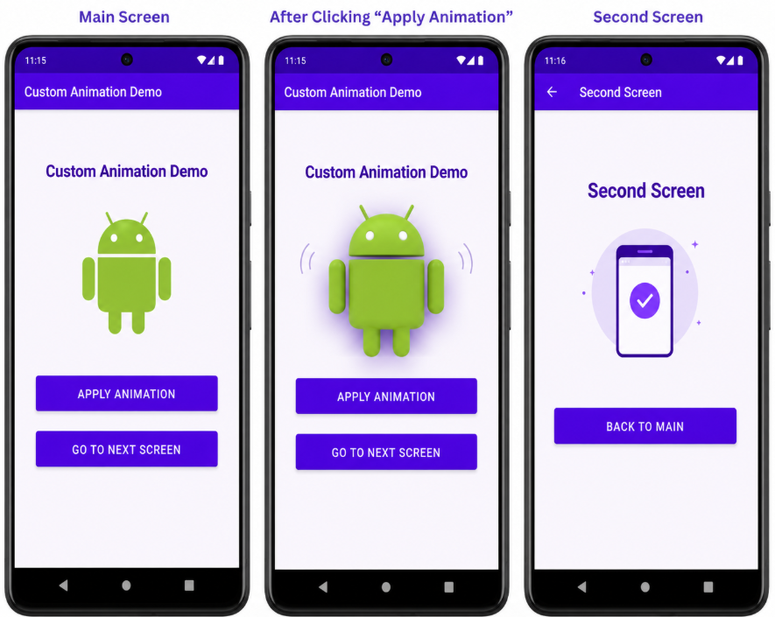

Result

Thus, a mobile application was successfully developed with custom animations for button clicks and screen transitions, providing effective user feedback.

Ex. No. : 8 Date:
Register No.: Name:

Location-Based App Design
Aim
Develop a location-based app that displays the user's current location on a map with interactive features such as markers and routes. Design Focus: Location-based UI, map interactivity.
Procedure
- Requirement Analysis
Identify the objective of developing a location-based mobile application that displays the user’s current location on a map and supports interactive features such as markers and routes.
- Create an Android Studio Project
Open Android Studio, create a new Empty Activity project, enter the application name as Location-Based App Design, and choose Kotlin as the programming language.
- Configure Google Maps API
  - Open the Google Cloud Console.
  - Enable the Google Maps SDK for Android.
  - Generate an API key.
  - Add the API key inside the AndroidManifest.xml file.
- Add Required Dependencies
Open the build.gradle(:app) file and add dependencies for:
  - Google Maps
  - Location Services
  - Play Services Maps
- Add Permissions in AndroidManifest.xml
Add the following permissions:
  - ACCESS_FINE_LOCATION
  - ACCESS_COARSE_LOCATION
  - INTERNET
- Design the User Interface
Open activity_main.xml and:
  - Add a SupportMapFragment to display the Google Map.
  - Add optional UI components such as:
    - Buttons for location updates
    - TextViews for displaying coordinates
    - Search or route controls
- Initialize Google Map
In MainActivity.kt:
  - Implement OnMapReadyCallback.
  - Obtain the map fragment using SupportMapFragment.
  - Load the Google Map asynchronously using getMapAsync().
- Enable User Location
  - Request runtime location permissions from the user.
  - Enable the My Location layer on the map using:
googleMap.isMyLocationEnabled = true
- Fetch Current Location
  - Use FusedLocationProviderClient to get the user’s current location.
  - Retrieve latitude and longitude values.
  - Display the location coordinates if needed.
- Add Marker on Map
- Create a LatLng object using the current location coordinates.
- Add a marker using:
googleMap.addMarker()
- Set a title for the marker.
- Move Camera to Current Location
- Use:
CameraUpdateFactory.newLatLngZoom()
- Focus the map camera on the user’s current location with suitable zoom level.
- Implement Route or Interactive Features
- Add multiple markers if required.
- Draw routes or paths using PolylineOptions.
- Enable map gestures such as zoom and drag.
- Test the Application
Run the application in an Android Emulator or physical device. Verify:
- Map loading
- Current location display
- Marker placement
- Route drawing and map interaction
- Handle Errors and Permissions
- Display messages if location permission is denied.
- Handle GPS disabled or network unavailable scenarios.
- Build and Run the Application
Clean and rebuild the project. Execute the application and verify that the location-based features work correctly.

AndroidManifest.xml
<?xml version="1.0" encoding="utf-8"?>
<manifest xmlns:android="http://schemas.android.com/apk/res/android">
<uses-permission android:name="android.permission.ACCESS_FINE_LOCATION" />
<uses-permission android:name="android.permission.ACCESS_COARSE_LOCATION" />
<uses-permission android:name="android.permission.INTERNET" />
<application
android:allowBackup="true"
android:label="Location Based App"
android:theme="@style/Theme.LocationBasedAppDesign">
<meta-data
android:name="com.google.android.geo.API_KEY"
android:value="PASTE_YOUR_GOOGLE_MAP_API_KEY_HERE" />
<activity
android:name=".MainActivity"
android:exported="true">
<intent-filter>
<action android:name="android.intent.action.MAIN" />
<category android:name="android.intent.category.LAUNCHER" />
</intent-filter>
</activity>
</application>
</manifest>

activity_main.xml
<?xml version="1.0" encoding="utf-8"?>
<FrameLayout xmlns:android="http://schemas.android.com/apk/res/android"
android:layout_width="match_parent"
android:layout_height="match_parent">
<fragment
android:id="@+id/mapFragment"
android:name="com.google.android.gms.maps.SupportMapFragment"
android:layout_width="match_parent"
android:layout_height="match_parent" />
<LinearLayout
android:layout_width="match_parent"
android:layout_height="wrap_content"
android:orientation="vertical"
android:padding="12dp"
android:background="#CCFFFFFF">
<TextView
android:id="@+id/tvLocation"
android:layout_width="match_parent"
android:layout_height="wrap_content"
android:text="Current Location"
android:textSize="16sp"
android:textStyle="bold"
android:textColor="#000000" />
<Button
android:id="@+id/btnCurrentLocation"
android:layout_width="match_parent"
android:layout_height="wrap_content"
android:text="Show Current Location" />
<Button
android:id="@+id/btnAddRoute"
android:layout_width="match_parent"
android:layout_height="wrap_content"
android:text="Show Sample Route" />
</LinearLayout>
</FrameLayout>

MainActivity.kt
package com.example.exp_08
import android.Manifest
import android.content.pm.PackageManager
import android.graphics.Color
import android.os.Bundle
import android.widget.Button
import android.widget.TextView
import android.widget.Toast
import androidx.appcompat.app.AppCompatActivity
import androidx.core.app.ActivityCompat
import com.google.android.gms.location.LocationServices
import com.google.android.gms.maps.CameraUpdateFactory
import com.google.android.gms.maps.GoogleMap
import com.google.android.gms.maps.OnMapReadyCallback
import com.google.android.gms.maps.SupportMapFragment
import com.google.android.gms.maps.model.*
class MainActivity : AppCompatActivity(), OnMapReadyCallback {
private lateinit var googleMap: GoogleMap
private lateinit var tvLocation: TextView
private lateinit var btnCurrentLocation: Button
private lateinit var btnAddRoute: Button
private val permissionCode = 100
override fun onCreate(savedInstanceState: Bundle?) {
super.onCreate(savedInstanceState)
setContentView(R.layout.activity_main)
tvLocation = findViewById(R.id.tvLocation)
btnCurrentLocation = findViewById(R.id.btnCurrentLocation)
btnAddRoute = findViewById(R.id.btnAddRoute)
val mapFragment = supportFragmentManager
.findFragmentById(R.id.mapFragment) as SupportMapFragment
mapFragment.getMapAsync(this)
btnCurrentLocation.setOnClickListener {
getCurrentLocation()
}
btnAddRoute.setOnClickListener {
drawSampleRoute()
}
}
override fun onMapReady(map: GoogleMap) {
googleMap = map
googleMap.uiSettings.isZoomControlsEnabled = true
googleMap.uiSettings.isCompassEnabled = true
googleMap.uiSettings.isMapToolbarEnabled = true
checkLocationPermission()
}
private fun checkLocationPermission() {
if (ActivityCompat.checkSelfPermission(
this,
Manifest.permission.ACCESS_FINE_LOCATION
) != PackageManager.PERMISSION_GRANTED
) {
ActivityCompat.requestPermissions(
this,
arrayOf(Manifest.permission.ACCESS_FINE_LOCATION),
permissionCode
)
} else {
enableLocation()
}
}
private fun enableLocation() {
if (ActivityCompat.checkSelfPermission(
this,
Manifest.permission.ACCESS_FINE_LOCATION
) == PackageManager.PERMISSION_GRANTED
) {
googleMap.isMyLocationEnabled = true
getCurrentLocation()
}
}
private fun getCurrentLocation() {
val fusedLocationClient = LocationServices.getFusedLocationProviderClient(this)
if (ActivityCompat.checkSelfPermission(
this,
Manifest.permission.ACCESS_FINE_LOCATION
) != PackageManager.PERMISSION_GRANTED
) {
checkLocationPermission()
return
}
fusedLocationClient.lastLocation.addOnSuccessListener { location ->
if (location != null) {
val currentLatLng = LatLng(location.latitude, location.longitude)
tvLocation.text =
"Latitude: ${location.latitude}\nLongitude: ${location.longitude}"
googleMap.clear()
googleMap.addMarker(
MarkerOptions()
.position(currentLatLng)
.title("You are here")
.snippet("Current Location")
)
googleMap.animateCamera(
CameraUpdateFactory.newLatLngZoom(currentLatLng, 16f)
)
} else {
Toast.makeText(
this,
"Unable to fetch location. Enable GPS.",
Toast.LENGTH_SHORT
).show()
}
}
}
private fun drawSampleRoute() {
googleMap.clear()
val point1 = LatLng(13.0827, 80.2707) // Chennai
val point2 = LatLng(13.0674, 80.2376) // Sample nearby point
googleMap.addMarker(
MarkerOptions()
.position(point1)
.title("Start Point")
)
googleMap.addMarker(
MarkerOptions()
.position(point2)
.title("Destination")
)
val polylineOptions = PolylineOptions()
.add(point1)
.add(point2)
.width(8f)
.color(Color.BLUE)
googleMap.addPolyline(polylineOptions)
googleMap.animateCamera(
CameraUpdateFactory.newLatLngZoom(point1, 13f)
)
tvLocation.text = "Sample route displayed using markers and polyline"
}
override fun onRequestPermissionsResult(
requestCode: Int,
permissions: Array<out String>,
grantResults: IntArray
) {
super.onRequestPermissionsResult(requestCode, permissions, grantResults)
if (requestCode == permissionCode) {
if (grantResults.isNotEmpty() &&
grantResults[0] == PackageManager.PERMISSION_GRANTED
) {
enableLocation()
} else {
Toast.makeText(
this,
"Location permission denied",
Toast.LENGTH_SHORT
).show()
}
}
}
}

Output

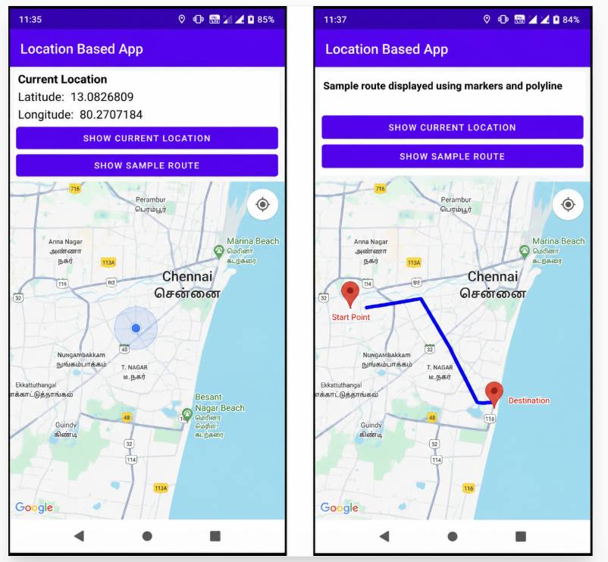

Result

Thus, a location-based mobile application was successfully developed to display the user’s current location on a map with interactive features such as markers and routes.

Ex. No. : 9 Date:
Register No.: Name:

Notifications and Alerts Design
Aim
Design custom notifications and alerts, integrating both visual and auditory feedback, and aligning the notification design with the app’s theme. Design Focus: Notification design, feedback.
Procedure
- Requirement Analysis
Identify the objective of developing a mobile application that displays custom notifications and alerts with visual and auditory feedback to improve user interaction.
- Create an Android Studio Project
Open Android Studio, create a new Empty Activity project, enter the application name as Notifications and Alerts Design, and choose Kotlin as the programming language.
- Design the User Interface
Open activity_main.xml and design the interface using ConstraintLayout or LinearLayout. Add UI components such as:
  - TextView for title
  - Button to trigger notification
  - Button to trigger alert dialog
  - Optional ImageView or icon for visual feedback
- Add Notification Permissions
In AndroidManifest.xml, add the required permission:
<uses-permission android:name="android.permission.POST_NOTIFICATIONS"/>
- Create Notification Channel
In MainActivity.kt, create a notification channel for Android Oreo and above using:
NotificationChannel
Configure:
  - Channel ID
  - Channel name
  - Importance level
  - Description
- Initialize Notification Manager
Obtain the NotificationManager system service and register the notification channel.
- Implement Custom Notification
  - Create a notification using NotificationCompat.Builder.
  - Set:
    - Small icon
    - Notification title
    - Notification message
    - Priority
    - Auto cancel option
  - Add sound, vibration, and LED feedback if required.
- Trigger Notification Using Button
Add a button click listener to display the notification using:
notificationManager.notify()
- Implement Alert Dialog
Create a custom alert dialog using:
AlertDialog.Builder
Configure:
  - Title
  - Message
  - Positive and negative buttons
  - Icon if needed
- Add Auditory Feedback
Configure notification sound using default notification sound or custom sound resource.
- Apply Theme Consistency
Customize notification colors, icons, and dialog appearance to match the application theme and maintain UI consistency.
- Test the Application
Run the application in the emulator or physical device. Verify:
- Notification appearance
- Alert dialog display
- Sound and vibration feedback
- Notification tap behavior
- Handle Runtime Permission (Android 13+)
Request notification permission dynamically for Android 13 and above devices.
- Build and Run the Application
Clean and rebuild the project. Execute the application and verify that notifications and alerts function properly.
AndroidManifest.xml
<?xml version="1.0" encoding="utf-8"?>
<manifest xmlns:android="http://schemas.android.com/apk/res/android">
<uses-permission android:name="android.permission.POST_NOTIFICATIONS" />
<uses-permission android:name="android.permission.VIBRATE" />
<application
android:allowBackup="true"
android:label="Notifications and Alerts"
android:theme="@style/Theme.NotificationsAndAlertsDesign"
android:supportsRtl="true">
<activity
android:name=".MainActivity"
android:exported="true">
<intent-filter>
<action android:name="android.intent.action.MAIN" />
<category android:name="android.intent.category.LAUNCHER" />
</intent-filter>
</activity>
</application>
</manifest>

activity_main.xml
<?xml version="1.0" encoding="utf-8"?>
<LinearLayout xmlns:android="http://schemas.android.com/apk/res/android"
android:id="@+id/mainLayout"
android:layout_width="match_parent"
android:layout_height="match_parent"
android:orientation="vertical"
android:gravity="center"
android:padding="24dp"
android:background="#F5F5F5">
<TextView
android:id="@+id/tvTitle"
android:layout_width="wrap_content"
android:layout_height="wrap_content"
android:text="Notifications and Alerts Design"
android:textSize="24sp"
android:textStyle="bold"
android:textAlignment="center"
android:layout_marginBottom="30dp" />
<Button
android:id="@+id/btnNotification"
android:layout_width="match_parent"
android:layout_height="wrap_content"
android:text="Show Notification" />
<Button
android:id="@+id/btnAlert"
android:layout_width="match_parent"
android:layout_height="wrap_content"
android:text="Show Alert Dialog"
android:layout_marginTop="16dp" />
<Button
android:id="@+id/btnToast"
android:layout_width="match_parent"
android:layout_height="wrap_content"
android:text="Show Toast Feedback"
android:layout_marginTop="16dp" />
</LinearLayout>

MainActivity.kt
package com.example.exp_09
import android.Manifest
import android.app.AlertDialog
import android.app.NotificationChannel
import android.app.NotificationManager
import android.content.pm.PackageManager
import android.graphics.Color
import android.media.RingtoneManager
import android.os.Build
import android.os.Bundle
import android.os.VibrationEffect
import android.os.Vibrator
import android.os.VibratorManager
import android.widget.Button
import android.widget.Toast
import androidx.appcompat.app.AppCompatActivity
import androidx.core.app.ActivityCompat
import androidx.core.app.NotificationCompat
import androidx.core.app.NotificationManagerCompat
class MainActivity : AppCompatActivity() {
private lateinit var btnNotification: Button
private lateinit var btnAlert: Button
private lateinit var btnToast: Button
private val channelId = "alert_notification_channel"
private val notificationId = 101
private val permissionRequestCode = 200
override fun onCreate(savedInstanceState: Bundle?) {
super.onCreate(savedInstanceState)
setContentView(R.layout.activity_main)
btnNotification = findViewById(R.id.btnNotification)
btnAlert = findViewById(R.id.btnAlert)
btnToast = findViewById(R.id.btnToast)
createNotificationChannel()
requestNotificationPermission()
btnNotification.setOnClickListener {
showNotification()
vibratePhone()
}
btnAlert.setOnClickListener {
showAlertDialog()
}
btnToast.setOnClickListener {
Toast.makeText(this, "This is a visual feedback message", Toast.LENGTH_SHORT).show()
vibratePhone()
}
}
private fun requestNotificationPermission() {
if (Build.VERSION.SDK_INT >= Build.VERSION_CODES.TIRAMISU) {
if (ActivityCompat.checkSelfPermission(
this,
Manifest.permission.POST_NOTIFICATIONS
) != PackageManager.PERMISSION_GRANTED
) {
ActivityCompat.requestPermissions(
this,
arrayOf(Manifest.permission.POST_NOTIFICATIONS),
permissionRequestCode
)
}
}
}
private fun createNotificationChannel() {
if (Build.VERSION.SDK_INT >= Build.VERSION_CODES.O) {
val channelName = "Alert Notifications"
val descriptionText = "Channel for custom notification alerts"
val importance = NotificationManager.IMPORTANCE_HIGH
val channel = NotificationChannel(channelId, channelName, importance).apply {
description = descriptionText
enableLights(true)
lightColor = Color.BLUE
enableVibration(true)
}
val notificationManager =
getSystemService(NotificationManager::class.java)
notificationManager.createNotificationChannel(channel)
}
}
private fun showNotification() {
if (Build.VERSION.SDK_INT >= Build.VERSION_CODES.TIRAMISU) {
if (ActivityCompat.checkSelfPermission(
this,
Manifest.permission.POST_NOTIFICATIONS
) != PackageManager.PERMISSION_GRANTED
) {
Toast.makeText(this, "Notification permission required", Toast.LENGTH_SHORT).show()
requestNotificationPermission()
return
}
}
val soundUri = RingtoneManager.getDefaultUri(RingtoneManager.TYPE_NOTIFICATION)
val notification = NotificationCompat.Builder(this, channelId)
.setSmallIcon(android.R.drawable.ic_dialog_info)
.setContentTitle("Custom Alert")
.setContentText("This is a custom notification with sound and vibration feedback.")
.setStyle(
NotificationCompat.BigTextStyle()
.bigText("This custom notification demonstrates visual, auditory, and vibration feedback aligned with the app theme.")
)
.setPriority(NotificationCompat.PRIORITY_HIGH)
.setColor(Color.BLUE)
.setSound(soundUri)
.setVibrate(longArrayOf(0, 300, 200, 300))
.setAutoCancel(true)
.build()
NotificationManagerCompat.from(this).notify(notificationId, notification)
}
private fun showAlertDialog() {
AlertDialog.Builder(this)
.setTitle("Custom Alert Dialog")
.setMessage("This alert provides visual feedback for user interaction.")
.setIcon(android.R.drawable.ic_dialog_alert)
.setPositiveButton("OK") { dialog, _ ->
Toast.makeText(this, "Alert confirmed", Toast.LENGTH_SHORT).show()
vibratePhone()
dialog.dismiss()
}
.setNegativeButton("Cancel") { dialog, _ ->
Toast.makeText(this, "Alert cancelled", Toast.LENGTH_SHORT).show()
dialog.dismiss()
}
.show()
}
private fun vibratePhone() {
try {
if (Build.VERSION.SDK_INT >= Build.VERSION_CODES.S) {
val vibratorManager =
getSystemService(VIBRATOR_MANAGER_SERVICE) as VibratorManager
val vibrator = vibratorManager.defaultVibrator
vibrator.vibrate(
VibrationEffect.createOneShot(
200,
VibrationEffect.DEFAULT_AMPLITUDE
)
)
} else {
@Suppress("DEPRECATION")
val vibrator = getSystemService(VIBRATOR_SERVICE) as Vibrator
if (Build.VERSION.SDK_INT >= Build.VERSION_CODES.O) {
vibrator.vibrate(
VibrationEffect.createOneShot(
200,
VibrationEffect.DEFAULT_AMPLITUDE
)
)
} else {
@Suppress("DEPRECATION")
vibrator.vibrate(200)
}
}
} catch (e: Exception) {
Toast.makeText(this, "Vibration not supported", Toast.LENGTH_SHORT).show()
}
}
}

Output
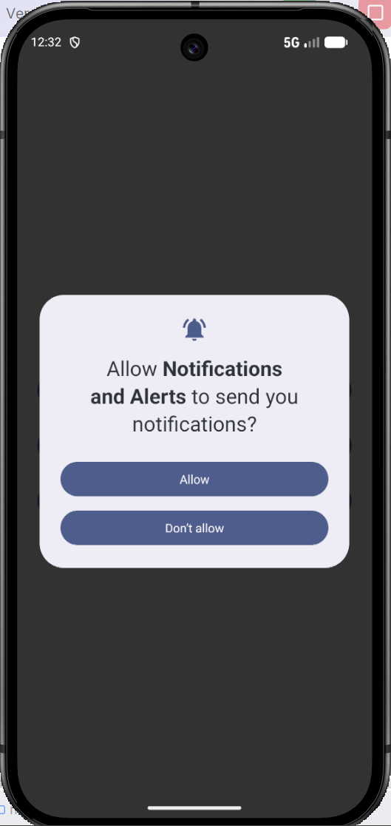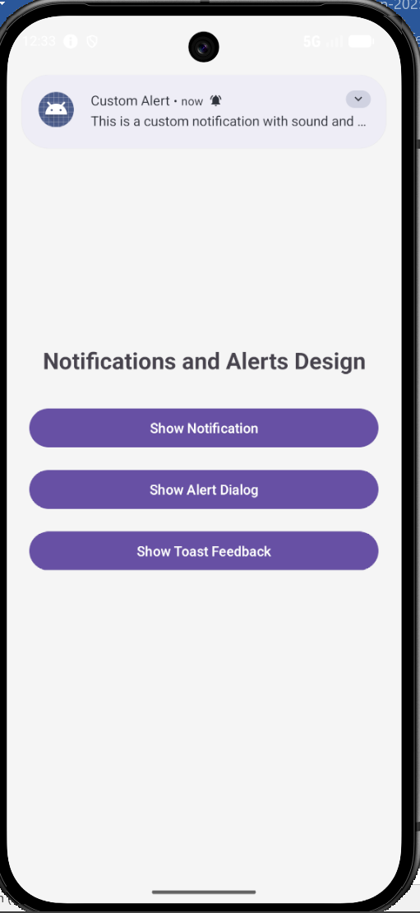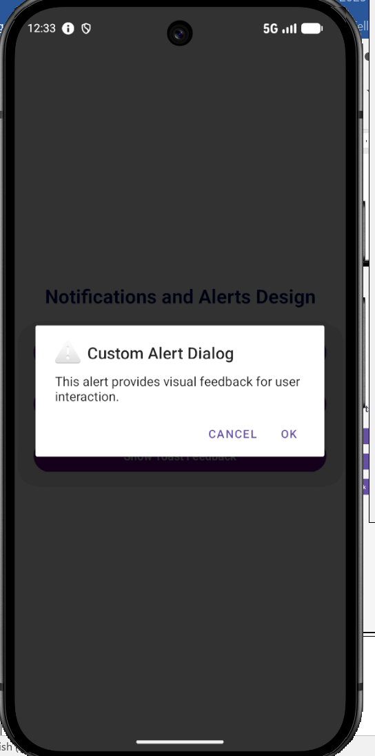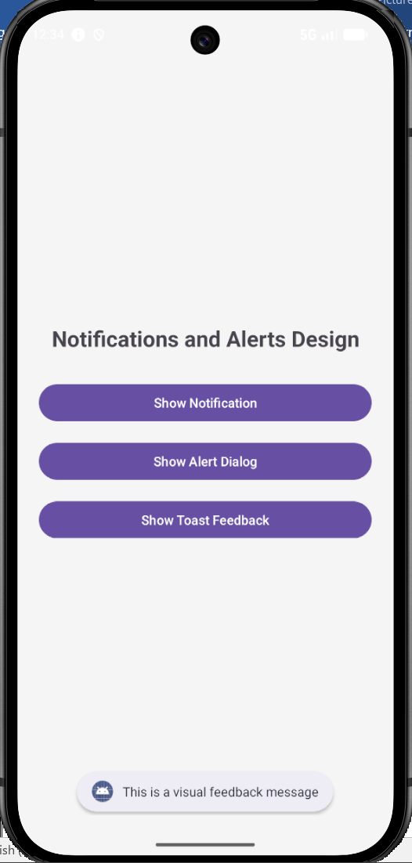

Result

Thus, a mobile application was successfully developed to demonstrate custom notifications and alerts with visual and auditory feedback aligned to the application theme.

Ex. No. : 10 Date:
Register No.: Name:

Camera and Image Editing App
Aim
Create an app that captures images, applies filters, crops, and edits photos with a visually appealing UI. Design Focus: Image editing tools, intuitive interface.

Procedure
- Requirement Analysis
Identify the objective of developing a mobile application that captures images using the device camera and provides image editing features such as filters, cropping, rotation, and brightness adjustment.
- Create an Android Studio Project
Open Android Studio, create a new Empty Activity project, enter the application name as Camera and Image Editing App, and choose Kotlin as the programming language.
- Add Required Permissions
Open AndroidManifest.xml and add permissions for:
  - Camera access
  - Reading media/images
  - Internet (optional)
- Design the User Interface
Open activity_main.xml and design the UI using ConstraintLayout or LinearLayout. Add:
  - ImageView to display the selected image
  - Button to open the camera
  - Button to select image from gallery
  - Buttons for editing actions such as:
    - Rotate
    - Apply filter
    - Crop
    - Reset image
- Implement Camera Capture Functionality
  - Use Intent(MediaStore.ACTION_IMAGE_CAPTURE) to open the device camera.
  - Capture the image and display it inside the ImageView.
- Implement Gallery Selection Functionality
  - Use an intent to open the gallery and select an image.
  - Retrieve the selected image URI and display it in the ImageView.
- Handle Runtime Permissions
  - Request camera and storage permissions dynamically at runtime.
  - Handle permission approval and denial properly.
- Implement Image Rotation
  - Use ImageView rotation or Bitmap transformation methods.
  - Rotate the image by a fixed angle such as 90 degrees on button click.
- Implement Image Filters
  - Apply visual effects such as:
    - Grayscale
    - Sepia
    - Brightness adjustment
    - Color filters
  - Use ColorMatrix or image processing methods.
- Implement Crop or Resize Feature
- Allow the image to be cropped or resized programmatically.
- Update the edited image in the ImageView.
- Implement Reset Functionality
- Restore the original image when the reset button is clicked.
- Provide User Feedback
- Display Toast messages for successful image capture, filter application, or reset actions.
- Add smooth animations or transitions if required.
- Test the Application
Run the application in the emulator or physical device. Verify:
- Camera capture functionality
- Gallery image selection
- Image editing operations
- UI responsiveness and clarity
- Build and Run the Application
Clean and rebuild the project. Execute the application and verify that all image editing features work correctly.

AndroidManifest.xml
<?xml version="1.0" encoding="utf-8"?>
<manifest xmlns:android="http://schemas.android.com/apk/res/android"
xmlns:tools="http://schemas.android.com/tools">
<uses-permission android:name="android.permission.CAMERA" />
<application
android:allowBackup="true"
android:dataExtractionRules="@xml/data_extraction_rules"
android:fullBackupContent="@xml/backup_rules"
android:icon="@mipmap/ic_launcher"
android:label="@string/app_name"
android:roundIcon="@mipmap/ic_launcher_round"
android:supportsRtl="true"
android:theme="@style/Theme.Exp10">
<activity
android:name=".MainActivity"
android:exported="true">
<intent-filter>
<action android:name="android.intent.action.MAIN" />
<category android:name="android.intent.category.LAUNCHER" />
</intent-filter>
</activity>
</application>
</manifest>

activity_main.xml
<?xml version="1.0" encoding="utf-8"?>
<ScrollView xmlns:android="http://schemas.android.com/apk/res/android"
android:layout_width="match_parent"
android:layout_height="match_parent"
android:fillViewport="true">
<LinearLayout
android:layout_width="match_parent"
android:layout_height="wrap_content"
android:orientation="vertical"
android:padding="16dp"
android:gravity="center_horizontal">
<TextView
android:layout_width="wrap_content"
android:layout_height="wrap_content"
android:text="Camera and Image Editing App"
android:textSize="24sp"
android:textStyle="bold"
android:layout_marginBottom="16dp" />
<ImageView
android:id="@+id/imageView"
android:layout_width="match_parent"
android:layout_height="350dp"
android:scaleType="centerCrop"
android:background="#E0E0E0"
android:src="@mipmap/ic_launcher" />
<Button
android:id="@+id/btnCamera"
android:layout_width="match_parent"
android:layout_height="wrap_content"
android:text="Capture Image"
android:layout_marginTop="16dp" />
<Button
android:id="@+id/btnGallery"
android:layout_width="match_parent"
android:layout_height="wrap_content"
android:text="Select from Gallery" />
<Button
android:id="@+id/btnRotate"
android:layout_width="match_parent"
android:layout_height="wrap_content"
android:text="Rotate Image" />
<Button
android:id="@+id/btnGray"
android:layout_width="match_parent"
android:layout_height="wrap_content"
android:text="Apply Grayscale Filter" />
<Button
android:id="@+id/btnCrop"
android:layout_width="match_parent"
android:layout_height="wrap_content"
android:text="Crop Image" />
<Button
android:id="@+id/btnReset"
android:layout_width="match_parent"
android:layout_height="wrap_content"
android:text="Reset Image" />
</LinearLayout>
</ScrollView>

MainActivity.kt
package com.example.exp_10
import android.Manifest
import android.content.pm.PackageManager
import android.graphics.*
import android.net.Uri
import android.os.Bundle
import android.provider.MediaStore
import android.widget.Button
import android.widget.ImageView
import android.widget.Toast
import androidx.activity.result.contract.ActivityResultContracts
import androidx.appcompat.app.AppCompatActivity
import androidx.core.app.ActivityCompat
import androidx.core.content.ContextCompat
class MainActivity : AppCompatActivity() {
private lateinit var imageView: ImageView
private var currentBitmap: Bitmap? = null
private var originalBitmap: Bitmap? = null
private val cameraPermissionCode = 100
private val cameraLauncher =
registerForActivityResult(ActivityResultContracts.TakePicturePreview()) { bitmap ->
if (bitmap != null) {
currentBitmap = bitmap
originalBitmap = bitmap.copy(bitmap.config ?: Bitmap.Config.ARGB_8888, true)
imageView.setImageBitmap(currentBitmap)
Toast.makeText(this, "Image captured successfully", Toast.LENGTH_SHORT).show()
} else {
Toast.makeText(this, "Image capture cancelled", Toast.LENGTH_SHORT).show()
}
}
private val galleryLauncher =
registerForActivityResult(ActivityResultContracts.GetContent()) { uri: Uri? ->
if (uri != null) {
val bitmap = MediaStore.Images.Media.getBitmap(contentResolver, uri)
currentBitmap = bitmap
originalBitmap = bitmap.copy(bitmap.config ?: Bitmap.Config.ARGB_8888, true)
imageView.setImageBitmap(currentBitmap)
Toast.makeText(this, "Image selected from gallery", Toast.LENGTH_SHORT).show()
} else {
Toast.makeText(this, "No image selected", Toast.LENGTH_SHORT).show()
}
}
override fun onCreate(savedInstanceState: Bundle?) {
super.onCreate(savedInstanceState)
setContentView(R.layout.activity_main)
imageView = findViewById(R.id.imageView)
val btnCamera: Button = findViewById(R.id.btnCamera)
val btnGallery: Button = findViewById(R.id.btnGallery)
val btnRotate: Button = findViewById(R.id.btnRotate)
val btnGray: Button = findViewById(R.id.btnGray)
val btnCrop: Button = findViewById(R.id.btnCrop)
val btnReset: Button = findViewById(R.id.btnReset)
btnCamera.setOnClickListener {
checkCameraPermission()
}
btnGallery.setOnClickListener {
galleryLauncher.launch("image/*")
}
btnRotate.setOnClickListener {
rotateImage()
}
btnGray.setOnClickListener {
applyGrayScale()
}
btnCrop.setOnClickListener {
cropImage()
}
btnReset.setOnClickListener {
resetImage()
}
}
private fun checkCameraPermission() {
if (ContextCompat.checkSelfPermission(this, Manifest.permission.CAMERA)
== PackageManager.PERMISSION_GRANTED
) {
cameraLauncher.launch(null)
} else {
ActivityCompat.requestPermissions(
this,
arrayOf(Manifest.permission.CAMERA),
cameraPermissionCode
)
}
}
private fun rotateImage() {
val bitmap = currentBitmap
if (bitmap == null) {
Toast.makeText(this, "Please capture or select an image first", Toast.LENGTH_SHORT).show()
return
}
val matrix = Matrix()
matrix.postRotate(90f)
val rotatedBitmap = Bitmap.createBitmap(
bitmap,
0,
0,
bitmap.width,
bitmap.height,
matrix,
true
)
currentBitmap = rotatedBitmap
imageView.setImageBitmap(currentBitmap)
Toast.makeText(this, "Image rotated", Toast.LENGTH_SHORT).show()
}
private fun applyGrayScale() {
val bitmap = currentBitmap
if (bitmap == null) {
Toast.makeText(this, "Please capture or select an image first", Toast.LENGTH_SHORT).show()
return
}
val grayBitmap = Bitmap.createBitmap(bitmap.width, bitmap.height, Bitmap.Config.ARGB_8888)
val canvas = Canvas(grayBitmap)
val paint = Paint()
val colorMatrix = ColorMatrix()
colorMatrix.setSaturation(0f)
val filter = ColorMatrixColorFilter(colorMatrix)
paint.colorFilter = filter
canvas.drawBitmap(bitmap, 0f, 0f, paint)
currentBitmap = grayBitmap
imageView.setImageBitmap(currentBitmap)
Toast.makeText(this, "Grayscale filter applied", Toast.LENGTH_SHORT).show()
}
private fun cropImage() {
val bitmap = currentBitmap
if (bitmap == null) {
Toast.makeText(this, "Please capture or select an image first", Toast.LENGTH_SHORT).show()
return
}
val size = minOf(bitmap.width, bitmap.height)
val x = (bitmap.width - size) / 2
val y = (bitmap.height - size) / 2
val croppedBitmap = Bitmap.createBitmap(bitmap, x, y, size, size)
currentBitmap = croppedBitmap
imageView.setImageBitmap(currentBitmap)
Toast.makeText(this, "Image cropped", Toast.LENGTH_SHORT).show()
}
private fun resetImage() {
if (originalBitmap == null) {
Toast.makeText(this, "No original image available", Toast.LENGTH_SHORT).show()
return
}
currentBitmap = originalBitmap!!.copy(
originalBitmap!!.config ?: Bitmap.Config.ARGB_8888,
true
)
imageView.setImageBitmap(currentBitmap)
Toast.makeText(this, "Image reset", Toast.LENGTH_SHORT).show()
}
override fun onRequestPermissionsResult(
requestCode: Int,
permissions: Array<out String>,
grantResults: IntArray
) {
super.onRequestPermissionsResult(requestCode, permissions, grantResults)
if (requestCode == cameraPermissionCode) {
if (grantResults.isNotEmpty() &&
grantResults[0] == PackageManager.PERMISSION_GRANTED
) {
cameraLauncher.launch(null)
} else {
Toast.makeText(this, "Camera permission denied", Toast.LENGTH_SHORT).show()
}
}
}
}

Output

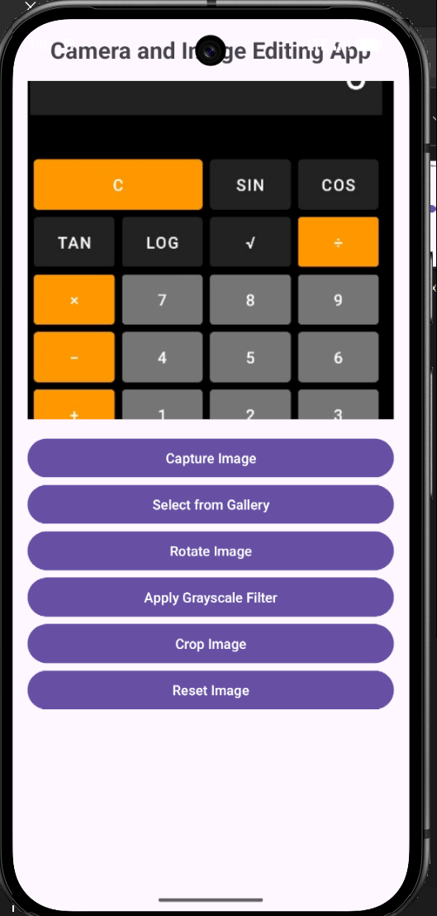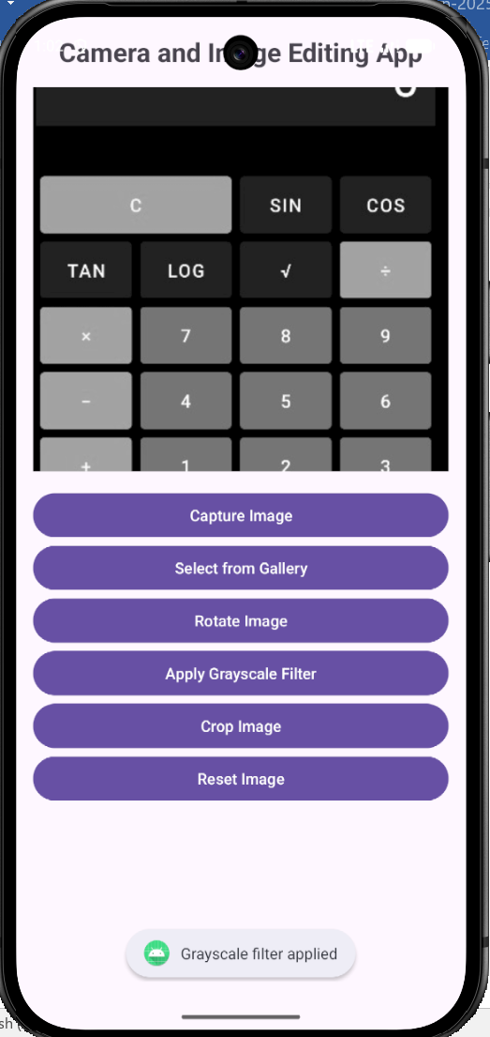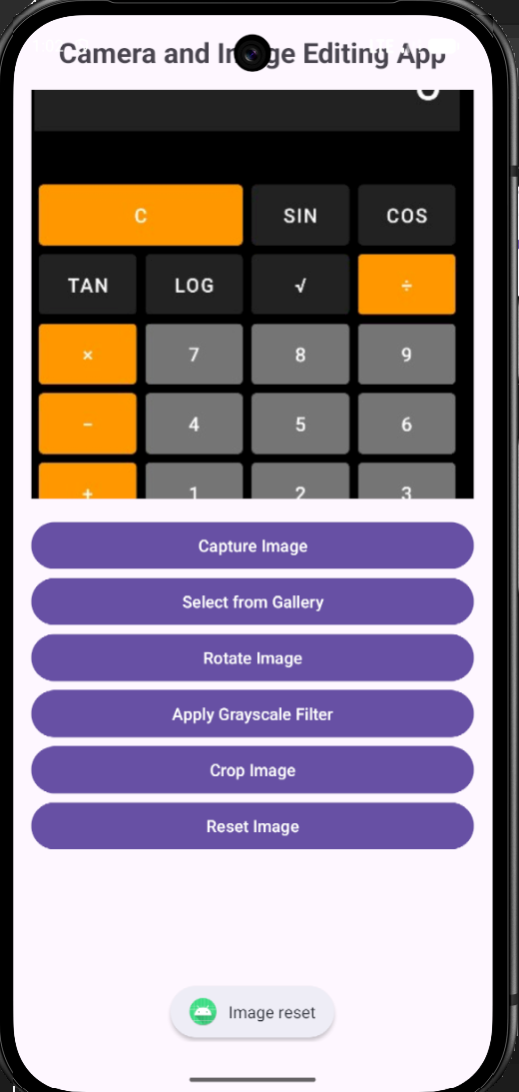

Result

Thus, a mobile application was successfully developed to capture and edit images with features such as filters, rotation, cropping, and reset operations using an intuitive user interface.

