# Title : Redesigning of canteen menu!

Aim: To create a design of canteen menu

Procedure:

1. **Identify Objectives**: Decide what the app should achieve. Example: displaying menu items, prices, nutritional info, ordering, or payment options.
2. **Target Audience**: Define your users (students, staff, or the general public).
3. **Key Features**:
   * Menu display with categories (e.g., breakfast, lunch, snacks).
   * Search and filter options.
   * Item descriptions (ingredients, allergens, calorie count).
   * Real-time availability updates.
   * Pre-order and payment options (optional).

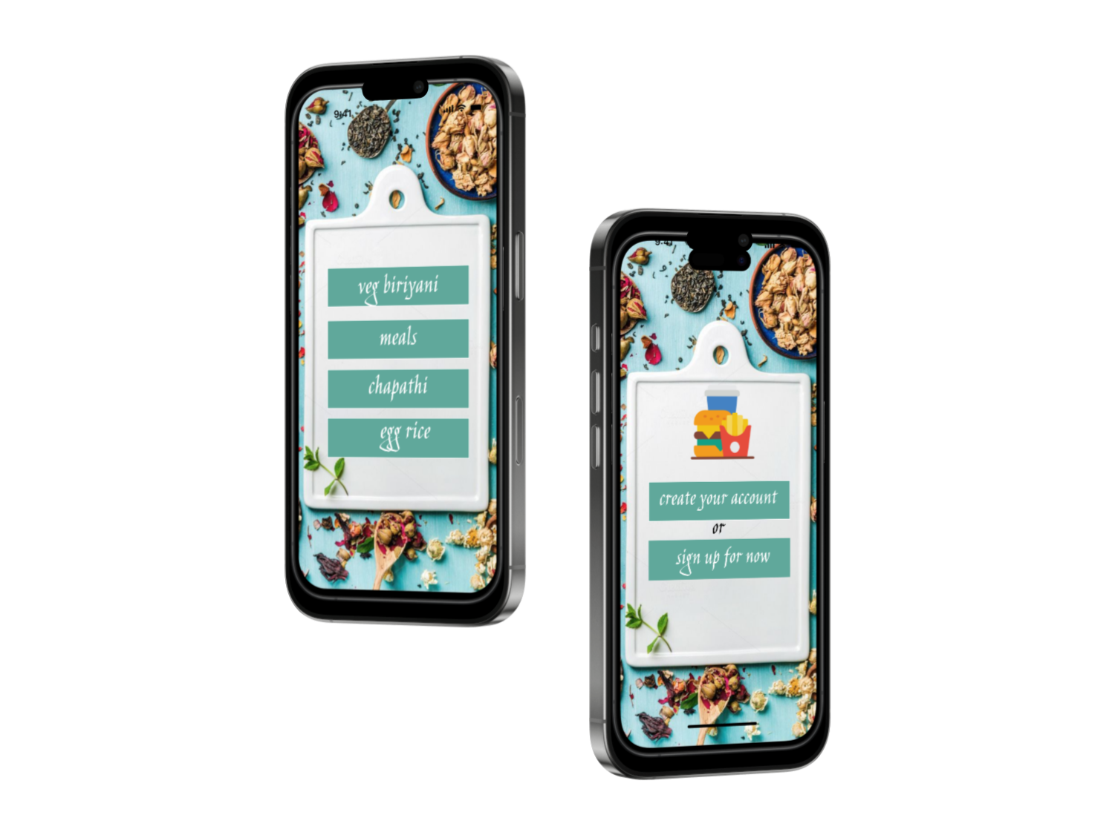

Result :

Redesigning of canteen menhy