**Exp. No.: 01 Name: A.Cheran**

**Date: 31/07/2024 Reg. No.: 231701009**

**Aim:**

To design a web application for donating vayanad

**Procedure:**

1. Open Figma.
2. Start a new design file.
3. Choose the size for your design or frame size.
4. Add and arrange text, images, and other elements.
5. Select the frame.
6. Find the “Fill” option.
7. Choose a new color or enter a hex code.
8. Save your design elements in the desired format.

**Screenshots:**

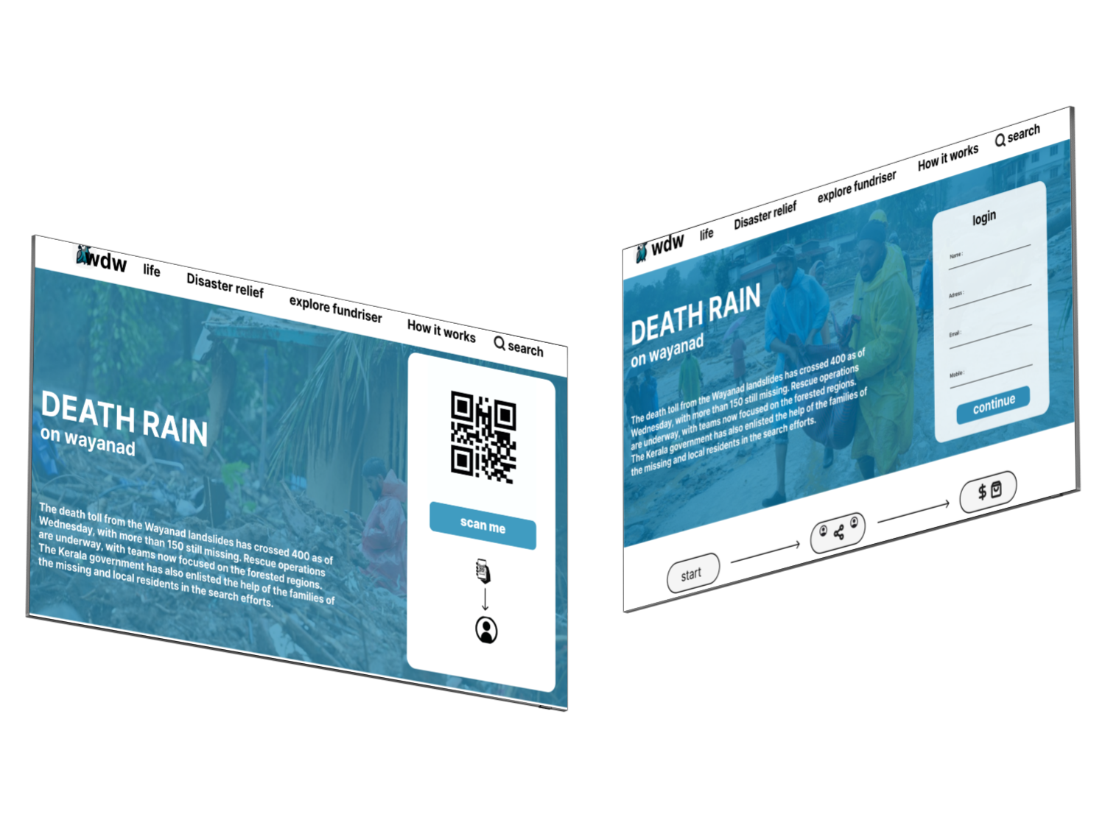

**Result:**

Designing a web application for donating wayanad is completed.