**ANALYZING THE PERCEIVED INTENTION TO ADOPT CRYPTOCURRENCY USING INTEGRATED  
TECHNOLOGY READINESS AND  
ACCEPTANCE MODEL (TRAM):  
A PLS-SEM APPROACH**



**A Thesis Proposal** Presented to the Faculty of the Department of Economics

Faculty of Management and Economics Visayas State University Visca, Baybay City, Leyte

In Partial Fulfillment

of the Requirements for the Course of

**Econ 198: Research Planning and Manuscript Preparation**

Prepared in the Department of Economics under the supervision and guidance of Lemuel S. Preciados.

**Word count: 8,586 words**

**Thesis Adviser:** Christopher A. Llones

**Student Research Committee 1:** Lemuel S. Preciados

**Student Research Committee 2:** Moises Neil V. Seriño

**CHERIE JOYCE L. BONGCARAS**

**May 2025**

**TABLE OF CONTENTS**

**INTRODUCTION3**

Nature and Importance of the Study3

Statement of the Problem4

Objectives of the Study6

Scope and Limitations of the Study6

**REVIEW OF RELATED LITERATURE7**

Cryptocurrency7

Current Landscape of Cryptocurrency in the Philippines8

Technology Readiness Index (TRI)9

Technology Acceptance Model (TAM)11

Perceived Risk13

Partial Least Square Systematic Equation Modelling (PLS-SEM)13

Generation Z: The Digital Natives14

**THEORETICAL AND CONCEPTUAL FRAMEWORK16**

Integrated Model: Technology Readiness and Acceptance Model (TRAM)16

Conceptual Framework18

1. Behavioral Intention to Use (BIU)20
2. Perceived Risk21
3. Perceived Ease of Use (PEU) and Perceived Usefulness (PU)21
4. Effect of Optimism (OPT) on PU and PEU22
5. Effect of Innovativeness (INN) on PU and PEU23
6. Effect of Insecurity (INS) on PU and PEU23
7. Effect of Discomfort (DIS) on PU and PEU24

**METHODOLOGY26**

Research Design26

Research Instrument26

Sampling Data Collection31

Data Analyses32

Data Preparation and Descriptive Statistics33

Measurement Model Evaluation33

Exploratory Factor Analysis (EFA)33

Confirmatory Factor Analysis (CFA)33

Structural Model Estimation33

Model Fit Evaluation34

Hypothesis Testing34

Ethical Consideration35

Conflicts of Interest35

Ethical Issues and Risk Identification35

Plans to Mitigate Anticipated Risks35

Protection of Privacy and Confidentiality of Research Information36

Vulnerability of Research Participants36

Management of Adverse Events37

Informed Consent37

**LITERATURE CITED38**

**APPENDICES41**

Survey Questionnaire42

Item-Congruence Test48

Experts Answers on Item-Congruence Test49

Focus Group Discussion Questions50

**CHAPTER I**

**INTRODUCTION**

**Nature and Importance of the Study**

The rapid digitalization of financial services has opened up new opportunities for the adoption of emerging technologies like cryptocurrency in the Philippines. Cryptocurrency, with its potential for decentralized, fast, and borderless transactions, has garnered significant attention as a transformative force in the Philippines' financial landscape (Santos & Cruz, 2023). However, widespread adoption remains hindered by concerns surrounding security, usability, and the perceived value of these virtual currencies (Garcia et al., 2024).

With this, the study aims to analyze the factors influencing the adoption of cryptocurrency among students of Visayas State University using an integrated approach that combines the Technology Readiness Index (Parasuraman & Colby, 2015) and the Technology Acceptance Model (Svendsen et al., 2013). Together, by employing the Integrated Technology Readiness and Acceptance Model (TRAM) (Parasuraman & Colby, 2015), the research examines how key dimensions of technology readiness, including optimism, innovativeness, insecurity, and discomfort, shape the perceived ease of use and perceived usefulness of cryptocurrency. These, in turn, are hypothesized to impact the overall intention to adopt cryptocurrencies.

Investigating the complex interplay between technology readiness, acceptance factors, and adoption intention of cryptocurrency in the Philippine context is crucial for several reasons. One is that the findings can inform policymakers on the key drivers and barriers to cryptocurrency adoption, enabling the development of targeted interventions and regulations to foster a more inclusive and robust digital financial ecosystem (Martinez & Lee, 2024). It can also provide valuable insights for financial service providers in the country, helping them design more user-centric cryptocurrency products and services that cater to the unique needs and concerns of the local population (Lin & Chang, 2020).

Furthermore, this research can offer guidance to cryptocurrency technology developers on the critical design and implementation considerations to enhance the usability and perceived value of their offerings, thereby facilitating greater adoption (Davis, 1989). This can also be essential for promoting financial inclusion and empowering underserved communities in the Philippines through alternative digital financial services (Martinez & Lee, 2024).

By adopting the TRAM framework in the Philippine setting, specifically the students of Visayas State University, this study aims to contribute to the growing body of knowledge on the adoption of emerging financial technologies, while also providing actionable insights for policymakers, financial institutions, and technology providers to drive the sustainable development of the country's digital economy.

**Statement of the Problem**

Despite the rapid growth of virtual currencies and blockchain-based decentralized technologies over the past decade, mainstream consumer adoption and use of these innovations remains limited (Lee & Shin, 2021). Cryptocurrencies have yet to become widely used alternatives for payments, investments, or financial services among the broader public. There remains a significant gap in understanding these adoption challenges specifically within emerging decentralized systems like cryptocurrencies, particularly for demographic groups that will likely drive future technological integration.

The focus will be exclusively on Generation Z participants — students born between 1997 and 2012 — to explore their perspectives, technological readiness, and cryptocurrency adoption intentions. By targeting this specific generational cohort, the study aims to capture the nuanced attitudes of digital natives who have grown up amid rapid technological transformations and are potentially more predisposed to embracing emerging financial technologies (Seemiller & Grace, 2019; Prensky, 2001). Generation Z's unique characteristics, characterized by technological fluency, entrepreneurial mindset, and heightened skepticism towards traditional financial systems, make them a particularly compelling demographic for understanding cryptocurrency perceptions and potential integration (Chicca & Shellenbarger, 2018).

Yet investigations into this cohort’s readiness, perceptions, and intention to use cryptocurrencies have been sparse. By examining the obstacles and opportunities for cryptocurrency adoption, this research will help policymakers and educational institutions develop more effective strategies for integrating emerging financial technologies. Through a comprehensive analysis of Generation Z's attitudes, the research aims to provide valuable insights into the evolving landscape of digital financial technologies within higher education, offering a nuanced understanding of how this generation might reshape future economic interactions

**Objectives of the Study**

Generally, this study aims to analyze the intention to adopt cryptocurrency using an Integrated Technology Readiness and Acceptance Model (TRAM): a PLS-SEM approach. Specifically, this study seeks to:

1. To describe and compare the socio-demographics of Visayas State University students about their adoption of cryptocurrency, within the context of an integrative framework combining the Technology Readiness Index (TRI) and the Technology Acceptance Model (TAM);
2. To analyze the interrelationships between inherent technology readiness (as measured by TRI) and perceived usefulness and ease of use (as measured by TAM) in the context of cryptocurrency adoption; and
3. To contribute to policy development by providing insights on the determinants of cryptocurrency adoption, which can inform strategies for promoting responsible use and regulation in academic and broader contexts.

**Scope and Limitations of the Study**

The study will focus exclusively on Generation Z participants, specifically students at Visayas State University analyzing their cryptocurrency adoption intentions through an integrated Technology Readiness and Acceptance Model (TRAM) using Partial Least Squares Structural Equation Modeling (PLS-SEM).

The researcher will employ a survey questionnaire, starting with a pre-screening test to identify participants who meet the criteria for qualification. Only those who qualify in the pre-screening will proceed to complete the full survey, ensuring the study’s focus on the targeted population. By leveraging PLS-SEM, the research seeks to provide valuable insights into the behavioral intentions of Generation Z.

**CHAPTER II**

**REVIEW OF RELATED LITERATURE**

**Cryptocurrency**

Cryptocurrencies are digital forms of money that work differently from traditional currency, using a technology called blockchain to allow direct financial transactions without banks or governments in the middle (Nakamoto, 2008). These digital currencies can be sent directly from one person to another across the internet, making money transfers faster and potentially cheaper than traditional banking systems.

The key innovation is blockchain technology, which acts like a public digital ledger that records every transaction transparently and securely (Tapscott & Tapscott, 2016). Instead of a bank keeping track of money movements, thousands of computers around the world verify and record transactions, making it extremely difficult to manipulate or cheat the system.

While cryptocurrencies offer exciting possibilities, they also come with challenges. They can help people in areas with limited banking access get financial services, but they also face issues like price fluctuations and uncertain regulations (World Bank, 2022). Some people see them as a revolutionary technology, while others are more cautious about their long-term potential.

One of the most promising aspects of cryptocurrencies is their ability to make international money transfers easier and cheaper, especially for people sending money across borders or in countries with unstable financial systems (World Economic Forum, 2022). They can potentially provide financial services to people who traditionally have been left out of banking systems, using just a mobile phone.

**Current Landscape of Cryptocurrency in the Philippines**

The Philippines has emerged as a significant cryptocurrency market in Southeast Asia, with Bitcoin and Ethereum leading digital currency adoption (Statista, 2023). Approximately 20.7% of Filipinos have invested in or used cryptocurrencies, making the country one of the highest cryptocurrency adopters in the Asia-Pacific region (Finder Cryptocurrency Adoption Index, 2023). An estimated 16 million Filipinos actively engage in cryptocurrency transactions, driven by remittance opportunities, investment potential, and alternative income sources, particularly during the COVID-19 pandemic (Blockchain Council Philippines, 2023).

The country's cryptocurrency ecosystem is unique, characterized by progressive regulatory approaches and high digital financial technology penetration (Dela Cruz & Tandoc, 2019). The Bangko Sentral ng Pilipinas (BSP) has taken a forward-thinking stance, recognizing virtual currencies as legitimate payment instruments while implementing strict anti-money laundering protocols (BSP Circular No. 944, 2017). Cryptocurrency transactions in the Philippines reached approximately $1.4 billion in 2022, with peer-to-peer (P2P) platforms accounting for nearly 40% of these exchanges, demonstrating the critical role of digital currencies in addressing financial inclusion challenges (Global Data, 2023).

Local platforms like Coins.ph and PDAX have been instrumental in facilitating cryptocurrency adoption, while international platforms like Binance have established a strong presence in the market (CoinMarketCap, 2024). The country's youth, particularly Generation Z, show remarkable digital technology literacy, with 56% of individuals aged 18-35 viewing cryptocurrencies as a viable investment and potential career opportunity (Philippine Social Media Insights, 2023). This combination of technological openness, regulatory support, and economic necessity has positioned the Philippines as a unique and dynamic cryptocurrency market in the global digital finance landscape.

**Technology Readiness Index (TRI)**

The Technology Readiness Index (TRI), developed by Parasuraman in 2000, is a comprehensive psychological construct designed to measure an individual's propensity to embrace and use new technologies (Parasuraman & Colby, 2015). Unlike traditional technology adoption models, TRI explores the psychological and emotional dimensions that influence an individual's readiness to engage with technological innovations.

TRI identifies four core predictors that directly influence an individual's technology readiness:

1. **Optimism**: A positive view of technology and its potential to increase control, efficiency, and flexibility in life (Parasuraman, 2000). In the context of cryptocurrencies, this represents an individual's positive outlook on digital financial technologies' potential to transform economic interactions.
2. **Innovativeness**: The tendency to be a technological pioneer and thought leader, championing new technologies before they become mainstream (Parasuraman & Colby, 2015). For cryptocurrency adoption, this predictor identifies individuals more likely to explore and experiment with emerging digital currency technologies.
3. **Discomfort**: Feelings of skepticism and potential stress associated with technological interactions (Parasuraman, 2000). In cryptocurrency studies, this represents users' concerns about technological complexity, security risks, and potential financial uncertainties.
4. **Insecurity**: Distrust and concerns about technology's reliability, privacy, and potential negative consequences (Parasuraman & Colby, 2015). For cryptocurrencies, this predictor captures users' apprehensions about digital currency security, potential fraud, and regulatory uncertainties.

In cryptocurrency research, TRI provides a nuanced framework for understanding individual technological adoption by exploring psychological barriers beyond traditional economic considerations (Raza et al., 2021). Researchers have utilized TRI to identify demographic variations in technological readiness, understand emotional and cognitive processes underlying technology adoption, and develop more comprehensive models of technological engagement (Choi et al., 2022).

In the Philippine context, technology readiness studies have predominantly focused on urban areas, revealing significant gaps in understanding technological adoption, particularly in rural academic settings like Visayas State University in Baybay, Leyte (Dela Cruz & Tandoc, 2019). Despite the Philippines' high digital technology penetration, localized studies examining technology readiness among students and faculty in rural contexts remain extremely limited, creating a critical research void that prevents a comprehensive understanding of technological adoption patterns in diverse geographical contexts (Uy et al., 2021). The absence of cryptocurrency-specific investigations in rural academic environments represents a significant limitation in comprehending how different demographic groups perceive and interact with emerging financial technologies (Bangko Sentral ng Pilipinas, 2022).

**Technology Acceptance Model (TAM)**

The Technology Acceptance Model (TAM), originally developed by Fred Davis in 1989, is a theoretical framework designed to explain and predict user acceptance of information technologies (Davis, 1989). Rooted in psychology and information systems research, TAM provides a systematic approach to understanding how individuals accept and use new technologies, focusing on the cognitive processes that influence technological adoption decisions.

Unlike TRI, TAM identifies only two core predictors that directly influence an individual's intention to use and actual usage of technology:

1. **Perceived Usefulness**: The degree to which an individual believes using a particular technology will enhance their performance and productivity. In the cryptocurrency context, this would relate to how users perceive digital currencies as potentially improving financial transactions, investment strategies, or economic opportunities (Venkatesh & Davis, 2000).
2. **Perceived Ease of Use**: The extent to which an individual believes that using a technology will be effortless and require minimal cognitive and physical effort. For cryptocurrencies, this might involve assessing the user-friendliness of digital wallets, transaction processes, and overall technological complexity (Davis, 1989).

In the context of cryptocurrency studies, TAM has emerged as a crucial theoretical lens for understanding technological adoption barriers and facilitators. Researchers are extending the model to explore complex factors influencing digital currency acceptance (Raza et al., 2021). The model helps illuminate how users evaluate new technologies, particularly in emerging financial domains, by examining psychological and cognitive processes that mediate technology acceptance decisions (Alalwan, 2020).

Recent adaptations of TAM in cryptocurrency research have incorporated additional variables such as trust, perceived risk, and social influences to create more comprehensive models of technological adoption (Choi et al., 2022). These modified frameworks recognize the unique characteristics of blockchain and digital currencies, providing nuanced insights into how different demographic groups, particularly younger generations, perceive and interact with innovative financial technologies (Kim et al., 2019).

In the Philippine context, TAM studies have revealed unique insights into technological adoption, particularly in digital financial technologies. Researchers like Uy et al. (2021) have found that Filipino users, especially among Generation Z, demonstrate high technological readiness with nuanced perceptions of digital innovations. However, a critical research gap exists in understanding cryptocurrency adoption in rural areas, particularly in regions like Baybay, Leyte, where Visayas State University is located. Despite the Philippines' overall high cryptocurrency adoption rates, there is a notable absence of studies examining technological acceptance in rural academic settings (Dela Cruz & Tandoc, 2019). This research void is particularly significant, as rural universities like Visayas State University represent unique ecosystems where technological diffusion may differ substantially from urban centers. The lack of localized studies in such contexts means that the technological acceptance patterns of students and faculty in these areas remain largely unexplored, creating a substantial empirical gap in understanding how rural academic communities perceive and potentially adopt emerging technologies like cryptocurrencies (Bangko Sentral ng Pilipinas, 2022).

**Perceived Risk**

Perceived risk emerges from the disparity between technological innovation outcomes and implementation extent (Jalan et al., 2021). Technological uncertainty represents the primary barrier to technological adoption (Mizanur & Sloan, 2017). Risk perception encompasses the cognitive assessment of potential technological insecurities that influence investor and consumer decision-making (Anser et al., 2020). As a critical determinant of technology acceptance, perceived risk significantly impacts behavioral intentions (Mutahar et al., 2018). Emerging financial technologies like cryptocurrencies exemplify contexts where risk perception plays a pivotal role in technological adoption and consumer trust (Granić & Marangunić, 2019).

Researchers have particularly focused on the role of perceived risk as a critical barrier to technology adoption, with cryptocurrency representing a complex and volatile domain for such analysis (Arias-Oliva et al., 2019). The integrated approach of combining technology readiness and acceptance models offers a comprehensive perspective for understanding emerging financial technology adoption mechanisms.

**Partial Least Square Systematic Equation Modelling (PLS-SEM)**

Partial Least Square Structural Equation Modeling (PLS-SEM) is a sophisticated statistical tool that helps researchers untangle complex relationships between multiple variables in technology research (Hair et al., 2019). Unlike traditional statistical methods, PLS-SEM allows researchers to explore intricate connections between different concepts simultaneously, making it particularly powerful for studying emerging technologies like cryptocurrency adoption (Chin, 2010). This approach is especially useful when dealing with smaller research samples or complex theoretical models that conventional statistical techniques might struggle to analyze comprehensively.

The real strength of PLS-SEM is its ability to examine both individual variables and how they interact within a larger system (Wetzels et al., 2009). In technology adoption studies, this means researchers can simultaneously investigate how factors like technological readiness, perceived usefulness, and behavioral intention influence each other (Venkatesh et al., 2012). It is a research microscope that can zoom in on individual components while also revealing how these components work together in a complex ecosystem.

PLS-SEM is particularly valuable because of its remarkable flexibility and ability to handle intricate research questions (Sarstedt et al., 2014). This method shines in cutting-edge research areas like cryptocurrency adoption, where traditional research approaches often fall short in capturing the nuanced and interconnected relationships between different factors. By providing a more comprehensive and adaptable analytical framework, PLS-SEM enables researchers to gain deeper insights into complex technological and behavioral phenomena.

**Generation Z: The Digital Natives**

The rapid evolution of digital financial technologies has particularly captured the attention of Generation Z, a demographic cohort born between 1997 and 2012, characterized by their digital nativity, technological fluency, and unique financial perspectives (Dimock, 2019; Prensky, 2001). This generation demonstrates unprecedented comfort with technological innovations and alternative financial systems (Twenge & Campbell, 2009; Tapscott, 2008).

Research indicates that Generation Z exhibits distinctive characteristics that significantly influence their technological adoption behaviors, including high digital literacy, a preference for innovative financial solutions, and a skeptical yet curious approach to traditional banking systems (Seemiller & Grace, 2016; Williams & Page, 2011). Their financial decision-making is notably different from previous generations, often driven by transparency, decentralization, and potential for financial empowerment (Fromm & Garton, 2013; Goh & Lee, 2020).

**CHAPTER III**

**THEORETICAL AND CONCEPTUAL FRAMEWORK**

**Integrated Model: Technology Readiness and Acceptance Model (TRAM)**

The Technology Readiness and Acceptance Model (TRAM) represents a sophisticated theoretical integration of the Technology Acceptance Model (TAM) and Technology Readiness Index (TRI), offering a comprehensive framework for understanding technological adoption processes. Developed through the seminal work of Davis and Parasuraman, this integrated approach explores the complex interplay between cognitive beliefs and psychological predispositions that influence technological engagement (Davis, 1989; Parasuraman, 2000).

At the core of TRAM lies the Technology Acceptance Model's fundamental constructs of perceived usefulness and perceived ease of use, which provide a rational, performance-oriented perspective on technological adoption. These cognitive beliefs explain how individuals evaluate technological innovations based on their anticipated instrumental benefits and the perceived effort required for implementation (Venkatesh et al., 2003). The model suggests that users' perceptions of a technology's utility and accessibility directly shape their attitudes, behavioral intentions, and ultimate technology usage.

The Technology Readiness Index complements TAM by introducing a nuanced psychological dimension to technology acceptance. Through four critical psychological constructs—optimism, innovativeness, discomfort, and insecurity—TRI explores the individual's emotional and dispositional readiness for technological engagement (Parasuraman & Colby, 2015). These dimensions reveal how personal psychological factors mediate technological acceptance beyond rational cognitive assessments, accounting for individual differences in technological receptiveness.

Empirical research demonstrates the synergistic potential of integrating TAM and TRI within TRAM. The psychological dimensions of technological readiness act as a critical filter that influences cognitive perceptions of technological attributes, creating a more comprehensive understanding of technology adoption processes (Nadlifatin et al., 2017). For instance, an individual's technological optimism can enhance perceived usefulness, while technological insecurity might diminish the perceived ease of use of a particular innovation.

The theoretical framework proves particularly valuable in emerging technological domains such as cryptocurrency. By considering both cognitive assessments and psychological predispositions, TRAM provides researchers and practitioners with a sophisticated tool for understanding the multifaceted nature of technological acceptance across diverse contexts (Rodriguez et al., 2021). The model acknowledges that technology adoption is not merely a rational decision-making process but a complex interplay of cognitive, emotional, and social factors.

Research implications of this integrated approach are particularly profound in the cryptocurrency domain, where TRAM provides critical insights into the complex psychological and technological barriers to digital currency adoption. By mapping the intricate interplay between perceived usefulness, technological readiness, and individual psychological factors, the framework offers an unprecedented understanding of cryptocurrency acceptance mechanisms, especially in emerging economic contexts (Seetharaman et al., 2020).

**Conceptual Framework**

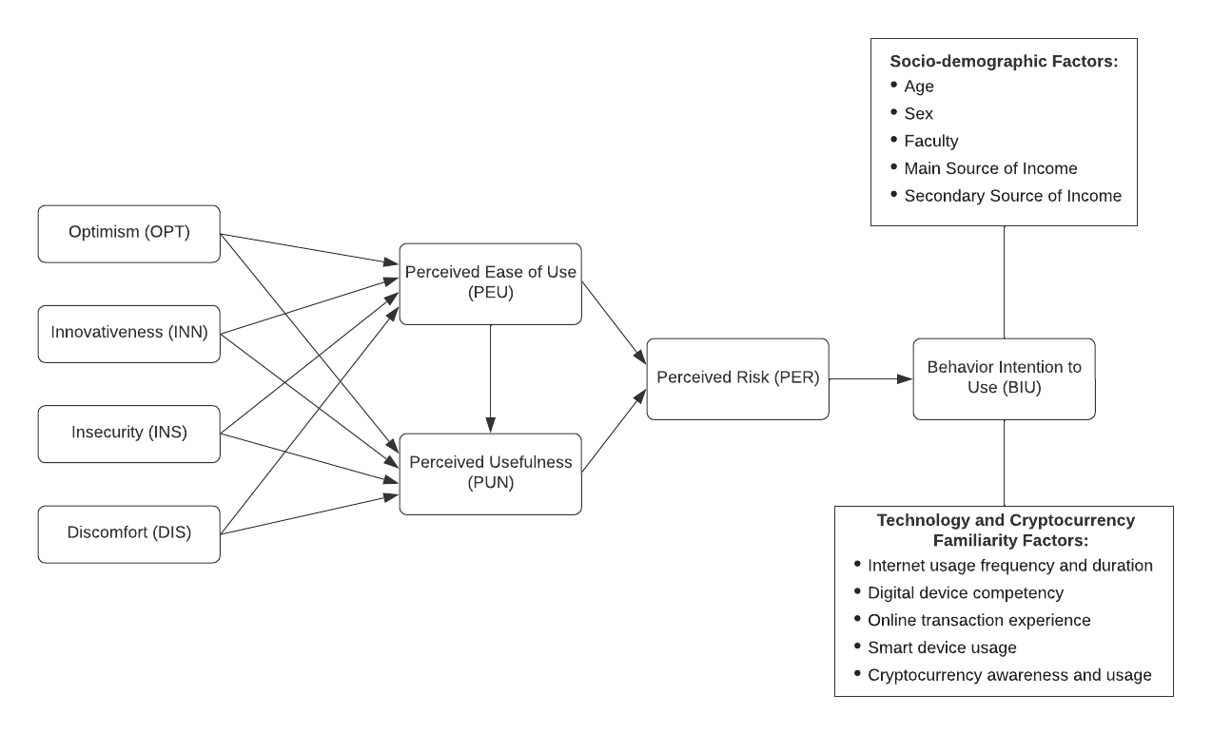As shown in Figure 1, it integrates the Technology Readiness Index (TRI) and the Technology Acceptance Model (TAM) as a whole Technology Readiness and Acceptance Model (TRAM). This integrated approach combines the rational, performance-oriented perspective of TAM with the psychological readiness dimensions of TRI, offering a comprehensive model for understanding technology adoption and acceptance.

## Figure 1. Conceptual Framework of the Technology Readiness and Acceptance Model (TRAM) in Analyzing to Adopt Cryptocurrency

The framework integrates Technology Readiness Index (TRI) dimensions, which represent individuals' psychological predispositions toward technology. These dimensions include Optimism (OPT), Innovativeness (INN), Insecurity (INS), and Discomfort (DIS), which are theorized to influence key Technology Acceptance Model (TAM) constructs like Perceived Ease of Use (PEU) and Perceived Usefulness (PUN) (Parasuraman & Colby, 2015).

The interaction between these psychological dimensions and technological perceptions ultimately shapes an individual's Behavior Intention to Use (BIU) cryptocurrency. This integrated approach suggests that a person's willingness to engage with cryptocurrency is not just about rational performance metrics, but is deeply rooted in their psychological readiness and comfort with technological innovations (Venkatesh et al., 2012). By combining the performance-oriented perspective of TAM with the psychological readiness dimensions of TRI, the framework provides a nuanced understanding of technology adoption.

**Table 1. Summarized Variables of the Integrated TRAM**

|  |  |
| --- | --- |
| Variables/Factors | Description |
| INDEPENDENT VARIABLES: Technology Readiness Index (TRI) | |
| Optimism (OPT) | Belief that technology improves life quality and efficiency. |
| Innovativeness (INN) | Tendency to be an early adopter of technology. |
| Insecurity (INS) | Concerns about privacy, reliability, or potential misuse of technology. |
| Discomfort (DIS) | Feelings of being overwhelmed or not confident with technology. |
| MEDIATING VARIABLES: Technology Acceptance Model (TAM) | |
| Perceived Ease of Use (PEU) | How simple and user-friendly the technology appears. |
| Perceived Usefulness (PUN) | The belief is that using the technology will enhance performance or achieve goals. |
| Perceived Risk (PER) | The potential uncertainties or negative consequences that users believe they may encounter when using the technology. |
| DEPENDENT VARIABLE | |
| Behavioral Intention to Use (BIU) | The likelihood that a person will adopt or continue using the technology. |

For a summarized version of the independent, mediating, and dependent variables of the integrated TRAM, the table above explains its descriptions and roles in the study. The descriptions are cited from Peng & Yan (2022).

**Table 2. Demographic Category of the Respondents**

|  |  |
| --- | --- |
| Demographics | Description |
| Age (18-23, 24-28) | An individual's age may influence their technology readiness and acceptance. |
| Gender (Male, Female, Prefer Not to Say) | Gender differences can play a role in technology adoption, with studies suggesting potential variations in perceptions of usefulness and ease of use across genders. |
| Main Source of Income | The primary source of an individual's income may influence their access to and experience with cryptocurrency. |
| Secondary Source of Income | Additional sources of income beyond the main one could provide more resources for technology adoption and mitigate perceived barriers. |
| Faculty | The difference in faculty may influence their access to and experience with cryptocurrency. |

The table above describes the respondents' demographic categories.

1. **Behavioral Intention to Use (BIU)**

IAV is the dependent variable in the present study. It is an attitude that the TAM theory classifies as a behavioral intention variable (Aisyah & Eszi, 2020). It is formulated with two core determinants of perception, i.e., PEU and PU.

According to technology adoption research, especially the Technology Acceptance Model (TAM), users' intentions to adopt technology are a proximal antecedent and predictor of their future usage behaviors (Davis, 1989; Venkatesh & Davis, 2000; Venkatesh et al., 2003). When individuals form stronger intentions to start using a new technology, they are more likely to ultimately act on those intentions and become a user of that system.

Therefore, based on TAM logic, the researcher expects intentions to adopt cryptocurrencies to have a significant positive effect on subsequent actions related to cryptocurrency usage. People reporting greater intention to begin actively adopting and integrating cryptocurrencies into transactions and investments should display higher usage behavior over time.

1. **Perceived Risk (PER)**

Recent studies indicate that perceived risk is a significant barrier to cryptocurrency adoption, with higher risk perceptions negatively impacting usage intentions (Anser et al., 2020; Mutahar et al., 2018; Granić & Marangunić, 2019). Conversely, perceptions of ease of use and usefulness can help mitigate these risk concerns - research shows PEU and PUN are negatively associated with PER, as they reduce user apprehensions about cryptocurrencies (Namahoot & Laohavichien, 2021; Oliveira et al., 2017; Awa et al., 2022; Gupta et al., 2021; Tsai et al., 2021; Phonthanukitithaworn et al., 2019).

*H1: Perceived risk (PER) has a significant negative impact on behavioral intention to use (BIU) cryptocurrencies.*

*H2: Perceived ease of use (PEU) has a significant negative impact on perceived risk (PER).*

*H3: Perceived usefulness (PUN) has a significant negative impact on perceived risk (PER).*

1. **Perceived Ease of Use (PEU) and Perceived Usefulness (PUN)**

Across recent research, perceived usefulness (PUN) demonstrates a reliable positive effect on intentions towards cryptocurrencies and digital currencies (Gupta et al., 2021; Tsai et al., 2021). Similarly, perceived ease of use (PEU) emerges as a consistent predictor that heightens intentions to adopt this new class of financial and payment technologies (Namahoot & Laohavichien, 2021; Oliveira et al., 2017). Completing the mediation pathway, multiple investigations reveal strong effects of the proven ease of use perceptions boosting usefulness beliefs regarding cryptocurrency and blockchain systems (Awa et al., 2022; Phonthanukitithaworn et al., 2019). Together, these findings offer confirmatory support for the changeling predictive validity of TAM vis-à-vis technological innovations like decentralized digital currencies and assets. Hence, it is hypothesized that:

*H4: Respondents’ PUN for cryptocurrencies has a significant impact on intentions to adopt.*

*H5: Respondents’ PEU for cryptocurrencies has a significant impact on their intentions to adopt.*

*H6: Respondents’ PEU for virtual currencies has a significant impact on PUN.*

1. **Effect of Optimism (OPT) on PU and PEU**

It is discovered that those who are optimistic choose paths that are more helpful in accomplishing their goals (Walczuch et al., 2007). They feel that technology is the way forward to accomplishing more useful tasks and that it is also easy to use (Alsyouf & Ku Ishak, 2017). Furthermore, empirical research by Walczuch, Lemmink, and Streukens (2007) demonstrated that optimism, defined as a positive view of technology, was positively associated with both the perceived usefulness (PU) and perceived ease of use (PEU) of new technologies. Additional support comes from a study by Jin (2013) which showed that users' optimism towards technology positively influenced both the PU and PEU of Facebook. Hence, it is hypothesized that:

*H7a: Respondents’ PEU for cryptocurrencies is positively influenced by optimism.*

*H7b: Respondents’ PU for cryptocurrencies is positively influenced by optimism.*

1. **Effect of Innovativeness (INN) on PU and PEU**

This dimension shows that all those individuals who have a high degree of innovative ability will generally look forward to the acceptance of new technologies and enjoy using them (Yi et al., 2003). INN is a very crucial element in cognitive absorption related to PEU and PU (Agarwal & Karahanna, 2000). Research by Lu et al. (2003) revealed that innovativeness with technology positively influenced both the perceived usefulness (PU) and perceived ease of use (PEU) of wireless internet services. Additionally, a study by Jin (2013) demonstrated that innovativeness, as part of technology readiness, positively affected both PU and PEU in the context of Facebook usage. Hence, it is hypothesized that:

*H8a: Respondents’ PEU for cryptocurrencies is positively influenced by innovativeness.*

*H8b: Respondents’ PU for cryptocurrencies is positively influenced by innovativeness.*

1. **Effect of Insecurity (INS) on PU and PEU**

According to a study by Alysyouf & Ku Ishak (2017), people with high levels of insecurity lack confidence and always feel that technologies are risky. To support this, research by Vize et al. (2013) revealed technology insecurity regarding privacy and payments negatively impacted the perceived usefulness (PU) and perceived ease of use (PEU) of an e-commerce platform. Furthermore, a study by Ho et al. (2013) found users' insecurity about information privacy reduced their PU and PEU of Web 2.0 tools. Hence, it is hypothesized that:

*H9a: Respondents’ PEU for cryptocurrencies is negatively influenced by insecurity.*

*H9b: Respondents’ PU for cryptocurrencies is negatively influenced by insecurity.*

1. **Effect of Discomfort (DIS) on PU and PEU**

People who are uneasy with technology believe that it controls them and is not meant for ordinary people (Parasuraman, 2000). Such people become apprehensive about the use of technology (Alsyouf & KuIshak, 2017). Research that supports this is by Jin (2013) demonstrated that user discomfort with technology negatively influenced both perceived usefulness (PU) and perceived ease of use (PEU) of Facebook. Additionally, Chen and Zhao (2013) revealed that consumer discomfort with wearable technologies diminished perceptions of usefulness and ease of use of wearable commerce applications. Hence, it is hypothesized that:

*H10a: Respondents’ PEU for cryptocurrencies is negatively influenced by discomfort.*

*H10b: Respondents’ PU for cryptocurrencies is negatively influenced by discomfort.*

To summarize, the following table shows the hypotheses and their hypotheses path, as well as their expected signs:

**Table 3. Hypothesized Relationship Between Variables/Factors with References**

|  |  |  |  |
| --- | --- | --- | --- |
| **Hypothesis** | **Hypothesized Path** | **Expected sign**  **(+/-)** | **Reference** |
| H1 | PER 🡪 BIU | - | Arif et al. (2020) |
| H2 | PEU 🡪 PER | - | Lee (2009) |
| H3 | PUN 🡪 PER | - | Kim et al. (2008) |
| H4 | PUN 🡪 BIU | + | Gupta et al. (2021), Tsai et al. (2021) |
| H5 | PEU 🡪 BIU | + | Namahoot & Laohavichien (2021), Oliveira et al. (2017) |
| H6 | PEU 🡪 PUN | + | Awa et al. (2022), Phonthanukitithaworn et al. (2019) |
| H7a+ | OPT 🡪 PEU | + | Walczuch et al. (2007), Alsyouf & Ku Ishak (2017) |
| H7b+ | OPT 🡪 PUN | + |
| H8a+ | INN 🡪 PEU | + | Yi et al. (2003) |
| H8b+ | INN 🡪 PUN | + |
| H9a- | INS 🡪 PEU | - | Alysyouf & Ku Ishak (2017) |
| H9b- | INS 🡪 PU | - |
| H10a- | DIS 🡪 PEU | - | Parasuraman (2000), Alsyouf & KuIshak (2017) |
| H10b- | DIS 🡪 PUN | - |

**CHAPTER IV**

**METHODOLOGY**

**Research Design**

To fulfill the objectives of this study, the Technology Readiness and Acceptance Model (TRAM) was utilized as the guiding framework. A quantitative methodology was adopted, aligned with past research efforts applying TRAM (Godoe, et al., 2012, Simiyu, 2019). This quantitative approach enabled data collection and analysis through a structured closed-ended survey instrument. As emphasized by Cohen et al. (2007), quantitative techniques allow findings from a sample population to be statistically generalized to the wider population. Thus, a quantitative methodology guided by TRAM allows research questions on technology adoption intentions to be reliably measured and projected based on findings from the survey sample.

**Research Instrument**

The proposed TRAM survey instrument consisted of seven (7) closed-ended questions of the Pre-Screening Test portion, and forty-eight (48) closed-ended items combining validated scales from both the Technology Readiness Index (TRI) and the Technology Acceptance Model (TAM). The questionnaire comprises seven (7) parts – the first being the Consent letter, the second being the Sociodemographic Profile, and the third being the Pre-Screening Test. Then, it is followed by twenty-four (24) measurement statements of TRI scored on a 5-point Likert agreement scale (1-Strongly Disagree to 5-Strongly Agree), and twelve (12) measurement scales of TAM scored on a 7-point Likert agreement scale (1-Strongly Unlikely to 5-Strongly Likely). Then, with six (6) measurement scales of Perceived Risk. Lastly, it ended with six (6) measurement statements of behavioral intention to use still on a 7-point Likert agreement scale.

The core TRAM items included 24 statements from TRI encompassing the readiness dimensions of optimism (6 items), innovativeness (6 items), insecurity (6 items), and discomfort (6 items) (Simiyu & Kohsuwan, 2019). Additionally, 24 statements were adapted from Davis (1989) and edited for the TAM constructs of perceived ease of use (6 items), perceived usefulness (6 items), perceived risk (6 items), and behavioral intention to use (6 items).

The following are the item statements of parts 4-7. Two (2) experts from the VSU Department of Economics reviewed them using the Item-Congruence Test (see Appendix 2).

***Part 4. Technology Readiness***

*Optimism*

1. I believe that using cryptocurrency gives me more control over my financial activities.
2. I believe that cryptocurrency is much more efficient because it utilizes the latest financial technologies.
3. I believe that cryptocurrency does not limit me to traditional banking hours.
4. I believe that using cryptocurrency makes my financial transactions more efficient.
5. I believe that cryptocurrency gives me greater freedom and flexibility in my financial activities.
6. I believe that I feel confident that cryptocurrency will deliver on what I expect from it.

*Innovativeness*

1. I believe I can already provide information to potential adopters of cryptocurrency, as I have some experience and knowledge to share.
2. I believe that in general, I can be among the first in my circle of friends to use new cryptocurrencies when they appear.
3. I believe that I can usually figure out new cryptocurrencies without help from others.
4. I believe that I can keep up with the latest news about cryptocurrency.
5. I believe that I enjoy the challenge of figuring out developments of cryptocurrency.
6. I believe that I encounter fewer problems in using cryptocurrency compared to others.

*Insecurity*

1. I believe that cryptocurrency are not helpful because the language used is too technical.
2. I believe that sometimes, cryptocurrency is not designed for use by ordinary people.
3. I believe that if I would use cryptocurrency, I prefer to have a single mobile wallet over having two or more.
4. I believe that I would feel embarrassed when I have trouble effecting a financial transaction through cryptocurrency.
5. I believe that new technology like cryptocurrency makes it too easy for governments and companies to spy on people.
6. I believe that cryptocurrency always seems to fail at the worst possible time; it cannot be relied on.

*Discomfort*

1. I do not consider it safe to conduct financial transactions with cryptocurrency from more than one platforms or services.
2. I believe that other people will see the personal information I send over the internet regarding my cryptocurrency activities.
3. I do not feel confident using many cryptocurrency platforms or services.
4. I believe that in every cryptocurrency financial transaction, I need to check carefully that the system is not making mistakes.
5. I believe that when I need assistance with cryptocurrency, I prefer to interact with a person rather than an automated system.
6. I believe that if I provide information the internet about cryptocurrency, I can never be sure it really gets to the right place.

***Part 5. Technology Acceptance***

*Perceived Usefulness*

1. I believe that using cryptocurrency gives me more control over my financial activities.
2. I believe that using cryptocurrency in my financial transactions increases my efficiency.
3. I believe that using cryptocurrency increases my productivity.
4. I believe that using cryptocurrency in my financial dealings enhances my effectiveness in terms of accuracy and speed of transaction.
5. I believe that using cryptocurrency makes it easier to do my financial transactions.
6. I believe overall, I find cryptocurrency useful in my financial dealings.

*Perceived Ease of Use*

1. I believe that learning to operate mobile wallets with cryptocurrency has been very easy for me.
2. I believe that I find it easy to follow instructions with cryptocurrency to accomplish my transactions.
3. I believe that cryptocurrency instructions are clearer and understandable to me.
4. I believe that I find it convenient and easy to use cryptocurrency,
5. I believe that it is easy for me to remember how to perform tasks using cryptocurrency.
6. I believe that overall, I find that cryptocurrency is easy to use.

***Part 6. Perceived Risk***

1. I believe that using cryptocurrency involves a high level of financial risk.
2. I believe that my personal information is at risk when using cryptocurrency.
3. I believe that the chances of fraud when using cryptocurrency are high.
4. I feel that the lack of regulation increases the uncertainty of using cryptocurrency.
5. I believe that the security measures in cryptocurrency platforms are insufficient.
6. I believe that overall, using cryptocurrency is risky for financial transactions.

***Part 7. Behavioral Intention to Use***

1. I intend to use/continue to use cryptocurrency for my financial transactions in the near future.
2. I will likely adopt/continue to use cryptocurrency as a means of payment in the coming year.
3. I plan to increase my usage of cryptocurrency platforms and services over time.
4. The likelihood of me starting/continuing to use cryptocurrency is high.
5. I am committed to incorporating cryptocurrency into my financial habits and routines.
6. I believe that overall, I expect to actively engage with and utilize cryptocurrency on a regular basis.

**Sampling Data Collection**

A sampling using Cochran’s formula was used to recruit Generation Z college students from Visayas State University-Main Campus. With the current (S.Y. 2024-2025) population size of 9,846 students at the university, the calculation of the sample size would be:

Where:

= Initial sample size for an infinite population

= Z-value corresponding to the confidence level (1.645 for 90%)

= Maximum variability (0.05)

= Desired margin of error (0.05 for 5%)

Then, values are plugged into the Cochran’s equation:

or **271**

The result shows a 271-sample size for an unknown population. However, since the population is known, the following formula is further used:

Where:

= Final sample size adjusted for the finite population (271)

= Population size (9,846)

or **264 respondents**

With this, the current college university student population of 9, 846 and using 90% confidence with a 5% margin of error, the recommended sample size is 264 based on Cochran’s formula. Thus, at least 264 student participants from Visayas State University were randomly sampled and surveyed.

**Time and Place of Study**

Data were gathered from March 24, 2025, to April 10, 2025, using the survey questionnaire online. Each completion of the survey took around 10 minutes using Google Forms. Of the 264 needed respondents, 500 students were distributed with the survey questionnaire to ensure a robust, usable sample. And instead of just 264, the researcher collected 277 responses from the random respondents.

**Data Analyses**

*Data Preparation and Descriptive Statistics*

The first step in the PLS-SEM analysis was to prepare the data in RStudio. This involves checking for missing values, outliers, and ensuring the data is properly formatted. The researcher then calculated the descriptive statistics, such as means, standard deviations, and frequency distributions, to gain a preliminary understanding of the sociodemographic category. This helped identify any potential issues or patterns in the data before proceeding with the more advanced analyses.

*Measurement Model Evaluation*

1. *Exploratory Factor Analysis (EFA)*

Next, the researcher evaluated the measurement model using Exploratory Factor Analysis (EFA) to identify the underlying factor structure of the constructs in the conceptual model. This helped understand the dimensionality of the measured variables and ensure they accurately reflect the intended latent factors.

1. *Confirmatory Factor Analysis (CFA)*

After the initial factor structure is identified, the researcher performed CFA in RStudio to assess the measurement model's reliability, convergent validity, and discriminant validity. This involved evaluating the factor loadings, composite reliability, and average variance extracted for each construct. In some instances, the researcher needed to refine the measurement model by removing or modifying poorly performing items.

*Structural Model Estimation*

With the measurement model established, the researcher specified and estimated the structural model in RStudio. Using PLS-SEM algorithms, the researcher calculated the path coefficients, which represent the strengths of the hypothesized relationships between the latent variables. The statistical significance of the path coefficients was assessed through bootstrap resampling techniques available in RStudio.

*Model Fit Evaluation*

The researcher will evaluate the overall fit of the PLS-SEM model using various goodness-of-fit indices in RStudio, such as the Standardized Root Mean Square Residual (SRMR), Normed Fit Index (NFI), and Comparative Fit Index (CFI). Additionally, the model's predictive relevance will be assessed by examining the coefficient of determination (R-squared) for the endogenous latent variables.

*Hypotheses Testing*

The researcher will interpret the significance and directionality of the path coefficients to determine which hypothesized relationships are supported by the data. RStudio's capabilities in statistical modeling and hypothesis testing will be leveraged to draw insights from the PLS-SEM analysis.

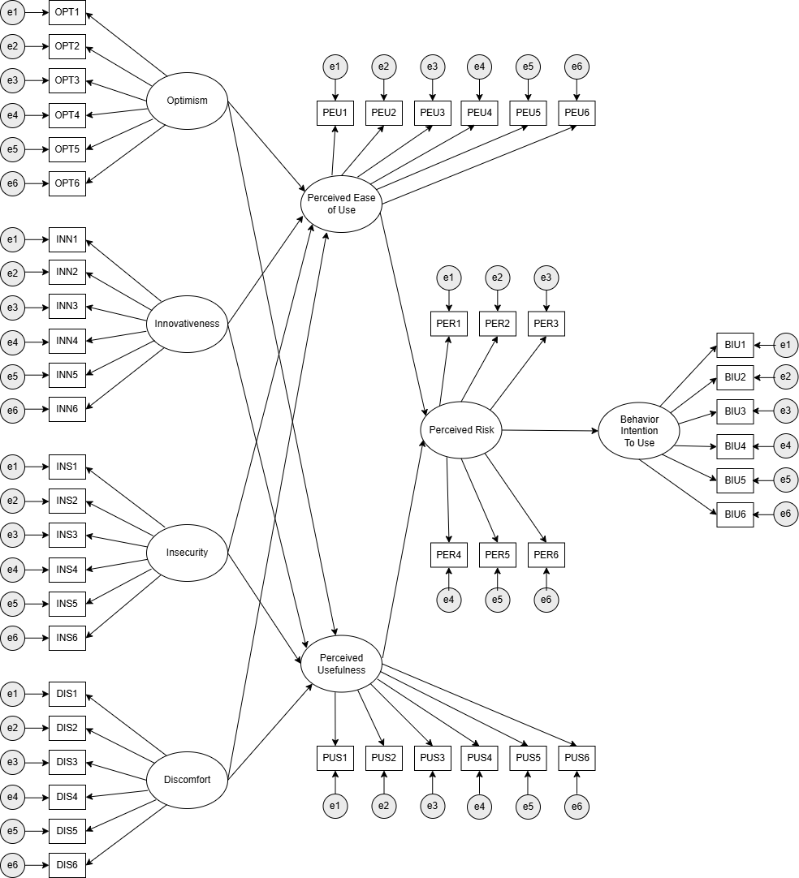

## Figure 2. Proposed structural equation model of the Technology Readiness and Acceptance Model (TRAM) in Analyzing to Adopt Cryptocurrency

**ETHICS CONSIDERATION**

This study adheres to strict ethical standards to ensure the protection and respect of all participants while maintaining scientific integrity. The protocol for this research will be submitted to the University Ethics Review Committee of Visayas State University to adhere to ethical standards and guarantee that it will receive appropriate consideration and approval before conducting any data collection activities.

**Conflicts of Interest**

The researcher declares no financial, professional, or personal relationships that could be construed as a conflict of interest in conducting this study. The research is being undertaken solely for academic purposes as part of the requirements for Economics 200.4 at Visayas State University.

**Ethical Issues and Risk Identification**

The study presents minor, non-significant risks to participants that have been carefully identified. These minimal risks primarily relate to standard privacy and data security considerations when collecting survey responses and conducting focus group discussions. The time investment required for survey completion (10 minutes) and focus group discussions (1-2 hours for selected student entrepreneurs) represents a modest commitment from participants. For FGD participants, there is a minimal risk of discomfort in sharing views in a group setting. None of these aspects pose any meaningful concerns to participants' wellbeing or the integrity of the research process.

**Plans to Mitigate Anticipated Risks**

Although the identified risks are minimal, the study implements comprehensive measures to ensure data protection. The research protocol will be submitted to the University Ethics Review Committee of Visayas State University for approval before conducting any data collection activities. The study implements thorough security protocols and transparent data handling procedures. For focus group discussions, participants will be informed that while confidentiality will be encouraged among all participants, complete confidentiality cannot be guaranteed due to the group nature of the activity.

**Protection of Privacy and Confidentiality of Research Information**

In compliance with the Data Privacy Act of 2012 (RA 10173), all participant information will be treated with strict confidentiality. Participants' identities will be protected through anonymous identification codes instead of names. Data will be stored in password-protected files, with results reported only in aggregate form. Access to raw data will be restricted to the researcher and academic advisers. The study will utilize secure, encrypted Google Forms for survey distribution and Google Meet for online focus group discussions. All data will be immediately transferred to secured storage and deleted from collection platforms after transfer. Digital files, including FGD recordings, will be encrypted and regularly backed up in secure cloud storage, while physical documents will be stored in a secure location with strict access controls.

**Vulnerability of Research Participants**

While university students are not typically categorized as a vulnerable population, the researcher acknowledges potential minor vulnerabilities that require attention but do not pose significant risks. These include varying levels of financial literacy and differing degrees of technological understanding. For FGD participants, additional consideration will be given to ensuring comfort in group settings and maintaining professional discourse. These modest vulnerabilities are easily addressed through clear explanations and emphasis on voluntary participation, ensuring they do not impact the quality of participation or data collection.

**Management of Adverse Events**

Given the low-risk nature of the study, the primary focus of event management will be on maintaining data security and participant privacy. The study will implement a responsive approach to managing any privacy-related concerns that arise. The researcher will maintain open communication channels to address any issues that arise during the research process, though significant issues are not anticipated.

**Informed Consent**

Informed consent will be obtained at the beginning of both the survey process and focus group discussions. Participants will be provided with clear information about the study's purpose, procedures, privacy protocols, and benefits. The consent form will emphasize the voluntary nature of participation and the right to withdraw at any time. Participants will be informed about data handling procedures, confidentiality measures, and the time commitment (approximately 10 minutes for surveys and 1-2 hours for FGDs). No monetary compensation will be provided, and no financial obligations will be imposed at any stage of the research process. The consent form will require active acknowledgment before proceeding with either the survey or FGD participation.

**LITERATURE CITED**

Alalwan, A. A. (2020). Mobile food ordering apps: An empirical study of the factors affecting customer e-satisfaction and continued intention to reuse.

Alsyouf, Z. A. K., & Ku Ishak, M. N. I. B. (2017). Technology readiness and innovation among fine dining restaurant chefs in five-star hotels in Jordan. Journal of Culinary Science & Technology, 15(4), 336-353.

Antonopoulos, A. M. (2017). Mastering Bitcoin: Programming the open blockchain.

Awa, H. O., Ukoha, O., & Emecheta, B. C. (2022). Revisiting technology- organization- environment (TOE) theory for blockchain technology adoption. Journal of Enterprise Information Management.

Bangko Sentral ng Pilipinas. (2017). Circular No. 944.

Blockchain Council Philippines. (2023). Cryptocurrency adoption report.

Catalini, C., & Gans, J. S. (2018). Initial coin offerings and the value of crypto tokens.

Chicca, J., & Shellenbarger, T. (2018). Connecting with Generation Z: Approaches in nursing education.

Choi, B., et al. (2022). Understanding the role of technology in cryptocurrency adoption.

CoinMarketCap. (2024). Cryptocurrency market data.

Corbet, S., et al. (2019). Cryptocurrencies as a financial asset: A systematic analysis.

Davis, F. D. (1989). Perceived usefulness, perceived ease of use, and user acceptance of information technology.

Dela Cruz, M., & Tandoc, E. (2019). Digital financial technologies in the Philippines.

Eichengreen, B. (2021). From commodity to fiat and now to crypto: What does history tell us?

Finder Cryptocurrency Adoption Index. (2023). Global cryptocurrency adoption report.

Garcia, M., et al. (2024). Barriers and opportunities in cryptocurrency adoption.

Global Data. (2023). Cryptocurrency transaction analysis.

Gupta, H., Jenkins Jr, G. D., & Kizildag, M. (2021). Financial literacy and cryptocurrency adoption. The Quarterly Review of Economics and Finance, 80, 140-152.

Hair, J. F., Risher, J. J., Sarstedt, M., & Ringle, C. M. (2019). When to use and how to report the results of PLS-SEM. European business review.

Kim, Y., et al. (2019). Factors influencing cryptocurrency adoption among younger generations.

Lee, B., & Shin, H. (2021). Cryptocurrency adoption challenges and opportunities.

Lin, K. J., & Chang, R. (2020). User-centric design in cryptocurrency platforms.

Martinez, A., & Lee, S. (2024). Policy implications for cryptocurrency adoption.

Nakamoto, S. (2008). Bitcoin: A peer-to-peer electronic cash system.

Namahoot, K. S., & Laohavichien, T. (2021). Using the technology acceptance model in understanding consumers’ behavioral intention to use digital currency: A case study in Thailand. Psychology and Education Journal, 58(1), 4382-4390.

Parasuraman, A. (2000). Technology readiness index (TRI) a multiple-item scale to measure readiness to embrace new technologies. Journal of service research, 2(4), 307-320.

Parasuraman, A., & Colby, C. L. (2001). Techno-ready marketing: How and why your customers adopt technology. Simon and Schuster.

Philippine Social Media Insights. (2023). Generation Z technology attitudes.

Phonthanukitithaworn, C., Sellitto, C., & Fong, M. W. (2019). Intention to adopt blockchain for supply chain solutions: An investigation of Australian supply chain professionals. In Understanding developments in cybersecurity and cyberthreats (pp. 1-23). IGI Global.

Prensky, M. (2001). Digital natives, digital immigrants.

Raza, S. A., et al. (2021). Cryptocurrency adoption: A technology acceptance perspective.

Santos, J., & Cruz, M. (2023). Cryptocurrency trends in the Philippines.

Seemiller, C., & Grace, M. (2019). Generation Z: A century in the making.

Statista. (2023). Cryptocurrency market in the Philippines.

Svendsen, A., et al. (2013). Technology acceptance model extensions.

Swan, M. (2015). Blockchain: Blueprint for a new economy.

Tapscott, D., & Tapscott, A. (2016). Blockchain revolution: How the technology behind bitcoin is changing money, business, and the world.

Tsai, M. C., Chin, J. B., & Chen, C. W. (2021). Exploring consumers’ behavioral intention to adopt cryptocurrency: an empirical study integrating perceived risk, perceived benefits, and personal innovativeness. Journal of Risk and Financial Management, 14(8), 359.

Venkatesh, V., & Davis, F. D. (2000). A theoretical extension of the technology acceptance model.

Walczuch, R., Lemmink, J., & Streukens, S. (2007). The effect of service employees’ technology readiness on technology acceptance. Information & management, 44(2), 206-215.

World Bank. (2022). Digital currencies and financial inclusion report.

World Economic Forum. (2022). Cryptocurrencies and digital economies.

Yi, M.Y., Fiedler, K.D., & Park, J.S. (2003, December). Outsourcing flexibility, technology, and success relationship: A firm level analysis. In Proceedings of the Fifith International Conference on Electronic Commerce (pp. 291-300). Hawaii International Conference on Systems Sciences.

**APPENDICES**

**Appendix 1.** Survey Questionnaire



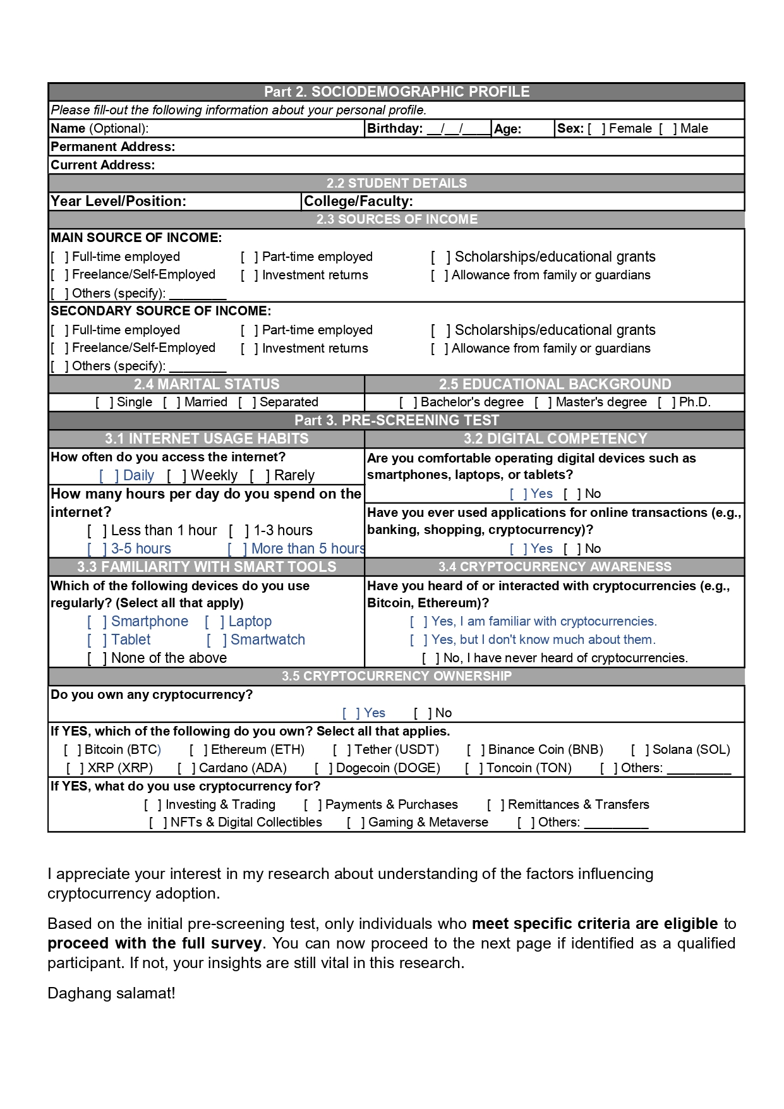





  
  
  
  
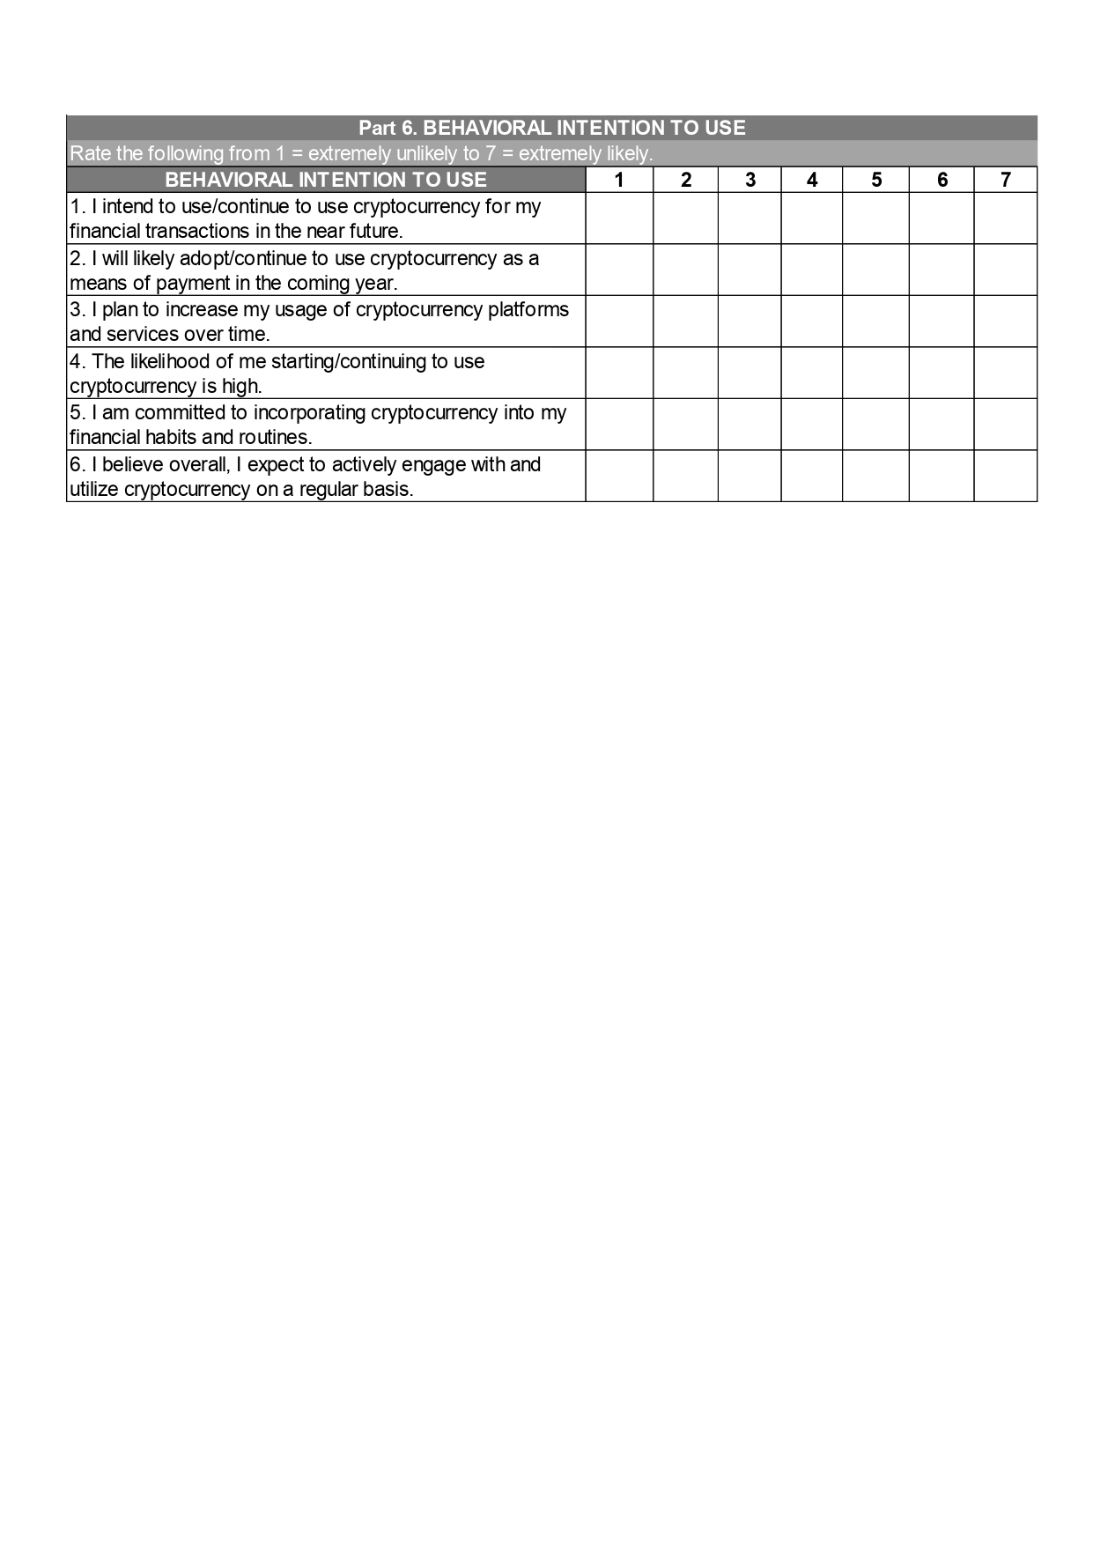

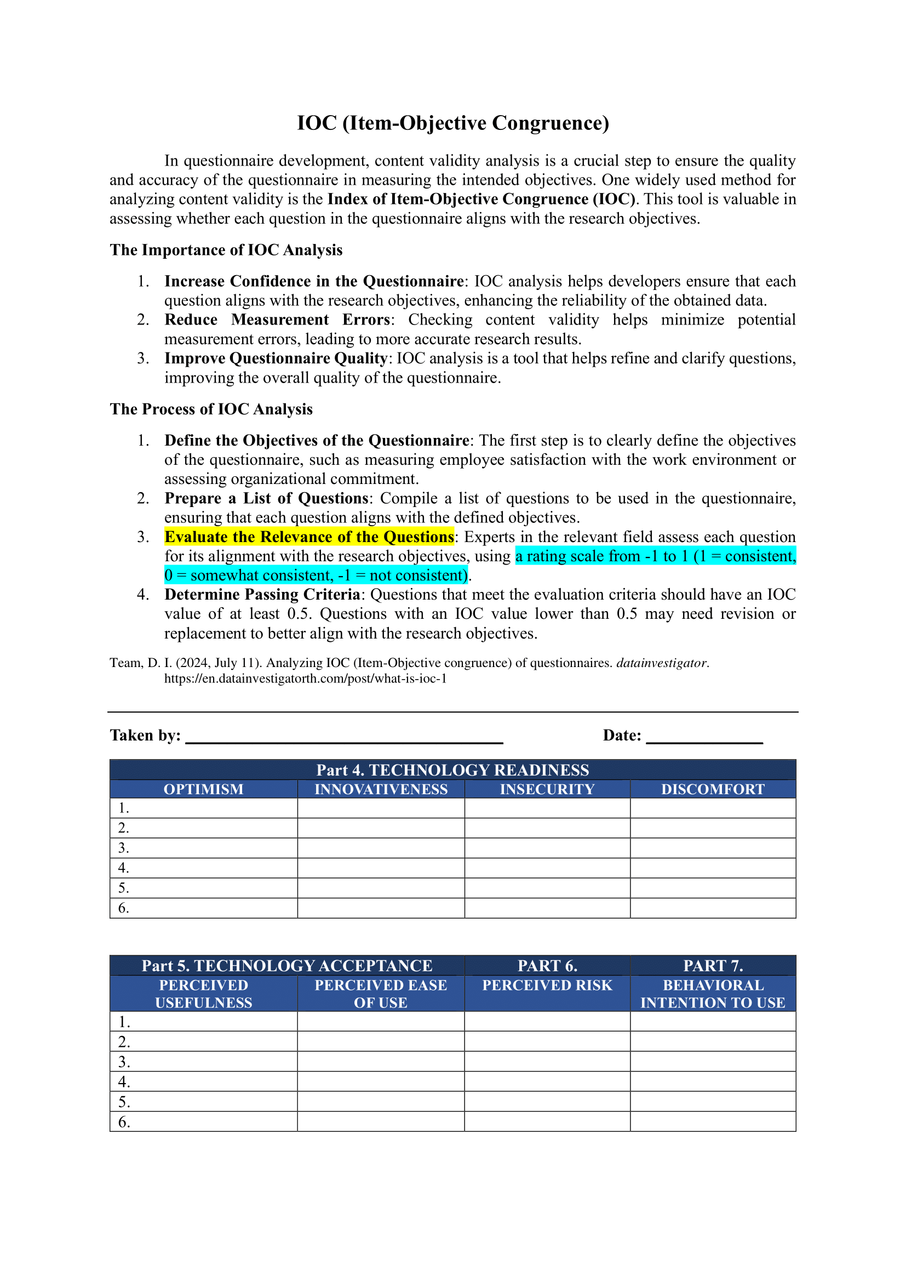**Appendix 2.** Item-Objective Congruence Test

**Appendix 3.** Experts’ Answers on Item-Objective Congruence Test

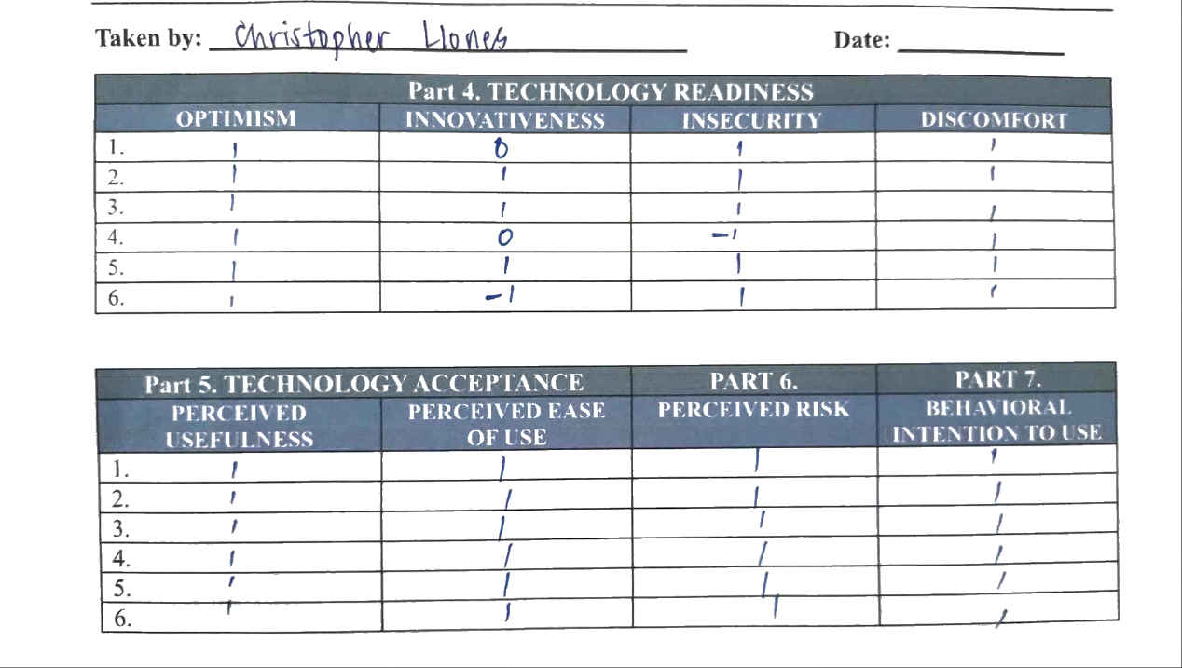

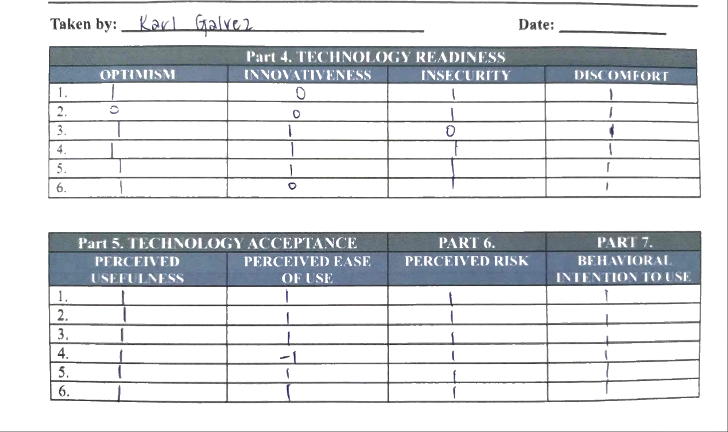

**Appendix 4.** Focus Group Discussion (FGD) Questions

**Focus Group Discussion (FGD) Questions**

**Opening/Introduction**

1. **Could you briefly introduce yourself and your business venture?**

* Follow-up: How long have you been in business?
* Probe: What made you start this business?

1. **What is your current involvement with cryptocurrency?**

* ***For owners:*** How long have you been investing?
* ***For non-owners:*** What's your general view of cryptocurrency?
* Probe: What influenced your decision to invest/not invest?

**Knowledge and Experience**

1. **How did you first learn about cryptocurrency?**

* Where do you get information about cryptocurrency?
* What resources helped you understand it better?
* Probe: How reliable do you find these information sources?

1. **For owners:** Could you walk us through your cryptocurrency journey?

* What platforms do you use?
* How did you choose these platforms?
* What challenges have you faced?

**For non-owners:** What factors have kept you from investing?

* What would convince you to start?
* What concerns you most about cryptocurrency?
* What information would you need to feel more confident?

**Business Integration**

1. **How do you see cryptocurrency fitting into student businesses?**

* What specific benefits could it bring?
* What challenges might arise?
* How might it affect customer relationships?

1. **Could you describe your plans (if any) for cryptocurrency in your business?**

* What steps would you need to take?
* What resources would you require?
* What concerns would you need to address?

**Risks and Security**

1. **What are your main concerns about cryptocurrency adoption?**

* How do these concerns affect your business decisions?
* What security measures do you think are necessary?
* How do you/would you manage these risks?

**Future Perspectives**

1. **How do you envision cryptocurrency's role in student entrepreneurship?**

* What changes do you expect in the next few years?
* What opportunities do you see emerging?
* What challenges need to be addressed?

**Closing**

1. **What advice would you give to other student entrepreneurs about cryptocurrency?**

* What key lessons have you learned?
* What resources would you recommend?
* What warnings would you share?

1. **Is there anything else you'd like to add about cryptocurrency adoption from your perspective as a student entrepreneur?**