Project Proposal

Table of Contents
1 Problem Formulation 2
1.1 Overview 2
1.2 Why Deep Learning 2
1.3 Deep Learning Framing 2
1.4 Project Scope and Caveats 3
2 Dataset & Research 4
2.1 Dataset 4
2.2 Prior research 4
3 Method 9
4 Experiments & Evaluation Plan 10
4.1 Experimental Setup 10
4.2 Training and Validation 10
4.3 Evaluation Metrics 11
4.4 Intended Analyses 11
5 Application-based integration 12
5.1 Planned Features 12
5.2 Model Integration and Deployment 12
6 References 13

Problem Formulation

Overview
Social media marketing has become a critical channel for businesses to promote products and services, particularly through platforms such as Instagram. One key challenge is predicting which posts—whether created by the business itself or by partnered influencers—will generate high audience engagement. Marketing teams often rely on manual inspection of historical posts, captions, images, and engagement metrics, which is time-consuming, subjective, and difficult to scale across large numbers of posts or potential influencer partners.
This project addresses the business problem of predicting the engagement performance of Instagram posts using historical post data. Engagement is defined as the level of audience interaction a post receives, measured through likes and comments relative to follower count. By predicting engagement levels in advance, businesses can assess their own content or influencer posts, enabling more informed decisions in content planning and marketing campaigns while reducing risk and improving return on investment.

Why Deep Learning
Predicting Instagram post engagement is challenging because it involves heterogeneous data modalities, including images, text captions, and structured metadata such as follower counts and posting context (e.g. time, location). Human judgment alone is often subjective and labor-intensive, making it difficult to evaluate posts at scale.
Deep learning is well suited to this problem because it can automatically learn meaningful representations from unstructured data. Convolutional Neural Networks (CNNs) can capture visual patterns in post images, while Recurrent Neural Networks (RNNs) can model sequential and semantic patterns in captions. By combining these features with metadata, deep learning provides a scalable, data-driven approach to predict post engagement, reducing reliance on manual assessment and supporting businesses in making informed content decisions.

Deep Learning Framing
The problem is framed as a supervised deep learning classification task, where the objective is to predict a post’s engagement level as low, medium, or high. Inputs are multimodal: images, text captions, and structured metadata, making deep learning approaches particularly suitable for capturing complex, non-linear relationships across heterogeneous data sources. The output provides a quantitative assessment of potential engagement, which can inform content strategy and marketing decisions.

Project Scope and Caveats
To reduce the scope of this project, video posts are excluded from the analysis, even though videos are also a common form of content on Instagram. The role of video content in digital marketing may be better studied using platforms such as TikTok or YouTube, where short-form or long-form video is the primary medium and richer video-specific engagement signals are available.
It is also recognized that engagement and marketing outcomes depend on nuanced qualitative factors beyond quantitative metrics, such as brand relevance, audience perception, or influencer authenticity. These factors are difficult to reliably capture using the available dataset, which consists primarily of images, captions, and post-level metadata.
Despite these limitations, the model remains a decision-support tool rather than a fully automated system. By predicting post engagement, businesses can efficiently assess their own content or potential influencer posts, identify high-performing posts, and make informed marketing decisions without manually analyzing large numbers of posts.

Dataset & Research

Dataset
This project will use a publicly-available Instagram Posts dataset consisting of 1,968 photo posts, totaling 5,426 images (Kapadia, 2022). Each post includes:
- One or more image files (for carousel posts)
- A caption text file
- A compressed JSON metadata file containing post-level information
From this dataset, the following features may be extracted and used:
- Follower and following counts
- Posting timestamp
- Binary indicators for location presence, carousel posts, and sponsored content
- Images
- Caption text and hashtags
- Likes and comments, used to compute engagement rate
The dataset is suitable for this project because it contains real-world Instagram posts with both unstructured (images and text) and structured metadata, directly reflecting the information businesses use when evaluating influencer performance. However, the posts may not necessarily be from influencers.
Dataset Source: Instagram Posts dataset, Kaggle (Kapadia, 2022)
Another Instagram influencer dataset may be added on to this project if required (Kim et al. 2020): Instagram Influencer Dataset
This is a larger dataset containing 33,935 influencers with their 10,180,500 Instagram posts (300 posts per influencer). It also contains the following information: caption, usertags, hashtags, timestamp, sponsorship, likes, comments, etc, making it similar to the above dataset. This is also the dataset used in the research paper referenced in the next section.

Prior research
Kim, S., Jiang, J.-Y., Nakada, M., Han, J., & Wang, W. (2020). Multimodal Post Attentive Profiling for Influencer Marketing. In The Web Conference (WWW ’20), ACM. Link
Overview
This paper proposes a multimodal deep learning model that uses text and image information from social media posts to:
- Classify influencers into specific interests or topics (e.g., fashion, beauty).
- Classify their posts into certain categories.
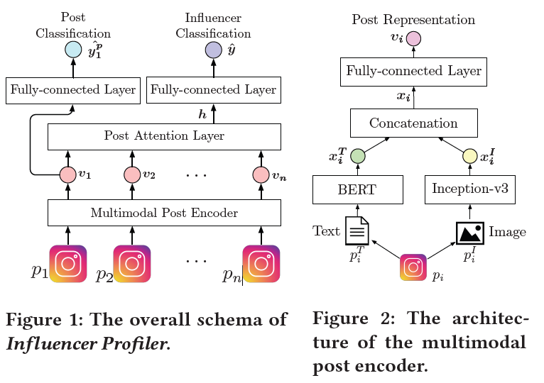
An attention mechanism is employed to prioritize relevant posts, enhancing the representation of influencers.
Methodology
The model processes social media posts, extracting features from both text (using BERT) and images (using Inception-v3).
Post representations are generated through a multimodal encoder, which combines text and image features. ​Next, the post attention layer takes post representations as an input and calculates a score for each post. The distribution of post scores is then used to output the influencer representation. Finally, the model predicts the category of a given influencer based on the influencer representation. The model also includes an auxiliary task for classifying individual posts into ten categories by learning the post representations.
Data collection and annotation
Data was collected from Instagram using the hashtag ‘#ad’ over 92 days. Influencers with fewer than 1,000 followers or 300 posts were filtered out, yielding a final dataset of 33,935 influencers. ​Finally, 300 recent posts of each influencer were downloaded, which includes image files, captions, hashtags, usertags, numbers of likes, associated comments, etc, obtaining 10,180,500 posts from 33,935 influencers.
Influencer categories were identified through topic modeling of their biographies, where influencers tend to introduce themselves. This resulted in eight major categories: beauty, family, fashion, fitness, food, interior, pet, and travel. ​
Posts were manually labeled into ten categories, which are the same categories of the eight influencer categories and two additional post categories including product and other. Posts that are not classified into any category, e.g., music, sports, arts, or humor posts, are labeled as other category.
Experimental setting
- Set learning-rate as 0.001 and dropout probability as 0.5.
- Heavy data augmentation to all images in the dataset by spatial rotation, spatial shifting, flipping, zooming, and channel shifting as a data preprocessing.
Baseline methods
- Four user profiling baseline methods that exploit different sets of input features, to understand the importance of proposed text and image embedding to represent an influencer:
  - Tag method uses tag information to classify social media users.
  - Text&Social method has four feature sets: social media profile, posting behavior, linguistic content, and social network features.
  - User method uses textual characteristics of captions, image features from profile pictures, and neighbor information based on like relationship.
  - Image method classifies users’ interest by using CNN based image classifier.
- Four model baselines that take the same input features as the proposed model, but use different machine learning approaches, to evaluate the novelty of the proposed model:
  - Gaussian Naive Bayes
  - K-Nearest Neighbours
  - SVC
  - Random Forest
Metrics used
F1 scores, Accuracy
Experimental Results
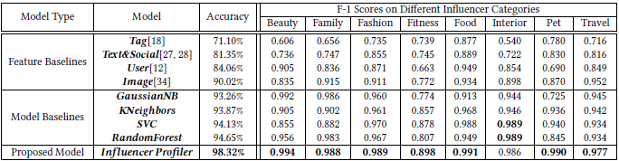
For Feature baselines:
- Tag method: poor performance
- Text&Social: improve overall classification accuracy but have poor F1 scores in specific influencer categories (e.g., fitness and pet).
- User: improve overall classification accuracy but have poor F1 scores in specific influencer categories (e.g., fitness and pet).
- Image: 90.02% accuracy and higher F1 scores than other baseline methods in the same category
This suggests that image information is more informative than other social media information for representing influencers’ interests.
For Model baselines:
The Model baselines show better classification performance than Feature baseline methods. This implies that the proposed input features play a significant role in classifying influencer categories.
The usage of attention scores to focus on more important posts that can represent influencers further increases the accuracy score.
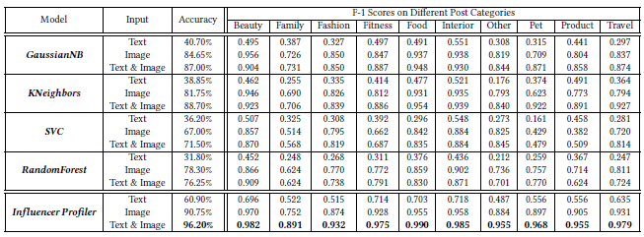
When comparing the Model baselines with three different input sets – only text, only image and both text and image, these were the findings:
- Image features are more useful than text features in identifying influencer categories, seen from the jump in Accuracy when using images instead of text
- Performance gain of using attention and fine-tuning
How this paper informs the project
Kim et al. (2020) demonstrate that influencer marketing tasks benefit from multimodal representation learning, where engagement-related signals are jointly extracted from post images and caption text. Their work provides strong empirical evidence that visual and textual modalities capture complementary aspects of audience response, motivating the core design decision in this project to use a CNN for image feature extraction and an RNN for caption modeling when predicting engagement outcomes.
While the paper focuses on influencer profiling and categorisation, this project reframes the problem as a classification task that assigns individual posts to low, medium, or high engagement categories.
In addition to learning from post images and caption text, this project extends prior work by incorporating readily available post-level metadata such as hashtags, temporal features derived from timestamps, and follower counts, enabling a richer and more deployable engagement classification model.
The paper demonstrates that unimodal baselines (text-only or image-only) underperform compared to multimodal models. This insight directly informs the evaluation strategy of this project, which includes explicit comparisons between:
- image-only models,
- text-only models, and
- multimodal models combining both modalities while also considering metadata
The paper also demonstrates that image information is more informative than other social media information, and are more useful than text features. Hence, these models will be evaluated in sequence, with image-only models as the main priority.
Finally, the paper employs an attention mechanism to dynamically assign different importance weights to learned visual and textual features, enabling selective emphasis on high-impact content rather than treating all features equally. While attention-based fusion is effective, this project will adopt a dense-layer fusion for simplicity and clarity of evaluation, with attention-based extensions left as future work.

Method
A multimodal deep learning architecture is proposed, combining separate networks for different data modalities:
- Image Encoder (CNN)
A Convolutional Neural Network is used to extract visual features from Instagram post images. CNNs are well suited for this task due to their ability to capture spatial and compositional patterns such as visual style, objects, and layout. A pretrained CNN is used as a feature extractor to leverage transfer learning and reduce overfitting given the dataset size.
- Text Encoder (RNN)
A Recurrent Neural Network processes the post captions as sequences of words. RNNs are chosen to capture sequential and contextual information in captions, including phrasing, sentiment, and hashtag usage. RNNs are chosen over bag-of-words representations because they preserve word order and context. Although transformer-based models could be applied, this project prioritises architectural interpretability and controlled multimodal comparison by adopting CNN and RNN encoders, which are sufficient to capture the key engagement-related patterns in the data.
- Metadata Encoder
Structured metadata (e.g., follower count, posting time features, post format flags) is processed through fully connected layers.
The outputs of the three components are concatenated and passed through dense layers for final engagement classification. This late-fusion design enables each modality to contribute independently and supports clear comparison against unimodal baselines.
This architecture is chosen because engagement on Instagram is influenced by the interaction between visual appearance, textual messaging, and posting context. CNNs and RNNs are capable of learning representations directly from raw images and text, reducing the need for manual feature engineering. Compared to traditional machine learning approaches, deep learning is better suited to modeling the complex and subjective nature of audience engagement. Compared to using only a single modality, the multimodal approach allows the model to leverage complementary information from images, captions, and metadata.

Experiments & Evaluation Plan

Experimental Setup
The goal is to evaluate the effectiveness of the proposed multimodal architecture in classifying Instagram posts into low, medium, or high engagement categories.
Data preparation
- Chronological split by timestamp: Posts are sorted by ‘publish_timestamp’, with the oldest 70% for training, the next 15% for validation, and the most recent 15% for testing. This mimics real-world usage, where engagement predictions are made for future posts, and prevents temporal leakage.
- Preprocessing:
  - Metadata features (follower count, temporal features, post format flags) are normalized.
  - Captions are tokenized and optionally embedded with pretrained word vectors.
  - Images are resized and normalized.
Model variants (ablation study)
To manage project complexity and ensure reliable model development within the given timeframe, the work will be conducted in a progressive and incremental manner. Initial experiments will focus on single-modality models, starting with image-based prediction using a Convolutional Neural Network (CNN), since prior research shows that images are more essential than text at improving model performance for this purpose. Subsequently, if time and resources permit, the project will extend to a multimodal architecture that combines both CNN- and RNN-derived features.
- Image-only CNN – Uses a pretrained ResNet-50 to extract visual features from post images
- Text-only RNN – Uses a GRU-based encoder to model caption text
- Metadata-only dense model – Uses fully connected layers to model structured metadata
- Multimodal CNN + RNN + metadata fusion – Full proposed model
This ablation allows quantification of each modality’s contribution to engagement classification. It also ensures that meaningful results can be obtained even if full multimodal integration is not achieved, while maintaining a clear path toward a more comprehensive solution.

Training and Validation
- Loss function: Categorical cross-entropy, suitable for multi-class engagement level classification.
- Optimizer: Adam with a fixed learning rate, treated as a tunable hyperparameter.
- Early stopping: Applied based on validation loss to prevent overfitting.
- Hyperparameter tuning: Parameters such as learning rate, number of RNN units (hidden size), number of CNN layers frozen or fine-tuned, dropout rate, and dense layer sizes.

Evaluation Metrics
This project adopts Accuracy and macro-averaged F1-score as the primary evaluation metrics, following the methodology in Kim et al. (2020).
- Accuracy measures the overall proportion of correctly classified posts, providing a simple and interpretable baseline.
- Macro-averaged F1-score computes the F1-score for each engagement category (low, medium, high) and averages them equally. This ensures that all classes are evaluated fairly, preventing dominant classes from skewing results and providing a balanced assessment for potentially imbalanced engagement categories.
By using these metrics, the evaluation is both comparable to prior research and sufficient to capture performance across all engagement levels. Optionally, per-class F1 or a confusion matrix can be reported to provide additional insight into class-specific strengths and weaknesses.

Intended Analyses
- Unimodal vs multimodal comparison: Quantify gains from combining images, captions, and metadata.
- Feature importance inspection: Examine metadata and textual contributions to engagement predictions.
- Temporal analysis: Explore how posting time affects model performance using features derived from timestamps.

Application-based integration

Planned Features
The project supports businesses in making data-driven marketing decisions by predicting the likely engagement level (low / medium / high) of Instagram posts. This enables businesses to assess both their own posts and potential influencer posts before publishing.
Core feature:
- Post Engagement Estimation
  - Input: an Instagram post’s image, caption, and metadata, including follower count and posting context (timestamp, day of week, hour, location).
  - Output: predicted engagement category with confidence scores.
  - Purpose: helps businesses anticipate which posts are likely to generate higher engagement, guiding content planning and scheduling.
Optional / future insights:
- Patterns in hashtags, posting times, or post formats that correlate with higher engagement could inform campaign strategy, but are not implemented in this project.

Model Integration and Deployment
- The trained multimodal CNN + RNN + metadata model will be deployed as a simple web application using Gradio or Streamlit.
- Businesses input images, captions, and metadata; the system returns predicted engagement levels.

References
Kim, S., Jiang, J.-Y., Nakada, M., Han, J., & Wang, W. (2020). Multimodal post attentive profiling for influencer marketing. In Proceedings of The Web Conference 2020 (pp. 2878–2884). ACM. https://jyunyu.csie.org/docs/pubs/www2020influencer_paper.pdf
Kapadia, H. (2022). Instagram Posts Dataset [Data set]. Kaggle. https://www.kaggle.com/datasets/thecoderenroute/instagram-posts-dataset

