Mysql * postgresql * sql-server

MySQL (prononcer [maj.ɛs.ky.ɛl]) est un système de gestion de bases de données relationnelles (SGBDR). Il est distribué sous une double licence GPL et propriétaire. Il fait partie des logiciels de gestion de base de données les plus utilisés au monde³, autant par le grand public (applications web principalement) que par des professionnels, en concurrence avec Oracle, PostgreSQL et Microsoft SQL Server.
PostgreSQL est un système de gestion de base de données relationnelle et objet (SGBDRO). C'est un outil libre disponible selon les termes d'une licence de type BSD.
Ce système est comparable à d'autres systèmes de gestion de base de données, qu'ils soient libres (comme MariaDB et Firebird), ou propriétaires (comme Oracle, MySQL, Sybase, DB2, Informix et Microsoft SQL Server). Comme les projets libres Apache et Linux, PostgreSQL n'est pas contrôlé par une seule entreprise, mais est fondé sur une communauté mondiale de développeurs et d'entreprises.
Microsoft SQL Server est un système de gestion de base de données (SGBD) en langage SQL incorporant entre autres un SGBDR (SGBD relationnel ») développé et commercialisé par la société Microsoft. Il fonctionne sous les OS Windows et Linux (depuis mars 2016), mais il est possible de le lancer sur Mac OS via Docker, car il en existe une version en téléchargement sur le site de Microsoft².

Différences :

MS SQL Server | MySQL
Developed by Microsoft. | Developed by Oracle.
It supports programming languages like C++, JAVA, Ruby, Visual Basic, Delphi, R etc. | MySQL offers extended running support for languages like Perl, Tcl, Haskey etc.
Expects a large amount of operational storage space. | Expects less amount of operational storage space.
It enables for stopping query execution. | It doesn’t allow query cancellation mid-way in the process.
Doesn’t block the database while backing up the data. | Blocks the database while backing up  the data.
It is not free. | It is open source. It is freely available.
It is a highly secured and doesn’t allow any kind of database file manipulation while running. | It allows database file manipulation  while running.
It is available in multiple editions, such as Enterprise, Standard, Web, Workgroup, or Express. | It is available in MySQL Standard  Edition, MySQL Enterprise Edition,  and MySQL  Cluster Grade Edition.

Side-by-side Comparison of SQL Tools
In this comparison, we’ll take a look at the functionality of the three most popular SQL databases, examine their use cases, respective advantages, and disadvantages. Firstly, we’ll start by exploring the in-depth functionality.

Data Changes
Here we evaluate the ease that the data can be modified with and the database defragmented. The key priority is the systems’ flexibility, security, and usability.
Row updates
This criterion refers to the algorithms that a database uses to update its contents, speed, and efficiency.
In the MySQL case, a solution updates data automatically to the rollback storage. If something goes wrong, developers can always go back to the previous version.
PostgreSQL: developers insert a new column and row in order to update the database. All updated rows have unique IDs. This multiplies the number of columns and rows and increases the size of the database, but in turn, developers benefit from higher readability.
SQL Server: the database has three engines that are responsible for row updates. The ROW Store handles the information on all previous row updates, IDs, and modified content. The in-memory engine allows analyzing the quality of an updated database with a garbage collector. The column-store database lets store updates in columns, like in column-driven databases.
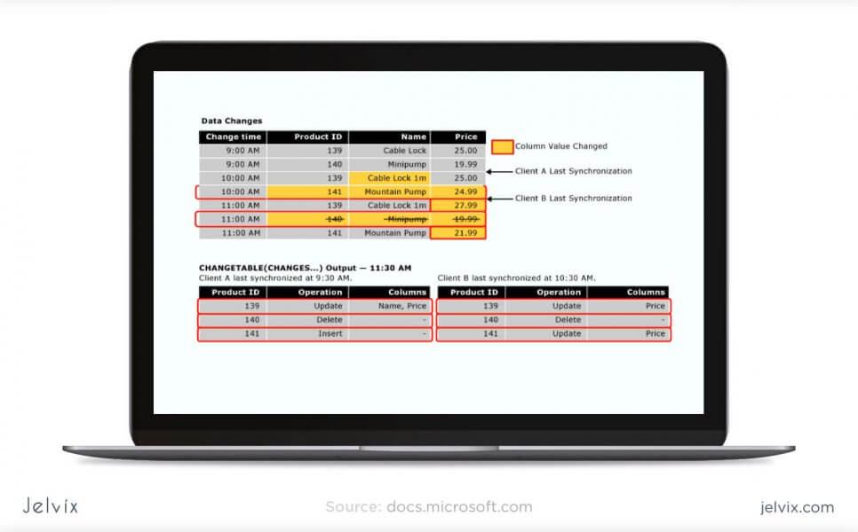
Among these three, SQL Server offers perhaps the most flexibility and efficiency, because it allows monitoring updated rows and columns, collecting errors, and automating the process. The difference between SQL Server and MySQL and Postgresql lies mainly in customizing the positions – SQL Server offers a lot more than others.

Defragmentation
When developers update different parts of an SQL database, the changes occur at different points of the systems and can be hard to read, track, and manage. Therefore, maintenance should include defragmentation – the process of unifying the updated database by assigning indexes, revisiting the structure, and creating new pages. The database frees up the disk space that is not used properly so that a database can run faster.
MySQL offers several approaches to defragmentation – during backup, index creation, and with an OPTIMIZE Table command. Without going into much detail, we’ll just say that having that many options for table maintenance is convenient for developers, and it surely saves a lot of time.
PostgreSQL allows scanning the entire tables of a data layer to find empty rows and delete the unnecessary elements. By doing so, the system frees up the disk space. However, the method requires a lot of CPU and can affect the application’s performance.
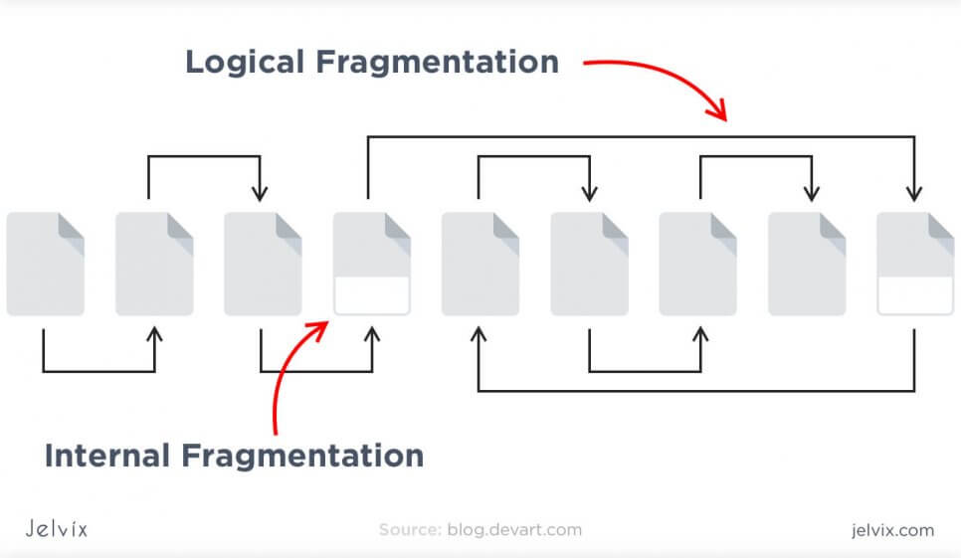
SQL Server offers an efficient garbage collector that doesn’t create more than 15-20% of overhead. Technically, developers can even run garbage collector on a continuous basis, because it’s that efficient.
Overall, MySQL and SQL Server offer more of defragmentation methods that Postgresql does. They consume less CPU and provide more flexible settings.

Data Queries
Here, we take a look at how the systems cache and process user requests, what approaches they take in storing data, and how developers can manage it.

Buffer Pool
Some systems call a buffer to pull cache, but regardless of terminology, our goal is to summarize the algorithms that systems use to process user queries and maintain connections.
MySQL offers a scalable buffer pool – developers can set up the size of the cache according to the workload. If the goal is to save CPU and storage space, developers can put strict benchmarks on their buffer pool. Moreover, MySQL allows dividing cache by segments to store different data types and maximize isolation.
PostgreSQL isolates processes even further than MySQL by treating them as a separate OS process. Each database has a separate memory and runs its own process. On the one hand, management and monitoring become a lot easier, but on the other, scaling multiple databases takes a lot of time and computing resources.
SQL Server also uses a buffer pool, and just like in MySQL, it can be limited or increased according to processing needs. All the work is done in a single pool, with no multiple pages, like in Postgresql.
If your priority is to save computing resources and storage, choose flexible solutions: the choice will be between MySQL vs SQL Server. However, if you prefer clear organization and long-term order, Postgre, with its isolated approach, might be a better fit.

Temporary Tables
Temporary tables allow storing intermediate results from complex procedures and branched business logic. If you need some information only to power the next process, it doesn’t make sense to store it in a regular table. Temporary tables improve database performance and organization by separating intermediary data from the essential information.
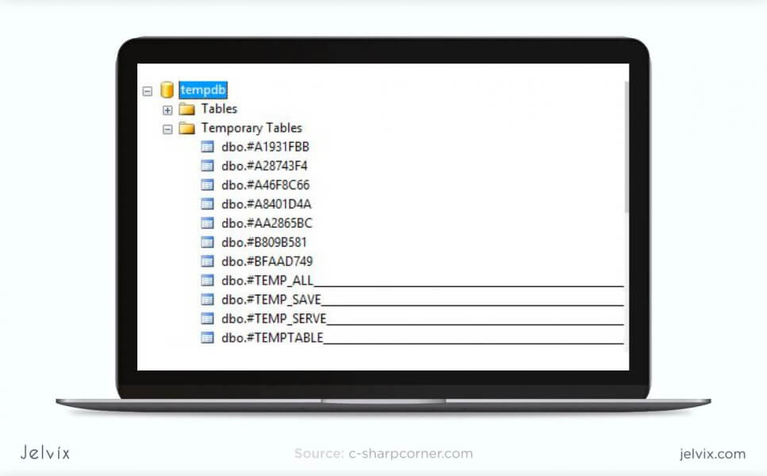
MySQL offers limited functionality for temporary tables. Developers cannot set variables or create global templates. The software even limits the number of times that a temporary table can be referred to – not more than once.
Postgresql offers a lot more functionality when it comes to temporary content. You divide temporary tables into local and global and configure them with flexible variables.
SQL Server also offers rich functionality for temporary table management. You can create local and global temporary tables, as well as oversee and create variables.
Temporary tables are essential for applications with complicated business logic. If your software runs a lot of complex processes, you will need to store multiple intermediary results. Having rich customization functionality will often be necessary throughout the development process.

