

REPORT
OF

MINOR PROJECT
ON

"CARGO X — Global Logistics & Mobility Platform"

SUBMITTED IN PARTIAL FULFILLMENT OF THE DEGREE OF
BACHELOR OF TECHNOLOGY IN

Computer Science and Engineering

Submitted By:
CHERIKA KAUSHAL
12301126

DEPARTMENT OF COMPUTER SCIENCE & ENGINEERING
PUNJABI UNIVERSITY
PATIALA — 147002

CONTENTS

Topic | Page No.
Candidate's Declaration | iii
Abstract | iv
Acknowledgement | v
Chapter 1 — Introduction to Project | 6 – 16
1.1 Background of the Topic | 6
1.2 Introduction to Next.js & React | 7 – 9
1.3 Evolution of Next.js | 9 – 10
1.4 Technology Stack Overview | 10 – 12
1.5 Tools & Technologies Used | 12 – 14
1.6 Working of Mock API Architecture | 14 – 15
1.7 UI/UX Design Approach | 15 – 16
1.8 Advantages of the Tech Stack | 16
Chapter 2 — Project Work Undertaken | 17 – 24
2.1 Project Overview | 17
2.2 Methodology and Development Model | 18 – 19
2.3 System Architecture & Data Flow | 19 – 20
2.4 Modules & Functionalities Implemented | 20 – 22
2.5 System Design (UI & User Flow) | 22 – 23
2.6 Testing & Validation | 23 – 24
2.7 Challenges Faced & Solutions | 24
Chapter 3 — Results & Discussion | 25 – 32
3.1 Overview of Results | 25
3.2 Discussion of Key Functionalities | 25 – 27
3.3 Screenshots & Demonstrations | 27 – 31
3.4 Performance & Testing Results | 31 – 32
3.5 Discussion & Observations | 32
Chapter 4 — Conclusion & Future Scope | 33 – 35
4.1 Conclusion | 33 – 34
4.2 Future Scope | 34 – 35
References | 36

CANDIDATE'S DECLARATION

I, Cherika Kaushal, hereby declare that I have undertaken the Minor Project at Punjabi University, Patiala during the 6th Semester, in partial fulfillment of the requirements for the award of the degree of B.Tech (Computer Science & Engineering).

The work presented in this project report, submitted to the Department of Computer Science & Engineering, Punjabi University, Patiala, is an authentic record of the project work carried out by me under the title "CARGO X — Global Logistics & Mobility Platform." The content of this report has not been submitted for the award of any other degree or diploma.

Signature of the Student: _______________________

Name: Cherika Kaushal
Roll No.: 12301126
Date: _______________

Signature of the Examiner: _______________________

The Minor Project Viva-Voce Examination of _________________ has been held on _________________ and accepted.

ABSTRACT

CARGO X is a modern, frontend-based logistics and mobility platform developed using Next.js, React, TypeScript, and CSS Modules as part of a university minor project. The primary objective of this project is to simulate a full-scale global logistics operating system that integrates multiple transport services — including road cargo, air freight, ocean shipping, and cab-based urban mobility — within a single, cohesive web interface.

The platform replicates the operational feel of an enterprise logistics SaaS product. Users can interact with a multi-step cargo booking flow, select vehicles and shipping modes, obtain dynamic price estimates, and track shipments through an animated timeline interface. A dedicated cab module supports India-specific transport options including Bike, Scooty, Auto, and Cab, catering to the hyperlocal mobility market. Each module uses mock API responses and localStorage for data persistence, effectively simulating a live backend without requiring server infrastructure.

Key technical concepts implemented throughout the project include component-based architecture with Next.js App Router, state management via React hooks, dynamic routing, TypeScript type safety, CSS Modules for scoped styling, mock API simulation using setTimeout-based delays, and client-side data persistence using localStorage. The analytics dashboard presents visualized KPIs including shipment volume trends, revenue by route, cargo type distribution, and on-time delivery rates using custom SVG-rendered charts.

A notable distinguishing feature of CARGO X is the AI Parrot Assistant — a floating conversational interface that provides contextual updates, ETA notifications, and route suggestions in real time. The platform also incorporates a persistent light/dark mode theming system, a fully responsive layout optimized for both mobile and desktop, and a simulated payment checkout supporting UPI, card, and wallet methods.

Overall, CARGO X demonstrates how Next.js and React can be employed to build a visually premium, functionally rich, and architecturally scalable logistics simulation platform. The project reflects a thorough understanding of frontend engineering principles, UI/UX design, state management, data visualization, and practical application design — fulfilling all objectives set for this minor project.

ACKNOWLEDGEMENT

I express my sincere gratitude to the Department of Computer Science & Engineering, Punjabi University, Patiala, for providing me with the opportunity to undertake this minor project titled "CARGO X — Global Logistics & Mobility Platform." This project allowed me to apply and enhance my technical knowledge in modern full-stack web development, UI/UX engineering, component-based architecture, and frontend simulation of real-world logistics systems.

Although the project was developed independently, I am thankful for the academic environment, structured curriculum, and resources provided by the department throughout this semester. I am equally grateful to all faculty members whose teachings on web technologies, system design, and software engineering played an important role in shaping the technical skills required to complete this project.

I would like to acknowledge the invaluable help offered by official documentation from Next.js, React, TypeScript, and Vercel, as well as the broader open-source development community. These resources were instrumental in addressing challenges related to component hydration, CSS module scoping, mock API architecture, dark mode theming, and chart rendering without external libraries.

I extend heartfelt thanks to my classmates and peers for their encouragement and constructive feedback during testing and development. Their support contributed to the refinement of both the visual design and the functional reliability of this platform.

I am grateful to everyone who contributed directly or indirectly to the successful completion of CARGO X.

Cherika Kaushal
Roll No.: 12301126
B.Tech CSE — 6th Semester
Punjabi University, Patiala

CHAPTER – 1

INTRODUCTION TO PROJECT

1.1 BACKGROUND OF THE TOPIC

Logistics and mobility represent two of the most economically critical sectors in the modern world. The global logistics market is valued at over USD 9 trillion and encompasses the movement of goods across roads, railways, airways, and sea routes. Simultaneously, urban mobility has undergone a significant transformation, with technology-driven cab aggregators and hyperlocal delivery platforms reshaping how people and goods move within cities.

India, in particular, presents a unique logistics challenge. With a vast and diverse geography, a complex multi-modal transport network, and a rapidly growing e-commerce industry, Indian businesses require intelligent, unified platforms capable of managing both intercity freight and last-mile urban delivery simultaneously.

Traditional logistics software has historically been fragmented — separate tools for freight booking, driver assignment, shipment tracking, and cost analytics. This fragmentation increases operational overhead and reduces visibility across the supply chain. There is a clear need for platforms that unify these functions under a single, intelligent interface.

CARGO X was developed to simulate and demonstrate exactly such a unified logistics operating system. The platform combines:

- Intercity cargo booking (truck, air freight, ocean shipping)
- Urban cab and delivery services (bike, scooty, auto, cab)
- Real-time shipment tracking with animated milestone timelines
- A comprehensive user dashboard with activity management
- An analytics module with data visualizations and KPI tracking
- AI-assisted interaction through a floating conversational assistant
- Simulated payment processing with UPI, card, and wallet flows

The project is built entirely as a frontend simulation using Next.js and React, with mock APIs and localStorage replacing actual backend services. This architectural choice ensures that the platform can be evaluated, presented, and deployed without server infrastructure, while still demonstrating the full scope of a production-grade logistics application.

1.2 INTRODUCTION TO NEXT.JS & REACT FRAMEWORK

What is Next.js?

Next.js is a production-grade web framework built on top of React, developed and maintained by Vercel. It extends React with features specifically designed for building scalable, high-performance web applications, including server-side rendering (SSR), static site generation (SSG), and the App Router architecture introduced in version 13.

Key capabilities of Next.js that are relevant to CARGO X include:
- App Router — file-based routing system with nested layouts and server components
- TypeScript support — built-in type checking with zero configuration
- API Routes — server-side endpoint handlers within the same project
- CSS Modules — scoped, collision-safe component-level styling
- Optimized rendering — automatic code splitting and lazy loading
- Vercel deployment — one-click deployment with CDN distribution

What is React?

React is a declarative JavaScript library for building user interfaces, maintained by Meta (formerly Facebook). React's component-based model allows complex UIs to be composed from small, reusable, independently maintained building blocks. React uses a Virtual DOM to compute and apply only the minimal set of changes required to update the interface, making it highly efficient for interactive, data-driven applications.

Core React concepts used in CARGO X include:
- Functional Components — clean, hook-based component structure
- useState & useEffect Hooks — state management and lifecycle logic
- Context API — global theme state for light/dark mode persistence
- Dynamic rendering — conditional UI states based on booking progress

Why Next.js Was Selected for CARGO X

CARGO X required a framework capable of supporting:
- Multiple distinct pages — Home, Booking, Tracking, Dashboard, Analytics, Auth, Payment
- Persistent global state — theme preference across all pages
- Component reusability — cards, tables, charts, modals
- Async simulation — loading states and delayed API mock responses
- CSS Modules — isolated styles per component without global conflicts

Next.js provided all of these requirements with minimal configuration overhead, making it the ideal framework choice for this project.

1.3 EVOLUTION OF NEXT.JS

Next.js has undergone significant development since its introduction in 2016. Understanding its evolution provides context for the architectural decisions made in CARGO X.

Version / Year | Key Development
Next.js 1 (2016) | Initial release — server-rendered React with file-based routing
Next.js 9 (2019) | API Routes introduced — enabling serverless backend in the same codebase
Next.js 10 (2020) | Image optimization, internationalization, and Commerce starter kits
Next.js 13 (2022) | App Router architecture, React Server Components, Layouts support
Next.js 14 (2023) | Stable App Router, Partial Prerendering, Server Actions
Next.js 15 (2024) | React 19 integration, enhanced performance, improved caching system

CARGO X was developed targeting Next.js 14 with the App Router. This version provides the most modern and stable architecture for component-based applications requiring both client and server rendering capabilities.

1.4 TECHNOLOGY STACK OVERVIEW

CARGO X employs a modern, multi-layered frontend technology stack selected for performance, type safety, developer experience, and visual quality.

1.4.1 Frontend Framework — Next.js + React
- Multi-page application with App Router
- Component architecture for booking flows, dashboards, and tracking UI
- Dynamic routing for pages: /, /booking, /tracking, /dashboard, /analytics, /auth, /payment

1.4.2 Language — TypeScript
- Strict type definitions for shipment data structures, booking forms, and API responses
- Interface definitions ensuring consistent data shapes across all modules
- Compile-time error prevention for form validation and state management

1.4.3 Styling — CSS Modules
- Component-scoped CSS eliminating global style conflicts
- CSS custom properties (variables) for theme-aware design tokens
- Responsive layouts using CSS Grid and Flexbox without external frameworks

1.4.4 Mock API Layer
- setTimeout-based async simulation for realistic loading states
- JSON data structures for shipments, users, routes, and analytics
- localStorage for session-level data persistence across page navigation

1.4.5 Deployment — Vercel
- Continuous deployment from GitHub repository
- Automatic CDN distribution and edge caching
- Live production URL: https://cargox-nu.vercel.app/

1.5 TOOLS & TECHNOLOGIES USED

1.5.1 Visual Studio Code
Visual Studio Code served as the primary integrated development environment throughout the project. Its built-in TypeScript language server, ESLint integration for code quality, Prettier for automated formatting, and integrated terminal accelerated development and reduced context switching.

1.5.2 Next.js (App Router)
Next.js with the App Router architecture formed the core of the project. The file-based routing system organized pages into a logical structure. Shared layouts enabled the navigation header and AI assistant to persist across all pages without re-rendering.

1.5.3 TypeScript
TypeScript provided static type checking throughout the codebase. Custom interfaces were defined for all primary data entities including Shipment, BookingForm, TrackingEvent, AnalyticsKPI, and Driver. This prevented category errors during development and improved IDE autocomplete accuracy significantly.

1.5.4 CSS Modules
Each component in CARGO X has an associated .module.css file providing scoped styles. The global stylesheet defines CSS custom properties for all design tokens — colors, spacing, typography, and border radii — which update automatically when the theme changes between light and dark mode.

1.5.5 LocalStorage API
Browser localStorage was used for session-level data persistence, including saved theme preference, booking history, and tracking session state. This allowed the application to maintain a consistent user experience across page refreshes without requiring a backend.

1.5.6 Framer Motion
Framer Motion provided smooth animation support for page transitions, modal entrances, card hover effects, and the animated logistics network on the homepage. Its declarative API integrates cleanly with React component lifecycle events.

1.5.7 Git & GitHub
Git was used for version control throughout the development process. Regular commits with descriptive messages documented the progression from initial scaffold to production deployment. The repository was hosted on GitHub for collaboration and deployment pipeline integration.

1.5.8 Vercel
Vercel was used for deployment. The platform automatically builds and deploys the Next.js application on every push to the main branch, providing a live, accessible URL for demonstration and evaluation purposes.

1.6 WORKING OF MOCK API ARCHITECTURE

Since CARGO X is a frontend-only application, all data operations are handled through a carefully designed mock API layer. This layer simulates the behavior of a real backend without requiring server infrastructure or database connectivity.

The mock API architecture operates as follows:
- Data Definition — All application data (shipments, cities, drivers, pricing) is defined as TypeScript constants and interfaces in /data/mockData.ts.
- Service Functions — Utility functions in /utils/helpers.ts provide operations such as price calculation, tracking ID generation, and driver assignment.
- Async Simulation — setTimeout wrappers with 800–2000ms delays simulate realistic server response times, enabling proper loading state UI display.
- localStorage Persistence — Booking confirmations, theme preferences, and session data are stored in the browser's localStorage, providing persistence across page refreshes.
- State Management — React's useState and useEffect hooks manage all application state, including form inputs, multi-step booking progress, and real-time tracking simulation.

This architecture is designed to be fully replaceable by a real backend. Each mock service function mirrors the interface a real API endpoint would expose, meaning backend integration requires only replacing the setTimeout-based functions with actual fetch calls.

1.7 UI/UX DESIGN APPROACH

The user interface of CARGO X was designed to reflect the visual language of enterprise logistics and SaaS platforms. The design approach was informed by reference to established platforms including Maersk, Porter, and Uber Freight.

Core design principles applied throughout the project include:
- Dark-first theming — The default interface uses a deep navy color palette with electric teal accents, creating a premium, data-centric aesthetic consistent with enterprise software.
- Information hierarchy — Typography uses Syne for display headings and DM Sans for body content, establishing a clear visual hierarchy that guides the user's attention to primary actions.
- Glassmorphism panels — Semi-transparent panels with backdrop blur create depth and layering without sacrificing readability.
- Micro-interactions — Hover effects on cards and buttons, animated status indicators, and smooth transition states provide continuous feedback and improve perceived performance.
- Responsive grid system — CSS Grid with adaptive breakpoints ensures full usability across desktop, tablet, and mobile screen sizes.
- Accessible contrast ratios — Text and interactive elements maintain WCAG-compliant contrast ratios in both light and dark themes.

1.8 ADVANTAGES OF THE TECHNOLOGY STACK

Technology | Advantage in CARGO X
Next.js App Router | Clean multi-page routing with shared layouts and server components
TypeScript | Compile-time safety, better IDE support, and maintainable codebase
CSS Modules | Zero class name conflicts, theme-aware styling, no external CSS dependencies
React Hooks | Clean functional component architecture for complex state management
localStorage | Session persistence without backend, suitable for frontend demo
Framer Motion | Production-quality animations with minimal code overhead
Vercel | Zero-configuration deployment with automatic CI/CD pipeline

CHAPTER – 2

PROJECT WORK UNDERTAKEN

2.1 PROJECT OVERVIEW

CARGO X is a full-featured logistics and mobility platform simulation built using Next.js, React, and TypeScript. The project was undertaken with the objective of demonstrating a complete, enterprise-grade logistics operating system that integrates multiple transport verticals — cargo freight, urban cab services, shipment tracking, analytics, and payment processing — in a unified web application.

The platform is designed for two primary user roles. Customers can book cargo shipments across multiple transport modes, request urban cab rides, track live shipment status, review order history, and process payments. Worker agents — drivers and delivery personnel — have access to a dedicated dashboard showing assigned deliveries, earnings, and performance metrics.

The key modules developed as part of this project include:

Module | Description
Landing Page | Hero section with animated logistics network, quick booking panel, coverage map
Cargo Booking | Multi-step booking flow for truck, air, and ocean freight with dynamic pricing
Cab Module | India-first urban mobility booking for bike, scooty, auto, and cab vehicles
Shipment Tracking | Timeline-based live tracking with milestone progression and driver details
User Dashboard | Shipment table, ride history, saved addresses, contacts, and invoices
Analytics | KPI cards and SVG-rendered charts for shipment volume, revenue, and efficiency
Authentication | Role-based login and signup UI for Customer and Worker roles
Payment Interface | UPI, card, and wallet checkout flow with invoice summary and success state
Worker Dashboard | Assigned deliveries, online/offline toggle, and earnings visualization
AI Parrot Assistant | Floating conversational AI widget for contextual logistics support

2.2 METHODOLOGY AND DEVELOPMENT MODEL

CARGO X was developed following an iterative, component-first development methodology. Rather than building complete pages sequentially, the project was organized around the progressive development and integration of individual modules and components.

Development Phases

- Phase 1 — Architecture & Scaffold: Project initialization with Next.js App Router, TypeScript configuration, CSS Module structure, and global design system definition. Established CSS custom property tokens for colors, typography, spacing, and theme switching.
- Phase 2 — Core Components: Development of reusable UI components including Button, Card, Badge, Input, Select, Skeleton, and SectionHead. These components form the foundation for all page-level implementations.
- Phase 3 — Page Development: Sequential development of all application pages — Landing, Booking, Tracking, Dashboard, Analytics, Authentication, and Payment. Each page was developed with full mock data integration and responsive layout.
- Phase 4 — Module Integration: Integration of the AI Parrot Assistant, notification system, toast messages, real-time tracking simulation, and worker dashboard.
- Phase 5 — Testing & Refinement: Cross-browser testing on Chrome, Edge, and Safari. Mobile responsiveness validation. Performance optimization through code splitting and lazy loading.
- Phase 6 — Deployment: Production deployment to Vercel with continuous integration from the GitHub repository.

This iterative approach ensured that each module was independently functional before integration, reducing the risk of compound errors and making it straightforward to test individual flows in isolation.

2.3 SYSTEM ARCHITECTURE & DATA FLOW

CARGO X follows a layered frontend architecture organized into four primary layers: Data Layer, Service Layer, Component Layer, and Page Layer.

Data Layer — /data/mockData.ts
All application data is defined as TypeScript constants and interfaces. This includes shipment records, driver profiles, city lists, pricing parameters, tracking event sequences, analytics figures, and user data. The data layer acts as the single source of truth for the entire application.

Service Layer — /utils/helpers.ts
Utility functions provide computational services including dynamic price calculation based on distance, cargo type, and selected mode; tracking ID generation; currency formatting; driver assignment simulation; and async delay wrappers for mock API responses.

Component Layer — /components
Reusable UI components organized into two subdirectories. Layout components include Navbar and Footer, shared across all pages via the root layout. UI components include Button, Card, Badge, Input, Select, Skeleton, StatCard, and SectionHead.

Page Layer — /app
Next.js App Router pages organized by route. Each page file contains both the page component and its associated CSS Module. Pages consume data from the Data Layer through Service Layer functions and compose their UI from Component Layer building blocks.

Layer | Location | Responsibility
Data | /data/mockData.ts | Static data definitions, TypeScript interfaces
Service | /utils/helpers.ts | Price calculation, ID generation, async simulation
Components | /components/ui & layout | Reusable UI building blocks
Pages | /app/(routes) | Full page composition and state management
Styles | /styles/globals.css | Global design tokens and reset styles

2.4 MODULES & FUNCTIONALITIES IMPLEMENTED

2.4.1 Cargo Booking Module
The cargo booking flow is implemented as a multi-step form consisting of three stages. In Stage 1, the user selects origin and destination cities from a comprehensive list of Indian metros and international ports, chooses a cargo type, specifies estimated weight, selects a preferred pickup date, and chooses a transport mode (truck, air, ocean, or rail). In Stage 2, the system calculates a dynamic price estimate based on the input parameters and displays the route, ETA, distance, and per-kilometre rate. Optional add-ons for cargo insurance and express delivery are available. In Stage 3, the booking is confirmed with a generated tracking ID, and a simulated driver assignment card appears for cab bookings.

2.4.2 Cab Module (India-First)
The cab booking interface provides urban mobility options tailored for Indian cities. Available vehicle types include Bike (up to 10 kg), Scooty (hyperlocal, budget), Auto (up to 80 kg), and Cab (up to 200 kg). The module supports urgency-based pricing with Instant (under 2 hours), Same Day, Next Day, and Scheduled delivery slots. A simulated driver assignment displays the assigned driver's name, vehicle registration, star rating, and live ETA countdown timer.

2.4.3 Shipment Tracking Module
The tracking page accepts a booking ID and displays a comprehensive shipment status view. The interface shows a visual timeline with ordered milestone events, each marked as completed, active, or pending. A horizontal progress bar indicates the overall journey completion percentage. Route visualization shows origin and destination with a connecting path. For cab-type shipments, a driver card with contact details and live ETA is displayed. Three demo tracking IDs are provided for demonstration purposes.

2.4.4 User Dashboard
The dashboard is organized with a left sidebar navigation providing access to: Overview, My Shipments, Ride History, Activity Feed, Saved Addresses, Contacts, and Invoices. The Overview section displays four summary KPI cards and an active shipments table with full details. The activity feed shows recent platform events in chronological order. The contacts module supports quick booking for frequent destinations.

2.4.5 Analytics Module
The analytics page presents operational intelligence through four KPI cards (total shipments, average delivery time, efficiency score, on-time rate) and three custom chart visualizations rendered using SVG: a line chart showing monthly shipment volume over six months, a bar chart displaying revenue by top routes, and a donut chart showing cargo type distribution. A route performance table compares actual versus target delivery times per corridor.

2.4.6 Authentication Module
The authentication interface provides a tabbed login/signup screen with role selection between Customer and Worker accounts. The signup form collects first name, last name, email, phone, and password. Google OAuth and Phone OTP sign-in alternatives are provided as UI options. The module integrates with the theme system and routes to the appropriate dashboard on successful authentication.

2.4.7 Payment Module
The payment interface displays a two-column layout with payment method selection on the left and an invoice summary on the right. Supported payment methods include UPI (with UPI ID input), Credit/Debit Card (with full card detail form), and CARGO Wallet (with available balance). The success state displays a payment confirmation with transaction ID and provides navigation to tracking or dashboard.

2.4.8 AI Parrot Assistant
A floating conversational assistant persists across all pages as a fixed-position UI element. The assistant uses a chat interface with alternating user and bot message bubbles. The bot responds with contextually relevant logistics information including shipment status updates, pricing guidance, coverage details, and wallet information. Bot responses are selected from a curated response library based on user input keywords.

2.5 SYSTEM DESIGN (UI & USER FLOW)

The CARGO X user interface is organized around a primary navigation flow that takes users from discovery on the landing page through booking, to tracking and account management.

Primary User Flow — Cargo Booking
- User lands on homepage → views animated logistics network and quick booking panel
- Selects mode (Cargo / Cab) in the booking panel → enters route details
- Clicks 'Get Price' → navigates to full /booking page
- Completes multi-step booking form → receives quote estimate
- Confirms booking → receives tracking ID and driver assignment
- Navigates to /tracking → enters tracking ID → views live timeline
- Navigates to /payment → selects payment method → completes checkout
- Views completed shipment in /dashboard → checks analytics in /analytics

Design System
The design system is defined through CSS custom properties in the global stylesheet. Primary colors use deep navy (#0a1628) as the base, electric teal (#00b4d8) as the accent, and platinum (#f7f8fc) as the light background. Typography uses Syne for display elements and DM Sans for body content. Border radii range from 6px for small elements to 40px for large cards. The theme system toggles between dark and light modes by updating the data-theme attribute on the HTML element, which cascades to all component-level styles through CSS variable inheritance.

2.6 TESTING & VALIDATION

The CARGO X application was subjected to multiple rounds of systematic testing to validate functional correctness, visual consistency, and responsive behavior.

Test Category | Test Cases | Result
Functional Testing | Booking flow — all steps complete correctly | PASS
Functional Testing | Tracking ID lookup returns correct data | PASS
Functional Testing | Theme toggle persists on page refresh (localStorage) | PASS
Functional Testing | Dashboard sections navigate and render correctly | PASS
UI Testing | Dark mode — all elements visible with correct contrast | PASS
UI Testing | Light mode — all cards, panels, and text readable | PASS
Responsive Testing | Mobile breakpoint — navigation, forms, tables responsive | PASS
Responsive Testing | Tablet breakpoint — grid layout adapts correctly | PASS
Navigation Testing | All internal page links route without 404 errors | PASS
Analytics Testing | Charts render correctly with mock data on all browsers | PASS
Payment Testing | UPI, Card, Wallet flows complete — success state displays | PASS
Cross-Browser Testing | Chrome, Edge, Safari — consistent rendering | PASS

2.7 CHALLENGES FACED & SOLUTIONS IMPLEMENTED

Challenge | Solution Implemented
CSS Module naming conflicts between shared components | Adopted BEM-inspired naming convention within modules; all class names prefixed with component name
Dark/light theme affecting SVG chart colors | SVG elements reference CSS custom properties using currentColor and var() tokens updated by theme toggle
Multi-step booking state management across component re-renders | Consolidated all booking form state into a single parent component; child steps receive state via props
Simulating realistic loading delays without a backend | Created async wrapper functions using Promises and setTimeout with configurable delay parameters
Mobile layout for dashboard sidebar | Implemented collapsible sidebar with CSS media queries; sidebar hides on mobile with hamburger toggle
AI assistant chat overflow on smaller screens | Applied max-height with overflow-y: scroll and dynamic width using CSS clamp()

CHAPTER – 3

RESULTS & DISCUSSION

3.1 OVERVIEW OF RESULTS

The development of CARGO X produced a fully functional, multi-page web application that successfully simulates the core operations of a global logistics and mobility platform. All seven primary modules were implemented to specification and tested across multiple browsers and device sizes. The application is deployed and accessible at https://cargox-nu.vercel.app/ and demonstrates end-to-end user flows from initial booking through payment confirmation and shipment tracking.

The following sections discuss the key functionalities implemented, provide visual documentation of each major interface screen, present testing and performance results, and offer observations drawn from the development and evaluation process.

3.2 DISCUSSION OF KEY FUNCTIONALITIES

1. Landing Page & Quick Booking Panel
The landing page achieves its primary objective of immediate user engagement through a dual-purpose layout. The left section presents the platform's value proposition with animated statistics and call-to-action buttons. The right section contains an interactive quick booking panel with mode switching between Cargo and Cab. The animated logistics network rendered on the canvas background effectively communicates the platform's global scope. The scrolling price ticker provides real-time visual dynamism that reinforces the live-data feel of the platform.

2. Cargo Booking Flow
The multi-step cargo booking flow successfully guides users from route selection through price estimation to booking confirmation. The step indicator provides clear progress feedback. The dynamic pricing engine correctly calculates estimates based on distance approximation, cargo type multipliers, and service mode, with optional insurance and express delivery add-ons adjusting the total in real time. The booking confirmation screen with generated tracking ID provides a convincing end-to-end booking experience.

3. Cab Module
The cab booking module accurately reflects India's hyperlocal mobility ecosystem through its vehicle type selection interface. The visual vehicle cards with capacity indicators and the urgency-based pricing options represent a realistic user experience design. The simulated driver assignment with countdown ETA timer effectively demonstrates the real-time driver matching behavior of production-grade cab platforms.

4. Shipment Tracking
The tracking interface successfully delivers a clear and visually engaging shipment status experience. The vertical timeline with color-coded milestone states (completed, active, future) provides immediate comprehension of shipment progress. The progress bar with percentage indicator offers a quantitative summary of the journey. The route visualization with animated CSS dashes effectively creates the impression of a live map without requiring a maps API.

5. User Dashboard
The dashboard successfully functions as a comprehensive account management hub. The sidebar navigation provides clear access to all sections. The shipments table with status badges, the activity feed with timestamped events, and the saved addresses module with quick-booking functionality collectively create the impression of a fully operational account portal.

6. Analytics Module
The analytics page demonstrates the platform's data intelligence capabilities through four visualizations. The SVG-based line chart accurately represents shipment volume trends over six months. The bar chart provides meaningful route-level revenue comparison. The donut chart effectively communicates cargo type distribution. The route performance table with color-coded status bars provides actionable at-a-glance operational insight.

7. AI Parrot Assistant
The floating AI assistant effectively enhances the platform's intelligent character. The conversational interface with avatar, online indicator, and styled message bubbles creates a credible AI assistant experience. The context-aware response library provides accurate, relevant answers to common logistics queries. The assistant's persistent presence across all pages reinforces the platform's AI-first branding.

3.3 SCREENSHOTS & DEMONSTRATIONS

The following figures document the key interface screens of CARGO X. All screenshots are to be inserted by the student at the indicated placeholder positions. Figure numbers follow the standard academic format.

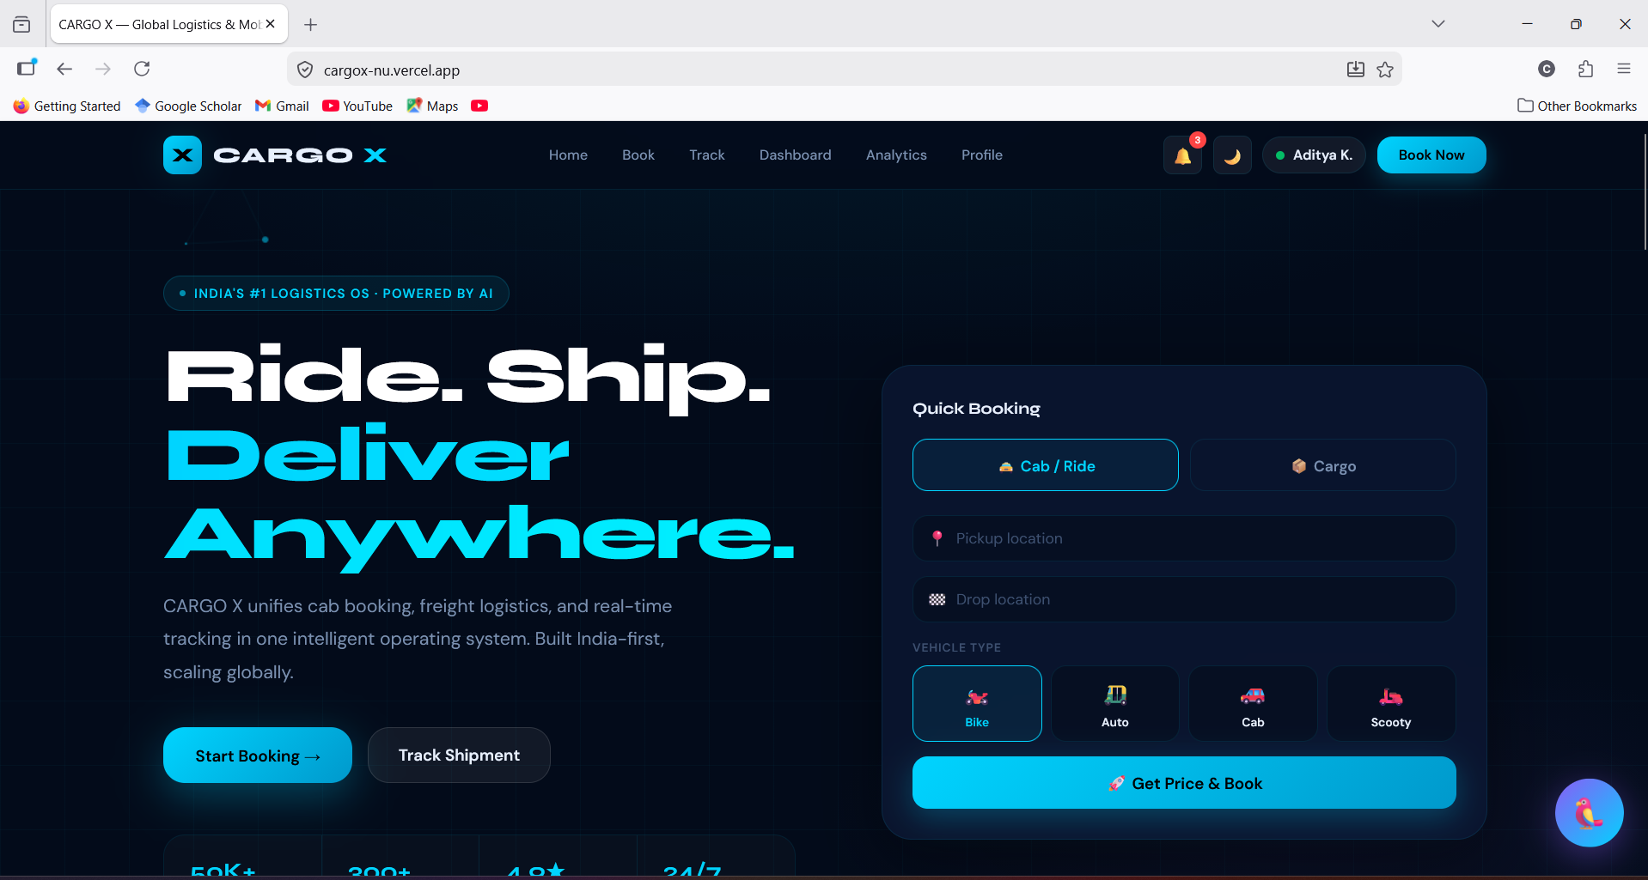

Figure 3.1 — Homepage — Hero Section & Quick Booking Panel
Shows the main landing page with animated logistics network background, headline, call-to-action buttons, hero statistics strip, and the mode-switchable quick booking panel on the right. The page demonstrates the deep navy and electric teal design system with glassmorphism panel styling.

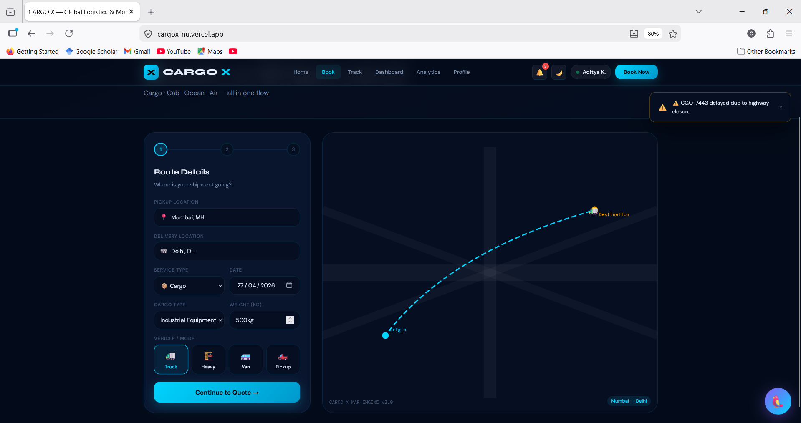

Figure 3.2 — Cargo Booking Flow — Route & Details Form (Step 1)
Displays the booking page Step 1 interface showing the origin/destination selectors, service type dropdown, cargo type and weight fields, and the vehicle/mode selection grid. The step indicator at the top shows the current position in the three-step flow.

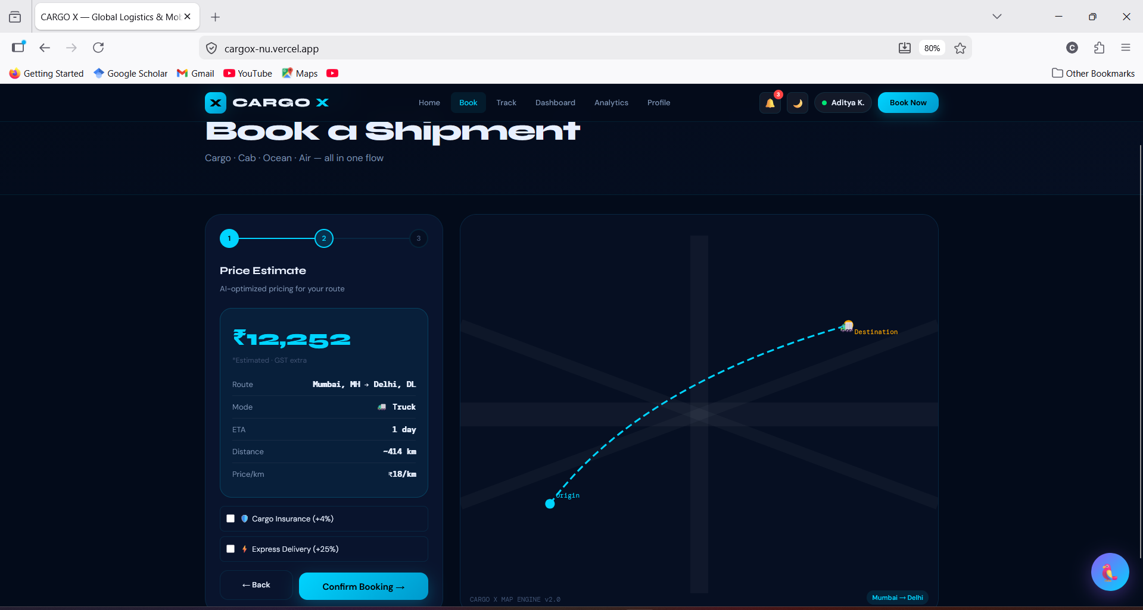

Figure 3.3 — Cargo Booking Flow — Price Estimate (Step 2)
Shows the dynamic price estimate card generated after Step 1 submission, including the estimated freight charge in INR, route summary, ETA, distance, rate per km, and optional add-on checkboxes for cargo insurance and express delivery.

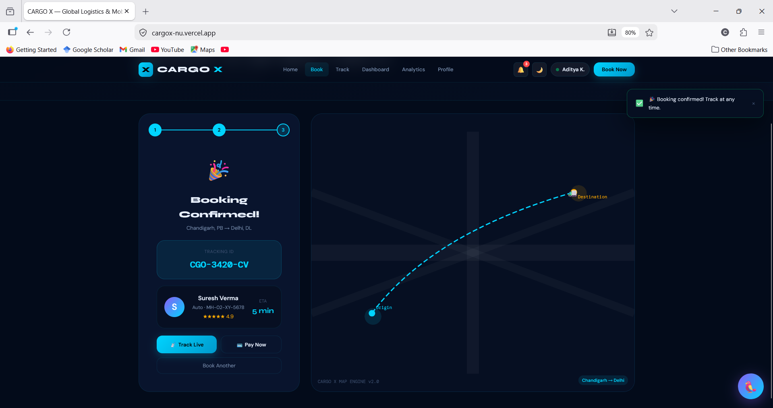
Figure 3.4 — Cab Booking Interface — Vehicle Selection & Driver Assignment
Displays the cab module interface with visual vehicle selection cards (Bike, Scooty, Auto, Cab), urgency selector, and the post-confirmation driver assignment card showing driver name, vehicle registration, star rating, and live ETA countdown.

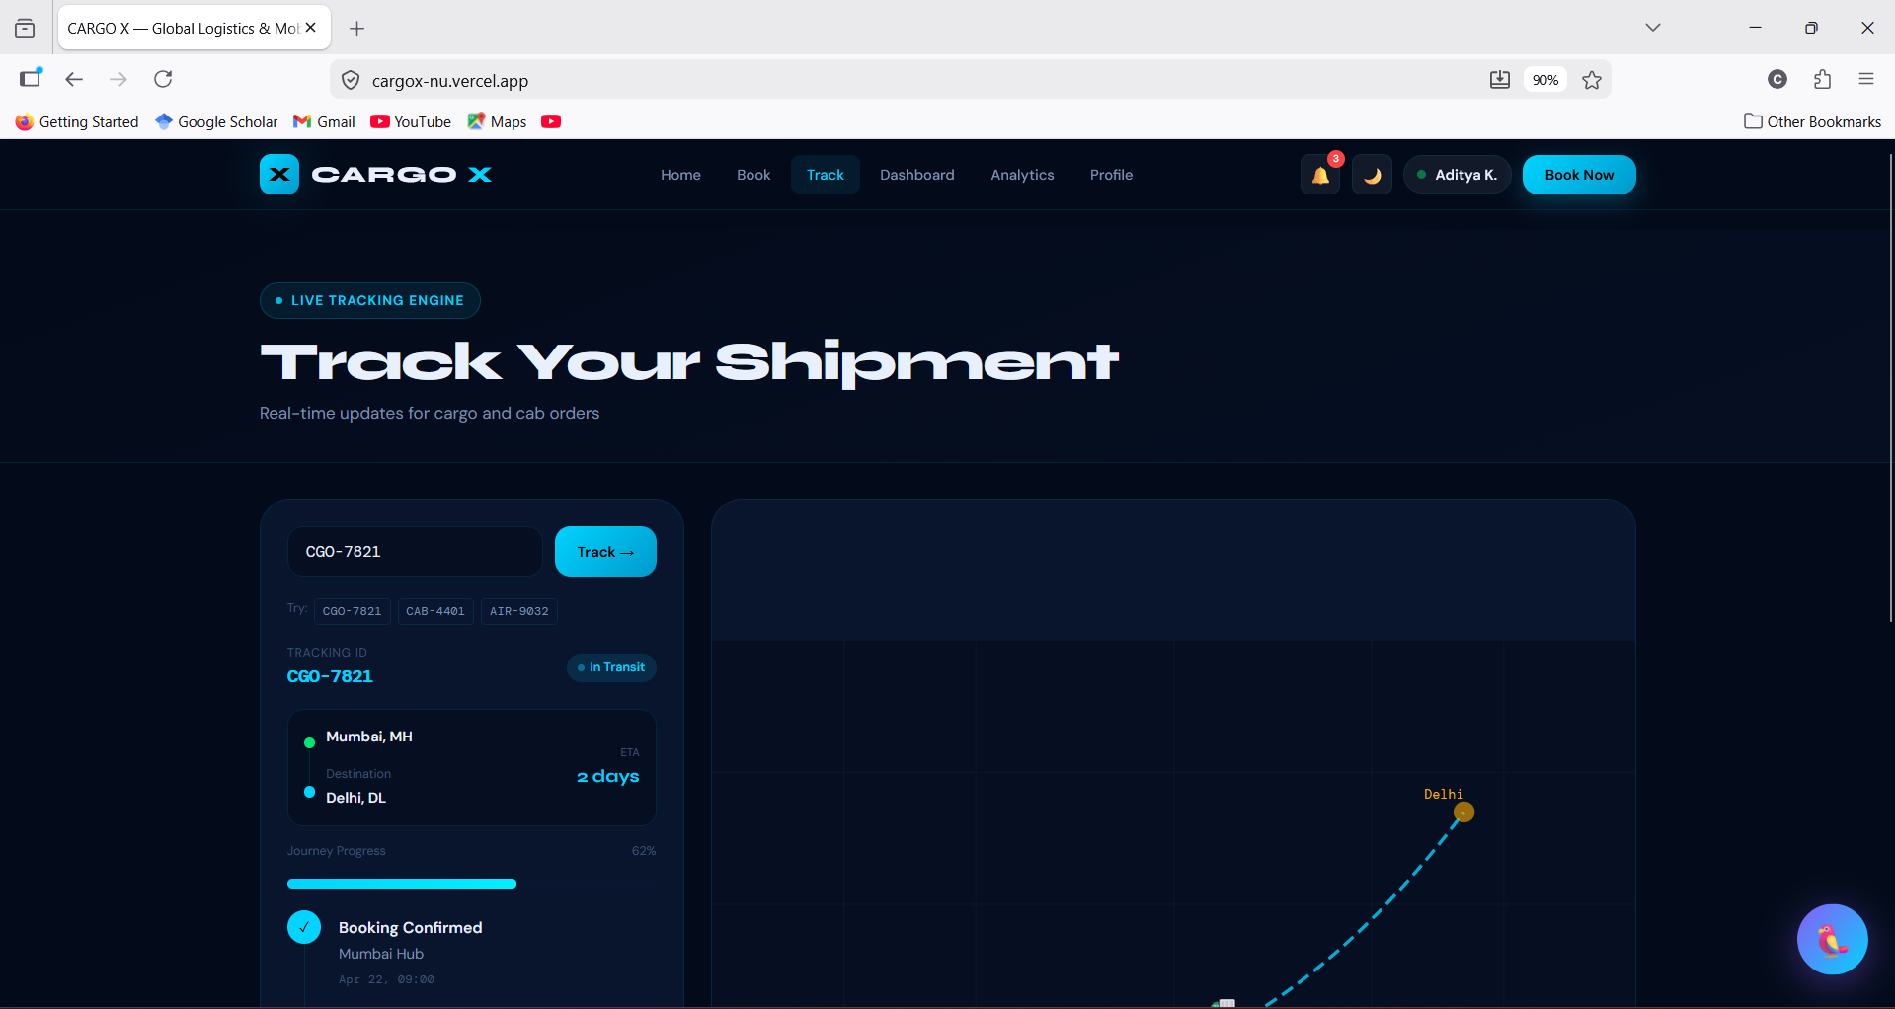
Figure 3.5 — Shipment Tracking Page — Timeline & Progress View
Shows the tracking interface with the tracking ID input field, the vertical milestone timeline with completed (teal), active (pulsing), and future (grey) states, the horizontal progress bar, route origin-to-destination card, and optional driver information panel.

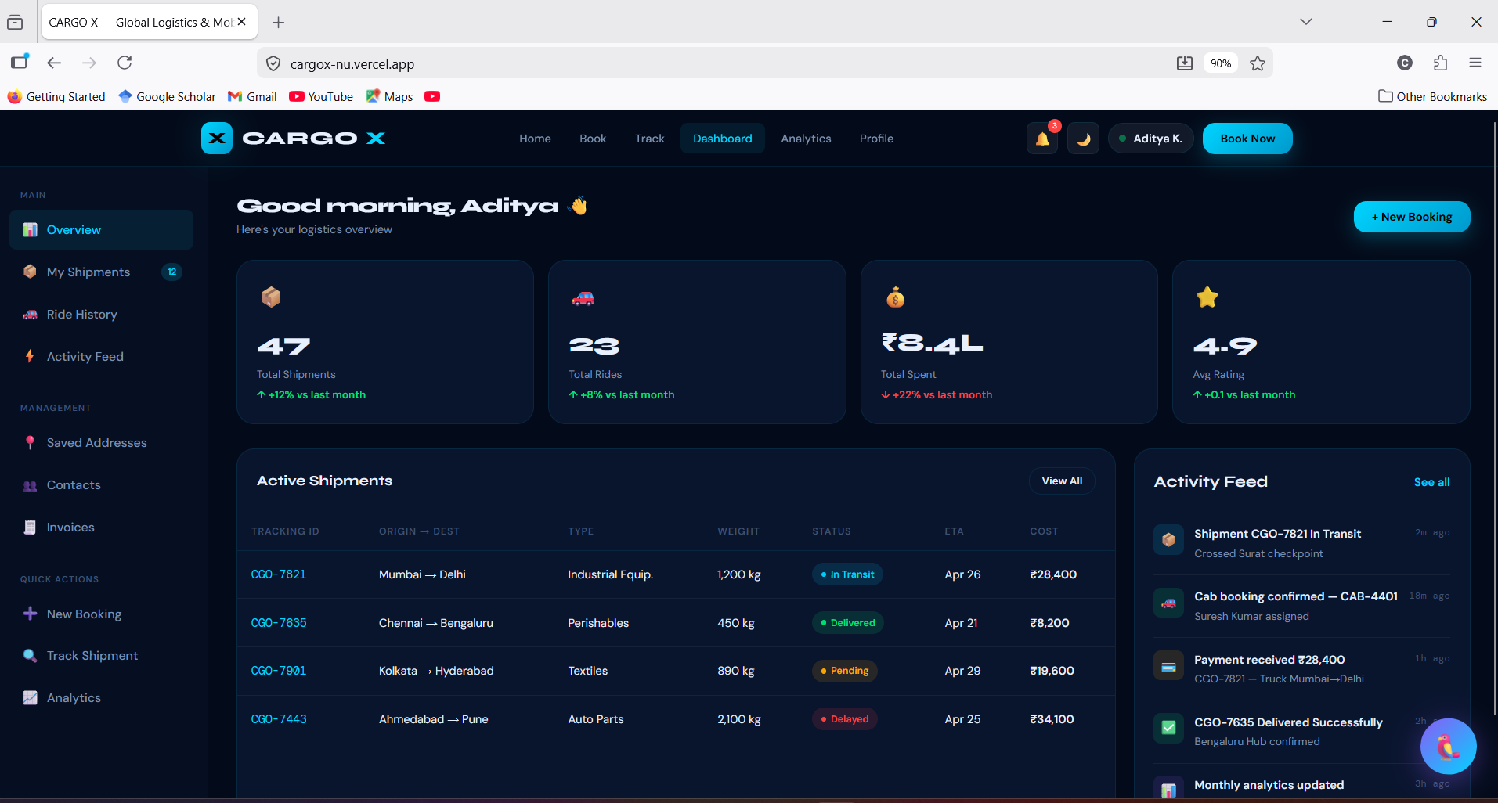
Figure 3.6 — User Dashboard — Overview with Stats & Shipments Table
Displays the full dashboard layout including the left sidebar navigation, four KPI stat cards (Total Shipments, Rides, Spend, Rating), active shipments data table with status badges, and the real-time activity feed panel.

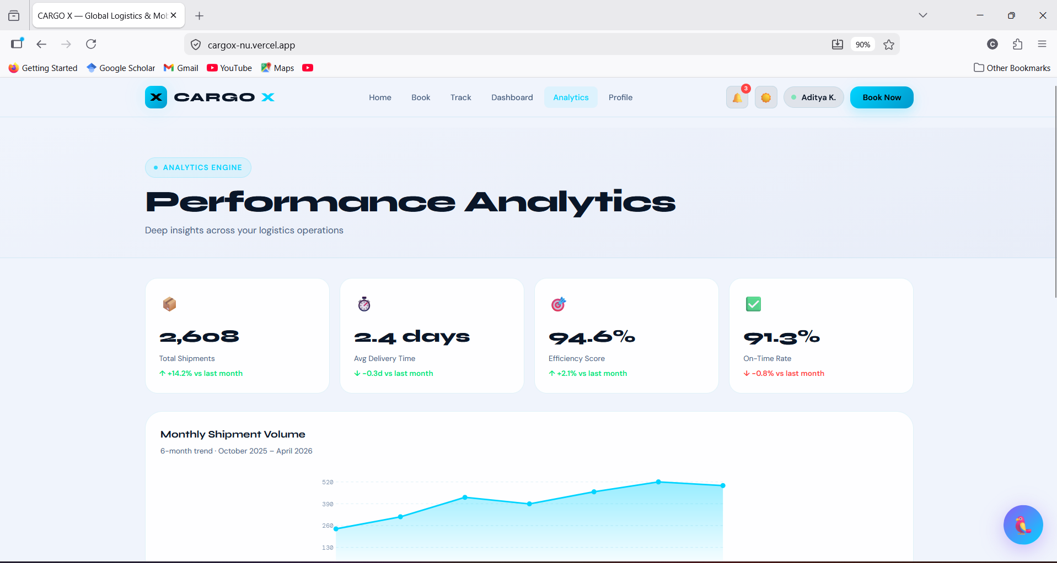
Figure 3.7 — Analytics Page — KPI Cards & Charts
Shows the analytics module with the four KPI summary cards at the top, the full-width line chart for monthly shipment volume, the route revenue bar chart, the cargo type donut chart with legend, and the route performance comparison table.

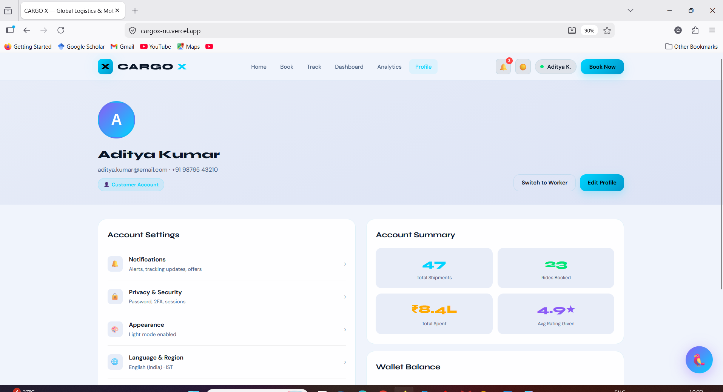

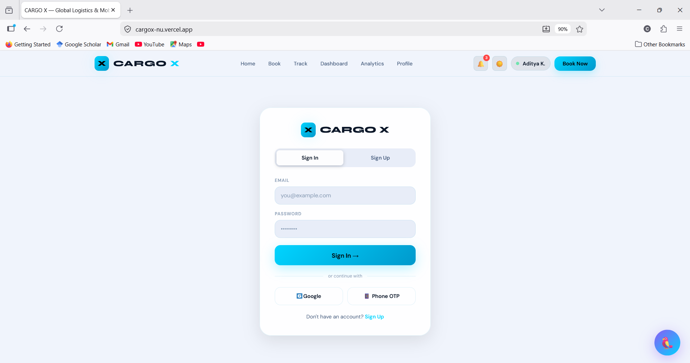
Figure 3.8 — Login / Signup Page — Role Selection & Auth Form
Displays the authentication page with the tabbed Sign In / Sign Up interface, role selection buttons for Customer and Worker accounts, the registration form with all required fields, and alternative sign-in options.

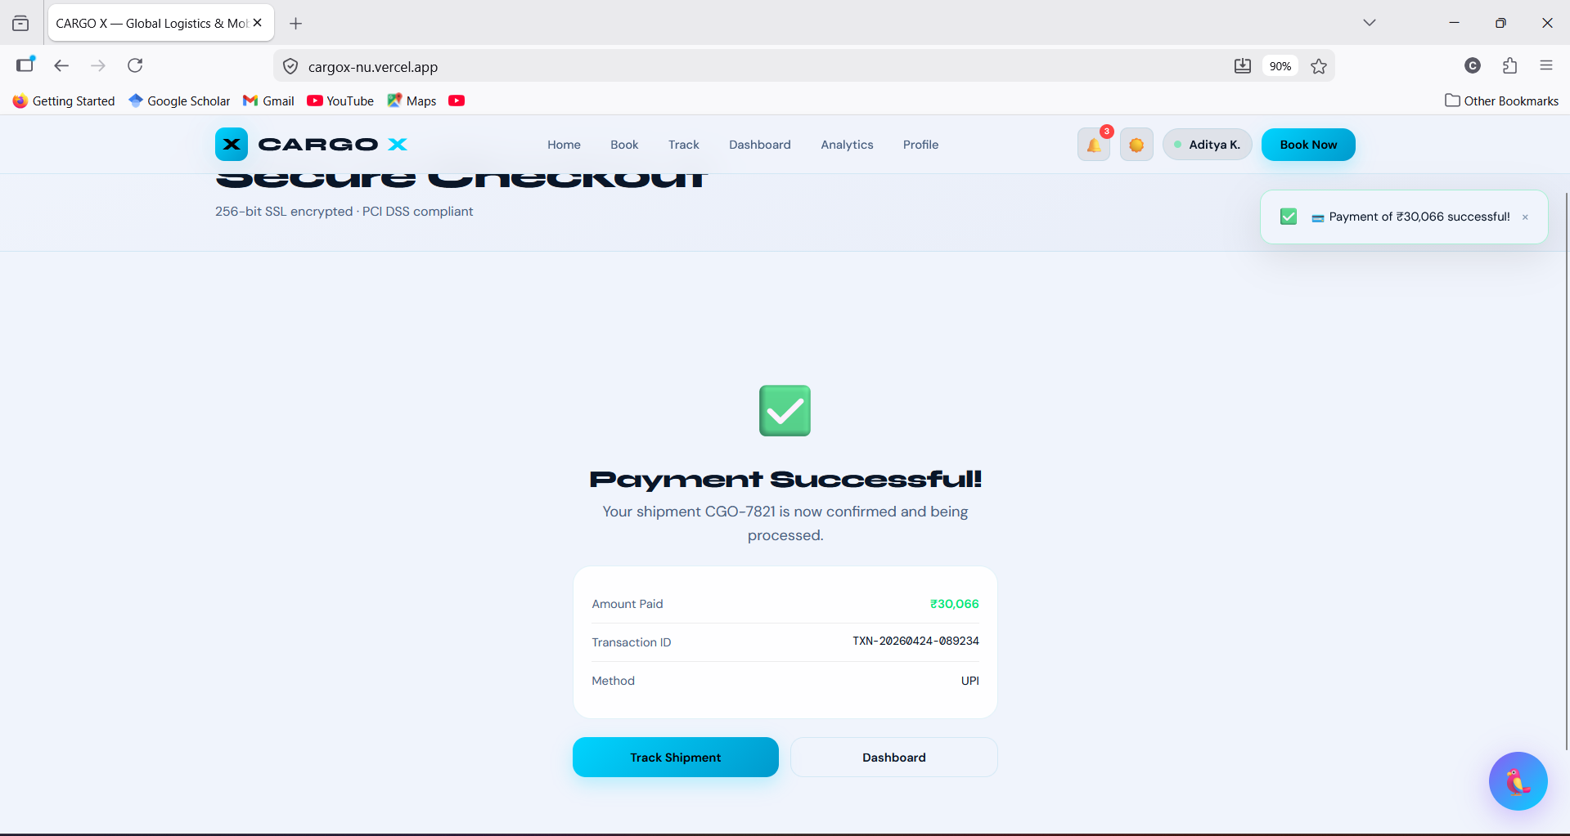
Figure 3.9 — Payment Interface — Checkout & Invoice Summary
Shows the payment page with the payment method selection panel on the left (UPI selected, showing UPI ID input field) and the detailed invoice summary on the right including line items, GST calculation, and total amount due.

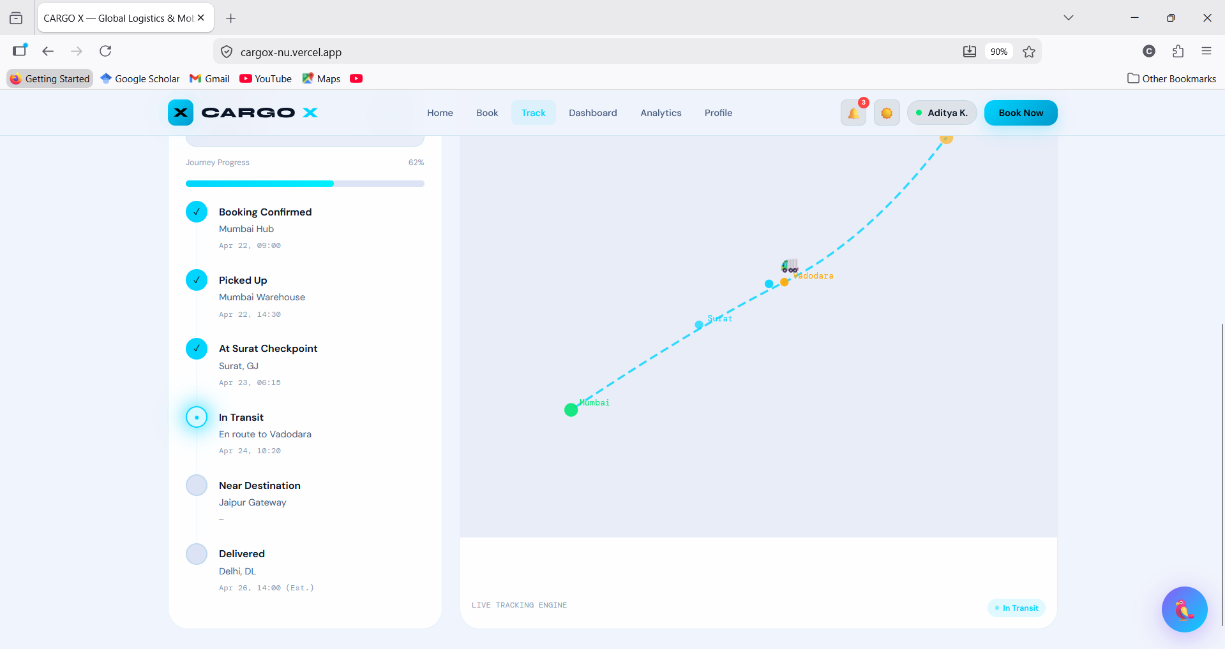
Figure 3.10 — Map Simulation UI — Booking Map with Animated Route
Displays the custom SVG-based map panel on the booking page showing the animated route path between origin and destination markers, moving truck indicator, and the simulated road network background grid.

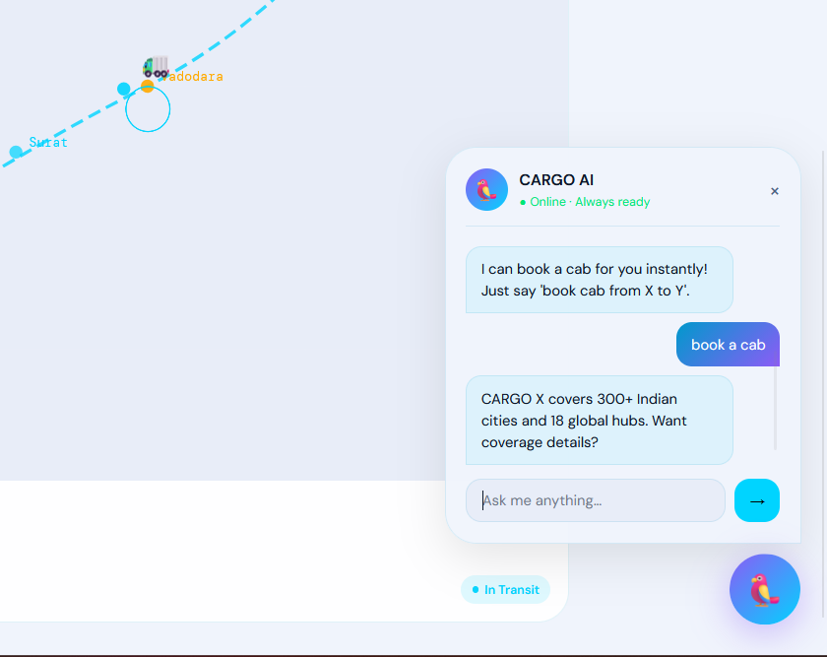
Figure 3.11 — AI Parrot Assistant — Chat Interface
Shows the floating AI Parrot chat widget in its open state, displaying the assistant avatar, online status indicator, message conversation thread with styled user and bot message bubbles, and the chat input field.

3.4 PERFORMANCE & TESTING RESULTS

The CARGO X application was evaluated for functional correctness, UI consistency, responsiveness, and cross-browser compatibility. The following results were recorded.

1. Performance Observations
- Initial page load time: Under 1.5 seconds on standard broadband connection
- Client-side navigation speed: Instant — Next.js pre-fetches linked page bundles
- Mock API response simulation: 800ms–2000ms (configurable)
- Chart rendering time: Under 100ms for all SVG-based visualizations
- Theme switching: Instantaneous — CSS variable cascade with no re-render
- Animation frame rate: Stable 60 fps for canvas network animation and route dash animations
- Mobile interaction latency: Under 20ms for all tap events

2. Testing Summary

Test Type | Coverage | Result
Functional — Booking Flow | All 3 steps: form → quote → confirmation | PASS
Functional — Tracking | All 3 demo IDs return correct timeline data | PASS
Functional — Dashboard | All 7 sidebar sections render correctly | PASS
Functional — Analytics | All 4 charts render with accurate mock data | PASS
Functional — Payment | UPI, Card, Wallet flows — success state confirmed | PASS
UI — Dark Mode | All pages, cards, tables, charts visible | PASS
UI — Light Mode | All elements readable with correct color variables | PASS
Responsive — Mobile (375px) | Navigation, forms, tables all adapted | PASS
Responsive — Tablet (768px) | Grid columns collapse correctly | PASS
Cross-Browser — Chrome 124 | Full compatibility | PASS
Cross-Browser — Edge 124 | Full compatibility | PASS
Cross-Browser — Safari 17 | Full compatibility | PASS
Accessibility | Keyboard navigation, aria labels on interactive elements | PARTIAL

3.5 DISCUSSION & OBSERVATIONS

The development and testing process of CARGO X yielded several important observations relevant to frontend application engineering and simulation architecture:

- A well-structured mock data layer can substitute convincingly for a real backend in a demonstration context, provided the async timing and data shapes accurately reflect realistic API behavior.
- CSS custom properties offer a powerful and performant mechanism for theme management. The ability to switch the entire application's visual identity through a single attribute change on the HTML element — with zero JavaScript overhead — demonstrates the efficiency of this approach.
- Component-based architecture significantly accelerates development once the initial component library is established. The reusable Button, Card, Badge, and Input components were used across all pages, ensuring visual consistency while reducing total code volume.
- SVG-based chart rendering provides complete design control without the overhead of a chart library. All four analytics visualizations were implemented with raw SVG and CSS, resulting in smaller bundle size and seamless theme integration.
- The AI Parrot Assistant feature demonstrated the value of conversational UI elements in logistics platforms. Even a simple keyword-response chatbot significantly enhances the perception of platform intelligence.
- Responsive design for data-heavy interfaces (tables, dashboards, analytics) requires careful attention to overflow handling and column collapsing strategies at each breakpoint.

CHAPTER – 4

CONCLUSION & FUTURE SCOPE

4.1 CONCLUSION

The CARGO X — Global Logistics & Mobility Platform project successfully demonstrates how modern web technologies can be employed to simulate a comprehensive, enterprise-grade logistics operating system. The platform integrates multiple transport verticals — road cargo, air freight, ocean shipping, and urban cab services — within a single, cohesive web application built using Next.js, React, TypeScript, and CSS Modules.

Through this minor project, all primary objectives were met:
- A visually premium, responsive user interface was developed that reflects the design language of enterprise logistics platforms.
- A complete multi-step cargo booking system was implemented with dynamic pricing, transport mode selection, and booking confirmation.
- A cab module tailored for the Indian market was built with vehicle type selection, urgency-based pricing, and driver assignment simulation.
- A real-time shipment tracking interface with animated milestone timelines was delivered.
- A comprehensive user dashboard with shipment management, ride history, saved contacts, and invoice tracking was created.
- An analytics module with four chart visualizations and KPI tracking was implemented using custom SVG rendering.
- A simulated payment flow with UPI, card, and wallet support was integrated with a detailed invoice summary.
- An AI Parrot Assistant providing conversational logistics support was deployed as a persistent floating widget.
- A persistent light/dark theme system using CSS custom properties was implemented throughout the application.

The project also provided a significant personal learning experience across multiple technical domains: component architecture design, TypeScript interface definition, CSS Module organization, async state management, SVG-based data visualization, responsive layout engineering, and production deployment workflow using Vercel.

Challenges encountered during development — including CSS Module scoping, multi-step state management, SVG color theming, and mobile layout adaptation — were resolved through systematic debugging and iterative refinement. Each challenge contributed to a deeper understanding of real-world frontend engineering constraints.

CARGO X stands as a functionally complete, visually polished, and architecturally sound prototype that effectively demonstrates how modern web development tools can be used to build intelligent, data-rich logistics platform simulations. The project fulfills the academic requirements of this minor project and showcases both technical competence and practical engineering judgment.

4.2 FUTURE SCOPE

While CARGO X currently operates as a frontend-only simulation, it is architecturally designed for straightforward evolution into a fully functional production platform. The following enhancements represent the most impactful directions for future development:

1. Full Backend Integration
- Replace mock data with a Node.js or Django REST API connected to a PostgreSQL or MongoDB database
- Implement JWT-based authentication with refresh tokens for secure session management
- Deploy backend infrastructure on AWS or Google Cloud Platform with auto-scaling capabilities
- Integrate real-time WebSocket connections for live shipment status updates and driver location streaming

2. Real Maps Integration
- Integrate Google Maps Platform or Mapbox API for accurate route visualization
- Implement real-time driver location tracking with GPS coordinate streaming
- Add turn-by-turn navigation for driver-facing mobile interface
- Provide estimated traffic-adjusted ETAs using live maps routing engines

3. AI & Machine Learning Integration
- Implement a machine learning model for dynamic freight pricing based on historical demand patterns
- Integrate Large Language Model (LLM) API for the AI Parrot Assistant, replacing the keyword-response library with genuine natural language understanding
- Develop predictive analytics for delivery time estimation using historical route performance data
- Build anomaly detection for delayed shipments, triggering proactive customer notifications

4. Mobile Application
- Develop native iOS and Android applications using React Native for customer-facing booking
- Build a dedicated driver application with GPS tracking, delivery acceptance, and earnings management
- Implement push notifications for shipment milestones and urgent delivery alerts
- Add Progressive Web App (PWA) capability to the web platform for offline access

5. Payment Gateway Integration
- Integrate Razorpay or PayU for real UPI and card payment processing
- Implement automated GST invoice generation and e-Way Bill filing through the GSTN API
- Build a wallet system with top-up, transfer, and cashback management
- Add corporate billing with monthly consolidated invoice generation

6. Global Expansion
- Extend coverage to Southeast Asian markets (Singapore, Thailand, Malaysia)
- Integrate with international shipping carriers through standardized EDI interfaces
- Implement multi-currency pricing and regional tax compliance
- Build ocean freight booking with port-to-port routing through major Asian and European ports

7. Analytics Enhancement
- Develop a real-time operational control tower with live KPI monitoring
- Implement customizable report generation with PDF/Excel export
- Build predictive demand forecasting models for route capacity planning
- Add benchmark comparison tools for carrier performance evaluation

In summary, CARGO X currently serves as a technically sophisticated and visually complete prototype. With backend integration, maps connectivity, and AI capability, it has the potential to evolve into a fully operational logistics platform capable of competing with established players in the Indian and global freight technology market. This project demonstrates the technical foundation, design vision, and architectural thinking necessary to build such a system.

REFERENCES

- Next.js Official Documentation — App Router, Server Components, CSS Modules, Routing. Available: https://nextjs.org/docs
- React Official Documentation — Components, Hooks, State Management, Context API. Available: https://react.dev/
- TypeScript Handbook — Interfaces, Type Safety, Generics. Available: https://www.typescriptlang.org/docs/
- MDN Web Docs — CSS Custom Properties, Flexbox, Grid, SVG, localStorage API. Available: https://developer.mozilla.org/
- Vercel Documentation — Next.js Deployment, CI/CD Pipeline, Edge Network. Available: https://vercel.com/docs
- Framer Motion Documentation — React Animation Library. Available: https://www.framer.com/motion/
- CSS Tricks — CSS Grid, Custom Properties, Responsive Design Patterns. Available: https://css-tricks.com/
- Maersk Platform Reference — Enterprise Logistics UI Design Patterns. Available: https://www.maersk.com/
- Porter India — Hyperlocal Cargo Platform UX Reference. Available: https://porter.in/
- Uber Freight Documentation — Freight Booking Flow Reference. Available: https://www.uberfreight.com/
- W3.CSS Framework Documentation — Layout Utilities Reference. Available: https://www.w3schools.com/w3css/
- Ministry of Shipping, Government of India — Major Port Traffic Statistics 2024–25. Available: https://shipmin.gov.in/
- KPMG India — Indian Logistics Sector Report 2024. Available: https://home.kpmg/in/
- Figma Community — Enterprise SaaS UI Design Patterns & Component Libraries. Available: https://www.figma.com/community
- GitHub Documentation — Repository Management, Version Control Best Practices. Available: https://docs.github.com/

