3/10/2019

Jeremy Bankes, Mohammed Shreim, Jacob Pecoskie, Cherish Browne

Hospital Process Model

Business Analysis

Contents

Process Flow Diagram 2

Datapalooza 3

Data Dictionary 4

Entity Relationship Diagram 5

Deliverables 6

Existing System 6

Statement Requirements 6

Analysis 6

Recommendations 6

# Process Flow Diagram

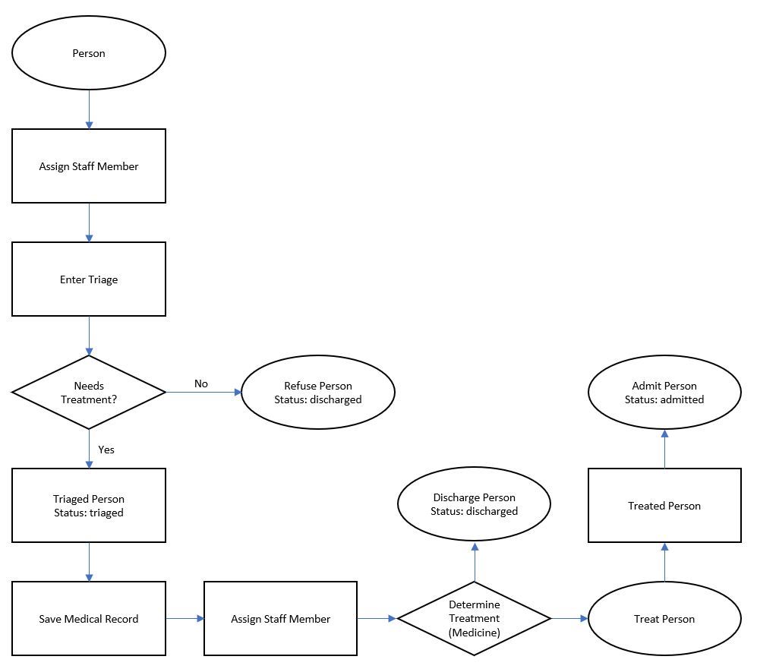

# Datapalooza

Patient Arrivals Flow Diagram

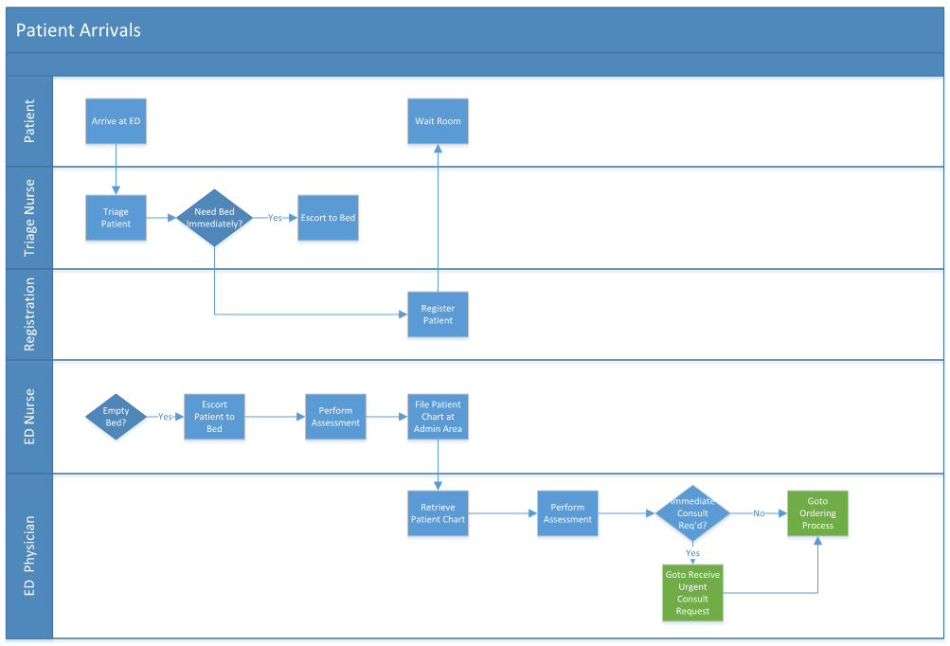

# Data Dictionary

|  |  |  |  |  |
| --- | --- | --- | --- | --- |
| Object Name | Object Type | Datatype | Methods | Notes |
| Person | Table | N/A | PK | The scenario dictates a need to track person information. People must be uniquely identified. |
| Person_ID | Field | Integer | PK, FK | Required to uniquely identify people |
| First_Name | Field | Text |  | First name of the person seeking treatment. |
| Last Name | Field | Text |  | Last name of person who would be seeking treatment. |
| Triage | Table | N/A | PK | The scenario requires tracking of diagnosis. |
| Triage_ID | Field | Integer | PK, FK | Required to uniquely identify each triage |
| Date | Field | Timestamp |  | The time of which the triage took place |
| Status | Field | Text |  | The current state of the triage |
| Staff | Table | N/A | PK | Someone who works at the hospital |
| Staff_ID | Field | Integer | PK, FK | Required to uniquely identify a staff member |
| Staff_Name | Field | Text |  | The name of a staff member |
| Staff_Role | Field | Text |  | The staff’s position at the hospital |
| Treatment | Table | Text | PK | The treatment that a triaged person has received |
| Treatment_ID | Field | Integer | PK, FK | Required to uniquely identify a case per treatment used. |
| Procedure | Field | Text |  | Covers the substance and operation used to treat the person in this case. |
| Price | Field | Timestamp |  | Total price of services and labor used in treatment. |

# Entity Relationship Diagram

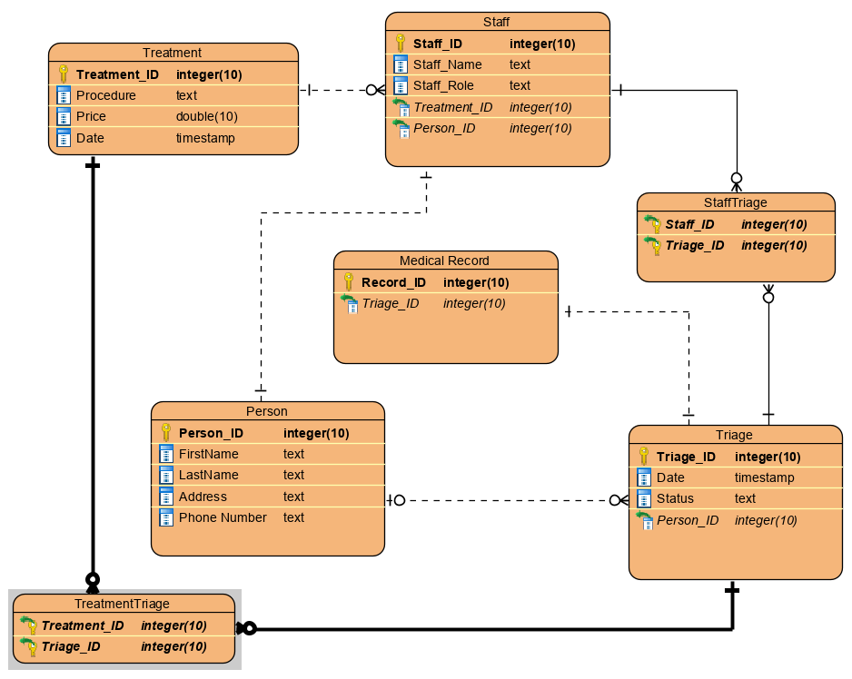

# Deliverables

## Existing System

The Atlantic Health Datapalooza involves teams tackling the real-world problem of Patient Flow. Business Processes can be categorized into Fulfillment, Production, and Procurement. It is assumed that the Patient Flow area is limited to the three business processes:

* Triage
* Treatment
* Discharge

Businesses priorities are assessed using the formula Profit = Revenue - Cost.

## Statement Requirements

I must supply and justify answers for each of the two scenarios above for the following questions:

* Provide completed process flow diagrams for the three processes, including business inputs, business outputs, and processes.
* Make a Data Dictionary for the things named in your process flow diagrams.
* Using the information from your Data Dictionary, design an ERD that contains all the information from your process flow diagram.

## Analysis

### Process Flow

People visit a hospital because they have a medical problem.  
  
They are assigned a staff member to be triaged to see if they need treatment or be discharged.

The person’s status is then updated accordingly. A medical record is saved on the result of the triage.

If the person is determined to have a medical issue, they are assigned another staff member diagnosed and treated.

The patient is then discharged or treated.

The treated person is then admitted if they are not discharged.

Their medical record is then updated.

### ERD

Refer to data dictionary

## Recommendations

I recommend the answers and justifications developed in the Analysis section above for satisfaction of the Statement of Requirement.