Task Description#1
● Use Google Gemini in Colab to write a function that reads a CSV file and calculates
mean, min, max.
Expected Output#1
● Functional code with output and screenshot
Prompt: write a function that reads a CSV file and calculates
mean, min, max.
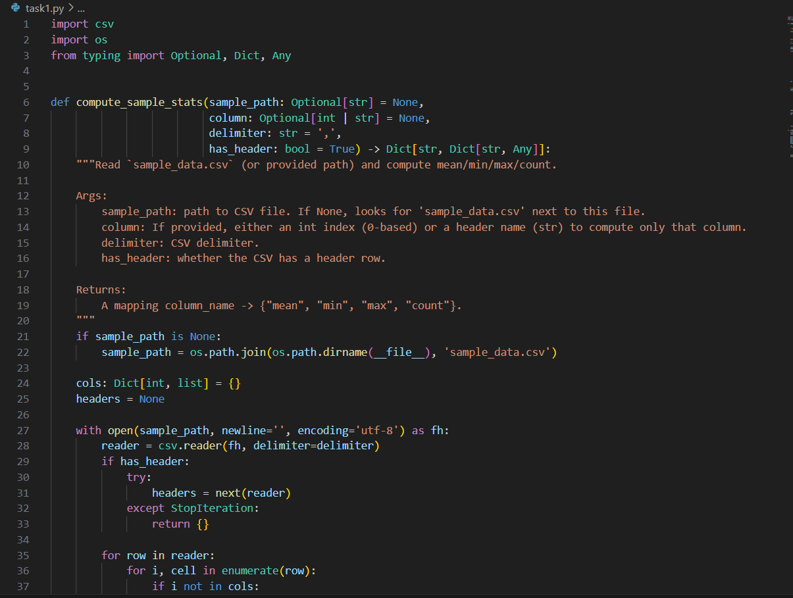
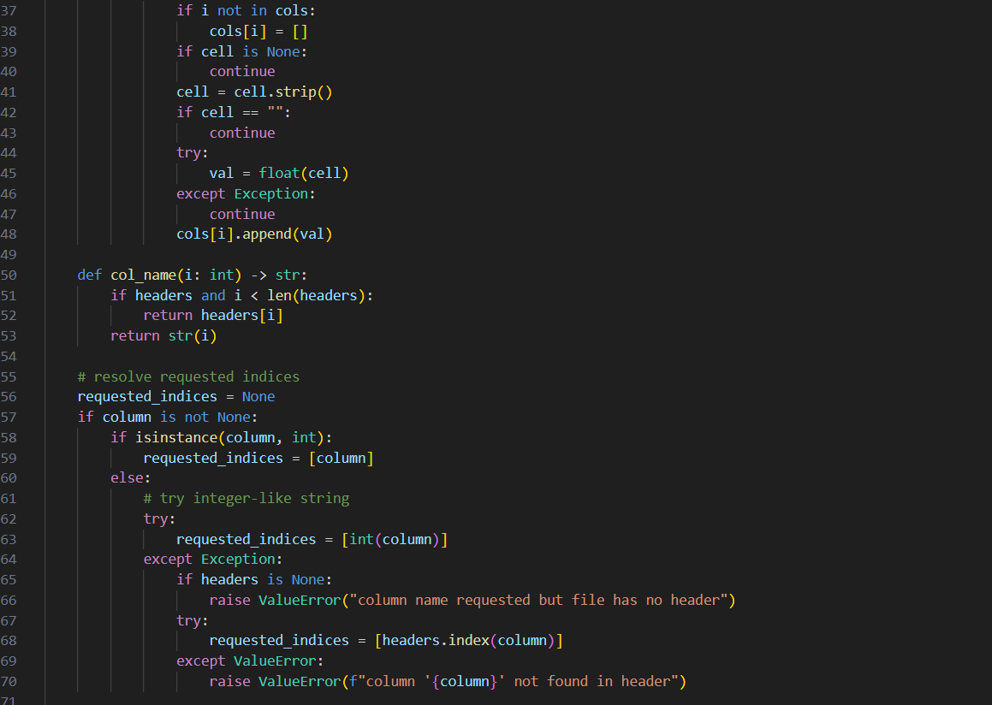
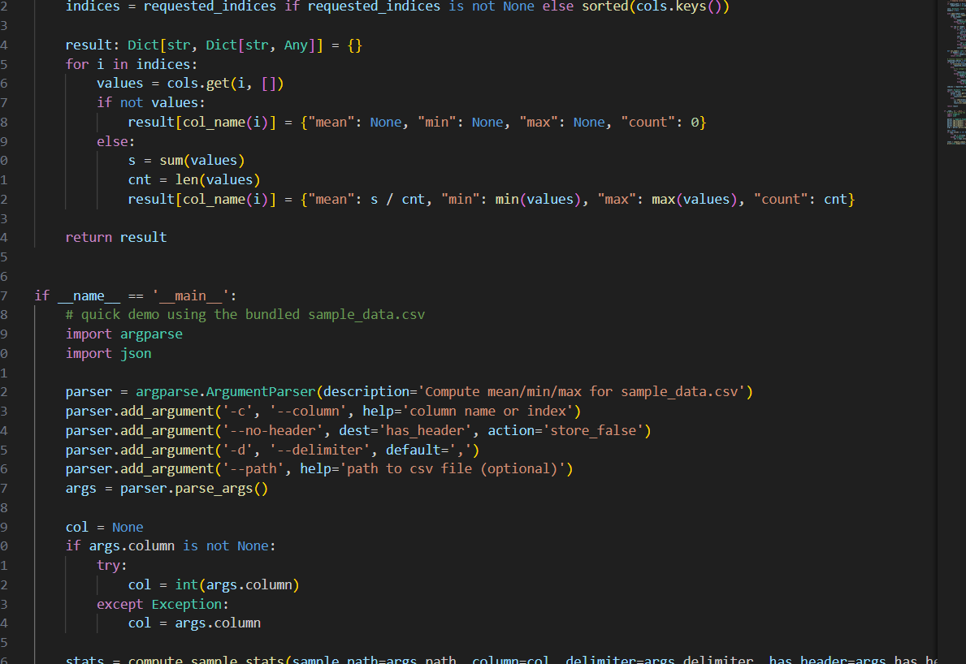
OUTPUT:
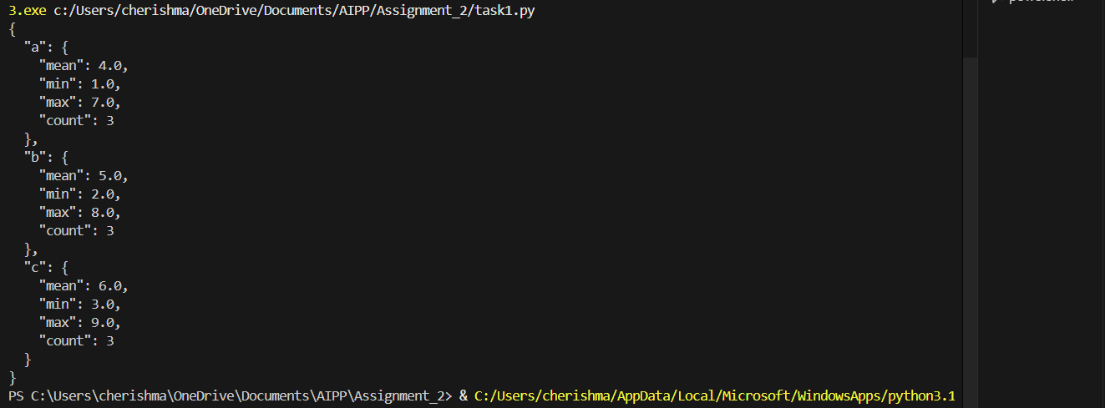
Task Description#2
● Compare Gemini and Copilot outputs for a palindrome check function.
Expected Output#2
● Side-by-side comparison and observations
Prompt: palindrome check function
CODE:
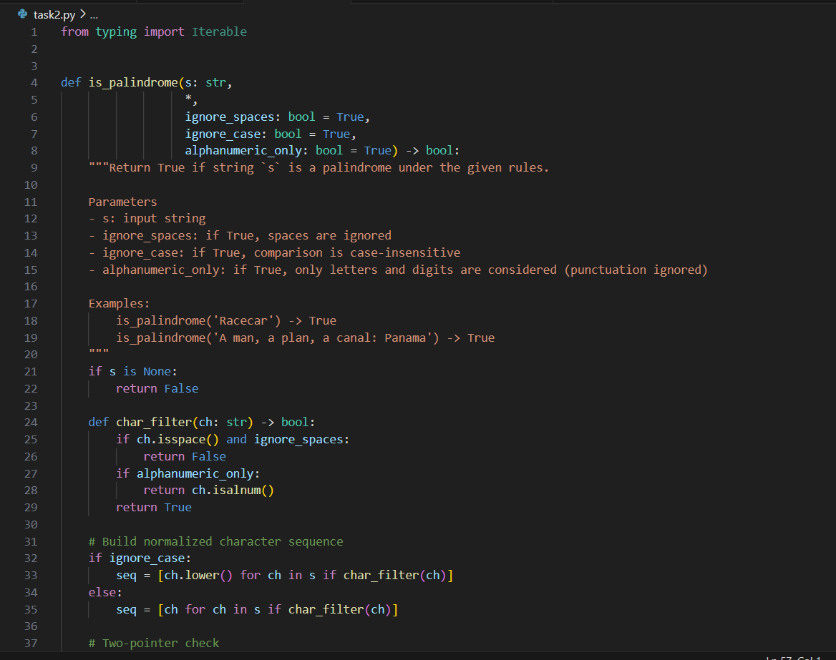
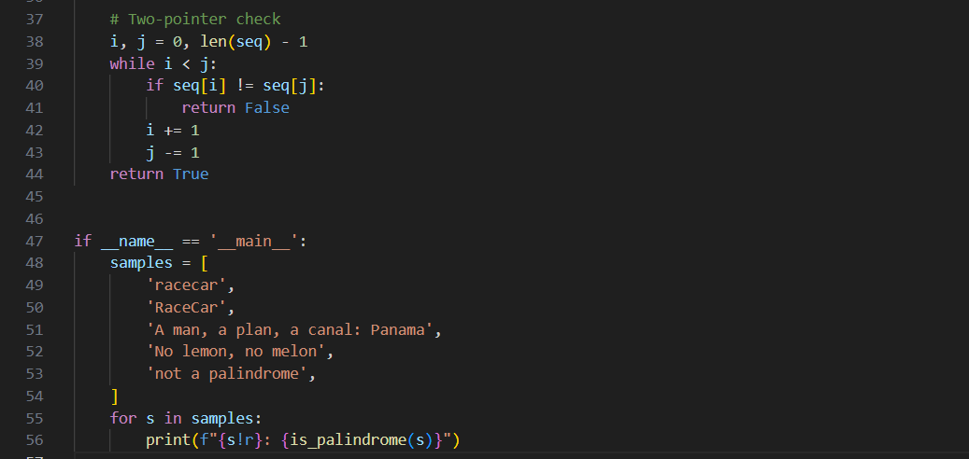
OUTPUT:
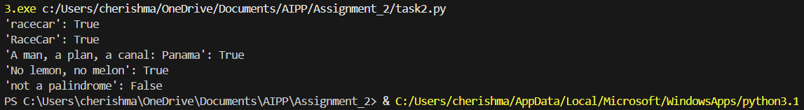
Task Description#3
● Ask Gemini to explain a Python function (to calculate area of various shapes) line by
line..
Expected Output#3
● Detailed explanation with code snippet
Prompt: Python function (to calculate area of various shapes line by
line
CODE:
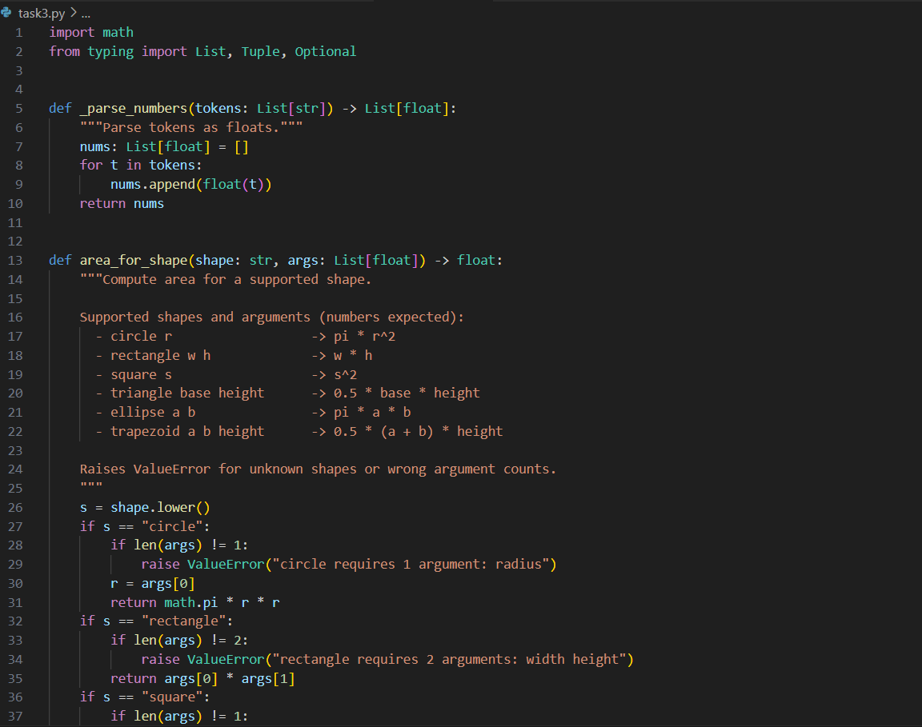
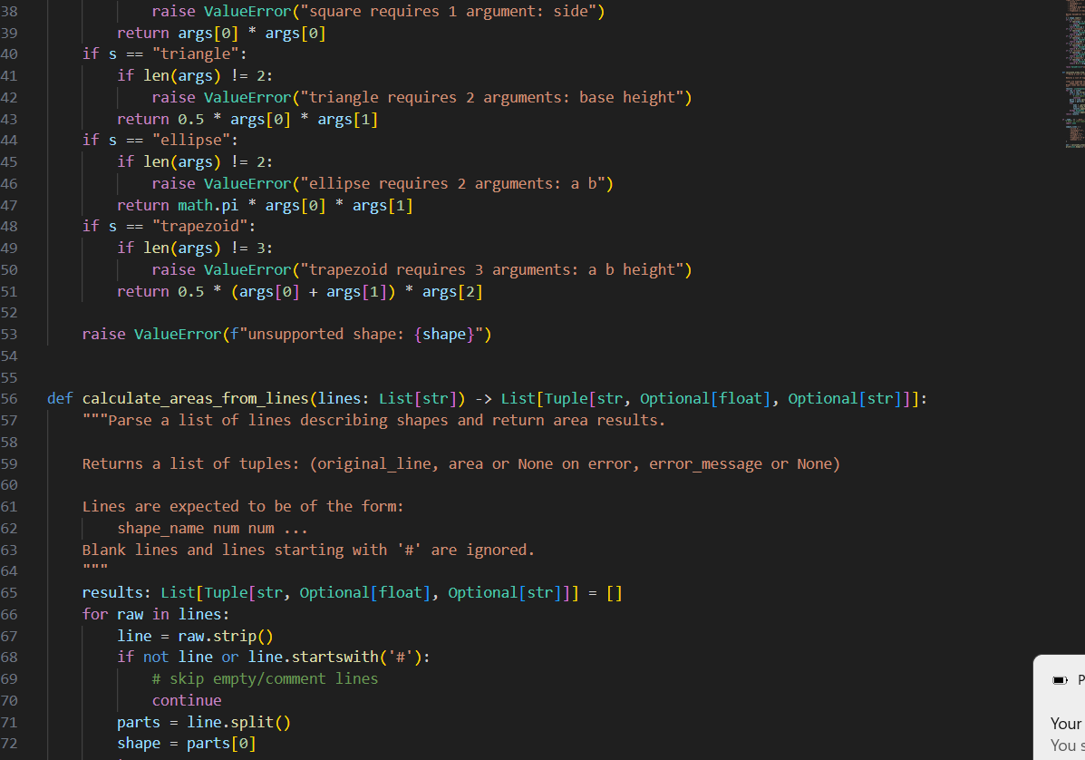
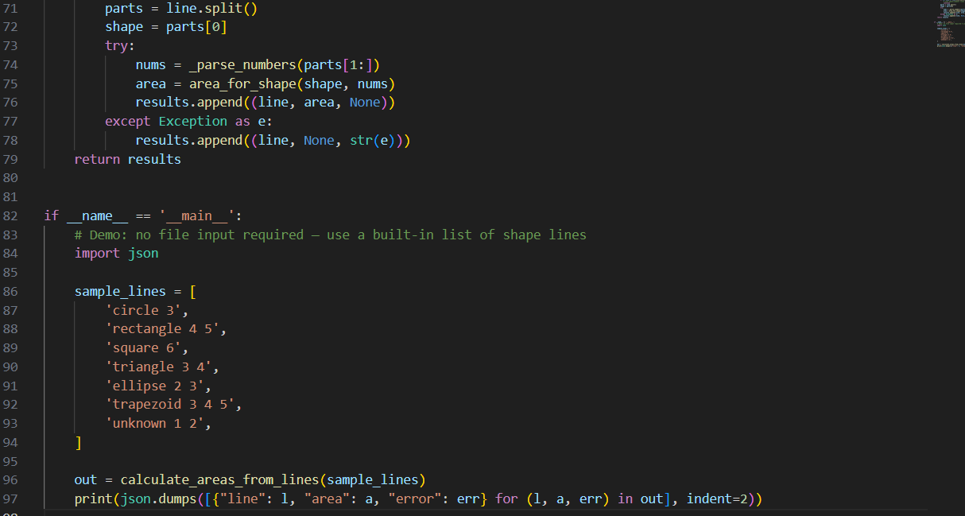
OUTPUT:
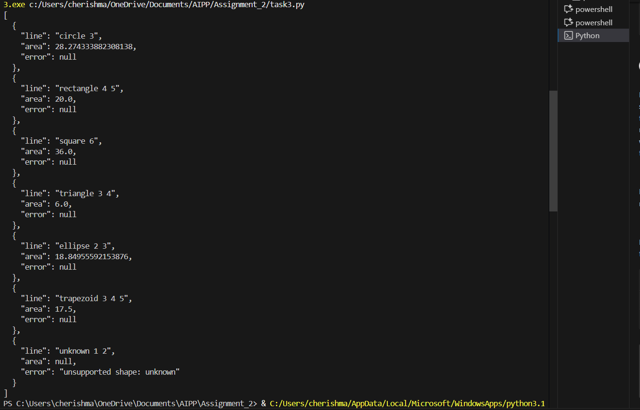
Task Description#4
● Install and configure Cursor AI. Use it to generate a Python function (e.g., sum of
squares).
Expected Output#4
● Screenshots of working environments with few prompts to generate python code
Prompt: generate a Python function sum of squares
CODE:
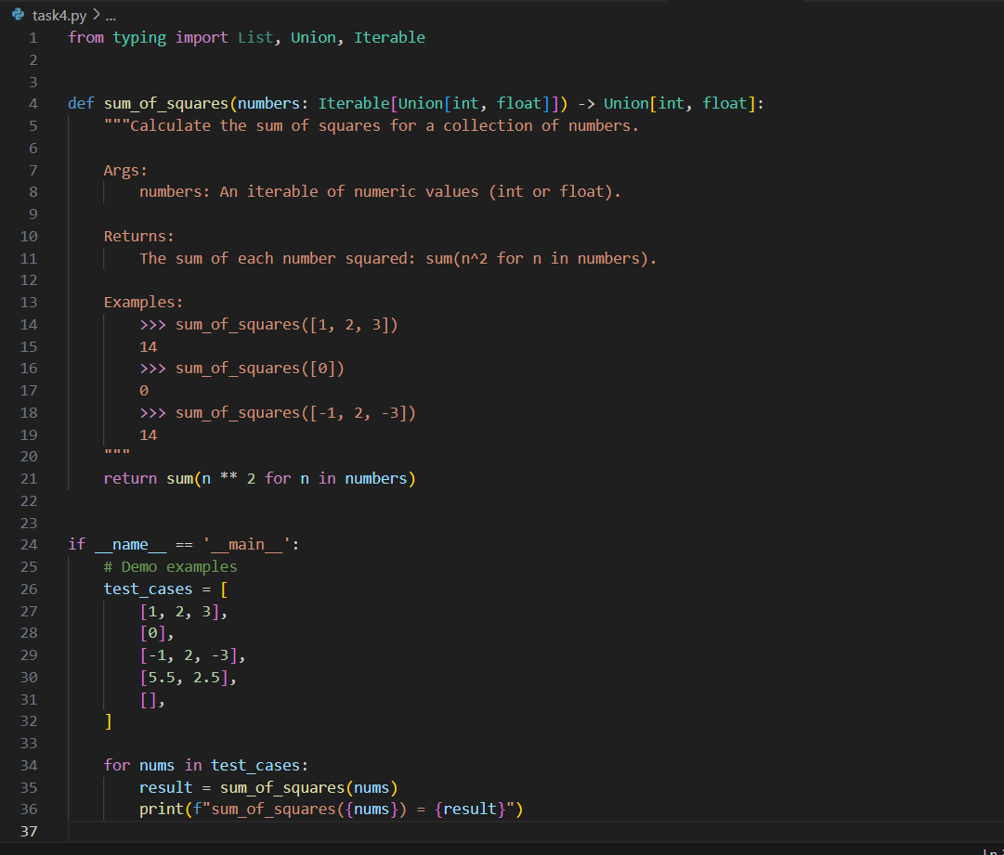
OUTPUT:
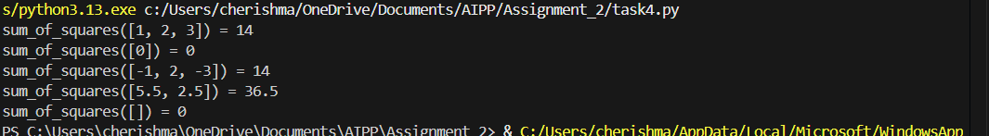
Task Description#5
● Student need to write code to calculate sum of add number and even numbers in the
list
Expected Output#5
● Refactored code written by student with improved logic
Prompt: calculate sum of add number and even numbers in the
list
CODE:
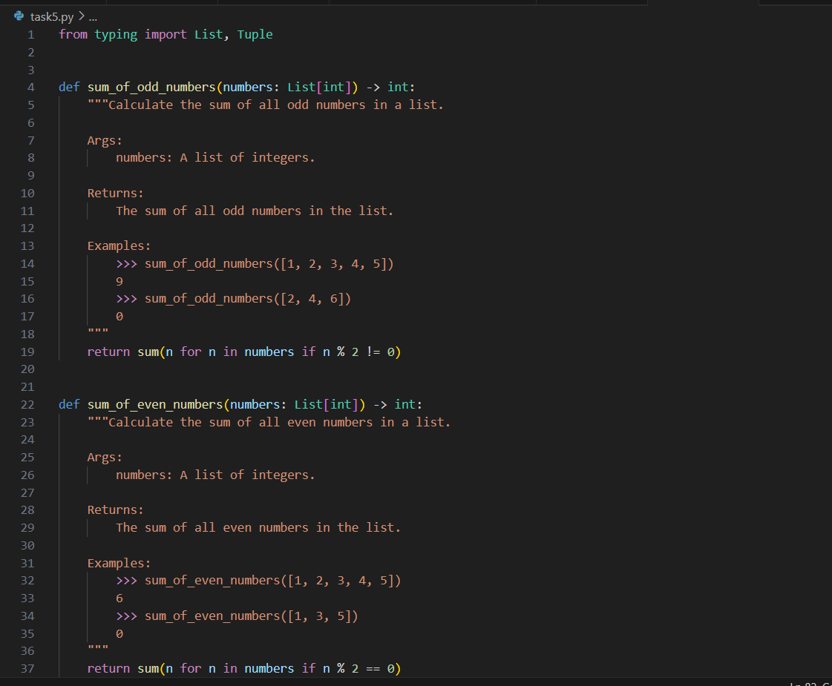
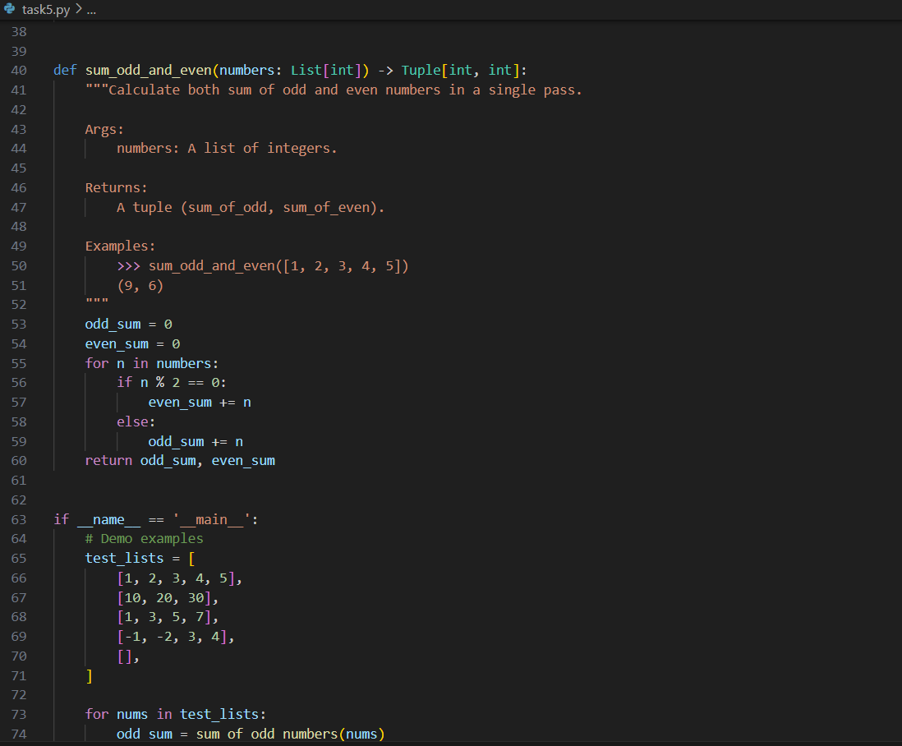
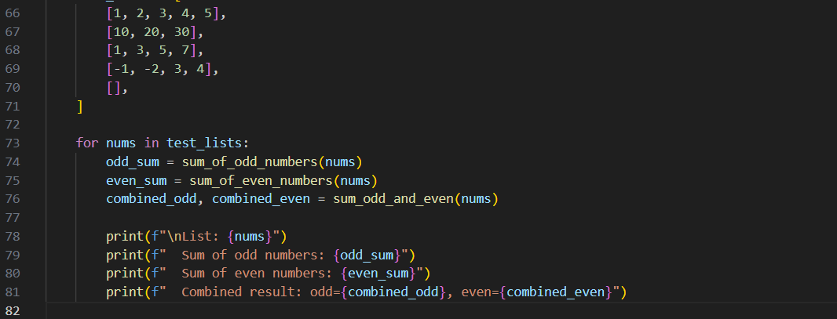
OUTPUT:
