AI Assisted Problem Solving Using Python
Task Description#2
● Use Copilot to generate a is_prime() Python function.
Expected Output#2
● Function to check primality with correct logic
Prompt: Generate a is_prime() Python function
CODE:
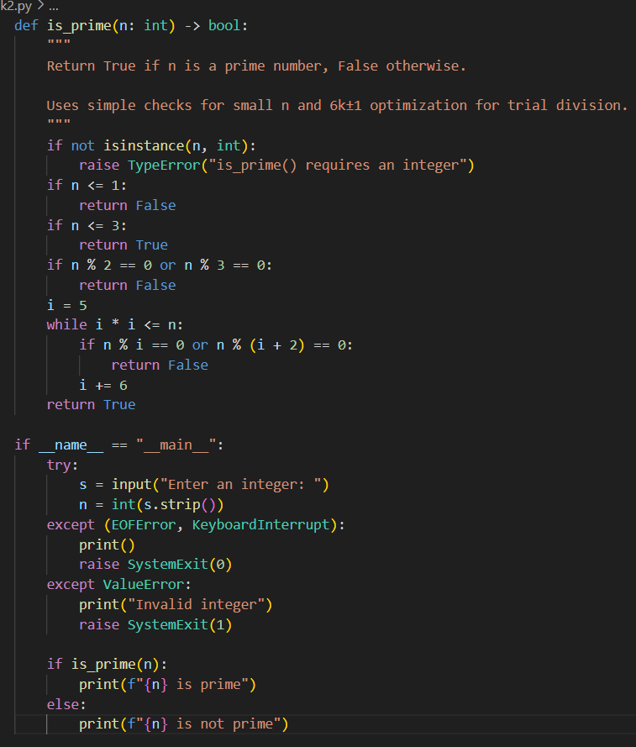

OUTPUT:
Task Description#3
● Write a comment like # Function to reverse a string and use Copilot to generate the
function.
Expected Output#3
● Auto-completed reverse function
Prompt: Function to reverse a string
CODE:
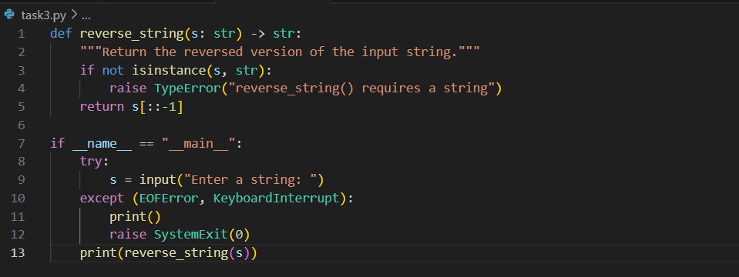
OUTPUT:
Task Description#4
● Generate both recursive and iterative versions of a factorial function using comments..
Expected Output#4
● Two working factorial implementations
Prompt: Generate both recursive and iterative versions of a factorial function using comment
CODE:
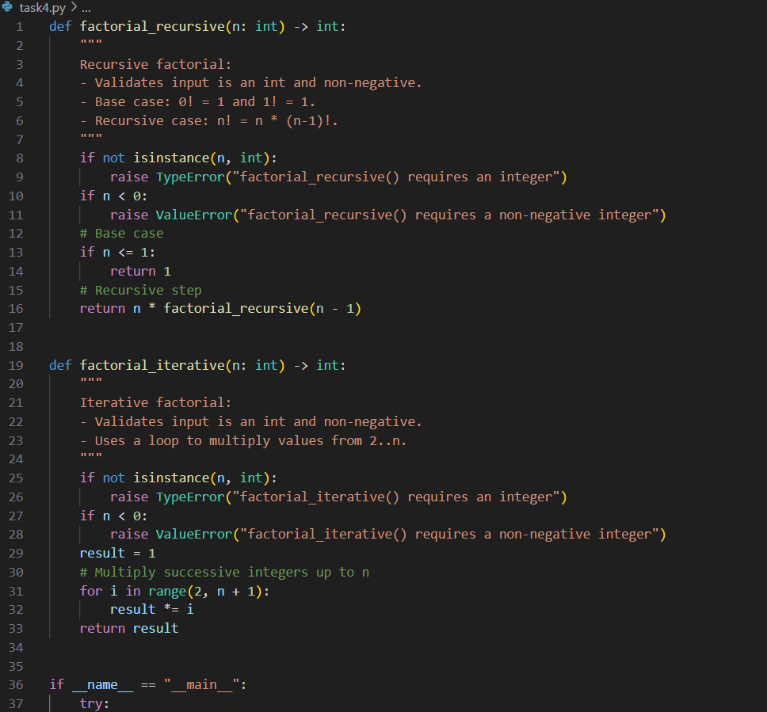

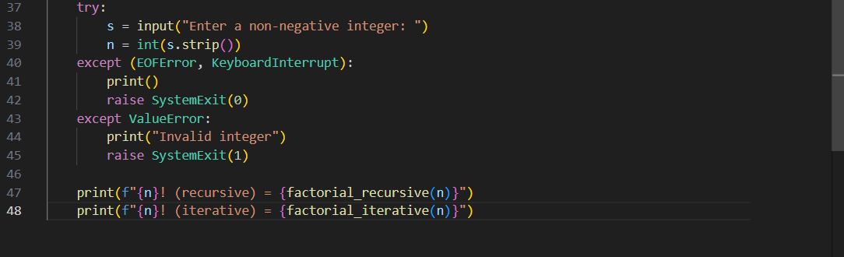
OUTPUT:
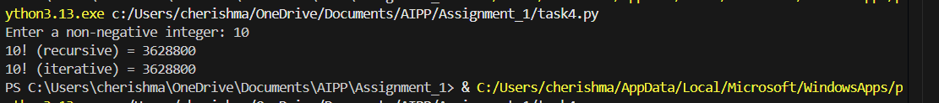

Task Description#5
● Use Copilot to find the largest number in a list. Assess code quality and efficiency.
Expected Output#5
● A valid function with your review
Prompt: find the largest number in a list. Assess code quality and efficiency
CODE:
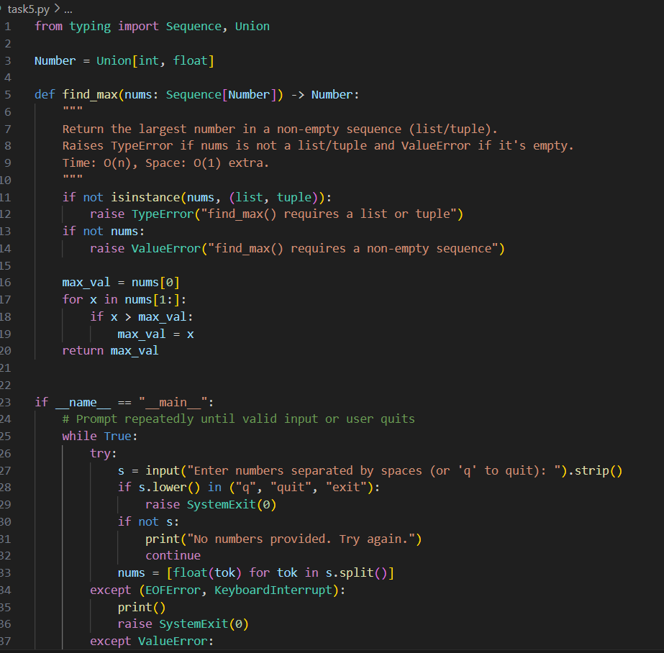
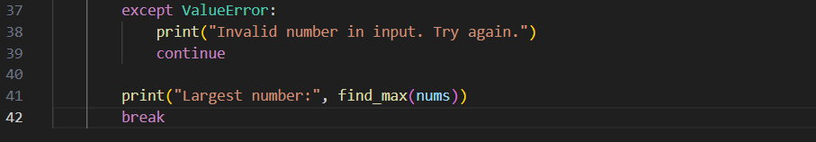
OUTPUT:

