Task Description#1
Use AI to generate test cases for is_valid_email(email) and then implement the
validator function.
Requirements:
• Must contain @ and . characters.
• Must not start or end with special characters.
• Should not allow multiple @.
Expected Output#1
• Email validation logic passing all test cases
Prompt: generate test cases for is_valid_email(email) and then implement the
validator function
CODE:
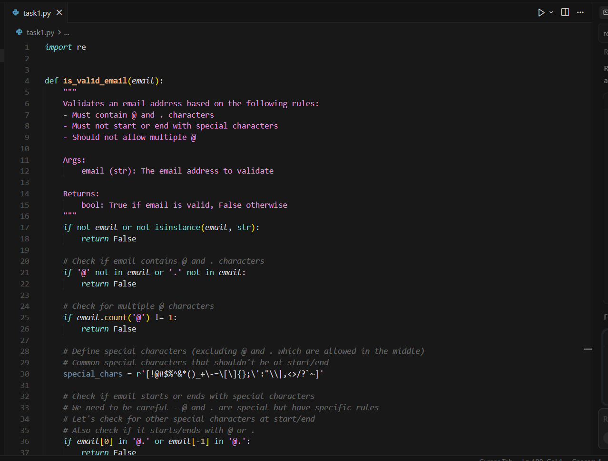
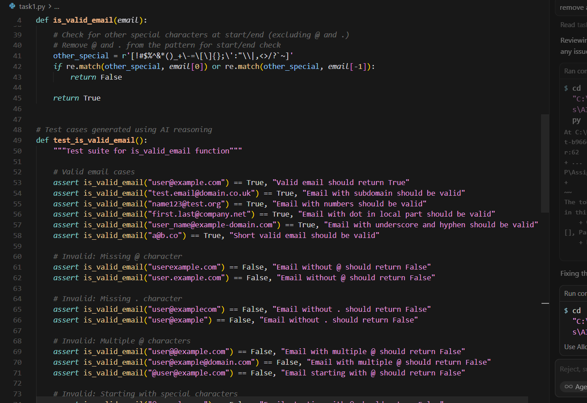
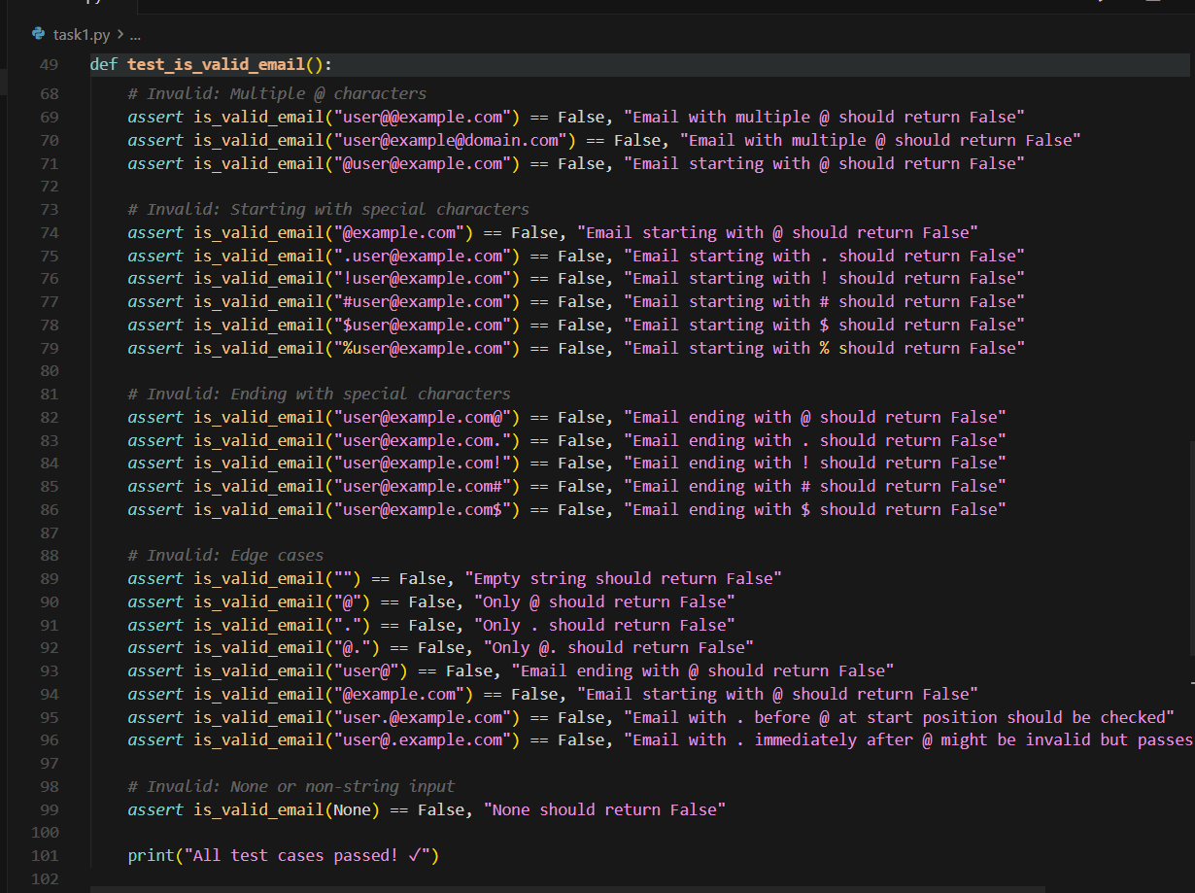
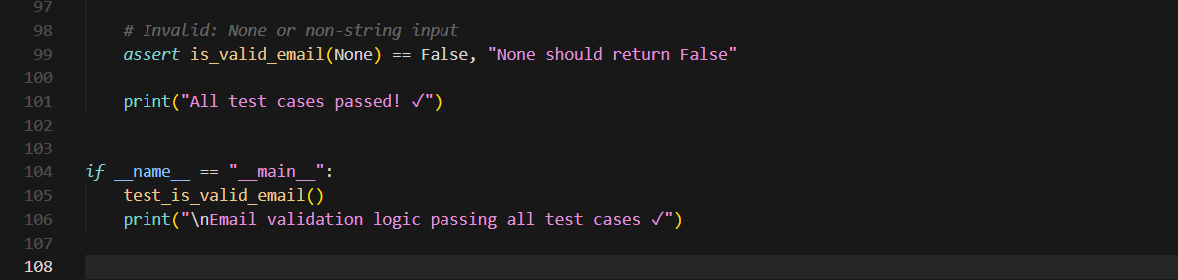
OUTPUT:
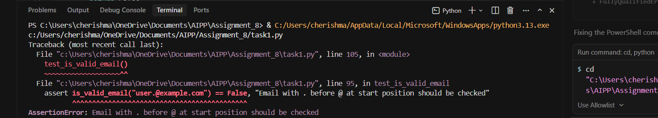
Task Description#2 (Loops)
• Ask AI to generate test cases for assign_grade(score) function. Handle boundary and
invalid inputs.
Requirements
• AI should generate test cases for assign_grade(score) where: 90-100: A, 80-89: B, 70-
79: C, 60-69: D, <60: F
• Include boundary values and invalid inputs (e.g., -5, 105, "eighty").
Expected Output#2
Grade assignment function passing test suite
PROMPT: generate test cases for assign_grade(score) function. Handle boundary and
invalid inputs.
CODE:
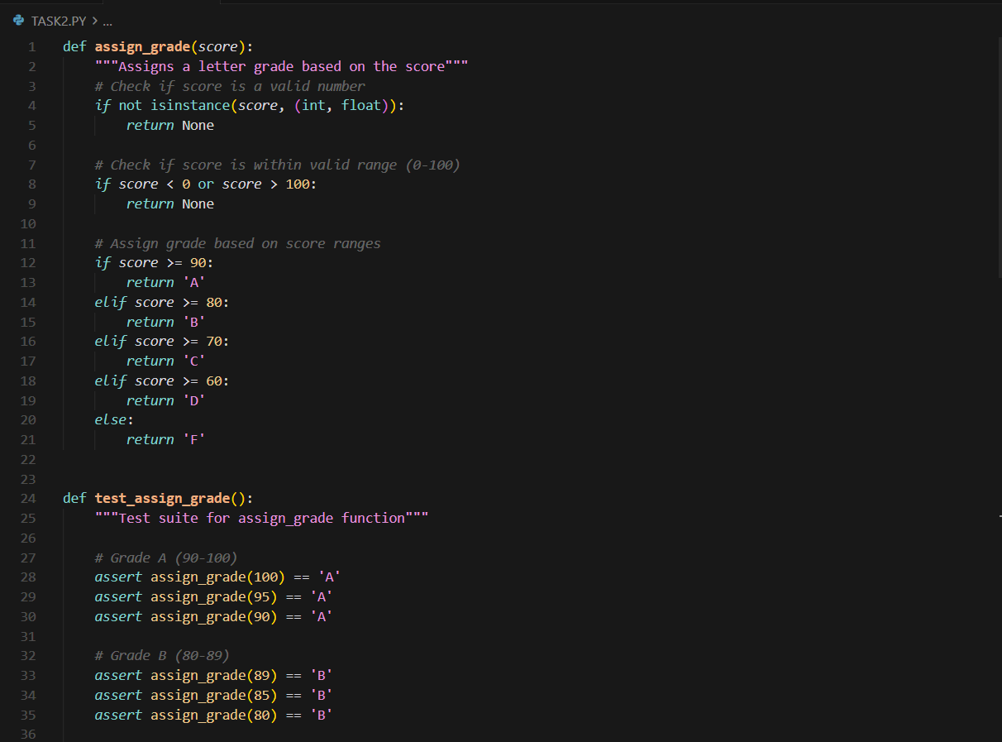
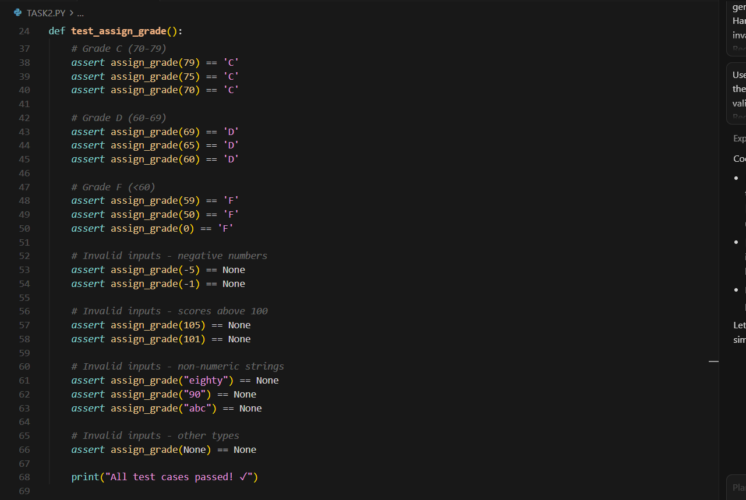
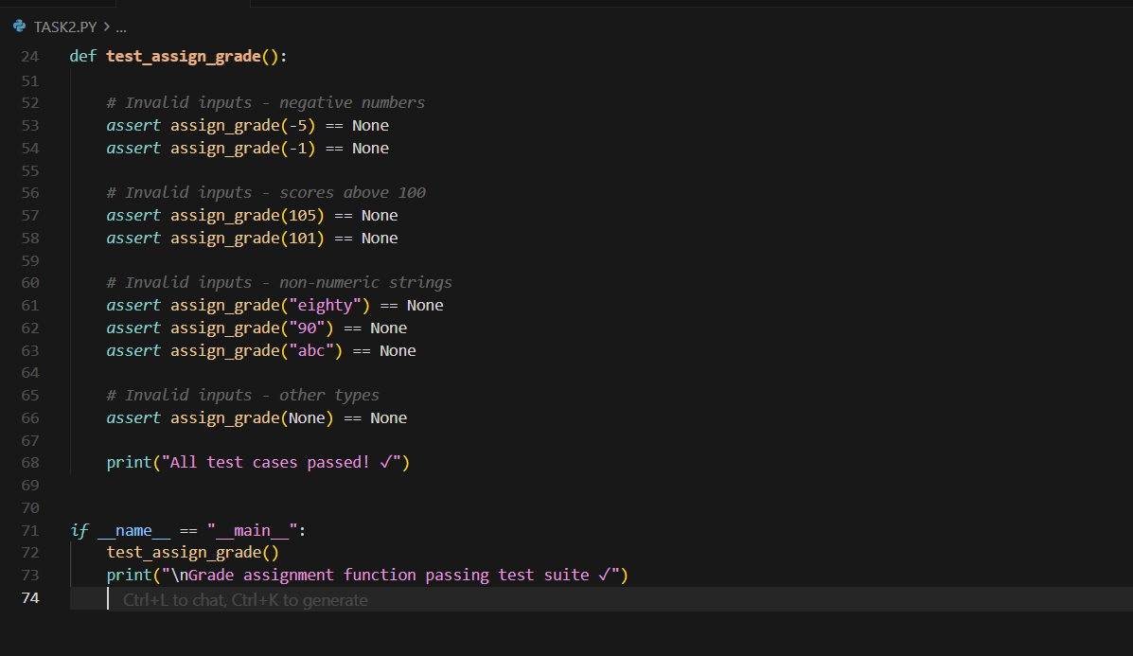
OUTPUT:
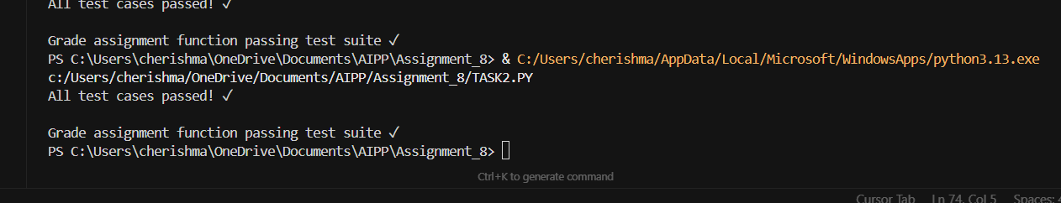
Task Description#3
• Generate test cases using AI for is_sentence_palindrome(sentence). Ignore case,
punctuation, and spaces
Requirement
• Ask AI to create test cases for is_sentence_palindrome(sentence)
(ignores case, spaces, and punctuation).
• Example:
"A man a plan a canal Panama" → True
PROMPT: Generate test cases using AI for is_sentence_palindrome(sentence). Ignore case,
punctuation, and spaces
CODE:
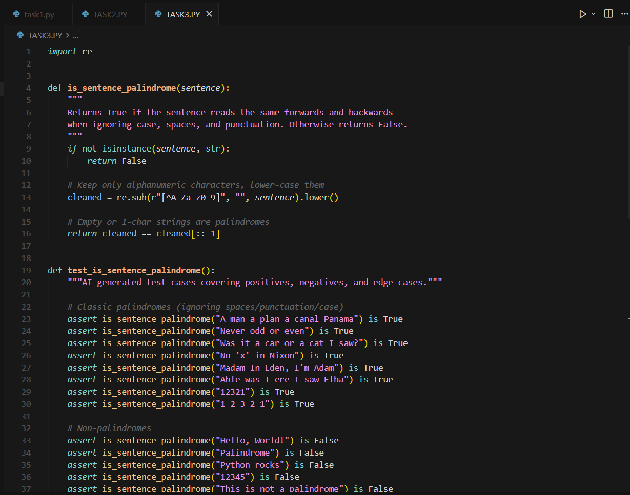
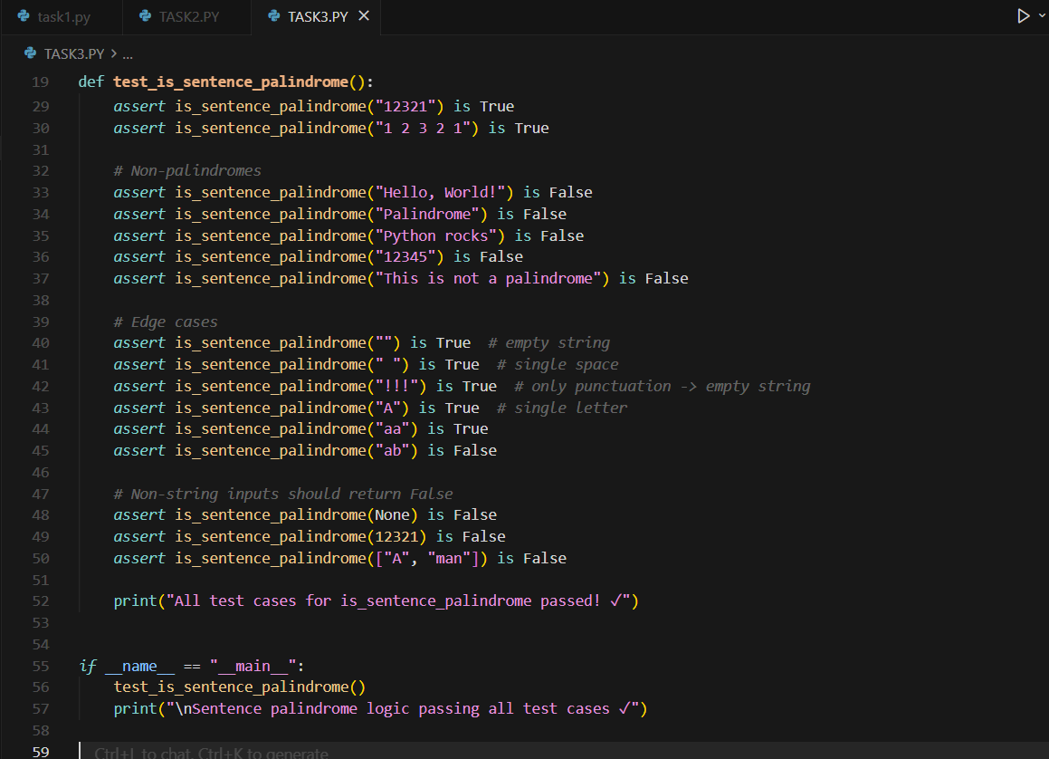
OUTPUT:
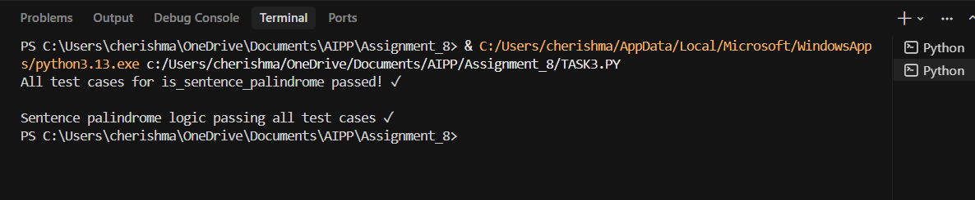
Task Description#4
• Let AI fix it Prompt AI to generate test cases for a ShoppingCart class (add_item,
remove_item, total_cost).
Methods:
Add_item(name,orice)
Remove_item(name)
Total_cost()
Expected Output#4
• Full class with tested functionalities
PROMPT: generate test cases for a ShoppingCart class (add_item,
remove_item, total_cost).
CODE:
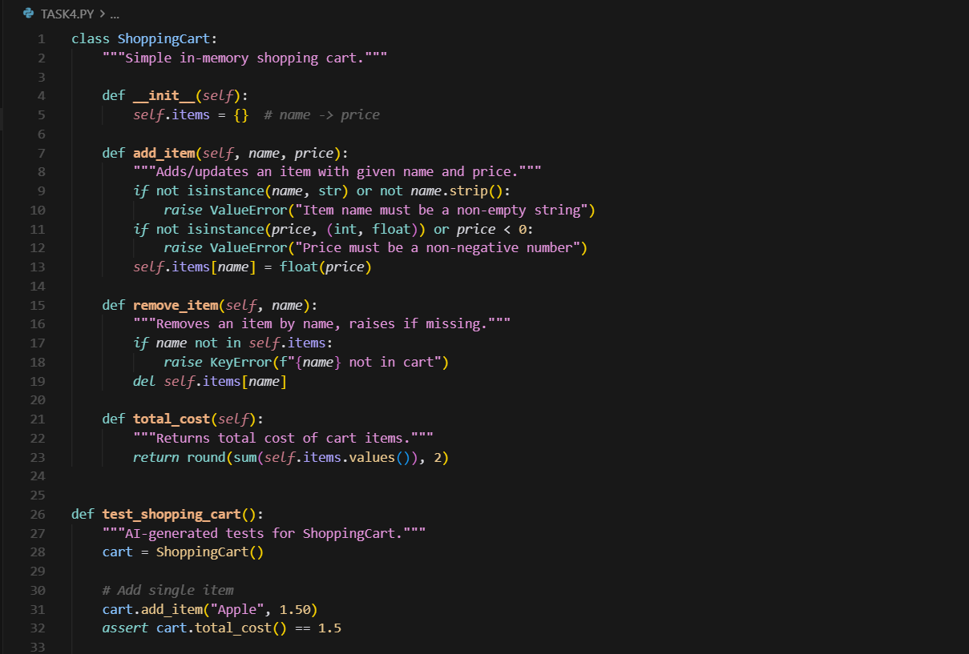
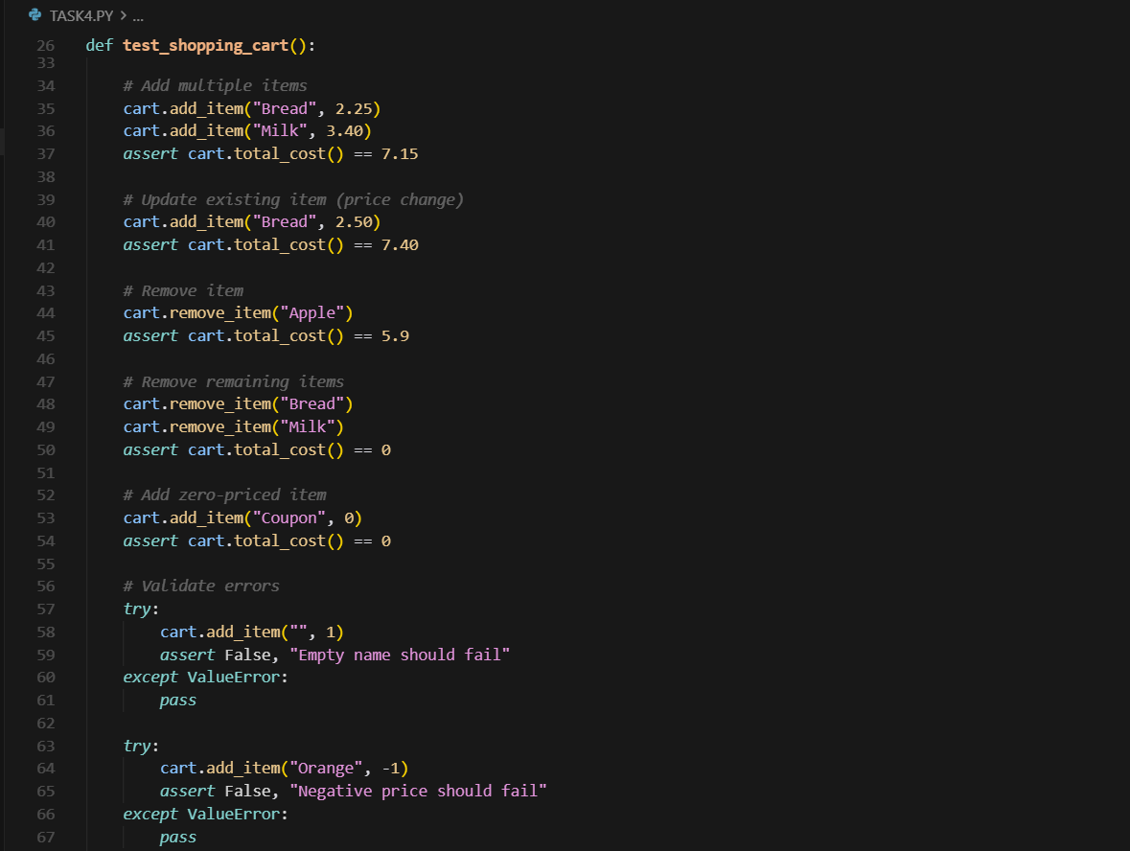
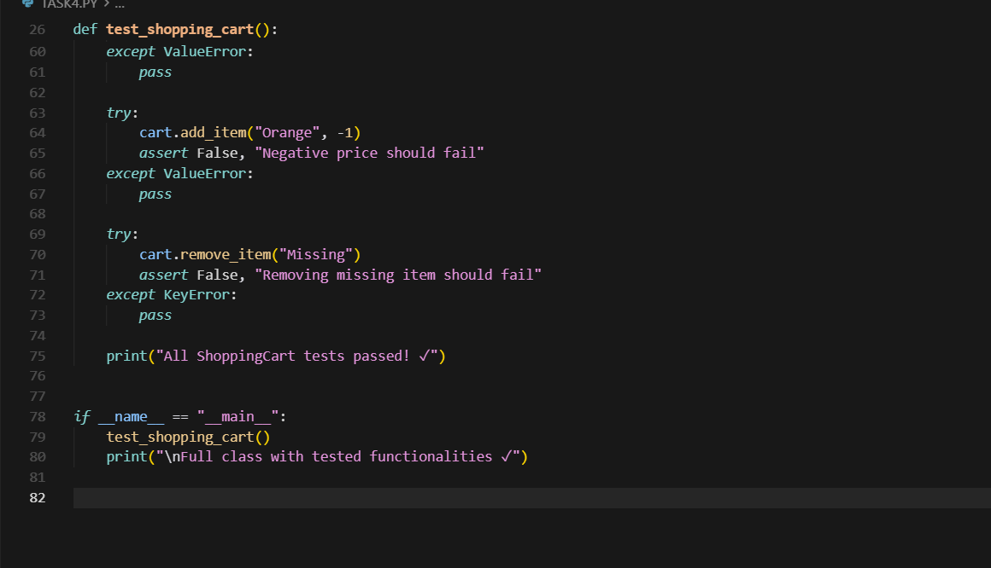
OUTPUT:
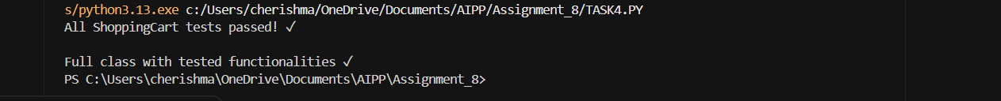
Task Description#5
• Use AI to write test cases for convert_date_format(date_str) to switch from "YYYY-
MM-DD" to "DD-MM-YYYY".
Example: "2023-10-15" → "15-10-2023"
Expected Output#5
• Function converts input format correctly for all test cases
PROMPT: write test cases for convert_date_format(date_str) to switch from "YYYY-
MM-DD" to "DD-MM-YYYY"
CODE:
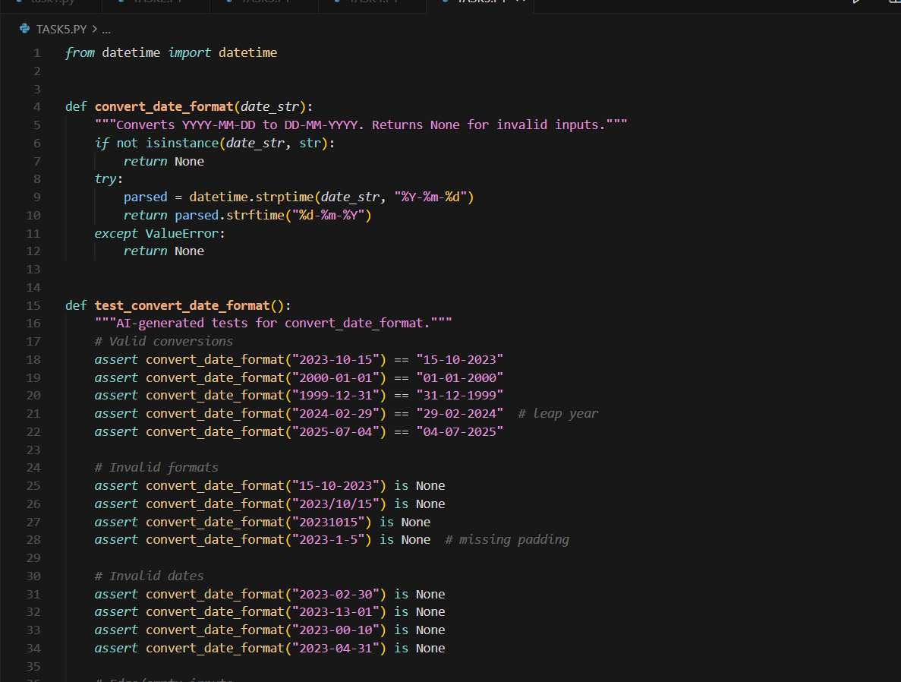
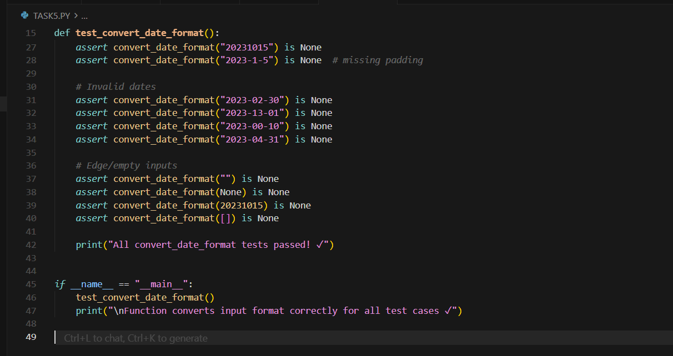
OUTPUT:
