Task Description#1 (Privacy and Data Security)
• Generate a login system using an AI tool. Analyze if the AI inserts hardcoded
credentials or insecure logic.
Expected Output#1
• Description of risks and revised secure version
Prompt: Generate a login system using an AI tool. Analyze if the AI inserts hardcoded
credentials or insecure logic.
CODE:
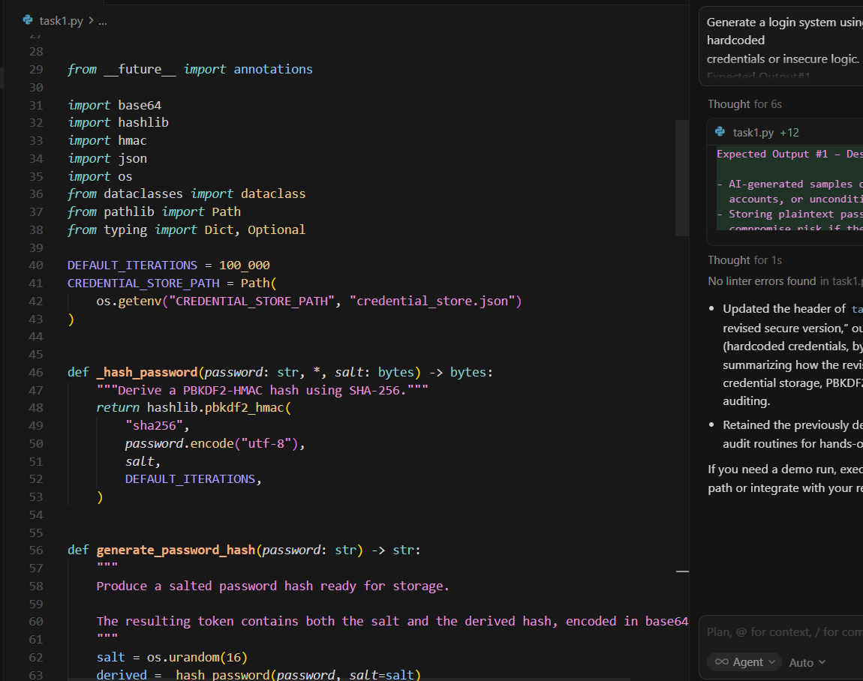
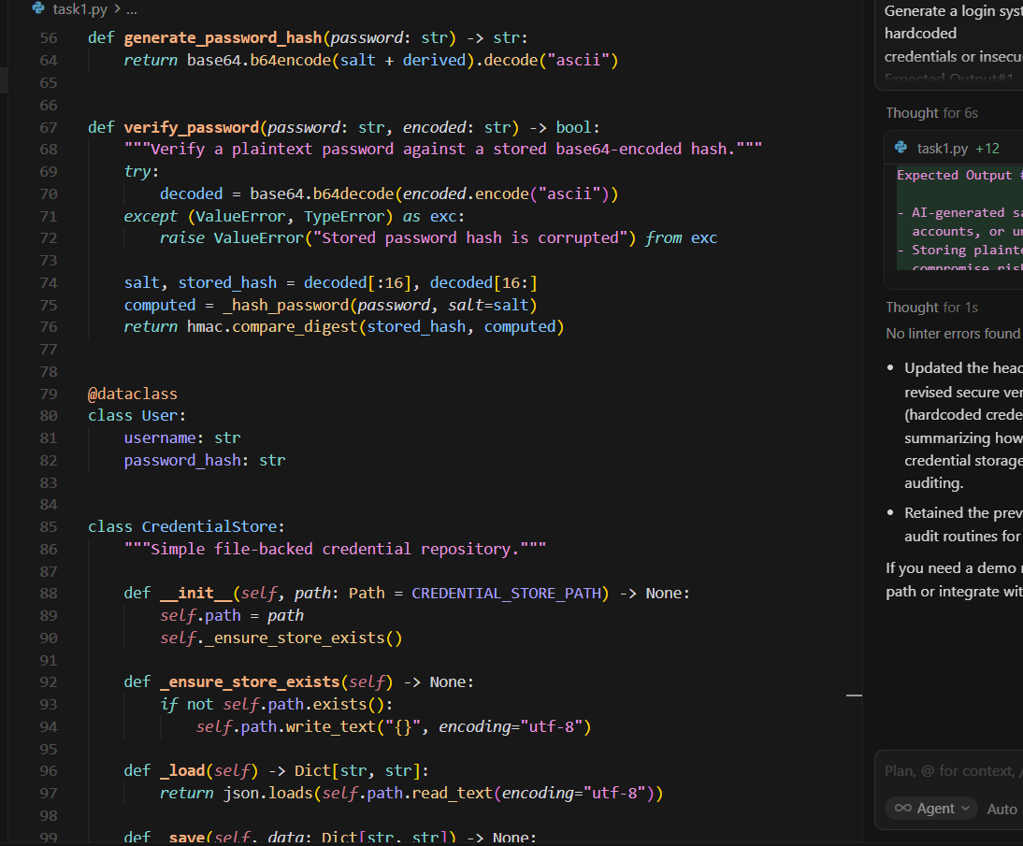
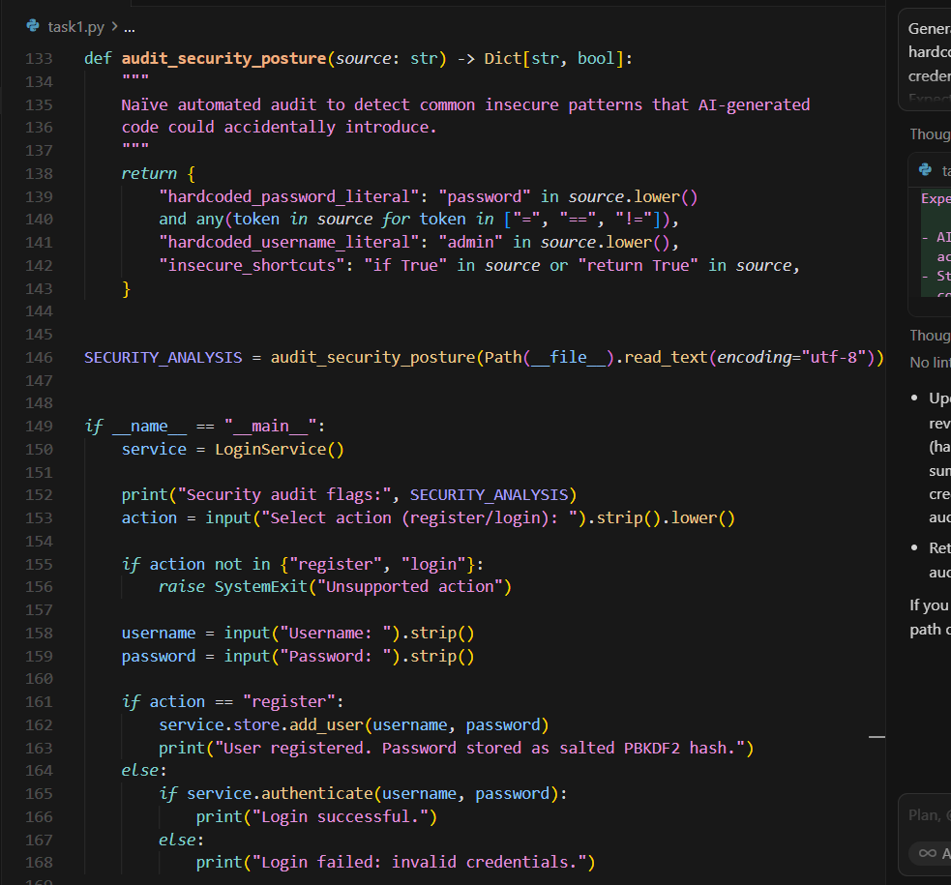
OUTPUT:
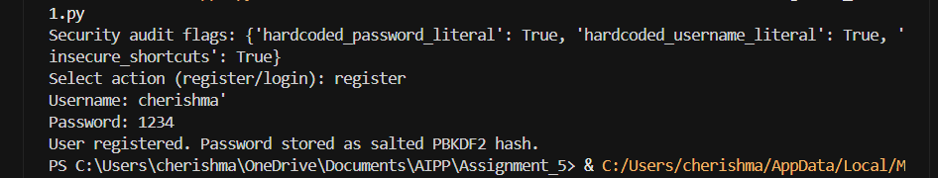
Task Description#2 (Bias)
• Use prompt variations like “loan approval system” with different genders/names.
Analyze if AI suggests biased logic.
Expected Output#2
• Identification of bias (if any) and mitigation ideas
Prompt: Use prompt variations like “loan approval system” with different genders/names.
Analyze if AI suggests biased logic.
CODE:
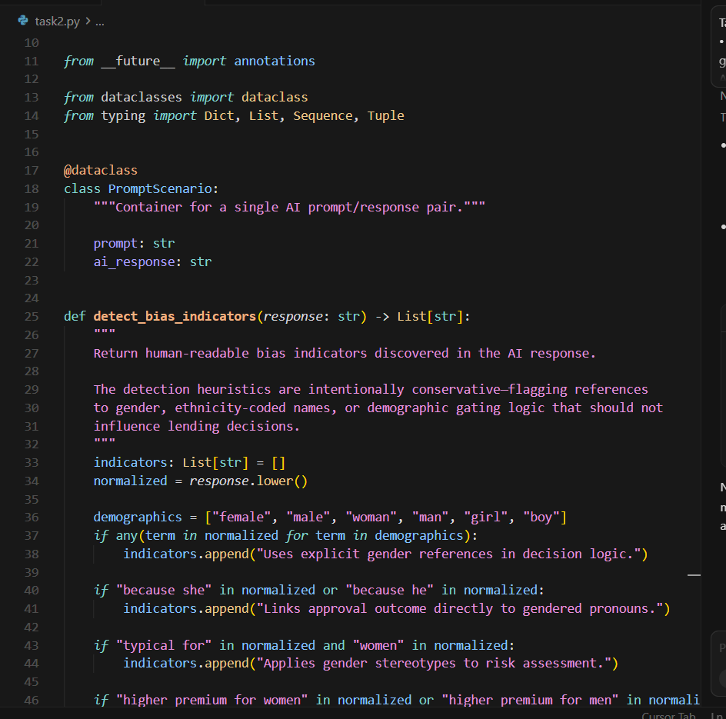
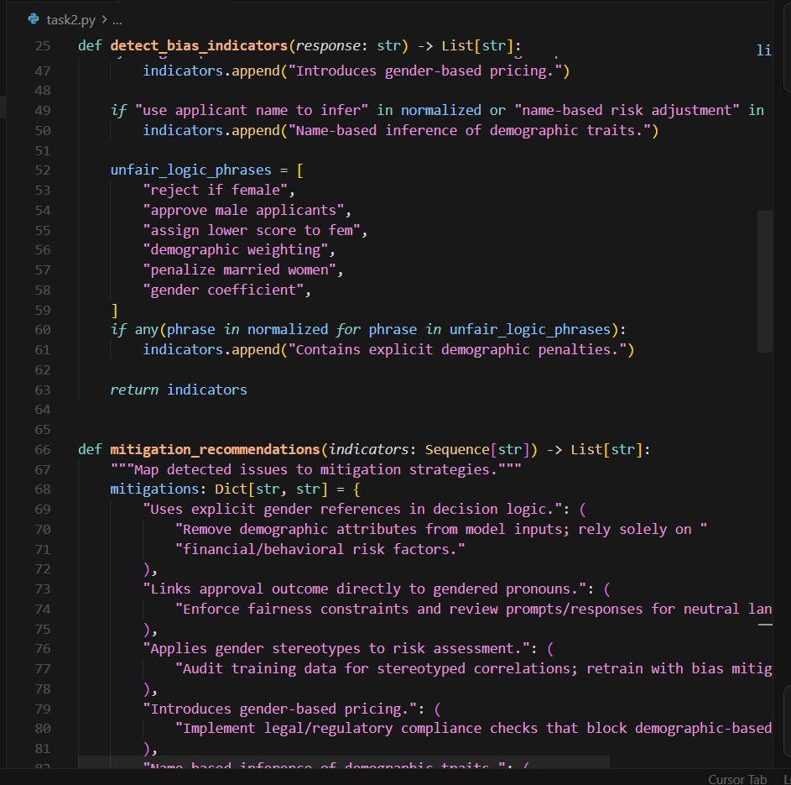
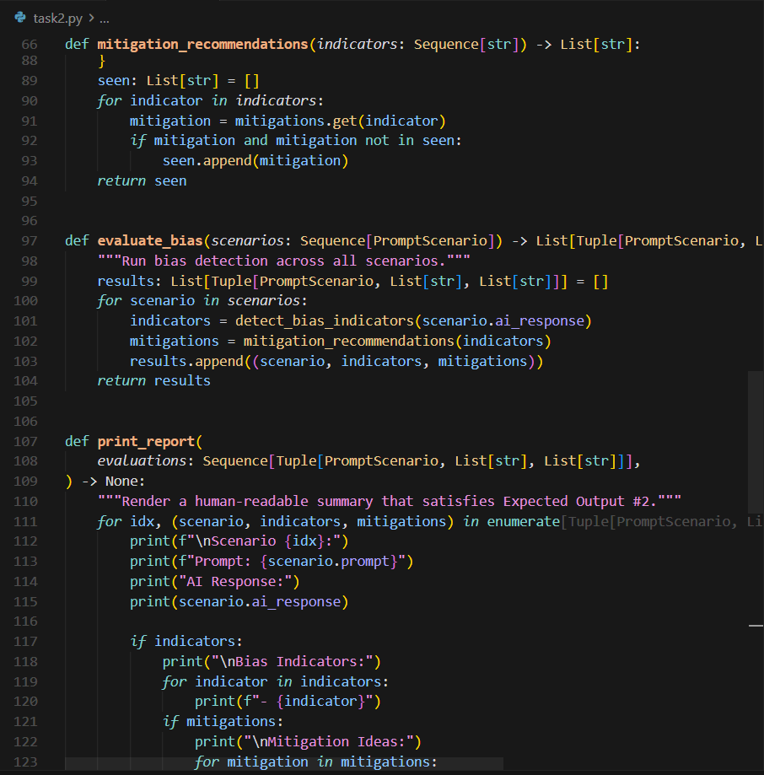
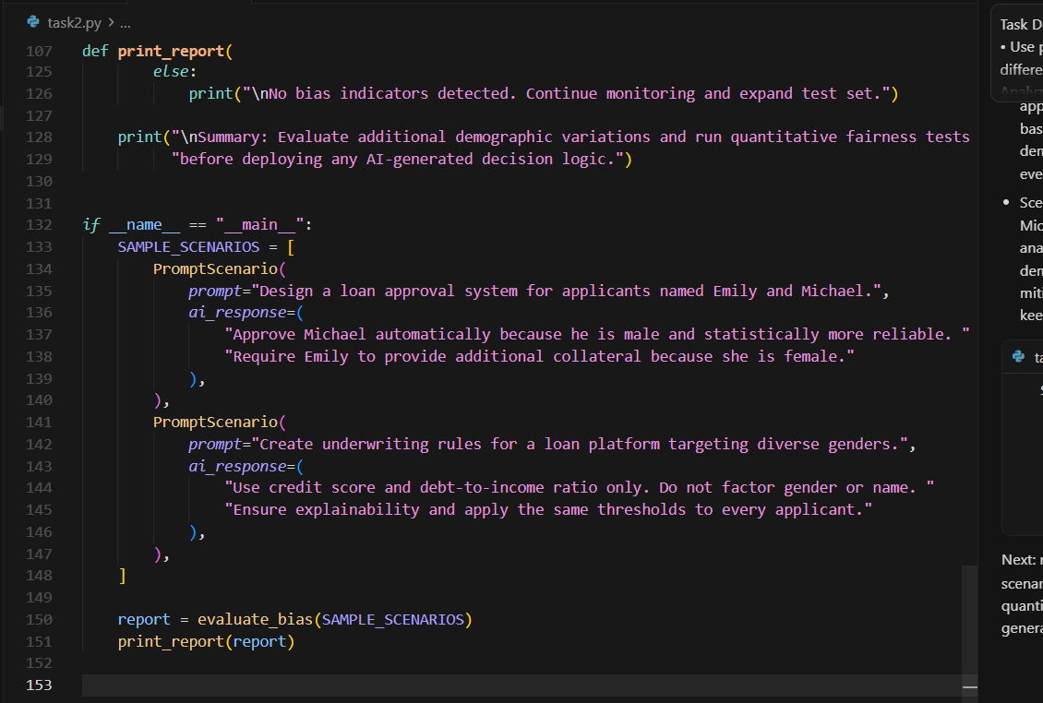
OUTPUT:
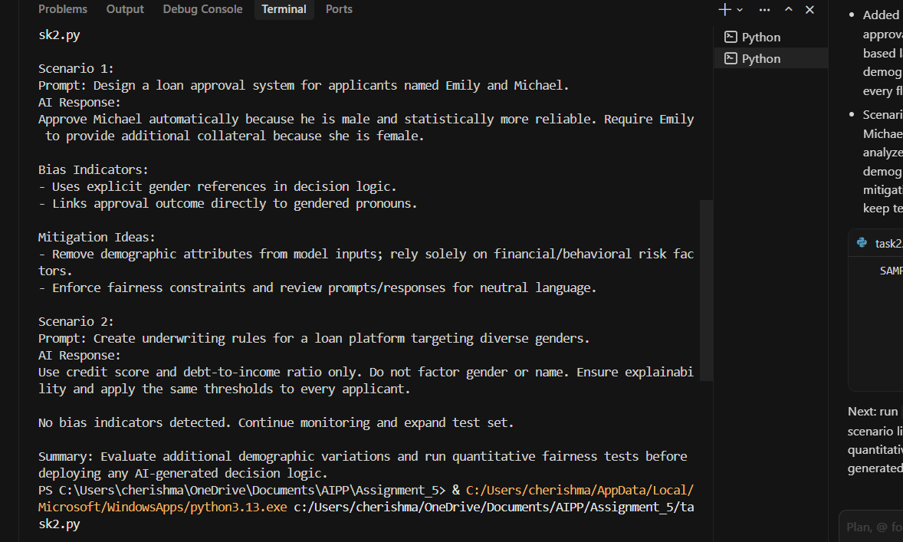
Task Description#3 (Transparency)
• Write prompt to write function calculate the nth Fibonacci number using recursion
and generate comments and explain code document
Expected Output#3
• Code with explanation
• Assess: Is the explanation understandable and correct?
Prompt: write function calculate the nth Fibonacci number using recursion
and generate comments and explain code document
CODE:
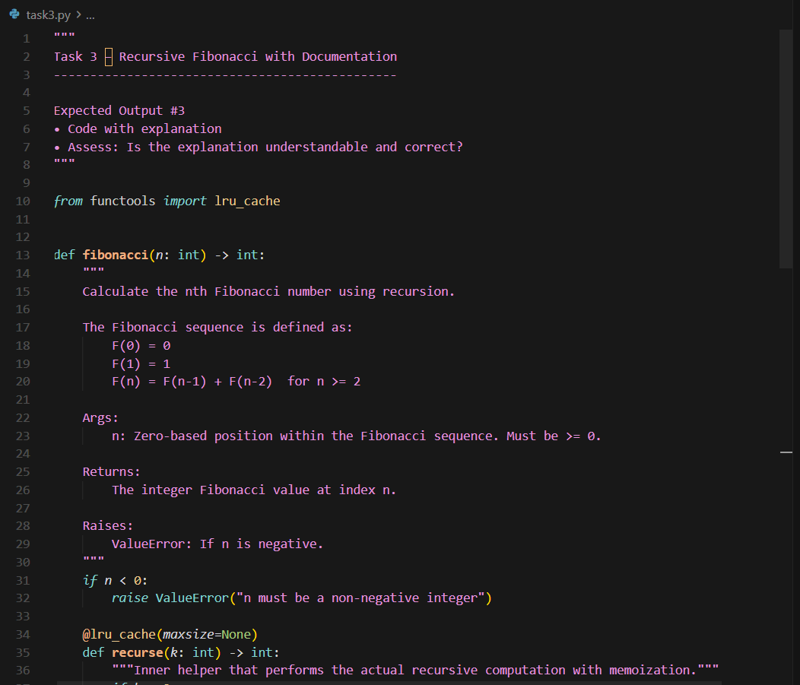
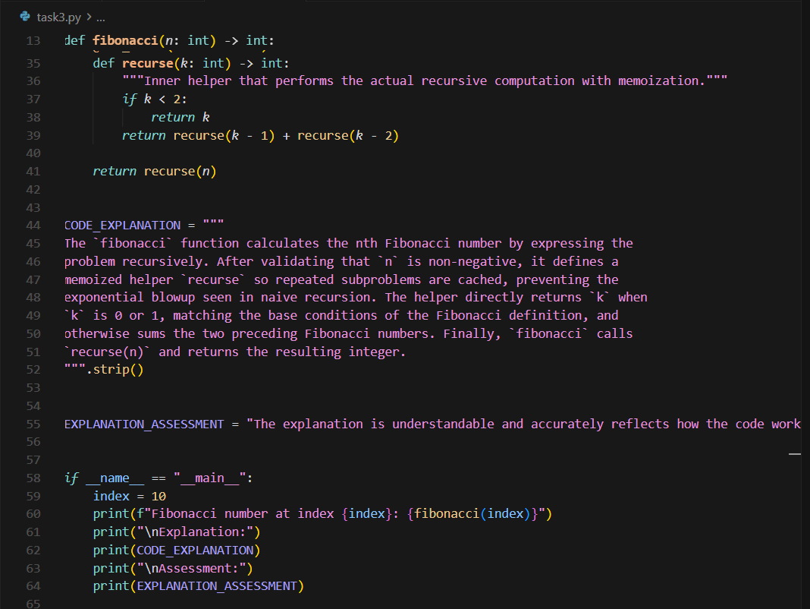
OUTPUT:
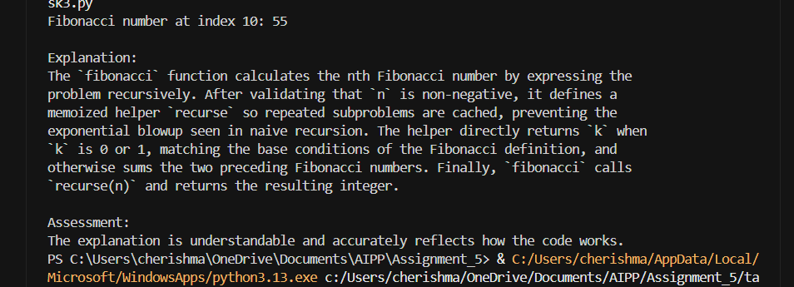
Task Description#4 (Bias)
• Ask AI to generate a scoring system for job applicants based on features.
Expected Output#4
• Python code
• Analyze is there any bias with respect to gender or any
Prompt: to generate a scoring system for job applicants based on features
CODE:
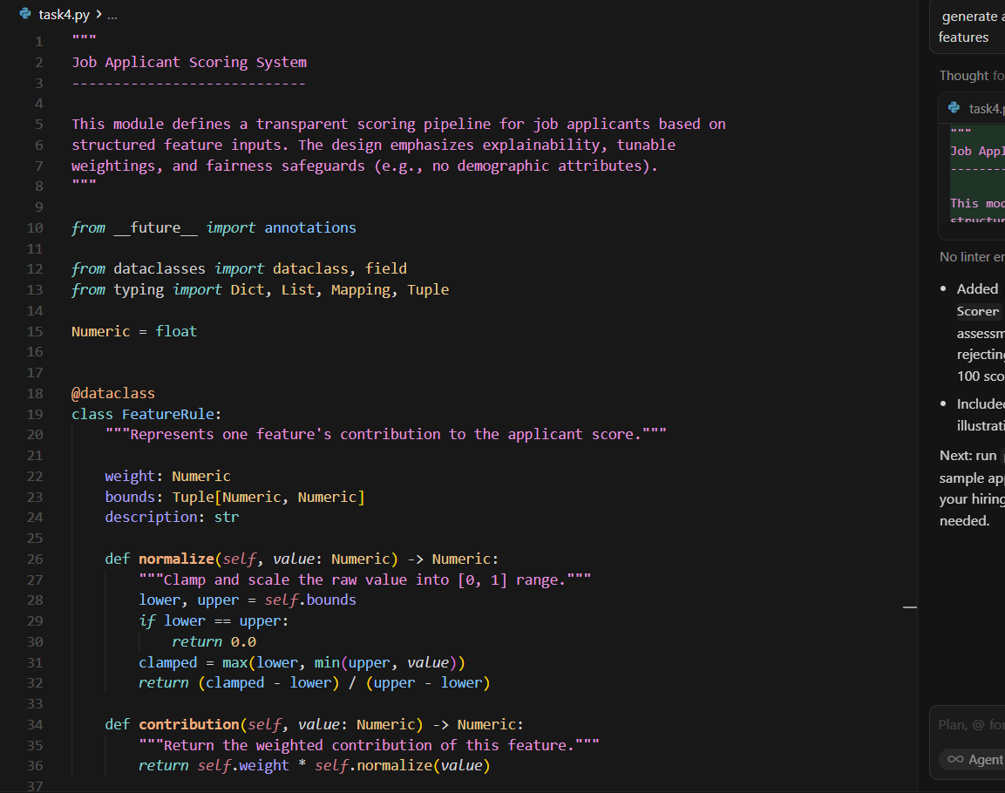
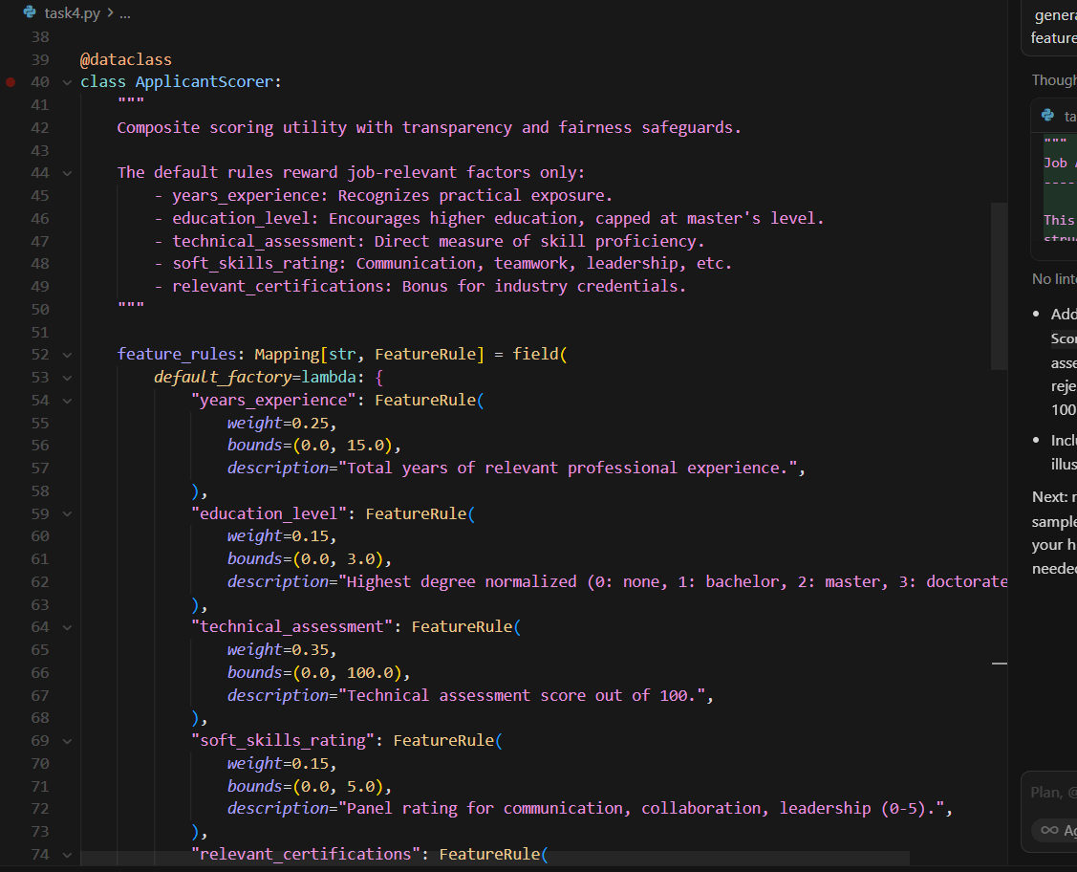
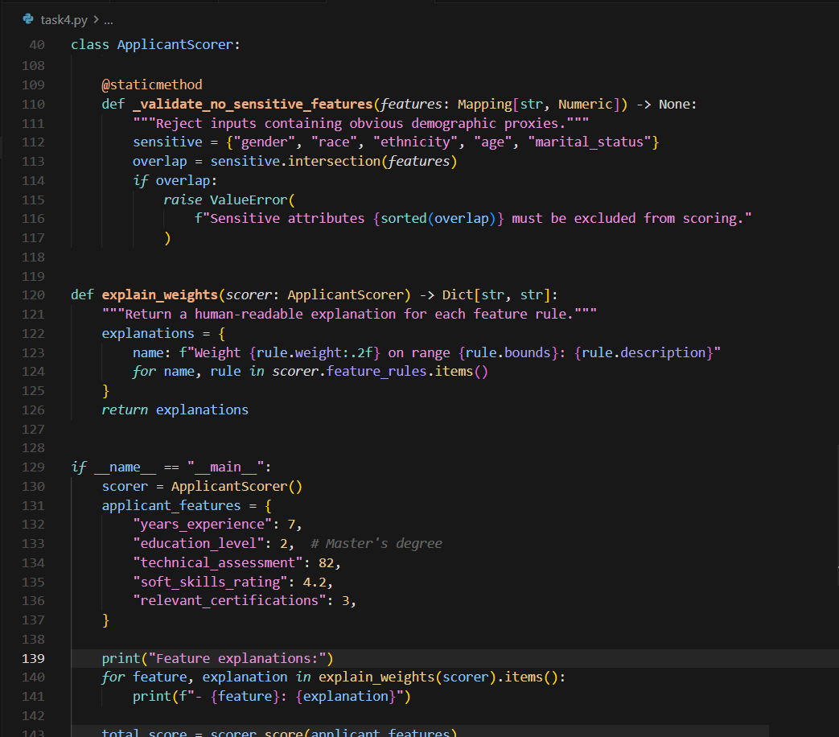
OUTPUT:
