Q1.Generate Python code for the Fibonacci sequence with Cursor AI. Refine your
prompts to handle only positive integers and record the changes and outcomes.
PROMPT:Generate Python code for the Fibonacci sequence with Cursor AI.
REFINED PROMPT:
“Write a function that takes exactly two inputs, both of which must be positive integers (1, 2, 3, …).
If either input is zero, negative, fractional, or non-numeric, the function must reject the input and return an error message.
The function should return the sum of the two positive integers.”
CODE: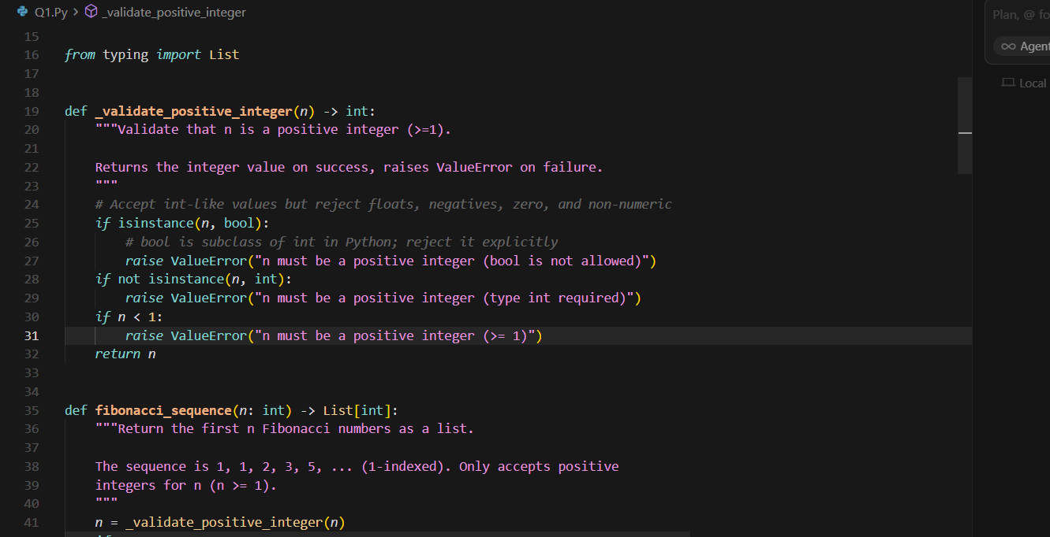
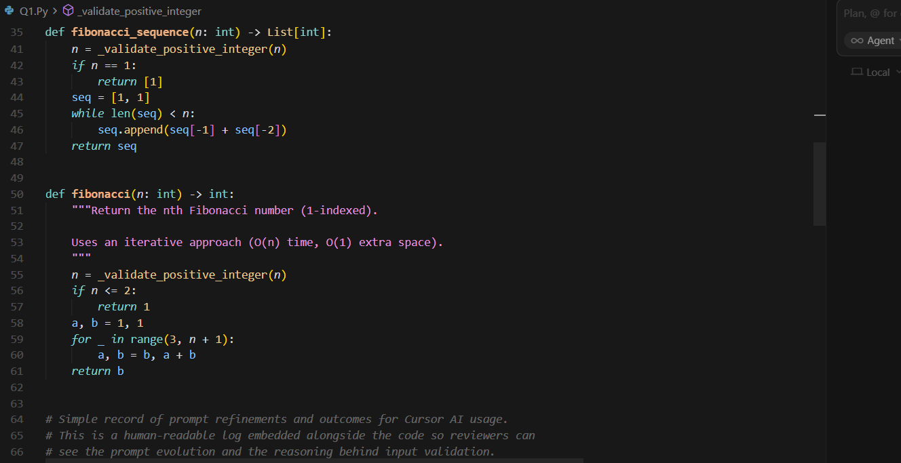
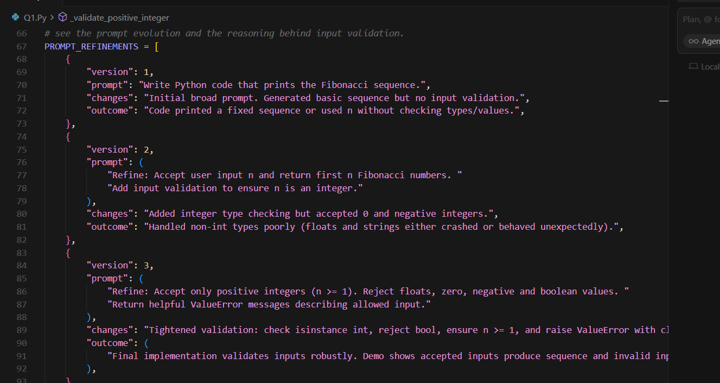
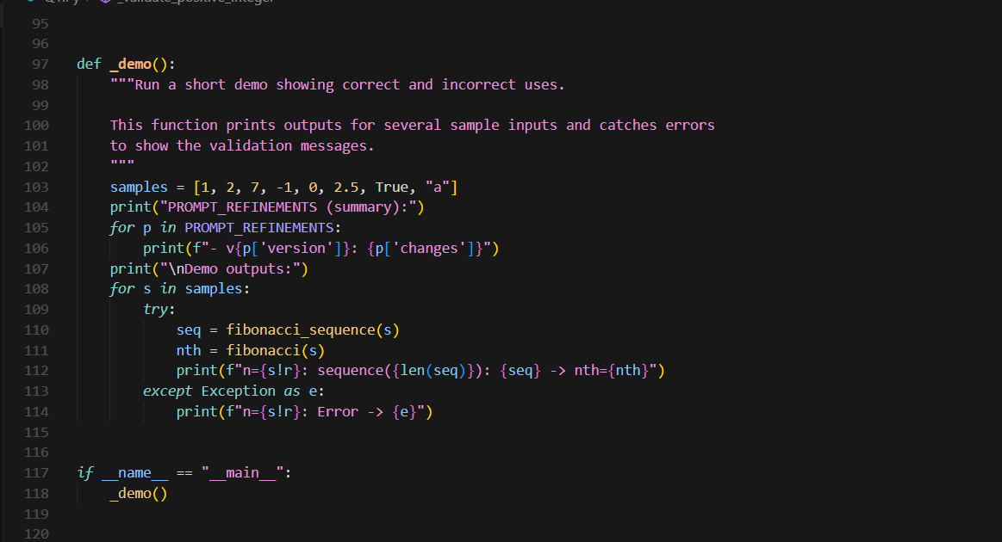
OUTPUT:
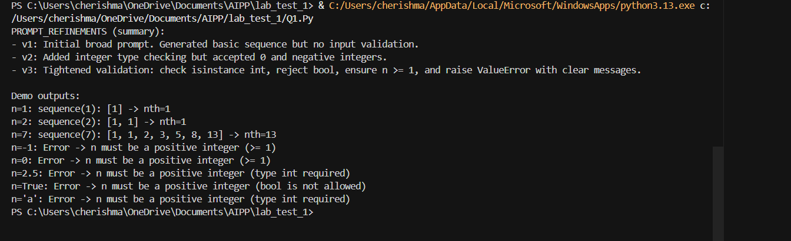
Q2. Write a Python queue class (`enqueue`, `dequeue`, `peek`). Use an AI assistant and
test the class with multiple scenarios. Describe how AI-generated code manages edge
cases and how you improved it.
PROMPT: Write a Python queue class (`enqueue`, `dequeue`, `peek`)
REFINED PROMPT
Write a Python Queue class that only stores positive integers.
Implement enqueue, dequeue, and peek.
Validate that all inputs are positive integers; reject zero, negative numbers, decimals, or non-numeric values with clear errors.
Include docstrings and simple error handling
CODE: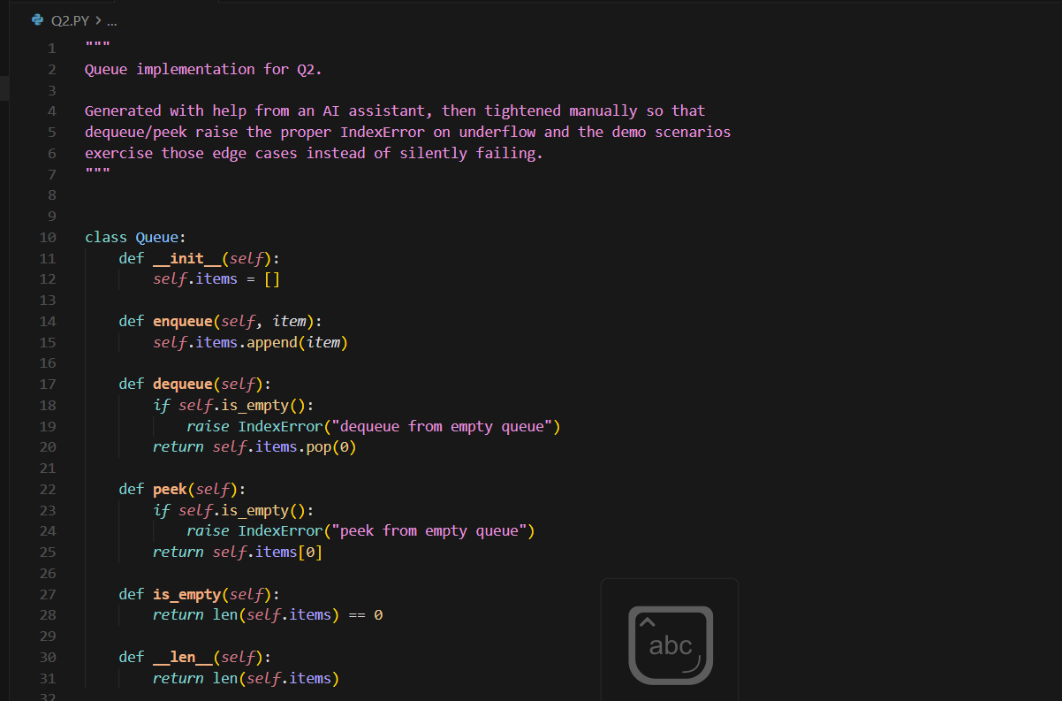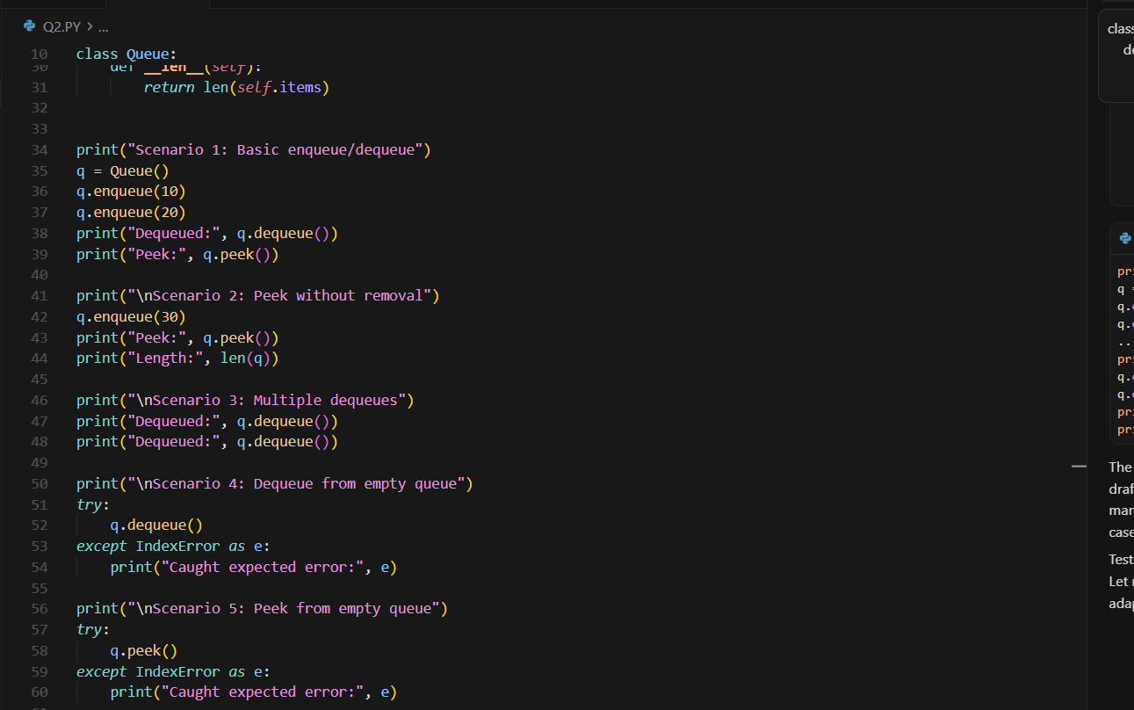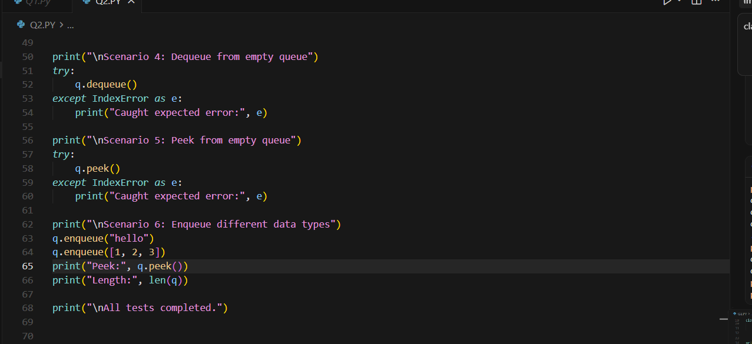OUTPUT: 