Task Description#1
● Paste a function with a missing colon (add(a, b)), and let AI fix the syntax error.
Expected Output#1
● Corrected function with syntax fix
Prompt: function with a missing colon (add(a, b)), and let AI fix the syntax error.
OUTPUT:
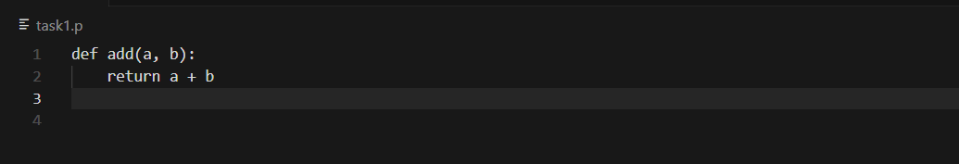
Task Description#2 (Loops)
● Identify and fix a logic error in a loop that causes infinite iteration.
Expected Output#2
● AI fixes increment/decrement error
PROMPT: Identify and fix a logic error in a loop that causes infinite iteration.
OUTPUT: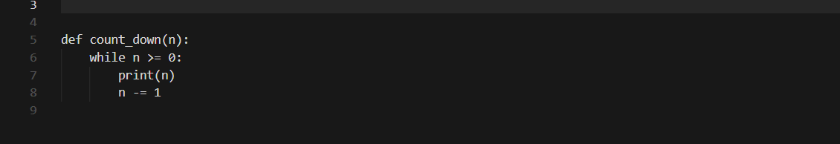
Task Description#3
● Debug a runtime error caused by division by zero. Let AI insert try-except.
Expected Output#3
● Corrected function with safe error handling
PROMPT: Debug a runtime error caused by division by zero
OUTPUT :
Task Description#4
● Provide a faulty class definition (missing self in parameters). Let AI fix it
Expected Output#4
● Correct __init__() method and explanation
PROMPT: Provide a faulty class definition (missing self in parameters).
OUTPUT:
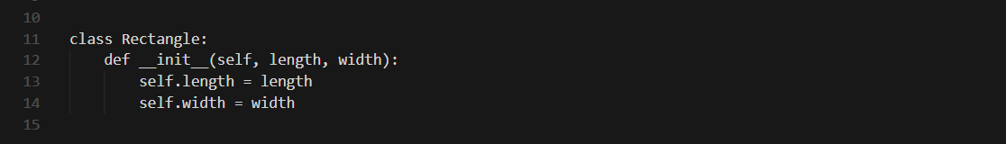
Task Description#5
● Access an invalid list index and use AI to resolve the Index Error.
Expected Output#5
● AI suggests checking length or using safe access logic
PROMPT: Access an invalid list index and use AI to resolve the Index Error.
OUTPUT:
