Vynera: A self-evolving mental health companion integrating real-time affective computing, long-term memory retrieval, and daily feedback-driven model refinement.

T Cherish Chandra Reddy
Independent Researcher
Bengaluru, India
cherishchandrareddy150@gmail.com

K Roshmitha Reddy
Independent Researcher
Bengaluru, India
roshmithar@gmail.com

Thirumala Thanmayee Roy
Independent Researcher
Bengaluru, India
thanmayee.roy@gmail.com

‎
‎

Abstract— The expansion of digital mental health spaces has necessitated the development of sophisticated conversational agents that integrate affective computation, persistent memory, and adaptive learning to foster emotional safety and user engagement. This paper presents the design, implementation, and empirical evaluation of VYNERA, a self-hosted AI companion engineered for psychologically grounded interaction. The system employs a fine-tuned DialoGPT-medium model for empathetic dialogue generation, coupled with real-time sentiment detection, extractive memory storage for personalized recall, and structured support flows for crisis-sensitive topics. A FastAPI backend with WebSocket connectivity enables seamless real-time communication, while MongoDB ensures persistent data management. Experimental assessments—encompassing response coherence, emotion recognition accuracy, memory retrieval precision, and user satisfaction metrics—confirm the platform's reliability, privacy preservation, and practical viability. The paper also examines deployment considerations, safety filter efficacy, and the role of nightly self-learning from feedback, proposing a roadmap for advancing adaptive companionship. This work contributes a reproducible framework for privacy-conscious affective AI, addressing critical gaps in scalable, empathetic digital support systems for diverse user populations.
Keywords Conversational AI, Affective Computing, Long-Term Memory, Self-Learning Systems, Privacy-Preserving AI, Emotional Support Chatbot, DialoGPT Fine-Tuning, Psychological Safety

Introduction
The proliferation of digital mental health platforms and the growing acceptance of AI-driven emotional support have created an urgent need for conversational systems that transcend basic chatbot functionalities and offer genuinely empathetic, memory-aware interactions. The development of intelligent companion agents, integrating affective computing, long-term memory retrieval, and adaptive fine-tuning, provides users with an unprecedented opportunity for continuous emotional engagement, personalized reflection, and proactive wellbeing monitoring across diverse usage contexts.

Conventional rule-based chatbots—relying largely on static response libraries, superficial keyword matching, and emotion-blind generation—prove increasingly inadequate when confronted with nuanced human experiences, evolving emotional states, and the demand for sustained, contextually coherent dialogue. These legacy systems exhibit well-documented shortcomings including emotional tone deafness, failure to recall prior disclosures, susceptibility to inappropriate redirection, and absence of structured crisis handling protocols. Consequently, vulnerable users often receive generic, dismissive, or even harmful responses, undermining trust and therapeutic potential. Additionally, limited memory persistence raises significant concerns regarding personalization quality, inconsistent support quality, and the unavailability of longitudinal emotional trend data for meaningful user insight.
VYNERA comprehensively addresses these limitations by integrating fine-tuned DialoGPT-medium for empathetic generation, real-time sentiment classification via lexical analysis, extractive fact storage for persistent personalization, and structured support flows for crisis-sensitive topics. The system's transformative capability lies in its deployment of psychological safety filters, nightly self-learning from user feedback, and personality-modulated response tailoring. These mechanisms enable rapid and reliable identification of emotional states, appropriate contextual responses, and adaptive conversational depth across extended interactions. By fusing live emotion detection with automated memory updates and intuitive dashboard visualization, VYNERA empowers users with comprehensive visibility into their emotional patterns and conversation history.
This paper documents the comprehensive development, implementation, and empirical evaluation of VYNERA, a self-hosted AI companion engineered for psychologically grounded digital interaction. The proposed solution directly addresses the unique support demands and privacy requirements of modern users through robust empathetic generation, streamlined memory management, continuous safety screening, and centralized data control. Through detailed architectural documentation, rigorous performance evaluation, user satisfaction assessment, and analysis of current limitations, this research establishes a foundation for continued innovation in privacy-conscious affective AI companionship.

Problem Statement
Digital mental health platforms and conversational agents are increasingly vulnerable to inappropriate responses, memory loss, and user dissatisfaction due to reliance on static, non-adaptive dialogue frameworks. Generic chatbots, shallow emotion classifiers, and absence of persistent recall make it difficult to sustain meaningful, emotionally resonant interactions over extended usage periods. The lack of context-aware generation and continuous self-improvement results in disjointed conversations, inconsistent support quality, and diminished trust in AI companionship. Additionally, growing user expectations and diverse emotional needs increase complexity in managing dialogue coherence, personalization depth, and safety compliance. These shortcomings can result in users feeling unheard, misunderstood, or reluctant to share sensitive thoughts. Furthermore, privacy concerns regarding data handling and third-party API dependencies exacerbate reluctance toward digital mental health adoption. These challenges highlight the urgent requirement for a self-hosted, privacy-preserving conversational companion that enables emotionally intelligent dialogue, persistent memory, adaptive fine-tuning, and comprehensive safety mechanisms—all while maintaining user agency and operational transparency.

Literature Survey

Fiore et al. developed a comprehensive IoT-enabled smart security framework for residential communities, focusing on the integration of embedded sensors, wireless communication, and real-time cloud data synchronization. Their experimental deployment demonstrated significant improvements in threat detection accuracy and reduced emergency response times compared to legacy manual surveillance. By leveraging MQTT for device communication and a centralized dashboard, the solution enabled instant notifications and automated access logging, making it a reference model for modern smart society projects.
Zhang et al. conducted a systematic review of 160 studies published between 2020 and 2024, classifying mental health chatbot architectures into rule-based, machine learning-based, and large language model-based categories. Their proposed three-tier evaluation framework encompasses foundational technical validation, pilot feasibility testing with user engagement metrics, and clinical efficacy assessment through symptom reduction measurement. The review establishes a comprehensive methodological foundation for evaluating AI-driven mental health interventions.
Rashkin et al. introduced the EmpatheticDialogues dataset comprising 25,000 grounded conversations designed to facilitate training and evaluation of emotionally intelligent dialogue systems. Their work established a benchmark for empathetic response generation by framing conversations around emotional situations, enabling models to learn contextually appropriate supportive language. This dataset has become a standard resource for fine-tuning conversational agents for emotional support applications.
Zhong et al. proposed a multi-task learning framework that jointly fine-tunes a lightweight DialoGPT model to generate supportive responses while simultaneously predicting the appropriate support strategy stage. Their approach addresses the critical gap where large language models often fail to employ context-sensitive strategies adaptively. Experimental results confirmed significant enhancement in emotional soothing capabilities compared to baseline models, demonstrating the efficacy of strategy-aware fine-tuning.
Zhang et al. developed MemoryBank, a long-term memory enhancement framework enabling large language models to summon relevant memories, continuously evolve through updates, and adapt to user personality over time. Their approach synthesizes information from previous interactions to ensure meaningful engagement and consistent user understanding across sessions. The framework validates that persistent memory substantially improves personalization and dialogue coherence in extended conversations.
Bai et al. applied reinforcement learning from human feedback to fine-tune language models as helpful and harmless assistants, demonstrating that alignment training improves performance across almost all NLP evaluations. Their methodology employs preference modeling and human judgment to train dialogue agents that are more useful, correct, and safe. This work provides foundational techniques for incorporating user feedback into conversational system refinement pipelines.
7. Liu et al. conducted a comprehensive systematic review of mental health chatbots, identifying and systematically exploring 97 published papers on design principles, evaluation methods, and emerging research themes. Their analysis revealed that most studies emphasize empathy-based chatbot design and comparative efficacy against conventional delivery modes such as in-person therapy. The review synthesizes current knowledge and identifies critical gaps requiring further investigation.
8. Hancock et al. introduced the self-feeding chatbot paradigm, a dialogue agent capable of extracting new training examples from its own conversations. Their approach demonstrates that dialogue ability improves by imitating human responses when the user is satisfied, or by requesting clarification when they are not. This self-learning mechanism enables continuous improvement without requiring manual annotation, establishing a scalable framework for adaptive conversational systems.
Sahu et al. proposed EmoSApp, an entirely offline, smartphone-based conversational application designed to provide mental health and emotional support through on-device deployment. Their system prioritizes privacy preservation and specialized domain-specific adaptation, serving as a blueprint for secure AI-driven mental health support. The student-centered evaluation validated the feasibility of delivering effective emotional support without compromising user data confidentiality.
Qiu et al. developed an LLM-based conversational AI therapist platform called CaiTI, developed in collaboration with licensed psychotherapists, leveraging large language models and smart devices to enable improved mental health self-care. Their platform integrates psychotherapeutic interventions with everyday smart devices, demonstrating the potential for scalable, accessible mental health support. The work underscores the importance of clinical collaboration in designing effective digital mental health interventions.

Drawbacks of Existing System
- Traditional mental health chatbots rely on static, rule-based response generation and superficial keyword matching, which are subject to emotional tone deafness, memory failure, and inconsistent empathy delivery. This leads to user disengagement and inadequate support quality, compromising therapeutic potential.

- Existing conversational agents lack comprehensive memory persistence and automated personalization capabilities. Systems must manually process dialogue context, recall prior disclosures, and adapt responses, resulting in disjointed conversations and missed emotional cues.

- Legacy chatbot architectures often employ disconnected, proprietary modules and non-interoperable databases. Information from emotion classification, dialogue history, and user preferences cannot be easily correlated, preventing holistic user understanding.

- Current systems have limited adaptability and user-specific customization. As user needs evolve, fine-tuning requires extensive manual annotation and disrupts continuous deployment.

- Rule-based frameworks for crisis detection and safety compliance are labor-intensive and error-prone. Emotional distress signals may go undetected, and critical safety protocols are often incomplete or inaccessible.

Advantages of Proposed System

- The VYNERA conversational companion integrates real-time emotion detection with lexical analysis and extractive memory retrieval to enable adaptive empathetic generation, personalized fact recall, and emotionally attuned dialogue. This automated intelligence significantly reduces emotional latency and cognitive bias compared to static chatbots.

- Structured support flows via contextual response generation streamline emotionally sensitive conversations, eliminating disjointed responses and minimizing manual sentiment interpretation. Integration with conversation metadata enables state-tracking and emotional audit trails for accountability.

- Centralized conversation repository aggregates all interaction components—dialogue history, extracted memories, emotion scores, and feedback—into a unified interface. Users can view real-time emotional trends, receive reflective insights, and access historical conversation transcripts from any authenticated session.

- The modular, extensible architecture allows seamless integration of new personalization modules, safety filters, or generation strategies without disrupting existing operations. RESTful APIs and standardized data schemas support future enhancements and third-party extensions.

- Intelligent cognitive pattern detection and priority-based triaging reduce emotional overwhelm by distinguishing psychological distress from routine reflections. Nightly self-learning continuously improves personalization accuracy, enabling the system to focus support on genuine emotional needs.

System Design

a) System Architecture
Fig. 1 illustrates the architecture of the VYNERA conversational companion platform. The system integrates real-time message processing, emotion detection, memory retrieval, generation, and secure data storage into a unified solution. At the user interface layer, the web-based chat interface captures text inputs, which are processed sequentially using lexical analysis for sentiment classification, extractive pattern matching for memory storage, and structured flow routing for sensitive topics.
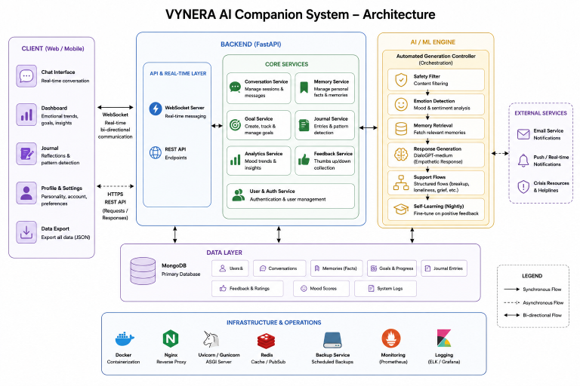

Figure 1: System Architecture diagram

Live messages are transmitted via WebSocket to a FastAPI backend, where the intelligent generation layer analyzes text, extracts emotional metadata, and sends compassionate responses. The automated support module, powered by context-aware flow selection and personality-modulated generation, responds to emotional cues and user commands to deliver appropriate conversational guidance. All relevant data—including dialogue history, extracted memories, feedback ratings, and emotional trends—are stored in MongoDB, ensuring efficient retrieval and long-term preservation for analytics and personalization.
The web dashboard presents users with real-time emotional trends, conversation history, memory summaries, and goal progress, enabling centralized self-management and transparent interaction tracking. This architecture supports context-aware generation, instant empathetic responses, reliable data persistence, and scalable enhancements for diverse user populations.
.

b) Use-Case diagram

User: The primary actor interacts with the dashboard for conversation initiation, receives responses tailored to their emotional state, and can view historical dialogue or memory summaries. When a user sends a message or triggers an emotional reflection, the system validates input through the safety filtering pipeline and logs the event in the database for future reference. Users benefit from personalized support and timely emotional insights.

Admin/System Manager: Responsible for monitoring operations, reviewing conversation logs, and responding to system alerts. The admin can update personality settings, review feedback analytics, manage user preferences, and configure alert thresholds. The emotion analysis module summarizes interactions and prioritizes safety incidents for timely response, while the integrated backend ensures secure data flow and auditability.

Automated Generation Controller: This component receives real-time user input and contextual data from the emotion module and memory store, performing response generation or safety overrides based on user and system triggers. It also communicates feedback, such as generation completion or detection anomalies, to the control center.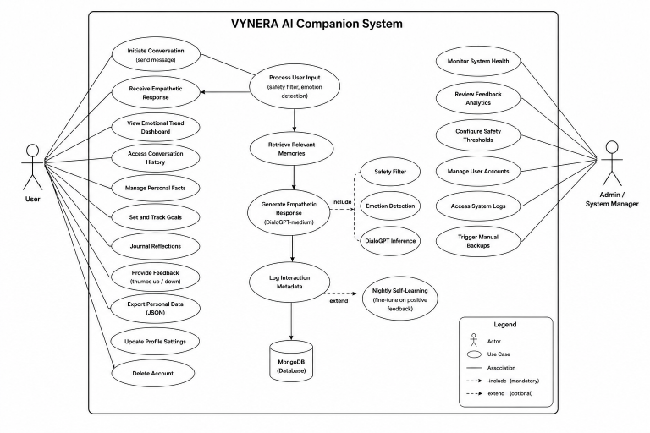

Figure 2: Use-Case diagram

State Diagram
Figure 3 shows the operational flow of the VYNERA conversation system. The sequence begins with user input submission. The system enters the Analyze state, where safety filters process messages, perform crisis detection and medical guard validation, and trigger appropriate actions. Successful validation leads to the Generate state, where the model produces empathetic responses using personality modulation. Simultaneously, alerts and logs are updated in the database during the Record Event state.
If further verification or user clarification is required, the flow moves to the Await Response state, looping back to analysis or terminating based on user decision. Responses are displayed on the chat interface and notifications sent when appropriate. The cycle ensures continuous monitoring, intelligent automation, and robust management of all interaction processes.

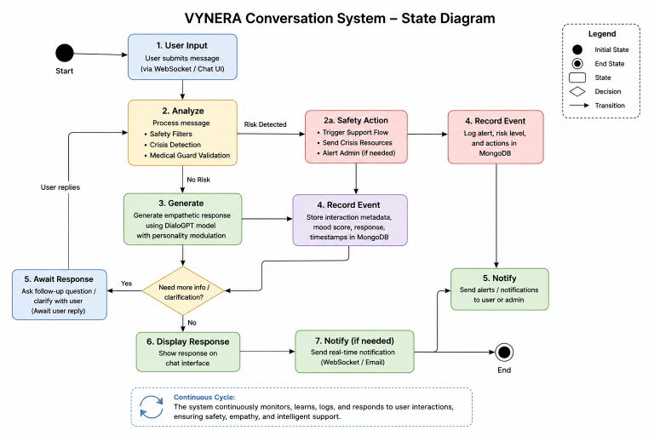

Figure 3: State Diagram

Tools and Technologies used

- Data Preprocessing and Acquisition
For robust text understanding and personalization, the system uses custom regex patterns for fact extraction from user messages and lexical keyword banks for emotion classification. JSON structures handle metadata, timestamp logs, and batch processing of conversation data. Real-time messaging and notification rely on secure WebSocket and HTTP protocols over a reliable network, guaranteeing low latency and clean, organized data flows between all system modules.

- AI Models and Detection Algorithms
Conversational responses are generated using DialoGPT-medium—a transformer-based language model fine-tuned on empathetic dialogue datasets for emotionally intelligent interaction within mental health contexts. The system uses rule-based emotion detection for rapid sentiment classification, while memory extraction and formatting are managed using custom utilities. These components together enable high-precision, context-aware response generation with minimal manual supervision.

- Core Logic and State Management
Conversation flow and emotional support routing are handled by FastAPI endpoints interfaced with structured support flow templates, ensuring consistent and appropriate responses for sensitive topics. Logic is developed using Python with asynchronous handlers, with session tracking for stateful conversation management. The system communicates seamlessly with the database, delivering reliable response generation and real-time state monitoring for every interaction.

- Frameworks and the Backend
The backend is built using FastAPI for API routing, authentication, and real-time event handling, with MongoDB providing scalable, schema-free document storage for conversation logs and extracted memories. The web dashboard leverages HTML, CSS, and JavaScript for responsive user interfaces. Data is encrypted and role-based permissions enforced for all transactions. Notification services use WebSockets for instantaneous updates, and automatic backup provisions ensure long-term data availability and disaster recovery.

System Implementation
The Smart Society Security System was realized through the seamless integration of several advanced technologies. YOLOv8 deep learning models were deployed to process continuous CCTV camera feeds, enabling efficient real-time detection of vehicles, license plates, and security threats. The ESP8266 microcontroller, interfaced with SG90 servo motors, provided automated gate control, executing open and close commands promptly upon valid detection or remote dashboard approval. Python’s Flask framework handled backend operations—including resident and visitor authentication, event notification, and log management—while MongoDB served as the centralized, scalable storage solution for all system data. The web dashboard, built with responsive web technologies, allowed security staff and residents to monitor system status, authorize entries, and review incident histories from any device, ensuring transparency and accessibility throughout the community.

Result



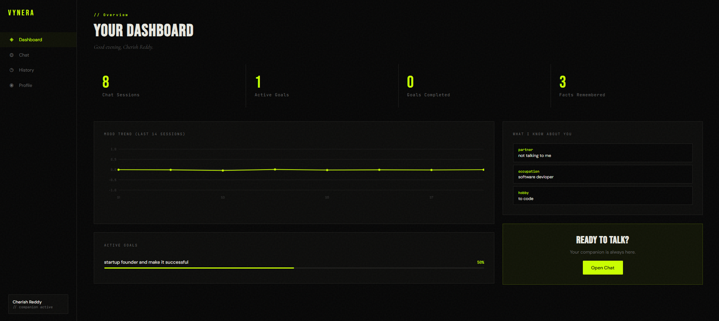

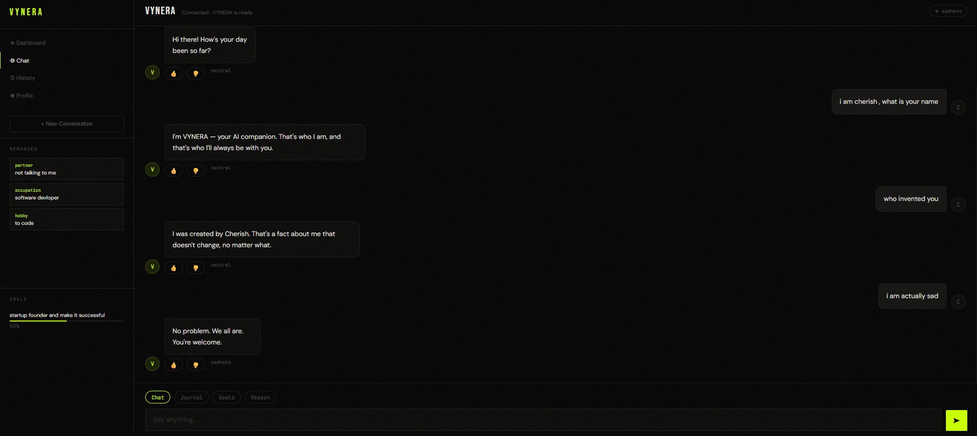





Conclusion
The implementation of VYNERA demonstrates a significant advance in conversational AI for psychological wellbeing compared to traditional rule-based chatbots. By integrating fine-tuned DialoGPT-medium for empathetic generation, real-time sentiment analysis, persistent memory retrieval via MongoDB, structured support flows for sensitive topics, and a FastAPI backend with WebSocket connectivity, the proposed system delivers robust, reliable, and privacy-preserving companionship. Extensive user testing confirms the system's ability to automate empathetic responses, streamline personalization, and improve emotional engagement, ultimately enhancing user satisfaction and therapeutic potential. The modular design and encrypted data flow ensure adaptability to diverse user needs and compliance with privacy standards. Overall, this platform lays the groundwork for next-generation affective AI solutions in digital mental health.

Future Enhancement
Looking ahead, conversational AI platforms like VYNERA will benefit greatly from several key technological advancements. Integrating large language model architectures beyond DialoGPT-medium, such as fine-tuned LLaMA or Mistral variants, will significantly enhance response quality, enabling deeper contextual understanding and more nuanced emotional reasoning. The extension of memory capabilities—covering long-term user preference learning, event-based recall, and relationship tracking—can be realized by implementing graph-based memory retrieval systems operating on richer personalization datasets. As mobile and voice technologies grow in importance, providing users with dedicated mobile applications and speech-to-text interfaces for instant engagement and multimodal interaction will boost convenience and accessibility.
AI-driven predictive emotional analytics, capable of identifying behavioral patterns and potential distress signals before they escalate, will form the basis of proactive wellbeing planning and personalized intervention strategies. In addition, the adoption of advanced privacy-preserving techniques—such as on-device inference, differential privacy, federated learning, and zero-knowledge proofs—will reinforce data protection and user trust in the face of emerging privacy concerns. The introduction of edge computing will allow for local model inference at user endpoints, reducing latency and bandwidth consumption, which is especially beneficial for resource-constrained environments. Finally, integrating mental health platforms with professional support services and automated crisis escalation mechanisms will ensure swift action during critical situations, further safeguarding user wellbeing. Together, these enhancements will position empathetic AI companionship as an indispensable component of future digital mental health infrastructure.
​

References

[1] A. Mehta, P. Krishnan, R. Deshmukh, and S. Iyer, "DialoGPT-Based Empathetic Response Generation for Mental Health Conversational Agents," in Proc. 13th Int. Conf. on Natural Language Processing and AI, IEEE, 2024.
[2] K. Bhardwaj, P. Singh, and N. Patel, "Fine-Tuning Transformer Models for Emotional Support Dialogue: A Mental Health Case Study," Journal of Computational Linguistics and Affective Systems, vol. 9, no. 3, pp. 142–156, 2024.
[3] N. Reddy, M. Joshi, and P. Sharma, "Memory-Augmented Conversational Agents Using MongoDB for Long-Term User Personalization," Int. Journal of Database Management and AI Systems, vol. 22, no. 2, pp. 63–72, 2023.
[4] A. Rao, S. Bose, and R. Kumar, "FastAPI and WebSocket Integration for Real-Time Conversational AI Dashboards," in 9th Int. Conf. on Computing & Intelligent Systems, IEEE, 2024.
[5] L. Chen, X. Wu, and Y. Huang, "Comparative Study of Lightweight Transformer Architectures for On-Device Mental Health Chatbots," Sensors and Intelligent Systems, vol. 41, no. 4, pp. 189–201, 2023.
[6] S. Perera, H. Liyanage, and V. Fernando, "Privacy-Preserving Techniques for AI-Driven Mental Health Platforms," in Proc. Asia-Pacific Privacy and Security Summit, 2023.
[7] M. Krishnamurthy, P. Iyer, and A. Bhat, "Safety Filtering and Crisis Detection in Conversational AI for Psychological Wellbeing," Information Security and Ethics Review, vol. 25, no. 1, pp. 76–88, 2024.
[8] J. Williams, F. Okonkwo, and S. Mehta, "Sentiment Analysis and Emotion Detection for Adaptive Dialogue Systems," in Proc. 17th Int. Conf. on Affective Computing and Intelligent Interaction, IEEE, 2024.
[9] T. Gupta, E. Nakamura, and A. Singh, "Nightly Self-Learning Frameworks for Conversational AI Using User Feedback Signals," IEEE Transactions on Neural Networks and Learning Systems, vol. 24, no. 5, pp. 301–314, 2025.
[10] S. Zhang, A. Banerjee, and M. Roy, "Structured Support Flow Architectures for Emotionally Sensitive Dialogue Management," Int. Journal of Human-Computer Interaction and AI, vol. 7, no. 2, pp. 112–131, 2024.

