

Names:

Eva-Veronica Szeredi, Philip Scott

Class: 6IF

Schoolyear: 2021-2022

Client: /

|  |  |
| --- | --- |
| Malwarebytes | Integrated Test - GIP |

Contents

Introduction 3

MALWAREBYTES: The Game 3

The Title Screen 4

The Settings 4

Graphics and Sound settings 5

Input Settings 6

The Playing Area 7

Cards 8

Draw Pile 9

Discard Pile 9

Exhaust Pile 9

Upgrading a card 10

The hudbar 11

The Deck 12

12

The map 13

The Legend 13

The Virus 14

The Monster 14

Rest Site 15

Winning the game 15

Infoboxes 16

# Introduction

For our end project we decided to create a 2D roguelike deck-building game in Java using the library libGDX. LibGDX is a free and open-source game-development application framework written in Java. We did not use a game engine like Unity. Everything you see is created from 0 by us. Every line of code, every visual aspect, is created by us. (Except some free game assets like the animated textures we used to display the player and enemy).

A roguelike deck-building game is a card game combined with generated randomness from roguelike games. Roguelike is a subgenre of role-playing games characterized by procedurally generated levels, turn-based gameplay, and permanent death of the player's character.

We have learned a lot by working on this project this schoolyear. It begun by trial and error but ended in something we’re proud to be able to finally share.

The game is no where near perfect, but we are planning to work on it further in our free time.

# MALWAREBYTES: The Game

The aim of the game is to invade and take over a PC as a computer virus. This will be done by beating certain software programs and physical parts of the computer. This gives the player MB of data as currency that can later be used in shops to buy various things that make the player stronger.

# The Title Screen

The first screen you get to see is the title screen. Here you start a new run by abandoning your old save file OR you can start a new run by clicking on play if there is no run in progress.

What you get to see IF there is already a run in progress:

ELSE:

You can also choose to change your settings first. You do this by clicking on the ‘Settings’ button.

# The Settings

The settings screen looks like the interface of a real BIOS. You know those things where you have to click on F10 when you boot your pc so you can change settings you can’t change anywhere else? Well this is kind of like that, except you can also change your settings while in combat!

## Graphics and Sound settings

* To use fullscreen mode, check the box next to ‘Fullscreen’. If left unchecked, the game will run in windowed mode.
* Running on a lower or higher resolution? No problem! Choose your desired resolution by selecting it in the choicebox next to ‘Resolution’. The first time you start up the game, it will open in 1920x1080.
* Switch between ‘false’ music and ‘true’ music by checking the music checkbox. Use the slider above the music checkbox to change the music volume.
* Switch between ‘false’ music and ‘true’ music by checking the sound checkbox. Use the slider above the sound effect checkbox to change the sound volume.

To save your settings, don’t forget to press on the **F10** key on your keyboard or else your preferences will be lost the next time you start up the game!

||

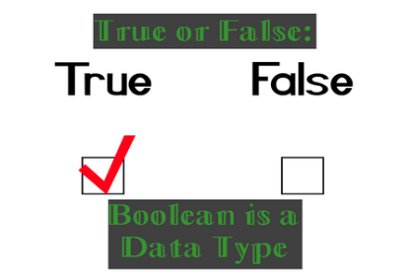Press the **ESC** key on your keyboard to discard settings.

Did you know?



## Input Settings

In the Input settings tab you’ll find all the currently assigned keys along with a small title about what that triggers. You can play the game on your keyboard by using those keys.

You can also change an assigned key to a different key if you prefer. To do this, click on the key you want to change and then type the key you’d like to assign. The newly assigned key is visible in the key box.

* Old key:



* Keybox waiting for a new key to be assigned:



* New key (Pressed L on keyboard):



There are 23 keys in total.

To save your settings, don’t forget to press on the **F10** key on your keyboard or else your preferences will be lost the next time you start up the game!

||

Press the **ESC** key on your keyboard to discard settings.



# The Playing Area

10. Session Timer

9. Pause Button

1. Your items

2. Function Card

8. Exhaust pile

7. End Turn Button

5. Discard pile

4. Draw Pile

3. Sequence

11. energy

6. Your hand

1. Items are permanent relics that provide a passive bonus for the rest of the run.
2. Once three cards have been stored in the sequence, you get a new card that triggers the effects of all three cards at once. A Function card can have a compile bonus, which runs at compile time: eg. ‘Draw 1 Card’ or a bad effect called a compile error: eg. ‘Insert 1 Slimed’.
3. Compile a function by encoding 3 cards in the sequence.
4. All cards in your deck start here at the start of combat. Cards drawn are drawn from this pile. If this pile is empty, your Discard Pile is shuffled into your draw pile.
5. The Discard Pile is where cards from your hand go at the end of your turn. If you try to draw cards when your draw pile is empty, your entire discard pile is shuffled into your Draw Pile.
6. These are your current drawn cards AKA your hand. Drag a card on yourself or the enemy to play the card.
7. Click to end your turn.
8. Exhausting a card puts it in your Exhausted Cards pile. Cards in this pile are effectively removed from combat and cannot be used again. If you exhaust a card that was in your deck, it will be returned to your deck at end of combat.
9. Pause the game. This will also pause the session timer.
10. Time elapsed since the start of the run.
11. Every turn you get 3 energy. This can be increased/decreased by cards.

# Cards

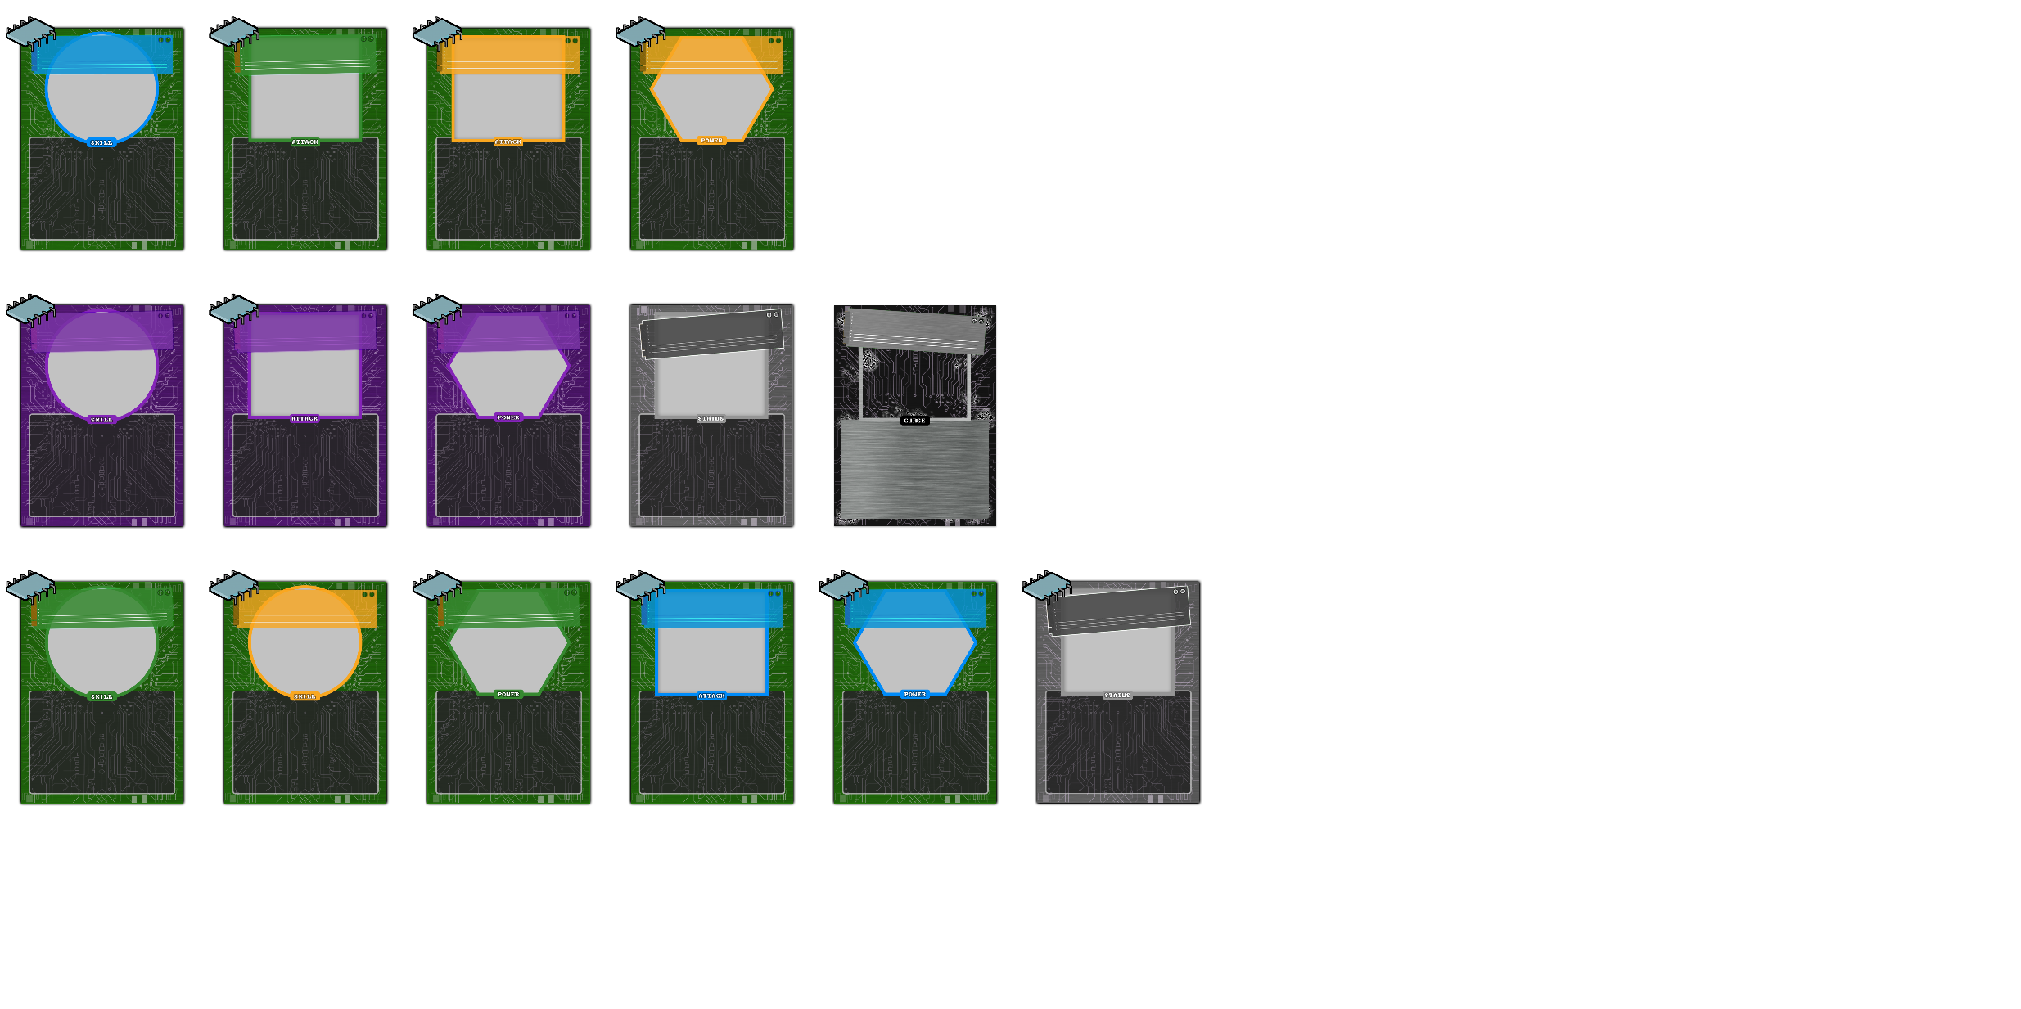

There are a total of 5 card types and 4 rarities (including function cards).

The 5 card types are:

* ATTACK CARD (square)
* SKILL CARD (circle)
* POWER CARD (pentagon)
* STATUS CARD (gray square)
* CURSE CARD (empty square)

The 4 rarities are:

* COMMON (green)
* UNCOMMON (blue)
* RARE (gold)
* FUNCTION (purple)

You can get new cards by winning combats against monsters. Usually gold cards have a smaller chance of appearing in combat rewards.

# Draw Pile

Cards are not shown in order. Every drawn card is random.

# Discard Pile

Cards are shown in the order they were discarded.

# Exhaust Pile

# Upgrading a card

On the upgrade card screen you will see a list of all cards currently In your deck. You may select a card to see what it does when upgraded. The differences are always coloured in green text. Once you’ve chosen what card you would like to upgrade, click on “Confirm” to get that card upgraded. You can always select a different card to upgrade by clicking next to the card on the faded background.

# The hudbar



1. This is where your health is shown. If it reaches zero you die.

2. Next to the health you will see how many MB of data you’ve collected as that is the currency of the game

3. Here you will find the session timer. This simply measures how long you’ve played in the current session

4. To view the map click on the “MAP” button to see what awaits you next.

5. By clicking on the “DECK” button you can view all the cards the player posesses

6. The pause button is located on the righter edge of the hudbar.

1

6

5

4

3

2

The Deck

This is the collection of all the cards that the player owns. You can sort the cards by time obtained, type, cost or alphabetically.

If you click on a card you can get a preview of what the card would look like if it was upgraded. Further, you can hover over cards with yellow text to get more information about what special effects they have.

The map

On the map you can see all the events that await you. You progress upwards by defeating an enemy or by visiting a “rest site”.

# The Legend

On the mapscreen you can see a legend that explains what all the different icons mean. With monster you can expect an ordinary fight. Rest means you’ll enter a Rest Site (explained later). Random means that it could be either.

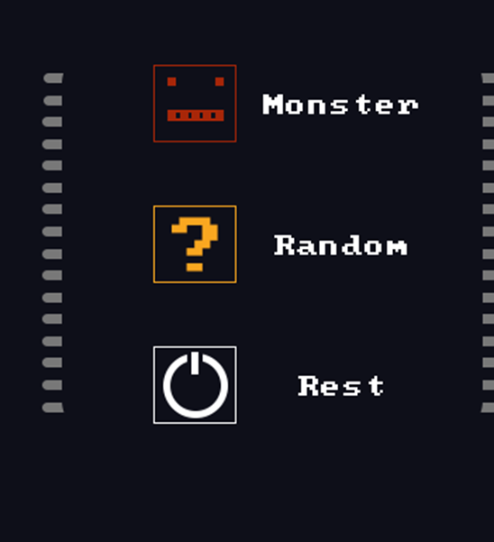

# The Virus

Progress bar/Health bar:  
Displays how much health the player has.

Virus name:  
When you hover over the player, it’s name will be shown.

Health:  
Numerical representation of health.

# The Monster

This number tells you how much the enemy will attack/block for.

Health:  
Numerical representation of enemy health.

Monster name:  
Shows enemy name when you hover over it.

Monster intent:  
This icon displays what the enemy will do next. Can be a block (shield) or attack (sword).

Progress bar/Health bar:  
Displays enemy health.

# Rest Site

You can see when the next Rest Site is by clicking on the “MAP” button.  
A Rest Site allows the player to either gain health or upgrade a card of their choosing.

# Winning the game

The point of the game is to build up a deck with powerful combinations. You should generally try and pick cards that work well together. Over time you will become more and more mighty as you collect all the cards you think would make a good addition to your deck. You learn all the best card combinations as you go.

# Infoboxes

Most of the game is explained within the game itself. Cards that do something unique have certain words coloured in yellow. The special effect will be explained to you if you hover over the card in your deck. A infobox will pop up next to the card describing what kind of effect this will have on the game.  
Items will also be explained in the same way.

