When sparsity hides the actuator: a pre-registered economic benchmark of SINDy-MPC for greenhouse climate control
Author One
Author Two
Abstract
Interpretable data-driven surrogates such as sparse identification of nonlinear dynamics (SINDy) are attractive for greenhouse model predictive control (MPC) because they yield explicit, inspectable equations rather than black boxes. Whether this interpretability comes at an economic cost, however, is rarely tested under a fair protocol: baselines are often untuned, the metric is a tracking proxy rather than profit, and—most subtly—the identification recipe is chosen by open-loop prediction quality. We report a pre-registered, in-silico economic benchmark of ten controllers on the GreenLight tomato simulator (Rostov-on-Don, 2018–2023 ERA5 weather), using the simulator’s own economic performance indicator (EPI, seasonal profit) as the primary metric and a two-axis Pareto criterion (EPI versus constraint violations), over 20 seeds with paired non-parametric statistics. The pre-registered SINDy-MPC recipe, frozen by open-loop metrics before any closed-loop evaluation, is economically among the weakest interpretable controllers ($1.18$ vs $4.63 EUR/m^{2}$ for a tuned rule-based baseline). A one-parameter ablation traces the cause: the sparsity threshold zeroes the boiler term in the temperature equation—the only modelled heating actuator—and closed-loop EPI collapses from $3.8$ to $1.0 EUR/m^{2}$ while the open-loop rollout error stays flat ($2.25→2.39$). The open-loop selection criterion is thus insensitive to the closed-loop failure it induces. Restoring the term, by a denser threshold or by DAgger, recovers EPI to parity with the heuristic without loss of interpretability, and the repaired model coincides with a first-principles grey-box model. Comparison with additional controllers rules out the obvious alternative explanations: the true-model oracle over-spends and is not a ceiling, a normalized PPO improves but does not win, and a black-box NN-MPC is worst—so neither insufficient fidelity nor interpretability is the bottleneck. The interpretable surrogate’s demonstrable value lies instead in safety and out-of-distribution guarding, not in economic supremacy. We conclude that parsimony is not interpretability, that sparsity must be removed from model-selection objectives when the downstream task is closed-loop control, and that open-loop-frozen pre-registration can systematically certify a control-catastrophic model.
greenhouse climate control ,model predictive control , sparse identification of nonlinear dynamics ,interpretable machine learning , identification for control ,economic benchmarking

Introduction
Greenhouse horticulture is an energy-intensive industry in which climate control decisions translate directly into profit: heating, CO₂ enrichment and supplemental lighting are the dominant variable costs, and they must be balanced against the revenue from crop growth. Model predictive control (MPC) is a natural fit, since it optimises a finite-horizon objective subject to the temperature, humidity and CO₂ constraints that define a productive climate (Henten 1994; Mayne et al. 2000; Lin et al. 2021). MPC, however, needs a model, and first-principles greenhouse models are laborious to build and calibrate. This motivates data-driven surrogates, and in particular sparse identification of nonlinear dynamics (SINDy), which recovers explicit governing equations as a sparse combination of candidate terms (Brunton et al. 2016a, 2016b; Kaiser et al. 2018). Unlike neural surrogates, a SINDy model is a glass box: its equations can be read, sign-checked against physics, and embedded analytically in an MPC solver. For a grower or a certifying body, this interpretability is not a luxury but a practical requirement for trust and debugging.
The central question is whether interpretability costs performance: whether an interpretable SINDy-MPC is Pareto-competitive with black-box alternatives, or pays a measurable “price of interpretability”. A fair answer is impeded by three systematic flaws in the comparison procedure itself, common in the greenhouse-control and learned-control literatures. Learned controllers are often compared against an under-tuned rule-based baseline, whereas a well-tuned agronomic heuristic is a strong competitor; setpoint-tracking error is reported in place of economic profit, although the two are not monotonically related; and, least obviously, the surrogate’s hyper-parameters are chosen by open-loop prediction accuracy, on the tacit assumption that a more accurate model yields better control. This last assumption is exactly what identification-for-control has warned against for three decades (Gevers 1993; Van den Hof and Schrama 1995), and what objective mismatch has re-established for learned dynamics (Lambert et al. 2020; Jackson et al. 2022).
We address all three by running a pre-registered, in-silico economic benchmark. The primary metric is the simulator’s own economic performance indicator (EPI)—seasonal profit read directly from the reward model, not a proxy—and, because EPI does not penalise constraint violations, the primary comparison is a two-axis Pareto criterion (EPI versus violations). Baselines include a tuned rule-based heuristic and fairly implemented reinforcement-learning controllers under an equal hyper-parameter budget. The identification recipe is frozen by open-loop and transparency criteria before any closed-loop evaluation, following pre-registration practice (Pineau et al. 2021), so that recipe selection cannot contaminate the honest comparison. We evaluate ten controllers over 20 seeds with paired non-parametric statistics (Wilcoxon 1945; Holm 1979; Efron and Tibshirani 1994).
The pre-registered hypothesis—that SINDy-MPC is non-dominated at a low price of interpretability—is not confirmed. The value of the benchmark, however, lies not in the negative result but in the mechanism it exposes: comparison with additional controllers isolates the cause of the pre-registered interpretable controller’s underperformance, and this cause is specific and transferable.
The main methodological result is an identified mechanism. The STLSQ sparsity threshold removes the control-critical boiler actuator term from the model, and closed-loop EPI follows the presence of that term, whereas the open-loop prediction error is almost insensitive to its disappearance. As a consequence, a recipe-selection procedure frozen by open-loop criteria to guard against circular inference systematically certifies a control-catastrophic model, which is the pre-registration trap. These findings rest on an honest economic benchmark on a validated agronomic simulator, in which EPI is verified term-for-term against the simulator’s reward, the rule-based baseline is tuned, the hyper-parameter budget is equal across methods, and the conclusions are supported by paired statistics over twenty seeds—something earlier RL-only greenhouse comparisons lacked (Laatum et al. 2025). Finally, the study reconsiders the value of interpretability itself: it lies in a model’s transparency, in safety, and in the ability to flag out-of-distribution operation, rather than in economic supremacy, and parsimony of description should not be conflated with interpretability.

Related work
Optimal and predictive control of greenhouse climate spans van Henten’s optimal-control formulation of the coupled climate–crop system (Henten 1994; Henten and Bontsema 2009), modern MPC (Lin et al. 2021; Chen and You 2020), and stochastic optimal control under weather uncertainty (Mourik et al. 2023). Reinforcement learning (RL) has been compared against MPC with mixed economic outcomes: RL can raise production but often at worse profitability (Morcego et al. 2023; Mallick et al. 2024; 2025). The simulator used here is GreenLight (Katzin et al. 2020, 2021), wrapped by GreenLight-Gym (Laatum et al. 2025). That benchmark, however, is an RL environment: it provides a fast differentiable simulator and benchmarks RL algorithms, but does not perform an honest economic comparison of controllers against a tuned rule-based baseline, nor does it consider interpretable sparse-identification surrogates or the open-loop/closed-loop selection question. The present work occupies that gap.
SINDy recovers parsimonious governing equations by sparse regression over a candidate library (Brunton et al. 2016a), extends to actuated systems (Brunton et al. 2016b), and combines naturally with MPC in the low-data limit (Kaiser et al. 2018). Robustness has been improved by ensembling (Fasel et al. 2022), relaxed and constrained optimisation (Champion et al. 2020), and mature tooling (Silva et al. 2020; Kaptanoglu et al. 2022). The sequentially-thresholded least-squares (STLSQ) core, however, is sensitive to its sparsity threshold: too large a threshold removes physically important small-coefficient terms, degrading the dynamics (Cortiella et al. 2021; Mangan et al. 2017), a problem that recent optimisers explicitly target (Dang et al. 2026). Prior work treats this as an identification pathology and proposes better optimisers; here its consequence is instead diagnosed inside an economic MPC loop, with an established causal link to profit, showing that a standard open-loop selection protocol walks straight into it.
That open-loop prediction accuracy is a poor proxy for closed-loop control is a foundational message of identification-for-control: the loop, not the fit, must arbitrate model quality (Gevers 1993; Hjalmarsson et al. 1994; Van den Hof and Schrama 1995; Hjalmarsson 2005). The same phenomenon was sharpened for learned dynamics as objective mismatch—one-step likelihood is not correlated with control performance (Lambert et al. 2020; Wei et al. 2023)—with related remedies in value-aware and control-oriented model learning (Farahmand et al. 2017; Sivaranjani et al. 2025). The contribution here is neither the general principle nor a new remedy, but a concrete, interpretable, and causally verified instance of it: because the surrogate is a glass box, the failure is legible term-by-term (a single removed actuator) rather than diagnosed by re-weighting a black-box model. To restore the term we use dataset aggregation (DAgger) (Ross et al. 2011), an established bridge between an MPC expert and a learned model (Sun et al. 2017; Tagliabue et al. 2021; Espin et al. 2024).

Methods
Primary metric. All controllers are scored by the simulator’s own economics rather than a proxy. At each step the GreenLight reward model returns a profit $π_{k}=g_{k}−c_{k}$, where the gain $g_{k}=(x_{k}^{fruit}−x_{k−1}^{fruit}) {{10}^{−6}}/{dmfm} p_{fruit}$ is the revenue from fruit dry-matter growth (converted to fresh weight through the dry-to-fresh ratio $dmfm=0.065$ and priced at $p_{fruit}=1.6 EUR/kg$), and the variable cost $c_{k}$ sums heating, lighting and CO₂ dosing priced at $0.09 EUR/kWh$, $0.30 EUR/kWh$ and $0.30 EUR/kg$. The seasonal indicator is EPI=k​πk $[EUR/m^{2}]$. We verified that the per-step economics used by every controller (and by the oracle, below) are identical term-for-term to the simulator’s reward, so EPI is the ground-truth objective and not an approximation. Because EPI omits constraint penalties and a controller can raise it by spending more time outside the productive corridors (CO₂$∈[300,1600]$ ppm, $T∈[15,34] ^{∘}$C, RH$∈[50,85]\%$), the primary comparison is a two-axis Pareto criterion—EPI versus the seasonal count of violation steps—reported with a non-dominated frontier (Fig. 1). As a secondary, dimensionally consistent severity scalar we report scaled_pen, the violation area per constraint normalised by the simulator’s own scaling. We do not combine EPI and violations into a single “EUR-penalised EPI”, since the simulator does not price violations.
Simulator, location and data. Experiments use the GreenLight tomato model (Katzin et al. 2020) through the GreenLight-Gym interface (Laatum et al. 2025). The location is Rostov-on-Don (${47.24}^{∘}$N, ${39.71}^{∘}$E); real weather for 2018–2023 is from ERA5/ERA5-Land via Open-Meteo, with derived sky and soil terms. A season is 60 days starting 1 March, at a 15-minute control period. We use a leakage-free year split: training on 2018–2019, in-distribution test on 2020, and 2021–2023 held out as out-of-distribution (OOD). Identification data are collected by the rule-based controller augmented with a pseudo-random binary excitation signal (PRBS, amplitude $0.3$) on the actuators, with the regression condition number monitored.
Controllers. We compare ten controllers spanning five families (Table [tab:controllers]): a tuned rule-based agronomic heuristic (the lower reference and the DAgger expert); the proposed SINDy-MPC in four variants—the pre-registered confirmatory recipe, a boiler-preserving dense recipe, and DAgger-repaired versions of each; a reduced first-principles grey-box MPC that reuses the same solver; a neural-network MPC (NN-MPC, $64×64$ surrogate); two reinforcement-learning policies, PPO (Schulman et al. 2017) and SAC (Haarnoja et al. 2018), via Stable-Baselines3 (Raffin et al. 2021); and an oracle MPC that plans over the true simulator dynamics. All learned controllers receive an equal hyper-parameter budget (16 trials). RL is trained for $2×{10}^{5}$ environment steps with observation and reward normalisation (VecNormalize), whose omission we found to distort the RL result badly.
Controller | Class | Alternative explanation tested | Answer from data
Rule-based | tuned heuristic | existence of a strong simple target (also DAgger expert) | yes — EPI 4.63, the bar
Grey-box MPC | reduced physics | weakness of the MPC/library itself | no — 3.79 works; the threshold is the cause
SINDy-MPC (confirmatory) | proposed, pre-reg. | the method under test | fails: 1.18 (boiler dropped)
SINDy-MPC (dense/+DAgger) | proposed, repaired | fixability without losing interpretability | yes — 3.8–5.2, still glass-box
Oracle (3 h CEM) | true-model MPC | insufficient model fidelity | no — 1.99, over-spends
NN-MPC | black-box surrogate | a black-box advantage | no — $−5.09$, worst
PPO / SAC | black-box RL | interpretability as the bottleneck | no — both below the heuristic
Pipeline and pre-registration. The proposed method has four stages. The rule-based controller with a superimposed PRBS signal first collects data; sparse regression then identifies an interpretable discrete one-step map $x_{k+1}=Ξ Θ(x_{k},u_{k},d_{k})$ of degree 1, low enough for analytic MPC embedding; the resulting surrogate is embedded in a CasADi/do-mpc solver that optimises an EPI-aligned objective under the climate constraints on a finite horizon; and, where needed, online adaptation (DAgger or EKF-SINDy) is added with an OOD monitor and a safe fallback. The identification recipe (denoising, optimiser and library) is not fixed a priori: it is selected in an ablation (E2) and then frozen by open-loop identification metrics (multi-step rollout stability, MPC-embeddability, transparency) before and independently of any closed-loop EPI on the held-out test season; this pre-registration guards against circular inference. The frozen confirmatory recipe uses the physics_no_cross library, degree 1, and an ensemble optimiser; a closed-loop-selected exploratory recipe is recorded separately and reported only as post-hoc sensitivity. The identical frozen recipe is loaded by every downstream experiment through a single source of truth.
Gates and statistics. A model is admitted only if it passes a transparency gate (glass-box equations, a threshold fraction of passed physical sign/dimension checks, bootstrap structural stability of the active-term set) and an MPC-embeddability gate. Both gates are deliberately open-loop; their consequences are examined below. The source of variance is the re-collection of training data per seed: each seed re-collects the identification dataset and re-fits the surrogate, so per-seed models genuinely differ. We use 20 seeds for all controllers; SAC converged on only 10 of 20 and is reported on those. Pairwise comparisons use the Wilcoxon signed-rank test paired by seed (Wilcoxon 1945) with Holm correction (Holm 1979), reporting Cohen’s $d$ and bootstrap 95% confidence intervals (Efron and Tibshirani 1994; Demšar 2006).
The oracle. The oracle is a receding-horizon cross-entropy-method (CEM) controller that plans directly over the true simulator integrator (48 sampled action sequences, a 3-hour horizon, two refinement iterations, warm-started from the rule-based action), with the same economic objective as the MPC. The gap between it and a surrogate-based MPC isolates the effect of model fidelity. It is not an upper bound on seasonal EPI: a short receding horizon greedily maximises short-horizon profit, and the sampling optimiser degrades at longer horizons, so it is treated as a fidelity control rather than a ceiling.

Results
The ten controllers are chosen to isolate the cause of the interpretable controller’s underperformance by ruling out the obvious alternative explanations (a weak MPC, insufficient model fidelity, a black-box advantage). Verdicts on the pre-registered hypotheses are summarised in Table 1.
Hypothesis scorecard (pre-registered H1–H4, 20-seed verdicts).
Hypothesis | Verdict | Evidence
Central | not confirmed | conf+DAgger ties RB ($p=0.26$); confirmatory sig. worse
H1 (gap-to-oracle) | not met | oracle 1.99 $<$ RB/PPO/grey-box
H2 (rollout stability) | met, but insufficient | RMSE stable yet closed-loop collapses
H3 (transparency) | partial | beats NN-MPC; confirmatory $<$ grey-box
H4a (adaptation) | not supported | DAgger $+0.39$, $p=0.088$; EKF worse
H4b (OOD guard) | supported | guard $−50\%$ viol, $p≈{10}^{−24}$
H4c (no exploitation) | partial | confirmatory over-violates; guard mitigates
The E2 ablation over denoising, optimiser, library and degree (42 recipes) selected, by open-loop rollout stability and the transparency and embeddability gates, a recipe with the physics_no_cross library, degree 1, and an ensemble optimiser as the confirmatory recipe, frozen before any closed-loop evaluation. Multi-step rollout divergence is negligible for this recipe (diverged-trajectory fraction $≈0$ for budgets $≥3$ days), so it passes the open-loop bar that pre-registration relies on. Hypothesis H2 (a stable-rollout recipe exists) is thus met; but, as shown below, open-loop stability is necessary and not sufficient.
Table [tab:e3main] reports the 20-seed closed-loop EPI, violations and severity for all ten controllers, with paired significance against the rule-based baseline; Fig. 1 shows the EPI–violation Pareto plane. Only the DAgger-repaired SINDy-MPC reaches the top: $5.23±2.40 EUR/m^{2}$, statistically indistinguishable from the rule-based $4.63$ ($Δ=+0.59$, $p_{Holm}=0.26$). Every other controller is significantly worse than the tuned heuristic: the grey-box MPC ($3.79$, $p_{Holm}=0.017$), PPO ($3.36$, $p_{Holm}=0.001$), the pre-registered confirmatory SINDy-MPC ($1.18$, $p_{Holm}=0.009$), SAC ($−2.41$) and NN-MPC ($−5.09$, $p_{Holm}≈2×{10}^{−5}$). The non-dominated frontier comprises the DAgger-repaired SINDy-MPC, the rule-based heuristic, PPO, and—as a degenerate minimum-violation corner with negative EPI—SAC. On the severity axis the DAgger SINDy-MPC accrues even a lower total violation severity than the rule-based controller ($426$ vs $485$) despite more violation steps; both axes are therefore reported together. The central pre-registered hypothesis is thus not confirmed, and the only interpretable controller that matches the heuristic achieves this through a repair whose mechanism is examined next.
Controller | EPI | Viol. | scaled | $T$-corr | $n$​ | $Δ$EPI | $p_{Holm}$​ | Front.
 | (EUR/m$​^{2}$) | steps | pen | % |  | vs RB
SINDy-MPC (conf+DAgger) | $5.23±2.40$​ | 4302 | 426 | 62 | 20 | $+0.59$​ | 0.26 (ns) | $•$​
Rule-based | $4.63±0.00$​ | 2458 | 485 | 95 | 20 | — | — | $•$​
SINDy-MPC (dense) | $3.81±1.27$​ | 6073 | 1206 | 65 | 20 | $−0.82$​ | 0.017
Grey-box MPC | $3.79±1.27$​ | 6083 | 1209 | 65 | 20 | $−0.85$​ | 0.017
PPO | $3.36±1.59$​ | 1842 | 392 | 84 | 20 | $−1.28$​ | 0.001 | $•$​
SINDy-MPC (dense+DAgger) | $3.23±2.21$​ | 4467 | 624 | 66 | 20 | $−1.40$​ | 0.031
Oracle (3 h CEM) | $1.99±0.68$​ | 2816 | 379 | 72 | 20 | $−2.65$​ | 2e-5
SINDy-MPC (confirmatory) | $1.18±4.33$​ | 5357 | 793 | 50 | 20 | $−3.46$​ | 0.009
SAC | $−2.41±1.24$​ | 1683 | 179 | 82 | 10 | $−7.04$​ | 0.010 | $•$​
NN-MPC | $−5.09±3.11$​ | 4368 | 767 | 70 | 20 | $−9.72$​ | 2e-5
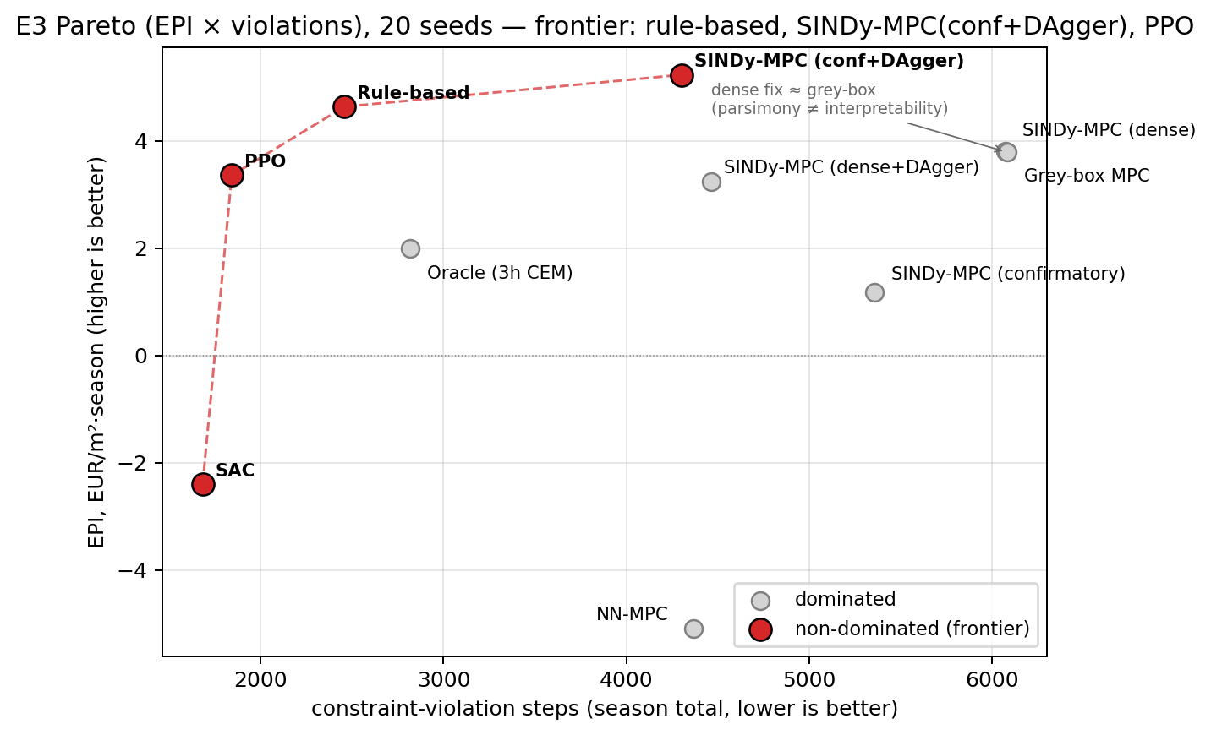
E3 Pareto plane (EPI $×$ violations, 20 seeds). The non-dominated frontier (red) is rule-based, SINDy-MPC(conf+DAgger), PPO, and SAC (degenerate minimum-violation corner). The repaired dense SINDy-MPC coincides with the grey-box model: parsimony is not interpretability.
Mechanism: sparsity hides the actuator. The pre-registered confirmatory recipe is the weakest of the interpretable controllers ($1.18±4.33$, against $4.63$ for the rule-based baseline and $3.79$ for the grey-box MPC that shares its solver and feature library). Yet the recipe was not selected for weak closed-loop control: it was frozen, before any closed-loop evaluation, as the most parsimonious model passing the open-loop and transparency gates. The recipe that pre-registration certified as identification-optimal is thus the recipe that fails in the loop.
We isolate the cause with a one-parameter ablation. Holding the feature library (physics_no_cross, degree 1) and the MPC fixed, the STLSQ sparsity threshold $λ$ is swept over $[{10}^{−6},{10}^{−1}]$; at each value, over 20 seeds, we record the number of surviving coefficients, the signed boiler coefficient in the temperature equation $Ξ_{u_{Boil}→T_{in}}$ (the greenhouse’s only modelled active heating actuator), the open-loop rollout-RMSE of $T_{in}$ on the deployment season, and the closed-loop EPI (Fig. 2, Table 2).
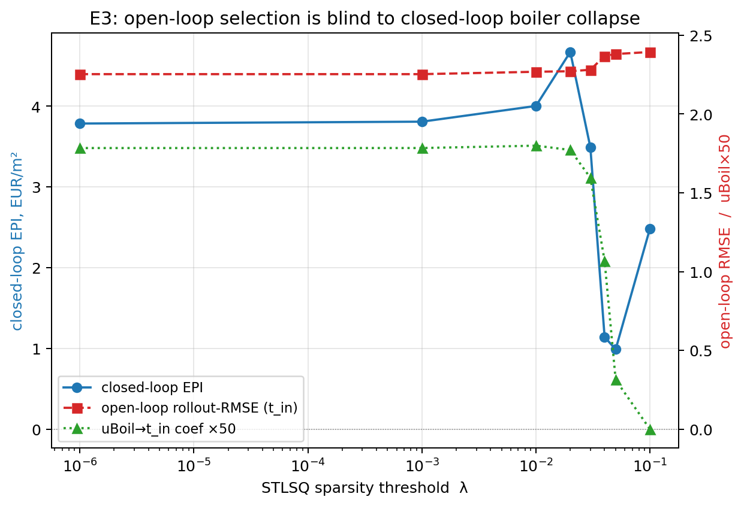
Sweeping the STLSQ sparsity threshold $λ$: closed-loop EPI (blue) collapses as the boiler coefficient $u_{Boil}​→​T_{in}$ (green) is thresholded to zero, while the open-loop rollout-RMSE (red) stays flat. Open-loop model selection is insensitive to the closed-loop failure.
Sparsity-threshold sweep ($λ$) of the physics_no_cross degree-1 surrogate, 20 seeds. The boiler coefficient and closed-loop EPI collapse around $λ​≈​0.05$ while open-loop rollout-RMSE stays flat.
$λ$​ | nonzero | $Ξ_{u_{Boil}→T_{in}}$​ | rollout-RMSE | EPI
${10}^{−6}$​ | 54.0 | 0.036 | 2.25 | 3.79
${10}^{−3}$​ | 49.9 | 0.036 | 2.25 | 3.81
0.01 | 41.8 | 0.036 | 2.27 | 4.00
0.02 | 38.4 | 0.035 | 2.27 | 4.67
0.03 | 34.8 | 0.032 | 2.28 | 3.49
0.04 | 30.8 | 0.021 | 2.37 | 1.14
0.05 | 27.7 | 0.006 | 2.38 | 0.99
0.10 | 20.3 | 0.000 | 2.39 | 2.49
Two quantities move in opposite directions. As $λ$ increases from ${10}^{−6}$ to $0.1$ the model becomes more parsimonious (surviving terms $54→20$) and the boiler coefficient decays and vanishes: $Ξ_{u_{Boil}→T_{in}}≈0.035$ for $λ≤0.02$, $0.032$ at $λ=0.03$, $0.006$ at $λ=0.05$, and exactly $0$ at $λ=0.1$. Closed-loop EPI tracks this collapse—from a peak of $4.67$ at $λ=0.02$ to $0.99$ at $λ=0.05$, exactly where the boiler term is thresholded out. Once the surrogate contains no heating actuator, the MPC cannot plan heating, and in a heating-dominated spring the loss is severe. The open-loop metric, by contrast, is almost inert: rollout-RMSE moves only from $2.25$ to $2.39$ (a $6\%$ change) while EPI moves by a factor of five and the boiler term disappears. The pre-registered open-loop criterion is therefore insensitive to the closed-loop failure it causes. This is a concrete, physically legible instance of the mismatch between predictive accuracy and control performance (Lambert et al. 2020; Jackson et al. 2022), and a sparse-identification realisation of the identification-for-control principle that the closed loop must arbitrate model quality (Gevers 1993; Van den Hof and Schrama 1995).
If removal of the boiler term is the cause, restoring it should recover performance, and two independent interventions do so (Table [tab:e3main]). A dense recipe (stlsq, $λ={10}^{−3}$) keeps $Ξ_{u_{Boil}→T_{in}}≈0.034$ and lifts EPI from $1.18$ to $3.81$; DAgger applied to the confirmatory recipe reintroduces the term through closed-loop data and lifts EPI to $5.23$, indistinguishable from the rule-based baseline. Across all SINDy-MPC variants, EPI is monotone in the presence of the boiler coefficient: whenever $Ξ_{u_{Boil}→T_{in}}≠0$, it rises from $≈1$ to $4$–$5 EUR/m^{2}$. The boiler coefficient is a one-dimensional causal proxy for economic competence.
The dense fix is not a black box: it is the same glass-box map with more non-zero terms, and the repaired dense SINDy-MPC ($3.81$) coincides with the first-principles grey-box MPC ($3.79$) to within noise (Fig. 1). Once over-sparsification is removed, the interpretable surrogate collapses onto the physical model it was meant to replace. What sparsity removed was neither accuracy nor transparency but the controllability conferred by a single small-magnitude actuator term. Two practical implications follow. Sparsity should not be a model-selection objective when the task is closed-loop control (Farahmand et al. 2017; Cortiella et al. 2021; Dang et al. 2026); and a transparency gate that certifies a model whose key actuator has been zeroed is incomplete—a dropped key actuator should itself be a gate failure.
Model fidelity does not explain the shortfall. If the shortfall were due to an inaccurate surrogate, an MPC over the true model should win. It does not: the oracle returns only $1.99±0.68 EUR/m^{2}$ (Table [tab:e3main]), below the heuristic, the DAgger and dense/grey-box models, and PPO. A horizon probe (Fig. 3) explains why: EPI falls rather than rises with horizon ($+0.26$ at 3 h, $+0.04$ at 12 h, $−0.51$ at 24 h on a 14-day window where the rule-based controller scores $+0.63$). Fruit growth and revenue rise toward the heuristic’s level as the horizon lengthens, but cost, chiefly electricity and CO₂, rises faster, so the oracle attains comparable production more expensively. This is greedy over-spend from a short receding horizon, not a fidelity deficit, so the “gap-to-oracle” framing (hypothesis H1) is not a meaningful ceiling here. It is a structural property of short-horizon economic MPC, not an experimental error: the oracle correctly maximises the very quantity the simulator rewards, only greedily and over too short a window.
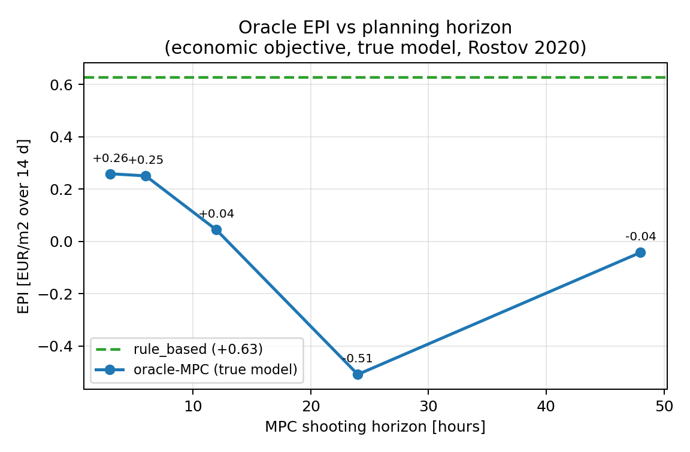
The oracle is not a ceiling. EPI of the true-model economic MPC falls as its planning horizon lengthens and stays below the rule-based heuristic (dashed): a short receding horizon greedily over-spends.
Interpretability is not the bottleneck. A black-box learner does not win either. RL baselines are sensitive to normalisation: a naive PPO scores $−13 EUR/m^{2}$, whereas standard observation/reward normalisation lifts it to $+3.4$—a reproducibility lesson rather than a property of RL (Henderson et al. 2018)—yet even the normalised PPO ($3.36$) remains significantly below the heuristic over 20 seeds, and SAC is unstable, diverging on 10 of them. The black-box NN-MPC, in turn, is the worst controller in the study ($−5.09 EUR/m^{2}$), beaten by every interpretable SINDy variant.
Online adaptation is a null. Under spring OOD shifts (2021–2023, same planting season), the offline surrogate already generalises well—mean EPI $≈0$, beating the rule-based controller’s $−2.9$ under the same shift—leaving little gap for adaptation. Over 60 (shift $×$ seed) pairs, DAgger improves on the static offline model by only $+0.39 EUR/m^{2}$ ($p=0.088$, not significant), and online EKF-SINDy is significantly worse ($−2.17$, $p<{10}^{−6}$); an earlier smaller sample ($n=9$) suggesting a significant DAgger gain does not survive. Hypothesis H4a is not supported. The failure under shift is not gradual coefficient drift but a data problem: single-season on-shift data are intrinsically confounded ($corr(u_{Vent},T_{in})=+0.67$ against $+0.03$ for multi-year offline data), so a re-fit mislearns the ventilation effect. What confers OOD robustness is structure (keeping the boiler term) and guarding, not coefficient adaptation.
Safety and out-of-distribution guarding. The demonstrable value of the transparent surrogate lies in safety. Its two epistemic signals—Mahalanobis distance on the exogenous inputs (Mahalanobis 1936; Lee et al. 2018) and ensemble prediction variance (Lakshminarayanan et al. 2017)—correlate with error and profit (Mahalanobis: $+0.63$ with rollout-RMSE, $−0.50$ with EPI; ensemble std: $−0.57$ with EPI), and the signal is a usable detector of high-error steps (ROC AUC $=0.70$; Fig. 4). Gating the controller on the Mahalanobis signal, with a fallback to the rule-based policy on OOD steps, cuts seasonal violations from $1723$ to $863$ (a $50\%$ reduction) while improving EPI (from $−2.06$ to $−1.48$); the reduction is highly significant over 200 pairs ($p≈{10}^{−24}$). Under injected faults (Table 3, Fig. 5), a residual-based supervisor with the same fallback significantly mitigates all six fault types, reducing violations by $1304$ steps on average ($p≈6×{10}^{−21}$, 120 pairs). This is the study’s strongest positive result (hypothesis H4b).
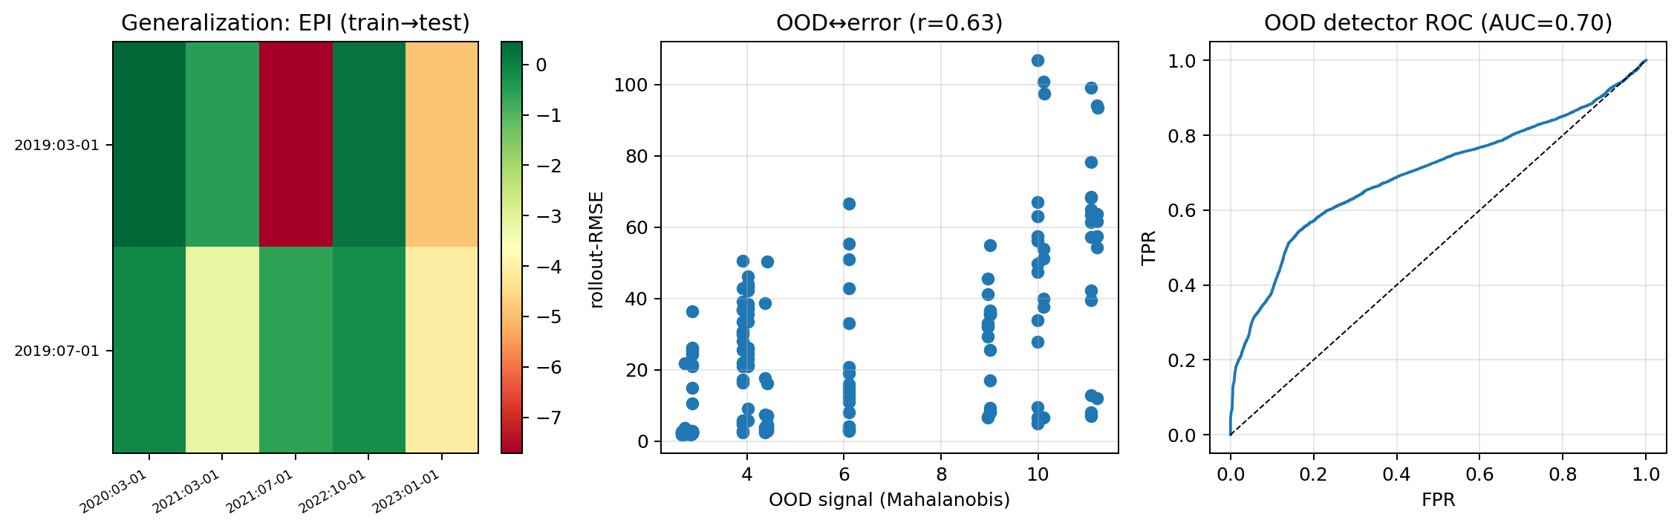
Generalization and OOD detection. Left: closed-loop EPI across train$→$test seasons (green good, red poor). Middle: the Mahalanobis OOD signal correlates with rollout error ($r=0.63$). Right: as a detector of high-error steps the signal reaches ROC AUC $=0.70$.
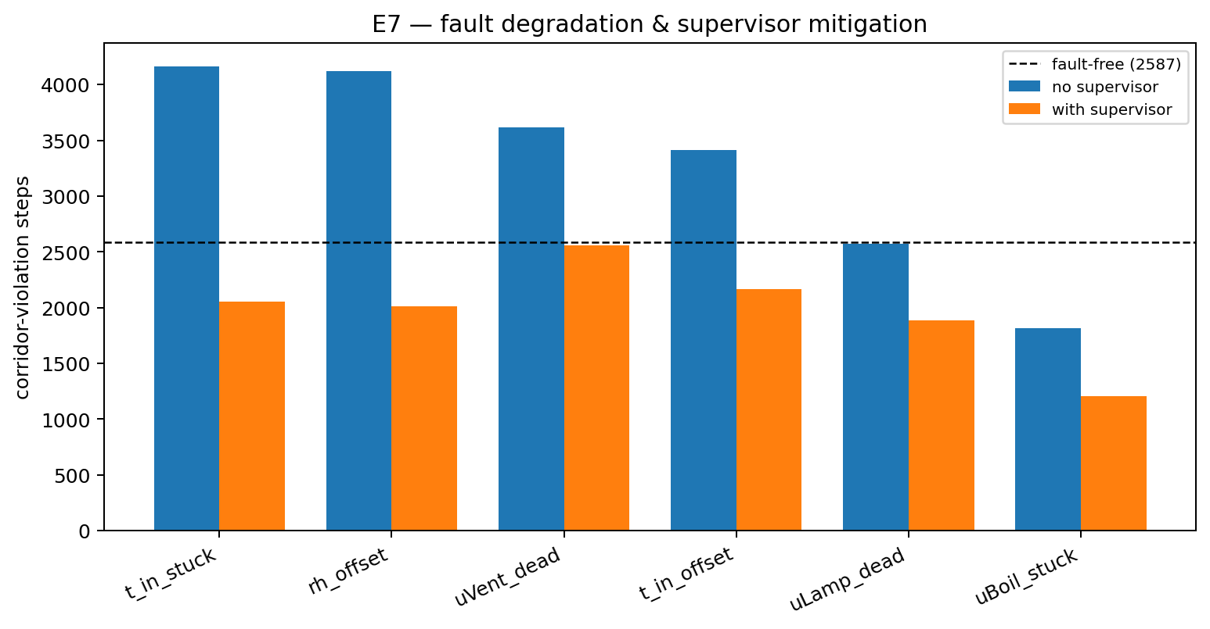
Fault robustness. Corridor-violation steps for six injected sensor/actuator faults, without (blue) and with (orange) the residual supervisor, against the fault-free baseline (dashed). The supervisor significantly reduces violations for every fault.
Fault injection: EPI and violation steps without and with the residual supervisor; fault-free baseline EPI $1.94$, viol. $2587$. The supervisor reduces violations for all six faults ($p≈6×{10}^{−21}$ overall).
Fault | EPI (unsup) | viol (unsup) | EPI (sup) | viol (sup)
$T_{in}$ stuck | 0.86 | 4163 | 0.99 | 2055
RH offset | $−0.07$​ | 4125 | 0.90 | 2013
$u_{Vent}$ dead | 2.01 | 3617 | 2.14 | 2558
$T_{in}$ offset | 1.62 | 3412 | 1.12 | 2165
$u_{Lamp}$ dead | 1.99 | 2574 | 2.40 | 1885
$u_{Boil}$ stuck | $−3.18$​ | 1816 | $−2.16$​ | 1208
Robustness of the ranking. A sensitivity analysis (Fig. 6) shows the ranking is governed by prices more than by design choices: the EPI range from the fruit price ($19.7$) and energy price ($13.3 EUR/m^{2}$) dwarfs that from crop-parameter uncertainty ($2.7$), the sparsity threshold ($1.3$) and the MPC horizon ($0.6$). The ranking is not robust to the energy price: when energy is expensive, the thrifty grey-box model overtakes the energy-intensive heuristic. A single-scalar ranking is therefore unreliable, and the Pareto structure is the preferred representation.
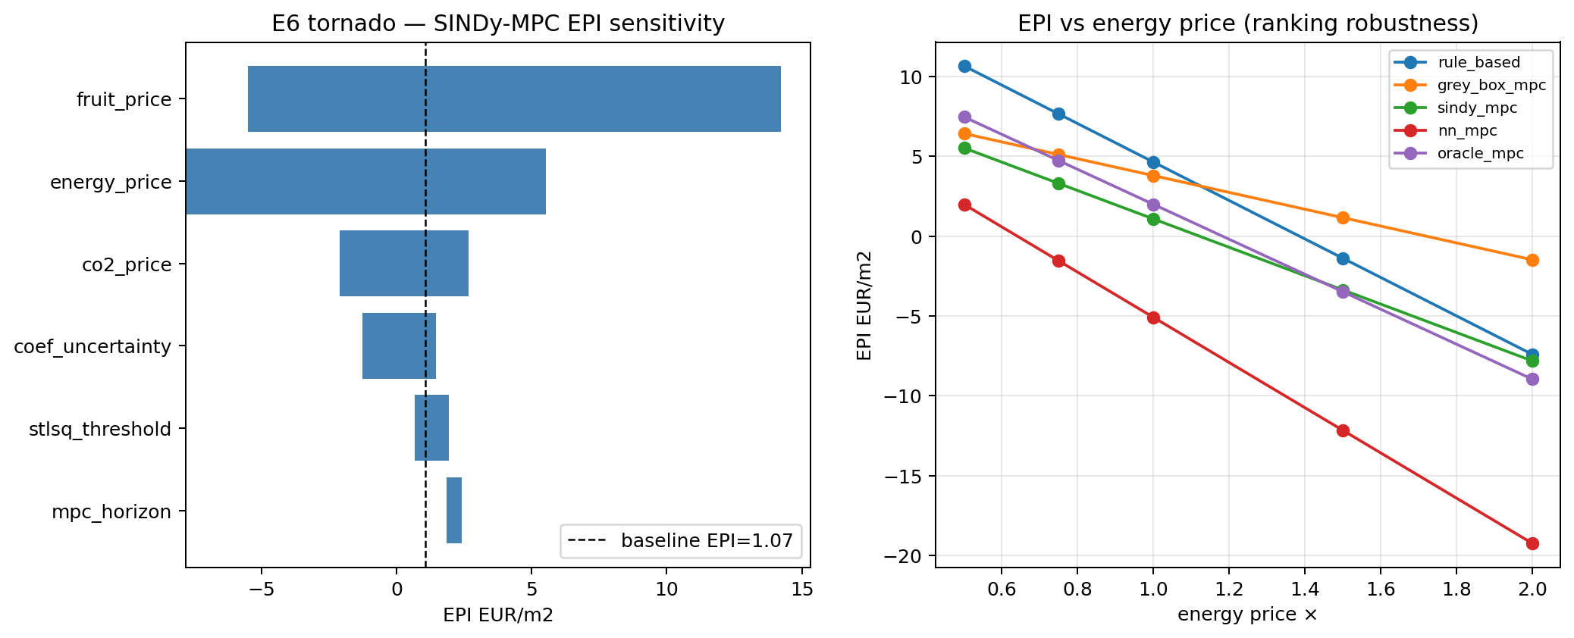
Sensitivity analysis. The EPI range is dominated by prices (fruit, energy) more than by design choices (crop uncertainty, sparsity threshold, horizon); the ranking is not robust to the energy price.

Discussion
Surrogate selection for control. The central lesson is procedural. Pre-registration froze the recipe by open-loop metrics to avoid circular inference, and thereby selected the model that fails in the loop, because that metric is insensitive to the closed-loop consequence. This is not an argument against pre-registration but against pre-registering the wrong criterion. Two corrections follow. Sparsity should not be a model-selection objective for closed-loop control: a small-coefficient term can be dynamically negligible for prediction yet control-critical; control-relevant or value-aware selection (Farahmand et al. 2017; Jackson et al. 2022), closed-loop-in-the-loop validation, or optimisers protecting small important terms (Dang et al. 2026; Cortiella et al. 2021) are the appropriate remedies. The transparency gate, in turn, is incomplete: a gate that certifies a model whose only heating actuator has been zeroed is not verifying control-relevant transparency; a dropped key actuator, detectable against the known actuation structure, should be a gate failure.
Parsimony and interpretability. The negative result might be read as a “price of interpretability”; it is not. The repair that recovers performance (restoring the boiler term) does not sacrifice transparency: the dense model is the same glass-box map, only less parsimonious. It coincides with the grey-box model to within noise ($3.81$ vs $3.79$): once over-sparsification is removed, the surrogate collapses onto the physical model it replaces. What sparsity destroyed was neither accuracy nor interpretability but controllability. Optimising parsimony in the name of interpretability can silently break control.
The strength of a tuned heuristic. The heuristic’s strength and the oracle’s over-spend share a root cause. Seasonal profit is dominated by fruit growth over days and weeks, whereas a receding economic MPC with a several-hour horizon optimises near-term profit and greedily trims heating and CO₂ that would have paid off later. A well-tuned rule set implicitly encodes the long-horizon trade-offs a short-horizon optimiser cannot see. The productive route to beating strong heuristics is therefore not a better short-horizon surrogate but a genuinely long-horizon economic formulation—a terminal value function on crop state, or a gradient-based multi-day optimiser—which we identify as the key open problem.
Generalization and limitations. The mechanism is not specific to horticulture: any pipeline that identifies a sparse surrogate, selects sparsity by prediction-oriented criteria, and embeds it in a controller is exposed to the same failure; the greenhouse merely makes it vivid, because the missing term is a named actuator whose coefficient can be watched tracking profit. The claims are in-silico and do not transfer to a physical greenhouse without separate validation. The headline E3 result uses a single test season, so deterministic controllers have zero test-weather variance and the reported variance reflects surrogate re-identification only; a multi-season economic benchmark is needed to characterise variance fully. The DAgger parity comes at an additional closed-loop data budget (three aggregation iterations of five days). The oracle is a short-horizon CEM and not a ceiling. Finally, SAC converged on only 10 of 20 seeds and is reported as a robustness observation rather than a tuned competitor.

Conclusions
We measured the price of interpretability for sparse-identification MPC in greenhouse climate control under a protocol designed to be honest: economic profit from the simulator as the metric, a tuned rule-based baseline, fairly normalised RL, an equal hyper-parameter budget, and a recipe frozen by pre-registration. The pre-registered claim—SINDy-MPC Pareto-competitive at a low price of interpretability—was not confirmed; the main result is the mechanism it exposed. A tuned heuristic is a strong economic reference, and the only interpretable controller that matches it does so through a repair, necessitated by a specific, transferable failure: the STLSQ threshold removes the control-critical boiler term, collapsing closed-loop profit while leaving open-loop error unchanged, so an open-loop pre-registered selection systematically certifies a control-catastrophic model. Comparison with additional controllers rules out the intuitive alternatives: the true-model oracle over-spends and is no ceiling, a normalised PPO improves but does not win, and a black-box NN-MPC is worst. The value of the transparent surrogate is real but lies elsewhere than EPI: an OOD guard halves violations while improving profit, and a fault supervisor mitigates six fault modes. Parsimony is not interpretability, and sparsity does not belong among model-selection objectives when the downstream task is closed-loop control. Future work should pursue a genuine economic ceiling—a long-horizon or terminal-value controller accounting for multi-day fruit dynamics—control-relevant recipe selection immune to the sparsity trap, and sim-to-real validation.

Reproducibility
All experiments are fully scripted and seed-controlled. We release the controller implementations, the pre-registered frozen recipe, the distributed 20-seed runners and mergers, and the analysis producing every table and figure. EPI is read from the simulator’s reward model, and its per-step economics were verified term-for-term against the oracle’s objective.
. 2025. “Adaptive Robust Greenhouse Climate Control: Combining Deep Reinforcement Learning and Economic Optimization.” Smart Agricultural Technology.
Brunton, Steven L., Joshua L. Proctor, and J. Nathan Kutz. 2016a. “Discovering Governing Equations from Data by Sparse Identification of Nonlinear Dynamical Systems.” Proceedings of the National Academy of Sciences 113 (15): 3932–37.
Brunton, Steven L., Joshua L. Proctor, and J. Nathan Kutz. 2016b. “Sparse Identification of Nonlinear Dynamics with Control (SINDYc).” IFAC-PapersOnLine (NOLCOS) 49: 710–15.
Champion, Kathleen, Peng Zheng, Aleksandr Y. Aravkin, Steven L. Brunton, and J. Nathan Kutz. 2020. “A Unified Sparse Optimization Framework to Learn Parsimonious Physics-Informed Models from Data.” IEEE Access 8: 169259–71.
Chen, Wan-Hui, and Fengqi You. 2020. “Data-Driven Robust Model Predictive Control Framework for Greenhouse Climate Control.” Chemical Engineering Transactions / Control Engineering Practice.
Cortiella, Alexandre, Kwang-Chun Park, and Alireza Doostan. 2021. “Sparse Identification of Nonlinear Dynamical Systems via Reweighted $ℓ_{1}$-Regularized Least Squares.” Computer Methods in Applied Mechanics and Engineering 376: 113620.
Dang, Zhenhua, Lei Zhang, Long Wang, and Guowei He. 2026. Balance-Guided Sparse Identification of Multiscale Nonlinear PDEs with Small-Coefficient Terms. https://arxiv.org/abs/2604.18414.
Demšar, Janez. 2006. “Statistical Comparisons of Classifiers over Multiple Data Sets.” Journal of Machine Learning Research 7: 1–30.
Efron, Bradley, and Robert J. Tibshirani. 1994. An Introduction to the Bootstrap. Chapman & Hall/CRC.
Espin, Jorge, Dong Zhang, Daniele Toti, and Andrea Pozzi. 2024. Deep-MPC: A DAgger-Driven Imitation Learning Strategy for Optimal Constrained Battery Charging. https://arxiv.org/abs/2406.15985.
Farahmand, Amir-massoud, André Barreto, and Daniel Nikovski. 2017. “Value-Aware Loss Function for Model-Based Reinforcement Learning.” Proceedings of the 20th International Conference on Artificial Intelligence and Statistics (AISTATS), PMLR, vol. 54: 1486–94.
Fasel, Urban, J. Nathan Kutz, Bingni W. Brunton, and Steven L. Brunton. 2022. “Ensemble-SINDy: Robust Sparse Model Discovery in the Low-Data, High-Noise Limit, with Active Learning and Control.” Proceedings of the Royal Society A 478 (2260): 20210904.
Gevers, Michel. 1993. “Towards a Joint Design of Identification and Control?” In Essays on Control: Perspectives in the Theory and Its Applications. Birkhäuser.
Haarnoja, Tuomas, Aurick Zhou, Pieter Abbeel, and Sergey Levine. 2018. “Soft Actor-Critic: Off-Policy Maximum Entropy Deep Reinforcement Learning with a Stochastic Actor.” Proceedings of the 35th International Conference on Machine Learning (ICML), PMLR, vol. 80: 1861–70.
Henderson, Peter, Riashat Islam, Philip Bachman, Joelle Pineau, Doina Precup, and David Meger. 2018. “Deep Reinforcement Learning That Matters.” Proceedings of the 32nd AAAI Conference on Artificial Intelligence.
Henten, Eldert J. van. 1994. “Greenhouse Climate Management: An Optimal Control Approach.” PhD thesis, Wageningen University.
Henten, Eldert J. van, and Jan Bontsema. 2009. “Time-Scale Decomposition of an Optimal Control Problem in Greenhouse Climate Management.” Control Engineering Practice 17 (1): 88–96.
Hjalmarsson, Håkan. 2005. “From Experiment Design to Closed-Loop Control.” Automatica 41 (3): 393–438.
Hjalmarsson, Håkan, Michel Gevers, Franky De Bruyne, and J. Leblond. 1994. “Identification for Control: Closing the Loop Gives More Accurate Controllers.” 33rd IEEE Conference on Decision and Control (CDC).
Holm, Sture. 1979. “A Simple Sequentially Rejective Multiple Test Procedure.” Scandinavian Journal of Statistics 6 (2): 65–70.
Jackson, Brian E., Jeong Hun Lee, Kevin Tracy, and Zachary Manchester. 2022. Data-Efficient Model Learning for Control with Jacobian-Regularized Dynamic-Mode Decomposition. https://arxiv.org/abs/2212.07885.
Kaiser, Eurika, J. Nathan Kutz, and Steven L. Brunton. 2018. “Sparse Identification of Nonlinear Dynamics for Model Predictive Control in the Low-Data Limit.” Proceedings of the Royal Society A 474 (2219): 20180335.
Kaptanoglu, Alan A., Brian M. de Silva, Urban Fasel, et al. 2022. “PySINDy: A Comprehensive Python Package for Robust Sparse System Identification.” Journal of Open Source Software 7 (69): 3994.
Katzin, David, Leo F. M. Marcelis, and Simon van Mourik. 2021. “Energy Savings in Greenhouses by Transition from High-Pressure Sodium to LED Lighting.” Applied Energy 281: 116019.
Katzin, David, Simon van Mourik, Frank Kempkes, and Eldert J. van Henten. 2020. “GreenLight – an Open Source Model for Greenhouses with Supplemental Lighting: Evaluation of Heat Requirements Under LED and HPS Lamps.” Biosystems Engineering 194: 61–81.
Laatum, Bart van, Eldert J. van Henten, and Sjoerd Boersma. 2025. “GreenLight-Gym: Reinforcement Learning Benchmark Environment for Control of Greenhouse Production Systems.” IFAC-PapersOnLine.
Lakshminarayanan, Balaji, Alexander Pritzel, and Charles Blundell. 2017. “Simple and Scalable Predictive Uncertainty Estimation Using Deep Ensembles.” Advances in Neural Information Processing Systems (NeurIPS) 30.
Lambert, Nathan, Brandon Amos, Omry Yadan, and Roberto Calandra. 2020. “Objective Mismatch in Model-Based Reinforcement Learning.” Proceedings of the 2nd Conference on Learning for Dynamics and Control (L4DC), PMLR, vol. 120: 761–70.
Lee, Kimin, Kibok Lee, Honglak Lee, and Jinwoo Shin. 2018. “A Simple Unified Framework for Detecting Out-of-Distribution Samples and Adversarial Attacks.” Advances in Neural Information Processing Systems (NeurIPS) 31.
Lin, Dawei, Lei Zhang, and Xiaohua Xia. 2021. “Model Predictive Control of a Venlo-Type Greenhouse System Considering Electrical Energy and Water Consumption.” Applied Energy 298: 117163.
Mahalanobis, Prasanta Chandra. 1936. “On the Generalised Distance in Statistics.” Proceedings of the National Institute of Sciences of India 2 (1): 49–55.
Mallick, Samuel, Filippo Airaldi, Azita Dabiri, Congcong Sun, and Bart De Schutter. 2024. Reinforcement Learning-Based Model Predictive Control for Greenhouse Climate Control. https://arxiv.org/abs/2409.12789.
Mangan, Niall M., J. Nathan Kutz, Steven L. Brunton, and Joshua L. Proctor. 2017. “Model Selection for Dynamical Systems via Sparse Regression and Information Criteria.” Proceedings of the Royal Society A 473 (2204): 20170009.
Mayne, David Q., James B. Rawlings, Christopher V. Rao, and Pierre O. M. Scokaert. 2000. “Constrained Model Predictive Control: Stability and Optimality.” Automatica 36 (6): 789–814.
Morcego, Bernardo, Wenjie Yin, Sjoerd Boersma, Eldert van Henten, Vicenç Puig, and Congcong Sun. 2023. “Reinforcement Learning Versus Model Predictive Control on Greenhouse Climate Control.” Computers and Electronics in Agriculture 215: 108372.
Mourik, Simon van, Bert van’t Ooster, and Michel Vellekoop. 2023. Plant Performance in Precision Horticulture: Optimal Climate Control Under Stochastic Uncertainty. https://arxiv.org/abs/2303.14678.
Pineau, Joelle, Philippe Vincent-Lamarre, Koustuv Sinha, et al. 2021. “Improving Reproducibility in Machine Learning Research (a Report from the NeurIPS 2019 Reproducibility Program).” Journal of Machine Learning Research 22 (164): 1–20.
Raffin, Antonin, Ashley Hill, Adam Gleave, Anssi Kanervisto, Maximilian Ernestus, and Noah Dormann. 2021. “Stable-Baselines3: Reliable Reinforcement Learning Implementations.” Journal of Machine Learning Research 22 (268): 1–8.
Ross, Stéphane, Geoffrey J. Gordon, and J. Andrew Bagnell. 2011. “A Reduction of Imitation Learning and Structured Prediction to No-Regret Online Learning.” Proceedings of the 14th International Conference on Artificial Intelligence and Statistics (AISTATS), PMLR, vol. 15: 627–35.
Schulman, John, Filip Wolski, Prafulla Dhariwal, Alec Radford, and Oleg Klimov. 2017. Proximal Policy Optimization Algorithms. https://arxiv.org/abs/1707.06347.
Silva, Brian M. de, Kathleen Champion, Markus Quade, Jean-Christophe Loiseau, J. Nathan Kutz, and Steven L. Brunton. 2020. “PySINDy: A Python Package for the Sparse Identification of Nonlinear Dynamics from Data.” Journal of Open Source Software 5 (49): 2104.
Sivaranjani, S., Yuanyuan Shi, Nikolay Atanasov, et al. 2025. Control-Oriented System Identification: Classical, Learning, and Physics-Informed Approaches. https://arxiv.org/abs/2512.06315.
Sun, Wen, Arun Venkatraman, Geoffrey J. Gordon, Byron Boots, and J. Andrew Bagnell. 2017. “Deeply AggreVaTeD: Differentiable Imitation Learning for Sequential Prediction.” Proceedings of the 34th International Conference on Machine Learning (ICML), PMLR, vol. 70: 3309–18.
Tagliabue, Andrea, Dong-Ki Kim, Michael Everett, and Jonathan P. How. 2021. Demonstration-Efficient Guided Policy Search via Imitation of Robust Tube MPC. https://arxiv.org/abs/2109.09910.
Van den Hof, Paul M. J., and Ruud J. P. Schrama. 1995. “Identification and Control — Closed-Loop Issues.” Automatica 31 (12): 1751–70.
Wei, Ran, Nathan Lambert, Anthony McDonald, Alfredo Garcia, and Roberto Calandra. 2023. “A Unified View on Solving Objective Mismatch in Model-Based Reinforcement Learning.” Transactions on Machine Learning Research (TMLR).
Wilcoxon, Frank. 1945. “Individual Comparisons by Ranking Methods.” Biometrics Bulletin 1 (6): 80–83.

