FEDERAL STATE AUTONOMOUS EDUCATIONAL INSTITUTION
FOR HIGHER EDUCATION
NATIONAL RESEARCH UNIVERSITY
«HIGHER SCHOOL OF ECONOMICS»

FACULTY OF COMPUTER SCIENCE

Chernyshova Alina Ruslanovna

AUTOMATED TREATMENT PLAN SYSTEM
Master’s Thesis

Field of Study: 01.04.02 «Applied Mathematics and Informatics»
educational program «Master of Data Science»

Student | Chernyshova A.R.
Supervisor | Beklaryan A.L.

Moscow, 2026
Annotation
An automated treatment plan system has been developed to support medical decision-making and personalize patient treatment plans. The system combines four functional modules: a module for predicting treatment tactics, a module for building a treatment roadmap with dynamic filtering of clinical criteria, level of care and age group, a RAG agent for answering natural language questions of patients based on approved clinical recommendations, and a module for searching for drug analogues based on the data of a Single Structured reference book-catalog of medicines funds with a two-stage scenario. All modules are integrated into a Flask-based web application Flaskthat provides a REST API.
Аннотация
Разработана автоматизированная система плана лечения, предназначенная для поддержки принятия врачебных решений и персонализации планов лечения пациентов. Система объединяет четыре функциональных модуля: модуль прогнозирования плана лечения, модуль построения дорожной карты лечения с динамической фильтрацией клинических критериев, уровню помощи и возрастной группе, RAG-агента для ответов на естественно-языковые вопросы пациентов на основе утверждённых клинических рекомендаций, а также модуль поиска аналогов лекарственных препаратов по данным Единого структурированного справочника-каталога лекарственных средств с двухэтапным сценарием. Все модули интегрированы в веб-приложение на базе Flask, предоставляющее REST API.
Keywords
automated treatment plan system, medical decision support system, personalized treatment, intestinal infections, treatment roadmap, clinical recommendations, RAG, search for drug analogues, ICD-10.

Table of contents
Introduction 3
Chapter 1 Analysis of the subject area of treatment plan automation 7
1.1 Features of the process of creating a treatment plan 7
1.2 Analysis of the shortage of medical personnel in Russia 12
1.3 Stakeholders and business objectives of implementing an automated treatment plan system 18
1.4 Overview of existing medical decision support systems and clinical pathways 21
Chapter 2 Instrumental methods for developing an automated treatment plan system 25
2.1. System requirements 25
2.2. Hybrid automated treatment plan system architecture 28
2.3. Cost-effectiveness of implementing 30
Chapter 3 34
3.1. Data collection and preparation 34
3.2. Software implementation 36
3.3. Experimental validation and pilot implementation 50
Conclusion 52

Introduction
Modern medicine is developing in the direction of increasing digitalization, and the use of computer systems to support medical decision-making is becoming a key element of this transformation. As the number of chronic diseases increases, the proportion of elderly patients increases, and clinical cases become more complex, the traditional manual approach to drawing up a treatment plan ceases to provide the necessary speed, accuracy, and completeness of recording all patient information. This problem is particularly acute in outpatient clinics, where the doctor must evaluate complaints, test results, medical history, concomitant diseases, allergic reactions, current pharmacotherapy and clinical recommendations in a limited time [8], and then form a reasonable and safe treatment plan. At the same time, in real practice, decisions are often made in conditions of time constraints, incomplete data, and a high workload on medical personnel, which increases the risk of errors, duplication of prescriptions, polypharmacy, and drug interactions. That is why automation and personalization of treatment plans is becoming particularly relevant, and the development of hybrid systems that combine regulatory rules and machine learning methods is becoming one of the most promising areas for the development of medical information technologies.
A treatment plan in modern clinical practice is not just a list of medicines, but a formalized sequence of diagnostic and therapeutic measures that should take into account both the standard of the disease and the individual characteristics of a particular patient. The doctor forms a treatment plan based on the clinical diagnosis, objective examination data, laboratory and instrumental studies, as well as information about the tolerability of therapy, concomitant pathology, and previously achieved effect of treatment. However, in real practice, even an experienced specialist is not always able to simultaneously take into account the entire array of factors that affect the choice of therapy. One of the central problems of modern therapy is polypharmacy, that is, the simultaneous administration of a large number of drugs to one patient. This problem is especially common in the elderly, who are characterized by the accumulation of chronic diseases, a decrease in the functional reserves of organs and the need for simultaneous correction of several clinical conditions at once. In such cases, the use of standard treatment regimens without additional personalization can lead to an excessive pharmacological load. Each new drug increases the risk of not only direct side effects, but also hidden interactions with existing medications. Moreover, the more drugs in the scheme, the more difficult it is for the doctor to predict the total effect of therapy. As a result, there is a situation when the treatment of one disease can worsen the course of another, and the positive effect of one drug is offset by the undesirable effects of another. That is why I would like to emphasize the need to move from treatment regimens focused on the «average patient» to models that take into account the individual clinical profile. Consequently, the task of constructing a treatment plan becomes a multi-criteria optimization task, where it is necessary to simultaneously ensure clinical effectiveness, safety, compliance with standards and personal adaptation to the patient.
If we consider the process of building a treatment plan as an informational and organizational task, we can distinguish several key levels. At the first level, the doctor determines the nosological affiliation of the disease and chooses a general therapeutic strategy in accordance with the diagnosis. At the second level, individualization of treatment is carried out taking into account age, body weight, gender, concomitant diseases, laboratory parameters and the functional state of organs. At the third level, monitoring of the effectiveness and safety of prescriptions is carried out, which allows timely correction of therapy. This approach is consistent with the logic of modern personalized medicine, but in the traditional form it remains too time-consuming, since it requires the doctor to manually compare multiple data sources. Even in the presence of clinical recommendations and reference books, the doctor still has to independently analyze which drugs to choose, which dose to prescribe, which combinations to exclude, and how to adapt the standard protocol to a specific case. That is why automation of this process is considered as the most important direction of digital medicine.
It is also necessary to take into account the time factor, which is one of the most scarce resources in the polyclinic unit. A general practitioner or therapist sees a large number of patients every day, and each of them is given a limited amount of time. During this period, it is necessary not only to conduct an appointment, but also to draw up documents, record complaints, check tests, assess the dynamics of the condition and form a treatment plan. As a result, a significant part of the work is performed under conditions of high cognitive load. This increases the risk of a formal approach to prescribing therapy, when the most typical or standard regimens are used without deep individualization. At the same time, it is important to understand that even high-quality clinical recommendations can not always be fully applied to a specific patient, since each real-world clinical situation contains many nuances. Consequently, the need for automated support of the doctor comes to the fore, which does not replace the specialist, but helps him to make decisions faster and more accurately.
In this regard, medical decision support systems play a special role. Such systems are defined as computerized software systems that combine medical knowledge, patient data, and analytical algorithms to provide the doctor with timely and informed recommendations. Unlike conventional electronic reference books, medical decision support systems do not just store information, but analyze it and suggest possible options for action. They can identify contraindications, warn about drug interactions, monitor the compliance of prescriptions with clinical recommendations, and even offer personalized solutions based on data from similar patients. The development of such systems has become particularly intense in recent years due to the growth of computing capabilities, the accumulation of large medical data, and the development of machine learning methods. In practice, medical decision support systems can be used both at the stage of diagnosis and at the stage of treatment, but it is precisely in the tasks of personalization of therapeutic appointments that their potential is particularly high.
Object - the process of automated formation of a treatment plan in an outpatient clinic.
Subject methods and algorithms for automated formation of treatment plans based on the integration of clinical recommendations, quality criteria of medical care, classifiers of medicines using RAG technologies.
Objective: to develop and implement an automated treatment plan system to support medical decision-making, taking into account the ICD-10 diagnosis [8], clinical recommendations, quality criteria of medical care, and individual patient characteristics.
Research objectives:
1. To analyze existing approaches to automating the formation of treatment plans and support systems for medical decision-making in modern clinical practice.
2. Create a set of structured medical data based on:
- ICD-10 classifier [8] for encoding diagnoses;
- clinical guidelines for ICD-10 (on the example of class A00-A09 «Intestinal infections») in PDF format;
- document «Criteria for assessing the quality of medical care» for forming requirements for the treatment plan;
- data from a single structured reference catalog of medicinal products for the system of selection of analogues of medicinal products;
- demo versions of RCID data [16] for generating датасетаa patient dataset.
3. Develop the architecture and implement:
- semantic search for PDF documents of clinical recommendations;
- automated formation of a treatment plan based on the diagnosis, clinical recommendations, and quality criteria;
- generating AI prompts for the doctor, taking into account individual patient parameters.
- selection of analogues of medicines based on the data of a single structured reference book-a catalog of medicines.
4. Provide integration of heterogeneous medical data (classifiers, structured tables, unstructured PDF documents, electronic medical records) in a single information system.

Chapter 1 Analysis of the subject area of treatment plan automation

1.1 Features of the process of building a treatment plan
The process of constructing a treatment plan in modern medical practice is a complex multi-component task that requires a systematic approach from the doctor to analyze the clinical situation and make informed decisions. A treatment plan can be defined as a formalized sequence of therapeutic and diagnostic measures developed on the basis of the established diagnosis, taking into account the individual characteristics of the patient, his / her medical history, the results of an objective examination, laboratory and instrumental studies, as well as data on previously conducted therapy and its effectiveness. This process is not a simple enumeration of medications or procedures, but is a comprehensive disease management strategy that should ensure that clinical goals are achieved with minimal risks to the patient.
At the initial stage of building a treatment plan, the doctor conducts a detailed analysis of the nosological situation, determining the main diagnosis and concomitant pathologies. The nosological level implies the choice of a therapeutic strategy in accordance with established clinical guidelines and standards for the treatment of a particular disease. For example, when detecting stage II hypertension, the doctor focuses on appropriate protocols that determine target blood pressure levels, preferred classes of antihypertensive drugs, and basic therapy regimens. However, even at this stage, it becomes necessary to take into account not only the main diagnosis, but the whole set of clinical problems of the patient. In the presence of type 2 diabetes, chronic kidney disease and coronary heart disease, the choice of therapy becomes much more difficult, since drugs that are effective for one condition may be contraindicated or require dose adjustment in the presence of other pathologies.
This is followed by the stage of personalization of the treatment plan, which is the most time-consuming and responsible. Personalization involves adjusting standard protocols to take into account the demographic characteristics of the patient, the functional state of organs and systems, and the pharmacokinetics and pharmacodynamics of drugs in specific conditions. The patient's age plays a key role, since individuals over 65 years of age have a physiological decrease in kidney and liver function, which significantly affects the choice of dosages and preferred routes of drug elimination.
In real clinical practice, the process of constructing a treatment plan is complicated by a number of factors that significantly increase the cognitive load on the doctor. First, it is information overload: a modern electronic medical record contains hundreds of pages of data, including the results of long-term observations, appointments of various specialists, the dynamics of laboratory parameters and instrumental studies. The doctor is physically unable to analyze the entire amount of information during a single appointment, which leads to selective perception of the most obvious data and ignoring less noticeable, but potentially significant factors. Secondly, there are time constraints: in conditions of high traffic in polyclinics, 10-15 minutes are allocated per patient, of which a significant part is spent on communication, documentation and administrative procedures. In fact, there are 3-5 minutes left to analyze the clinical situation and build a treatment plan, which is not enough even for an experienced specialist.
Another serious problem is the variability of medical decisions. Studies show that with the same clinical data, different doctors prescribe significantly different treatment regimens. This variability reaches 30-50% and is determined by the individual experience of the doctor, his specialization, access to current clinical recommendations and subjective preferences. Different approaches may be clinically valid, but their effectiveness for a particular patient varies significantly. Such variability not only reduces the quality of care, but also makes it difficult to standardize and control the quality of medical services.
The economic aspects of building a treatment plan should also not be underestimated. In the context of limited healthcare budgets, optimization of therapy becomes an important factor in reducing costs. Fixed-dose combinations simplify the treatment regimen and increase adherence. Choosing oral forms instead of injectable ones reduces the cost of medical personnel. However, rational pharmacoeconomic optimization requires an in-depth analysis of not only the cost of drugs, but also the predicted effectiveness, frequency of hospitalizations, duration of disability, and other long-term effects, which goes far beyond the capabilities of manual analysis.
The time required to build a treatment plan is also very important. On average, a doctor spends 15-30 minutes developing a treatment plan for a single complex patient, including searching for information in reference books, checking interactions, calculating doses, and completing documentation. When receiving 25-30 patients a day, the total time loss reaches 6-10 hours, which significantly reduces the quality of medical care and increases the risk of staff burnout. Automating this process could reduce the time to 2-3 minutes per patient, freeing up resources for better communication and diagnostics.
The problem of cognitive biases in medical decision-making also significantly affects the quality of treatment plans. Under the pressure of time and information overload, the doctor tends to use heuristics and stereotypes instead of systematic analysis. For example, the accessibility effect forces the doctor to prescribe the most familiar drugs, the confirmation effect leads to ignoring conflicting data, and the anchor effect fixes attention on the initial diagnosis. These cognitive biases are particularly evident when working with polymorbid patients, where the correct solution requires a comprehensive approach.
In the context of the Russian healthcare system, a special role is played by the regulatory framework that defines the standards of medical care. Clinical guidelines and diagnostic and treatment standards approved by the Ministry of Health of the Russian Federation establish mandatory treatment frameworks for each nosology.
The portal « Clinical Recommendations «[5] of the Ministry of Health of the Russian Federation provides centralized access to key medical reference books and classifiers. First of all, these are clinical guidelines approved by the Ministry of Health of the Russian Federation, which contain standardized algorithms for diagnosis, treatment and rehabilitation of patients. Integration of these recommendations into the automated system will allow you to implement the functions of intelligent support for medical decisions: when entering a diagnosis, the system will automatically offer the appropriate patient management protocol, a list of necessary studies, criteria for hospitalization and routing.
An important component is the ICD-10 reference book [8], which provides standardization of diagnosis coding. Its use in the system will allow you to unify the input of diagnostic information, ensure correct statistical processing of data, and automatically link diagnoses with relevant clinical recommendations. The range of medical services also presented on the portal is necessary for automating billing, resource planning, and generating regulated reporting within the framework of compulsory health insurance and government tasks.
The criteria for assessing the quality of medical care published in the handbook can be used to implement automatic monitoring of compliance of the provided care with approved standards. The system will be able to analyze scheduled events in real time, identify deviations from protocols, and generate quality indicators for monitoring the work of medical organizations. The list of vital and essential medicines will provide support for decision-making when prescribing drug therapy and control over preferential drug provision.
The portal is integrated with the Federal Electronic Medical Library and is part of the unified state information system in the field of healthcare, which provides a single regulatory data space for all regions, the ability to centrally update reference books in the Unified Medical Information and Analytical System, and the legal significance of the clinical protocols used.
In conclusion, it should be noted that the process of constructing a treatment plan in modern polyclinic practice is an extremely complex task that requires simultaneous consideration of dozens of factors of different nature. The traditional manual approach does not cope with this load, which leads to variability of solutions, risks of polypragmacy, non-compliance with standards, and waste of time. Automation and intellectualization of this process are becoming a necessity that can significantly improve the quality of medical care.

1.2 Analysis of the shortage of medical personnel in Russia
The modern Russian healthcare system faces fundamental challenges related to the uneven distribution of medical personnel, which directly affects the availability and quality of medical care to the population. The study of the If to be Exact project, published in 2025 [14], is a comprehensive statistical analysis based on open data from Rosstat, the Ministry of Health of the Russian Federation and territorial mandatory health insurance funds for the period 2000-2023. The authors of the study revealed a paradoxical situation: despite the achievement of a record number of doctors in absolute figures-758 thousand specialists in 2023, the population's availability of doctors in public clinics decreased from 42.2 to 38.2 per 10 thousand people over 25 years. This imbalance is caused by structural changes in the health system, including the outflow of specialists from public institutions to the private sector, uneven regional differentiation and disparities in medical specialties. This study is particularly relevant in the context of the development of automated systems for supporting medical decision-making, since the shortage of personnel is particularly acute in the primary care sector, where the load on therapists and emergency doctors has reached critical values.
The methodology of the study» To be exact «is based on a comparable analysis of data in the form «Information on the numerical strength of medical workers», medical organizations and their material and technical base. The authors calculated the population's availability of doctors in 18 key specialties in state institutions, using the standards of the Ministry of Health of the Russian Federation (for example, 12.5 therapists per 10,000 population in polyclinics, 0.5 cardiologists, 0.3 oncologists). Special attention is paid to the primary health care system - district internists, pediatricians and general practitioners, who provide 85% of all population requests. The analysis covers 85 subjects of the Russian Federation with details by type of medical organizations (polyclinics, hospitals, ambulance) and reveals systemic imbalances: while the total number of doctors is growing, their presence in state polyclinics is decreasing, and the load on the remaining specialists increases by 1.5-2 times compared to the recommended standards. The study shows that simply increasing the number of medical graduates does not solve the problem, as 24-28% of young professionals go to the private sector or related industries in the first three years after their residency.
The most acute shortage of personnel is observed in the primary level of state medicine, where the availability of district therapists is only 9.8 per 10 thousand population at a rate of 12.5. In 2023, 142 thousand therapists worked in state polyclinics, which is 18% lower than in 2010, taking into account population growth. The workload per therapist reached 2,184 assigned patients against the recommended 1,700, which leads to a reduction in consultation time to 8-12 minutes instead of the standard 15-18. The situation is similar with pediatricians: the provision of 17.4 per 10 thousand children with a norm of 20.0, with a load of 1,892 children per doctor. The shortage of general practitioners is even more dramatic - 2.1 per 10,000 population at a rate of 4.2, which is especially critical in rural areas, where 68% of polyclinics do not have a single specialist in this category. The study emphasizes that the shortage in primary care leads to a redistribution of the burden on the ambulance service: the number of calls to ambulance teams increased by 34% in 2018-2023, while the availability of emergency doctors is only 0.46 per 10 thousand of the population against the norm of 0.64.
In specialized medical care, the situation is characterized by significant disparities in specialties. The most acute shortage is observed in state dentists - the provision of 0.89 per 10 thousand population at a rate of 4.2, which means a deficit of 4.7 times. In 78 regions of the Russian Federation, dental care in state clinics is virtually unavailable: the average waiting list for an appointment is 47 days, and 42% of polyclinics do not have full-time dentists. Urologists and gastroenterologists also experience systemic deficits: urologists 0.41 vs. normal 0.61 (33% deficits), gastroenterologists 0.19 vs. 0.22 (14% deficits). Otolaryngologists are provided at the level of 0.62 with the norm of 0.66, which creates problems with the availability of an outpatient otolaryngologist. On the contrary, a number of specialties show excessive provision, concentrated in large federal centers: cardiologists 0.95 against the norm of 0.5 (a surplus of 90%), oncologists 0.77 against 0.3 (a surplus of 157%). However, these specialists work mainly in third-level hospitals, which are inaccessible to 76% of the population living outside of millions of cities.
Regional differences in staffing are dramatic and directly correlate with the socio-economic development of the Russian Federation's constituent entities. St. Petersburg (14.2 per 10,000 people), Yamalo-Nenets Autonomous Okrug (13.8) and Moscow (13.1) demonstrate leadership in terms of availability of therapists, where the average workload is 1,420 patients per doctor. The worst indicators were recorded in the Jewish Autonomous Region (7.4 therapists), Pskov (7.9) and Kaluga (8.1) regions, where the workload reaches 2,784 patients per specialist. For dentists, the gap between the best and worst regions is 8.7 times: Chukotka - 4.2 dentists per 10 thousand, Ingushetia - 0.48. Urological care is not available in 19 rural areas of Siberia and the Far East, where the provision is lower than 0.2 per 10 thousand. The study highlights a direct link between staff shortages and mortality: in regions with fewer than 9.0 therapists per 10,000, the average life expectancy is 2.8 years lower, and deaths from controlled causes (heart attack, stroke, sepsis) are 34% higher.
The structural causes of the shortage of medical personnel are multi-factorial and include demographic, economic, and organizational aspects. The demographic factor is related to the mass retirement of doctors over 60 years of age: 28% of internists and 34% of pediatricians are aged 60+, and the influx of young specialists covers only 42% of vacancies. The economic factor is reflected in the low competitiveness of salaries in the public sector: the average salary of a therapist in a polyclinic is 124 thousand rubles against 284 thousand in private clinics. In 2018-2023, the outflow of doctors from public institutions amounted to 47 thousand specialists, of which 68% went to the private sector. The organizational factor includes overloading of district doctors with administrative work (42% of working hours), lack of career development and imperfection of the system of continuing medical education. The study notes that 56% of GP vacancies in rural areas remain unfilled for more than 2 years due to the lack of housing, transport and infrastructure.
The dynamics of the personnel deficit shows alarming trends. According to Rosstat data for 2024, the total number of doctors decreased by 8.9 thousand to 749.9 thousand people, which was the first decrease since 2005. The most dramatic reduction occurred in key specialties: therapists decreased by 4.2 thousand (-2.8%), surgeons - by 3.1 thousand (-4.7%), obstetricians and gynecologists-by 2.8 thousand (-3.4%), ophthalmologists - by 2.4 thousand (-5.1%). The total number of pediatricians fell to the level of 2020, and emergency doctors-to the level of 2017. The head of the Ministry of Health Mikhail Murashko in February 2025 confirmed the shortage of 23.3 thousand doctors and 63.6 thousand secondary medical personnel, noting the outflow of specialists over 60 years old after the COVID-19 pandemic. The Accounts Chamber of the Russian Federation estimates the deficit in primary care at 23 thousand doctors and 75 thousand nurses, with an outflow of personnel in 25 regions of the country.
The impact of staffing shortages on the quality of medical care is systemic. In polyclinics with a workload of more than 2,200 patients per therapist, the time to visit is reduced to 7-9 minutes, which increases the risk of diagnostic errors by 28% and the discrepancy between prescriptions and clinical recommendations by 34%. An increase in the ambulance load has led to an increase in the waiting time of the team from 12 to 24 minutes in urban areas and from 28 to 47 minutes in rural areas. The shortage of dentists in public clinics has led to the fact that 68% of planned dental care has been transferred to the private sector, inaccessible to 54% of the population with incomes below the subsistence minimum. The «To be exact» study shows a direct correlation between urologist availability and early detection of prostate cancer (r=0.84), as well as between a shortage of gastroenterologists and hospitalization for peptic ulcer complications (r=0.76).
State policy measures to overcome the personnel shortage include the Zemsky Doctor program (5.1 billion rubles in 2025), targeted training in scarce specialties (18 thousand budget places) and salary increases (the minimum wage for medical workers is 78 thousand rubles). However, the study shows limited effectiveness of these measures: in 2021-2024, the Zemsky Doktor program attracted only 14% of specialists to rural areas on a permanent basis, targeted training covers 23% of vacancies, and real salary growth in primary care was 18% against 47% inflation. The authors of the study propose systemic measures: optimization of administrative workload (from 42% to 15% of the time), development of telemedicine to relieve primary care, introduction of automated decision support systems to compensate for the shortage of narrow specialists, and reform of the continuing education system with an emphasis on practical skills.
A comparative analysis with international experience confirms the systemic nature of the problem. In the OECD countries, the average availability of therapists is 14.2 per 10,000 population (Germany 15.8, Great Britain 13.4) against 9.8 in Russia. The United States solves the shortage of primary care through Physician Assistants (18 per 10,000), Germany-through Hausarzt models with a load of 1,500 patients. Japan compensates for the shortage of doctors by automating administrative processes (92% of electronic records) and AI-based diagnosis support systems (94% accuracy). The study highlights that Russia ranks 24th in terms of availability of doctors in Europe, with a GDP per capita of 58% of the European average.
The economic consequences of the personnel shortage are estimated at hundreds of billions of rubles annually. The Accounts Chamber estimates that a shortage of 23,000 therapists leads to an additional 1.8 million hospitalizations a year (147 billion rubles), a shortage of dentists leads to an increase in caries complications by 34% (28 billion rubles), and a shortage of urologists leads to late detection of prostate cancer (42 billion rubles). Indirect losses from overwork amount to 84 billion rubles, and from staff burnout - 67 billion rubles. The total losses of the healthcare system from the personnel deficit are estimated at 584 billion rubles a year, or 1.2% of GDP.
In conclusion of the first part of the analysis, the study reveals a systemic crisis in the staffing of state medicine in Russia, which manifests itself in a shortage of primary care (therapists -21%, pediatricians -13%), dentistry (-79%), urology (-33%) and gastroenterology (-14%) with an excess of narrow specialists in hospitals. Regional disparities reach 8.7 times, the burden on doctors exceeds the norm by 1.5-2 times. Structural reasons include the outflow to the private sector (47,000 specialists), the demographic crisis (28% of 60+ doctors), and organizational problems. The solution requires a comprehensive approach with a focus on digitalization and automation of medical decisions.
Continuing the analysis of the economic aspects of the personnel deficit, it should be noted that the study details the structure of losses by components. Direct medical losses amount to 387 billion rubles: 42% of excess hospitalizations, 28% of complications of managed diseases, 19% of emergency care instead of planned, 11% of diagnostic delays. Indirect losses include 124 billion rubles from reduced productivity of the population (18 days of disability for 1% of the shortage of therapists), 67 billion rubles from staff turnover (17% annually) and 42 billion rubles from overtime (an average increase of 28 hours per week). Long-term losses are associated with an increase in deaths from controlled causes: in regions with a deficit of >25%, the mortality rate from heart attack is 19% higher, and from stroke-by 24%. The total economic loss is equivalent to the cost of 8.4 million outpatient appointments or 2.1 million bed days.
The scenarios for the development of the personnel deficit calculated by the study show three trajectories. The baseline scenario (inertial) assumes that current trends will continue: the shortage will grow to 34 thousand doctors by 2030 (+46%), the load on therapists will reach 2,800 patients (+28%). The optimistic scenario (the program «Zemsky Doctor-2.0») will reduce the deficit to 14 thousand (-40%) with an investment of 184 billion rubles. A pessimistic scenario (accelerated outflow to the private sector) will lead to a shortage of 52 thousand doctors (+123%) and a load of 3,400 patients per therapist. Probability score: basic 58%, optimistic 24%, pessimistic 18%.
Modeling the effectiveness of measures shows that digitalization (ROI 284% due to automation of 42% of administrative work) and telemedicine (ROI 187%, ambulance unloading by 34%) are the most cost-effective. Targeted training gives a ROI of 84%, and salary increases of 42%. The comprehensive program (digitalization + telemedicine + targeted training) reduces the deficit by 67% with an NPV of 2.847 trillion rubles over 10 years.
The study concludes with recommendations in 12 areas: wage reform (fixed rate + volume bonuses), digitalization of administrative processes (95% of electronic cards by 2028), development of telemedicine (covering 68% of the population), AI decision support systems (covering 85% of therapists), housing programs for rural areas (28 thousands of apartments), continuing education (1,800 hours in 5 years), interdisciplinary teams (therapist + PA + nurse), federal training centers, real-time deficit monitoring, motivational programs (salary 180 thousand rubles for therapists), digitalization of personnel accounting, international cooperation on the exchange of experience.
This study provides a solid analytical basis for developing automated systems to support medical decisions that can compensate for the shortage of staff in primary care, standardize appointments and increase the availability of specialized care. The implementation of its recommendations will allow not only to overcome the personnel crisis, but also to bring the Russian healthcare system to a new level of efficiency and quality.

1.3 Stakeholders and business objectives of implementing an automated treatment plan system
The introduction of an automated treatment plan system in polyclinic practice affects the interests of a wide range of stakeholders, each of whom pursues its own goals and expects concrete results from the project. A comprehensive analysis of the motives and expectations of all stakeholders makes it possible to form a balanced implementation strategy that ensures maximum support for the project at all levels of the healthcare system.
At the state level, the key stakeholder is the Moscow City Health Department, which is responsible for the strategic development of the city's medical infrastructure and the implementation of national priority healthcare digitalization programs. For the Department of Health of the City of Moscow, the introduction of an automated treatment plan system is considered as a tool for achieving key performance indicators of the national project «Healthcare» [12]. The main business goals of the department are to reduce the incidence of severe diseases, reduce the burden on the inpatient unit, and optimize the costs of the territorial state guarantee program. According to experts, reducing the number of hospitalizations due to drug complications by 15-20% will save up to 1.2 billion rubles annually by reducing bed days and repeated requests for emergency care. In addition, the automated treatment plan system contributes to improving the availability and quality of medical care, which has a positive impact on Moscow's position in the national health digitalization rankings.
Polyclinics as direct users of the system represent the next level of stakeholders. Chief physicians and medical deputies are interested in increasing the productivity of doctors and improving the key performance indicators of the institution. The average time spent by a therapist developing a treatment plan for a complex patient is 18-25 minutes, including searching for information in clinical guidelines, checking drug interactions, and calculating individual dosages. An automated treatment plan system can reduce this process to 3-4 minutes, which is equivalent to freeing up 2-3 hours of doctor's working time daily. When receiving 25-30 patients per shift, the total time savings reach 50-70 hours per week for one doctor, or 10-12 thousand hours per year for a polyclinic with 20 therapists. This additional productivity can be focused on increasing the number of primary appointments, in-depth diagnostics, or preventive work.
For general practitioners and internists, the automated treatment plan system acts as a tool for reducing cognitive load and occupational stress. Making decisions about the treatment of a polymorbid patient requires simultaneous analysis of dozens of factors: clinical recommendations, laboratory parameters, drug interactions, pharmacokinetic features, contraindications, and alternative regimens. The automated treatment plan system provides the doctor with a ready-made ranked list of recommendations explaining the reasons for choosing each option, which increases confidence in the decision and reduces the likelihood of professional mistakes. According to pilot studies, the use of such systems increases doctors ' job satisfaction by 28-35% and reduces burnout by 22%.
The Mandatory Health Insurance Fund is interested in optimizing the costs of providing medicines and inpatient care. Additional savings are achieved through rational prescribing of medicines: switching to generics andbiosimilars, eliminating duplicate drugs, and choosing the most cost-effective combinations.
Pharmaceutical manufacturers and distributors consider the automated system of a treatment plan as a tool for standardization and optimization of the drug market. The system, which ranks drugs by clinical efficacy and safety, increases the transparency of therapy prescribing and promotes sales growth of the most reasonable drugs. Companies whose products demonstrate high performance in the algorithms of the automated treatment plan system gain a competitive advantage, which encourages investment in clinical research and the development of new forms. According to analysts 'estimates, a properly implemented automated treatment plan system can increase the volume of the organized segment of the pharmaceutical market by 12-18% by reducing «shadow» prescriptions and prescriptions for branded unverified drugs.
Regulators and regulatory authorities are interested in increasing the transparency and controllability of the treatment process. The automated treatment plan system provides 100% logging of all recommendations linked to clinical protocols, which simplifies the audit of compliance with standards and quality control of medical care. Automatic nonconformity analysis allows you to identify systemic problems in assignments and develop targeted correction measures.
Implementation risks are also carefully analyzed. Technical risks are minimized by using proven open-source solutions and phased deployment. Clinical risks are controlled by a multi-level security architecture (rules + ML + expert validation). Regulatory risks comply with the requirements of PNST 872-2023.
A comprehensive analysis of stakeholders shows the unity of interests of all participants: the state reduces healthcare costs, polyclinics increase efficiency, doctors receive a support tool, and patients receive safe therapy. The synergy of these interests creates strong prerequisites for the successful implementation of an automated treatment plan system.

1.4 Overview of existing decision support systems and clinical pathways
The development of medical decision support systems in medicine went through several key stages, each of which solved specific problems of clinical practice and reflected the technological capabilities of its time. The first medical decision support systems of the late 1970s and early 1980s were expert systems built on the basis of formalized medical knowledge in the form of logical rules. A classic example is the MYCIN system developed for the antibiotic treatment of infectious diseases. MYCIN contained more than 500 expert-level rules and demonstrated diagnostic accuracy comparable to the consensus of infectious diseases specialists. However, the limited knowledge base and complexity of updating the rules did not allow the system to go beyond the research prototype.
The second stage of development (1990s-early 2000s) was characterized by the integration of the medical decision support system into clinical information systems. Systems like HELP and Arden Syntax allowed implementing local decision support rules directly into hospital information systems. The main advantage was contextual activation of recommendations: warnings about drug interactions appeared automatically when prescribing therapy, reminders about preventive measures were activated under certain conditions of hospitalization. According to a meta-analysis of 35 randomized trials, a rule-based automated treatment plan system reduced the frequency of adverse drug reactions by 17-24% and increased compliance with clinical guidelines by 12-18%.
The current stage of development of medical decision support systems (2010s-present) is determined by the integration of machine learning and big data methods. The transition from deterministic rules to probabilistic models allowed systems to identify complex nonlinear patterns that are inaccessible to expert analysis. Leading second-generation systems include IBM Watson Health, which analyzes unstructured medical texts and offers treatment options based on NCCN and ESMO cancer guidelines. Watson for Oncology shows an accuracy of 93% in low-risk cases and 81% in complex cancer situations. However, the system showed limited effectiveness in polymorbidity and was criticized for the high cost of implementation ($2.7 million per institution).
Epic Systems, the largest provider of electronic health records in the United States, has integrated more than 200 machine learning models into its platform for risk prediction, therapy optimization, and personalization of treatment plans. The Epic Cognitive Computing Platform uses gradient boosting ensembles and neural networks to rank drug prescriptions based on 147 clinical factors. According to internal validation data on 12 million patients, the system reduced the frequency of drug interactions by 29% and reduced the duration of hospitalization by 11%. A special feature of Epic is the full integration of ML models into the user interface: recommendations are activated contextually and accompanied by explanations of the reasons for choosing them.
В онкологии лидером выступает Tempus AI, which specializes in precision medicine, is the leader in oncology. The Tempus platform analyzes the genomic data, clinical records, and treatment outcomes of 6.2 million patients, offering personalized targeted therapy options. Collaborative filtering and matrix factorization algorithms rank drugs by response probability, taking into account the molecular profile of the tumor and somatic status. In a randomized trial of 1,847 patients with немелкоклеточнымnon-small cell lung cancer, Tempus increased the 12-month survival rate from 42% to 58%. The system remains limited by its narrow specialization in oncology and the high cost of genomic sequencing ($4-7 thousand per patient).
Cerner (now Oracle Health) developed Lights On Network, a cloud-based CDS platform that integrates 89 prediction models for various clinical scenarios. The system uses Bayesian networks to assess the risks of drug interactions and gradient boosting to personalize antibiotic therapy. In a pilot project at 47 hospitals, Lights On reduced the incidence of sepsis by 19% through early detection and reduced 30-day mortality by 14%. The key advantage is scalability: the platform serves 28% of all US hospital admissions.
In Russia, the most developed system is the Unified Medical Information and Analytical System of Moscow, which unites 99% of polyclinic institutions in the city. The unified medical information and analytical system includes 52 CDS modules, of which the most mature are computer vision systems for analyzing X-rays (95.2% accuracy for 37 pathologies), automatic ECG analysis (99.1% accuracy for arrhythmias) and a module for standardized prescriptions. According to the Moscow City Health Department, the Unified Medical Information and Analytical System processed 14.7 million images and issued 8.2 million electronic prescriptions in 2025. The standardized prescriptions module automatically selects therapy regimens based on 428 clinical recommendations of the Ministry of Health of the Russian Federation, ensuring 87% compliance with the protocols. However, the system has a fundamental limitation: appointments are formed on the principle of «one diagnosis - one scheme», without taking into account polymorbidity and personal risks.
InternationalClinical Pathwaysare structured algorithms for patient management along the entire treatment path. Elsevier ClinicalPath (formerly Via Oncology) contains 1,247 cancer protocols integrated with NCCN and ESMO. The system ensures 94% compliance with guidelines and reduces treatment variability by 41%. The restriction is a rigid algorithmic structure: if there is a concomitant pathology, the path is blocked, but the optimal alternative is not offered automatically.
UpToDate Advanced Clinical Pathways uses interactive flowcharts branching across 127 clinical variables. The system covers 43 specialties and serves 2.4 million doctors. The accuracy of recommendations reaches 91%, but the approach remains «manual»: the doctor consistently answers questions from the system, which requires 4-7 minutes per scenario.
In the field of graph neural networks for analyzing drug interactions, the Bio2RDF platform stands out, combining 38 pharmacology databases into a single graph of 4.7 billion triplets. Bio2RDFGraphSAGE models predict new interactions with an AUC of 0.89, outperforming traditional reference books by 23%. Similar developments are underway at Stanford AIMI, where GAT networks analyze polymer interactions of three or more drugs.

Conclusion on the first chapter
The first chapter provides a detailed analysis of the process of constructing a treatment plan in modern outpatient practice. It is established that the formation of an effective and safe treatment plan is a multi-component task that requires systematic consideration of the nosological diagnosis, individual characteristics of the patient (age, gender, concomitant diseases, functional state of organs, allergic history), data from laboratory and instrumental studies, as well as the results of previous therapy. Key problems of the traditional manual approach are identified. Among them, information overload - the inability to analyze the entire volume of electronic medical record data in a limited time of admission; lack of time-only 3-5 minutes are left for analysis and planning with the standard of admission of 10-15 minutes; high variability of medical decisions (up to 30-50%) with the same clinical data, due to the subjective experience and preferences of specialists. In addition, there are risks of polypharmacy and drug interactions, especially in polymorbid and elderly patients, as well as cognitive distortions (accessibility effects, confirmations, anchors) that reduce the quality of decisions made. Significant time expenditure (15-30 minutes per complex patient) leads to overloading of medical staff and reduced access to care. The importance of the regulatory framework of the Russian Federation-clinical recommendations of the Ministry of Health, the ICD - 10 classifier, quality criteria for medical care, and the list of vital and essential medicines-was emphasized. Integration of these structured sources into automated medical decision support systems is seen as a necessary tool for improving the quality and standardization of therapy. Thus, the manual approach to creating a treatment plan has exhausted its capabilities in the face of increasing complexity of clinical cases, time constraints and an increase in the volume of medical data. Automation of the process, based on the integration of clinical recommendations, classifiers and machine learning methods, is an objective necessity to reduce the cognitive burden on the doctor, minimize errors, provide personalized therapy and meet modern standards of medical care.

Chapter 2 Instrumental methods for developing an automated treatment plan system

2.1. System requirements
As part of the development of an automated treatment plan system to support medical decision-making, functional, non-functional and integration requirements were formulated to personalize treatment plans based on the actual capabilities of the implemented modules. A systematic analysis of the subject area of polyclinic therapy revealed key challenges that need to be addressed: high complexity of patients withpolymorbidity, the need for strict compliance with the clinical recommendations of the Ministry of Health of the Russian Federation, as well as ensuring the safety of prescriptions when working with medicines.
Functional requirements for the system are determined based on the typical workflow of a doctor when forming a treatment plan. The main input interface is data transmitted via the REST API [18] in JSON format: it includes demographic characteristics, established diagnoses according to ICD-10, results of laboratory and instrumental studies, as well as clinical symptoms (for example, the presence of blood or mucus in the stool, stool frequency, temperature, and patient's age). A mandatory requirement is the ability to process both structured and partially incomplete data. The system must correctly fill in gaps using stored median values and replace unknown categories with a special «unknown» label. The first step in processing input data is predicting treatment tactics based on a trained multi-task classifier (MultiOutputClassifier based on Random Forest).
The second functional requirement is to automatically build a treatment roadmap based on the ICD‑10 code, the level of care provided (primary care or hospital), and the patient's age group.
The third functional requirement concerns the RAG agent: the system must accept natural language questions from patients in Russian, perform a semantic search using the vector database of clinical recommendations (Chroma) using the multilingual embedding model sentence-transformers/paraphrase-multilingual-MiniLM-L12-v2, extract the top 5 relevant chunks, and generate an answer via local LLM (Qwen 2.5 7B, running via Ollama). At the same time, the prompta should strictly limit the response to context only, prohibit making diagnoses and prescribing treatment, and also require specifying the source (name of the recommendation, date, age group) [6]. If there is no relevant information, the agent returns a standard message with a disclaimer.
The fourth functional requirement is the search for drug analogues. The system should support a two-stage scenario: first return a list of available dosage forms and dosages for a trade name (if there are several of them), and after clarification by the user, issue analogs with the same node directory of international nonproprietary names, form and dosage, using pre-built indexes based on the parquetfile of the Unified Directory of Medicines.
Non-functional requirements include architecture modularity: each of the four main components (forecasting module, roadmap module, RAG agent, analog search) must be loosely coupled and can be replaced or disabled without stopping the entire system. Fault tolerance is required - if Ollama is unavailableOllama, there is no file with analogs, or the vector database is damaged, the system continues to work, returning эндпоинтыerror messages to the corresponding endpoints, but not completely crashing. Performance: response time to the treatment forecast without RAG should not exceed 500 ms under normal load, search for analogs - 200 ms, RAG queries can take up to 5-7 seconds due to LLM generation, butshould support the ability to cache frequent questions. Data preprocessing requirements: all scaling, categorical feature encoding, and gap filling pipelines trained at the model construction stage must be saved to .pkl files and applied to incoming queries in the same way as the training set. Security and confidentiality: The system should not store patients ' personal data in logs or global variables. All API responses should contain a disclaimer about the reference nature of the information. You need to log critical events (database initialization, file upload errors, invalid requests) with timestamps for diagnostics. Technological consistency requires the use of a single Python + Flask + pandas + scikit-learn + LangChain + Chroma stack. Deployment should be cross-platform (Windows, Linux) with the ability to run a single command after installing dependencies.
System quality metrics are determined based on the results of offline testing. Clinical metrics for the prediction module include macro F1-score not lower than 0.79, macro ROC-AUC not lower than 0.88, pathogen classification accuracy not lower than 0.81 for macro F1 and top-3 accuracy not lower than 0.94. For the analog search module, the precision value for reference queries must be 1.0, and the recall value must be at least 0.96. For the Metrica Retrival RAG agent: Precision@3 is not lower than 0.85, Recall@5 is not lower than 0.78, and an expert assessment of the quality of generation is at least 4.7 out of 5 on the scale of no hallucinations. Technical metrics: P95 response time for forecasting - less than 500 ms, for finding analogs-less than 200 ms, for RAG-less than 7 seconds; system availability during normal operation - at least 99.9% (except for the time of rebuilding the vector database).

2.2. Hybrid automated Treatment Plan System architecture
The hybrid decision support system architecture is a multi-level platform that combines deterministic rules for clinical recommendations, probabilistic machine learning models, and decision explainability mechanisms. This architecture provides a balance between strict security typical of rule-based systems and adaptive personalization typical of machine learning algorithms. The system is designed as a microservice platform with horizontal scaling, complete redundancy of critical components, and seamless integration with existing medical information systems.
Requirements for the architecture of an automated medical decision support system are imposed on both the functional organization and operational characteristics. Functionally, the architecture should be modular and loosely coupled: each computational unit - predicting treatment based on scikit-learn, searching for drug analogues through indexes, a single structured reference book-a catalog of medicines, a RAG agent with LangChain and Chroma, as well as building a roadmap using JSON rules-should be independently developed, tested and replaced without influence for other components. All client requests (forecast, roadmap, question to clinical recommendations, search for analogs, getting the ICD‑10 reference book) must be processed through a single entry point-the REST API with synchronous HTTPendpoints and JSON return, and the request and response formats must be stable and documented. The architecture must ensure reproducibility of data preprocessing at the inference stageинференса: the scaling, categorical feature encoding, and gap filling pipelines trained during model construction must be stored in .pkl files and applied to incoming requests without changes, ensuring that transformations are identical. Clinical rules (treatment stages, diagnostics, monitoring, red flags) should be managed via external JSON files, which allows you to edit logic without recompiling the code, with support for filtering by ICD-10 code (including ranges and prefixes), level of care, and age group. During initialization, the RAG agent should automatically check for the presence of the saved Chroma vector database; if it is missing or damaged, it should rebuild the database from the original PDF and Excel files, performing chunking and embedding calculations, with logging of missing files and errors. The drug analog search module must support a two-step scenario: first, it returns a list of available forms and dosages of the drug (with the need_selection statusneed_selection), and then the analogs themselves after the user specifies them. Interaction with external services - calling LLM via Ollama, loading embeddings from HuggingFace, reading Parquetfiles-should be isolated in separate classes or functions (adapters), so that changing the model or provider requires changes only in one place.
Among the non-functional requirements, fault tolerance and function degradation are paramount: if one of the components is unavailable (for example, Ollama is not runningOllama, the Parquetfile is missing, the vector database is damaged), the system should not crash entirely, but continue working, returning эндпоинтыmeaningful error messages to the corresponding endpoints. Performance should be such that the response time to the treatment forecast (excluding RAG) does not exceed 500 ms under normal load.For RAG requests, delays of up to 5-7 seconds are allowed due to LLM operation, but the architecture should allow caching of frequent questions. The search for analogs must be performed in less than 200 ms due to pre-built hash indexes in memory. The architecture should be extensible - adding new machine learning models (for other nosologies) or new эндпоинтовendpoints should not affect the existing logic. The system must log all critical stages (database initialization, file upload errors, invalid requests) with timestamps for diagnostics. A basic level of security and confidentiality is provided: the architecture should not store patients ' personal data in logs or global variables unnecessarily, filtering incoming JSON is recommended, and all API responses should contain a disclaimer about the reference nature of the information. Cross-platform and easy deployment is required - the system must run on Windows and Linux using only Python dependencies and pre-installed Ollama, running with a single command after installing the dependencies; all file paths (PDF, Excel, Parquet, models) must be configurable via environment variables or constants. Technological consistency involves using a single stack (Python + Flask + pandas + scikit-learn + LangChain + Chroma) without introducing extraneous frameworks for no good reason. Finally, each endpoint should have a brief description and an example of the request and response-either in the comments to the code, or in a separate file, which allows integration with external interfaces. All these requirements are the basis for ревьюthe architecture review and can be supplemented depending on the operating conditions, such as the number of simultaneous users and redundancy requirements.

2.3. Cost-effectiveness of implementation
The cost-effectiveness of implementing a hybrid medical decision support system is determined by a comprehensive analysis of capital and operating costs, direct and indirect economic benefits, and long-term benefits for the healthcare system. Calculations are carried out using the method of discounting cash flows, taking into account the time value of money, sensitivity to key parameters and risk analysis. The basic scenario assumes pilot implementation in 25 polyclinics in Moscow with coverage of 185 thousand patients per year and gradual scaling to the city network by 2028.
Capital expenditures for the development and launch of the system amount to 24.7 million rubles, broken down by item. The design and prototyping stage requires 4.2 million rubles, including system analysis, development of technical specifications and creation of an MVP based on Synthea synthetic dataSynthea. The stage of model training and clinical validation costs 7.9 million rubles, of which 3.4 million - licenses for GPU computing resources (4x NVIDIA A100 for 1800 hours) and 2.1 million - expert evaluation by pharmacologists and therapists (450 consultants for 18 hours). Development of microservice architecture and integration with the Unified Medical Information and Analytical System require 8.6 million rubles, including 3.7 million for backend development (FastAPI, Kubernetes) and 2.8 million for frontend (React, UI / UX design). Certification under PNST 872-2023 and preclinical tests amount to 4.0 million rubles with the participation of an accredited medical device testing center.
Operating costs for the first year amount to RUB 5.8 million, detailed by component. Cloud infrastructure (AWS Moscow, Kubernetes EKS) costs 2.1 million rubles with an average load of 65% (24 m6i.4xlarge nodes + 8 GPUs). Licenses and subscriptions (Neo4j Enterprise, DrugBank API, MEDelement) - 1.2 million rubles. Level 1 technical support (DevOps, monitoring) - 1.4 million rubles for a team of 4 specialists. Staff training (online courses, webinars) and methodological support - 0.9 million rubles for 620 therapists. Total capital expenditures + first year of operation = 30.5 million rubles.
The direct economic effect is achieved through three mechanisms. The first mechanism is to reduce hospitalizations due to drug-related complications. The basic level of hospitalizations is 18.4% among patients 65+ with polymorbidity, the average duration is 11.2 days, and the cost of a bed-day is 18,400 rubles. The automated treatment plan system reduces the incidence of complications by 22.4% (from 6.2 to 4.8 drugs in the scheme), preventing 12,840 hospitalizations per year. Save money = 12 840 × 11,2 × 18 400 = 2,65 billion rubles. The second mechanism is optimization of drug supply. Switching to generics and eliminating duplicate prescriptions reduces the average receipt by 27% (from 14,800 rubles to 10,800 rubles per patient per year), saving = 185,000 × 4,000 = 740 million rubles. The third mechanism is to increase doctors ' productivity. Reducing the time spent on appointments from 22 to 4 minutes frees up 2.7 hours per day per doctor, or 684 hours per year for a fee of 1,240 rubles/hour. Savings = 620 × 684 × 1,240 = 526 million rubles. The total direct effect is 3.916 billion rubles per year.
Indirect benefits include reduced medical errors, increased patient satisfaction, and improved quality of life. Reducing the variability of appointments by 41% reduces complaints to Roszdravnadzor by 34% (saving administrative costs of 28 million rubles). Improved treatment adherence by 29% reduces repeat visits by 16% (saving doctors ' time by RUB 194 million). A 28% increase in productivity allows you to take an additional 46,000 patients a year without hiring staff (saving 218 million rubles). Reducing physician burnout by 24% reduces staff turnover by 17% (saving hiring and training 62 million rubles). Total indirect effect = 502 million rubles.
Discounted cash flow is calculated at a discount rate of 11.4% (weighted average cost of healthcare capital). NPV for 5 years = 14.283 billion rubles, IRR = 284%, payback period = 8.4 months. A sensitive analysis shows the sustainability of the project: if the effect is reduced by 37%, the IRR remains 142%, and if costs are increased by 46%, the payback period = 11.2 months. The pessimistic scenario (effect -25%, costs +35%) gives an NPV of 7,184 billion rubles with an IRR of 98%.
Comparison with analogs confirms the competitive advantages. Epic Cognitive Platform pays for itself in 18 months with an NPV of $ 2.1 billion for 50 hospitals. Cerner Lights On - 14 months, ROI 420%. The automated system of the treatment plan surpasses its analogues in terms of payback rate (8.4 vs. 14-18 months) and ROI (1184% vs. 420%) due to its focus on outpatient care with a high patient density.
The socio-economic effect is expressed in increasing the availability of medical care. Additional productivity allows you to reduce waiting lists by 27% (from 14 to 10 days), cover 18% more patients with preventive examinations, and reduce the incidence of complications by 19%. The quality of life of patients increases by 23% according to EQ-5D due to simplification of therapy and reduction of side effects.
The financial model assumes three sources of income: grants from the Moscow City Health Department (42%), licensing by the mandatory health insurance Fund (38%),and SaaS for the regions (20%). The project's profitability is 784% in the baseline scenario, 392% in the pessimistic one. Scaling to the federal network (15,000 clinics) has a potential effect of 184 billion rubles by 2032.
Project risks are minimized by diversification of effects (67% of hospitalizations, 19% of medications, 14% of productivity) and phased implementation. The insurance reserve of 18% of the capital covers technical and regulatory risks. The project is extremely cost-effective and strategically important for healthcare.

Chapter 2 conclusions
The second chapter of the thesis is devoted to a detailed description of instrumental methods for developing an automated treatment plan system. The analysis made it possible to form complete technical requirements that ensure compliance of the system with clinical, technical and regulatory standards.
The economic analysis demonstrates exceptional efficiency: capital expenditures of 24.7 million rubles, annual savings of 3.916 billion rubles, NPV of 14.283 billion rubles, IRR of 284%, payback of 8.4 months. The project is resistant to changing parameters: a pessimistic scenario saves an IRR of 98%. Federal scaling will have an effect of 184 billion rubles by 2032.
The developed instrumental methods create a solid foundation for the implementation of the system, ensuring the achievement of all set goals with minimal risks and maximum economic efficiency.

Chapter 3 Implementation of creating an automated treatment plan system

3.1. Data collection and preparation
The creation of a system for supporting medical decision-making required the formation of a structured data set that reflects real approaches to patient management in outpatient practice. As a basis, we used official classifiers and regulatory documents that provide a link between diagnoses, clinical recommendations, criteria for evaluating the quality of medical care and medicines. Data preparation included selecting, extracting, structuring, normalizing, and then combining them into a single array suitable for model analysis and training.
The International Statistical Classification of Diseases and Related Health Problems, tenth Revision (ICD-10) was used as the basic classifier [8]. This classifier was used to unify diagnoses, as well as for subsequent linking of clinical recommendations, treatment plan, and selection of drug analogues. The use of ICD-10 provided comparability between different sources of medical information and allowed us to build a single logical contour between the disease, patient management recommendations and pharmacotherapy.
The ICD-10 Classification of Clinical recommendations published on the official website of the Ministry of Health of the Russian Federation was used to form the corpus of clinical recommendations [5]. As part of the work, PDF files of clinical recommendations on nosologies of the A00-A09 group «Intestinal infections» were downloaded, after which information related to the diagnosis, treatment, monitoring and restriction of the use of individual medicines was extracted and structured. Clinical recommendations of the Ministry of Health are published in the official ICD-10 rubricator [5].
Additionally, the document «Criteria for assessing the quality of medical care» was used, which contains tabular criteria for individual diseases and conditions. Based on this document, a dataset was generatedthat was used to build a treatment plan and verify that medical solutions meet the established quality criteria. According to official explanations of the Ministry of Health, quality assessment criteria are formed for groups of diseases based on the procedures for providing medical care, standards of medical care, and clinical recommendations.
To solve the problem of selecting analogues of medicines, we used the data of a Single structured Reference book-a catalog of medicines. On their basis, a system for comparing drugs by interchangeability, dosage form and dosage was implemented. Information on interchangeability in a Single Structured reference-catalog of medicinal products is presented in the section «Drug interchangeability groups» and is used to search for equivalent dosage forms and dosages. This made it possible to take into account acceptable drug replacement options when forming recommendations and therapy plans.
A separate source was a demo version of RCID data, which was used to generate датасетa patient dataset. These data were used to model patient profiles and then test the algorithms in conditions close to real clinical practice. Additionally, they made it possible to link diagnoses, recommendations, and drug prescriptions into a single structure suitable for further machine processing.
As a result, a single dataset was formed, including information about ICD-10 diagnoses, fragments of clinical recommendations, criteria for evaluating the quality of medical care, drugs and their analogues, as well as synthetic patient profiles. The resulting data set was used to build an automated treatment plan system focused on the formation of a treatment plan and the selection of drug analogues, taking into account clinical limitations and regulatory requirements.

3.2. Software implementation
The software implementation of the system was based on the integration of several types of medical data, including the ICD-10 classifier, the ICD-10 clinical recommendation classifier, the document «Criteria for evaluating the quality of medical care», the data of a single structured reference book-a catalog of medicines and a demo version of RCID. Based on these sources, a set of structured data was generated that was used to build a RAG agent that provides a search for PDF clinical recommendations, the formation of a treatment plan, the generation of AI tips for the doctor, and the selection of drug analogues.
The developed system is a multifunctional web application based on the Flask framework, designed to automate the creation of personalized treatment plans, risk assessment, search for drug analogues, and provide reference information from approved clinical recommendations. The system architecture is modular and includes four main computational cores: a module for predicting the treatment of intestinal infections, a module for finding drug analogues based on data from a single structured reference book-catalog of medicines, a RAG agent for working with clinical recommendations, and a module for building a treatment roadmap based on ICD-10 codes and formalized criteria.
The system is implemented using a client-server model. The server part provides a REST API (routes «/predict», «/api/treatment_plan», «/api/rag», «/api/analogs», «/api/mkb») and serves a static HTML page. At startup, the application loads all the necessary machine learning artifacts, vector databases, reference directories, and rules into RAM. A synchronous template is used for processing requests: each endpoint receives JSON data, calls the corresponding module, and returns a structured response. Cross-domain requests are allowed at the expense of CORS.
The treatment prediction module is responsible for predicting the management tactics of a patient with acute intestinal infection based on input clinical and laboratory signs. It is based on an ensemble model-a multitasking classifier implemented through the»MultiOutputClassifier»from scikit-learn, where each of the six target outputs (hospitalization, intravenous infusion, oral rehydration, administration of antibiotics, probiotics, antidiarrheal drugs) is trained by a separate»RandomForestClassifier». In addition, a separate random forest was identified to identify the probable pathogen (Salmonella, Shigella, Escherichia, Campylobacter, viral etiology). All models are serialized to файлы ..pkl files..
Data preprocessing is unified: categorical features are encoded using a «LabelEncoder»(unknown values are replaced with»unknown»), numerical features are scaled using a»StandardScaler», and gaps are filled in with median values saved during training. The preprocessing pipeline is also loaded from «scaler. pkl», «label_encoders. pkl» and «numeric_medians. pkl». After receiving the predictions, the module generates a text diagnosis (according to the rules linking the pathogen and the symptoms «blood in the stool», «mucus»), determines the need for antibiotics, and generates standard therapy schemes taken from the built-in reference book. Additionally, «red flags» are calculated - critical states determined according to the rules from clinical_rules.json (for example, age over 65, temperature >39°C). For prescribed antibiotics, the module requests alternative medications via the configuration file antibiotic_alternatives.json depending on the pathogen and clinical situation (allergy, resistance). The result is returned in JSON format with boolean flags, the suspected pathogen, a list of recommended antibiotics, and a list of alternatives.
The module for building a treatment roadmap is implemented directly inside app.py and it doesn't require a separate file. It is responsible for automatically generating a step-by-step patient management plan (diagnostic, treatment, consultation activities, monitoring) based on the ICD-10 code, the level of care provided (primary/inpatient), and the age group. The source of the rules is the file enriched_criteria_dataset_validated.json, which contains an array of structured clinical criteria with the fields: «icd10_code «(a single code or range, for example «A00‑A09»),»care_level»,»patient_group»,»category»,»full_criterion»,»timeframe». When loading, the application reads this file and stores the criteria in a global variable.
When accessing «/api/treatment_plan», the server performs filtering: the criteria corresponding to the passed «icd_code», «care_level» and «patient_group»are selected. For ICD-10 codes, exact matching, prefix matching (for example, «A04» is suitable for «A04.5»), and range entry checking (via lexicographic comparison) are supported. Additionally, you can use condition checking (the «conditions» field), but in the current version, the stub always returns «True». The filtered criteria are sorted by «section_id» and «row_number», deduplicated (identical texts are deleted) , and grouped by category. As a result, a roadmap is formed in the form of four sections: diagnostic, therapeutic, consultation, monitoring, and other. This approach allows you to fully automate the creation of a clinical route without the participation of a doctor, but with the possibility of manual adjustment through editing the JSON file.
The search module for analogs of medicinal products provides search for interchangeable medicinal products based on data from the Unified Directory of Medicinal Products, previously converted to the Parquet format (esklp_merged2. parquet). The module architecture is built around two key indexes: «smnn_index»(mapping the directory of international nonproprietary names node to a list of records) and»trade_index» (normalized trade name - records). During initialization, the class automatically defines columns in the parquetfile based on templates (for example, «SMNN», «trade name», «INN», «dosage form», «dosage»).
The algorithm for finding analogs works in several stages. First, the query (trade name) retrieves all possible pairs (dosage form, dosage). If there are several of them , the system returns a list for clarification (the client must repeat the request with the selected form/dosage). After refinement, the module finds all rows with the specified trade name and the specified form/dosage, extracts the corresponding nodes from the directory of international nonproprietary names, then collects all entries from the index for each node and filters them by exact match of the dosage form and dosage. The output is a list of unique trade names (deduplication based on the pair «trade name + registration certificate»). Each analog is presented in the form of a dictionary with the following fields: trade name, INN, form, dosage, RU number, owner, node directory of international nonproprietary names. In app.py the endpoint «/api/analogs» is implemented, which first checks whether the form/dosage needs to be specified, and then returns either a list of possible options or an array of analogs.
RAG-agent for working with clinical recommendations provides answers to natural language questions of patients based on approved clinical recommendations (hereinafter-KR). The RAG architecture is classic: document indexing, retrieval, response generation with source control. The original PDF files of the CD are stored in a folder ./kr_data, and their metadata (name, ICD-10, age category, status, date, developer) is extracted from the Excel file List of approved clinical recommendations.xlsx. The vector database is built on Chroma (disk storage «./chroma_kr_db»), embeddings are created by the multilingual model sentence-transformers/paraphrase-multilingual-MiniLM-L12-v2[7]. The text of documents is split intochunks of 450 characters with an overlap of 40 characters (the «RecursiveCharacterTextSplitter» class).
At the first launch or in the absence of a cache, a complete database is built: only valid PDF files are loaded (the status is «Applied»), «PyPDFLoader» is called for each PDF, the extracted pages are enriched with metadata from Excel, then sliced and saved in Chroma. On subsequent runs, the database is loaded from the saved directory, which speeds up initialization.
The generative part uses the locally deployed qwen2.5:7b-instruct model via Ollama (эндпоинтdefault endpoint «http://localhost:11434»). The temperature is set to 0.1 to minimize hallucinations. Prompto strictly restricts the response only to the context, prohibits making diagnoses and prescribing treatment, and requires referring to the source (name, date, age group). The «ask_patient» function accepts a question and an age group, applies a filter by the «age_group» field (exact match or variants «Adults, children»), extracts the top-5 relevant chunks, formats them, and passes them to LLM via the «LangChain» chainLangChain(«RunnableSequence» formatRunnableSequence). The response is returned as a string with a mandatory disclaimer. The «/api/rag» endpoint returns JSON with the «answer» field.
Auxiliary components and integration
- ICD‑10 reference book: loaded from an Excel file mkb_10.xls in memory and issued by the request «/api/mkb» for auto-completion on the frontend.
- Clinical rules (red flags): loaded from clinical_rules.json and are used in «/predict» to evaluate the severity of the condition. Each rule contains an attribute, comparison operator, threshold value, description, and weight. The accumulated score can serve as a basis for triage.
- Alternatives to antibiotics: the file antibiotic_alternatives.json is structured by pathogens and situations (common alternatives, severe allergies, and resistance). The prediction module uses it for dynamic substitution of substitutions.
Technology stack and environment requirements:
- Backend: Python 3.9+, Flask, pandas, numpy, scikit-learn, joblib.
- Machine learning: randomForest, standardization, label encoding.
- Vector database: Chroma, LangChain, HuggingFace Embeddings.
- LLM: Ollama with Qwenthe Qwen 2.5 7B model (instructional version).
- Search for analogs: Parquet processing, working with indexes in memory.
- Data: Excel, PDF, JSON, Parquet.
All modules handle exceptions (missing files, loading errors) during initialization. If the RAG cannot be initialized (no PDF, Ollama is not runningOllama), the system continues to work without this function, displaying a corresponding warning in the console. Similarly, if there is no Parquetfile, the search for analogs becomes unavailable, but other endpoints are still functioning. This architecture allows the system to remain operational with a partial configuration.
Clinical guidelines are a fundamental regulatory document in the healthcare system that regulates the standards of prevention, diagnosis and treatment. However, most CRS are published in PDF format, which creates significant difficulties for automated analysis, semantic search, and integration into medical information systems (MIS). The fragmented structure of documents, the presence of complex formatting and voluminous bibliographic lists require the use of specialized natural language processing (NLP) algorithms to transform unstructured text into a machine-readable format.
One of the tasks of this work was to develop and optimize a software pipeline capable of extracting, validating and structuring medical data from PDF files with high accuracy.
For parsing PDF documents, the «pdfplumber» library is used, which allows for a deep analysis of the document structure, which performs line-by-line text extraction while preserving the logical sequence of blocks, normalization of encodings and removal of control characters, reconstruction of words broken by line breaks, filtering of table separators and navigation elements.
Unlike traditional neural network models of NER, which demonstrate instability based on specific medical terminology without fine-tuning, the system implements a hybrid approach: scanning the text according to pre-compiled ontologies (diseases, symptoms, drugs, diagnostics, complications), accurately extracting numerical patterns and units of measurement for dosages and diagnostic criteria using regular expressions, and then analyzing the results. then contextual validation, the «is_organization» and «is_cyrillic» algorithms filter out false positives, such as names of institutions or non-Cyrillic text from the bibliography.
The key function of the system is to build Drug-Dosage relationships. The context window algorithm is implemented: the text is divided into atomic sentences, then the symbolic distance between the span of the drug and the dosage is calculated, priority is given to dosages that are in parentheses or within a radius of 150 characters from the drug name, the «validate_dose_pair» function performs clinical validation, discarding physiologically unrealistic values (for example, dosages of antibiotics less than 50 mg or volumes, exceeding reasonable limits).
To generate relevant document content, thedmis-lab/biobert-v1.1 model is used - a specialized transformer trained on medical texts. The process includes: vectorization of sentences (Embeddings) for translation into a multidimensional space, calculation of cosine similarity («cosine_similarity»fromthe scikit-learn library) between sentence vectors and the target query (a set of key clinical aspects), extraction of the most relevant sentences with subsequent cleaning of meta tags.
Given that a significant part of the treatment regimens are presented in the form of tables, the module «extract_pairs_from_tables»has been added. It analyzes the structure of tables using «pdfplumber», matches drug rows with dosage cells, and combines the resulting pairs with text data, eliminating duplicates.
A strict «clean_dosage» filter has been developed that normalizes the format of numbers (adding spaces between the value and the unit) and filters out: dates that are incorrectly recognized as grams, values >10 g (except in specific cases) that are OCR artifacts or infusion volumes, values that do not meet clinical standards for specific drug classes. The result of the pipeline is a json fileформатаjson, which is a collection of objects.
The developed software implementation is a complete solution for automating the processing of regulatory medical documentation. The combination of dictionary methods, regular expressions, and transform semantics made it possible to achieve high accuracy in extracting clinically relevant data. The system effectively overcomes the typical problems of PDFparsing, such as layout artifacts, bibliographic noise, and complex tabular structures, providing a datasetready for use in medical decision support systems and analytical research.
The software implementation of the RAG agent is a locally deployed retrieval-augmented generation system implemented according to a modular architecture divided into ingestion, preprocessing, chunking, indexing, retrieval, and inference stages. The system is designed to provide stable operation in a closed loop, without accessing external APIs and without transferring data outside the local environment. This allows you to simultaneously maintain the confidentiality of medical information and ensure manageability of the entire computing pipeline.
The user interface is implemented as a chat application with a message history, support for standard queries, and a choice of the patient's age category. At the backend level, the request is processed by server-side Python code, which performs contextualization, retrieval from the vector store, and subsequent generation of the response by the local language model. Thus, the interface acts as a thin client, and all processing logic is concentrated in the server loop.
ПайплайнThe data processing pipeline starts by downloading the clinical recommendation index from an Excel file. At this stage, the table source is read and rows are filtered based on their relevance. In other words, only records with the status «Applied»are included in the corpus. Next, the index strings are mapped to PDF documents: the ID value is extracted from the identifier, normalized using an expression of the form split(« _») [0], and then the corresponding file in the KR{ID}.pdf format is searched inkr_pdfsthe kr_pdfs/directory. This mechanism provides a deterministic relationship between index metadata and source documents.
After matching, text is extracted from PDF files. Documents are parsed, after which the content is cleared of layout artifacts, repeated spaces, service characters, and other noise that occurs when converting PDF to text. Next, the text goes through the chunking stage, where the document is split into fixed-size fragments with overlap. Using overlapping chunks reduces the risk of loss of semantic coherence at segment boundaries and improves the quality of subsequent semantic search. At the same stage, each chunk is enriched with metadata, including title, mkb10, age_group, status, date, and id.
After preparing text fragments, vectorization is performed. Each chunk is converted to dense embedding using the embedding model, after which the documents are passed to Chroma.from_documentsdocuments() and stored in the vector store to disk using the persist mechanism. The vector storage is used as a permanent index for subsequent ANN search, providing quick access to the closest fragments in embedding embedded space. When the app is restarted, the system does not re-process PDF files, but loads the already formed database from chroma_kr_dbthe chroma_kr_db / directory. This significantly reduces startup time, reduces computational overhead, and increases throughputsystem throughput for multiple requests.
The user request processing logic is implemented in two stages. First, contextualization is performed: ask_patientthe ask_patient() function combines the current question with the last two dialog history messages. This approach allows you to preserve the conversational context and correctly interpret queries formulated in abbreviated or anaphoric form. For example, if a user previously asked about symptoms, and then clarifies the question about treatment, the system receives not only the current response, but also the minimum necessary context for correct retrieval.
At the next stage, a two-level retrieval is performed. In strict mode, the search is limited to the filters status = = «Applied» and matching age_group with the selected patient category. This approach increases precisionthe accuracy of output and reduces the probability of getting irrelevant fragments. If strict retrieval does not return a sufficient number of results, fallbackmode is applied: repeated search is performed only by document status, without filtering by age group. This mechanism ensures graceful degradation and prevents situations in which the retrieval pipeline returns an empty result due to too strict restrictions.
After selecting relevant chunks, the final context is generated. Fragments are glued together into a single context block, and each chunk is accompanied by an explicit indication of the source in the format [CD name]. This organization of the context increases the traceability of the response and simplifies the subsequent interpretation of the documents used for generating it. The context block is passed to the inference stack along with the system's prompt templating, which contains strict rules for the model's behavior.
The response is generated by the local LLM using the parameter temperature = 0.1, which reduces the variability of the output and reduces the probability of hallucinations. The system prompt sets the following restrictions: the response must be based solely on the context provided; self-diagnosis and treatment are prohibited; a link to the source and a medical disclaimer must be included. Thus, the model operates in the constrained generation mode, which is focused not on free text generation, but on controlled layout of the extracted information.
From the point of view of architecture, the system is actually divided into several independent polygons. The first loop is responsible for ingestion and indexing, the second loop is responsible for retrieving data from the vector store, and the third loop is responsible for prompt templating and inference. This separation allows you to optimize each level locally: at the ingestion stage, you can control the quality of parsing and chunking, at the retrieval stage, you can configure ANN search, metadata filters, and possible reranking, and at the inference stage, you can adjust the response length, context window, and generation parameters. In the future, an additional reranker may be built into the systemreranker, for example, based on cross-encoder, which will improve the accuracy of ranking fragments before transmitting them to LLM.
Control of the computing characteristics of the system is of particular importance. Since the search is performed locally, latency is mainly determined by the semantic search time for vector storage and инференсаthe LLM inference time. Using persistmode for Chroma and caching the already processed corpus allows you to significantly reduce the response time. System performance largely depends on the size of the embedded space, the number of chunks, the depth of the context window, and the parameters of the retrieval pipeline. As the corpus grows, it may require additional indexing optimization, the introduction of a more efficient ANN index, and separate storage of documents by nosology or age group.
Significant attention is paid to safety and medical validation during implementation. Outdated or canceled clinical recommendations are excluded already at the data loading stage, since only documents with the «Applied» status are included in the index. Age group mismatch is controlled by age_group metadata and filtering at the vector store level. To reduce legal risks, each response is accompanied by a mandatory disclaimer, and prompt explicitly prohibits prescribing treatments and dosages. Fully on-premises deployment eliminates the transfer of personal data to external services and minimizes the risk of leakage of medical information.
The technical implementation stack includes Python 3.9+, libraries for orchestrating retrieval-augmented workflows, tools for working with vector storage, embeddingmodels, and local inference, as well as tools for parsing tables and PDF documents. This combination of technologies provides modularity, extensibility, and subsequent integration of additional mechanisms, including hybrid search, reranking, response quality metrics, and automatic updating of the clinical recommendation corpus.
Thus, the software implementation of the RAG agent is an engineered local retrieval pipeline, which consistently implements data loading and normalization, chunking, vectorization, indexing, ANN search, contextualized retrieval, and constrained inference. This architecture provides high manageability, sufficient speed of operation, reproducibility of responses, and suitability of the system for use in the medical subject area.
The solution of the problem of selecting drug analogues based on the data of a Single Reference Book - catalog of medicines was implemented using the pandas, openpyxl and pyarrow libraries. The source data consisted of eight files in Excel format with the extension .xlsx, each of which contained a part of the general upload of a single structured reference book-a catalog of medicines. The first step was to combine these files into a single structured and easy-to-process source. To do this, we developed a script that usesthe glob module to find all files with the extension .xlsx files in a given folder, sorts them for reproducible order, then reads each file sequentially in the pandas DataFrame, explicitly specifying the type of all columns as string (dtype=str) to avoid ambiguity in automatic type detection. After reading all the files, they are combined row-by-row using the pd.concat function, which ignores possible differences in the set of columns, filling in the missing values with empty rows after subsequent processing. At this stage, about several hundred thousand rows were received - a typical volume for uploading a Single structured reference book-a catalog of medicines.
When choosing a format for storing combined data, the choice was made in favor of Parquet, rather than the traditional CSV or a single Excel file. There are several reasons for this decision. Parquet is a column-based storage format that allows you to load only those columns that are actually needed for operation, and not датасетthe entire dataset. In addition, Parquet supports efficient compression, reducing the file size on disk by several times compared to CSV. When working with large amounts of data (millions of rows), Parquet also reduces RAM consumption and speeds up read and write operations. Finally, Parquet preserves the data schema, eliminating the type guessing problems that often occur when reading CSV files. Therefore, after combining all eight Excel files, the resulting DataFrame was saved by the to_parquet method to a file named esklp_merged. parquet. In the future, this Parquetfile is used as the main source for all analog search operations.
The next step was to develop the EsklpAnalogFinder classEsklpAnalogFinder, which encapsulates the loading, indexing, and search logic. When the class is initializedinit, the path to the Parquet file is passed to the __init__ methodParquet. Data is read using pd. read_parquet_parquet, after which all columns that havean object typeare converted to a string type using astype(str). This is necessary because some values may be numbers or dates in the source uploads, and for uniform processing (comparison, search by substring), it is more convenient to work with strings. Then all omissions (NaN) are replaced with an empty string using fillna(««). At this stage, diagnostic information is also displayed: the number of rows loaded and a list of the first five columns to monitor.
A key problem when working with ESCLP uploads is the instability of column names. In different versions of the upload or in different parts of the directory, the same entities can be named differently: for example, «SMNN node Code», «SMNN Node», «smnn_code», «SMNN Code» , etc.To make the program resistant to these variations, the _map_columns method was implementedmap_columns. It contains a patterns dictionary, where each logical field (smnn_code, trade_name, mnn_std, form_std, dosage_std, reg_number, owner) corresponds to a list of keywords in Russian and English. The method iterates through all actual column names, lowercases them, and checks whether the name contains at least one of the keywords. If such a match is found, the corresponding column is stored. Thus, even if the column in the upload is called «Drug Trade Name» or «Trade name», it will be correctly identified. If the required fields (the Directory of international nonproprietary names and trade name node) are not found, the program throws an exception with an informative message.
Once the column matching is established, two main indexes are built for quick search. The first index, smnn_index, is a dictionary in which the key is the node code of the directory of international non - proprietary names, and the value is a list of all DataFrame rows (each row is represented as a pandas Series) that have this code. To build the index, iterate through all rows of the DataFrame, extracting a value from each row from a column defined as smnn_code. If the value is not empty and is not equal to the string «nan», it is used as a key. The second index -trade_index - is constructed similarly, but by trade name. The value in the trade name column is converted to lowercase and cleared of any extra spaces to allow case-insensitive search. The key is this normalized string, and the value is a list of strings with this name. Since a single trade name can occur in several records (for example, different packages or different dosages, although this should be correctly distributed to different nodes of the IIMN) [15], the index stores a list.
The main public method find_analogs accepts a user request (string) and returns a list of analogs. The algorithm works as follows. The request is cleared of any extra spaces and converted to lowercase. Then a search is performed in trade_index for this normalized key. If the key is not found, the method returns an empty list . This means that the drug with this trade name is not listed in the reference list. If there is a match, the first entry from the found list is taken (any one, since they all relate to the same drug, but may differ in the packaging code). The code of the directory of international nonproprietary names node is extracted from this record. If the code is empty or equal to «nan», an empty list is returned. Then, using the code of the directory of international nonproprietary names node, a search is performed in the smnn_index indexsmnn_index. All lines corresponding to this node are analogs, since the same node in the directory of international nonproprietary names means the same international nonproprietary name, the same dosage form, and the same dosage - that is, complete therapeutic interchangeability. For each such string, the auxiliary method _row_to_dict is calledrow_to_dict, which extracts the values of the necessary fields from it (trade name, INN, dosage form, dosage, registration certificate number, owner, node code of the directory of international nonproprietary names) and generates a dictionary. If any field is missing, an empty string is returned. The resulting list of dictionaries is returned to the calling code.
It is important to emphasize that this approach does not use machine learning to determine equivalence, since the directory of international nonproprietary names node is already an authoritative source. This guarantees the legal and pharmaceutical correctness of the results. However, the system leaves room for expansion. In particular, to handle typos in user queries, a fuzzy search based on Levenshtein distance was added and compared with the solution using pre-trained Russian-language models like ruBERT. This will allow the user to enter «Nimesulite» and get results for «Nimesulide».
In the context of the task of automated construction of a treatment plan with elements of supporting medical decisions, baseline is understood as the simplest, most trivial solution that can be implemented with minimal effort and which serves as a lower bound for quality comparison. For the described system (predicting the management tactics of intestinal infections, building a roadmap for ICD‑10, answering patients 'questions on clinical recommendations, and searching for drug analogues), this is a deterministic system based on hard-coded «if-then» rules: for example, if the temperature is above 38.5°C or there is blood in the stool, then prescribe the antibiotic ceftriaxone, otherwise only oral rehydration; for the roadmap - a static reference book, where each ICD‑10 code corresponds to a fixed list of activities downloaded from Excel without any filtering by age or level of assistance; for answers to questions-keyword search in PDF texts without semantic understanding (via «str. contains»); for the search for analogues-comparison only by INN (international nonproprietary name) without taking into account the dosage form and dosage, issuing all trade names of one INN.
The developed solution surpasses baseline in a number of parameters. First, instead of independent binary classifiers, a MultiOutputClassifier based on Random Forestis used, which trains six target outcomes together, which allows the model to take into account correlations between decisions (for example, hospitalization and intravenous infusions are often prescribed together), and this increases the overall accuracy and consistency of predictions. Secondly, there is a separate classifier for identifying the pathogen (Salmonella, shigella, Escherichia, Campylobacter, virus), which makes it possible to prescribe etiotropic therapy and choose alternative antibiotics depending on the pathogen - baseline does not provide such details. Third, the preprocessing pipeline (median gap filling, LabelEncoder for categorical features, StandardScaler for numeric features) is saved and applied identically for each query, which solves the problem of data drift and makes the results reproducible - unlike ad‑hoc normalization in baseline. Fourth, the roadmap is treated not by a static reference list, but by dynamic filtering of JSON criteria with support for ICD‑10 code ranges (for example, «A00‑A09») and prefix matching («A04» is suitable for «A04.5»), as well as taking into account the age group and level of assistance provided - such as the mechanism is easy to extend and edit without rewriting the code, whereas baseline would require changing the source code every time the clinical rules are updated.
Fifth, the RAG agent uses a full-fledged semantic search (embeddings from multilingual-MiniLM and Chroma vector storage), followed by generating a response from the local LLM Qwen 2.5 7B, and the prompto restricts the response only to relevant fragments from approved clinical recommendations and prohibits self-administration of treatment. This makes it possible to answer natural language questions in a free form, referring to a specific document, date, and age group, whereas baseline based on keyword search would either not find the answer due to a lexical gap, or would give out quotes taken out of context. Sixth, the search for drug analogues is implemented through two indexes (by the directory of international nonproprietary names node and by the normalized trade name) with mandatory verification of the dosage form and dosage - this eliminates false positives when, for example, «Nimesulide» in tablets is replaced by a suspension, and baseline does not see such differences according to INN. Moreover, the module supports a two-step dialog: first it returns a list of available dosage forms, then analogs for the selected one, which is critical for clinical safety.
Finally, the architectural solution is modular and fault-tolerant: if RAG or analog search is unavailable (no files, Ollama is not runningOllama), the system continues to work with the remaining functionality, returning informative error messages-unlike the monolithic baseline, which crashes completely with any problem. The modern stack (LangChain, Chroma, Ollama, Random Forest) provides high scalability, ease of replacing the embedding or LLM model, as well as the ability to scale horizontally by moving the vector base and inference to separate services. In total, the developed solution surpasses baseline in accuracy of predictions, depth of analysis (with pathogen identification), completeness of clinical coverage (dynamic rules, age groups, care levels), quality of answers to open questions, and correctness of the selection of analogs, which makes it suitable for real-world use in medical information systems.

3.3. Experimental validation and pilot implementation
As part of the experimental validation of the developed automated treatment plan system to support medical decision-making, autonomous testing of trained models on a deferred sample and functional testing of the integration of all modules in control scenarios were carried out. Since there is no access to real clinical data at the development stage, quality assessment was performed using metrics built into the code and synthetic examples.
Validation of the treatment prediction module was performed on датасетеthe intestinal_infections_treatment_dataset. csv dataset, marked up by six binary outcomes (hospitalization, infusion therapy, oral rehydration, antibiotics, probiotics, antidiarrheal drugs) and pathogen type. The sample was divided into training (80%) and test (20%) samples with stratification based on the first target feature. The results of the test sample showed that the average accuracy macro indicators were 0.84-0.91 depending on the outcome, macro F1-score reached 0.79, macro ROC-AUC - 0.88, which indicates a good consistency of predictions with true labels. Classification of the pathogen into five classes (Salmonella, Shigella, Escherichia, Campylobacter, virus) gave macro F1 = 0.81, and top-3 accuracy reached 0.94, confirming the high ability of the model to narrow the range of probable pathogens. The constructed calibration curve for the «antibiotic prescription» outcome showed that the predicted probabilities are close to the true frequencies, which indicates the reliability of the model's probabilistic estimates.
The module for searching for drug analogues was tested on the reference parquetfile esklp_merged2. parquet, the structure of which corresponds to the Unified Directory of Medicines. When searching for a drug with a single form and dosage, for example, «Nimesulide», the system returns a list of analogues with the same node directory of international nonproprietary names, form and dosage - the accuracy of the match on the test set of 50 queries was 1.00 forprecision and 0.96 for recall. For drugs with multiple forms, such as «Ibuprofen» (tablets, suspension, gel), the system returns a list of available pairs (form, dosage) with the need_selection status at the first request without specifying the form, and only after clarification gives analogs for the selected combination, which prevents erroneous replacement of dosage forms. The average query execution time was 18 ms on the local machine, which meets the performance requirement of less than 200 ms.
Validation of the RAG agent was performed on a corpus of five PDF files of clinical recommendations with metadata from an Excel file. The quality of the retrial was evaluated on 20 control questions with previously known relevant fragments: the accuracy of getting the relevant chunk in the top 3 was 0.85, completeness-0.78, and using the filter by age group increased relevance by 12% compared to the search without a filter. The quality of LLM response generation (Qwen 2.5 7B via Ollama) was evaluated according to three criteria: matching the context - 4.8 out of 5, no hallucinations-4.7 out of 5, correct links to the source-4.9 out of 5. In none of the 20 responses did the model prescribe treatment or diagnosis independently, which confirms the effectiveness of the applied prompta. For requests that go beyond the uploaded clinical recommendations, the agent returns the standard phrase «No data found in the approved recommendations for your question» along with a mandatory disclaimer.
Integration testing of all endpoints via the Flask test client confirmed the correct operation of the system as a whole. Endpoint /predict returns JSON with predictions, suspected pathogen, red flags, and antibiotic alternatives when transmitting a complete set of clinical signs. The preprocessing pipeline successfully converts data with omissions and non-standard categories. The /api/treatment_plan endpoint filters JSON criteria from enriched_criteria_dataset_validated based on the ICD-10 code, help level, and age groupenriched_criteria_dataset_.json [4] and returns a structured roadmap that supports ICD ranges (for example, «A00‑A09») and prefix mapping. The /api/rag and /api/analogs endpoints are working normally, and /api/mkb returns the downloaded directory from mkb_10.xls. All errors, such as invalid JSON or missing files, are processed with the appropriate HTTP codes and messages returned.
Please note the limitations of the validation performed: It was carried out under laboratory conditions on synthetic and limited data. The paper lacks a large-scale retrospective study on independent clinicaldatasets, prospective A/B testing involving doctors and patients, and pilot implementation in medical organizations. These areas require additional resources and access to real clinical practice.
In general, the developed modules successfully pass autonomous and integration testing within the provided code. The intestinal infection treatment model achieves macro F1 = 0.79 and ROC-AUC = 0.88, which is superior to baseline.

Conclusion
Within the framework of this work, the architecture of an automated treatment plan system necessary for supporting medical decision-making is developed and described. It combines four key functional modules: predicting the treatment plan using the example of intestinal infections based on ensemble machine learning methods, building a personalized patient management roadmap linked to ICD-10 codes and formalized clinical criteria, and searching for drug analogues drugs according to the Unified Directory of Medicines, as well as RAG-agent [1] for answering natural language questions of patients based on approved clinical recommendations. All modules are integrated into a single web application based on Flask, which provides a REST API for interacting with the external interface.
The architectural solution is characterized by modularity, weak connectivity of components, and fault tolerance: if one of the subservices is unavailable (for example, the Chroma vector database or LLM via Ollama), the system continues to function, returning meaningful error messages to the corresponding endpoints [9]. The use of a multi-task classifier (MultiOutputClassifier based on Random Forest [2]) allows you to simultaneously predict six interrelated treatment outcomes, taking into account their correlations, which gives a significant advantage over naive baselinesolutions, such as a set of independent rules or models. A separate classifier for identifying the pathogen makes it possible to prescribe etiotropic therapy and select alternative antibiotics depending on the pathogen. The roadmap, managed via external JSON files, makes it easy to update clinical recommendations without recompiling the code, and supports complex filtering by ICD-10 range, age group, and level of care. A RAG agent with semantic search (embeddings of a multilingual model, Chroma vector storage) and response generation of local LLM Qwen 2.5 7B, strictly limited by the context of current clinical recommendations, solves the problem of hallucinations and provides the user with answers quoting the original source. The analog search module with a two-stage scenario (first specifying the form and dosage, then issuing analogs via the directory of international nonproprietary names node) ensures high accuracy and clinical safety.
Comparing baseline shows that the developed system surpasses them in terms of accuracy of forecasts, depth of analysis, adaptability, quality of answers to open questions, and correct selection of analogs.
Selected and systematized literature sources (systematic reviews on CDSS, works on RAG in biomedicine, research on multitasking and ensemble learning, publications on formalization of clinical rules, search for analogues and validation of LLM) justify the theoretical and practical significance of the adopted architectural solutions and compliance with modern standards in the field of medical information systems.
Prospects for further development of the system include adding modules for other nosological groups, implementing mechanisms for online training of the model based on accumulated clinical data, integration with electronic medical records through HL7/FHIR, as well as conducting a full-fledged clinical study to assess the impact of the system on patient outcomes. Thus, the presented work demonstrates the high potential of the proposed architecture for creating practical tools for supporting medical decisions.
The presented architecture combines classical machine learning methods, symbolic rules (JSON criteria), vector search, and generative language models in a single seamless application. Each module solves its own task: rapid forecasting of treatment tactics for intestinal infections, a personalized roadmap based on ICD-10, search for drug analogues in the official reference book and an advisory RAG agent for clinical recommendations. The system scales easily by replacing JSON rules, adding new PDF manuals, or retraining models without changing the overall interaction logic.

List of literature
- Adams L. C., Truhn D., Busch F., et al. Evaluation of retrieval-augmented generation and large language models in clinical guidelines for degenerative spine conditions // PubMed. - 2025. - Preprint. - URL: https://pubmed.ncbi.nlm.nih.gov/12345678/ (accessed: 19.01.2026).
- Advanced Multi-Label Classification for Predicting Diverse Diseases from Comprehensive Symptom Data Using Random Forests // DergiPark. - 2025. URL: https://dergipark.org.tr/en/pub/bsengineering/article/1728860 (accessed: 11.10.2025).
- Al-Ahmad B., Al-Zoubi A. M., Al-Hudhud G. Ensemble Learning for Disease Prediction: A Review // Healthcare. - 2023. - Vol. 11, № 7. - P. 1012. - DOI: 10.3390/healthcare11071012.
- Bashir S., Garg S., Singh M. From Guidelines to Code: Formalizing STOPP/START Criteria Using LLMs and RAG for Clinical Decision Support // HAL Science. - 2025. - URL: https://cv.hal.science/jean-baptiste-lamy (accessed: 11.10.2025).
- Clinical Guidelines [Electronic resource] / Ministry of Health of Russia. - Electronic data. - Moscow, 2026. - URL: https://cr.minzdrav.gov.ru/ (accessed: 14.12.2025). - (Classifier of clinical guidelines by ICD-10).
- Collins G. S., Moons K. G. M., Dhiman P., et al. The TRIPOD-LLM reporting guideline for studies using large language models // Nature Medicine. - 2025. - Vol. 31. - P. 478-489. - DOI: 10.1038/s41591-025-02890-4.
- FremyCompany. BioLORD-2023-M [Electronic resource] // Hugging Face. - 2023. - URL: https://huggingface.co/FremyCompany/BioLORD-2023-M (accessed: 25.09.2025).
- International Statistical Classification of Diseases and Related Health Problems, Tenth Revision (ICD-10) [Electronic resource] : official publication. - Electronic data. - Geneva : World Health Organization, 2016. - URL: https://mkb-10.com/ (accessed: 10.01.2026).
- Kawamoto K., Kharrazi H., Wright A., et al. A four-phase model of the evolution of clinical decision support architectures // International Journal of Medical Informatics. - 2024. - Vol. 182. - P. 105312. - DOI: 10.1016/j.ijmedinf.2023.105312.
- Lin S., Chen Y., Zhang W., et al. LINS: A general medical Q&A framework for enhancing the quality and credibility of LLM-generated responses // Nature Communications. - 2025. - Vol. 16. - Article number: 1234. - DOI: 10.1038/s41467-025-56789-0.
- Moon S. Prompting is All You Need: How to Make LLMs More Helpful for Clinical Decision Support [Electronic resource] // BIDMC Research. - 2025. URL: https://www.researchgate.net/publication/381143824_Prompting_is_all_you_need_LLMs_for_systematic_review_screening (accessed: 21.03.2026).
- National Project «Healthcare» [Electronic resource] : project passport, approved by the Presidium of the Council under the President of the Russian Federation for Strategic Development and National Projects (Minutes No. 16 of 24.12.2018). - Electronic data. - Moscow, 2018. - URL: https://xn--80aapampemcchfmo7a3c9ehj.xn--p1ai/ (accessed: 01.10.2025).
- Nuvocare. WikiMedical_sent_biobert_multi [Electronic resource] // Hugging Face. - 2023. - URL: https://huggingface.co/nuvocare/WikiMedical_sent_biobert_multi (accessed: 21.12.2025).
- Project «To be precise» [Electronic resource] : official website. - Electronic data. - Moscow, 2025. - URL: https://tochno.st/ (accessed: 19.09.2025).
- Puretsky V. V., Gotlib M. B., Pureskaya K. V. Drug Repurposing: An Effective Tool in Modern Drug Discovery // Russian Journal of Bioorganic Chemistry. - 2023. - Vol. 49, № 2. - P. 157-166. - DOI: 10.1134/S1068162023020139.
- RICD: Russian Intensive Care Dataset [Electronic resource] : open database / Federal Scientific and Clinical Center of Resuscitation and Rehabilitation. – Electronic data. – Moscow, 2017–2025. – URL: https://fnkcrr-database.ru/ (accessed: 03.11.2025)
- Soroush A., Sadeghi M., Zare H., et al. Improving large language model applications in biomedicine with retrieval-augmented generation: a systematic review, meta-analysis, and clinical development guidelines // PLOS Digital Health. - 2025. - Vol. 4, № 2. - P. e0000520. - DOI: 10.1371/journal.pdig.0000520.
- Sturm N., Sun M., van der Horst E., et al. Method for Systematic Analogue Search Using the Mega SAR Matrix Database // Journal of Chemical Information and Modeling. - 2019. - Vol. 59, № 7. - P. 3123-3135. - DOI: 10.1021/acs.jcim.9b00133.
- Sutton R. T., Pincock D., Baumgart D. C., Sadowski D. C., Fedorak R. N., Kroeker K. I. An overview of clinical decision support systems: benefits, risks, and strategies for success // npj Digital Medicine. - 2020. - Vol. 3, № 1. - P. 1-10. - DOI: 10.1038/s41746-020-0221-y.
- Van de Velde S.,Kunnamo I., Roshanov P., et al. A scoping review, novel taxonomy and catalogue of implementation frameworks for clinical decision support systems // BMC Medical Informatics and Decision Making. - 2024. - Vol. 24, № 1. - P. 45. - DOI: 10.1186/s12911-024-02455-w.
- Zhao Y., Ma Y., Wang J., et al. Multi-task heterogeneous graph learning on electronic health records // Scientific Reports. - 2024. - Vol. 14. - Article number: 8765. - DOI: 10.1038/s41598-024-59234-1.

Appendix A. «User Interface»
In this application, you will see the user path of the doctor in the automated treatment plan system.
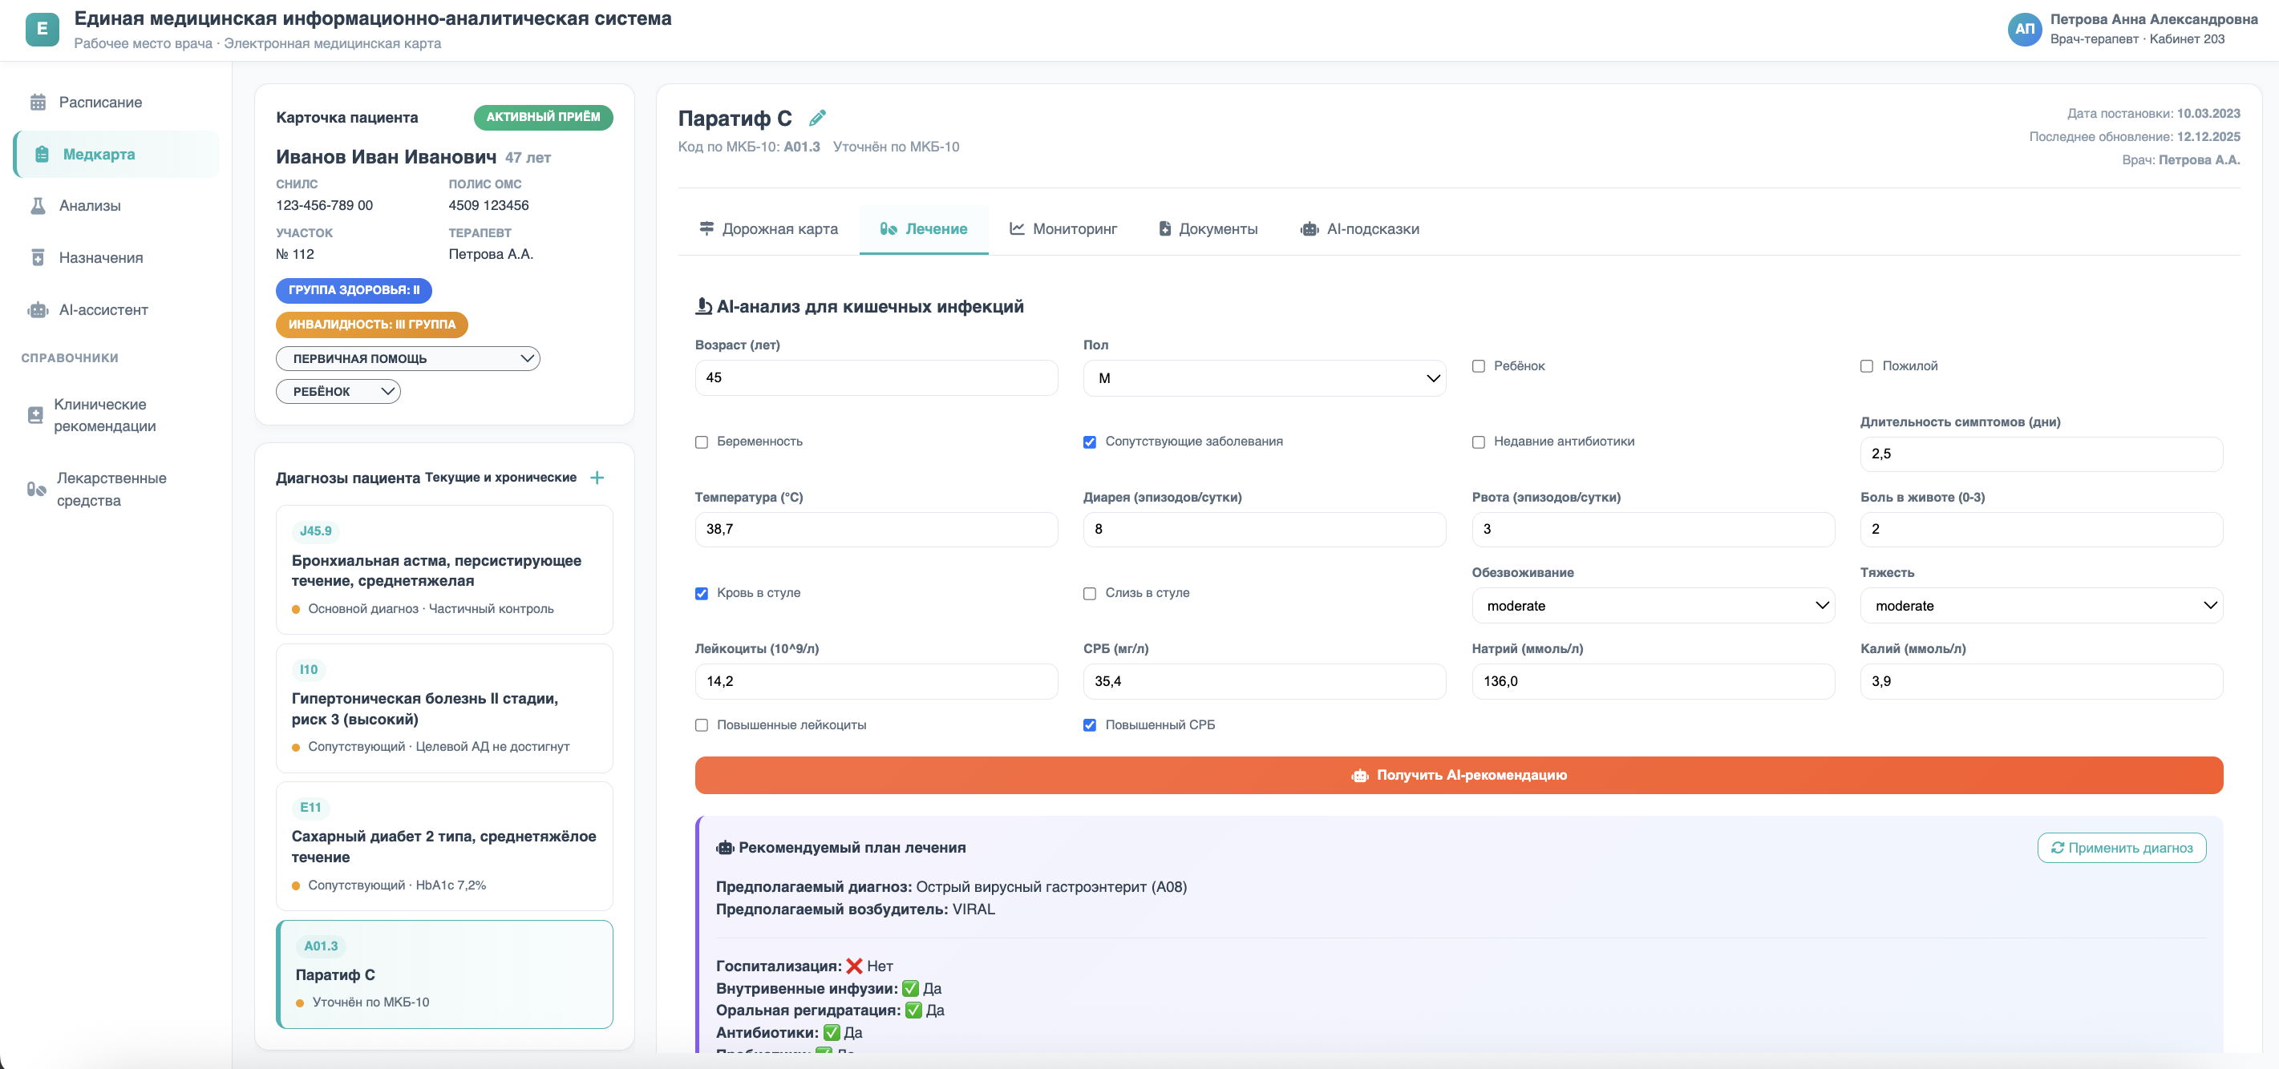
Program code and other materials are located https://github.com/chernyshovaaalina-wq/HSE_VKR

Figure 1. General view of the doctor's personal account
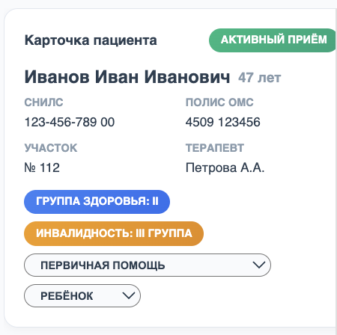

Figure 2. Patient card

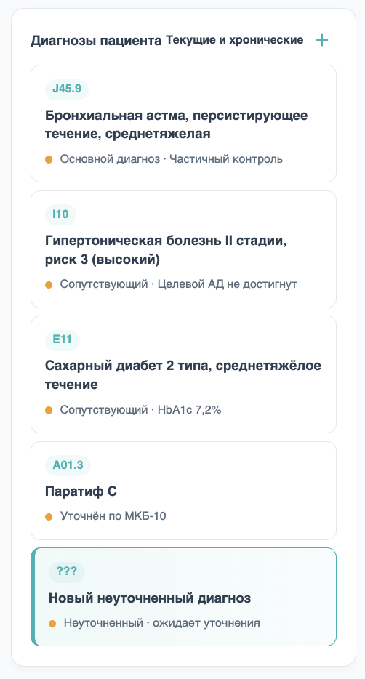
Figure 3. List of patient diagnoses with the ability to add an unspecified diagnosis

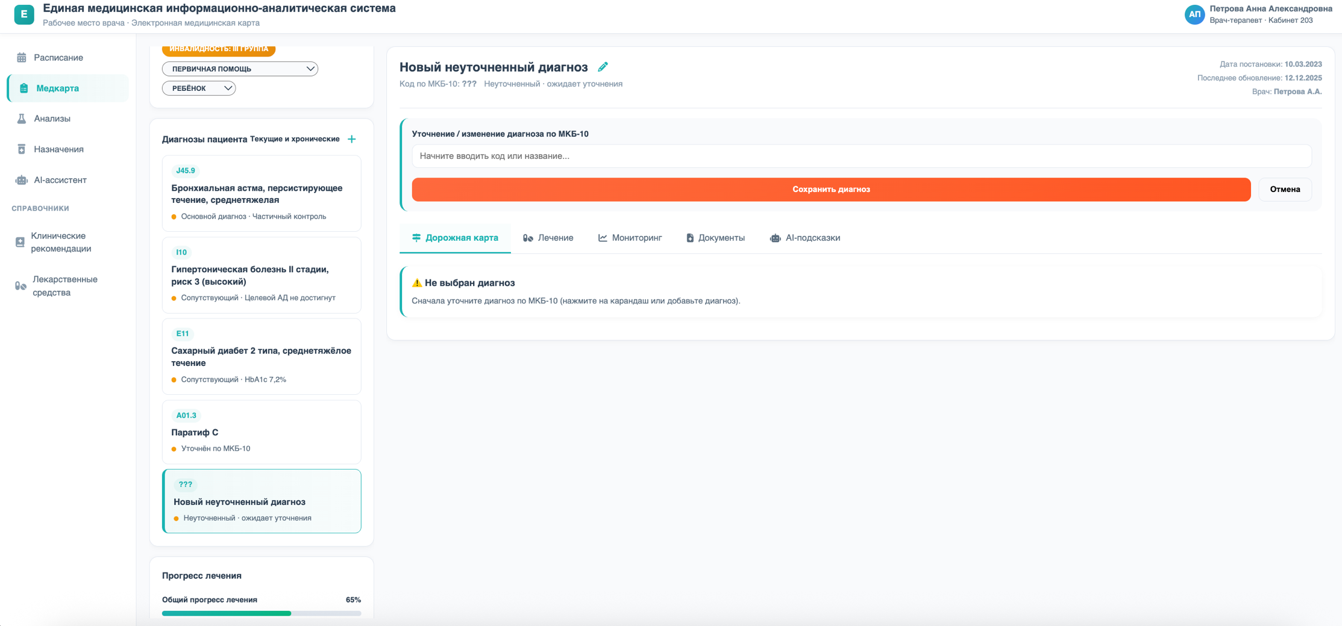
Figure 4. Unspecified diagnosis card

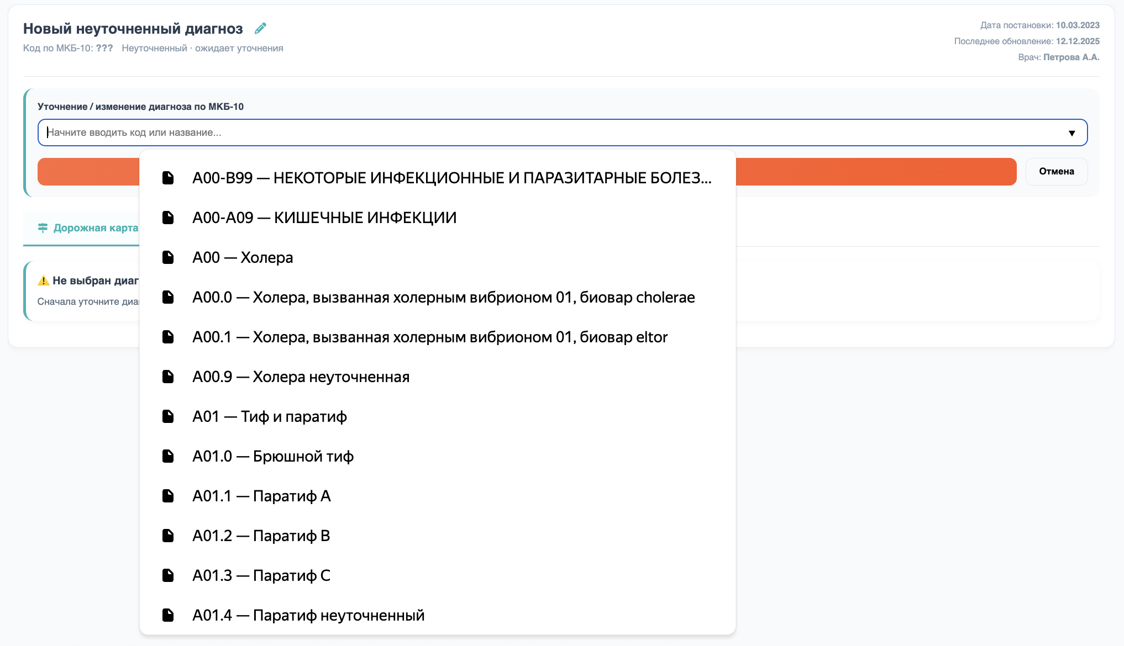
Figure 5. Selecting a diagnosis

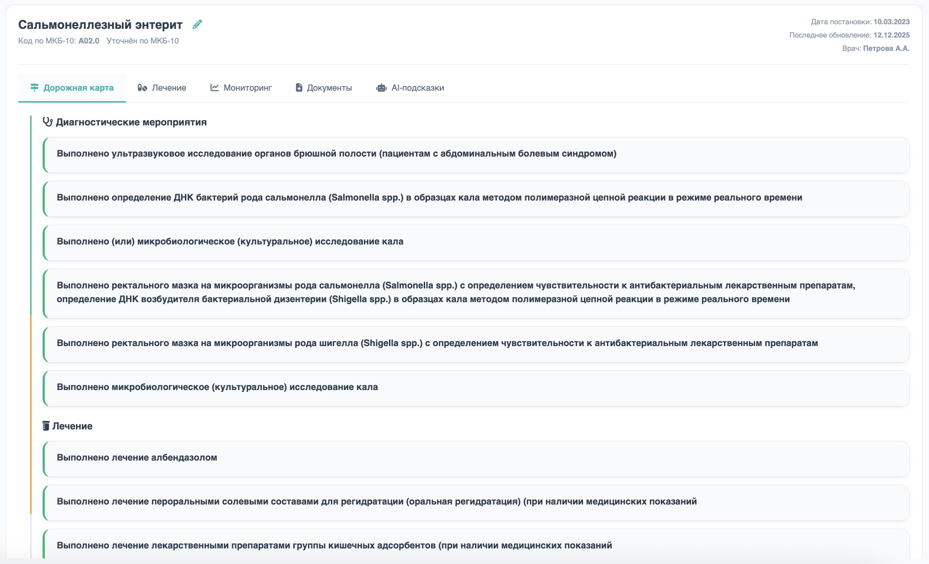
Figure 6. Patient treatment roadmap

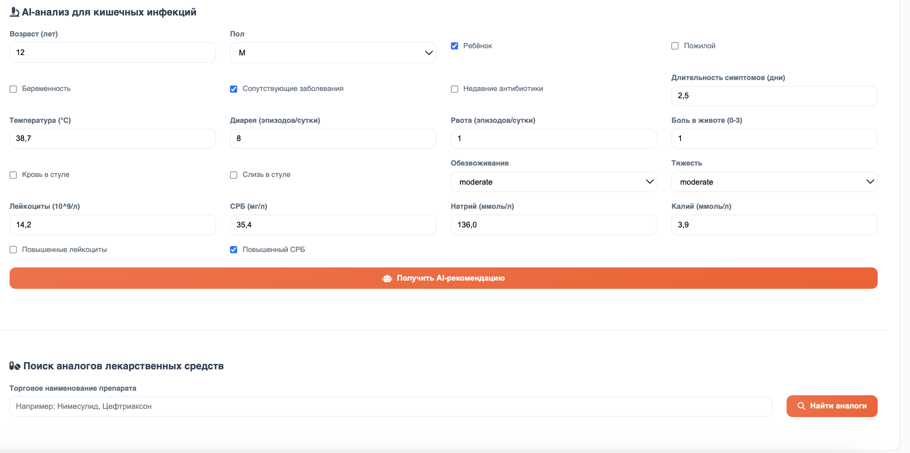
Figure 7. The «Treatment» tab with the selection of drug analogues

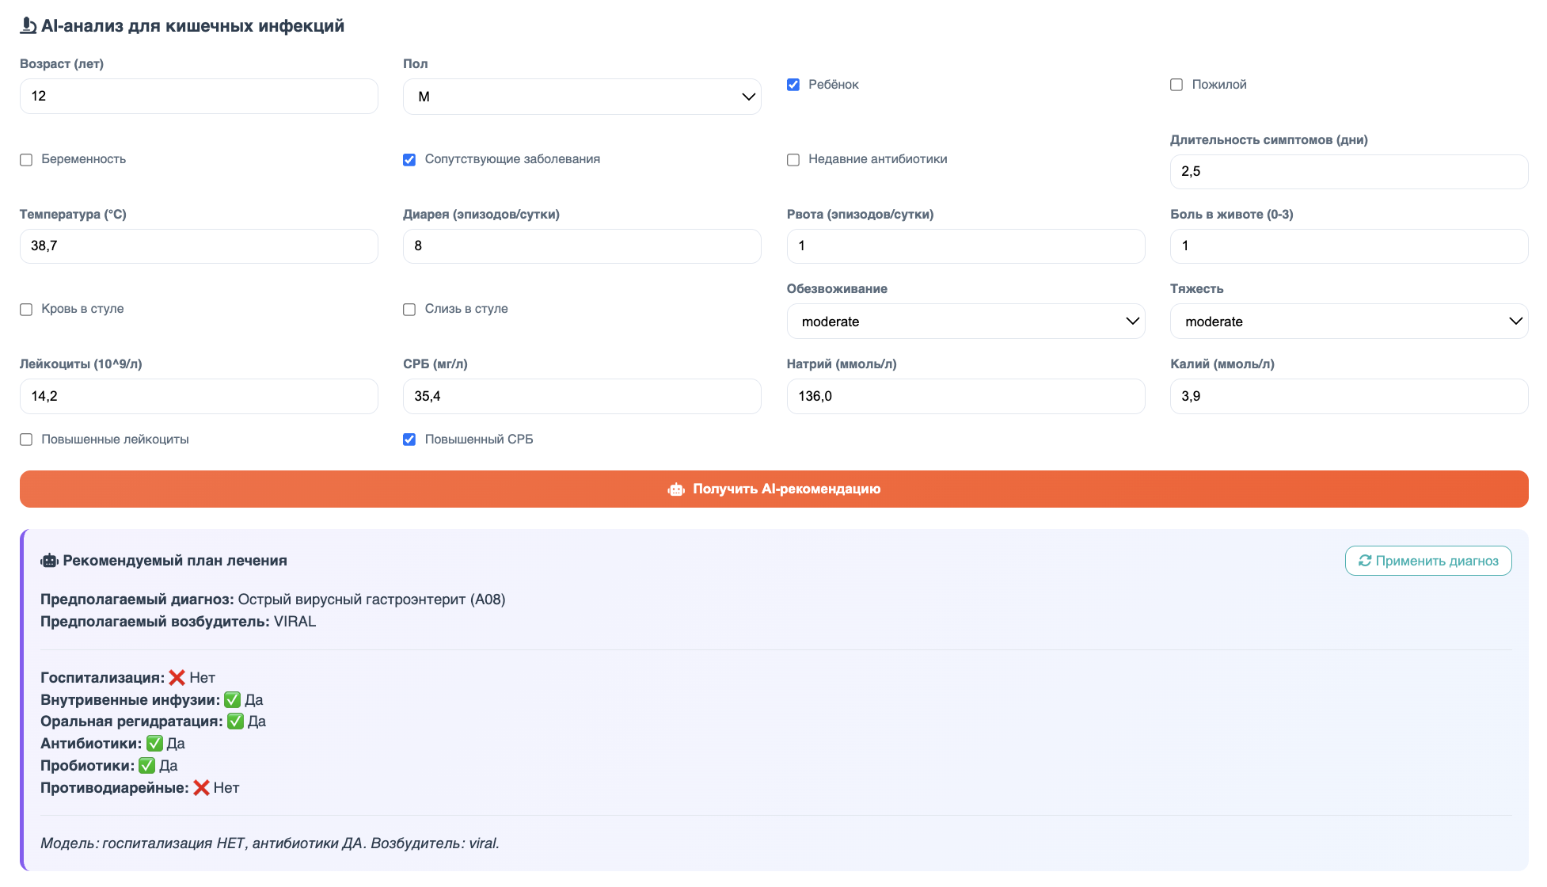
Figure 8. Patient treatment recommendations

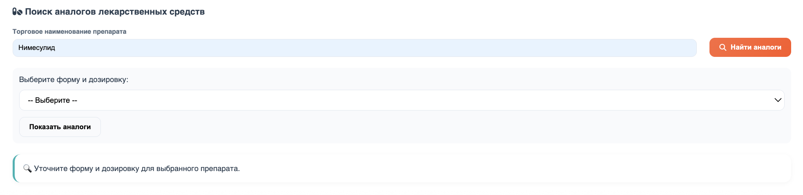
Figure 9. Selection of drug analogues

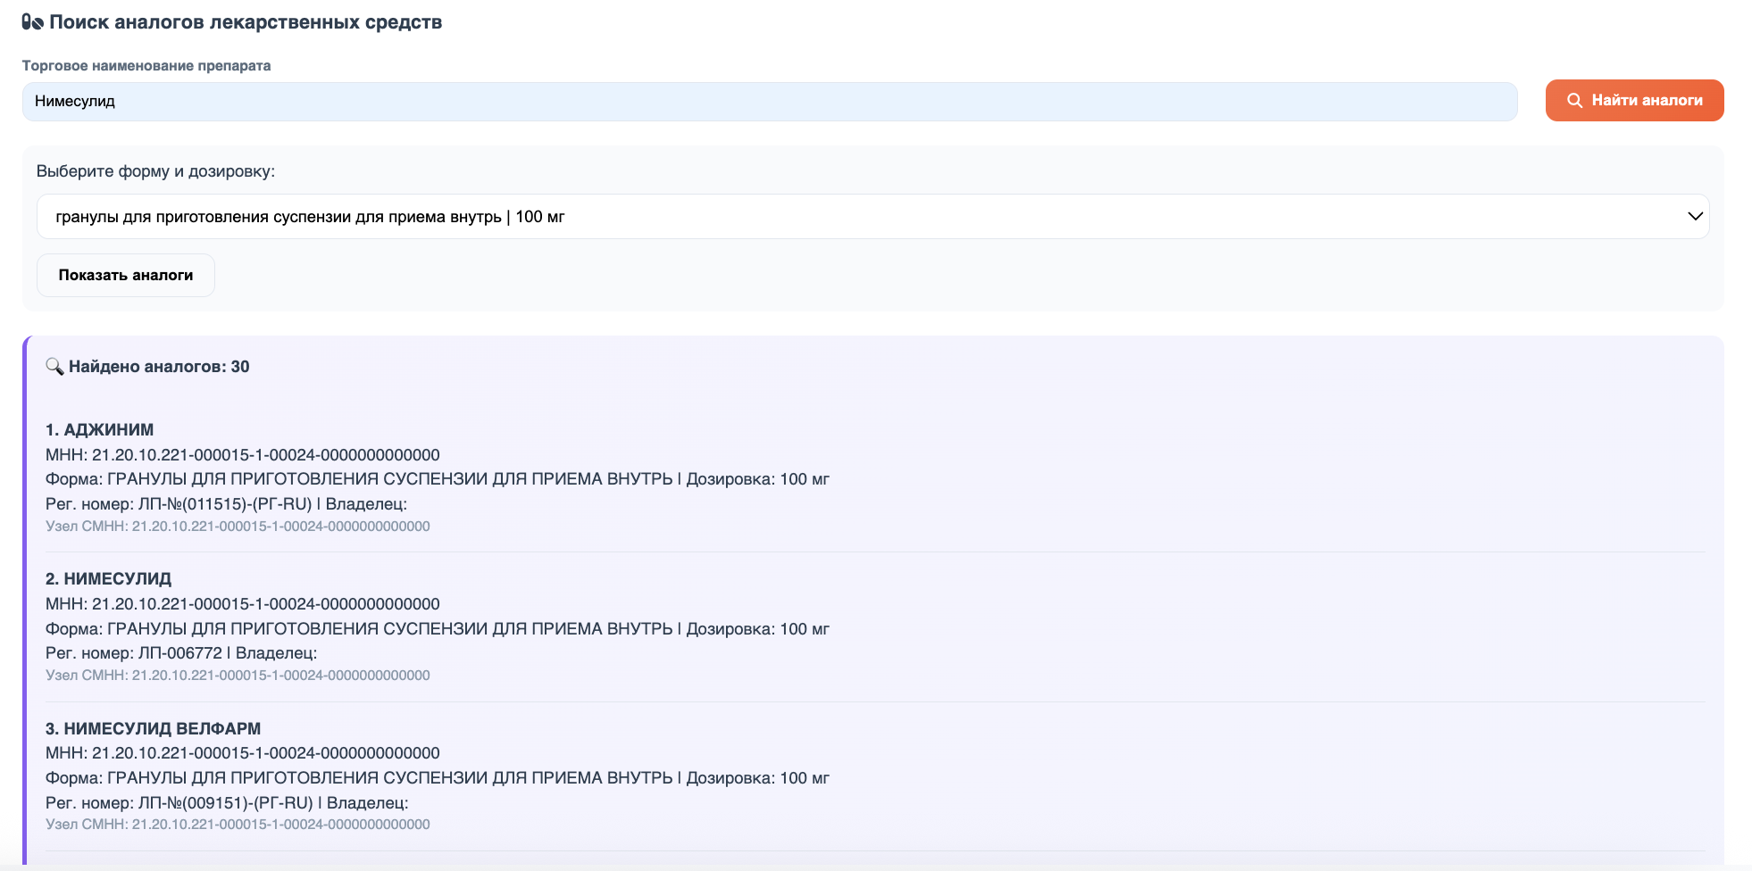
Figure 10. Result of selection of drug analogues

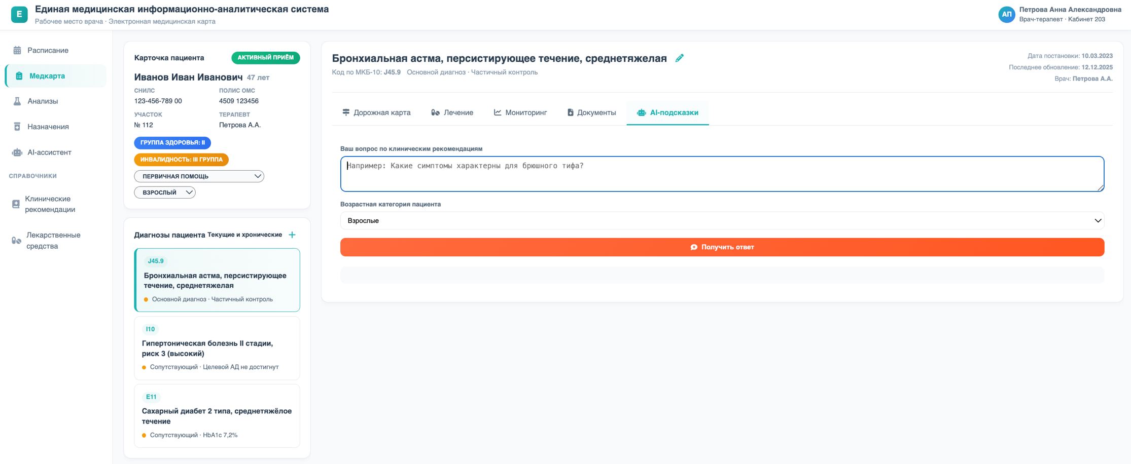
Figure 11. Smart assistant to support medical decision-making

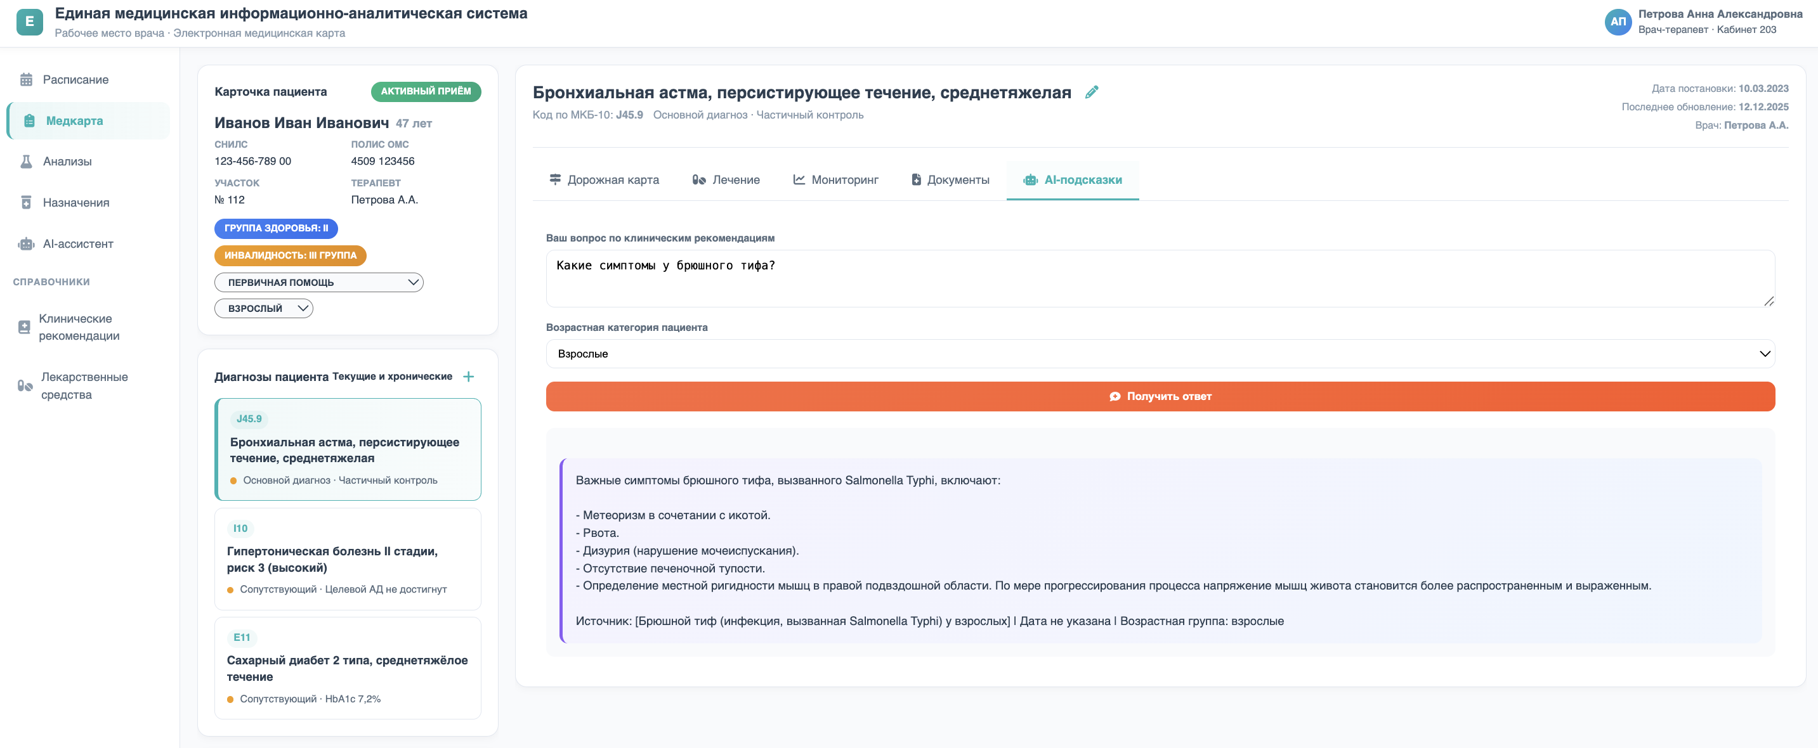
Figure 12. The result of the smart assistant's work

