Appendix: Landsat Filters

B. Steele

2021-11-16

# Background:

Upon inspection of the Colab-exported histograms, it seemed clear that some of the ranges of data seemed ecologically unfeasible with some displaying a range of 20 degrees C or more over the surface of Lake Sunapee. In this appendix, we explore some of the additional quality assurance filters that we explored that may be helpful for others using this tool.

For example, here are some histograms that looked awry, one each from Landsat missions 4, 5, 7, and 8:

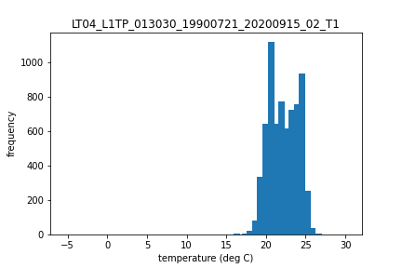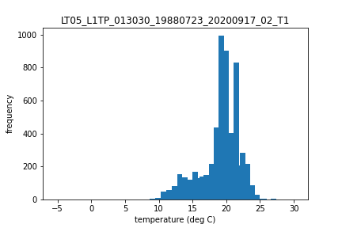

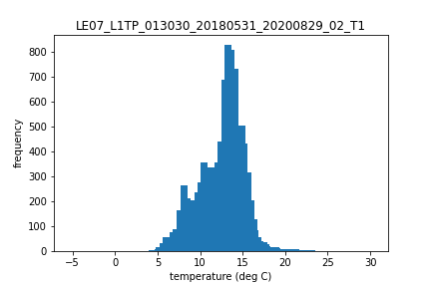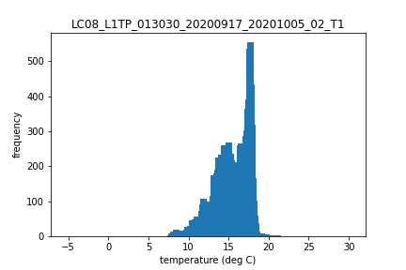

In addition to the possible range-of-value issues shown above, there were clear bimodal distributions that would not suit our analysis of using a single median value to describe the scene, as well as scenes with negative temperatures reported even though pixels classified as snow or ice were filtered out in the Colab script. Note that bimodal distributions in surface temperature across a lake surface are certainly ecologically possible outcomes and may be useful for some systems or analyses. We tried to filter out the scenes with presumed atmospheric interference (indicated by grossly large estimated temperature ranges) using measures from the extensive *in-situ* data network at Lake Sunapee and from statistical measures of distributions, namely kurtosis, or the ‘tailedness’ of the distribution. Knowing that we did not filter for clouds or cloud shadows, and given that there is documented interference with the surface temperature product, we also used a cloud filter to eliminate some scenes.

# Methods

The filters we explored were (listed in order of increased stringency based on the number of scenes eliminated from analysis):

* **freeze**: removing all scenes whose minimum temperature was below 0
* **IQR**: *freeze* filter and removing scenes that reported interquantile ranges greater than 110% in a summary of the *in-situ* record
* **kurtosis**: removing any scenes whose histogram has a kurtosis value less than 2.
* **cloud**: *freeze* filter and removing scenes with cloud cover greater than 40%. Cloud cover is a known issue with the surface temperature product.
* **range**: *freeze* filter and removing scenes that reported ranges greater than 110% obeserved in a summary of the *in-situ* record

## Load, summarize, and filter data

In order to define the maximum acceptable Landast range and interquantile range from the *in-situ* data, we limit the *in-situ* data to those values measured between the hours of 9 and 11 am, the approximate time of Landsat flyover and aggregate to a daily value. From these values we find the maximum range and interquantile range of observed data.

## [1] "Maximium spread observed is:"

## [1] 9.19

## [1] "Maximium interquantile range observed is:"

## [1] 2.6575

# Presentation and discussion of filter performance

## Comparison of filter performance

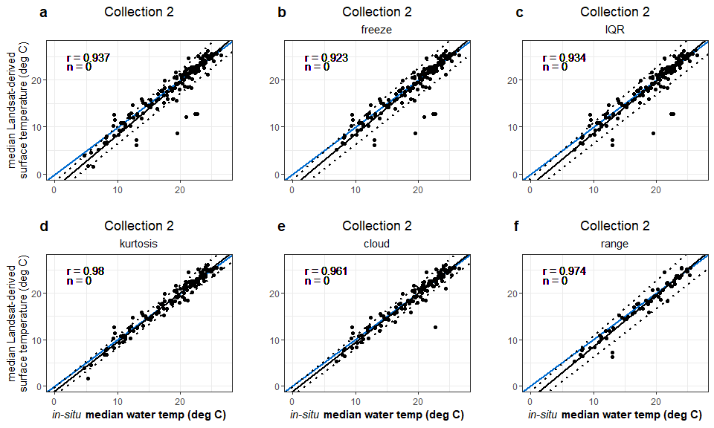

## Summarize the slope and intercepts for each of the Deming regressions

