**CPSC 6040**

**Computer Graphics Images**

**Final Project Proposal**

**Project due: 12/3/15**

**Author: Rui Chang**

**Email: rchang@g.clemson.edu**

**1.Project Description:**

This project is to implement one function of photoshop named layer blending.

When Giving two pictures, one is base picture and another is top picture, my program blend the two picture together in different mode. User can use command line to choose blending mode they want.

There are totally 15 kinds of different mode to choose from.

Test pictures I use is from the following website: http://www.northlite.net/ps/blend.htm and I will write result of all mod e in my document /result examples.

This program will input two pictures and display the blending result. When you type "w", the displaying result picture will be written.

**2. Rubric for Grading**

Reading and Writing

+ 15 Code correctly reads in and writes out processed image if second filename is specified .

+ 10 the result is correctly displays the processed image

+ 75 for all 15 kinds of blending mode I implement. One mode for 5.

**3.Target results**

**top picture**

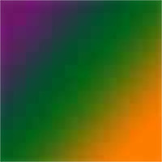

**base picture**

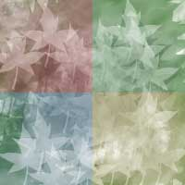

**example result**

**eg1. Saturation**

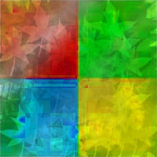

**eg2.overlay**

