**Readme**

* Student ID: 20183151
* Name: Chaelin Kim
* Check list:

|  |  |  |
| --- | --- | --- |
| Items | Status | Comments |
| **User Interface** | | |
| GUI | O | In GUI, there are 6 functions for facial retargeting.   * Source animation scene : Export source animation data file * Source ROE scene : Export Range of Expression File * Target ROE scene : Export Target CV List File  (Before using this, select the target control vectors)  Export Range of Expression File * Target animation scene : Export Final Retargeting Result File  Import Final Result File |
| **Data Generation** | | |
| FRR_blendExoprt.cpp | O | 1. Select blendshape node by name using MSelectionList  2. Get blendshape weights at each frames using MFnBlendShapeDeformer and write down each weight value on the source animation file or source ROE file |
| FRR_CVExport.cpp | O | 1. Get the controllers on the target controller list file using MStringArray  2. Iterate the controllers at each frame  3. Get plugs to access attributes of controllers and write down each value on target ROE file |
| **RBF** | | |
| rfbKernel.cpp | O | 1. Build the basis matrix from input data by using buildBasisMat() function for making _inverseBasisMatrix  2. Calculate the matrix product of _inverseBasisMatrix and output data and save it to _weightMat |
| **Data Out** | | |
| FRR_Training.cpp | O | 1. Run RBF interpolation using interpolation function of rbf class |
| FRR_CVImport.cpp | O | 1. Get the controllers on the target controller list file using MStringArray  2. Get animation data from final result file  3. Get plugs to access attributes of controllers and write down each result value on each transform of controller |

* Target machine & software: Window 10, Maya 2017x64, Visual Studio 2017
* Maya commands & instructions
  + FRRBlendExport -bn "targetBlend" -bfn "humanSourceAnimation.dat" -f 360  
    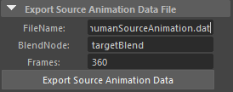
  + FRRBlendExport -bn "targetBlend" -bfn "humanROE.dat" -f 36  
    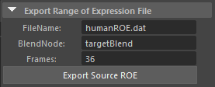
  + FRRCtrlListExport -cln "kokoCtrlList.dat"  
    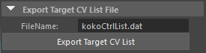
  + FRRCVExport -cln "kokoCtrlList.dat" -cfn "kokoROE.dat" -f 36  
    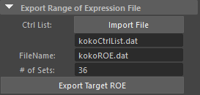
  + FRRTraining -bfn "humanROE.dat" -cfn "kokoROE.dat" -sfn "humanSourceAnimation.dat" -ffn "kokoFinalResult.dat"  
    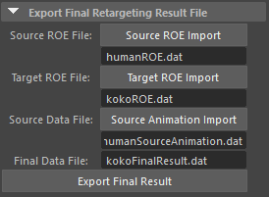
  + FRRCVImport -cln "kokoCtrlList.dat" -ffn "kokoFinalResult.dat"  
    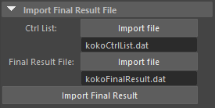
* Anything else TAs need to know for building your source codes  
  : If you run the code on “squirrely” scene file, ignore the error window in first start.