GCT561 Scientific concept and thinking

Name: Chaelin Kim

Student ID: 20205096

**HW1: Probability**

1. **English text**
   * “Alice's Adventures in Wonderland by Lewis Carroll 1865” in nltk.gutenberg package
   * Length of the text: 144,395
2. **Find the probabilities of each character**

* **Probability distribution P(x)**

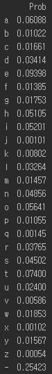 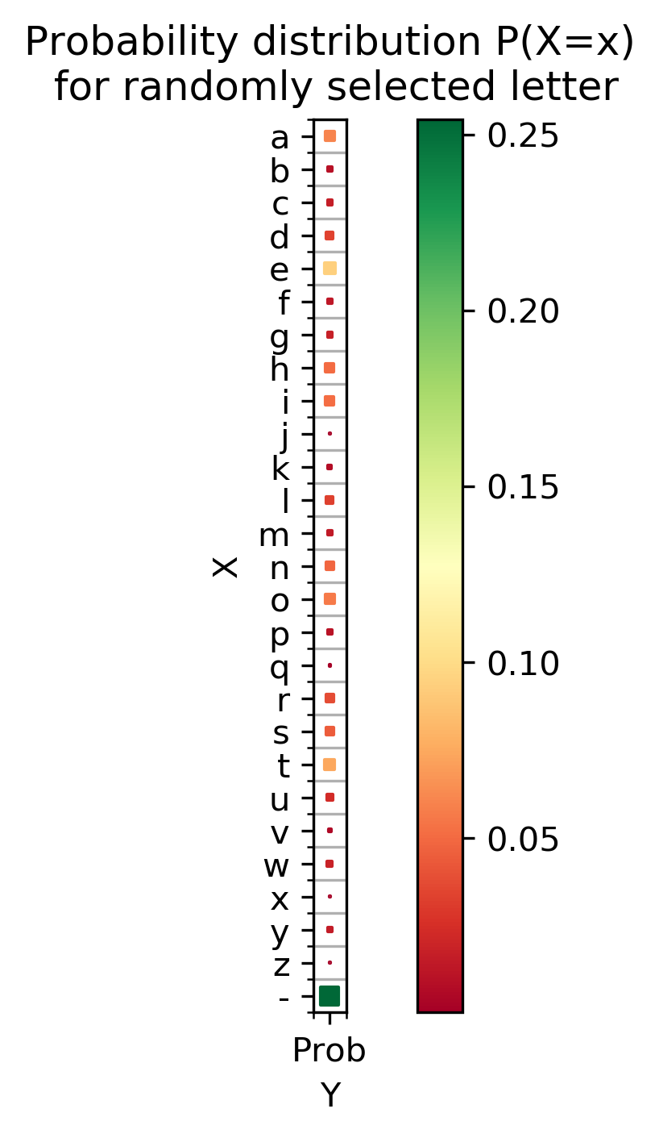

1. **Find the probabilities of each bigram**

* **Probability distribution P(x,y)**  
  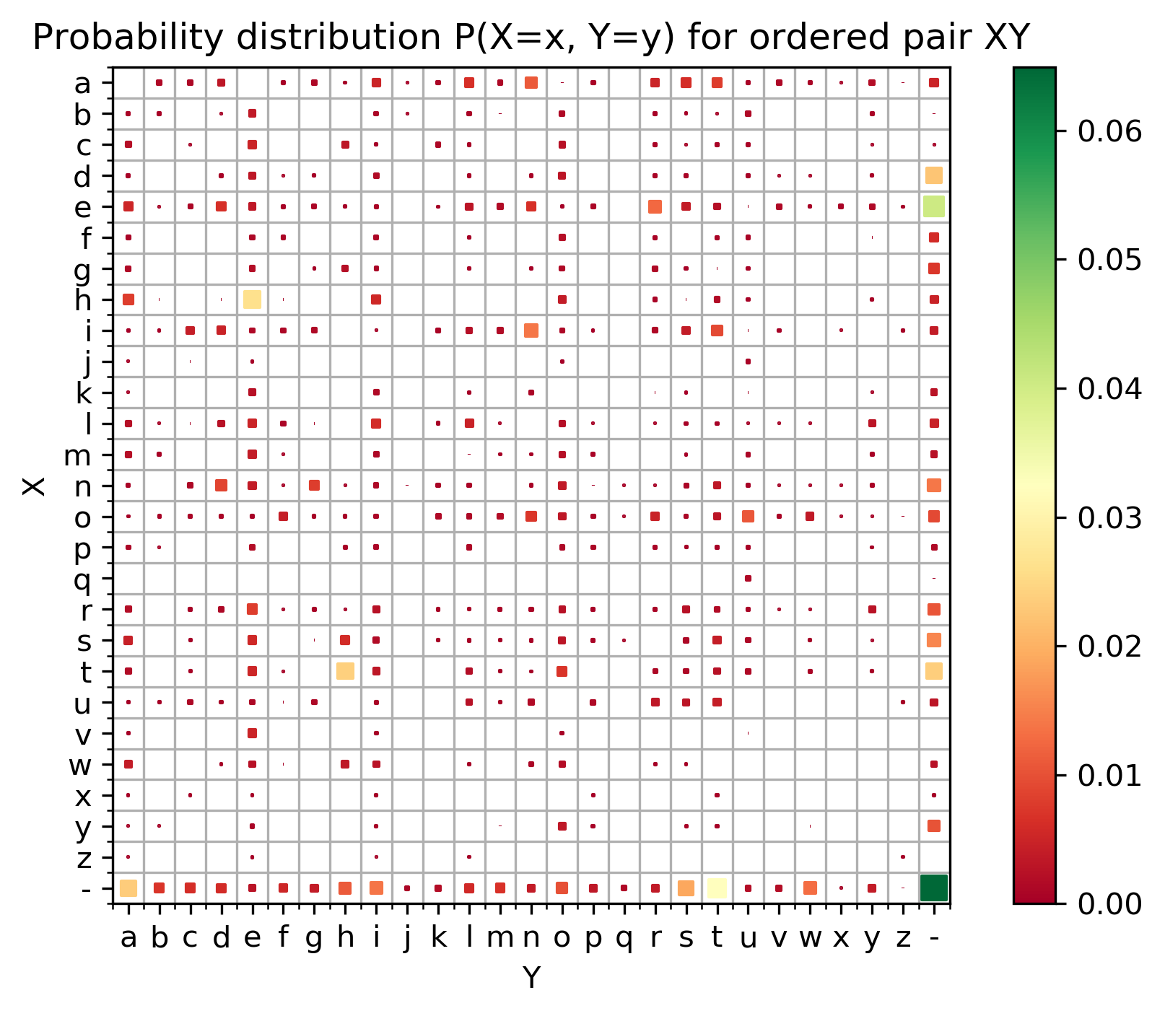
* **Conditional probability distribution P(y|x)**  
  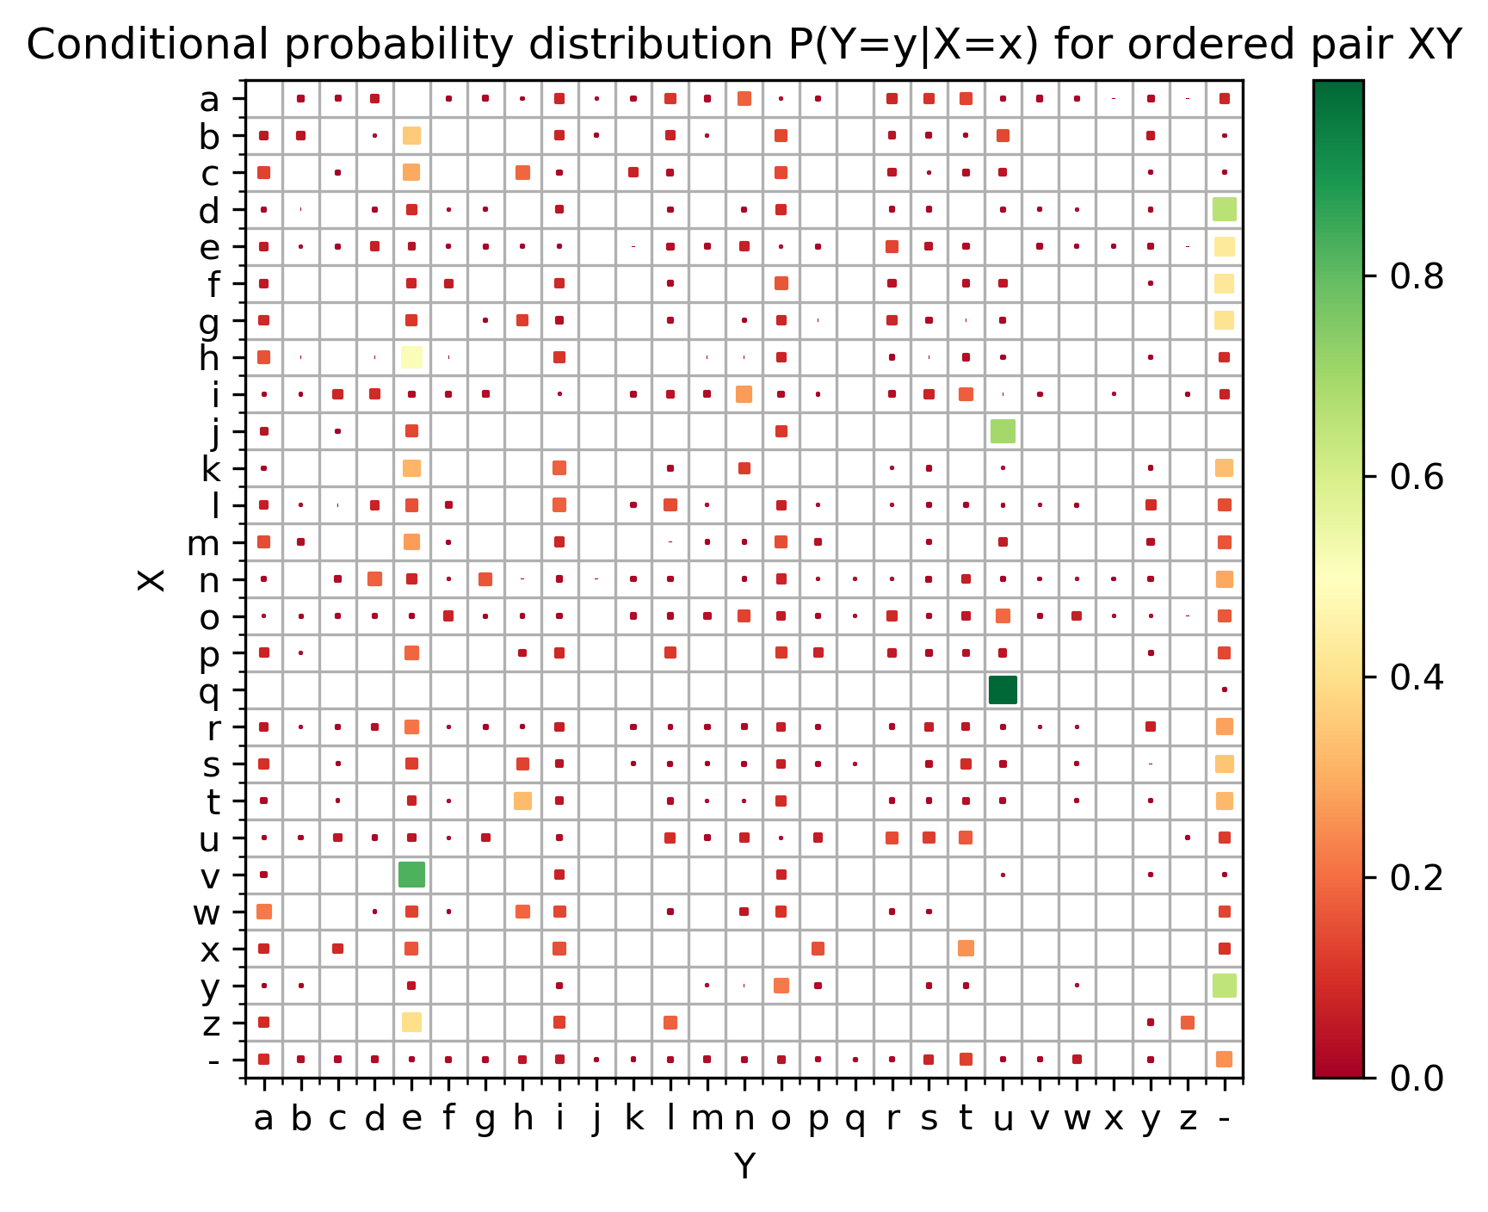
* **Conditional probability distribution P(x|y)**  
  