GCT561 Scientific concept and thinking

Name: Chaelin Kim

Student ID: 20205096

**HW2: The Monty Hall Problem**

You're playing a game show. You are shown three closed doors, behind one of which sits your dream car. If you guess which door, you win the car. The game is played as follows. You choose one door, then the host (who knows where the car is) opens a door with nothing behind it.

1. **You choose door #2. Then the host opens #1, of course with nothing behind it. Prove that it makes sense at this point to change your choice to #3.**

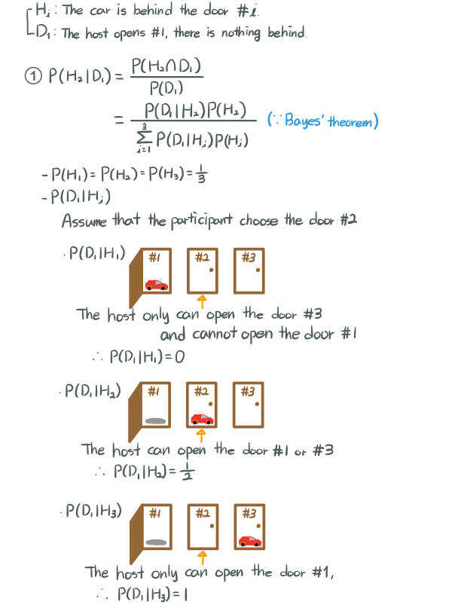

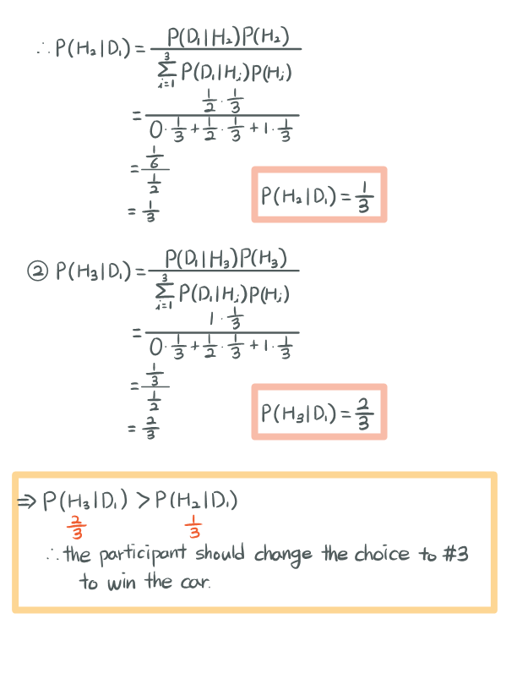

1. **You choose door #2. Before the host has a chance to approach a door to open it, there is an earthquake which causes door #1 to open. When the door is opened by the earthquake, there is no car behind it. Prove that it does not matter whether you keep your choice of door #2.**

