GCT561 Scientific concept and thinking

Name: Chaelin Kim

Student ID: 20205096

**HW3: Majority Rule**

1. **Consider the symmetric channel.**
2. **In class we saw that, when P(s=0) = P(s=1) = 1/2. The simple majority rule is the best option when the encoding process involved duplicating each bit three times.**

* **Calculate the resulting error probability.  
  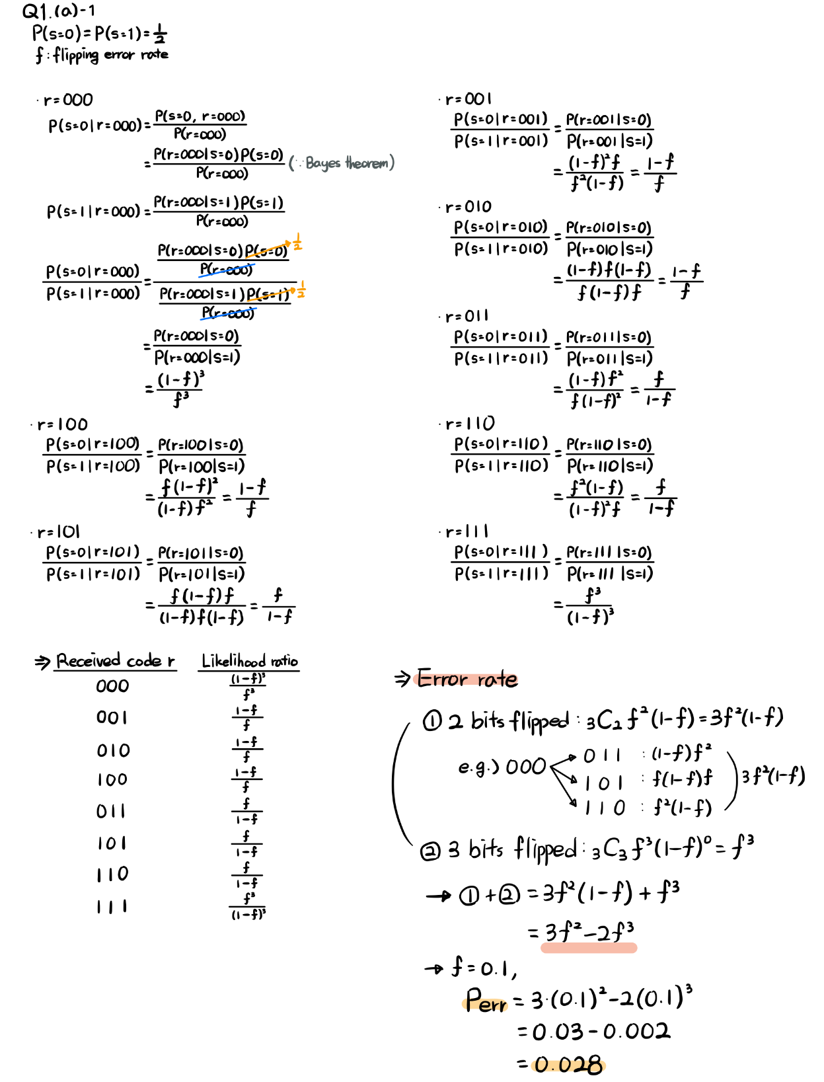**
* **Calculate the resulting error when each bit is duplicated five times.  
  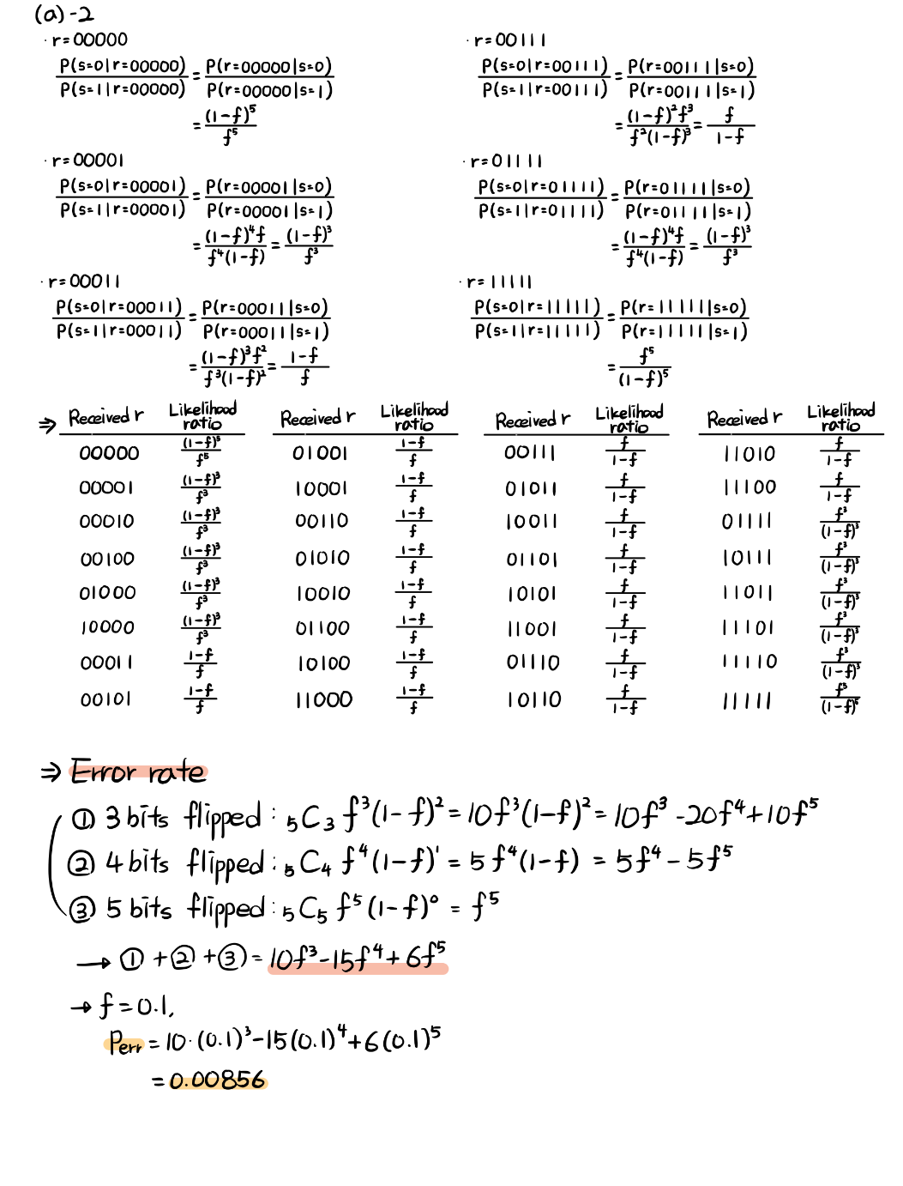**
* **Can you generalize it when each bit is duplicated 2n+1 times (n is a positive integer)?  
  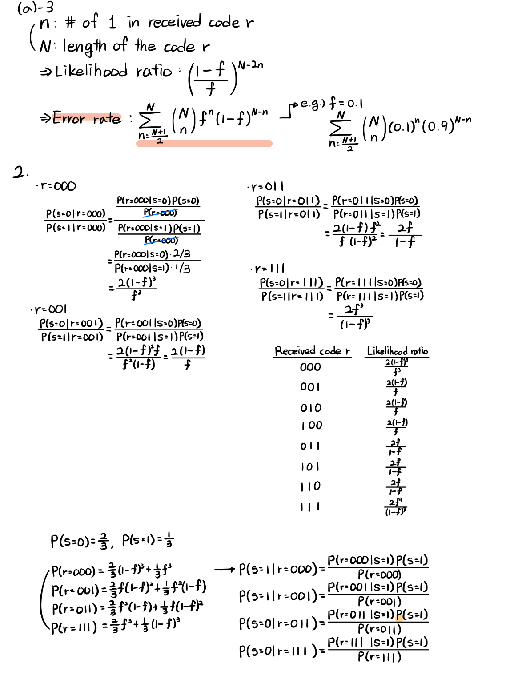**

1. **Assume that P(s=0) = 2/3 and P(s=1) = 1/3. With each bit duplicated three times in the encoding phase, what is the error rate when one takes the majority rule?**

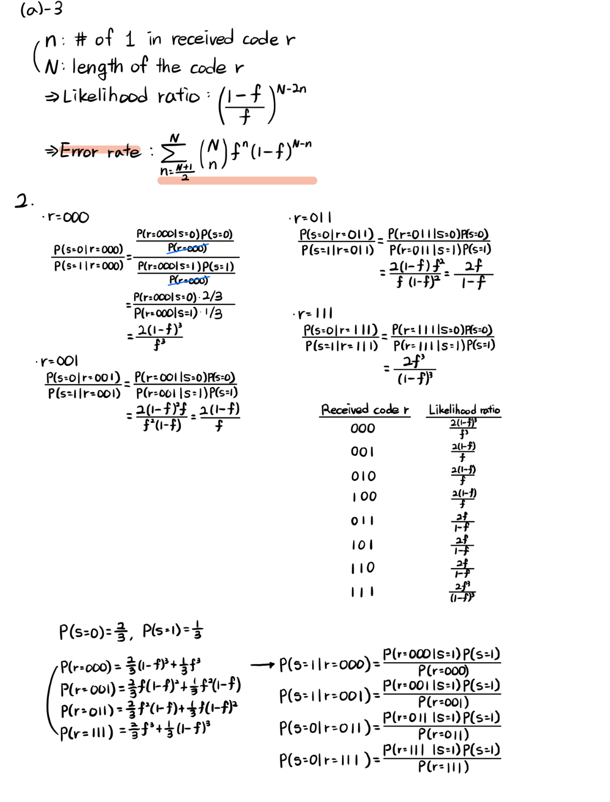

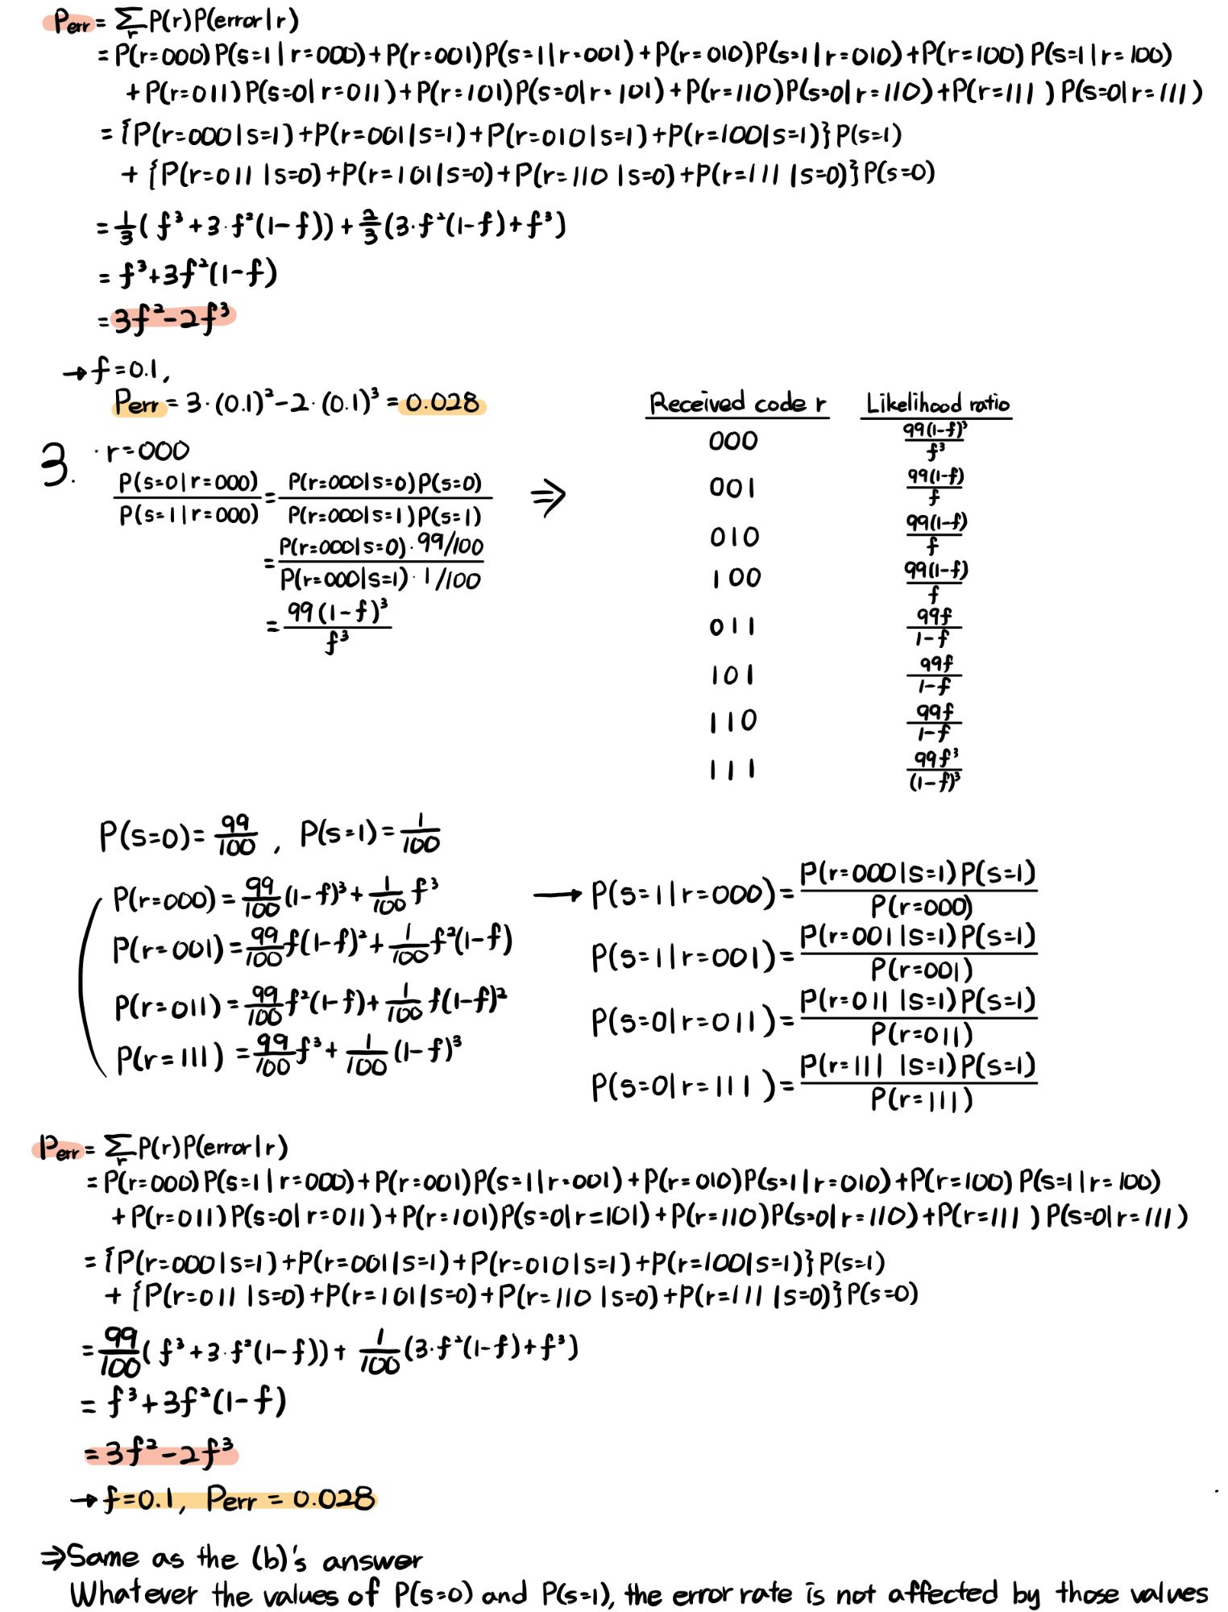

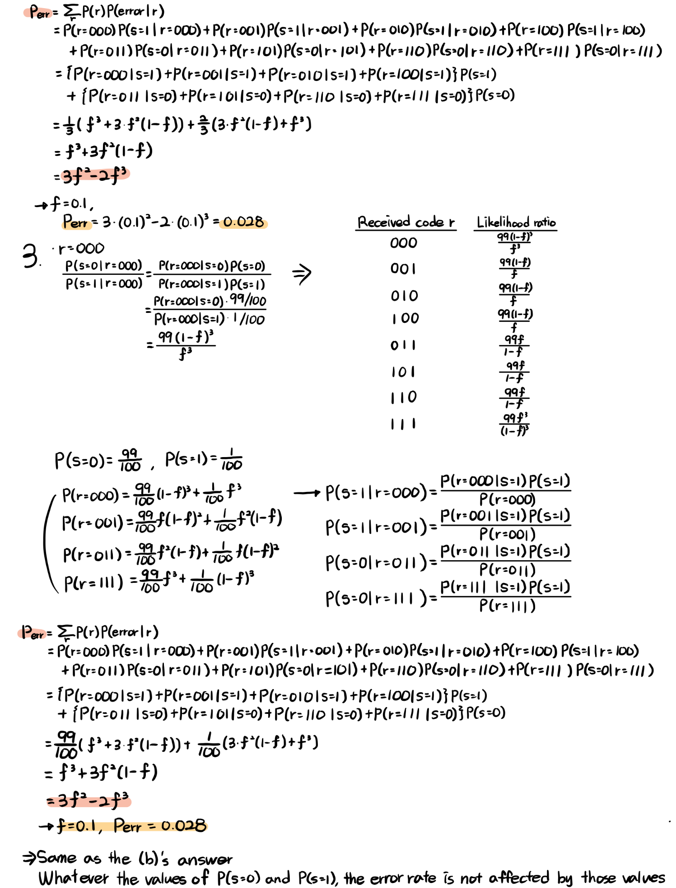

1. **Repeat the process for when P(s=0) = 99/100 and P(s=1) = 1/100, and each bit is duplicated three times. What is the error rate? Can you suggest a better method?**

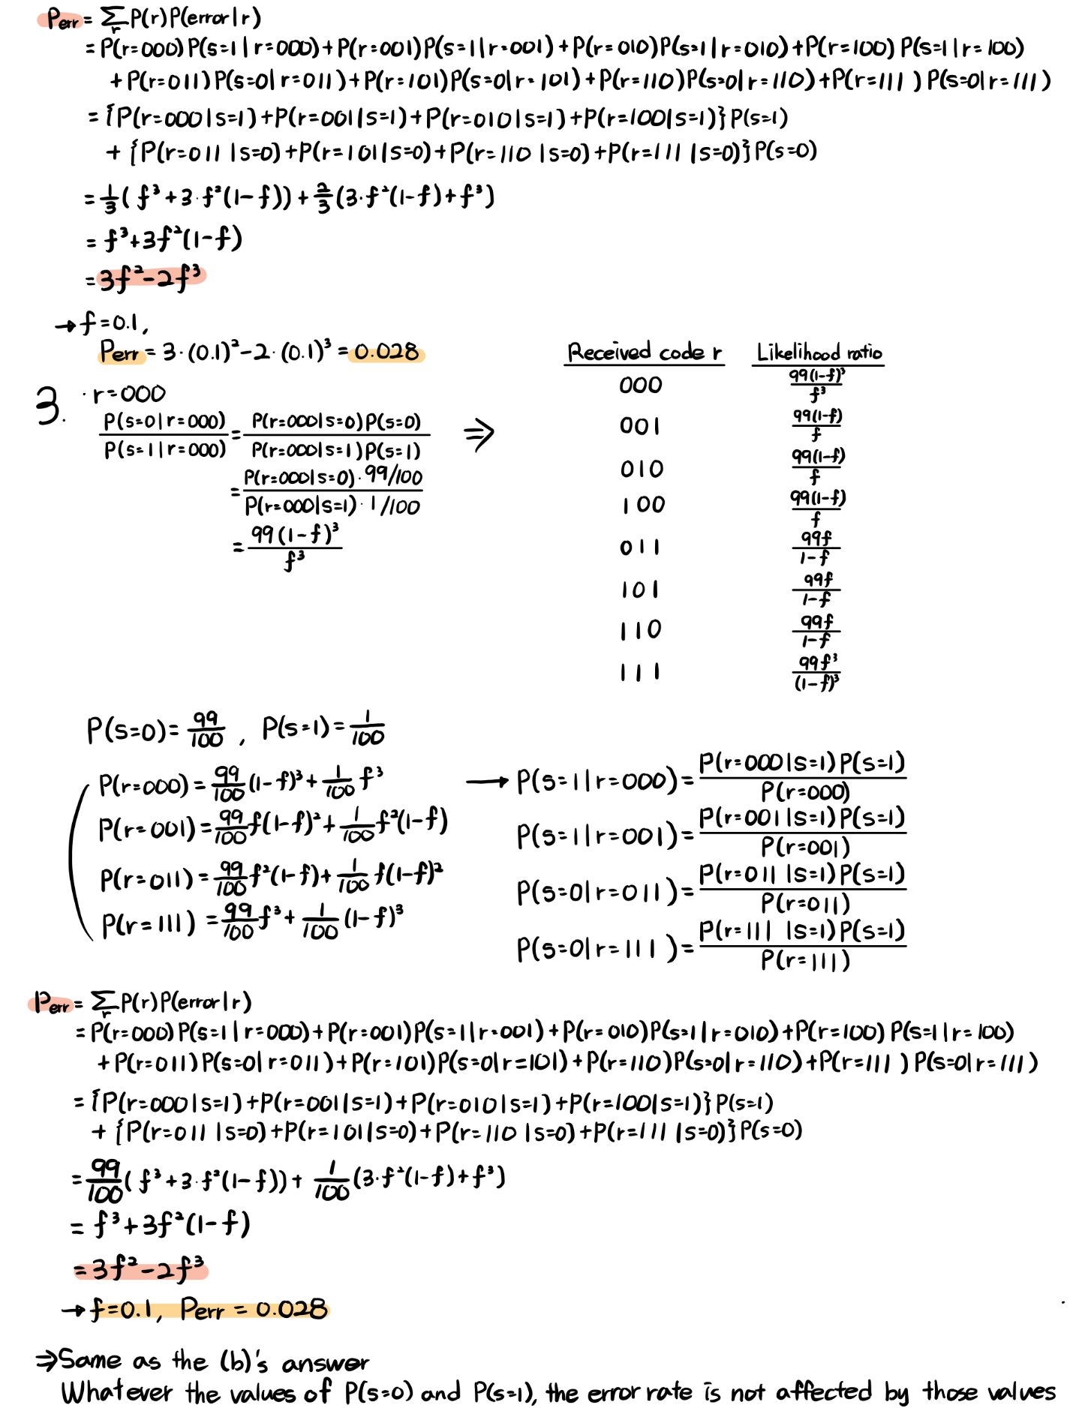

* **Another method for data transmission  
  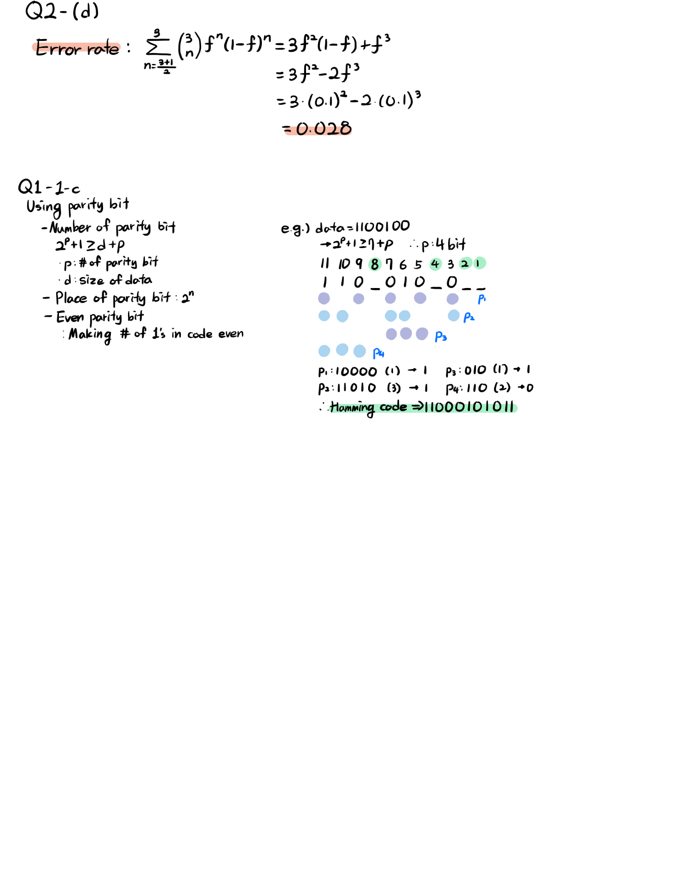**

1. **Attached is a b&w pixel art version of *Auguste Rodin’s* *The Thinker*. The image is 200x200. We write black=0 and white=1.**

(The code is attached – hw3_Q2_majorityrule.py)

1. **What are P(0) and P(1)?**

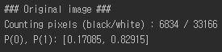

1. **Generate three images that have passed through a symmetric noisy channel with f=0.1.**

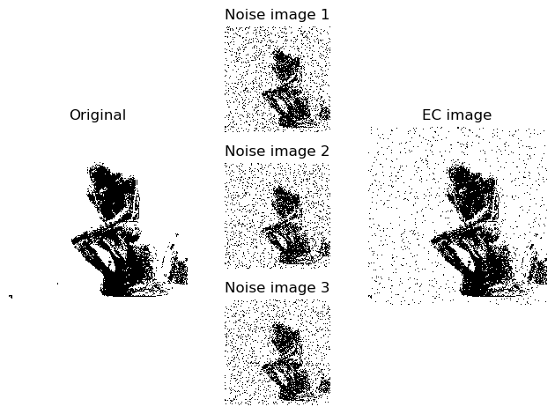

1. **Using the simple majority rule, find the error-corrected image.**

Refer to (b)’s result image (EC image)

1. **What is the error rate?**

* In mathematics,

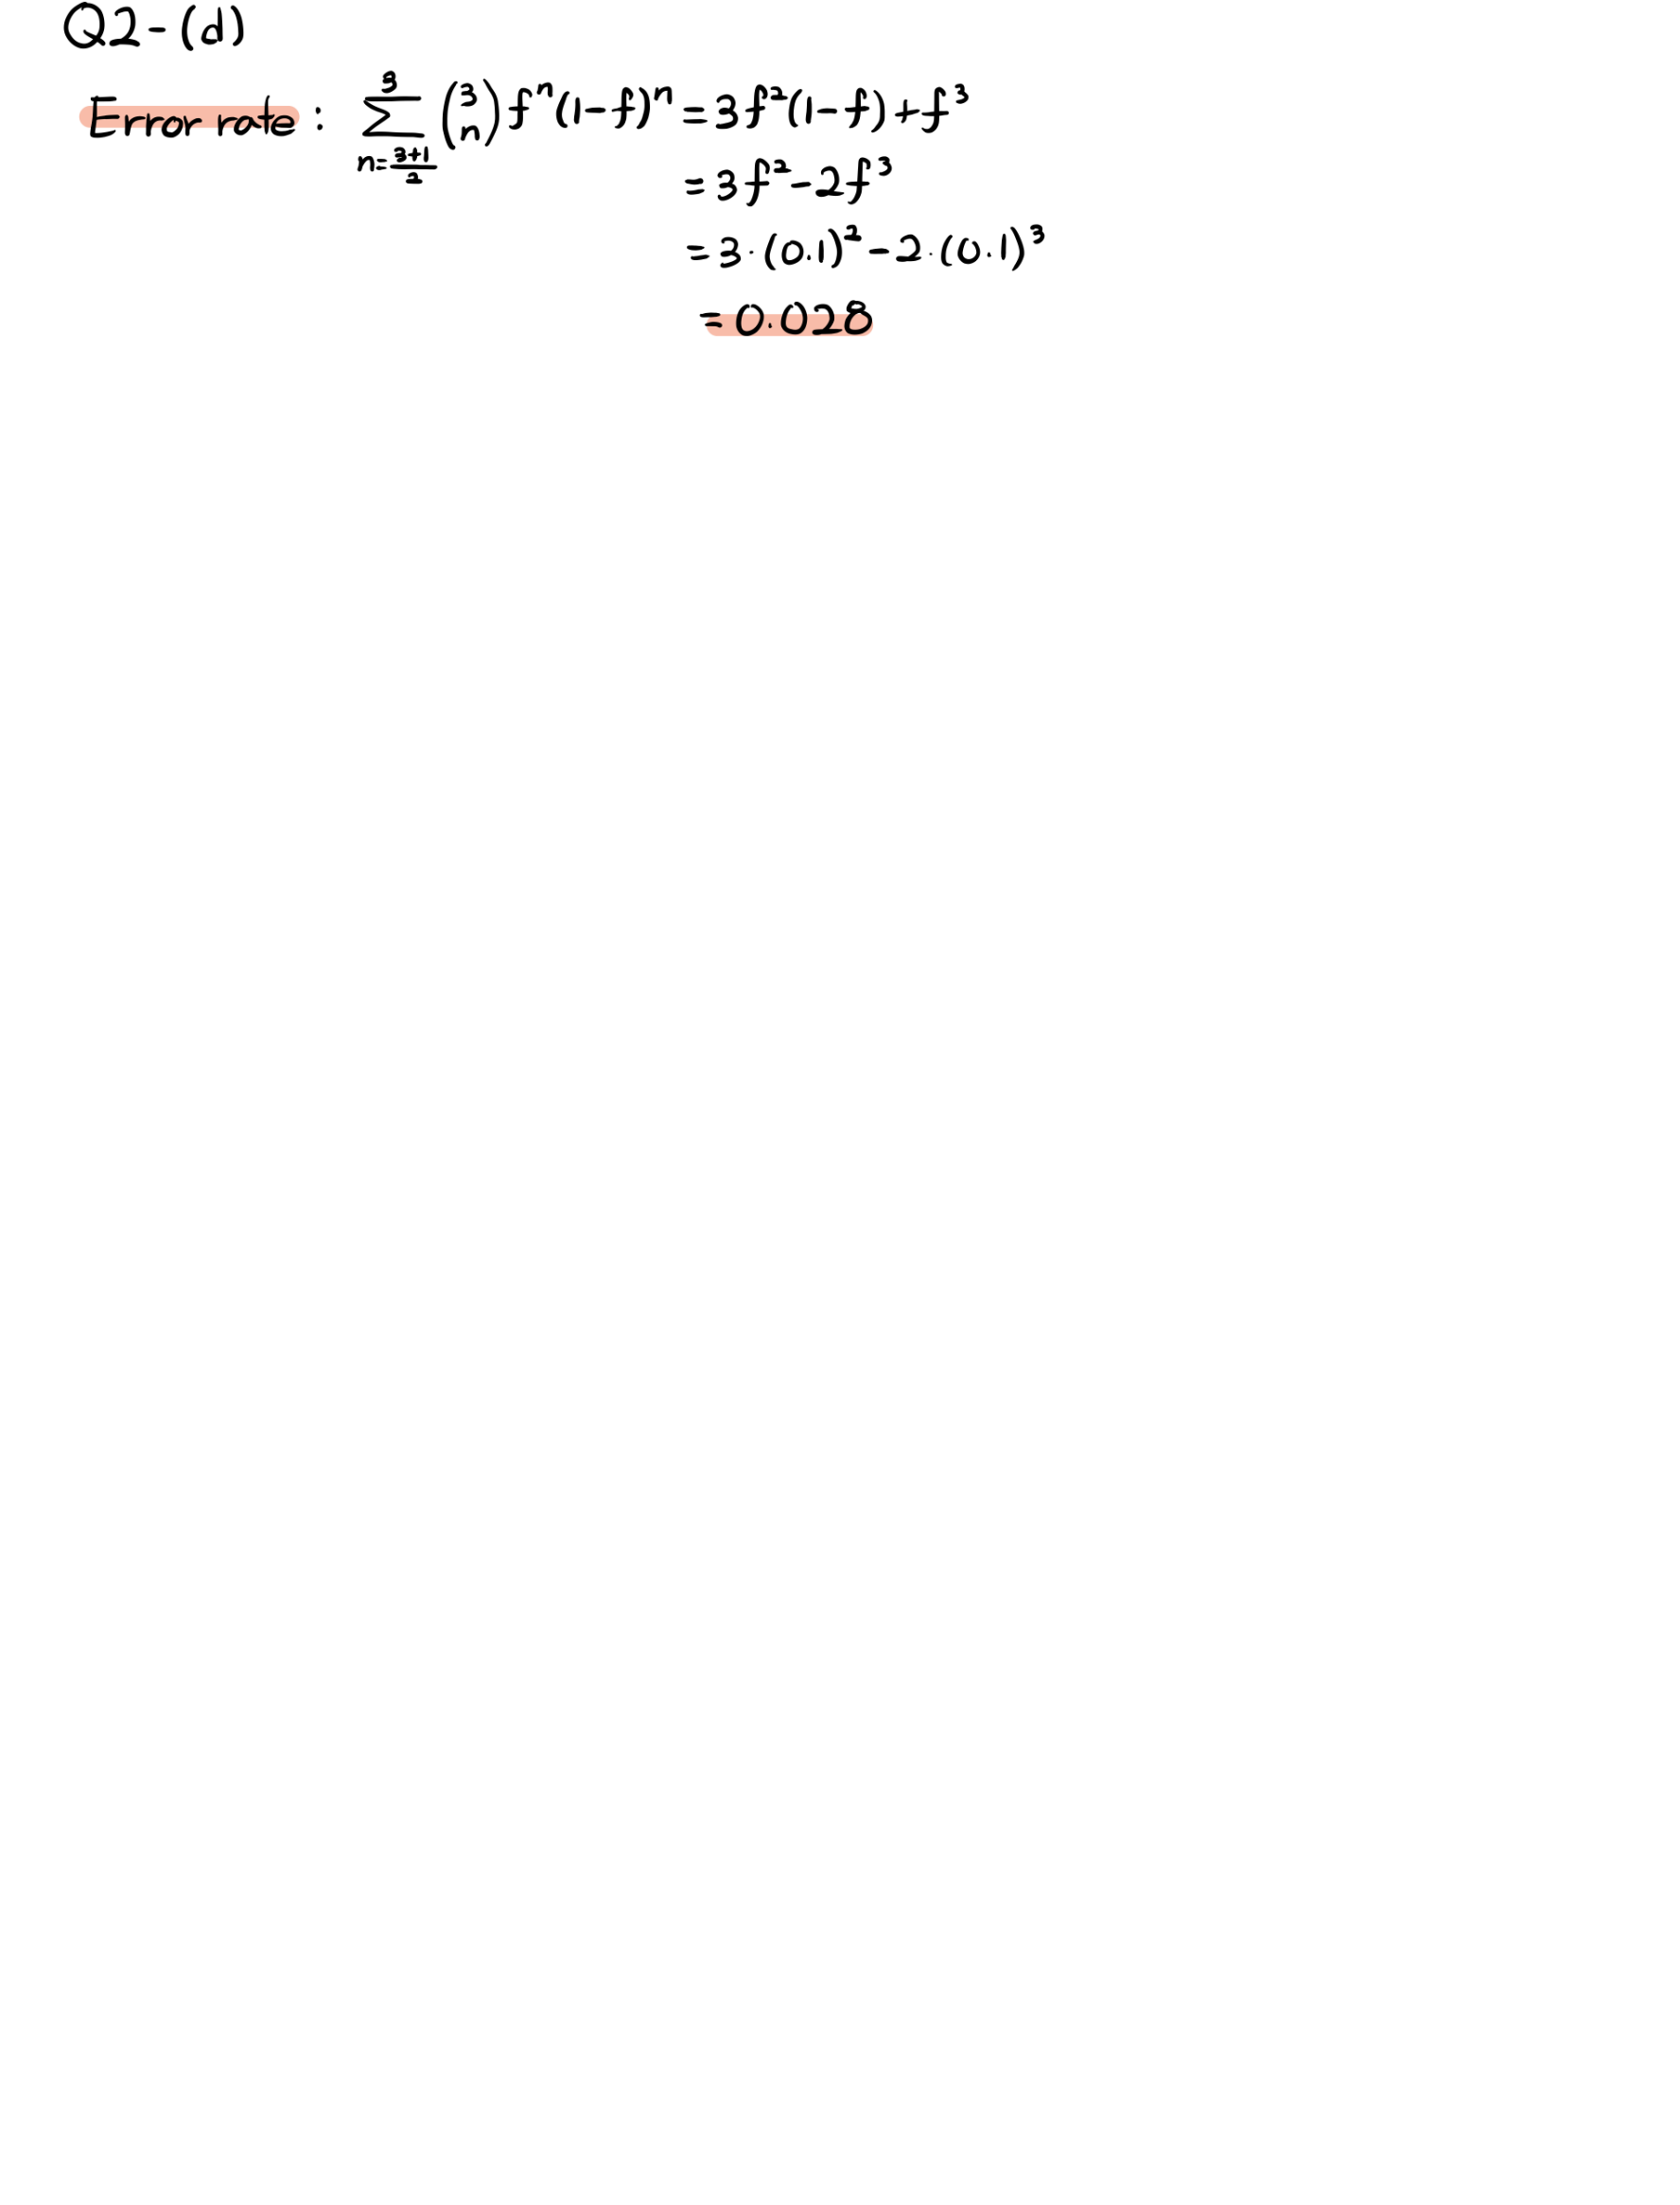

* In example case  
  