# EXERCISE 3: GLOBAL OPTIMIZATION

GCT722 MATHEMATICAL METHODS FOR VISUAL COMPUTING  
20183151 Chaelin Kim

## PART 1: BRANCH AND BOUND FOR MAXIMUM COVERAGE

### **Description of implementation**

There are 1 script file & 2 function files for the exercise branch and bound.

* **Script file**
* **main.m**  
  : This is the main script that execute branch and bound, find inlier and outlier points, and draw images and convergence plot.  
   Branch and bound is done in while loop. At each iteration, take the best candidate in the list, split the space into two children, put them into the list and remove the parent space from the list. Then find the highest lower bound and the lowest upper bound in the list, and update the best bound values with them. After that, remove all the elements in the list that upper bound is lower than current best lower bound. The iterations stop when the current lower bound and upper bound are nearer than 1.  
   If the iteration is over, compute inlier and outlier points in the result antenna location and draw the plot on the image.
* **Function files**
* **makeChilds.m**  
  : This function is used to split the current space into two children along the longest dimension. It returns first and second child node that lower and upper bound is calculated in space.
* **calBounds.m**  
  : This function is used to calculate the cardinality bounds. For calculating the lower bound, test the model at the center in the current space. For calculating the upper bound, test the extended shape corresponding to the union of all the antenna coverages in the current space. The return values *lowerBound* and *upperBound* are the number of inliers in each, and *lowerInliers* and *upperInliers* are the indices list of inliers in each.

### **Instructions for running**

1. Open the file “main.m” in Matlab.
2. Execute that file.
3. The window that shows the result images and graph is opened.
   1. The left part shows result images of applying BnB before and after.
   2. The right part shows the result plot of convergence of bounds

### **Screenshots**

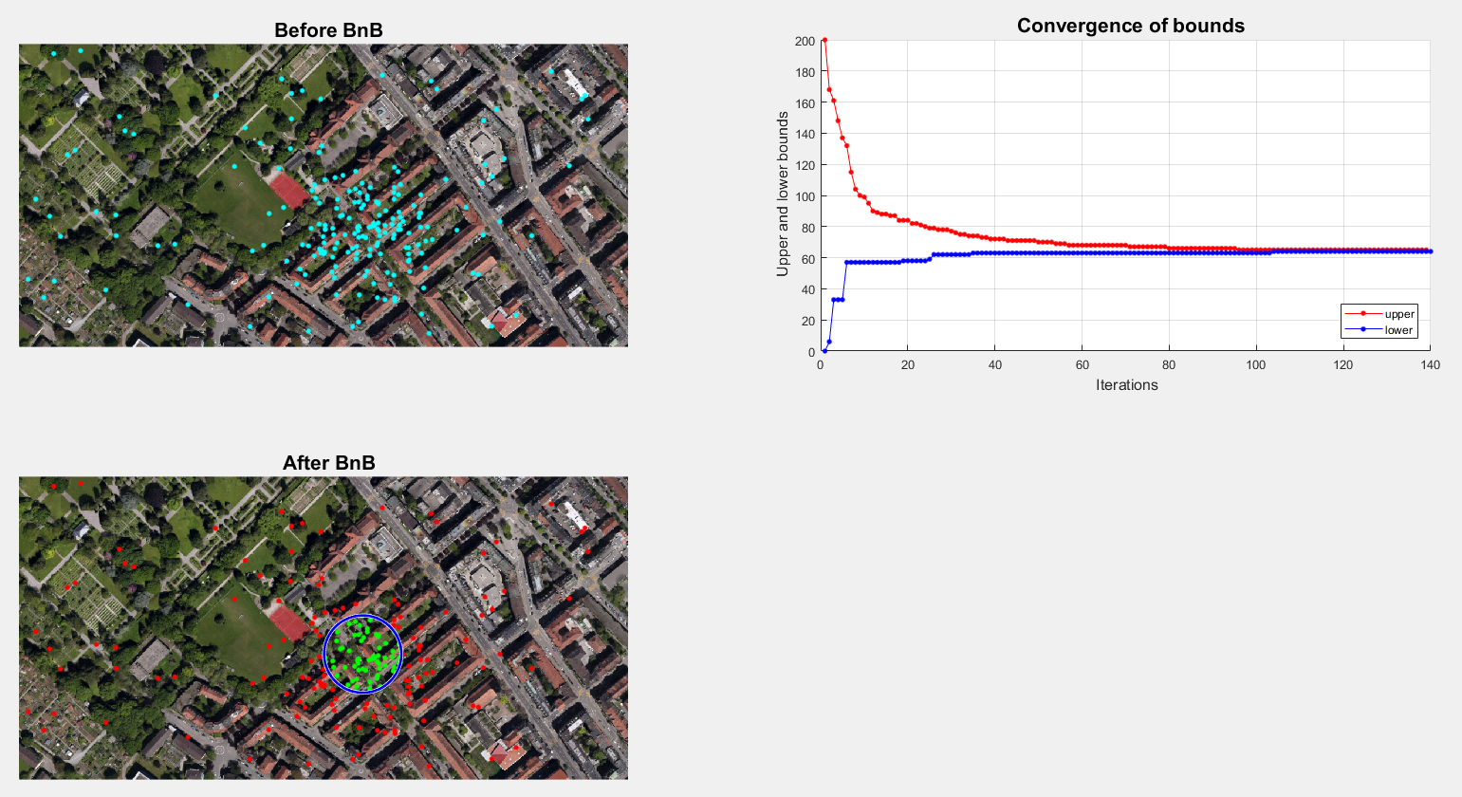

### **The results of the antenna location**

(x, y) = (623.5918, 322.0938)

### **Indices of the inliers and outliers**

|  |  |  |  |  |  |  |  |  |
| --- | --- | --- | --- | --- | --- | --- | --- | --- |
| **Inliers** | | | |  | **Outliers** | | | |
| 2 | 58 | 100 | 152 |  | 1 | 50 | 101 | 150 |
| 4 | 62 | 102 | 153 |  | 3 | 51 | 103 | 151 |
| 8 | 76 | 105 | 156 |  | 5 | 52 | 104 | 154 |
| 10 | 80 | 106 | 158 |  | 6 | 53 | 107 | 155 |
| 13 | 87 | 110 | 161 |  | 7 | 54 | 108 | 157 |
| 14 | 89 | 111 | 164 |  | 9 | 55 | 109 | 159 |
| 26 | 90 | 114 | 165 |  | 11 | 56 | 112 | 160 |
| 30 | 92 | 116 | 167 |  | 12 | 57 | 113 | 162 |
| 33 | 93 | 120 | 168 |  | 15 | 59 | 115 | 163 |
| 39 | 94 | 121 | 170 |  | 16 | 60 | 117 | 166 |
| 42 |  | 122 | 171 |  | 17 | 61 | 118 | 169 |
| 44 |  | 125 | 179 |  | 18 | 63 | 119 | 172 |
| 45 |  | 129 | 182 |  | 19 | 64 | 123 | 173 |
| 46 |  | 132 | 184 |  | 20 | 65 | 124 | 174 |
|  |  | 133 | 188 |  | 21 | 66 | 126 | 175 |
|  |  | 137 | 189 |  | 22 | 67 | 127 | 176 |
|  |  | 139 | 192 |  | 23 | 68 | 128 | 177 |
|  |  | 142 | 193 |  | 24 | 69 | 130 | 178 |
|  |  | 143 | 194 |  | 25 | 70 | 131 | 180 |
|  |  |  | 198 |  | 27 | 71 | 134 | 181 |
|  |  |  | 200 |  | 28 | 72 | 135 | 183 |
|  |  |  |  |  | 29 | 73 | 136 | 185 |
|  |  |  |  |  | 31 | 74 | 138 | 186 |
|  |  |  |  |  | 32 | 75 | 140 | 187 |
|  |  |  |  |  | 34 | 77 | 141 | 190 |
|  |  |  |  |  | 35 | 78 | 144 | 191 |
|  |  |  |  |  | 36 | 79 | 145 | 195 |
|  |  |  |  |  | 37 | 81 | 146 | 196 |
|  |  |  |  |  | 38 | 82 | 147 | 197 |
|  |  |  |  |  | 40 | 83 | 148 | 199 |
|  |  |  |  |  | 41 | 84 | 149 |  |
|  |  |  |  |  | 43 | 85 |  |  |
|  |  |  |  |  | 47 | 86 |  |  |
|  |  |  |  |  | 48 | 88 |  |  |
|  |  |  |  |  | 49 | 91 |  |  |
|  |  |  |  |  |  | 95 |  |  |
|  |  |  |  |  |  | 96 |  |  |
|  |  |  |  |  |  | 97 |  |  |
|  |  |  |  |  |  | 98 |  |  |
|  |  |  |  |  |  | 99 |  |  |

### **Discuss the results**

I have implemented coverage maximization by branch and bound where the model to find is the (x, y) 2D position of the antenna. The upper and lower bounds are converged at **iteration 140**. The result of the antenna location is **(623.5918, 322.0938)** and the number of inliers is **64** (the iterations stop when the lower and upper bound are nearer than 1). The execution time is about 2 secs, so it finds the optimal solution quite fast.

The branch and bound is methods for global optimization problems, so normally it is slower than methods for local optimization problems. In addition, if the points are comparatively scattered, it will search most spaces. So the execution time depends on the number of data points and how data points are scattered. But the branch and bound method is faster than exhaustive search, because in this method we cannot search the space estimated there is no optimal solution. Also, it guarantees the optimal solution because it considers global objective values.