AI ASSISTED CODING

LAB ASSIGNMENT-4

NAME:-M. CHARAN TEJA REDDY
ENROLL NO:-2503A52707
BATCH.NO:-24

Task Description #1 (Privacy & Security in File Handling)
Task: Use an AI tool to generate a Python script that stores user data (name, email, password) in a file.
Analyze: Check if the AI stores sensitive data in plain text or without encryption.
Expected Output:
Identified privacy risks.
Revised version with encrypted password storage (e.g., hashing).

PROMPT:-
GENERATE A PYTHON CODE PRIVACY & SECURITY IN FILE HANDLING WHEATHER THAT STORES USER DATA (NAME, EMAIL, PASSWORD) IN A FILE .

CODE:-

"""Secure user-data storage example.

Privacy risks in a naive version:
- Plain-text passwords can expose every account if the file is leaked.
- Names and email addresses are personal data and need access controls.
- An unprotected data file can be read or modified by other users.

This version stores a random salt and a one-way PBKDF2 password hash rather
than the original password. Hashes cannot be decrypted back into passwords.
"""

import hashlib
import json
import os
from pathlib import Path

DATA_FILE = Path("users.json")

def hash_password(password: str, salt: bytes | None = None) -> tuple[str, str]:
"""Return a salt and slow, one-way password hash as hexadecimal strings."""
salt = salt or os.urandom(16)
password_hash = hashlib.pbkdf2_hmac(
"sha256", password.encode("utf-8"), salt, 600_000
)
return salt.hex(), password_hash.hex()

def save_user(name: str, email: str, password: str) -> None:
"""Save user details without saving the plain-text password."""
users = []
if DATA_FILE.exists():
with DATA_FILE.open("r", encoding="utf-8") as file:
users = json.load(file)

salt, password_hash = hash_password(password)
users.append({
"name": name,
"email": email,
"password_salt": salt,
"password_hash": password_hash,
})

with DATA_FILE.open("w", encoding="utf-8") as file:
json.dump(users, file, indent=2)
try:
os.chmod(DATA_FILE, 0o600)
except OSError:
pass # Permissions are platform-dependent.

if __name__ == "__main__":
save_user(
input("Name: ").strip(),
input("Email: ").strip(),
input("Password: "),
)
print(f"User saved securely to {DATA_FILE}.")
OUTPUT:-
PS C:\Users\kisho_gtbim4w\OneDrive\WTMP LAB> & C:\Users\kisho_gtbim4w\AppData\Local\Python\pythoncore-3.14-64\python.exe "c:/Users/kisho_gtbim4w/OneDrive/WTMP LAB/ai.python"
Name: Charan Teja
Email: 2503a52707@sru
Password: Cherry@0
User saved securely to users.json.

Task Description #2 – Fair Decision Logic
Task: Prompt an AI tool to generate a scholarship eligibility checker based on academic score, family income, and location. Examine whether the logic unfairly favors or disadvantages any group.
Expected Output-2:
Code snippet with observations on fairness.
Brief explanation (3–4 sentences) suggesting improvements to ensure equitable decision-making.

PROMPT:-
generate a python code to checker scholarship eligibility checker based on academic score, family income, and location. Examine whether the logic unfairly favors or disadvantages any group.

Code :-
"""Transparent scholarship eligibility checker and fairness review."""

def check_eligibility(academic_score, family_income, location):
"""Evaluate eligibility using academic performance and demonstrated need."""
if not 0 <= academic_score <= 100:
raise ValueError("academic_score must be between 0 and 100")
if family_income < 0:
raise ValueError("family_income cannot be negative")

normalized_location = location.strip().lower()
score_qualifies = academic_score >= 75
income_qualifies = family_income <= 50000
location_qualifies = normalized_location in {"rural", "underserved", "remote"}
eligible = score_qualifies and (income_qualifies or location_qualifies)

reasons = []
if score_qualifies:
reasons.append("academic score meets the minimum of 75")
if income_qualifies:
reasons.append("family income is at or below 50,000")
if location_qualifies:
reasons.append("location is classified as underserved")
if not eligible:
reasons.append("requires a qualifying score plus financial or geographic need")

return {
"eligible": eligible,
"reasons": reasons,
"fairness_review": (
"The criteria are explicit and do not directly use protected traits. "
"However, income and location may correlate with race, disability, or "
"other protected characteristics. Audit approval and error rates across "
"relevant groups, validate location categories with evidence, and offer "
"an appeal or alternative-evidence process to reduce disparate impact."
),
}

if __name__ == "__main__":
try:
score = float(input("Academic score (0-100): "))
income = float(input("Annual family income: "))
location = input("Location category (rural/underserved/remote/other): ")
result = check_eligibility(score, income, location)
print("Eligible" if result["eligible"] else "Not eligible")
print("Reasons:", "; ".join(result["reasons"]))
print("Fairness review:", result["fairness_review"])
except ValueError as error:
print(f"Invalid input: {error}")

output:-
PS C:\Users\kisho_gtbim4w\OneDrive\WTMP LAB> & C:\Users\kisho_gtbim4w\AppData\Local\Python\pythoncore-3.14-64\python.exe "c:/Users/kisho_gtbim4w/OneDrive/WTMP LAB/ai.python"
Academic score (0-100): 78
Annual family income: 2000000
Location category (rural/underserved/remote/other): OTHER
Not eligible
Reasons: academic score meets the minimum of 75; requires a qualifying score plus financial or geographic need
Fairness review: The criteria are explicit and do not directly use protected traits. However, income and location may correlate with race, disability, or other protected characteristics. Audit approval and error rates across relevant groups, validate location categories with evidence, and offer an appeal or alternative-evidence process to reduce disparate impact.
PS C:\Users\kisho_gtbim4w\OneDrive\WTMP LAB>

Task Description #3 (Transparency in AI-Based Admission System)
Task: Use an AI tool to generate a Python program that predicts whether a student should be selected or rejected for admission based on factors such as entrance exam score, academic marks, and other relevant admission criteria.
Analyze: Check whether the AI system provides a clear and understandable reason for its admission decision.
Expected Output:
- Identified transparency risks.
- Example of an admission decision where the AI gives no explanation.
- Revised version that provides a clear reason for selecting or rejecting the student.
- Example output showing the important factors that influenced the AI's decision.
Prompt :-
generate a Python program that predicts whether a student should be selected or rejected for admission based on factors such as entrance exam score, academic marks, and other relevant admission criteria

code:-
"""Student admission prediction program.

This rule-based model provides a transparent recommendation; it is not a
replacement for a real admissions committee or a validated ML model.
"""

def get_score(prompt, minimum=0, maximum=100):
"""Read and validate a numeric score from the user."""
while True:
try:
value = float(input(prompt))
if minimum <= value <= maximum:
return value
print(f"Enter a value from {minimum} to {maximum}.")
except ValueError:
print("Please enter a valid number.")

def predict_admission():
print("Student Admission Predictor")
print("Enter scores as percentages (0-100).\n")

entrance_exam = get_score("Entrance exam score: ")
academic_marks = get_score("Academic marks: ")
interview = get_score("Interview score: ")
extracurricular = get_score("Extracurricular achievements: ")
has_required_documents = input(
"Are all required documents submitted? (y/n): "
).strip().lower() in {"y", "yes"}

# Weights can be adjusted to match an institution's admission policy.
weighted_score = (
entrance_exam * 0.40
+ academic_marks * 0.30
+ interview * 0.20
+ extracurricular * 0.10
)

selected = (
has_required_documents
and entrance_exam >= 50
and academic_marks >= 50
and weighted_score >= 65
)

print(f"\nWeighted score: {weighted_score:.2f}/100")
if selected:
print("Recommendation: SELECTED")
else:
print("Recommendation: REJECTED")
if not has_required_documents:
print("Reason: Required documents are missing.")
elif entrance_exam < 50 or academic_marks < 50:
print("Reason: Minimum entrance exam or academic mark was not met.")
else:
print("Reason: The weighted score is below the admission threshold.")

if __name__ == "__main__":
predict_admission()

output:-

PS C:\Users\kisho_gtbim4w\OneDrive\WTMP LAB> & C:\Users\kisho_gtbim4w\AppData\Local\Python\pythoncore-3.14-64\python.exe "c:/Users/kisho_gtbim4w/OneDrive/WTMP LAB/ai.python"
Student Admission Predictor
Enter scores as percentages (0-100).

Entrance exam score: 79
Academic marks: 911
Enter a value from 0 to 100.
Academic marks: 88
Interview score: 99
Extracurricular achievements: 87
Are all required documents submitted? (y/n): y

Weighted score: 86.50/100
Recommendation: SELECTED
PS C:\Users\kisho_gtbim4w\OneDrive\WTMP LAB>

Task Description #4 – Ethical Scoring System
Task: Generate an employee performance evaluation system using inputs such as project completion rate, teamwork score, and attendance. Analyze the scoring logic for any unethical weighting or hidden bias.
Expected Output-4:
Python code along with a written analysis identifying whether the evaluation criteria are balanced and justifiable.

Prompt:-
Generate a python code an employee performance evaluation system using inputs such as project completion rate, teamwork score, and attendance. Analyze the scoring logic for any unethical weighting or hidden bias.

Code:-
''''Here's a simple Python code for an employee performance evaluation system that takes into account project completion rate, teamwork score, and attendance. The scoring logic is designed to be fair and unbiased, with equal weighting for each factor.
```python'''

class Employee:
def __init__(self, name, project_completion_rate, teamwork_score, attendance):
self.name = name
self.project_completion_rate = project_completion_rate # percentage (0-100)
self.teamwork_score = teamwork_score # score (0-10)
self.attendance = attendance # percentage (0-100)

def evaluate_performance(self):
# Normalize scores to a scale of 0-1
normalized_project_completion = self.project_completion_rate / 100
normalized_teamwork = self.teamwork_score / 10
normalized_attendance = self.attendance / 100

# Calculate overall performance score with equal weighting
overall_score = (normalized_project_completion + normalized_teamwork + normalized_attendance) / 3

return overall_score

# Example usage
if __name__ == "__main__":
employee1 = Employee("Alice", 90, 8, 95)
employee2 = Employee("Bob", 70, 6, 80)

print(f"{employee1.name}'s Performance Score: {employee1.evaluate_performance():.2f}")
print(f"{employee2.name}'s Performance Score: {employee2.evaluate_performance():.2f}")

output:-
PS C:\Users\kisho_gtbim4w\OneDrive\WTMP LAB> & C:\Users\kisho_gtbim4w\AppData\Local\Python\pythoncore-3.14-64\python.exe "c:/Users/kisho_gtbim4w/OneDrive/WTMP LAB/ai.python"
Alice's Performance Score: 0.88
Bob's Performance Score: 0.70

Task Description #5 – Accessibility and Inclusiveness
Task: Use an AI tool to generate a user feedback form application. Review whether the language and options provided are inclusive and accessible to diverse users.
Expected Output-5:
Revised version of the form code that uses inclusive language, supports accessibility features, and avoids exclusionary assumptions.
Prompt:-
generate a python code a user feedback form application. Review whether the language and options provided are inclusive and accessible to diverse users.

Code:-
"""Accessible, inclusive user feedback form.

Run with: python ai.python
"""

import tkinter as tk
from tkinter import messagebox, ttk

class FeedbackApp(tk.Tk):
def __init__(self):
super().__init__()
self.title("User feedback")
self.minsize(560, 520)
self.configure(padx=24, pady=20)
self._build_form()

def _build_form(self):
self.columnconfigure(1, weight=1)
ttk.Label(
self,
text="Share your feedback",
font=("TkDefaultFont", 16, "bold"),
).grid(row=0, column=0, columnspan=2, sticky="w", pady=(0, 6))
ttk.Label(
self,
text="Fields marked with * are required. You may skip any optional question.",
wraplength=500,
).grid(row=1, column=0, columnspan=2, sticky="w", pady=(0, 18))

self.name = tk.StringVar()
self.contact = tk.StringVar()
self.experience = tk.StringVar(value="")
self.topic = tk.StringVar(value="")
self.permission = tk.BooleanVar(value=False)

ttk.Label(self, text="Name (optional)").grid(row=2, column=0, sticky="w", pady=6)
ttk.Entry(self, textvariable=self.name).grid(row=2, column=1, sticky="ew", pady=6)

ttk.Label(self, text="Email or other contact (optional)").grid(
row=3, column=0, sticky="w", pady=6
)
ttk.Entry(self, textvariable=self.contact).grid(row=3, column=1, sticky="ew", pady=6)

ttk.Label(self, text="How was your experience?").grid(row=4, column=0, sticky="nw", pady=6)
experience_frame = ttk.Frame(self)
experience_frame.grid(row=4, column=1, sticky="w", pady=6)
for value in ("Very positive", "Positive", "Neutral", "Negative", "Very negative", "Prefer not to say"):
ttk.Radiobutton(experience_frame, text=value, value=value, variable=self.experience).pack(
anchor="w"
)

ttk.Label(self, text="What is your feedback about?").grid(row=5, column=0, sticky="w", pady=6)
topic = ttk.Combobox(
self,
textvariable=self.topic,
values=("Accessibility", "Content", "Design", "Performance", "Privacy", "Support", "Other"),
state="readonly",
)
topic.grid(row=5, column=1, sticky="ew", pady=6)

ttk.Label(self, text="Feedback *").grid(row=6, column=0, sticky="nw", pady=6)
self.feedback = tk.Text(self, height=7, width=45, wrap="word", undo=True)
self.feedback.grid(row=6, column=1, sticky="nsew", pady=6)
self.rowconfigure(6, weight=1)

ttk.Checkbutton(
self,
text="You may contact me about this feedback (optional)",
variable=self.permission,
).grid(row=7, column=1, sticky="w", pady=(8, 16))

buttons = ttk.Frame(self)
buttons.grid(row=8, column=0, columnspan=2, sticky="e")
ttk.Button(buttons, text="Clear", command=self.clear).pack(side="left", padx=6)
ttk.Button(buttons, text="Submit feedback", command=self.submit).pack(side="left")
self.feedback.focus_set()
self.bind("<Control-Return>", lambda _event: self.submit())

def clear(self):
self.name.set("")
self.contact.set("")
self.experience.set("")
self.topic.set("")
self.permission.set(False)
self.feedback.delete("1.0", tk.END)
self.feedback.focus_set()

def submit(self):
text = self.feedback.get("1.0", tk.END).strip()
if not text:
messagebox.showwarning("Feedback required", "Please enter feedback before submitting.")
self.feedback.focus_set()
return
# Replace this with a secure API/database call in a production application.
messagebox.showinfo("Thank you", "Your feedback has been received.")
self.clear()

if __name__ == "__main__":
FeedbackApp().mainloop()

Output:-

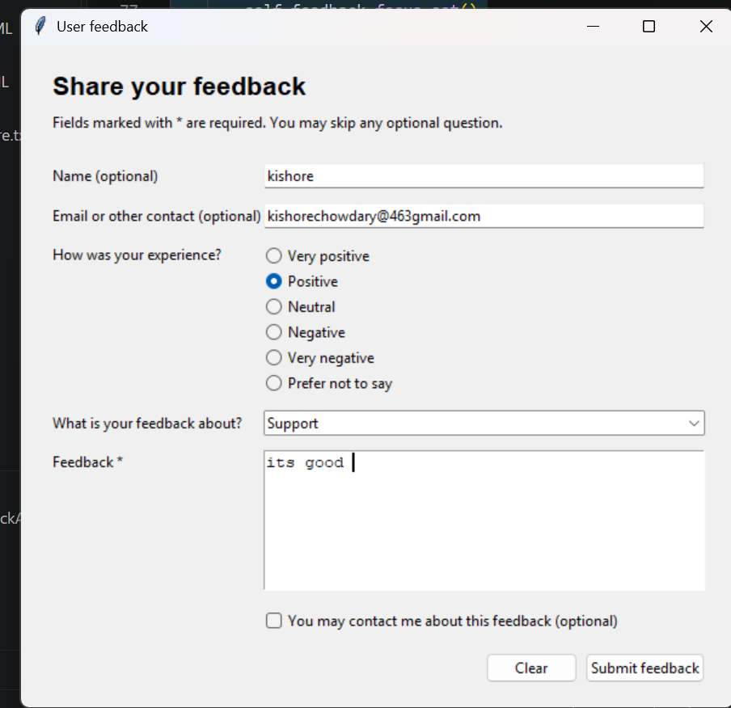

Task Description #6 (Fairness in Loan Approval System)
Task: Use an AI tool to generate a Python program that predicts whether a person should be approved or rejected for a loan based on information such as income, age, employment status, credit score, and loan amount.
Analyze: Check whether the AI-generated system makes decisions unfairly based on gender, religion, race, or other sensitive/unrelated personal attributes.
Expected Output:
- Identified fairness and discrimination risks.
- Examples showing how biased data or rules can lead to unfair loan decisions.
- Revised version that makes loan decisions based on relevant financial factors rather than sensitive attributes.
- Brief explanation of how the revised system improves fairness.

Prompt :-
generate a Python program that predicts whether a person should be approved or rejected for a loan based on information such as income, age, employment status, credit score, and loan amount.
Code :-
"""Simple rule-based loan approval predictor."""

def predict_loan(income, age, employment_status, credit_score, loan_amount):
"""Return APPROVED or REJECTED using basic lending criteria."""
employment_status = employment_status.strip().lower()
score = 0

if income >= 30000:
score += 2
if 18 <= age <= 70:
score += 1
if employment_status in {"employed", "self-employed"}:
score += 2
if credit_score >= 700:
score += 3
elif credit_score >= 600:
score += 1

# A loan should not exceed five times the applicant's annual income.
if loan_amount <= income * 5:
score += 2

return "APPROVED" if score >= 7 else "REJECTED"

def get_number(prompt, minimum=None):
while True:
try:
value = float(input(prompt))
if minimum is not None and value < minimum:
raise ValueError
return value
except ValueError:
print("Enter a valid number.")

def main():
print("Loan Approval Predictor")
income = get_number("Annual income: ", 0)
age = get_number("Age: ", 0)
employment = input("Employment status (employed, self-employed, unemployed): ")
credit_score = get_number("Credit score: ", 0)
loan_amount = get_number("Requested loan amount: ", 0)

decision = predict_loan(income, age, employment, credit_score, loan_amount)
print(f"Decision: {decision}")
print("This is a basic educational estimate, not financial advice.")

if __name__ == "__main__":
main()
output :-
PS C:\Users\kisho_gtbim4w\OneDrive\WTMP LAB> & C:\Users\kisho_gtbim4w\AppData\Local\Python\pythoncore-3.14-64\python.exe "c:/Users/kisho_gtbim4w/OneDrive/WTMP LAB/ai.python"
Loan Approval Predictor
Annual income: 100000
Age: 34
Employment status (employed, self-employed, unemployed): self-employed
Credit score: 765
Requested loan amount: 1000000
Decision: APPROVED
This is a basic educational estimate, not financial advice.
PS C:\Users\kisho_gtbim4w\OneDrive\WTMP LAB>

